**ASPASIA_ADECO_Git**

Contenido

1 Registro: 2

1.1 Archivos: 2

# Registro:

[GitHub: Where the world builds software · GitHub](https://github.com/)

[FullStack@rom.cat](mailto:FullStack@rom.cat)



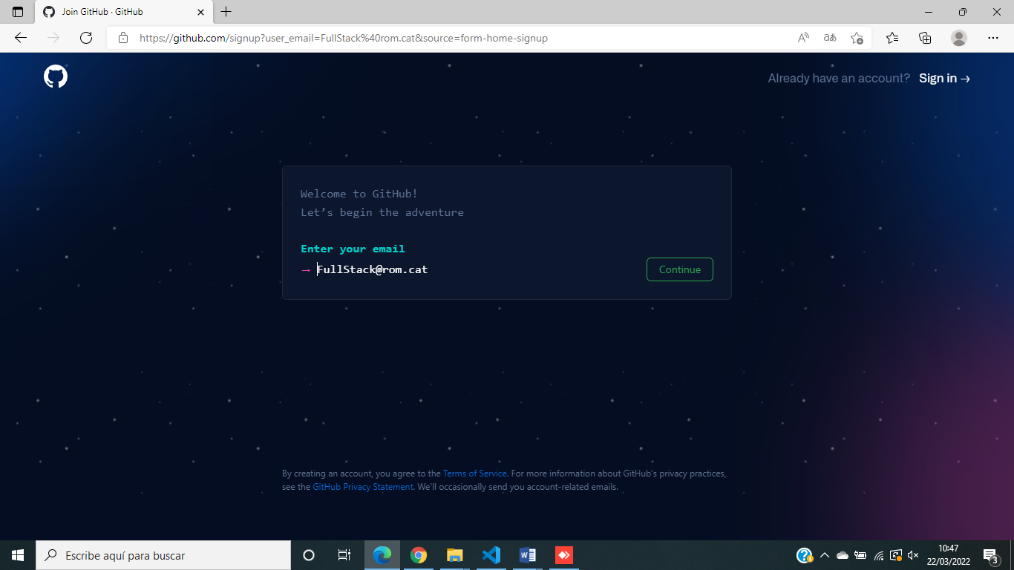

FullStambul

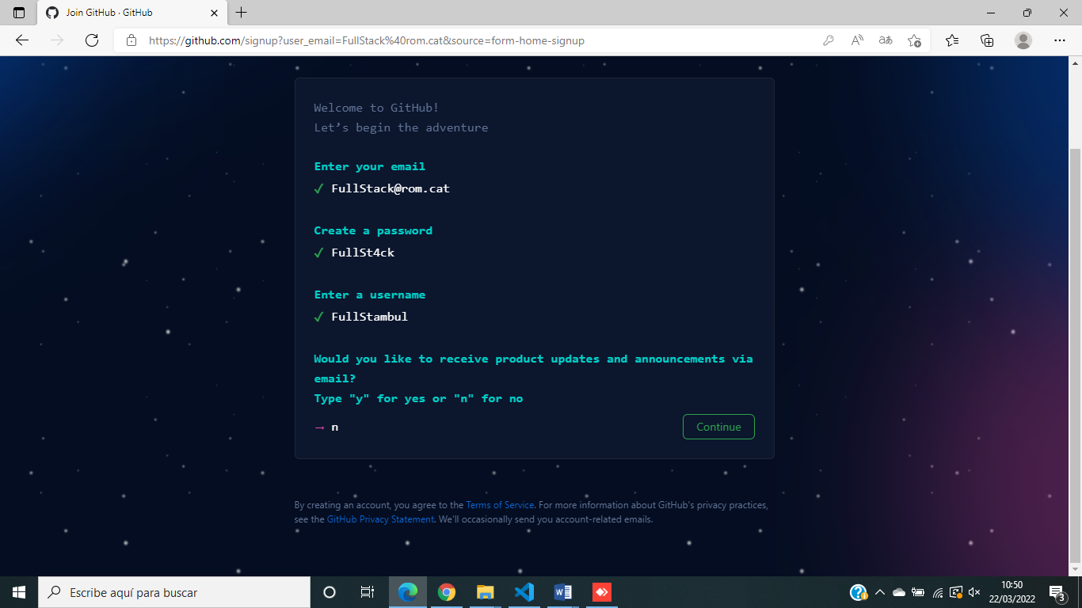



Free

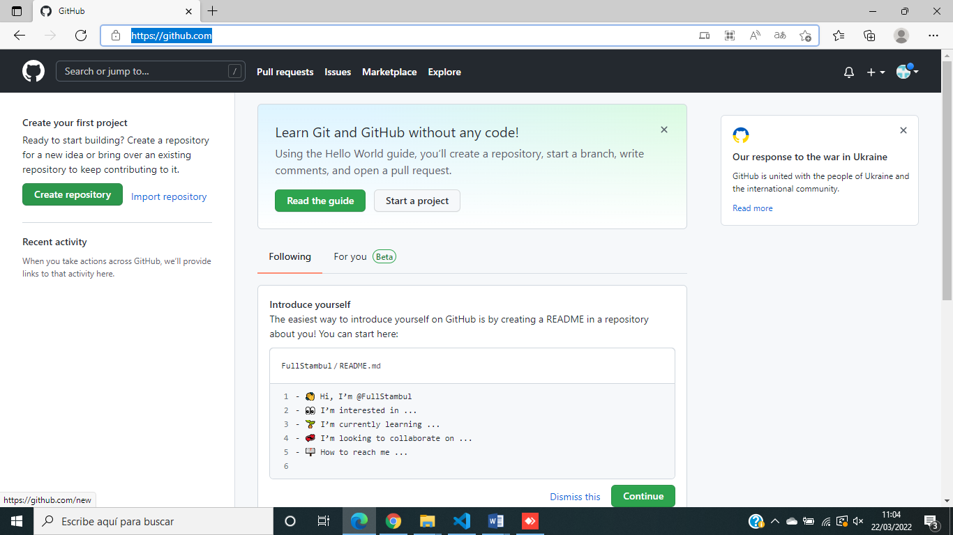

Create Repository

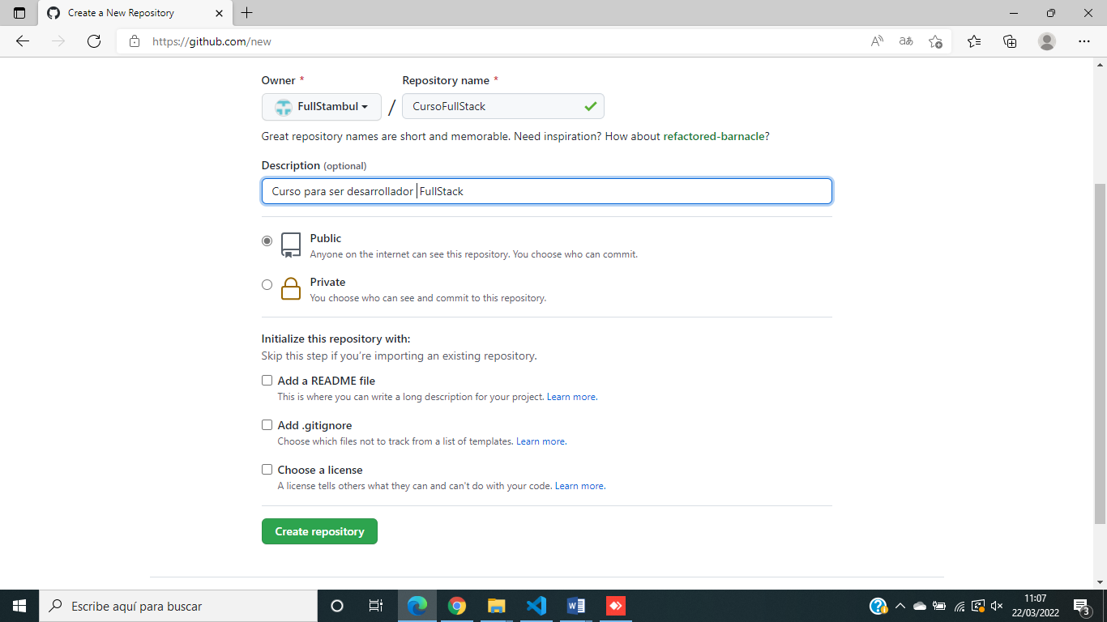

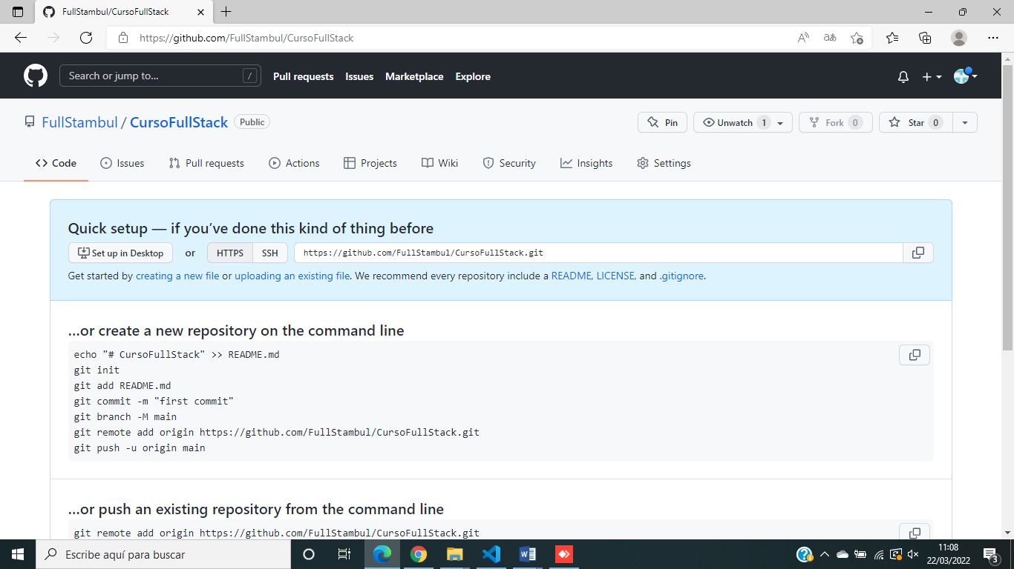

<https://github.com/FullStambul/CursoFullStack.git>

# Descargamos la herramienta Git Bash:

<https://github.com/git-for-windows/git/releases/download/v2.35.1.windows.2/Git-2.35.1.2-64-bit.exe>

La instalamos.

(Sí a todo…)

# Archivos:

Paquete de

Windows PowerShell

Copyright (C) Microsoft Corporation. Todos los derechos reservados.

Prueba la nueva tecnología PowerShell multiplataforma https://aka.ms/pscore6

PS C:\Users\admin> cd C:\Curso

PS C:\Curso> git init

Initialized empty Git repository in C:/Curso/.git/

PS C:\Curso> git add .

warning: LF will be replaced by CRLF in 04.html.

The file will have its original line endings in your working directory

warning: LF will be replaced by CRLF in 16_ejercicio/00.html.

The file will have its original line endings in your working directory

warning: LF will be replaced by CRLF in 16_ejercicio/01.html.

The file will have its original line endings in your working directory

warning: LF will be replaced by CRLF in 16_ejercicio/02.html.

The file will have its original line endings in your working directory

warning: LF will be replaced by CRLF in 16_ejercicio/03.html.

The file will have its original line endings in your working directory

warning: LF will be replaced by CRLF in 16_ejercicio/04.html.

The file will have its original line endings in your working directory

warning: LF will be replaced by CRLF in Api/api/.htaccess.

The file will have its original line endings in your working directory

warning: LF will be replaced by CRLF in Api/api/LICENSE.

The file will have its original line endings in your working directory

warning: LF will be replaced by CRLF in Api/api/README.md.

The file will have its original line endings in your working directory

warning: LF will be replaced by CRLF in Api/api/api.php.

The file will have its original line endings in your working directory

warning: LF will be replaced by CRLF in Api/api/extras/core.php.

The file will have its original line endings in your working directory

warning: LF will be replaced by CRLF in Api/api/lib/php_crud_api_transform.js.

The file will have its original line endings in your working directory

warning: LF will be replaced by CRLF in Api/api/lib/php_crud_api_transform.php.

The file will have its original line endings in your working directory

warning: LF will be replaced by CRLF in Api/api/lib/php_crud_api_transform.py.

The file will have its original line endings in your working directory

warning: LF will be replaced by CRLF in Json2table/EjemploJSON/cssestilo.css.

The file will have its original line endings in your working directory

warning: LF will be replaced by CRLF in Json2table/EjemploJSON/demo_json.sql.

The file will have its original line endings in your working directory

warning: LF will be replaced by CRLF in bootstrap/css/bootstrap-grid.css.

The file will have its original line endings in your working directory

warning: LF will be replaced by CRLF in bootstrap/css/bootstrap-grid.min.css.

The file will have its original line endings in your working directory

warning: LF will be replaced by CRLF in bootstrap/css/bootstrap-grid.rtl.css.

The file will have its original line endings in your working directory

warning: LF will be replaced by CRLF in bootstrap/css/bootstrap-grid.rtl.min.css.

The file will have its original line endings in your working directory

warning: LF will be replaced by CRLF in bootstrap/css/bootstrap-reboot.css.

The file will have its original line endings in your working directory

warning: LF will be replaced by CRLF in bootstrap/css/bootstrap-reboot.min.css.

The file will have its original line endings in your working directory

warning: LF will be replaced by CRLF in bootstrap/css/bootstrap-reboot.rtl.css.

The file will have its original line endings in your working directory

warning: LF will be replaced by CRLF in bootstrap/css/bootstrap-reboot.rtl.min.css.

The file will have its original line endings in your working directory

warning: LF will be replaced by CRLF in bootstrap/css/bootstrap-utilities.css.

The file will have its original line endings in your working directory

warning: LF will be replaced by CRLF in bootstrap/css/bootstrap-utilities.min.css.

The file will have its original line endings in your working directory

warning: LF will be replaced by CRLF in bootstrap/css/bootstrap-utilities.rtl.css.

The file will have its original line endings in your working directory

warning: LF will be replaced by CRLF in bootstrap/css/bootstrap-utilities.rtl.min.css.

The file will have its original line endings in your working directory

warning: LF will be replaced by CRLF in bootstrap/css/bootstrap.css.

The file will have its original line endings in your working directory

warning: LF will be replaced by CRLF in bootstrap/css/bootstrap.min.css.

The file will have its original line endings in your working directory

warning: LF will be replaced by CRLF in bootstrap/css/bootstrap.rtl.css.

The file will have its original line endings in your working directory

warning: LF will be replaced by CRLF in bootstrap/css/bootstrap.rtl.min.css.

The file will have its original line endings in your working directory

warning: LF will be replaced by CRLF in bootstrap/js/bootstrap.bundle.js.

The file will have its original line endings in your working directory

The file will have its original line endings in your working directory

warning: LF will be replaced by CRLF in bootstrap/js/bootstrap.esm.js.

The file will have its original line endings in your working directory

warning: LF will be replaced by CRLF in bootstrap/js/bootstrap.esm.min.js.

The file will have its original line endings in your working directory

warning: LF will be replaced by CRLF in bootstrap/js/bootstrap.js.

The file will have its original line endings in your working directory

warning: LF will be replaced by CRLF in bootstrap/js/bootstrap.min.js.

The file will have its original line endings in your working directory

PS C:\Curso> git commit -m "Mi primer Commit..."

[master (root-commit) cd836b4] Mi primer Commit...

154 files changed, 68731 insertions(+)

create mode 100644 00ImagenSvg.svg

create mode 100644 01.html

create mode 100644 02.php

create mode 100644 03.html

create mode 100644 04.html

create mode 100644 06.html

create mode 100644 07.php

create mode 100644 08.html

create mode 100644 09.html

create mode 100644 10.html

create mode 100644 11.html

create mode 100644 12.html

create mode 100644 13.html

create mode 100644 14.html

create mode 100644 15.html

create mode 100644 16_ejercicio/00.html

create mode 100644 16_ejercicio/01.html

create mode 100644 16_ejercicio/02.html

create mode 100644 16_ejercicio/03.html

create mode 100644 16_ejercicio/04.html

create mode 100644 20.html

create mode 100644 21.css

create mode 100644 22.html

create mode 100644 23.css

create mode 100644 24.html

create mode 100644 25.css

create mode 100644 26.html

create mode 100644 27.css

create mode 100644 28.html

create mode 100644 29.css

create mode 100644 30.html

create mode 100644 31.css

create mode 100644 32.html

create mode 100644 33.css

create mode 100644 34.html

create mode 100644 35.css

create mode 100644 36.html

create mode 100644 37.css

create mode 100644 38.js

create mode 100644 40.html

create mode 100644 41.css

create mode 100644 42.js

create mode 100644 44.html

create mode 100644 45.css

create mode 100644 46.html

create mode 100644 47.css

create mode 100644 48.html

create mode 100644 49.css

create mode 100644 50.html

create mode 100644 51.css

create mode 100644 52.html

create mode 100644 53.css

create mode 100644 54.html

create mode 100644 55.css

create mode 100644 56.html

create mode 100644 57.css

create mode 100644 58.html

create mode 100644 59.css

create mode 100644 60.html

create mode 100644 61.css

create mode 100644 62.html

create mode 100644 63.css

create mode 100644 64.html

create mode 100644 65.css

create mode 100644 66.html

create mode 100644 67.css

create mode 100644 70.html

create mode 100644 71.css

create mode 100644 72.js

create mode 100644 74.html

create mode 100644 75.css

create mode 100644 76.js

create mode 100644 Api/api/.htaccess

create mode 100644 Api/api/01.html

create mode 100644 Api/api/LICENSE

create mode 100644 Api/api/README.md

create mode 100644 Api/api/api.php

create mode 100644 Api/api/extras/core.php

create mode 100644 Api/api/lib/php_crud_api_transform.js

create mode 100644 Api/api/lib/php_crud_api_transform.php

create mode 100644 Api/api/lib/php_crud_api_transform.py

create mode 100644 BombillaOff.png

create mode 100644 BombillaOn.png

create mode 100644 Casa.png

create mode 100644 Curso.rar

create mode 100644 FotosPizarra/photo_2022-03-09_20-03-45.jpg

create mode 100644 FotosPizarra/photo_2022-03-09_20-03-49.jpg

create mode 100644 FotosPizarra/photo_2022-03-09_20-03-51.jpg

create mode 100644 FotosPizarra/photo_2022-03-09_20-03-54.jpg

create mode 100644 FotosPizarra/photo_2022-03-09_20-03-57.jpg

create mode 100644 FotosPizarra/photo_2022-03-10_21-54-40.jpg

create mode 100644 FotosPizarra/photo_2022-03-11_17-03-13.jpg

create mode 100644 FotosPizarra/photo_2022-03-11_17-03-15.jpg

create mode 100644 FotosPizarra/photo_2022-03-11_17-03-17.jpg

create mode 100644 Hoy.txt

create mode 100644 Json2table/EjemploJSON/cssestilo.css

create mode 100644 Json2table/EjemploJSON/demo_json.sql

create mode 100644 Json2table/EjemploJSON/generarJSON.php

create mode 100644 Json2table/EjemploJSON/mostrarJSON.html

create mode 100644 Json2table/LosDosEjemplosFuncionan.txt

create mode 100644 Json2table/mostrar_json-main/consultas.sql

create mode 100644 Json2table/mostrar_json-main/index.html

create mode 100644 Json2table/mostrar_json-main/php/consulta.php

create mode 100644 Practicas/01.html

create mode 100644 Practicas/02.html

create mode 100644 Practicas/03.css

create mode 100644 Practicas/03.html

create mode 100644 Practicas/04.html

create mode 100644 bootstrap/css/bootstrap-grid.css

create mode 100644 bootstrap/css/bootstrap-grid.css.map

create mode 100644 bootstrap/css/bootstrap-grid.min.css

create mode 100644 bootstrap/css/bootstrap-grid.min.css.map

create mode 100644 bootstrap/css/bootstrap-grid.rtl.css

create mode 100644 bootstrap/css/bootstrap-grid.rtl.css.map

create mode 100644 bootstrap/css/bootstrap-grid.rtl.min.css

create mode 100644 bootstrap/css/bootstrap-grid.rtl.min.css.map

create mode 100644 bootstrap/css/bootstrap-reboot.css

create mode 100644 bootstrap/css/bootstrap-reboot.css.map

create mode 100644 bootstrap/css/bootstrap-reboot.min.css

create mode 100644 bootstrap/css/bootstrap-reboot.min.css.map

create mode 100644 bootstrap/css/bootstrap-reboot.rtl.css

create mode 100644 bootstrap/css/bootstrap-reboot.rtl.css.map

create mode 100644 bootstrap/css/bootstrap-reboot.rtl.min.css

create mode 100644 bootstrap/css/bootstrap-reboot.rtl.min.css.map

create mode 100644 bootstrap/css/bootstrap-utilities.css

create mode 100644 bootstrap/css/bootstrap-utilities.css.map

create mode 100644 bootstrap/css/bootstrap-utilities.min.css

create mode 100644 bootstrap/css/bootstrap-utilities.min.css.map

create mode 100644 bootstrap/css/bootstrap-utilities.rtl.css

create mode 100644 bootstrap/css/bootstrap-utilities.rtl.css.map

create mode 100644 bootstrap/css/bootstrap-utilities.rtl.min.css

create mode 100644 bootstrap/css/bootstrap-utilities.rtl.min.css.map

create mode 100644 bootstrap/css/bootstrap.css

create mode 100644 bootstrap/css/bootstrap.css.map

create mode 100644 bootstrap/css/bootstrap.min.css

create mode 100644 bootstrap/css/bootstrap.min.css.map

create mode 100644 bootstrap/css/bootstrap.rtl.css

create mode 100644 bootstrap/css/bootstrap.rtl.css.map

create mode 100644 bootstrap/css/bootstrap.rtl.min.css

create mode 100644 bootstrap/css/bootstrap.rtl.min.css.map

create mode 100644 bootstrap/js/bootstrap.bundle.js

create mode 100644 bootstrap/js/bootstrap.bundle.js.map

create mode 100644 bootstrap/js/bootstrap.bundle.min.js

create mode 100644 bootstrap/js/bootstrap.bundle.min.js.map

create mode 100644 bootstrap/js/bootstrap.esm.min.js

create mode 100644 bootstrap/js/bootstrap.esm.min.js.map

create mode 100644 bootstrap/js/bootstrap.js

create mode 100644 bootstrap/js/bootstrap.js.map

create mode 100644 bootstrap/js/bootstrap.min.js

create mode 100644 bootstrap/js/bootstrap.min.js.map

create mode 100644 index.html

create mode 100644 ~$22_02_18_ASPASIA_ADECO_Docente_Curso_Programacion.docx

PS C:\Curso> git push -u origin main

error: src refspec main does not match any

error: failed to push some refs to 'https://github.com/tuPelu/fullstack.git'

PS C:\Curso> git remote show origin

* remote origin

Fetch URL: https://github.com/tuPelu/fullstack.git

Push URL: https://github.com/tuPelu/fullstack.git

HEAD branch: main

Remote branch:

main new (next fetch will store in remotes/origin)

PS C:\Curso> git push origin master

info: please complete authentication in your browser...

Enumerating objects: 164, done.

Counting objects: 100% (164/164), done.

Delta compression using up to 4 threads

Compressing objects: 100% (160/160), done.

Writing objects: 100% (164/164), 2.60 MiB | 3.44 MiB/s, done.

Total 164 (delta 33), reused 0 (delta 0), pack-reused 0

remote: Resolving deltas: 100% (33/33), done.

remote:

remote: Create a pull request for 'master' on GitHub by visiting:

remote: https://github.com/tuPelu/fullstack/pull/new/master

remote:

To https://github.com/tuPelu/fullstack.git

* [new branch] master -> master

PS C:\Curso>