Submitted To
Dr. Ashraf Uddin
Assistant Professor, CS, AIUB
Credit scoring for borrowers in bank

Group: G-01, Section: H
AI Usage Declaration
We, the undersigned students, hereby declare that this project and its accompanying report/code have been primarily prepared by our group.
We acknowledge that the use of Artificial Intelligence (AI) tools such as ChatGPT, GitHub Copilot, Grammarly, or similar systems was permitted only to assist in learning, idea generation, code debugging, or language improvement.
We further declare that:
- We have clearly mentioned below the specific purposes for which AI tools were used (if any).
- The core design, implementation, analysis, and conclusions are our own original work.
- We collectively take full academic responsibility for the content of this submission.
AI Usage Details:
☐ No AI tools were used.
☐ AI tools were used for the following purposes (please specify clearly):

 | Name | Student ID | Signature with Date
1. | DIP, TURJO DAS | 22-48558-3
2. | IVY, NUSRAT FARAEZI | 22-48608-3
3. | TANJILA, SAIMA AHMED | 23-50458-1
4.

Table of Contents
Title & Introduction 4
The key Questions this analysis include 5
Headings 4
Figures/Tables 4
Guideline for Updating Table of Contents 5
Conclusion 5

List of Table and Figures
Table 1: Write the table caption 5

Fig. 1: Write a proper caption 4

Borrower Credit Score Classification Using Datasets Analysis

The project Borrower Credit Score Classification Using Datasets Analysis is intended to explore how data can be used for assessing the creditworthiness of people applying for bank loans. Banks are highly dependent on credit scoring so that safe lending decisions are granted while erroneous assessment leads to financial losses. This project was undertaken as an exercise to come up with a more reliable and data-driven way of classifying borrowers based on financial behavior and personal information. In line with this, relevant datasets were retrieved, cleaned and analyzed to outline the patterns driving credit scores. Accordingly, machine learning-based classification techniques were applied to build a model that could predict the credit category of a borrower. It also gives valuable insight into which factors most strongly affect credit scoring and how data science techniques can underpin better, more consistent loan approval decisions.
Data Source
The dataset used in this project was collected from Kaggle and then uploaded to Google Drive. The dataset contains banking-related information used for analyzing borrower characteristics and credit score classification.
Dataset Link
https://drive.google.com/uc?export=download&id=1hh5frOJR94dWkkT4HLXt6ke9-4asgUz_
Dataset Description
The dataset contains 17 columns, representing demographic, financial and behavioral attributes of bank customers. Below is a complete description of all features:
- Age: Age of the borrower.
- Job: Type of occupation.
- Marital: Marital status.
- Education: Education level.
- Default: Indicates if the customer has credit in default.
- Balance: Customer’s yearly average account balance.
- Housing: Whether the customer has a housing loan.
- Loan: Whether the customer has a personal loan.
- Contact: Communication method used.
- Day: Day of last contact.
- Month: Month of last contact.
- Duration: Duration of last contact in seconds.
- Campaign: Number of contacts performed during the campaign.
- PDays: Days passed since last contact.
- Previous: Number of contacts performed before the campaign.
- POutcome: Outcome of the previous marketing campaign.
- Y: Target variable indicating whether the client subscribed to a term deposit.
These variables collectively help in understanding borrower behavior and are used to classify credit scores more accurately in this study.

Data Understanding

Loading and Viewing the Dataset
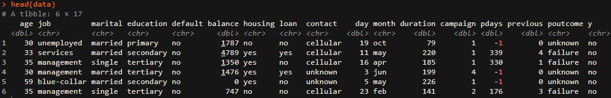
The dataset was loaded in R using read_delim(). The first few rows, dimensions, structure and summary statistics were inspected.

Shape of Dataset
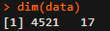
The dataset contains 4521 rows and 17 columns.

Data Types with Categorical and Numerical features
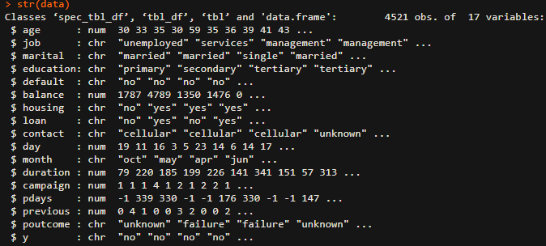
The dataset contains both numerical features (Age, Balance, Day, Duration, Campaign, PDays, Previous) and categorical variables (Job, Marital, Education, Default, Housing, Loan, Contact, Month, POutcome, Y).

Basic Descriptive Statistics
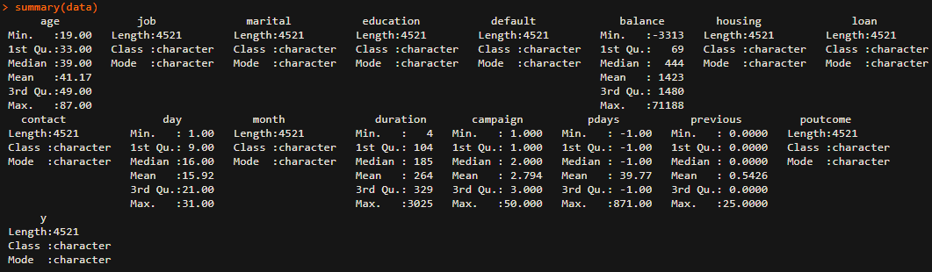
Basic descriptive statistics (mean, median, mode, min, max, quartiles) were computed for numerical features. These statistics help identify distribution patterns and potential skewness.

The key questions addressed in this analysis include:
- What are the main factors that influence a borrower’s credit score?
- How do financial and demographic attributes such as age, job type marital status and education relate to creditworthiness?
- Do variables like account balance, existing loans and housing status significantly impact the likelihood of credit approval?
- Can this dataset be used to accurately classify borrowers into different credit score categories?
- How do variables such as balance, housing loan, personal loan and campaign interactions coexist and contribute to borrower profiling?
This report presents the full workflow from data collection to dataset cleaning, explores the relationships among the variables, highlights key analytical findings and visualizations and concludes with important observations and limitations of the study.

Guideline for Updating TOC, List of Figures and Tables
Ensure all headings, figures, and tables have been properly formatted and captioned before updating. Click anywhere in the TOC.

Headings
Use Word’s built-in heading styles (e.g., Heading 1, Heading 2).

Figures/Tables
Use Insert Caption and select the appropriate label (Figure or Table).
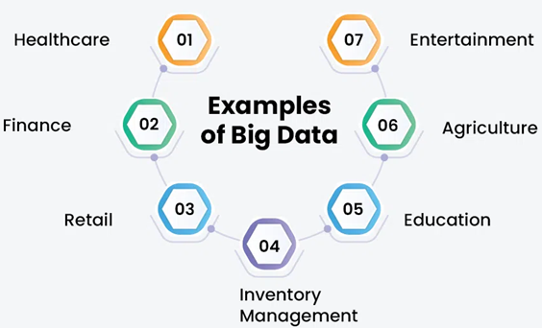
Fig. 1: Write a proper caption

Guideline for Updating Table of Contents
Click anywhere in the TOC. Go to References → Update Table → Update entire table. This ensures all new headings or page number changes are reflected.
Updating List of Figures / List of Tables
Click anywhere in the list. Right-click and choose Update Field → Update entire table. This ensures all new figures/tables or page number changes are included. Repeat updates after making any further edits to headings, figures, or tables to keep the document consistent.
Table 1: Write the table caption
Column 1 | Column 2 | …

Conclusion
Write a single paragraph summarizing the key findings and results of the project. Highlight the significance of these outcomes and how the project objectives were achieved. Optionally, mention limitations and suggest possible future improvements. Keep the paragraph clear, coherent, and at least 100 words in a formal academic tone.

