

Requirement & Design Specification
Facility & Equipment Management System (F-EMS)
Version: 1.0

– Da Nang 2026 –

Record of Changes
Version | Date | A*  M, D | In charge | Change Description
V1.0 | 10/2/2026 | A | Anh Tuấn (DE170051)
V2.0 | 25/3/2026 | A | Hoàn Mỹ (DE190596)  Nguyên Thảo (DE190609) | Initial creation based on codebase reverse-engineering
*A - Added M - Modified D - Deleted

Contents
Record of Changes 2
I. Overview 4
1. User Requirements 4
1.1 Actors 4
1.2 Use Cases 4
2. Overall Functionalities 6
2.1 Screens Flow 6
2.2 Screen Descriptions 6
2.3 Screen Authorization 7
2.4 Non-UI Functions 7
3. System High Level Design 8
3.1 Database Design 8
3.2 Code Packages 10
II. Requirement Specifications 11
1. Common Functions 11
1.1 UC-2_Login System 11
3. Student & Lecturer Feature 12
3.1 UC-1_Report Damage/Fault 12
3.2 UC-04_Request Borrow Equipment 13
III. Design Specifications 15
1. Authentication 15
1.1 Login Page 15
2. Report Fault Form (Guest + All Roles) 16
3. Equipment Management (Technician / Admin) 17
IV. Appendix 19
1. Assumptions & Dependencies 19
2. Limitations & Exclusions 19
3. Business Rules 20

I. Overview

1. User Requirements

1.1 Actors
# | Actor | Description
1 | Admin | System administrator with full access to all modules. Manages users, equipment assets, buildings, rooms, class schedules, borrow requests, damage reports, time slots, classes, and system-wide notifications. Can perform direct equipment allocation.
2 | Lecturer | Teaching staff of the institution. The system analyzes the lecturer’s assigned teaching schedule and current time to determine whether an active session exists. When an active slot is detected, the corresponding class/session information is displayed at the top of the lecturer dashboard, and the lecturer can press Start Session to check in. The lecturer reviews and approves/rejects equipment borrow requests submitted by students during the active session, submits damage reports, and views their academic calendar together with approval and report history.
3 | Student | University student enrolled in academic classes. Browses available equipment in the room of their active session, submits borrow requests, confirms receipt of borrowed equipment through a handover checklist, and may reject receipt if the actual equipment condition does not match the handover checklist presented by the system. Initiates return requests, views personal borrow history, tracks the current processing status of submitted reports, and views report history.
4 | Technician | Equipment maintenance staff. Manages equipment inventory (create, update, mark broken, delete). Processes repair tickets assigned to them, updating status from processing to fixed. Views technician-specific dashboard analytics. Can also approve/reject/return borrow requests.
5 | Guest | Unauthenticated visitor. Can access the public report form at /report-issue to submit equipment or infrastructure damage reports without logging in. No access to any other protected feature.

1.2 Use Cases
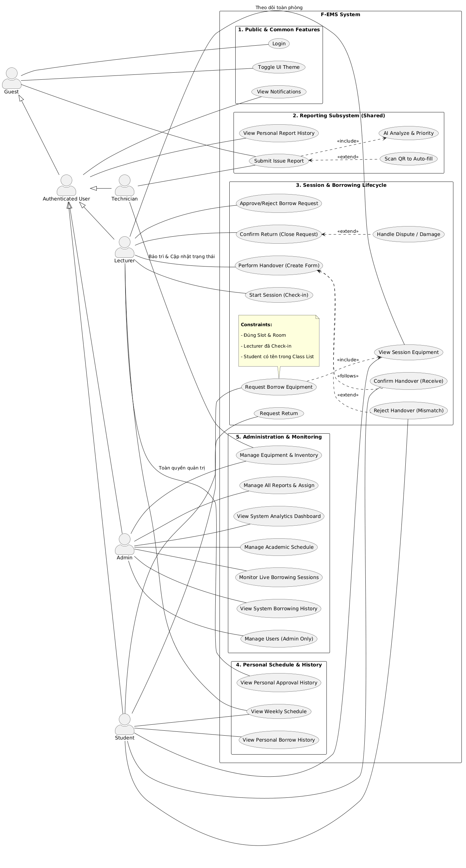

b. Descriptions
ID | Feature | Use Case | Use Case Description
UC-01 | Authentication | Sign In with Credentials | User submits username (or email) and password; system validates, issues JWT access token and refresh token, creates a session record.
UC-02 | Authentication | Sign In with Google OAuth | User authenticates via Google; system verifies Google token, matches email to an existing account, issues FEMS JWT tokens.
UC-03 | Authentication | Sign Out | User logs out; system deletes the active refresh token session from the database and clears cookies.
UC-04 | Authentication | Forgot Password | User submits email; system sends a 6-digit OTP to that email (via Gmail SMTP), subject to rate limiting (max 5 requests per 30 minutes).
UC-05 | Authentication | Verify Reset OTP | User submits email and 6-digit OTP; system validates token validity and expiry (5-minute TTL).
UC-06 | Authentication | Reset Password | User submits email, verified OTP, and new password; system hashes and overwrites password, destroys all active sessions for that user.
UC-07 | Authentication | Change Password | Authenticated user submits current password and new password; system verifies current password, hashes and stores new password, destroys all active sessions.
UC-08 | Authentication | Refresh Access Token | Client presents expired access token; system uses refresh token cookie to issue a new access token (15-minute TTL).
UC-09 | User Management | Create User Account | Admin creates a new user account with username, email, password, role, and display name.
UC-10 | User Management | View and Search Users | Admin and Technician retrieve the full user list. Admin can filter by role and active status.
UC-11 | User Management | Update User Profile (Admin) | Admin edits any user's profile fields including role, display name, phone, date of birth, class assignment, and active status.
UC-12 | User Management | Delete User | Admin permanently deletes a user account.
UC-13 | User Management | Activate / Deactivate User | Admin toggles the isActive flag of a user account to grant or revoke login access.
UC-14 | User Management | Update Own Profile | Authenticated user updates their own display name, phone, date of birth, and avatar image.
UC-15 | Equipment Management | Add Equipment | Admin or Technician creates a new equipment asset with name, category, status, room assignment, image, description, and last maintenance date. System auto-generates a unique alphanumeric code.
UC-16 | Equipment Management | View Equipment Inventory | All authenticated users and public (via inventory endpoint) browse equipment with filters for search, category, building, room, and status. Borrow status (available / reserved / in_use) is derived from active BorrowRequests.
UC-17 | Equipment Management | Update Equipment Details | Admin or Technician edits equipment name, category, status, room assignment, image, description, or last maintenance date.
UC-18 | Equipment Management | Delete Equipment | Admin or Technician permanently removes an equipment record.
UC-19 | Equipment Management | View Equipment by QR Code | Any user scans an equipment QR code; system fetches equipment details by unique code.
UC-20 | Equipment Management | Mark Equipment as Broken | Admin or Technician flags equipment status as broken; system atomically creates a linked repair Report record. Blocked if an open repair report already exists.
UC-21 | Equipment Management | Generate QR Code | Admin or Technician views the QR code for an equipment item based on its unique code.
UC-22 | Borrow Request | Create Borrow Request (Student) | Student submits a borrow request for equipment in their active session room. System validates that the equipment is borrowable, the student has an active session in the equipment's room, and the lecturer session has been started.
UC-23 | Borrow Request | Review Active-Session Borrow Requests (Lecturer) | Lecturer views and processes student borrow requests generated during the currently active teaching session after pressing Start Session.
UC-24 | Borrow Request | Approve Borrow Request | Lecturer approves a pending borrow request in their active session class with optional decision note. System re-validates equipment availability.
UC-25 | Borrow Request | Reject Borrow Request | Lecturer rejects a pending borrow request in their active session class with optional decision note.
UC-26 | Borrow Request | Confirm or Reject Equipment Receipt | Student reviews the physical equipment against the handover checklist. If the condition matches, the student confirms receipt and the request transitions to handed_over. If the condition does not match, the student can reject receipt and the system records the mismatch for follow-up processing.
UC-27 | Borrow Request | Submit Return Request | Student signals intent to return equipment. Transitions status from handed_over to returning. No form required.
UC-28 | Borrow Request | Confirm Equipment Return | Lecturer, Technician, or Admin confirms physical return after inspection; submits return checklist and optional evidence images. Transitions status from returning to returned.
UC-29 | Borrow Request | Cancel Borrow Request | Borrower (student) cancels their own pending or approved request with a required cancellation reason.
UC-30 | Borrow Request | View Borrow / Approval History | Student views personal borrow history. Lecturer views approval history for requests they have processed. Admin and Technician view all requests.
UC-31 | Borrow Request | Send Overdue Reminder | System sends a reminder notification to a borrower for an overdue request.
UC-32 | Damage Report | Submit Damage Report | Any user (including guest) submits a damage report specifying type (equipment / infrastructure / other), description, priority, images, and optionally the affected equipment or room.
UC-33 | Damage Report | View All Reports | Admin and Technician view all submitted damage reports with status, priority, assignment details, and processing timeline.
UC-34 | Damage Report | Update Report Status | Admin or Technician updates a report's status through the workflow pending → approved → processing → fixed. Equipment technical status is synchronized when report status changes. The system records processed_by to identify the technician/user who completed the repair.
UC-35 | Damage Report | Cancel Report | The original reporter cancels their own pending report.
UC-36 | Damage Report | View Personal Report History and Processing Status | Authenticated user views their own submitted reports, report history, and the current processing stage of each report.
UC-37 | Schedule Management | Create Schedule | Admin creates a teaching session schedule linking lecturer, class, room, and slot. System computes startAt/endAt from the date and slot definition.
UC-38 | Schedule Management | View All Schedules | Admin queries schedules with optional filters: date, date range, lecturerId, roomId, classId.
UC-39 | Schedule Management | View My Schedule | Lecturer or Student views their own upcoming and past schedules.
UC-40 | Schedule Management | Update/Delete Schedule | Admin updates or permanently deletes a schedule record.
UC-41 | Attendance Management | Start Session (Lecturer Check-In) | When the current time falls within one of the lecturer’s assigned schedule slots, the system displays the active class/session at the top of the dashboard and enables Start Session. Pressing the button records lecturer check-in and activates borrow processing for that session.
UC-42 | Attendance Management | End Session (Lecturer Check-Out) | Lecturer ends an active session; system marks the schedule as completed and prevents new borrow requests for that session.
UC-43 | Class Management | Manage Classes | Admin creates, reads, updates, and deletes academic class records (code, name, major).
UC-44 | Notification | View Notifications | Authenticated user views their notification inbox, filtered by unread/read status.
UC-45 | Notification | Mark Notifications as Read | User marks individual or all notifications as read.
UC-46 | Notification | Delete Notifications | User deletes individual notifications or clears all notifications.
UC-47 | Notification | Broadcast Notification | Admin broadcasts a notification to all users of a specific role, or to a specific individual user.
UC-48 | AI Assistant | Chat with FEMS AI | Authenticated user sends messages to the FEMS AI assistant (Groq Llama). AI can query equipment list, retrieve equipment details, view user's borrow history, and create borrow requests on behalf of the user via a two-step confirmation flow.
UC-49 | Dashboard | Admin Dashboard | Admin views aggregated statistics: total equipment, pending borrow requests, borrow rate, damage rate, health status, monthly borrow trends, damage trends, technician performance, and top borrowed equipment.
UC-50 | Dashboard | Technician Dashboard | Technician views ticket pipeline by status, device health distribution, equipment analytics, and active work orders.
UC-51 | Dashboard | Lecturer Dashboard | Lecturer views the current detected teaching session, Start Session control, borrow request approval panel, report history access, and recent activities.
UC-52 | Dashboard | Student Dashboard | Student views the current active session card, personal stat cards (total borrows, reports, pending items), and recent activity timeline.
UC-53 | Profile | View and Update Own Profile | Any authenticated user views and updates their own profile: display name, phone, date of birth, and avatar (uploaded to Cloudinary).

2. Overall Functionalities

2.1 Screens Flow

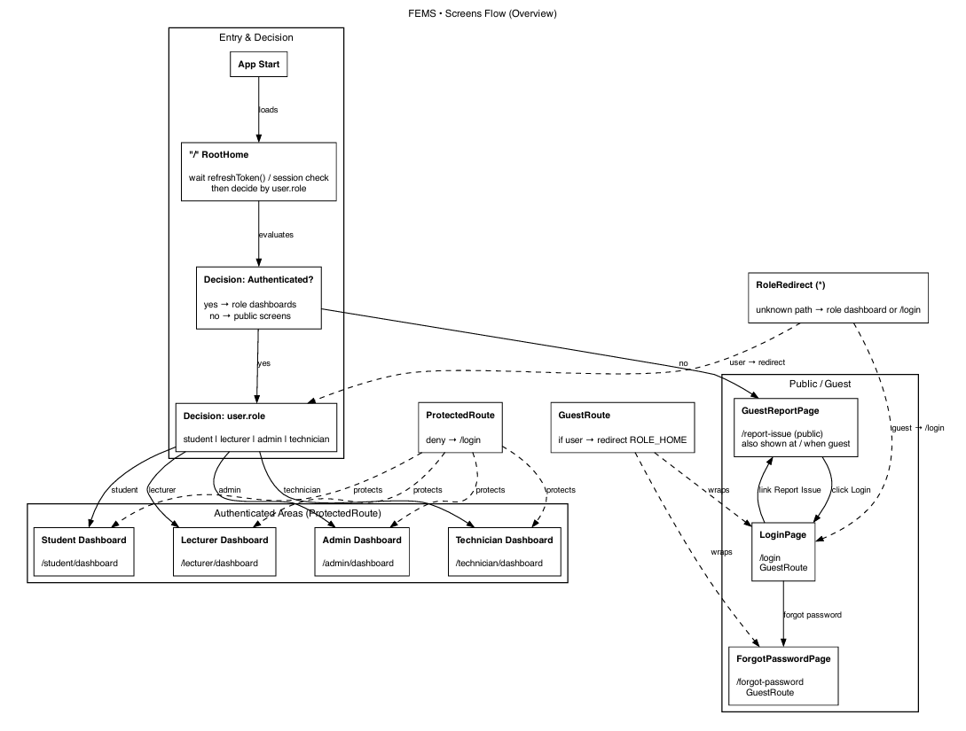
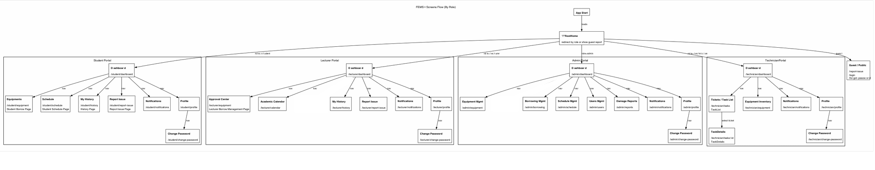

2.2 Screen Descriptions
# | Feature | Screen | Description
1 | Authentication | Login Page (/login) | Login form with username/password fields and Google OAuth button. Redirects to role-specific dashboard on success.
2 | Authentication | Forgot Password Page (/forgot-password) | Multi-step flow: email submission, OTP verification, and new password reset.
3 | Public Report | Guest Report Page (/report-issue) | Public damage report form accessible without login.
4 | Admin | Admin Dashboard (/admin/dashboard) | Main admin overview screen showing system-wide statistics, request monitoring, and operational summaries.
5 | Admin | Equipment Management (/admin/equipment) | Equipment inventory page with search, filters, CRUD actions, detail modal, and QR code generation.
6 | Admin | Borrowing Management (/admin/borrowing) | Full borrow request management page with approval, rejection, return confirmation, and direct allocation support.
7 | Admin | User Management (/admin/users) | User administration page with search, filter, create, update, delete, and activation/deactivation actions.
8 | Admin | Damage Reports (/admin/reports) | Centralized report handling page with status filters, priority filters, technician assignment, full processing timeline, and processed_by field to show who handled the repair.
9 | Admin | Schedule Management (/admin/schedule) | Schedule management page for creating, updating, filtering, and deleting teaching sessions.
10 | Admin | Notifications (/admin/notifications) | Notification inbox with read/unread management and broadcast modal.
11 | Admin | Change Password (/admin/change-password) | Password change form for the admin account.
12 | Admin | Profile (/admin/profile) | Admin profile page for viewing and updating personal information.
13 | Lecturer | Lecturer Dashboard (/lecturer/dashboard) | Dashboard showing currently detected teaching session, Start Session control, approval panel, and recent activities.
14 | Lecturer | Approval Center (/lecturer/equipment) | Borrow approval page for lecturer actions during the active session.
15 | Lecturer | Academic Calendar (/lecturer/calendar) | Lecturer teaching calendar page.
16 | Lecturer | My History / Approval & Report History (/lecturer/history) | History page containing lecturer report history and approval history for handled borrow requests.
17 | Lecturer | Report Issue (/lecturer/report-issue) | Lecturer report submission page with authenticated context.
18 | Lecturer | Notifications (/lecturer/notifications) | Lecturer personal notifications page.
19 | Lecturer | Change Password (/lecturer/change-password) | Password change page for lecturer.
20 | Lecturer | Profile (/lecturer/profile) | Lecturer profile page.
21 | Student | Student Dashboard (/student/dashboard) | Dashboard showing active session card, personal statistics, and recent activity timeline.
22 | Student | Equipment Borrow Page (/student/equipment) | Student borrowing page for viewing room-based equipment, creating requests, confirming handover, or rejecting receipt if checklist does not match actual condition.
23 | Student | Schedule (/student/schedule) | Student schedule page.
24 | Student | My History (/student/history) | Student history page containing borrow history and report history, including report processing status tracking.
25 | Student | Report Issue (/student/report-issue) | Student report submission page.
26 | Student | Notifications (/student/notifications) | Student personal notifications page.
27 | Student | Change Password (/student/change-password) | Password change page for student.
28 | Student | Profile (/student/profile) | Student profile page.
29 | Technician | Technician Dashboard (/technician/dashboard) | Technician dashboard showing ticket pipeline, equipment health, and repair activity analytics.
30 | Technician | Tickets / Task List (/technician/tasks) | Main technician task list page with status-based filtering and task processing actions.
31 | Technician | Task Details (/technician/tasks/:id) | Detailed repair-task page showing full ticket information and repair progression.
32 | Technician | Equipment Inventory (/technician/equipment) | Technician equipment inventory page with search, filter, asset editing, QR support, and maintenance-related actions.
33 | Technician | Notifications (/technician/notifications) | Technician personal notifications page.
34 | Technician | Change Password (/technician/change-password) | Password change page for technician.
35 | Technician | Profile (/technician/profile) | Technician profile page.

2.3 Screen Authorization
Screen | Admin | Lecturer | Student | Technician | Screen
Login Page | ✓ (guest only) | ✓ (guest only) | ✓ (guest only) | ✓ (guest only) | Login Page
Forgot Password Page | ✓ | ✓ | ✓ | ✓ | Forgot Password Page
Guest Report Page | ✓ | ✓ | ✓ | ✓ | Guest Report Page
Admin Dashboard | ✓ | — | — | — | Admin Dashboard
Equipment Management (Admin) | ✓ | — | — | — | Equipment Management (Admin)
Borrowing Management (Admin) | ✓ | — | — | — | Borrowing Management (Admin)
User Management | ✓ | — | — | — | User Management
Damage Reports (Admin) | ✓ | — | — | — | Damage Reports (Admin)
Schedule Management (Admin) | ✓ | — | — | — | Schedule Management (Admin)
Admin Notifications | ✓ | — | — | — | Admin Notifications
Admin Profile / Change Password | ✓ | — | — | — | Admin Profile / Change Password
Lecturer Dashboard | — | ✓ | — | — | Lecturer Dashboard
Lecturer Borrow Management | — | ✓ | — | — | Lecturer Borrow Management
Lecturer Approval & Report History | — | ✓ | — | — | Lecturer Approval & Report History
Lecturer Report Issue | — | ✓ | — | — | Lecturer Report Issue
Lecturer Academic Calendar | — | ✓ | — | — | Lecturer Academic Calendar
Lecturer Notifications | — | ✓ | — | — | Lecturer Notifications
Lecturer Profile / Change Password | — | ✓ | — | — | Lecturer Profile / Change Password
Student Dashboard | — | — | ✓ | — | Student Dashboard
Student Equipment Borrow | — | — | ✓ | — | Student Equipment Borrow
Student History | — | — | ✓ | — | Student History
Student Report Issue | — | — | ✓ | — | Student Report Issue
Student Schedule | — | — | ✓ | — | Student Schedule
Student Notifications | — | — | ✓ | — | Student Notifications
Student Profile / Change Password | — | — | ✓ | — | Student Profile / Change Password
Technician Dashboard | — | — | — | ✓ | Technician Dashboard
Technician Task List | — | — | — | ✓ | Technician Task List
Technician Equipment Inventory | — | — | — | ✓ | Technician Equipment Inventory
Technician Notifications | — | — | — | ✓ | Technician Notifications
Technician Profile / Change Password | — | — | — | ✓ | Technician Profile / Change Password

Activity-level authorization per screen:
Screen Activity | Admin | Lecturer | Student | Technician
Query All Borrow Requests | ✓ | ✓ | — | ✓
Query Own Borrow Requests | ✓ | — | ✓ | ✓
Query Approved-by-Me Requests | ✓ | ✓ | — | ✓
Create Borrow Request (session-gated) | — | — | ✓ | —
Create Borrow Request (direct allocation) | ✓ | — | — | ✓
Approve Borrow Request | ✓ | ✓ | — | ✓
Reject Borrow Request | ✓ | ✓ | — | ✓
Confirm Receipt (handover checklist) | — | — | ✓ | —
Reject Receipt Due to Mismatch | — | — | ✓ | —
Submit Return Request | — | — | ✓ | —
Confirm Return (return checklist) | ✓ | ✓ | — | ✓
Cancel Own Borrow Request | ✓ | — | ✓ | ✓
Query All Equipment | ✓ | — | — | ✓
Add/Edit/Delete Equipment | ✓ | — | — | ✓
Mark Equipment Broken | ✓ | — | — | ✓
Query All Reports | ✓ | — | — | ✓
Query Own Reports | ✓ | ✓ | ✓ | ✓
Update Report Status / Assign Technician | ✓ | — | — | ✓
View Report Processing Status | ✓ | ✓ | ✓ | ✓
Cancel Own Report | ✓ | ✓ | ✓ | ✓
Create/Update/Delete Schedule | ✓ | ✓ (create/update only) | — | —
Delete Schedule | ✓ | — | — | —
View Own Schedule | — | ✓ | ✓ | —
Start Session / End Session | — | ✓ | — | —
CRUD Users | ✓ | — | — | —
Read All Users | ✓ | — | — | ✓
CRUD Buildings | ✓ | — | — | —
CRUD Rooms | ✓ | — | — | —
CRUD Classes | ✓ | — | — | —
CRUD Slots | ✓ | — | — | —
Broadcast Notifications | ✓ | — | — | —
View/Manage Own Notifications | ✓ | ✓ | ✓ | ✓
Update Own Profile | ✓ | ✓ | ✓ | ✓
Chat with AI Assistant | ✓ | ✓ | ✓ | ✓

2.4 Non-UI Functions
# | Feature | System Function | Description
1 | Borrow Request Automation | Auto-Cancel Slot-Ended Requests | Cron job running every 5 minutes. Queries all borrow requests with status pending or approved that have a linked scheduleId. Cancels any request whose schedule.endAt is in the past. Sends an in-app notification to the borrower for each auto-cancelled request. Does not affect direct-allocation requests (scheduleId = null).
2 | Borrow Request Automation | Daily Overdue Alert | Cron job running at 08:00 daily. Queries borrow requests in status handed_over or returning where expectedReturnDate is past the current time. If any exist, sends a bulk notification to all active admins alerting them to the count of overdue items.
3 | Authentication | JWT Token Refresh | REST API endpoint (POST /api/auth/refresh-token). Validates refresh token against Session collection, verifies JWT signature and expiry, issues a new 15-minute access token. Returns error if session not found or refresh token is expired.
4 | Authentication | Email OTP Delivery | Service function invoked during the forgot-password flow. Sends a 6-digit numeric OTP to the user's email address via Gmail SMTP using Nodemailer (STARTTLS, port 587). The OTP has a 5-minute database TTL enforced by MongoDB TTL index on expiresAt field.
5 | Authentication | Password Reset Rate Limiting | Service-level rate limiter on the POST /api/auth/forgot-password endpoint. Allows a maximum of 5 OTP requests per email address within any 30-minute window. Exceeding the limit blocks that email address for 1 hour. State is persisted in the ResetPasswordRateLimit collection.
6 | Authentication | Google OAuth Token Verification | Verifies Google access token via https://www.googleapis.com/oauth2/v3/userinfo. If email matches an existing FEMS user, links googleId and optionally populates avatar from Google profile picture on first OAuth login.
7 | Equipment Management | Equipment Code Generation | At equipment creation, system generates a unique alphanumeric code in the format [2-char category prefix][2-digit year][2-digit month][3 random uppercase letters] (e.g., LA2603XYZ for a laptop). Loops until uniqueness is confirmed against the database.
8 | Borrow Request | Borrow Request Code Generation | Auto-generated at request creation in format BR[YY][MM][3 random uppercase letters] (e.g., BR2603ABC). Uniqueness validated against BorrowRequest collection before insert.
9 | Damage Report | Report Code Generation | Auto-generated at report creation in format RP[YY][MM][3 random uppercase letters] (e.g., RP2603XYZ). Uniqueness validated against Report collection before insert.
10 | Equipment Management | Equipment Status Synchronization | When a damage report's status is updated, the linked equipment's status field is automatically synchronized: approved → equipment becomes broken; processing → equipment becomes maintenance; fixed → equipment becomes available.
11 | Equipment Management | Mark Broken Compensation | The markBroken operation atomically sets equipment status to broken and creates a linked Report record. If report creation fails, the equipment status is rolled back to its previous value (compensating transaction pattern). Blocked if an open repair report (status in pending, approved, processing) already exists for the equipment.
12 | File Upload | Image Upload to Cloudinary | REST endpoint POST /api/upload. Accepts up to 2 files per request via multipart/form-data using Multer. Uploads to Cloudinary CDN. Returns CDN URLs used as evidence images in handover/return forms and avatar URLs in user profiles.
13 | Notification | In-App Notification Dispatch | Service function creates persisted Notification documents for specific users. Types: borrow, approval, return, equipment, report, general. Action payloads of type open_detail, open_list, or open_external allow frontend deep-linking.
14 | Notification | Admin Broadcast | Service function queries all active admin accounts and bulk-inserts notification records for all of them simultaneously using Notification.insertMany.
15 | AI Assistant | FEMS AI Agent (Groq Llama) | Agentic AI function backed by Groq SDK using the Llama model. Supports tool calls: get_equipment_list, get_equipment_detail, get_my_equipment, create_borrow_request. Implements a 2-step borrow confirmation pattern: AI presents draft and asks for confirmation before invoking the borrow tool. Maintains up to 4 messages of conversation history. Maximum 5 agentic iterations per request. Responses in Vietnamese.
16 | Schedule Management | Active Session Detection | The system compares the current time with each lecturer’s assigned schedule and slot definition to detect whether an active session exists. If matched, session data is surfaced on the lecturer dashboard and the Start Session action becomes available.
17 | Schedule Management | VN Timezone Date Handling | All schedule startAt and endAt values are computed from the slot's startTime/endTime strings combined with the schedule date, explicitly calculated in Asia/Ho_Chi_Minh (UTC+7) to ensure correctness regardless of server timezone.
18 | Session Management | Session TTL | MongoDB Session documents have a TTL index on expiresAt (14-day TTL). Expired sessions are automatically deleted by MongoDB. Session is also explicitly deleted on sign-out and password change.

3. System High Level Design

3.1 Database Design

a. Database Schema
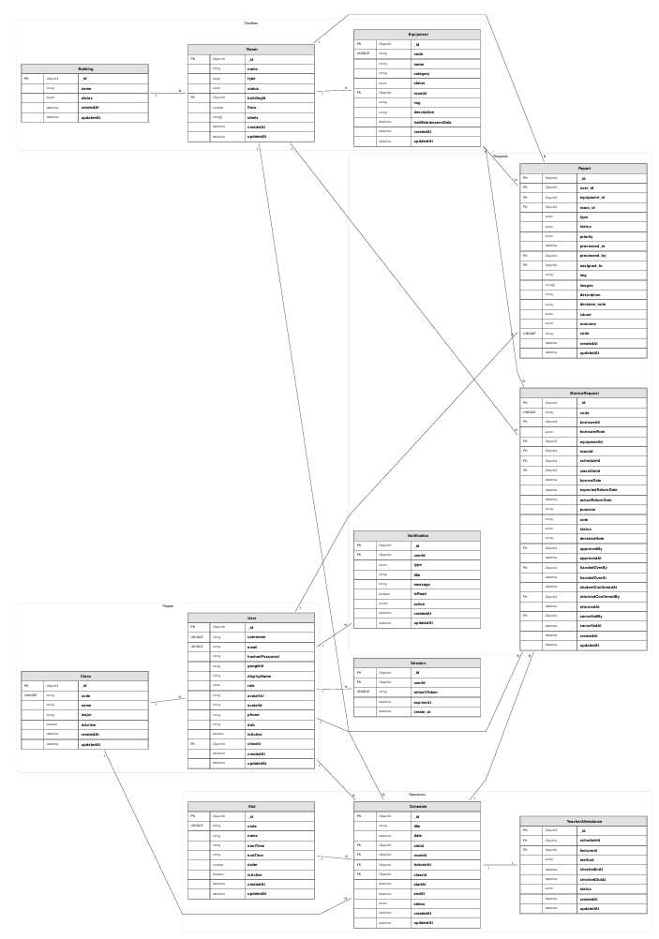

b. Table Descriptions
No | Collection | Description
01 | users | Stores all registered user accounts. Fields include username (unique, lowercase), email (unique), hashedPassword (bcrypt), googleId, displayName, role (enum: admin/student/lecturer/technician), avatarUrl, avatarId (Cloudinary), phone, dob, isActive, classId (ref: Class, students only).
02 | sessions | Persists active refresh token sessions. Fields: userId (ref: User), refreshToken (unique), expiresAt. TTL index on expiresAt (auto-delete). One user can have multiple concurrent sessions.
03 | resetpasswords | Stores OTP tokens for password reset flow. Fields: userId, email, token (6-digit numeric string), usageCount (max 1 use enforced in logic), expiresAt (5-minute TTL via MongoDB index).
04 | resetpasswordreatelimits | Tracks OTP request frequency per email to enforce rate limiting. Fields: email (unique), attempts, firstAttemptAt, blockedUntil.
05 | equipment | Equipment asset records. Fields: code (unique, auto-generated), name, category, status (enum: available/maintenance/broken), roomId (ref: Room), img, description, lastMaintenanceDate. Technical status only; borrow availability is derived from BorrowRequest.
06 | borrowrequests | Equipment borrow request lifecycle. Fields: code (auto-generated, format BR[YY][MM][XXX]), borrowerId (ref: User), borrowerRole (student), equipmentId (ref: Equipment), roomId (ref: Room, audit), scheduleId (ref: Schedule), classSlotId (ref: Slot), borrowDate, expectedReturnDate, actualReturnDate, purpose, note, status (pending/approved/rejected/handed_over/returning/returned/cancelled/rejected_receipt if implemented in current logic), decisionNote, approvedBy, approvedAt, handedOverBy, handedOverAt, handoverInfo (checklist + notes + images), studentConfirmedAt, returnRequest (checklist + notes + images), returnedConfirmedBy, returnedAt, cancelledBy, cancelledAt.
07 | reports | Damage and issue reports submitted by users or guests. Fields: user_id (ref: User, null for guests), equipment_id (ref: Equipment), room_id (ref: Room), type (equipment/infrastructure/other), status (pending/approved/rejected/processing/fixed/cancelled), priority (low/medium/high/critical), processed_at, processed_by (ref: User), assigned_to (ref: User, technician), img, images (array), description, decision_note, cause (user_error/hardware/software/environment/unknown), outcome (fixed_internally/external_warranty/beyond_repair), code (auto-generated, format RP[YY][MM][XXX]).
08 | buildings | Physical building records. Fields: name, status (active/inactive/maintenance).
09 | rooms | Room records within buildings. Fields: name, type (classroom/lab/office/meeting/other), status (available/occupied/maintenance), buildingId (ref: Building), floor, labels (array of string tags).
10 | schedules | Teaching session schedule records. Fields: title, date, slotId (ref: Slot), roomId (ref: Room), lecturerId (ref: User), classId (ref: Class), startAt, endAt (computed from date + slot, stored as UTC for fast range queries in VN timezone), status (scheduled/ongoing/completed/cancelled).
11 | slots | Time slot definitions. Fields: code (unique), name, startTime (HH:mm string), endTime (HH:mm string), order (integer for display ordering), isActive.
12 | classes | Academic class records. Fields: code (unique, uppercase), name, major, isActive. Students are linked to a class via User.classId.
13 | teacherattendances | Lecturer session start/end records per schedule session. Fields: scheduleId (ref: Schedule), lecturerId (ref: User), method (manual/qr_scan/system if available in backend), checkedInAt, checkedOutAt, status (present/absent/late). Unique index on (scheduleId, lecturerId).
14 | notifications | In-app notification records per user. Fields: userId (ref: User), type (borrow/approval/return/equipment/report/general), title, message, isRead, action (sub-document: type, resource, resourceId, payload).

3.2 Code Packages
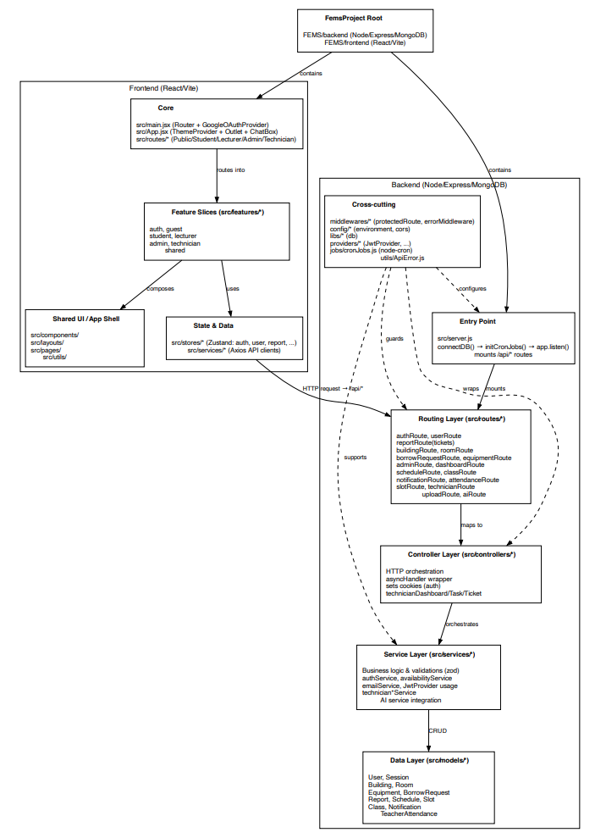
Package descriptions
No | Package (Path) | Description
01 | backend/src/server.js | Express application entry point. Registers all route prefixes, CORS, cookie-parser, JSON body parser, global request logger, and error handling middleware. Connects to MongoDB then starts the HTTP server and initializes cron jobs.
02 | backend/src/config/ | Configuration files. environment.js: loads .env variables (PORT, MONGODB_CONNECTION_STRING, JWT secrets, email credentials, Google Client ID, client URL). cors.js: defines CORS allowed origins whitelist.
03 | backend/src/libs/ | Infrastructure libraries. db.js: Mongoose connectDB function.
04 | backend/src/middlewares/ | Express middleware. authMiddlewares.js: protectedRoute (validates JWT access token, attaches req.user), restrictTo(...roles) (role-based guard), optionalAuth (attaches user if token present, else continues). errorMiddleware.js: global error handler. asyncHandler.js: async error wrapper.
05 | backend/src/providers/ | External provider wrappers. JwtProvider.js: wraps jsonwebtoken to generate and verify tokens.
06 | backend/src/models/ | Mongoose schemas and models: User, Session, ResetPassword, ResetPasswordRateLimit, Equipment, BorrowRequest, Report, Building, Room, Schedule, Slot, Class, TeacherAttendance, Notification.
07 | backend/src/routes/ | Express router files, one per domain: authRoute, userRoute, equipmentRoute, borrowRequestRoute, reportRoute, buildingRoute, roomRoute, scheduleRoute, attendanceRoute, slotRoute, classRoute, notificationRoute, dashboardRoute, adminRoute, technicianRoute, uploadRoute, aiRoute.
08 | backend/src/controllers/ | HTTP request handlers. Each controller parses request parameters/body, delegates to a service, and sends the HTTP response. Covers: auth, user, equipment, borrow request, report, building, room, schedule, attendance, slot, class, notification, dashboard, admin, technician task/dashboard, upload.
09 | backend/src/services/ | Business logic layer. Key services: authService, userService, equipmentService, borrowRequestService, reportService, scheduleService, attendanceService, buildingService, roomService, slotService, classService, notificationService, emailService, dashboardService, technicianTaskService, technicianDashboardService, adminService, availabilityService.
10 | backend/src/groq-ai/ | AI assistant module. config.js: Groq SDK initialization, model and temperature settings. tools.js: tool schema definitions. tools/equipment-tool.js: implementations for get_equipment_list, get_equipment_detail, get_my_equipment. tools/borrowRequest-tool.js: implementation for create_borrow_request. index.js: runAgent agentic loop.
11 | backend/src/jobs/ | Background jobs. cronJobs.js: initializes cron schedules such as every-5-minute slot-ended auto-cancel and daily overdue borrow alert.
12 | backend/src/utils/ | Utility functions. ApiError.js: custom error class with statusCode property. constants.js: CORS whitelist domains. dateVN.js: VN timezone date calculation helpers.
13 | backend/src/scripts/ | One-time migration and seed scripts (not runtime). Includes slot seeding, equipment migration, room/notification migration, user active-flag migration.
14 | frontend/src/features/auth/ | Authentication pages and components: LoginPage, ForgotPasswordPage, login-form, forgot-password-form, otp-verification-form, ProtectedRoute, GuestRoute, RoleRedirect.
15 | frontend/src/features/admin/ | Admin-specific pages and components: Dashboard, EquipmentManagement, BorrowingManagement, UserManagement, DamageReports, ScheduleManagement, and supporting components for each.
16 | frontend/src/features/lecturer/ | Lecturer-specific pages and components: LecturerDashboard, LecturerBorrowManagementPage, AcademicCalendar, Profile, approval/history components, report components, and session controls.
17 | frontend/src/features/student/ | Student-specific pages and components: HomePage (dashboard), StudentBorrowPage, Profile, StudentSchedulePage, history components, active request items, handover confirmation/rejection flows.
18 | frontend/src/features/technician/ | Technician-specific pages and components: Dashboard, TaskList, EquipmentInventory, Profile, ticket modals, repair table, QR code modal, asset card.
19 | frontend/src/features/shared/ | Cross-role shared pages and components: HistoryPage, ReportIssuePage, NotificationsPage, ChangePasswordPage, PageHeader, Pagination, SearchBar, StatusBadge, ConfirmModal, report form components, navbar components (NavNotificationBell, NavUserDropdown, DarkModeToggle), history table components.
20 | frontend/src/features/guest/ | Guest-facing page: GuestReportPage — public report form requiring no authentication.
21 | frontend/src/routes/ | React Router route definitions grouped by role: adminRoutes.jsx, lecturerRoutes.jsx, studentRoutes.jsx, technicianRoutes.jsx, publicRoutes.jsx.
22 | frontend/src/layouts/ | Role-specific layout shell components: AdminLayout, LecturerLayout, StudentLayout, TechnicianLayout. Each wraps role-specific navigation and an <Outlet />.
23 | frontend/src/stores/ | Zustand global state stores. Includes: useAuthStore, useBorrowRequestStore, useEquipmentStore, useReportStore, useUserStore, useAdminStore, useDashboardStore.
24 | frontend/src/services/ | Axios-based API client functions for each backend domain: authService, borrowRequestService, equipmentService, reportService, scheduleService, attendanceService, technicianApi, etc.
25 | frontend/src/hooks/ | Custom React hooks: useCurrentSession, useReportForm, useHistoryMappings, and other role-specific helpers.
26 | frontend/src/components/ | Base UI component library (shadcn/ui-based): badge, card, select, progress, navigation-menu, item. Motion components: AnimatedPage, AnimatedList, SlideOver, RouteTransitionWrapper. Navbar components.
27 | frontend/src/utils/ | Frontend utility functions: dateUtils.js (VN date helpers), uploadHelper.js (Cloudinary upload), equipmentUtils.js (derive borrow status).

II. Requirement Specifications

1. Common Functions

1.1 UC-2_Login System

a. Functional Description
UC ID and Name: UC-01 – Sign In with Credentials
Created By: FEMS Dev Team
Date Created: 2026-03-27
Primary Actor: Admin, Lecturer, Student, Technician
Secondary Actors: None
Trigger:
User navigates to /login and submits the login form with username (or email) and password.
Description:
The system validates the submitted credentials against the users collection. On success, it generates a 15-minute JWT access token and a 14-day refresh token, persists the session in the sessions collection, and sets both tokens as httpOnly cookies. The user is redirected to their role-specific dashboard via RoleRedirect.
Preconditions:
- User account must exist in the users collection with a hashedPassword set.
- User account must have isActive = true.
- User must not already be authenticated (GuestRoute guard).
Postconditions:
- A new Session document is created in the database.
- Access token and refresh token cookies are set on the client.
- User is redirected to their role-specific dashboard (/admin/dashboard, /lecturer/dashboard, /student/dashboard, or /technician/dashboard).
Normal Flow:
- User navigates to /login.
- User enters username (or email address) and password.
- User submits the form.
- System validates input with Zod schema (username min 1 char, password min 1 char).
- System queries users collection using $or: [{ username }, { email: username }].
- System verifies the password against the stored bcrypt hash.
- System generates access token (15 min TTL) and refresh token (14 days TTL).
- System creates a Session document with userId, refreshToken, and expiresAt.
- System sets accessToken and refreshToken as cookies.
- System returns user info (role, displayName).
- Client redirects user to role-specific dashboard.
Alternative Flows:
- AF-01: User enters email address instead of username — system accepts it via the $or query.
- AF-02: User clicks “Continue with Google” — flow redirects to UC-02.
Exceptions:
- EX-01: Validation failure → HTTP 400 with Zod validation error message.
- EX-02: Username/email not found → HTTP 404 “Invalid username or email”.
- EX-03: isActive = false → HTTP 403 “Your account is deactivated. Please contact admin.”.
- EX-04: Incorrect password → HTTP 401 “Invalid password”.
- EX-05: User has no hashedPassword (Google-only account) → bcrypt comparison fails → HTTP 401.
Priority: Critical
Frequency of Use: Very high
Business Rules: BR-AUTH-01, BR-AUTH-02
Other Information: Credentials accepted as either username or email address.
Assumptions: ACCESS_TOKEN_SECRET and REFRESH_TOKEN_SECRET environment variables are set.

b. Business Rules
ID | Business Rule | Business Rule Description
BR-AUTH-01 | Account Active Check | Login is rejected with HTTP 403 if user.isActive is false.
BR-AUTH-02 | Password Hash Verification | Passwords are stored as bcrypt hashes. Plain-text password is never stored or compared directly.

1.2 UC-02 – Sign In with Google OAuth

a. Functional Description
UC ID and Name: UC-02 – Sign In with Google OAuth
Created By: FEMS Dev Team
Date Created: 2026-03-27
Primary Actor: Admin, Lecturer, Student, Technician
Secondary Actors: Google OAuth service
Trigger:
User clicks the Google sign-in button on the Login Page, which triggers the @react-oauth/google client flow and sends the Google access token to POST /api/auth/google.
Description:
The system verifies the Google access token by calling the Google userinfo API, extracts the email address, looks it up in the users collection, and if found and active, issues FEMS JWT tokens. On first Google login, the system links the googleId to the user record and optionally populates the avatar from the Google profile picture.
Preconditions:
- User account must already exist in users with a matching email address.
- User account must have isActive = true.
- GOOGLE_CLIENT_ID environment variable must be configured.
Postconditions:
- User.googleId is populated on first OAuth login.
- User.avatarUrl may be populated from Google picture if not previously set.
- A new Session document is created.
- Access and refresh token cookies are set.
- User is redirected to their role-specific dashboard.
Normal Flow:
- User clicks “Continue with Google” on the Login Page.
- Google OAuth consent screen is shown.
- On consent, frontend receives a Google access token.
- Frontend sends POST /api/auth/google with the Google access token.
- System calls https://www.googleapis.com/oauth2/v3/userinfo with the token.
- System extracts email, sub, name, and picture from the Google payload.
- System finds the user by email in the users collection.
- System generates FEMS access and refresh tokens.
- System creates a Session document.
- System sets cookies and returns user info.
- Client redirects to role-specific dashboard.
Alternative Flows:
- AF-01: First Google login — system sets user.googleId = sub and user.avatarUrl = picture if avatarUrl was empty.
Exceptions:
- EX-01: Google token invalid or expired → HTTP 401.
- EX-02: Email not found in FEMS users → HTTP 404.
- EX-03: isActive = false → HTTP 403.
Priority: High
Frequency of Use: High
Business Rules: BR-AUTH-01, BR-OAUTH-01
Other Information: Google OAuth does not allow self-registration.
Assumptions: The Google account email matches the email registered by admin in the system.

b. Business Rules
ID | Business Rule | Business Rule Description
BR-OAUTH-01 | Pre-Registration Required | Google sign-in only succeeds if the user's Google email address matches an existing FEMS account.
BR-OAUTH-02 | Google Avatar Fallback | On first Google login, if the user has no avatarUrl, the system sets it to the Google profile picture URL.

1.3 UC-04 / UC-05 / UC-06 – Forgot Password / OTP Verify / Reset Password

a. Functional Description
UC ID and Name: UC-04/05/06 – Forgot Password Flow
Created By: FEMS Dev Team
Date Created: 2026-03-27
Primary Actor: Admin, Lecturer, Student, Technician
Secondary Actors: Gmail SMTP email service
Trigger:
User clicks “Forgot password?” on the Login Page and submits their email address.
Description:
A three-step flow. Step 1: user submits email; system checks rate limit, generates a 6-digit OTP, stores it in ResetPassword collection, and sends it via email. Step 2: user submits email + OTP; system verifies OTP existence and non-expiry. Step 3: user submits email + OTP + new password; system resets password and destroys all active sessions.
Preconditions:
- The email address must correspond to an existing user account.
- The rate limit must not be exceeded.
Postconditions:
- User's hashedPassword is replaced with new bcrypt hash.
- All Session documents for the user are deleted.
- All ResetPassword tokens for the user are deleted.
- User must re-authenticate with new password.
Normal Flow:
- User navigates to /forgot-password.
- User submits their email address.
- System verifies email exists in users, checks ResetPasswordRateLimit.
- System generates a 6-digit numeric OTP.
- System deletes any existing ResetPassword tokens for the user.
- System creates a new ResetPassword document with expiresAt = now + 5 minutes.
- System sends email with OTP via Nodemailer/Gmail SMTP.
- User receives OTP and enters it on the verification form.
- System validates OTP.
- User enters new password.
- System increments usageCount.
- System hashes and saves new password.
- System deletes all Session documents for the user.
- System deletes all ResetPassword tokens for the user.
- User is redirected to login page.
Alternative Flows:
- AF-01: Under allowed attempt window — counter increments, new OTP sent.
- AF-02: Time window expired — rate limit counter resets.
Exceptions:
- EX-01: Email not found → HTTP 404.
- EX-02: Rate limit blocked → HTTP 429.
- EX-03: OTP invalid or expired → HTTP 400.
- EX-04: OTP already used → HTTP 400.
- EX-05: Email send failure → HTTP 500.
Priority: High
Frequency of Use: Low
Business Rules: BR-RESET-01, BR-RESET-02, BR-RESET-03
Other Information: OTP TTL is enforced by both MongoDB TTL index and application-level expiry checks.
Assumptions: EMAIL_USER and EMAIL_PASS environment variables are configured.

b. Business Rules
ID | Business Rule | Business Rule Description
BR-RESET-01 | OTP Expiry | OTP tokens expire 5 minutes after generation.
BR-RESET-02 | Single-Use OTP | Each OTP can only be used once.
BR-RESET-03 | Rate Limit | Maximum 5 OTP requests per email per 30-minute window; exceeding the limit blocks the email for 1 hour.

2. Common Functions

2.1 UC-14 / UC-57 – View and Update Own Profile

a. Functional Description
UC ID and Name: UC-14/57 – View and Update Own Profile
Created By: FEMS Dev Team
Date Created: 2026-03-27
Primary Actor: Admin, Lecturer, Student, Technician
Secondary Actors: Cloudinary CDN
Trigger:
User navigates to their role-specific profile page (/[role]/profile).
Description:
The authenticated user can view their current profile information and update displayName, phone, date of birth, and avatar image. Avatar images are uploaded to Cloudinary via POST /api/upload. The profile update endpoint is PATCH /api/auth/profile.
Preconditions:
- User must be authenticated.
Postconditions:
- User document is updated in the database.
- If avatar changed, Cloudinary CDN URL is stored in avatarUrl.
Normal Flow:
- User navigates to profile page.
- System fetches current profile via GET /api/auth/me.
- User edits allowed fields.
- If changing avatar, frontend uploads file to POST /api/upload.
- Upload returns Cloudinary CDN URL.
- User submits profile form.
- System sends PATCH /api/auth/profile.
- System updates the User document and returns updated user info.
Alternative Flows: None.
Exceptions:
- EX-01: Upload failure → avatar not updated.
- EX-02: User not found → HTTP 404.
Priority: Medium
Frequency of Use: Low
Business Rules: BR-PROF-01
Other Information: hashedPassword is never returned in read queries.
Assumptions: Cloudinary upload endpoint returns a valid CDN URL.

b. Business Rules
ID | Business Rule | Business Rule Description
BR-PROF-01 | Password Not Exposed | The hashedPassword field is excluded from all user read queries using Mongoose .select('-hashedPassword').

2.2 UC-48 / UC-49 / UC-50 – Notification Management

a. Functional Description
UC ID and Name: UC-48/49/50 – View and Manage Notifications
Created By: FEMS Dev Team
Date Created: 2026-03-27
Primary Actor: Admin, Lecturer, Student, Technician
Secondary Actors: None
Trigger:
User clicks the notification bell icon in the navbar or navigates to [role]/notifications.
Description:
Users view their in-app notification inbox. Notifications are created automatically by system workflows such as borrow approvals, report status changes, auto-cancellations, overdue alerts, and broadcasts. Users can mark individual or all notifications as read, and delete individual or all notifications.
Preconditions:
- User must be authenticated.
Postconditions:
- Notification.isRead is updated on mark-read actions.
- Notification documents are deleted on delete/clear actions.
Normal Flow:
- User navigates to notifications page or opens notification dropdown.
- System queries GET /api/notifications and returns all notifications for req.user._id, sorted newest first.
- Unread notifications are visually highlighted.
- User clicks “Mark as Read” on an item → PATCH /api/notifications/:id/read.
- User clicks “Mark All Read” → PATCH /api/notifications/mark-all-read.
- User deletes one notification → DELETE /api/notifications/:id.
- User clears all notifications → DELETE /api/notifications/clear-all.
Alternative Flows:
- AF-01: User opens a notification action link; frontend deep-links to the target page or target item based on the action payload.
Exceptions:
- EX-01: Notification not found or does not belong to current user → HTTP 404 or HTTP 403.
- EX-02: Unauthorized access → HTTP 401.
Priority: Medium
Frequency of Use: High
Business Rules: BR-NOTI-01, BR-NOTI-02
Other Information: Broadcast notifications are still stored per recipient as individual records.
Assumptions: Related workflows have already created notification records.

b. Business Rules
ID | Business Rule | Business Rule Description
BR-NOTI-01 | User-Scoped Notification Access | A user can only view, mark, or delete their own notification records.
BR-NOTI-02 | Persistent Notification Storage | Notifications remain available until explicitly deleted or cleared by the user.

3. Student & Lecturer Feature

3.1 UC-1_Report Damage/Fault

a. Functional Description
UC ID and Name: UC-42 – Start Session (Lecturer Check-In)
Created By: FEMS Dev Team
Date Created: 2026-03-27
Primary Actor: Lecturer
Secondary Actors: None
Trigger:
The lecturer opens the dashboard while the current time falls within one of their assigned teaching slots, and clicks Start Session.
Description:
The system analyzes the lecturer’s teaching schedule and compares it with the current time. If an active session exists, the corresponding class/session information is displayed prominently at the top of the lecturer dashboard. The lecturer can then start the session, which records check-in and enables borrow request approval for that active teaching slot.
Preconditions:
- Lecturer must be authenticated.
- A valid schedule assigned to the lecturer must exist for the current date/time.
- The session must not already be completed.
Postconditions:
- Lecturer attendance/check-in is recorded.
- Active session status becomes available for session-scoped borrowing logic.
- Student borrow requests in that session can be processed.
Normal Flow:
- Lecturer navigates to /lecturer/dashboard.
- System loads lecturer schedules and evaluates current time against slot definitions.
- System detects an active session.
- System displays the active class/session information at the top of the page.
- Lecturer clicks Start Session.
- System records lecturer check-in.
- System marks the session as active/ongoing for downstream borrow workflow processing.
Alternative Flows:
- AF-01: If no active schedule matches the current time, the dashboard does not display the start-session control.
Exceptions:
- EX-01: Lecturer has no matching current slot → no check-in action available.
- EX-02: Schedule already completed → session cannot be started again.
- EX-03: Backend attendance write fails → session start rejected.
Priority: High
Frequency of Use: High during teaching hours
Business Rules: BR-SESSION-01, BR-SESSION-02
Other Information: This replaces the earlier wording that implied QR/manual check-in was the core flow.
Assumptions: Slot times and schedule times are evaluated in VN timezone.

b. Business Rules
ID | Business Rule | Business Rule Description
BR-SESSION-01 | Active Session Detection | A lecturer session is only considered active when current time falls within a valid assigned schedule slot.
BR-SESSION-02 | Borrow Approval Enablement | Student borrow processing for a session is only enabled after the lecturer starts that session.

3.2 UC-04_Request Borrow Equipment

a. Functional Description
UC ID and Name: UC-27 – Confirm or Reject Equipment Receipt
Created By: FEMS Dev Team
Date Created: 2026-03-27
Primary Actor: Student
Secondary Actors: Lecturer, Technician, Admin
Trigger:
Student receives the equipment and reviews the handover checklist shown by the system.
Description:
The system displays handover checklist information for the approved borrow request. The student compares the actual equipment condition with the checklist. If the equipment matches, the student confirms receipt and the request moves forward. If the actual condition does not match, the student may reject receipt instead of accepting the handover.
Preconditions:
- Student must be authenticated.
- Borrow request must be in an approvable/handover stage.
- Handover checklist information must be available for review.
Postconditions:
- If accepted, request transitions to handed_over.
- If rejected, the system records the mismatch outcome for follow-up processing.
Normal Flow:
- Student opens the request detail or handover modal.
- System shows the handover checklist.
- Student compares actual equipment condition with checklist items.
- Student chooses Confirm Receipt if conditions match.
- System records confirmation and transitions the request to handed_over.
Alternative Flows:
- AF-01: Student chooses Reject Receipt if actual equipment condition does not match the checklist.
- AF-02: Student attaches notes or evidence images if the mismatch must be documented.
Exceptions:
- EX-01: Borrow request is no longer in a valid handover stage.
- EX-02: Required handover data are missing.
- EX-03: Backend transition fails.
Priority: High
Frequency of Use: Medium
Business Rules: BR-HANDOVER-01
Other Information: Student must not be forced to accept mismatched equipment.
Assumptions: Current UI and backend store enough data to identify acceptance vs rejection outcome.

b. Business Rules
ID | Business Rule | Business Rule Description
BR-HANDOVER-01 | Right to Reject Mismatched Equipment | Student may reject receipt if the real equipment condition does not match the system-provided handover checklist.

3.3 UC-37 – View Personal Report History and Processing Status

a. Functional Description
UC ID and Name: UC-37 – View Personal Report History and Processing Status
Created By: FEMS Dev Team
Date Created: 2026-03-27
Primary Actor: Lecturer, Student
Secondary Actors: Admin, Technician
Trigger:
User navigates to their history page or report history section.
Description:
The system displays the user’s own submitted reports together with historical entries and the current processing stage of each report. This allows the user to monitor whether a report is pending, approved, processing, fixed, or cancelled.
Preconditions:
- User must be authenticated.
Postconditions:
- No data is modified.
- User can observe current processing status and history.
Normal Flow:
- User opens the history page.
- System fetches the user’s own reports.
- System displays report cards or rows with status and related metadata.
- User opens a report detail view.
- System shows the processing timeline/status progression for that report.
Alternative Flows:
- AF-01: User filters reports by status or severity if supported by the page.
Exceptions:
- EX-01: Auth failure → access denied.
- EX-02: Report query failure → history cannot be loaded.
Priority: Medium
Frequency of Use: Medium
Business Rules: BR-REPORT-01
Other Information: Student and lecturer both use this history view for report monitoring.
Assumptions: Report status timeline or equivalent progress indicator exists in current frontend/backend flow.

b. Business Rules
ID | Business Rule | Business Rule Description
BR-REPORT-01 | Reporter Visibility | A reporter can view the current processing state and historical records of reports they submitted.

III. Design Specifications

1. Lecturer Dashboard

1.1 Lecturer Home / Active Session

a.Screen
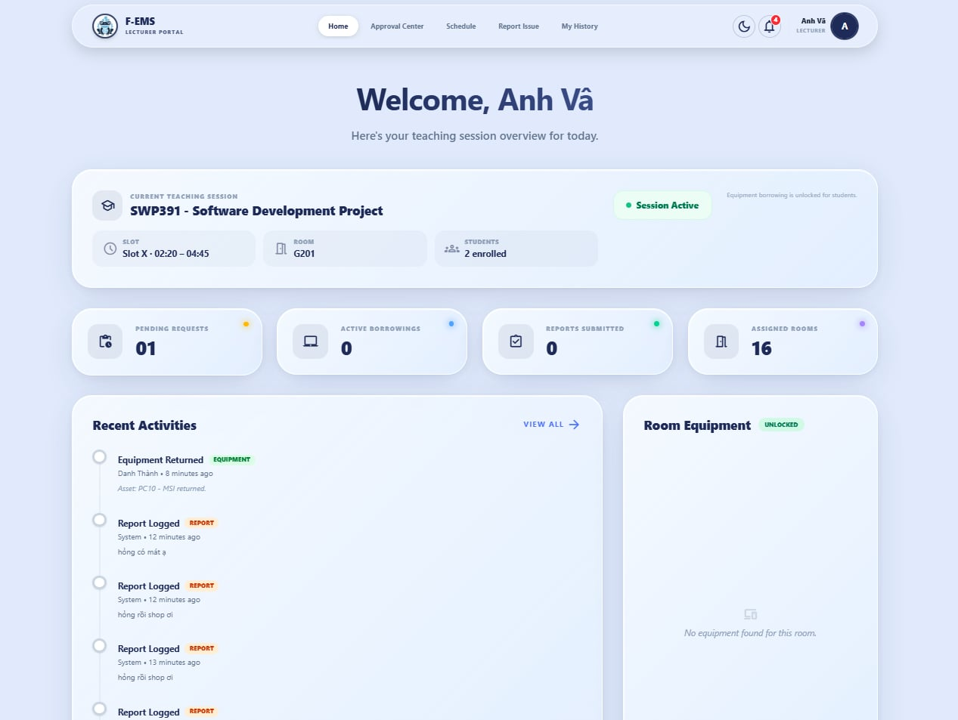
UI Design
Field Name | Field Type | Description
Active Session Card | Card | Displayed at the top of the page when the current time matches one of the lecturer’s assigned schedule slots.
Class Title | Text | Shows class/session information for the detected active slot.
Room Information | Text | Shows room assigned to the active class.
Slot / Time Range | Text | Shows current slot and time range.
Start Session Button | Button | Enables lecturer to check in and activate the session.
End Session Button | Button | Ends the active session.
Pending Requests Panel | Table/List | Shows student borrow requests awaiting lecturer action during the active session.
Activity List | List | Displays recent lecturer-related activities.

Database Access
(C-Create, R-Read, U-Update, or D-Delete)
Table | CRUD | Description
schedules | R | Detect current lecturer session based on current time and assigned schedule
teacherattendances | C/U/R | Record session start/end and read attendance state
borrowrequests | R/U | Query and process pending borrow requests for the active session

Lecturer History

2.1 Approval & Report History Screen

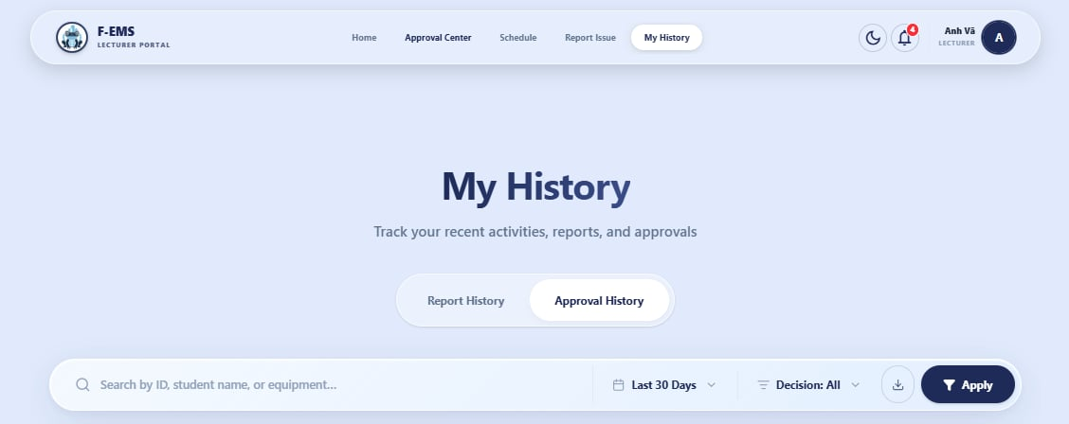

UI Design
Field Name | Field Type | Description
Tab: My Reports | Tab | Displays reports submitted by the lecturer
Tab: Approval History | Tab | Displays borrow requests approved or handled by the lecturer
Status Filter | Select | Filters by report/request status
Severity Filter | Select | Filters report items by severity
History List/Table | Table/List | Shows historical records

Database Access
Table | CRUD | Description
reports | R | Fetch lecturer-submitted reports
borrowrequests | R | Fetch requests approved/handled by lecturer

3. Student Borrow Screen
3.1 Equipment Borrow and Handover Verification

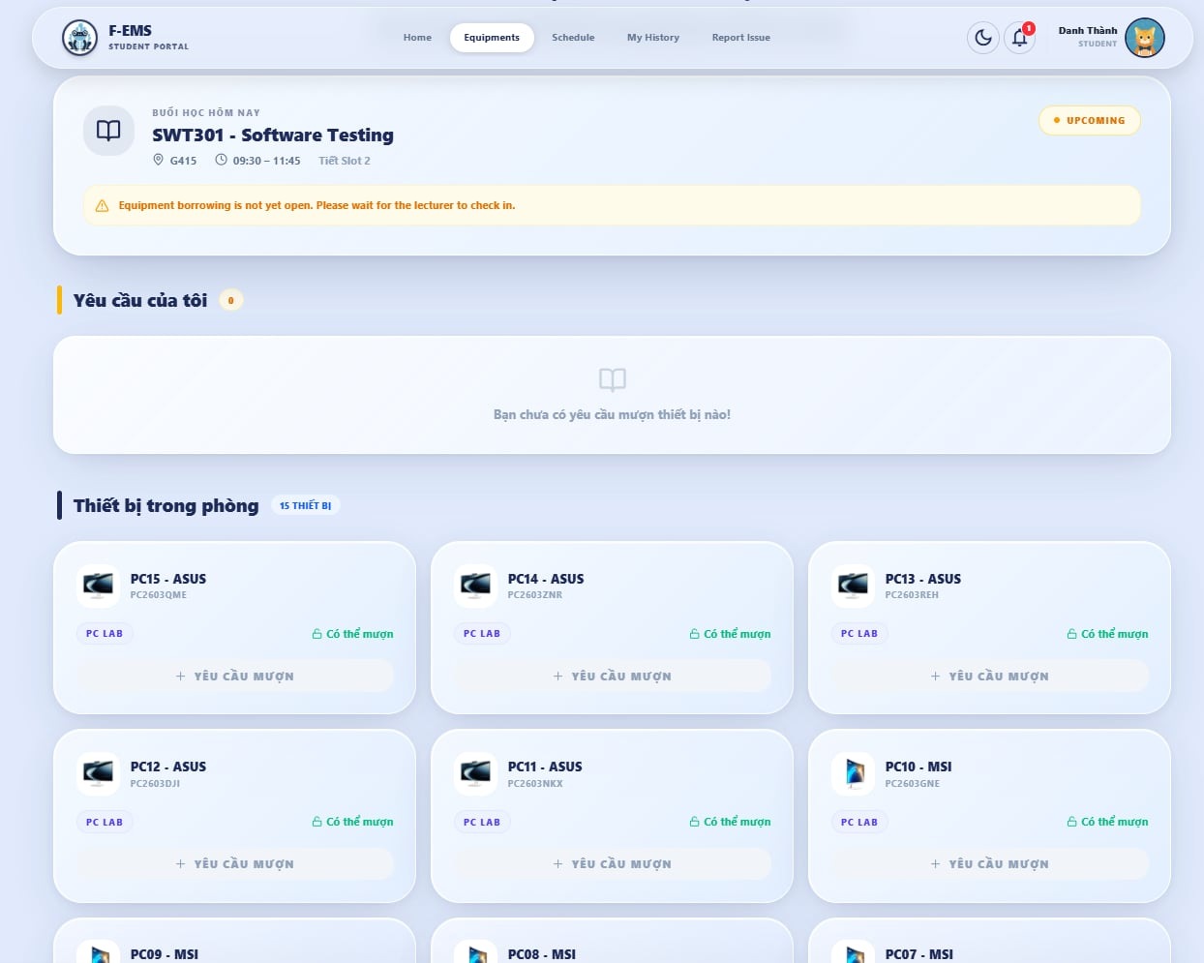

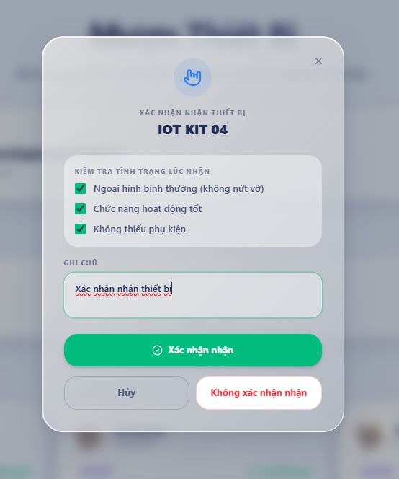

UI Design
Field Name | Field Type | Description
Active Session Header | Card | Displays current room, slot, and lecturer information
Equipment Grid | Grid/List | Shows equipment available in the session room
Borrow Status Badge | Badge | Shows derived borrow status
Borrow Button | Button | Creates borrow request for selected equipment
Handover Checklist Modal | Modal | Displays checklist for equipment receipt confirmation
Confirm Receipt Button | Button | Confirms handover if checklist matches actual condition
Reject Receipt Button | Button | Rejects receipt if actual equipment condition does not match checklist
Evidence Upload | File Input | Optional evidence image upload for mismatch
Active / Recent Requests List | List | Displays current student borrow requests

Database Access
Table | CRUD | Description
schedules | R | Determine active session context
equipment | R | Display equipment in the session room
borrowrequests | C/R/U | Create borrow request, confirm receipt, reject receipt, submit return request

4. Student History

4.1 Borrow & Report History Screen
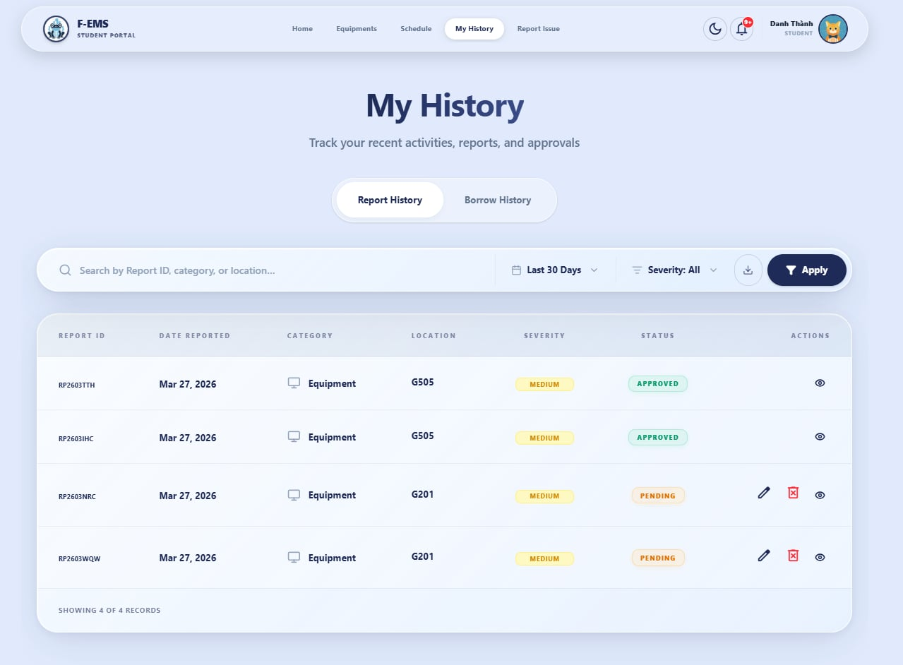
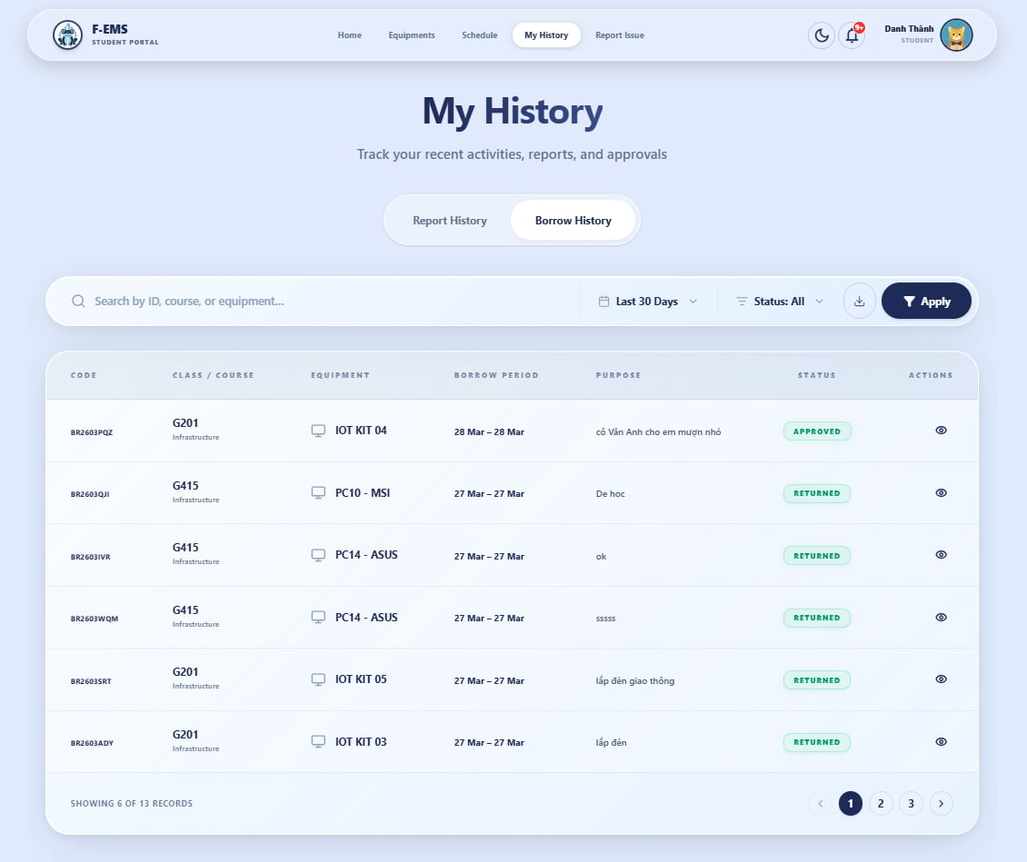

UI Design
Field Name | Field Type | Description
Tab: My Borrows | Tab | Displays student borrow history
Tab: My Reports | Tab | Displays student report history
Status Badge | Badge | Shows borrow/report status
Processing Timeline / Progress | Component | Shows report processing stage
Detail Modal | Modal | Displays item detail
Cancel Action | Button | Cancels pending item where permitted

Database Access
Table | CRUD | Description
borrowrequests | R/U | Read history, cancel where allowed
reports | R/U | Read history, cancel where allowed, show current processing state

5. Admin Damage Report Management

5.1 Damage Reports Screen

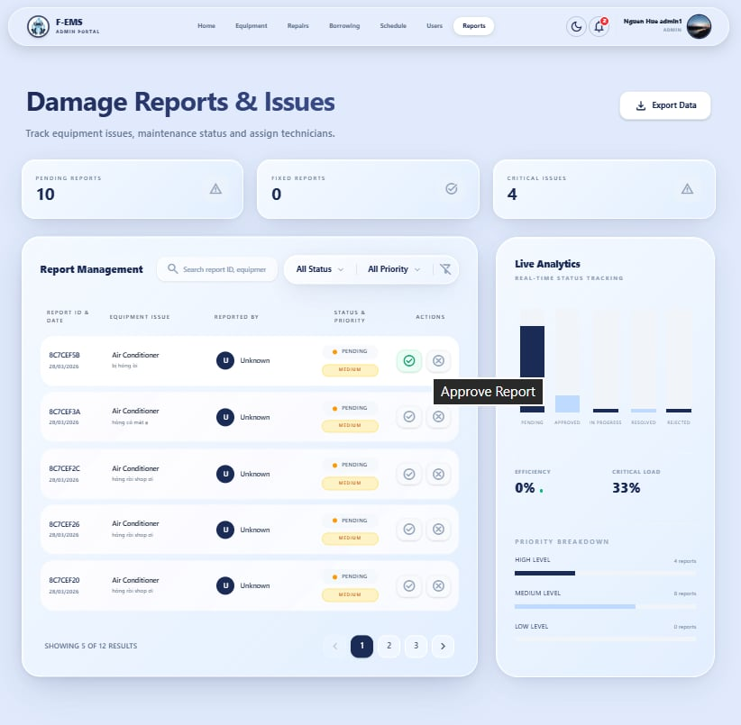
UI Design
Field Name | Field Type | Description
Status Filter | Select | Filter reports by status
Priority Filter | Select | Filter reports by priority
Technician Assignment Modal | Modal | Assign technician to a report
Report Detail Modal | Modal | Show report details, timeline, cause, outcome, and actions
Processed By Field | Text | Shows who fixed/processed the report
Resolution Statistics Panel | Panel | Summarizes report resolution metrics
Report Table | Table | Main report listing

Database Access
Table | CRUD | Description
reports | R/U | Query reports and update report status
users | R | Retrieve technician or processor information
equipment | R/U | Synchronize equipment status with report workflow

6. Technician Task Management

6.1 Technician Task List
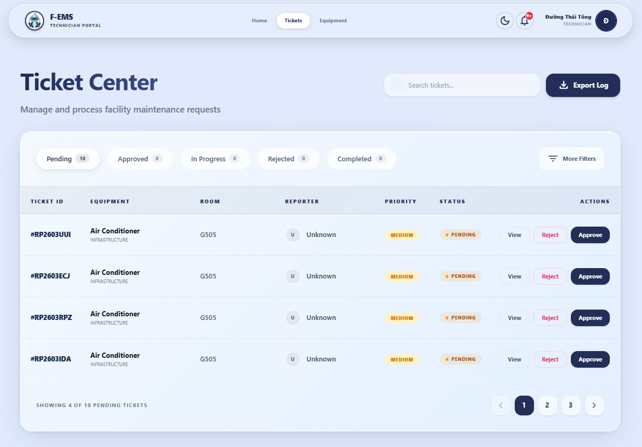
UI Design
Field Name | Field Type | Description
Status Tabs | Tabs | Filter tasks by pending, processing, fixed
Task Table / List | Table/List | Displays assigned repair tasks
Inline / Modal Actions | Action Controls | Approve, start processing, mark fixed
Equipment Info Summary | Text | Shows related equipment information
Cause / Outcome Fields | Form Fields | Editable fields when resolving repair item

IV. Appendix

1. Assumptions & Dependencies
· The system depends on MongoDB, Cloudinary, Gmail SMTP, and Groq AI services.
· Schedule evaluation and slot matching are performed using VN timezone rules.
· Lecturer session availability depends on schedule and slot data being correctly configured.

2. Limitations & Exclusions
· No dedicated Repair Management page; relevant repair information is merged into Admin Damage Reports.
· No dedicated Lecturer Usage Statistics page.
· No dedicated Technician Task Details page.
· Lecturer does not perform personal borrowing in the current workflow.
· The previously shown “upcoming due returns” section is not included in the current student dashboard.

3. Business Rules
ID | Category | Rule Definition
BR-01 | Session Detection | Lecturer active session is determined from assigned schedule and current time.
BR-02 | Session Start | Borrow approval workflow for a teaching slot is enabled only after lecturer presses Start Session.
BR-03 | Handover Validation | Student may reject equipment receipt if the actual condition does not match the handover checklist.
BR-04 | Report Tracking | Reporters can view current processing status and report history for their own reports.
BR-05 | Consolidated Repair View | Repair-related information for admins is handled inside the Damage Reports screen rather than a separate Repair Management page.
BR-06 | Repair Accountability | The system records processed_by to identify who completed the repair/update action.

