

FEMS
Software Design Specification

– DA NANG, February 2026 –

Record of changeS
Date | A*  M, D | In charge | Change Description
10/02/2026 | A | Lê Anh Tuấn | Khởi tạo cấu trúc tài liệu SDS và phân công nhiệm vụ nghiên cứu module.
12/02/2026 | A | Nguyễn Thị Vân Anh | Phác thảo sơ đồ thực thể (ERD) và thiết kế Database ban đầu.
14/02/2026 | A | Võ Thành Danh | Hoàn thành phiên bản 1.0 của tài liệu (Code bằng TypeScript).
22/02/2026 | D | Lê Anh Tuấn | Loại bỏ toàn bộ kiến trúc cũ để chuyển sang Node.js & React theo yêu cầu mới.
01/03/2026 | M | Phạm Huỳnh Nguyên Thảo | Tái cấu trúc phần Code Packages cho Backend Express và Frontend React.
08/03/2026 | A | Võ Thành Danh | Cập nhật hệ thống API cho tính năng quét mã QR và quản lý thiết bị.
15/03/2026 | M | Đỗ Ngọc Hoàn Mỹ | Chỉnh sửa luồng Borrowing Workflow; thêm logic xử lý thông báo tự động.
20/03/2026 | M | Nguyễn Thị Vân Anh | Cập nhật lại 3 chức năng chính cho tài liệu.
24/03/2026 | M | Phạm Huỳnh Nguyên Thảo | Cập nhật lại toàn bộ Table Description dựa trên Database MongoDB thực tế.
26/03/2026 | M | Lê Anh Tuấn | Tổng hợp nội dung từ VS Code, format bảng biểu và chốt tài liệu phiên bản cuối.

*A - Added M - Modified D - Deleted

Table of Contents
I. Overview 4
1. Code Packages 4
2. Database Design 9
a. Database Schema 9
II. Code Designs 12
1. Feature: Quản lý thiết bị & Kiểm kê (Equipment Inventory) 12
2. Feature Quy trình mượn / duyệt / bàn giao / trả (Borrow Request Workflow) 13
3. Feature Báo cáo hỏng / Ticket & xử lý trạng thái sửa chữa (Reports / Tickets) 16

I. Overview

1. Code Packages
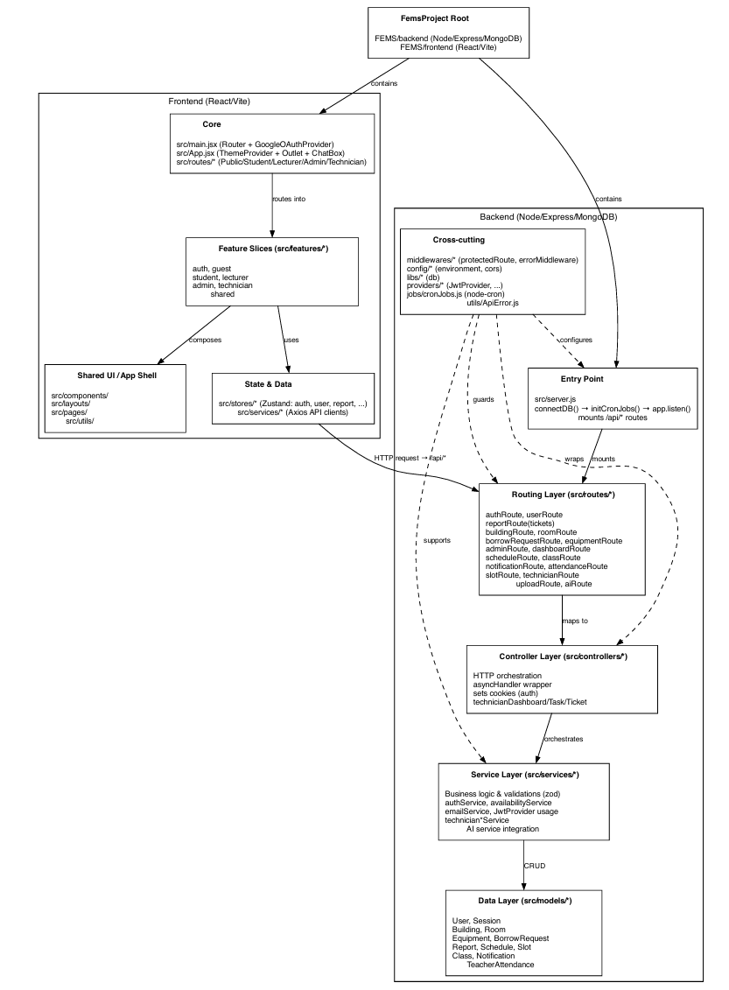
Package descriptions
No | Package (Path) | Description
01 | backend/src/server.js | Express application entry point. Registers all route prefixes, CORS, cookie-parser, JSON body parser, global request logger, and error handling middleware. Connects to MongoDB then starts the HTTP server and initializes cron jobs.
02 | backend/src/config/ | Configuration files. environment.js: loads .env variables (PORT, MONGODB_CONNECTION_STRING, JWT secrets, email credentials, Google Client ID, client URL). cors.js: defines CORS allowed origins whitelist.
03 | backend/src/libs/ | Infrastructure libraries. db.js: Mongoose connectDB function.
04 | backend/src/middlewares/ | Express middleware. authMiddlewares.js: protectedRoute (validates JWT access token, attaches req.user), restrictTo(...roles) (role-based guard), optionalAuth (attaches user if token present, else continues). errorMiddleware.js: global error handler. asyncHandler.js: async error wrapper.
05 | backend/src/providers/ | External provider wrappers. JwtProvider.js: wraps jsonwebtoken to generate and verify tokens.
06 | backend/src/models/ | Mongoose schemas and models: User, Session, ResetPassword, ResetPasswordRateLimit, Equipment, BorrowRequest, Report, Building, Room, Schedule, Slot, Class, TeacherAttendance, Notification.
07 | backend/src/routes/ | Express router files, one per domain: authRoute, userRoute, equipmentRoute, borrowRequestRoute, reportRoute, buildingRoute, roomRoute, scheduleRoute, attendanceRoute, slotRoute, classRoute, notificationRoute, dashboardRoute, adminRoute, technicianRoute, uploadRoute, aiRoute.
08 | backend/src/controllers/ | HTTP request handlers. Each controller parses request parameters/body, delegates to a service, and sends the HTTP response. Covers: auth, user, equipment, borrow request, report, building, room, schedule, attendance, slot, class, notification, dashboard, admin, technician task/dashboard, upload.
09 | backend/src/services/ | Business logic layer. Key services: authService, userService, equipmentService, borrowRequestService, reportService, scheduleService, attendanceService, buildingService, roomService, slotService, classService, notificationService, emailService, dashboardService, technicianTaskService, technicianDashboardService, adminService, availabilityService.
10 | backend/src/groq-ai/ | AI assistant module. config.js: Groq SDK initialization, model and temperature settings. tools.js: tool schema definitions. tools/equipment-tool.js: implementations for get_equipment_list, get_equipment_detail, get_my_equipment. tools/borrowRequest-tool.js: implementation for create_borrow_request. index.js: runAgent agentic loop.
11 | backend/src/jobs/ | Background jobs. cronJobs.js: initializes cron schedules such as every-5-minute slot-ended auto-cancel and daily overdue borrow alert.
12 | backend/src/utils/ | Utility functions. ApiError.js: custom error class with statusCode property. constants.js: CORS whitelist domains. dateVN.js: VN timezone date calculation helpers.
13 | backend/src/scripts/ | One-time migration and seed scripts (not runtime). Includes slot seeding, equipment migration, room/notification migration, user active-flag migration.
14 | frontend/src/features/auth/ | Authentication pages and components: LoginPage, ForgotPasswordPage, login-form, forgot-password-form, otp-verification-form, ProtectedRoute, GuestRoute, RoleRedirect.
15 | frontend/src/features/admin/ | Admin-specific pages and components: Dashboard, EquipmentManagement, BorrowingManagement, UserManagement, DamageReports, ScheduleManagement, and supporting components for each.
16 | frontend/src/features/lecturer/ | Lecturer-specific pages and components: LecturerDashboard, LecturerBorrowManagementPage, AcademicCalendar, Profile, approval/history components, report components, and session controls.
17 | frontend/src/features/student/ | Student-specific pages and components: HomePage (dashboard), StudentBorrowPage, Profile, StudentSchedulePage, history components, active request items, handover confirmation/rejection flows.
18 | frontend/src/features/technician/ | Technician-specific pages and components: Dashboard, TaskList, EquipmentInventory, Profile, ticket modals, repair table, QR code modal, asset card.
19 | frontend/src/features/shared/ | Cross-role shared pages and components: HistoryPage, ReportIssuePage, NotificationsPage, ChangePasswordPage, PageHeader, Pagination, SearchBar, StatusBadge, ConfirmModal, report form components, navbar components (NavNotificationBell, NavUserDropdown, DarkModeToggle), history table components.
20 | frontend/src/features/guest/ | Guest-facing page: GuestReportPage — public report form requiring no authentication.
21 | frontend/src/routes/ | React Router route definitions grouped by role: adminRoutes.jsx, lecturerRoutes.jsx, studentRoutes.jsx, technicianRoutes.jsx, publicRoutes.jsx.
22 | frontend/src/layouts/ | Role-specific layout shell components: AdminLayout, LecturerLayout, StudentLayout, TechnicianLayout. Each wraps role-specific navigation and an <Outlet />.
23 | frontend/src/stores/ | Zustand global state stores. Includes: useAuthStore, useBorrowRequestStore, useEquipmentStore, useReportStore, useUserStore, useAdminStore, useDashboardStore.
24 | frontend/src/services/ | Axios-based API client functions for each backend domain: authService, borrowRequestService, equipmentService, reportService, scheduleService, attendanceService, technicianApi, etc.
25 | frontend/src/hooks/ | Custom React hooks: useCurrentSession, useReportForm, useHistoryMappings, and other role-specific helpers.
26 | frontend/src/components/ | Base UI component library (shadcn/ui-based): badge, card, select, progress, navigation-menu, item. Motion components: AnimatedPage, AnimatedList, SlideOver, RouteTransitionWrapper. Navbar components.
27 | frontend/src/utils/ | Frontend utility functions: dateUtils.js (VN date helpers), uploadHelper.js (Cloudinary upload), equipmentUtils.js (derive borrow status).

2. Database Design

a. Database Schema
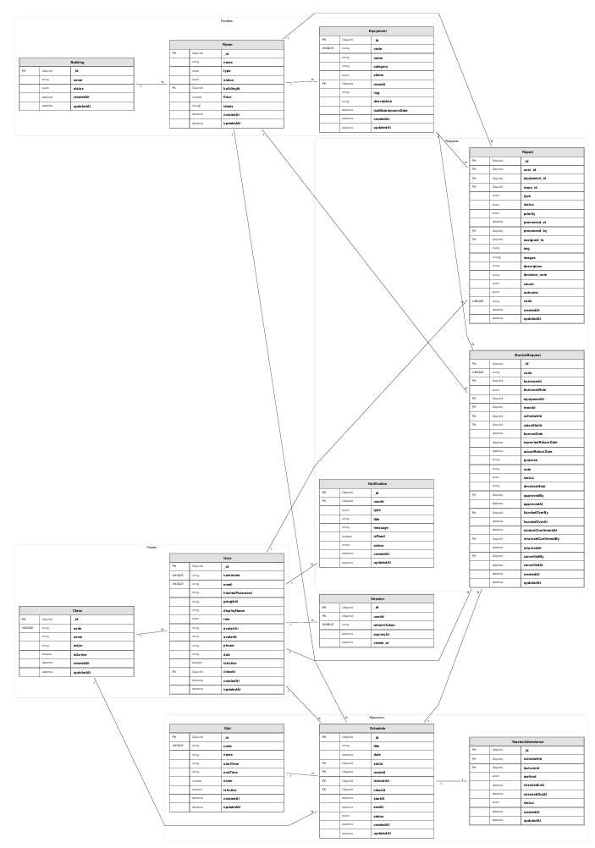

b. Table Descriptions
No | Collection | Description
01 | users | Stores all registered user accounts. Fields include username (unique, lowercase), email (unique), hashedPassword (bcrypt), googleId, displayName, role (enum: admin/student/lecturer/technician), avatarUrl, avatarId (Cloudinary), phone, dob, isActive, classId (ref: Class, students only).
02 | sessions | Persists active refresh token sessions. Fields: userId (ref: User), refreshToken (unique), expiresAt. TTL index on expiresAt (auto-delete). One user can have multiple concurrent sessions.
03 | resetpasswords | Stores OTP tokens for password reset flow. Fields: userId, email, token (6-digit numeric string), usageCount (max 1 use enforced in logic), expiresAt (5-minute TTL via MongoDB index).
04 | resetpasswordreatelimits | Tracks OTP request frequency per email to enforce rate limiting. Fields: email (unique), attempts, firstAttemptAt, blockedUntil.
05 | equipment | Equipment asset records. Fields: code (unique, auto-generated), name, category, status (enum: available/maintenance/broken), roomId (ref: Room), img, description, lastMaintenanceDate. Technical status only; borrow availability is derived from BorrowRequest.
06 | borrowrequests | Equipment borrow request lifecycle. Fields: code (auto-generated, format BR[YY][MM][XXX]), borrowerId (ref: User), borrowerRole (student), equipmentId (ref: Equipment), roomId (ref: Room, audit), scheduleId (ref: Schedule), classSlotId (ref: Slot), borrowDate, expectedReturnDate, actualReturnDate, purpose, note, status (pending/approved/rejected/handed_over/returning/returned/cancelled/rejected_receipt if implemented in current logic), decisionNote, approvedBy, approvedAt, handedOverBy, handedOverAt, handoverInfo (checklist + notes + images), studentConfirmedAt, returnRequest (checklist + notes + images), returnedConfirmedBy, returnedAt, cancelledBy, cancelledAt.
07 | reports | Damage and issue reports submitted by users or guests. Fields: user_id (ref: User, null for guests), equipment_id (ref: Equipment), room_id (ref: Room), type (equipment/infrastructure/other), status (pending/approved/rejected/processing/fixed/cancelled), priority (low/medium/high/critical), processed_at, processed_by (ref: User), assigned_to (ref: User, technician), img, images (array), description, decision_note, cause (user_error/hardware/software/environment/unknown), outcome (fixed_internally/external_warranty/beyond_repair), code (auto-generated, format RP[YY][MM][XXX]).
08 | buildings | Physical building records. Fields: name, status (active/inactive/maintenance).
09 | rooms | Room records within buildings. Fields: name, type (classroom/lab/office/meeting/other), status (available/occupied/maintenance), buildingId (ref: Building), floor, labels (array of string tags).
10 | schedules | Teaching session schedule records. Fields: title, date, slotId (ref: Slot), roomId (ref: Room), lecturerId (ref: User), classId (ref: Class), startAt, endAt (computed from date + slot, stored as UTC for fast range queries in VN timezone), status (scheduled/ongoing/completed/cancelled).
11 | slots | Time slot definitions. Fields: code (unique), name, startTime (HH:mm string), endTime (HH:mm string), order (integer for display ordering), isActive.
12 | classes | Academic class records. Fields: code (unique, uppercase), name, major, isActive. Students are linked to a class via User.classId.
13 | teacherattendances | Lecturer session start/end records per schedule session. Fields: scheduleId (ref: Schedule), lecturerId (ref: User), method (manual/qr_scan/system if available in backend), checkedInAt, checkedOutAt, status (present/absent/late). Unique index on (scheduleId, lecturerId).
14 | notifications | In-app notification records per user. Fields: userId (ref: User), type (borrow/approval/return/equipment/report/general), title, message, isRead, action (sub-document: type, resource, resourceId, payload).

II. Code Designs

1. Feature: Quản lý thiết bị & Kiểm kê (Equipment Inventory)
a. Class/Component Logic
- Frontend (React) gọi equipmentService để:
+ Lấy danh sách thiết bị (GET /api/equipments)
+ Xem chi tiết (GET /api/equipments/:id)
+ Tạo/cập nhật/xóa (role-protected)
+ Xem inventory có phân trang và có borrowStatus suy ra từ BorrowRequest (GET /api/equipments/inventory)
- Backend (Express):
+ equipmentRoute.js map endpoint → equipmentController.js
+ equipmentController.js gọi equipmentService.js
+ equipmentService.js thao tác Mongoose Equipment và dùng aggregation join rooms và borrowrequests để tính borrowStatus.
No | Class/Service | Method | Description
1 | equipmentRoute.js | GET /code/:code | Input: code. Output: equipment (populate roomId). Logic: tra theo Equipment.findOne({code}).
2 | equipmentRoute.js | GET /inventory | Input query: search, category, buildingId, status, page, limit. Output: { items, pagination }. Logic: aggregation pipeline derive borrowStatus từ BorrowRequest active.
3 | equipmentRoute.js | GET / | Output: list equipments populate room fields.
4 | equipmentRoute.js | GET /:id | Input: id. Output: equipment populate room fields (kèm buildingId trong populate).
5 | equipmentRoute.js | POST / | Auth required + role admin/technician. Input: equipment payload. Output: {message, equipment}. Logic: validate name/category, generate unique code.
6 | equipmentRoute.js | PUT/PATCH /:id | Auth + role admin/technician. Input: patch fields. Output: {message, equipment}. Logic: whitelist fields, convert date fields.
7 | equipmentRoute.js | DELETE /:id | Auth + role admin/technician. Output: {message}.
8 | equipmentService.js | getEquipmentInventory(queries) | Logic chính: $lookup rooms + filter building + $lookup borrowrequests trạng thái approved/handed_over để suy ra borrowStatus = available/reserved/in_use/broken/maintenance.

b. Sequence Flow
b.1. User mở trang inventory (ví dụ portal technician) → frontend gọi GET /api/equipments/inventory?page=...&limit=...&status=....
b.2. Backend equipmentRoute → equipmentController.getEquipmentInventory.
b.3. equipmentService.getEquipmentInventory build aggregation pipeline:
$match theo search/category/status (technical)
$lookup rooms + $match theo buildingId (nếu có)
$lookup borrowrequests active (status approved/handed_over)
$addFields borrowStatus (available/reserved/in_use hoặc broken/maintenance)
paginate và trả về items + pagination.
b.4. Frontend render items và dùng borrowStatus để hiển thị khả dụng.

c. Database Query (MongoDB aggregate mẫu)
db.equipment.aggregate([
{ $match: { category: /^Laptop$/i } },
{ $lookup: { from: "borrowrequests", let: { eqId: "$_id" }, pipeline: [
{ $match: { $expr: { $eq: ["$equipmentId", "$$eqId"] }, status: { $in: ["approved","handed_over"] } } },
{ $limit: 1 },
{ $project: { status: 1 } }
], as: "activeRequest"
}},
{ $addFields: { activeRequest: { $arrayElemAt: ["$activeRequest", 0] } } }
])

2. Feature Quy trình mượn / duyệt / bàn giao / trả (Borrow Request Workflow)
a. Class/Component Logic
- Frontend dùng borrowRequestService gọi /api/requests/* để:
+ Tạo request (student/lecturer)
+ Xem danh sách cá nhân/pending/all
+ Thực thi workflow actions: approve/reject/handover/return/cancel/remind
- Backend:
+ borrowRequestRoute.js set protectedRoute toàn bộ.
+ borrowRequestController.js phân nhánh tạo request theo role (lecturer vs student).
+ borrowRequestService.js implement business rules:
- Student: phải ở trong session hợp lệ + giảng viên đã check-in
- Lecturer: phải có session hợp lệ (không cần check-in gate)
- Approve: re-check availability
- Auto-cancel: approved nhưng không đến nhận trước 17:00 ngày mượn
- Notification: notify admins/borrower/staff theo sự kiện.b. Class Specifications
b. Specifications
No | Class/Service | Method | Description
1 | borrowRequestRoute.js | POST / | Role: student/lecturer. Input: {equipmentId, purpose, note}. Output: {message, borrowRequest}. Logic: controller gọi createLecturerRequest hoặc createStudentRequest.
2 | borrowRequestService.js | createStudentRequest(user, body) | Validate: equipment exists; availabilityService.assertEquipmentBorrowable; scheduleService.assertUserInSession(user, equipment.roomId); attendanceService.assertTeacherCheckedIn(sessionId, lecturerId); create BorrowRequest status pending, expectedReturnDate = session.endAt; notify admins.
3 | borrowRequestService.js | createLecturerRequest(user, body) | Similar student nhưng bỏ check-in gate; notify admins.
4 | borrowRequestRoute.js | PATCH /:id/approve | Role: technician/admin. Output {message, request}. Logic: approveRequest(id, approverId, decisionNote).
5 | borrowRequestService.js | approveRequest(id, approverId, decisionNote) | Require status pending; re-check availability; set approvedBy/approvedAt/status; notify borrower.
6 | borrowRequestRoute.js | PATCH /:id/reject | Role: technician/admin; includes decisionNote.
7 | borrowRequestService.js | rejectRequest(id, approverId, decisionNote) | Set status rejected, approval fields; notify borrower.
8 | borrowRequestRoute.js | PATCH /:id/handover | Role: technician/admin.
9 | borrowRequestService.js | handoverToStudent(id, handedOverBy) | Require status approved; set handed_over, handedOverBy/At; notify borrower.
10 | borrowRequestRoute.js | PATCH /:id/return | Role: technician/admin.
11 | borrowRequestService.js | confirmReturn(id, confirmedBy) | Require status handed_over; set returned, returnedAt, actualReturnDate; notify staff (admin+technician).
12 | borrowRequestRoute.js | PATCH /:id/cancel | Role: borrower/staff; service chỉ cho borrower hủy request của họ trong trạng thái pending/approved và bắt buộc decisionNote.
13 | borrowRequestService.js | autoCancselExpiredRequests() | Cron-like/triggered by read methods: approved mà quá 17:00 borrowDate thì set cancelled + notify borrower.
14 | borrowRequestRoute.js | POST /direct-allocation | Role: technician/admin. Input: {borrowerId, equipmentId, borrowDate, expectedReturnDate, purpose, note}. Output: request trạng thái handed_over.

c. Sequence Flow
1. Student/lecturer nhấn “Borrow” trên UI → frontend POST /api/requests với equipmentId.
2. Backend xác thực (protectedRoute) + restrictTo(student|lecturer) → controller.
3. Service load Equipment:
- Check borrowable (availabilityService.assertEquipmentBorrowable)
- Check session hợp lệ (scheduleService.assertUserInSession)
- Nếu student: check lecturer checked-in (attendanceService.assertTeacherCheckedIn)
4. Tạo BorrowRequest status pending, generate code BRYYMMXXX.
5. Notify admins: “Yêu cầu mượn mới”.
6. Staff duyệt → frontend PATCH /api/requests/:id/approve:
service re-check borrowable, set approved*, notify borrower đến nhận trước 17:00.
7. Khi bàn giao → PATCH /handover: set handed_over, notify borrower.
8. Khi trả → PATCH /return: set returned, timestamps, notify staff.
d. Database Query (MongoDB query mẫu)
db.borrowrequests.find({ status: "pending" }).sort({ createdAt: -1 })

3. Feature Báo cáo hỏng / Ticket & xử lý trạng thái sửa chữa (Reports / Tickets)
a. Class/Component Logic
- Frontend
+ reportService.create → POST /api/tickets/report (guest hoặc authenticated; backend dùng optionalAuth)
+ reportService.getPersonalHistory → GET /api/tickets/history (protected)
+ reportService.getAll → GET /api/tickets (admin/technician)
+ reportService.updateStatus → PATCH /api/tickets/:id/status (admin/technician) với {status, technicianId}
- Backend
+ reportRoute.js map endpoints vào reportController.js
+ reportController.createReport: nếu req.user tồn tại thì set user_id
+ reportService.updateReportStatus: cập nhật status report, gán technician khi processing, sync lại Equipment.status theo status report, bắn notification cho technician và reporter.
b. Specifications
No | Class/Service | Method | Description
1 | reportRoute.js | POST /report | Auth optional. Input: report payload (vd equipment_id, room_id, type, severity/priority, description, img/images). Output: {message, report_id, report}. Logic: generate code RPYYMMXXX, create Report; nếu severity high/critical thì notify admins.
2 | reportService.js | createReport(body) | Create report với fields snake_case; populate refs; notify admins theo severity.
3 | reportRoute.js | GET /history | Protected. Output: list reports của user hiện tại (user_id = req.user._id).
4 | reportRoute.js | DELETE /history/:id | Protected. Input body: {decision_note}. Logic: chỉ hủy được khi status pending, set status=cancelled.
5 | reportRoute.js | GET / | Protected + restrictTo admin/technician. Output: toàn bộ reports (populated).
6 | reportRoute.js | GET /:id | Protected. Output: report detail. Logic: nếu role student thì chỉ xem report của chính mình.
7 | reportRoute.js | PATCH /:id/status | Protected + restrictTo technician/admin. Input: {status, technicianId}. Output: {message, report} populated. Logic: set processed_by/processed_at, (nếu processing) set assigned_to và notify technician; đồng bộ Equipment.status (approved→broken, processing→maintenance, fixed→good); notify reporter.
c. Sequence Flow
1. User/guest gửi report từ UI → frontend POST /api/tickets/report.
2. Backend optionalAuth: nếu login thì set user_id, nếu guest thì user_id=null.
3. reportService.createReport tạo Report với status pending + code.
4. Staff xem danh sách (GET /api/tickets) và cập nhật trạng thái:
PATCH /api/tickets/:id/status với status=approved|processing|fixed|rejected...
5. Khi status=processing và có technicianId:
- set assigned_to
- tạo notification cho technician “New Maintenance Task Assigned”
6. Đồng bộ trạng thái kỹ thuật của thiết bị (nếu equipment_id tồn tại):
- approved → Equipment.status = broken
- processing → Equipment.status = maintenance
- fixed → Equipment.status = good
7. Tạo notification cho reporter về trạng thái mới.

