PRACTICAL EXAMINATION 02
Subject code: FER202 – FA25
Duration: 85 minutes
You need to create a user account management application by creating an react application.
Note:
- Students must install and configure all required packages before the test, such as: json-server, react-router-dom, react-bootstrap bootstrap, axios, react-icons,…
- Students are allowed to use resources stored on their computers but are not allowed to use the Internet during the test (except for submitting the exam).
- If identical test results are detected, the students’ work will receive a score of zero.
- If the code does not run or does not use db.json in Given folder, the students’ work will receive a score of zero.
- A deduction of 0.5 point will be applied in the following cases:
  - Not using React Bootstrap components
  - Not using axios or fetch to interact with the JSON Server.
- Students will receive 100% of the total marks if they use Redux Toolkit or useContext combined with useReducer; otherwise, 1 point will be deducted from the total score.
- Submit a folder containing your project (excluding node_modules) and a readme.txt (listing installed packages and how to run, if applicable).
The application should include the following functionalities:
- Project scaffold: (0.25 mark) Create a React application named fer202-02
- Project structure: (0.75 mark)
Organize the source into meaningful folders: components, pages, contexts, services, routes…(0.25 mark)
Mock data (0.25 mark)
  - Copy db.json file in the project root to initialize a JSON server, using the user account data supplied in Given folder.
Static assets (0.25 mark)
  - Copy all user avatar images into the public/images/users folder.
- Login Form: (2 marks)
Display the login form that authenticates by username or email. (0.25 mark)

Validation and Behavior:
  - Validate credentials against accounts fetched from db.json.
  - If Username/Email is empty, show “Username or Email is required.” If Password is empty, show “Password is required.” (0.25 mark)
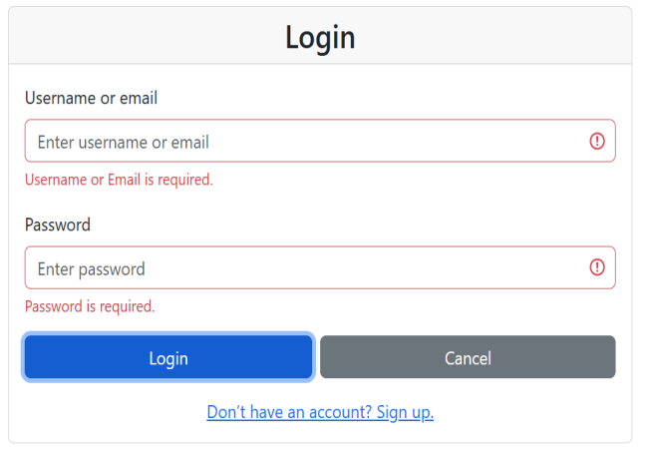
  - If credentials are incorrect, show an alert “Invalid username/email or password!” (0.25 mark)
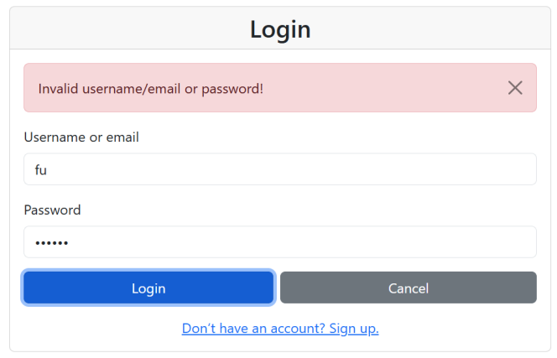
  - If the user’s role is not admin, show an alert: ‘Access denied. Only admin users can log in.’” (0.25 mark)
  - If credentials are correct:
    - If the status is locked, an alert is displayed with message: “Account is locked. Please contact admin.” (0.25 mark)
    - Otherwise, the show a modal on the center of the login page: “Welcome, <username>! Login successful.”, then click on Continue will redirect to account list page. (0.5 mark)
    - You should create a MessageModal component and use it on the login page. (0.25 mark).
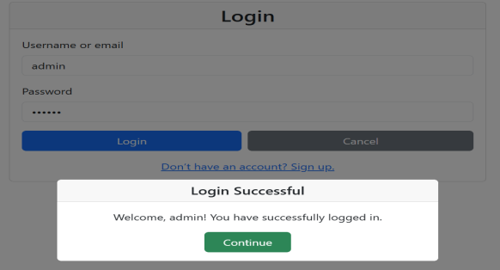
- Data display: (2 marks)
- Fetch and display accounts from the JSON Server in a responsive table (1 mark)
- Columns: Avatar, Username, Email, Role, Status, Actions. (0.25 mark)
- Each row has 2 action buttons: (0.25 mark)
    - View Details,
    - Lock or Unlock (depending on current status) (0.5 mark)
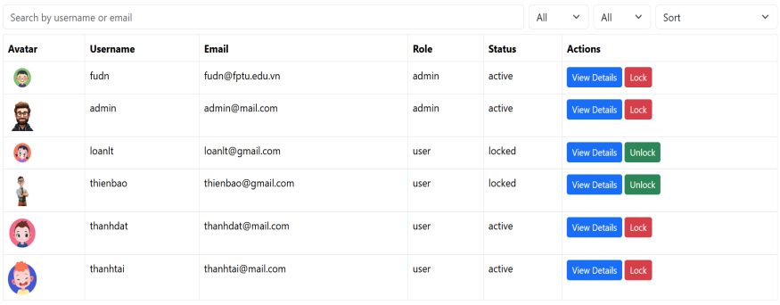
- Filter and Sorting (1 mark)
You should create a FilterBar component and use it on the account list page. (0.25 mark)
- Search by username or email. (0.25 mark)
- Filter by: (0.25 mark)
    - Status (All/Active/Locked)
    - Role (All/Admin/User)
- Sorting: (0.25 mark)
    - By Username (A->Z/ Z->A)
    - By Role (Admin/User)
    - By Status (Active/Locked)
- View Details (2 marks)
- Clicking View Details, open a detail page which showing the current user with avatar, username, email, role, status. (1.5 mark)
- Clicking Back to Lists button should return to the account list. (0.5 mark)
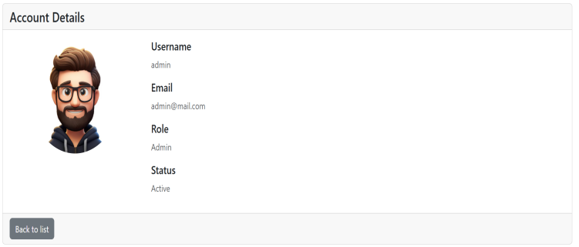
- Lock/ Unlock account (2 marks)
- Clicking Lock (if status is active) or Unlock (if status is locked) shows a confirmation modal:
    - Lock: “Lock account <username>? The user cannot log in after this”. (0.25 mark)
    - Unlock: “Unlock account <username>?” (0.25 mark)
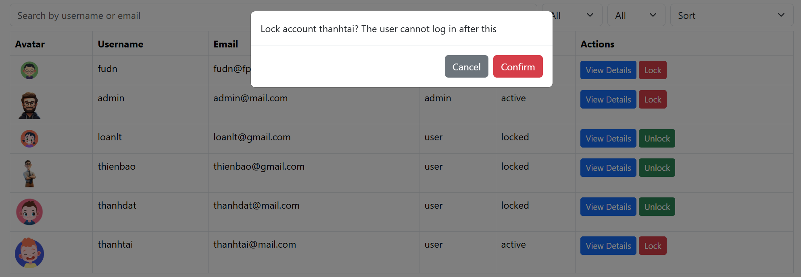
- If confirmed,
    - Update the account status and update the row in-place (no full page reload). Save the updated status to the db.json file. (0.5 mark)
    - Show a toast message: “Locked successfully” or “Unlocked successfully.” (0.25 mark)
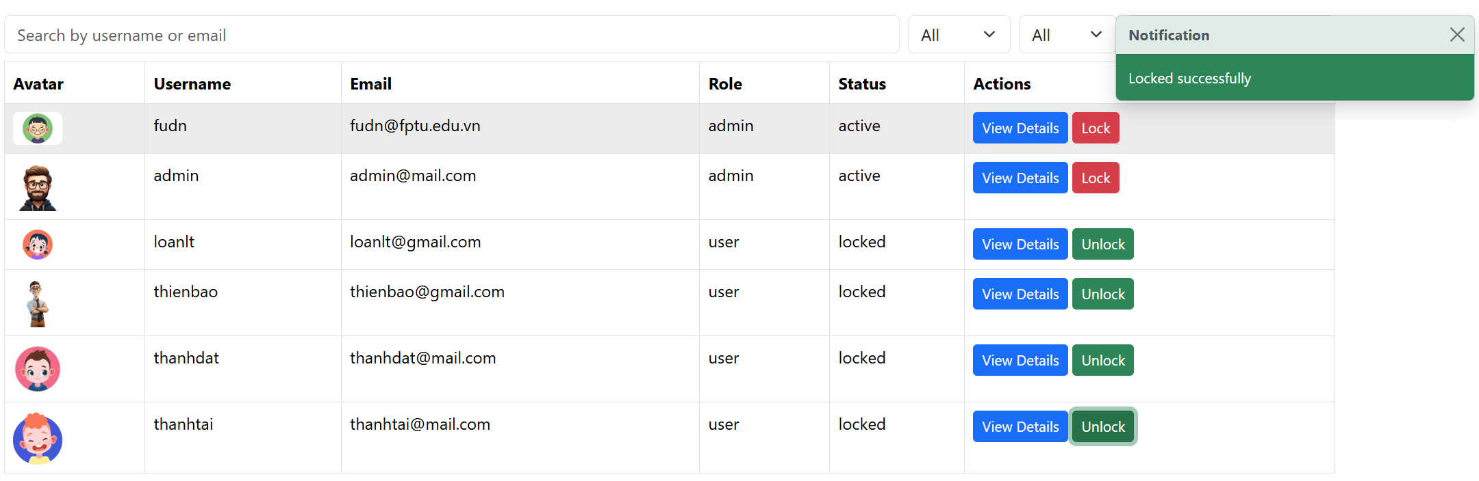
    - Note:
      - ToastMessage is a component which is used in the account list page (0.25 mark).
      - Do not self-lock the currently logged-user admin (show a warning and do nothing). (0.25 mark)
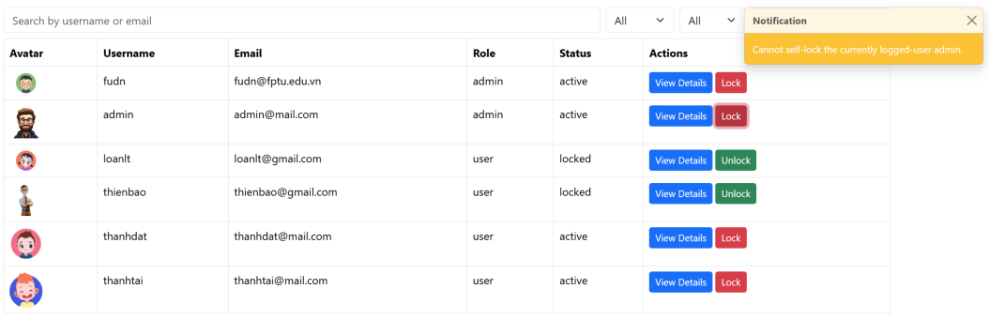
- If canceled, close the modal. (0.25 mark)

---END---

