SDN302

LAB 01 REPORT
Back-end Development Fundamentals & Node.js Environment
Student | Le Anh Tuan
Student code | DE170051
Course | SDN302 - Server-side Development with NodeJS, Express and MongoDB
Case study | BookNest Online Bookstore
Submitted: 7 September 2026

1. Requirement 1 - Development Environment
The development environment was configured with Node.js LTS, npm, Visual Studio Code and Git. The project was initialized in the chapter-1 folder and the package.json file was inspected. The project includes a start script so the CommonJS application can be run with npm start.
Verification commands and results:
node -v # v22.22.1
npm -v # 10.9.4
npm start -- 12 4
- Global tool: nodemon can be installed with npm install --global nodemon. It watches files and restarts the Node.js process during development.
- Local dependency: chalk is installed in this project and used to color terminal output.
- dependencies contain packages required when the application runs. devDependencies contain packages used mainly for development, testing or build tasks.
The generated package.json defines start, start:esm, eventloop and eventloop:async scripts. The screenshots below show the environment verification and project setup.
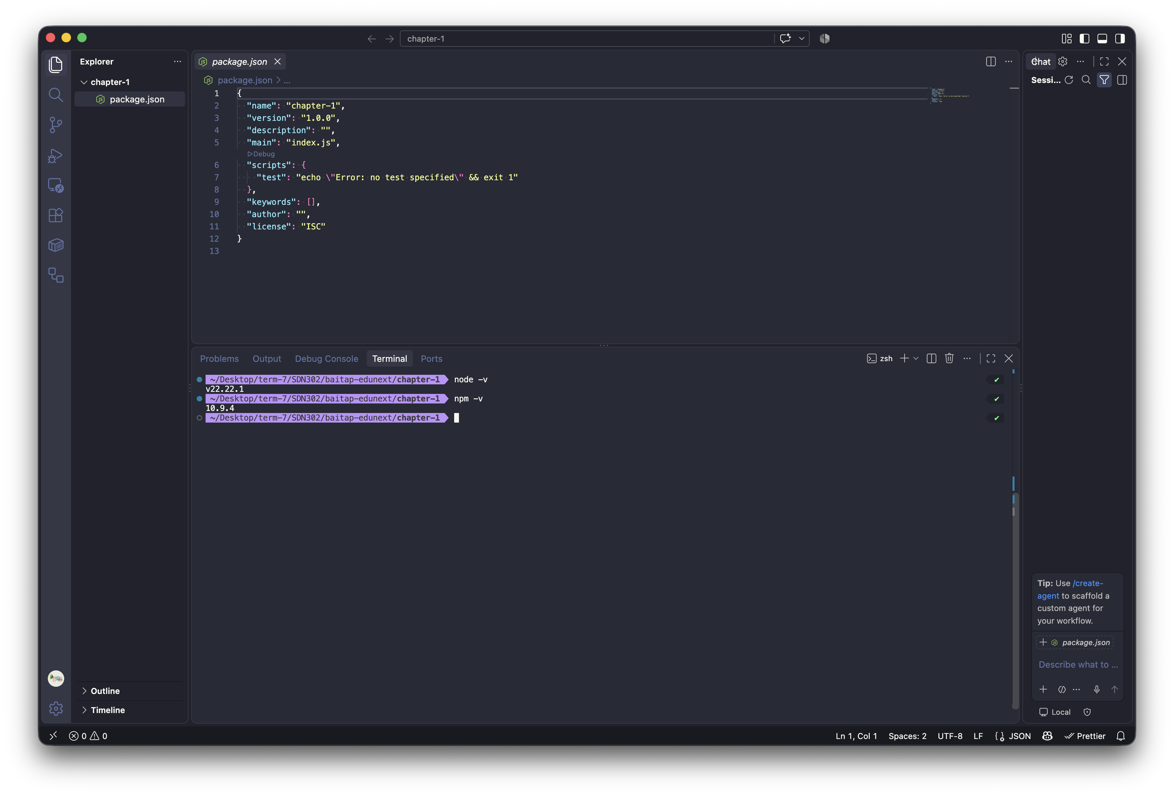
Figure 1. Node.js and npm versions, together with the generated package.json.

2. Requirement 2 - First Node.js Application
The CommonJS application in app.js reads two values from process.argv, converts them to numbers and prints the sum, difference, product and quotient. It also prints the student identity and current date. The built-in os module provides platform, CPU count and free memory; the path module resolves the absolute path of the current file.
npm start -- 200 25
Sum: 225
Difference: 175
Product: 5000
Quotient: 8
Platform: darwin
CPU count: 10
Current file: .../chapter-1/app.js
The program validates invalid numeric input and avoids returning a misleading quotient when the second number is zero. The execution output is shown in Figure 2.
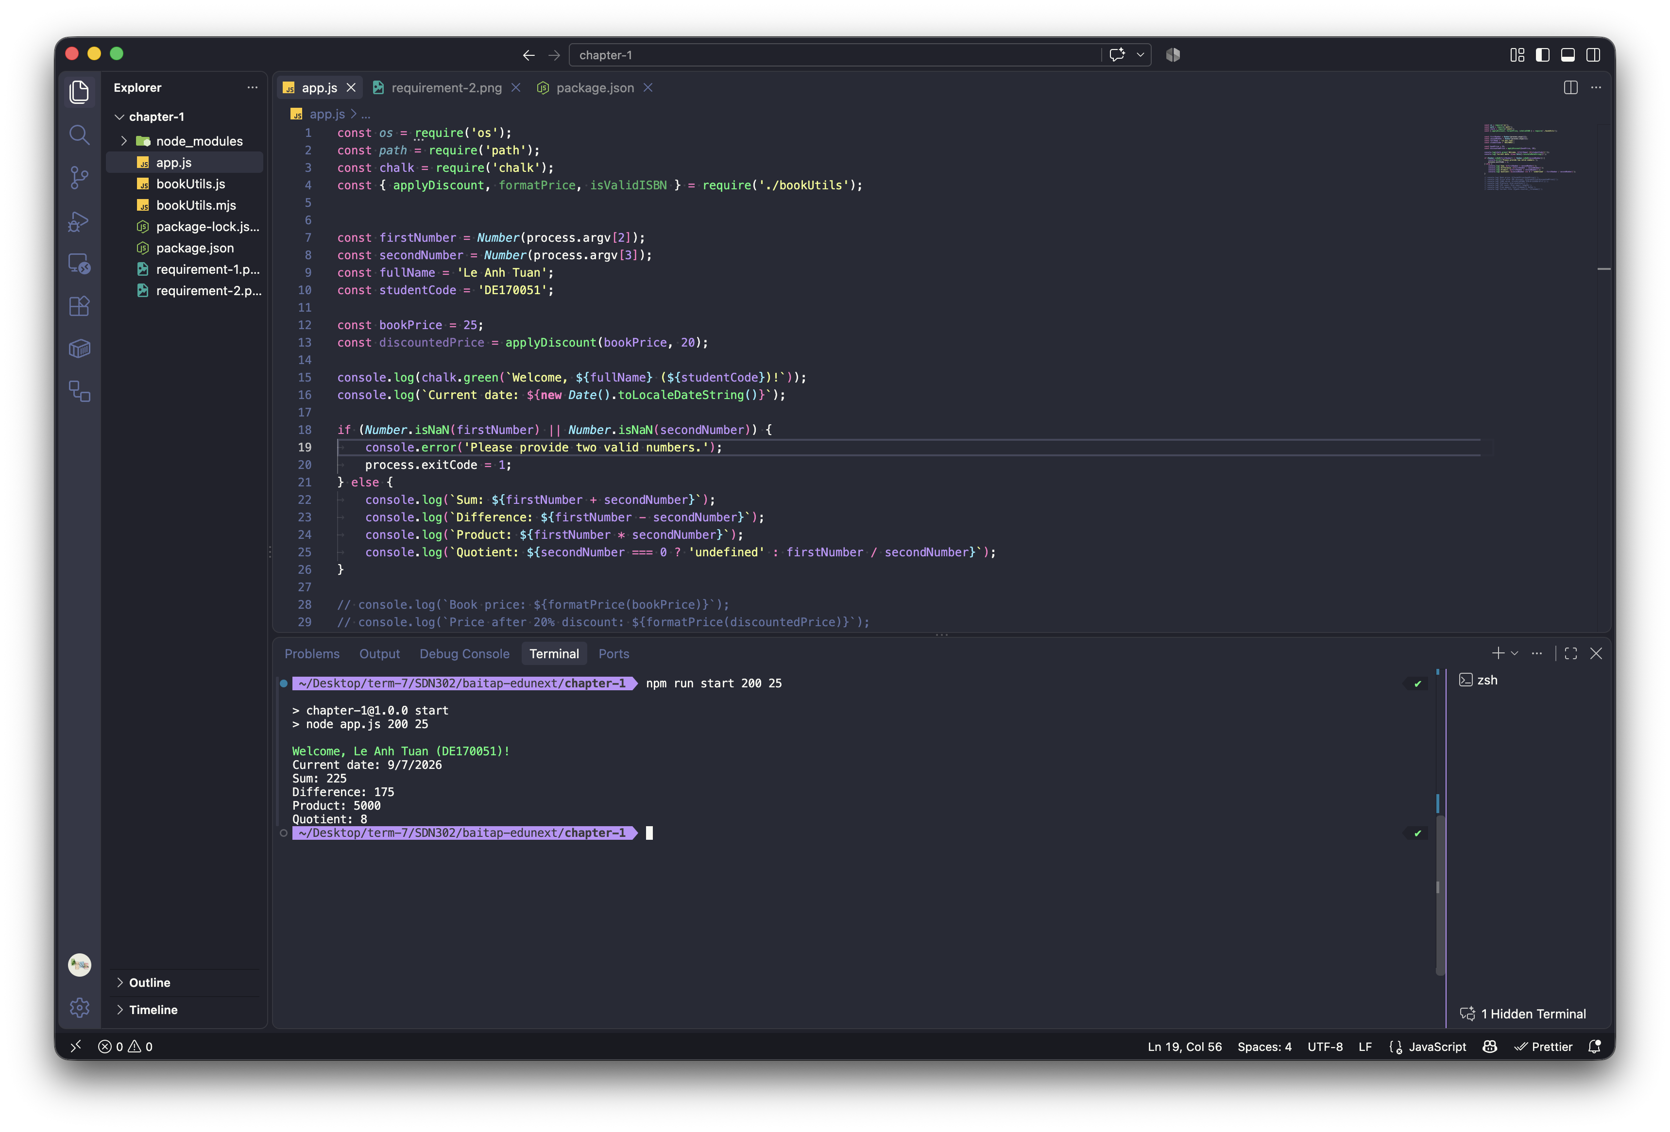
Figure 2. app.js source code and console output for the command-line calculation.

3. Requirement 3 - Modules
The project demonstrates built-in, custom and third-party modules. app.js imports os and path from Node.js, chalk from npm and three functions from the custom bookUtils.js module: formatPrice, applyDiscount and isValidISBN. These functions are used for BookNest price and ISBN examples.
A second implementation is provided with ES Modules. bookUtils.mjs uses named export statements and app-esm.mjs imports those functions with import syntax. The two versions produce the same application behavior.
Aspect | CommonJS | ES Modules
Syntax | require() / module.exports | import / export
Files in this project | app.js, bookUtils.js | app-esm.mjs, bookUtils.mjs
Configuration | Works directly with .js | Uses .mjs; or .js with "type": "module"
Typical strength | Mature Node.js compatibility | Standard JavaScript module syntax
Configuration note: ESM can use .js files after adding "type": "module" to package.json. If that setting is added, the CommonJS files must be renamed to .cjs or converted because require() is not available in a normal ESM file.
npm start -- 200 25
npm run start:esm -- 200 25
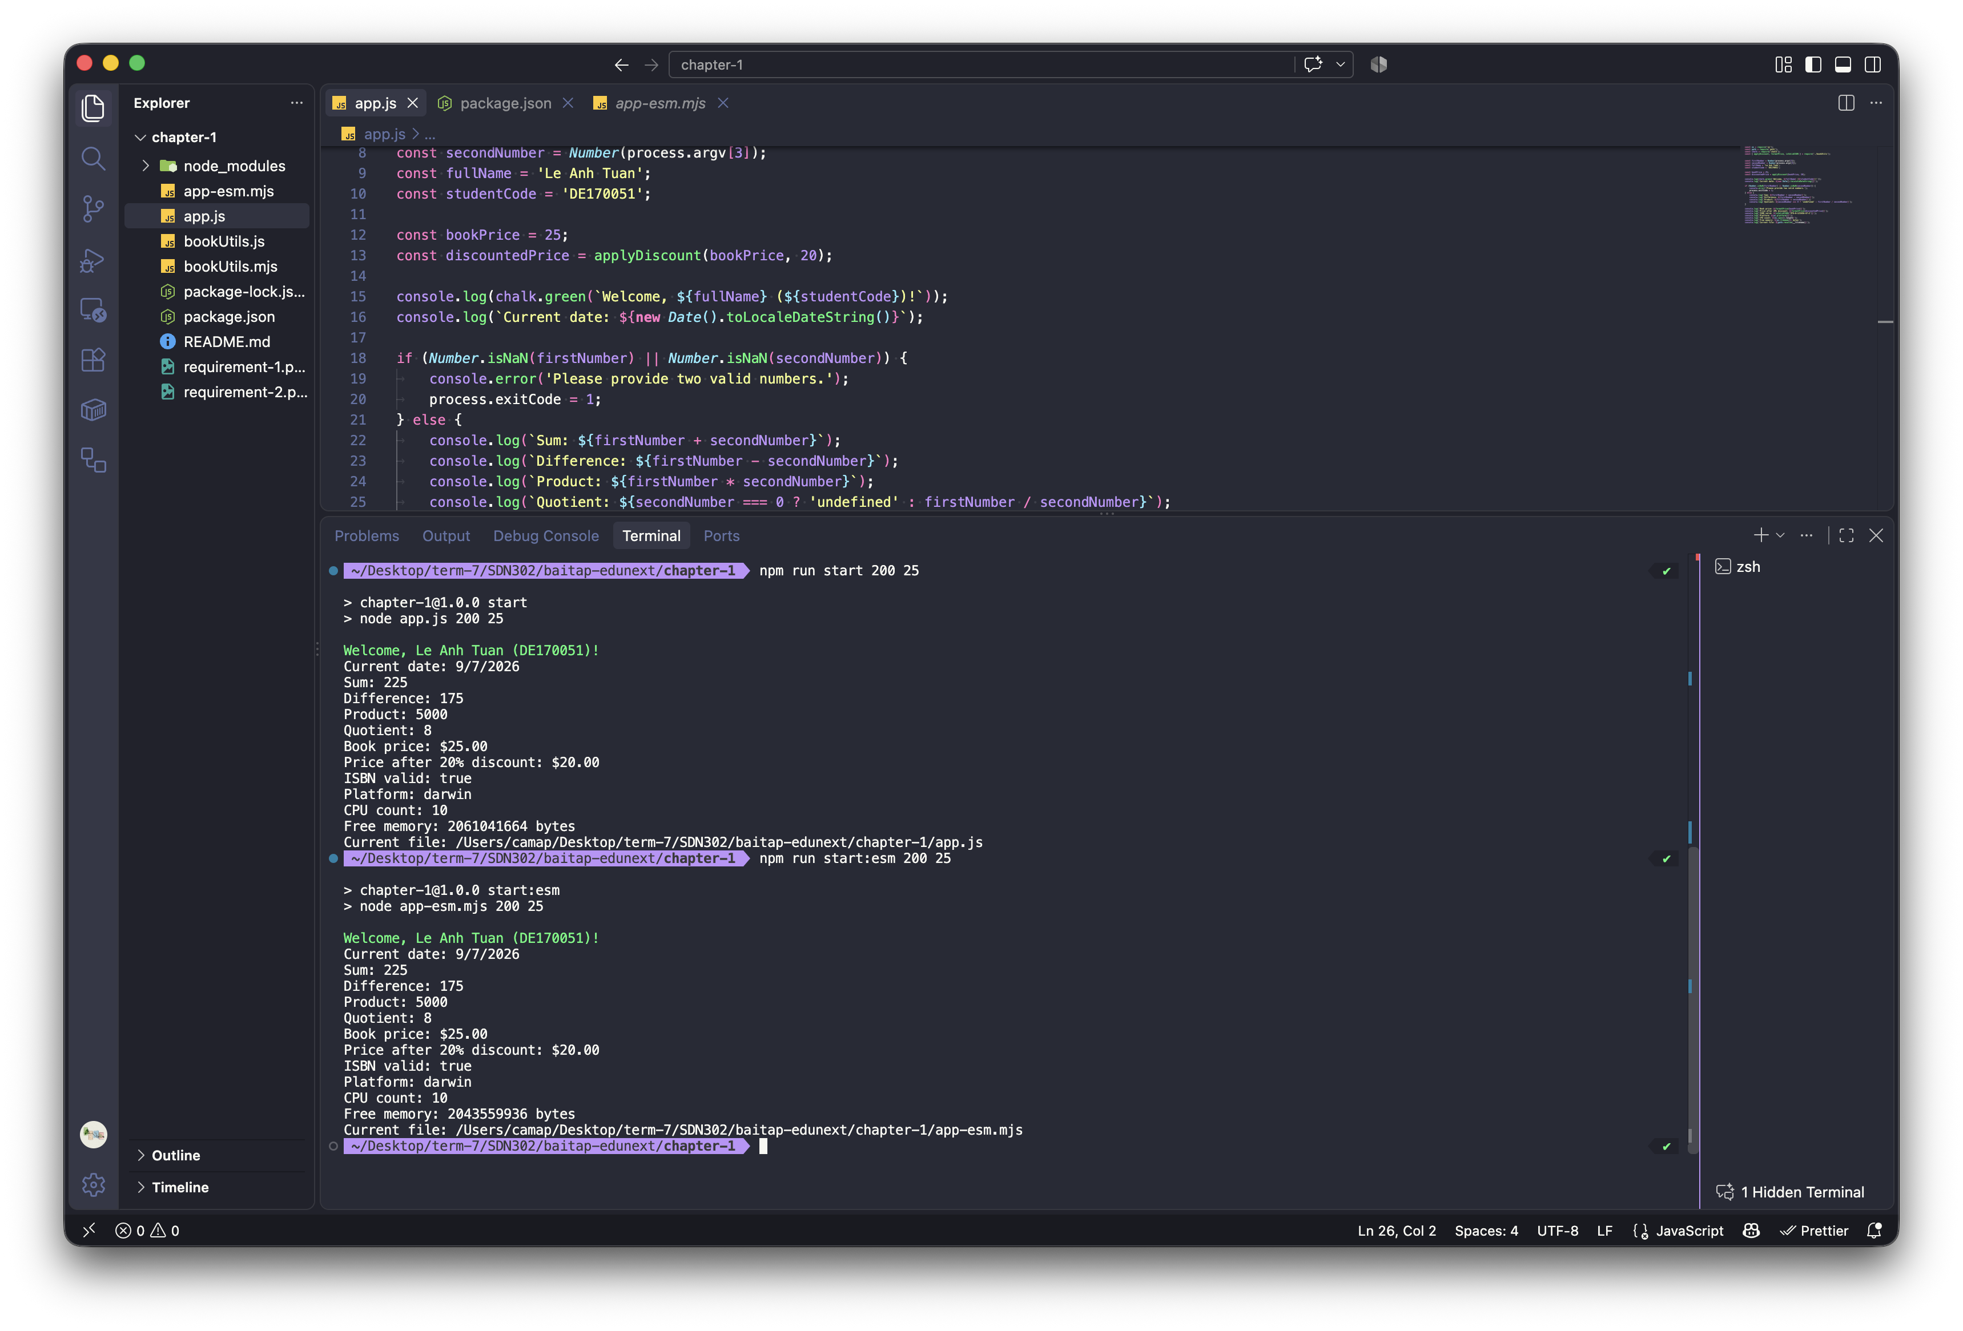
Figure 3. CommonJS and ES Module executions with custom and third-party module output.

4. Requirement 4 - Event Loop and Non-blocking Behaviour
The predicted order at top level is: synchronous statements first, then process.nextTick, the resolved Promise callback, and finally the timer and immediate callbacks. The relative order of setTimeout(..., 0) and setImmediate() at top level is not guaranteed because they belong to different event-loop phases.
The blocking version performs a loop of 3,000,000,000 iterations synchronously. During that work, Node.js cannot return to the event loop, so timer callbacks are delayed until the loop finishes. In the recorded run, the blocking work took approximately 1,800 ms and both callbacks ran after that delay.
The asynchronous version performs the same total work in 1,000,000-iteration chunks and schedules the next chunk with setImmediate(). This yields control between chunks, allowing timers and other callbacks to run near the beginning while the remaining work continues. The total CPU work can still take a similar amount of time, but the event loop remains responsive.
Blocking: node eventloop.js
Asynchronous: node eventloop-async.js
Fast test option: ITERATIONS=1000000 node eventloop-async.js

Observed event-loop phases
- Synchronous execution runs first and includes the blocking loop in eventloop.js.
- The next-tick queue is drained before the Promise microtask queue, so process.nextTick appears before the resolved Promise callback.
- setTimeout is handled in the timers phase; setImmediate is handled in the check phase.
- Chunked setImmediate scheduling lets Node.js revisit the timers and check phases between units of work.
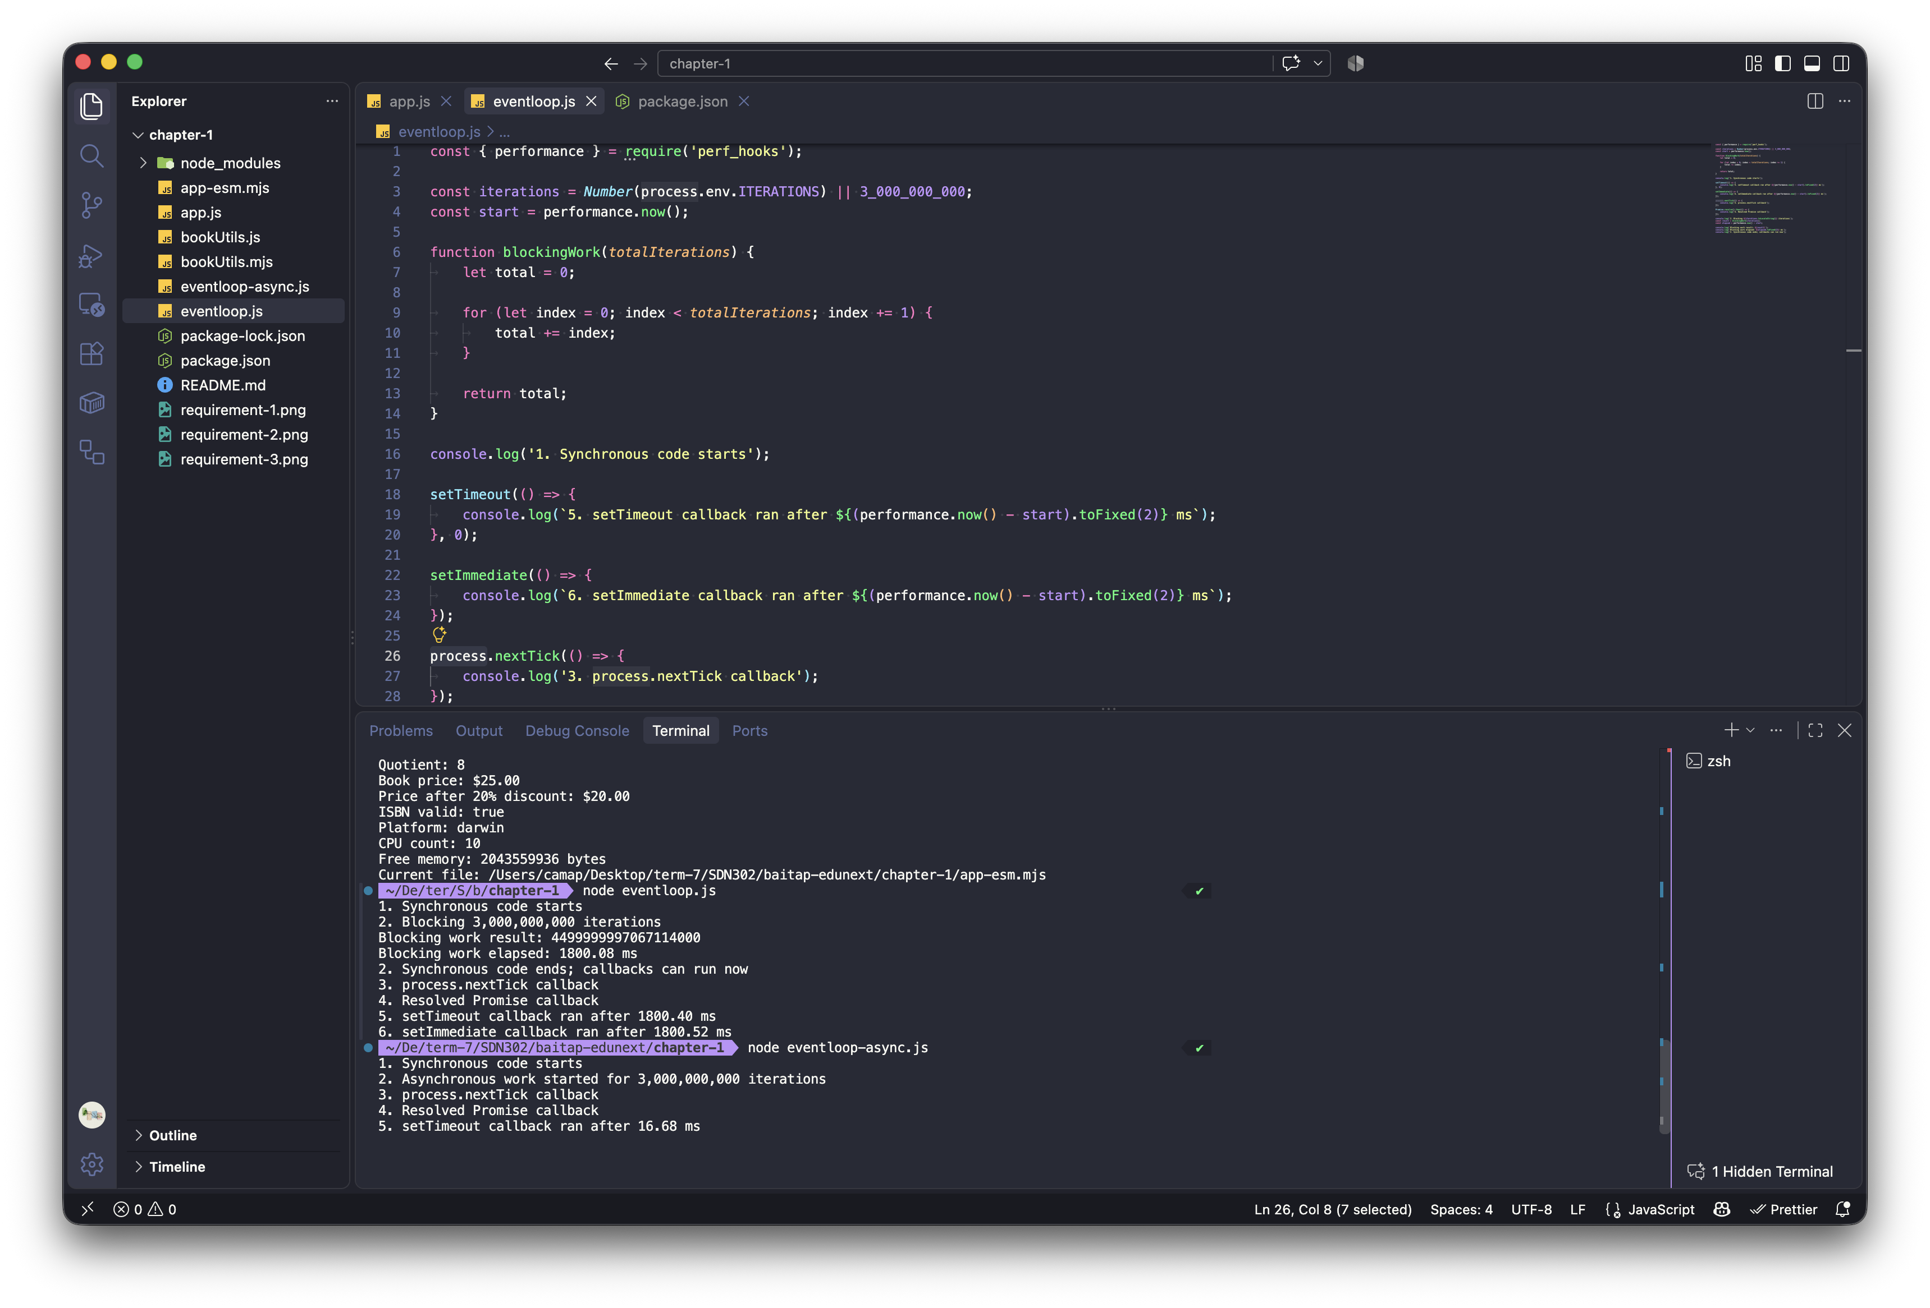
Figure 4. Blocking and chunked asynchronous event-loop demonstrations.

5. Requirement 5 - Short Written Report

5.1 Role Comparison
Role | Responsibilities | Languages | Frameworks and typical tools
Front-End | Builds the interface and browser experience, including layout, accessibility and client-side performance. | HTML, CSS, JavaScript, TypeScript | React, Angular, Vue; VS Code, DevTools, npm, Figma, Git
Back-End | Builds business logic, APIs, authentication, data processing and database integrations. | JavaScript/TypeScript, Python, Java, C#, Go, PHP | Express, NestJS, Django, Spring Boot, ASP.NET Core; Postman, Docker, database clients, logging tools
Full-Stack | Connects the interface, server, database and deployment into one complete application. | JavaScript/TypeScript plus Python, Java or C# | Next.js, MERN, MEAN, Laravel, Django + React; VS Code, GitHub, Docker, CI/CD tools, cloud platforms

5.2 Five Essential Back-End Skills
Skill | Why it matters
Programming and problem solving | Produces reliable business rules, handles edge cases and keeps code maintainable.
API design | Gives front-end clients and other services a predictable way to use application features.
Database management | Keeps data accurate and applications responsive through good schemas, queries, indexes and transactions.
Security | Protects users and systems through authentication, authorization, validation and secure secret handling.
Testing, debugging and deployment | Helps locate defects quickly and release changes safely and repeatedly.

5.3 Web Hosting and CI/CD
Web hosting stores an application and makes it available on the internet. A hosting provider supplies computing resources, networking, domain support and often deployment tools. Vercel is a popular hosting service for modern front-end and full-stack JavaScript applications.
CI/CD means Continuous Integration and Continuous Delivery or Deployment. A pipeline automatically builds and tests code after changes are pushed, then prepares or releases the application. This reduces manual errors and makes delivery faster and more repeatable. GitHub Actions is a popular CI/CD service.
Key idea: front-end focuses on the user experience, back-end focuses on server-side functionality and data, and full-stack combines both areas.

Conclusion
This lab establishes a working Node.js foundation for the BookNest Online Bookstore case study. The project verifies the runtime, demonstrates command-line input and system modules, compares CommonJS with ES Modules, and shows why asynchronous chunking keeps the event loop available during CPU-heavy work.

