Course Cast

Focused Use Cases

Version 2.0

Revision History
Date | Version | Description | Author
11-14-07 | 1.0 | Focused Use Cases, Use Case Diagram, Activity Diagrams | XXXXXX
12-5-07 | 2.0 | Update | XXXXXX

Table of Contents
UC1 4
UC2 7
UC3 11
UC4 14
UC5 17

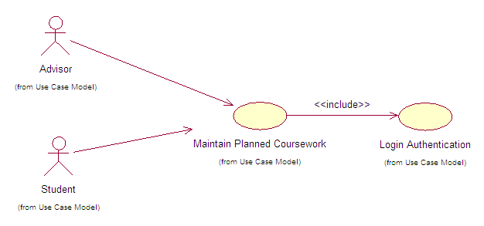
Use Case Number: | UC1
Use Case Name: | Maintain Planned Course Work
Actor (s): | Student, Advisor
Maturity: | Focused
Summary: | Students, or an Advisor aiding a student, will create and maintain their student preferences for future semesters.
Basic Course of Events:  (luồng nghiệp vụ chính) | Actor Action | System Response
 | 1. Perform {Login Authentication}
 |  | 2. System displays welcome page with main features for actor to choose from.
 | 3. The use case begins when the Student actor selects to maintain planned coursework. A1.
 |  | 4. The system displays the student’s program of study and also returns any previously planned course preferences.
 | 5. The Student and Advisor actors select the future courses, term, day and time. (Repeat as many times as necessary.) A2
 | 6. The Actor selects to save the information. A3
 |  | 7. The system validates the planned coursework entered by the Actor. {Validate Planned Courses}
8. The system updates the students planned coursework in the database and informs the actor that the information was updated successfully.
The use case ends.
Alternative Paths:  (luồng phụ) | A1.
 | Actor Action | System Response
 | 1. The Advisor actor enters the student’s UNFID for the appropriate student.
 |  | 2. The system validates that the UNFID. E2
 | 3. The Advisor actor selects to maintain planned coursework.
 |  | Return to step 4 of the Basic Course of Events.
 | A2. An actor has the ability to review catalog information for a particular course when selected.
A3.
1. The actor has the ability to “Cancel” changes to return the information to the previously saved version. Returns to step 8 of Basic Course of Events.
2. The actor has the ability to “Reset” information which removes all planned coursework for a student. Returns to step 8 of Basic Course of Events.
Exception Paths: | E1. At {Validate Planned Courses} if errors (prerequisites not met, more than six courses selected for a term, planning a course that the student has already passed), the system indicates the courses where there are errors.  Returns to Basic Flow Step 5.  E2. If the system cannot find the UNFID in stored data, the system informs the user that their UNFID cannot be found and the actor is returned to step 1 of Alternate Path 1 (A1).
Extension Points: | Validate Planned Courses  Review of the planned courses compares against courses the student has already taken, currently registered for or future planned courses to verify that the student has met the necessary prerequisites or the prerequisite is planned. (See Business Rule 2.1) E1
Triggers: | Actor wishes to input student preferences for future semesters.
Assumptions: | The Advisor will not make any changes without first consulting the Student.
Preconditions: | None.
Post Conditions: | The updated student preferences are saved to stored data.
Reference: Business Rules | 2.1, 2.7, 2.8, 2.9 2.10
Author(s): | XXXXX
Date: | 11-14-07
Activity Diagram: Next Page

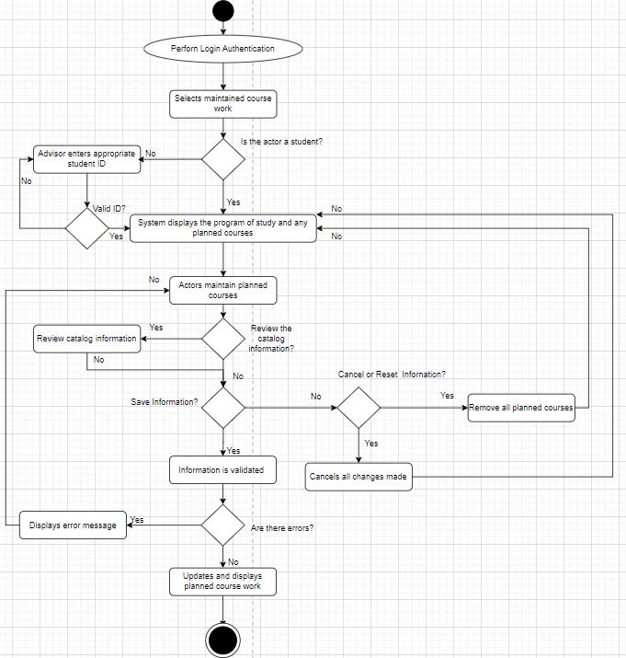

Sequence Diagram:
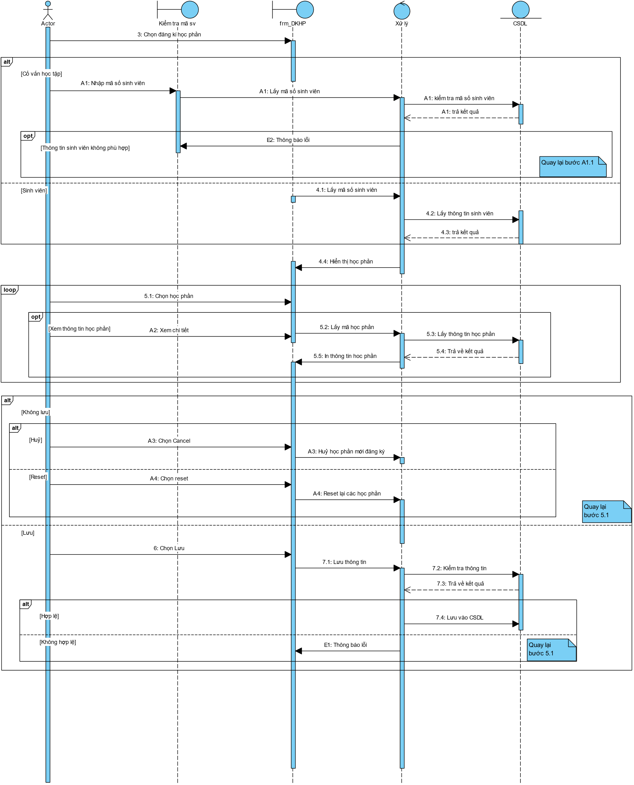

Interface:
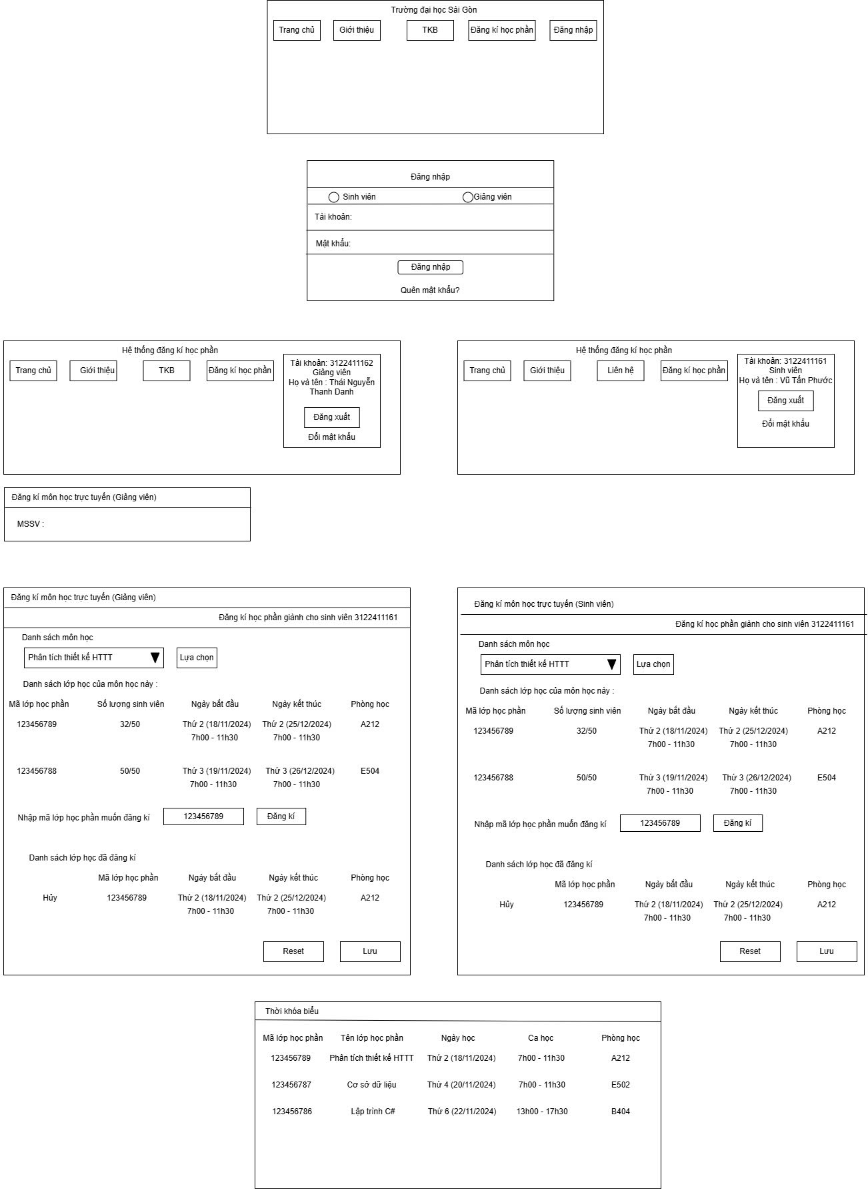

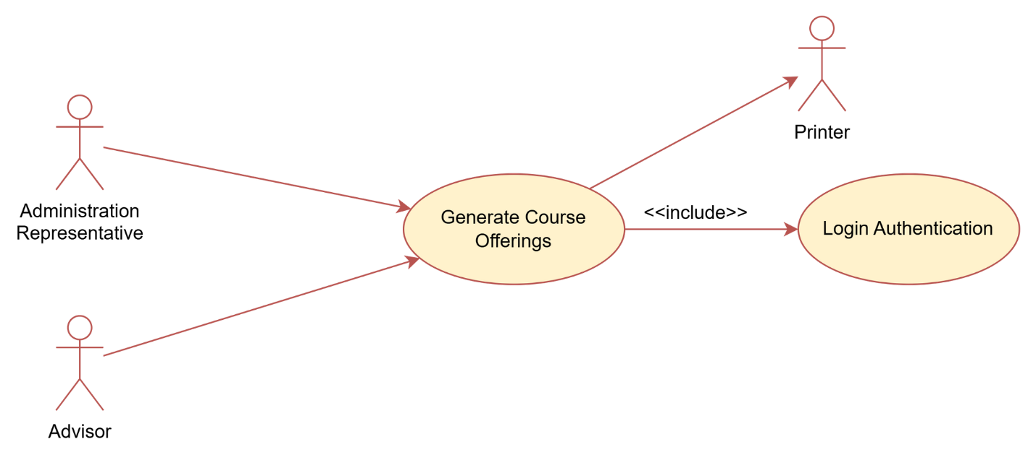
Use Case Number: | UC2
Use Case Name: | Generate Course Offerings
Actor (s): | Advisor, Administration Representative
Maturity: | Focused
Summary: | Administration will generate a course offering for a future semester based off of student preferences.
HBasic Course of Events: | Actor Action | System Response
 | 1. Perform {Login Authentication}
 |  | 2. System displays welcome page with main features for actor to choose from.
 | 3. The Advisor or Administration Representative actor selects to generate a course offering.
 |  | 4. The system requests the semester and year for which the course offering will be generated.
 | 5. The actor inputs the semester and year for which the course offering will be generated.
6. The system validates the entered semester and year.
E1.
7. The system calculates the course offering for the selected semester based on student preferences.

The calculation assigns weights to: number of students who have planned a course, the seniority of the student, differentiation between major requirements versus elective requirements, and whether the course is used in multiple tracks.

 |  | 8. Based on the calculations and the students’ day and time preferences, the system displays this course offering along with its course information.
 |  | 9. The system generates the student preferences statistics for the parameters selected by the actor. It will include: course information, subtotals of time and day, and totals.
10. The actor views the generated course offering. The use case end here.
A1

Alternative Paths: | A1. From this point the actor can select to print the generated course offering. After that is completed the actor is returned to the same point in the flow of events.
Exception Paths: | .E1. If the actor enters a semester that has already occurred, the system prompts the user and requests another semester. Control returns to step 5 of the Basic Course of Events.
Extension Points: | None
Triggers: | Actor wishes to generate a course offering.
Assumptions: | Student preferences have been entered into the system.
Preconditions: | The actor possesses the correct authority level.
Post Conditions: | A course offering will be generated.
Reference: Business Rules: | 2.3, 2.4, 2.5, 2.6, 2.7, 2.10
Author(s): | XXXXX
Date: | 11-14-07
Activity Diagram:
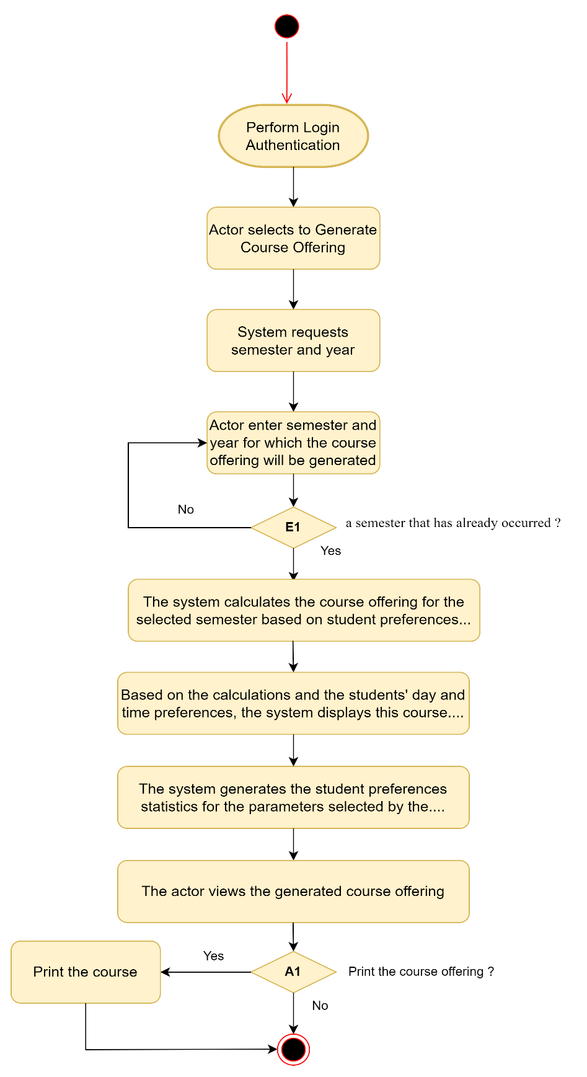

Sequence Diagram: 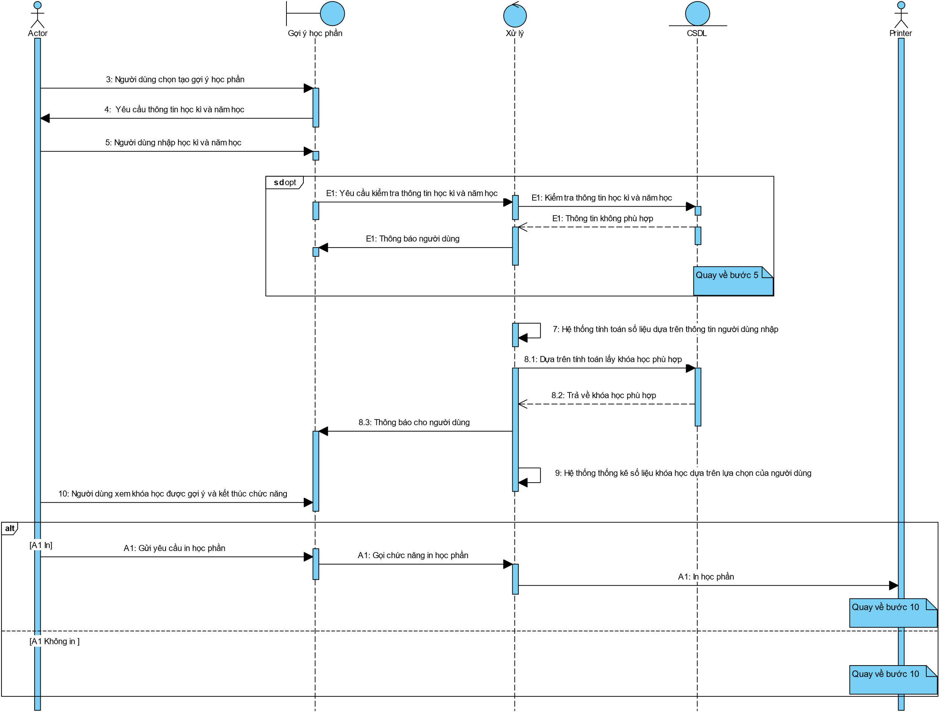

Interface:
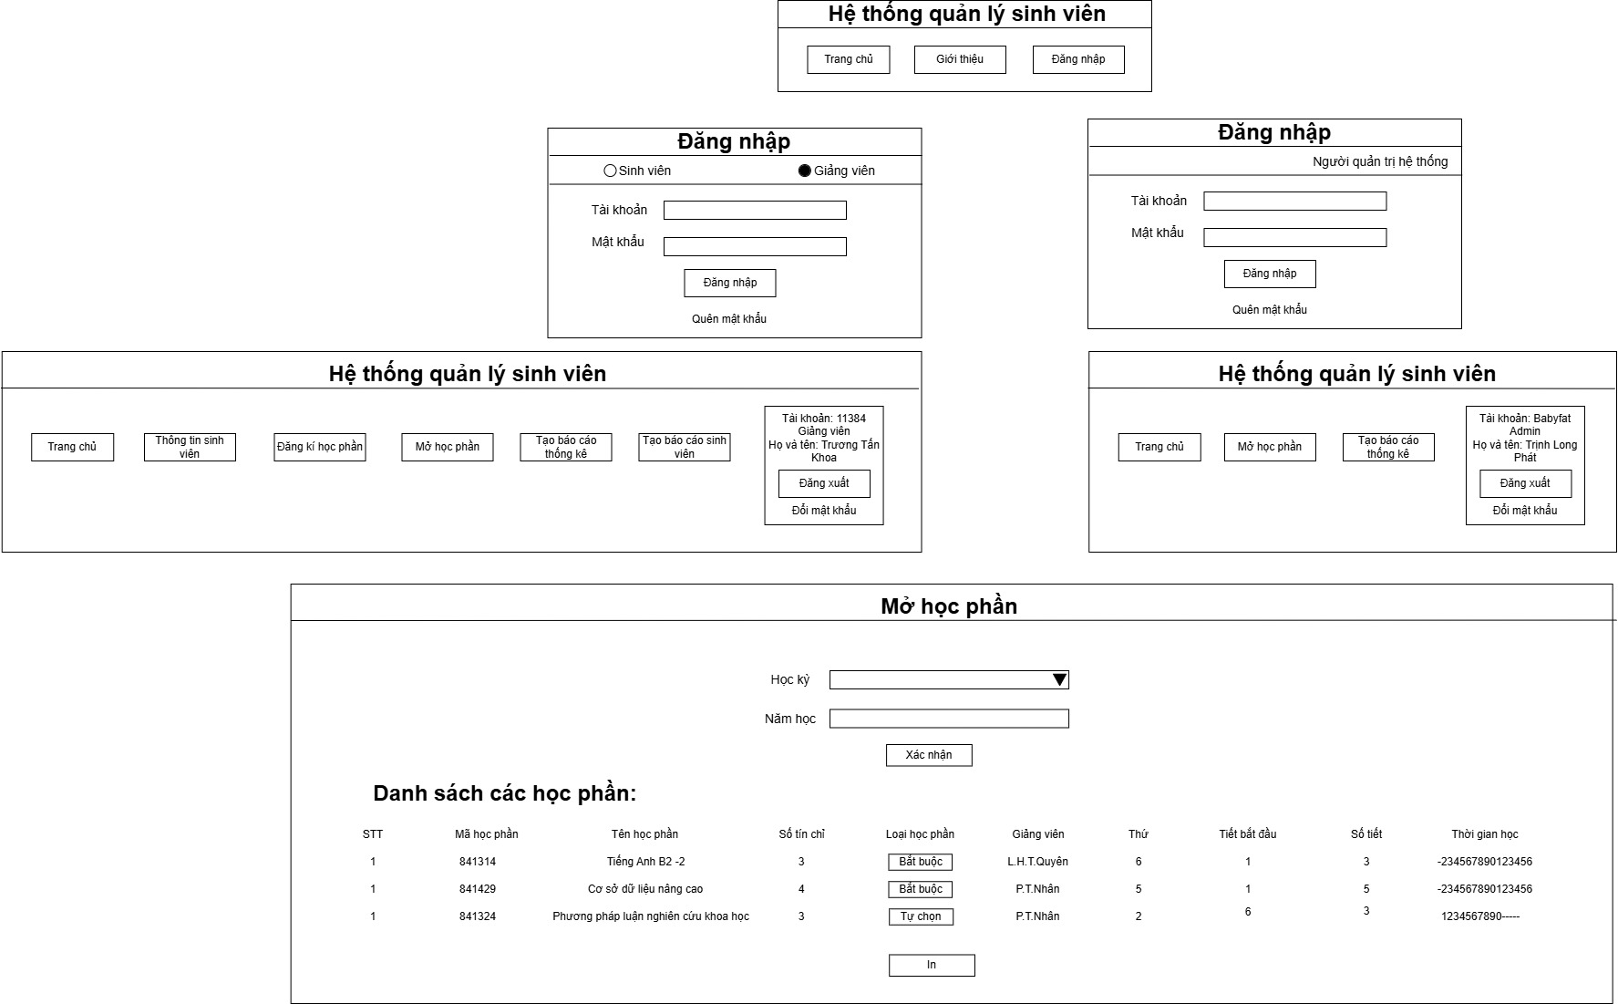

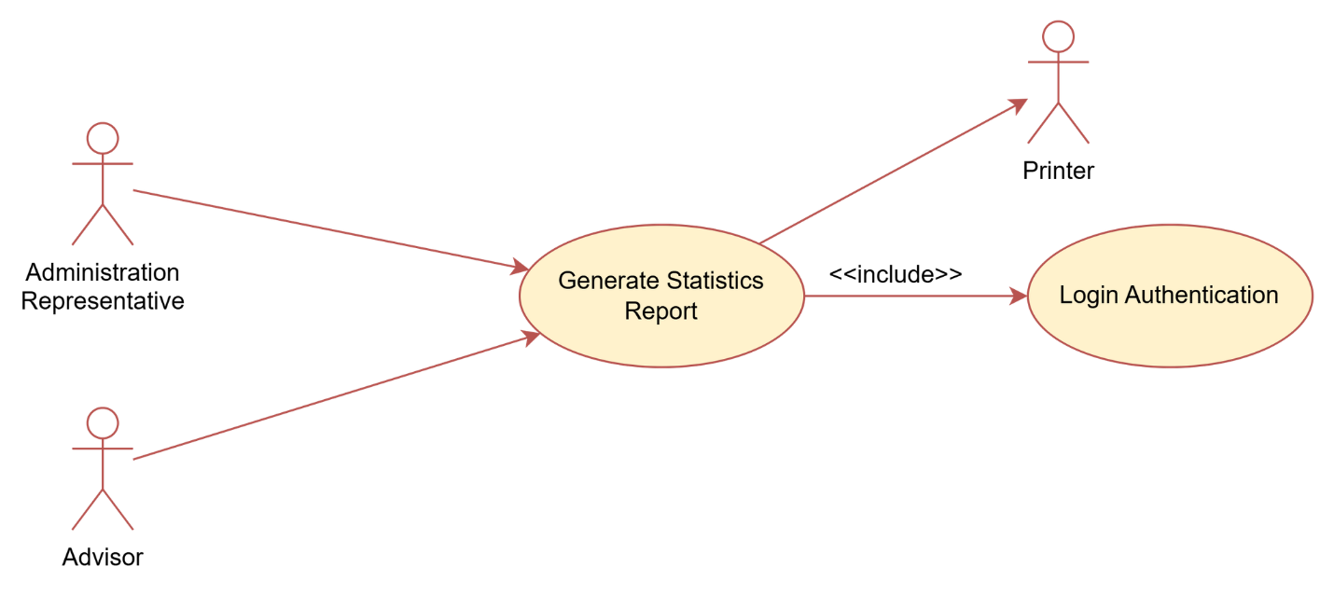
Use Case Number: | UC3
Use Case Name: | Generate Statistics Report
Actor (s): | Advisor, Administration Representative
Maturity: | Focused
Summary: | Advisors or an Administration Representative will generate a Statistics Report based on student preferences.
Basic Course of Events: | Actor Action | System Response
 | 1. Perform {Login Authentication}.
 |  | 2. System displays welcome page with main features for actor to choose from.
 | 3. The Advisor or Administration Representative actor selects to generate Statistics Report.
 |  | 4. The system directs them to enter parameters. Parameters are: Semester, Year, Time and/or Day.
 | 5. The user enters the parameters.
 |  | 6. The system generates the student preferences statistics based on information stored in the database for the parameters selected by the actor. It will include: course information, subtotals of time, day or both, and totals.
7. The actor views the administrative report. The use case ends here.
A1
Alternative Paths: | A1. From this point the actor can select to print the generated Statistics Report. The use case ends here.
Exception Paths: | None
Extension Points: | None
Triggers: | The actor wishes to generate Statistics Report.
Assumptions: | Student preferences have been entered into the system.
Preconditions: | None
Post Conditions: | A Statistics Report will be generated.
Reference: Business Rules | None
Author(s): | XXXXXX
Date: | 11-14-07
Activity Diagram:

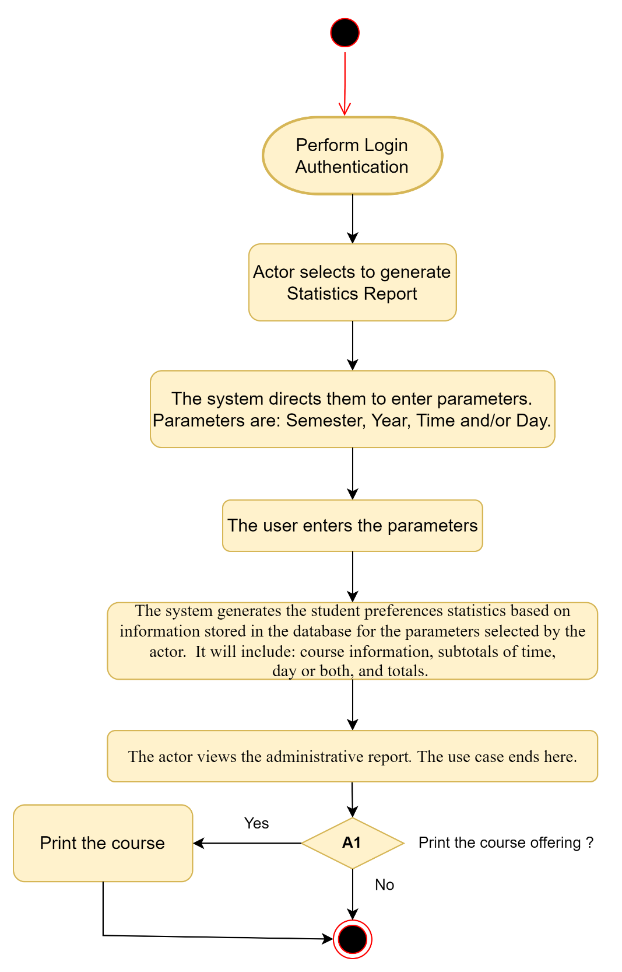

Sequence Diagram:
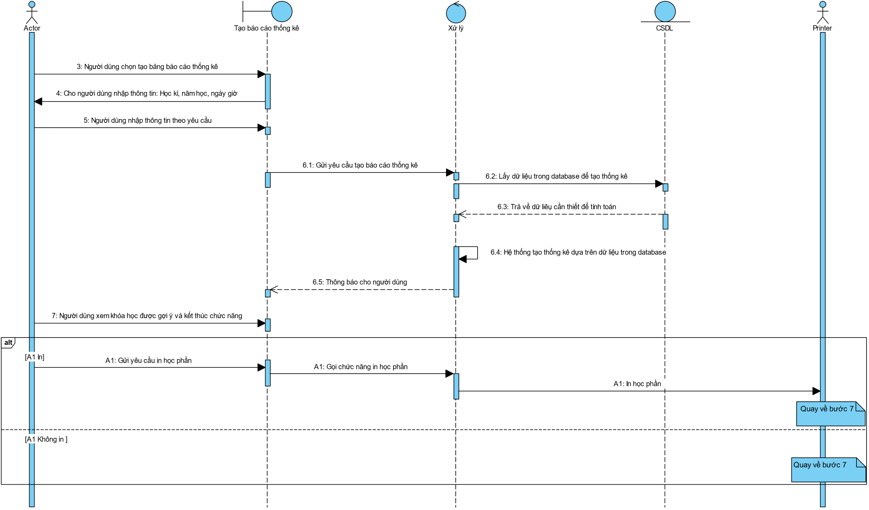
Interface:
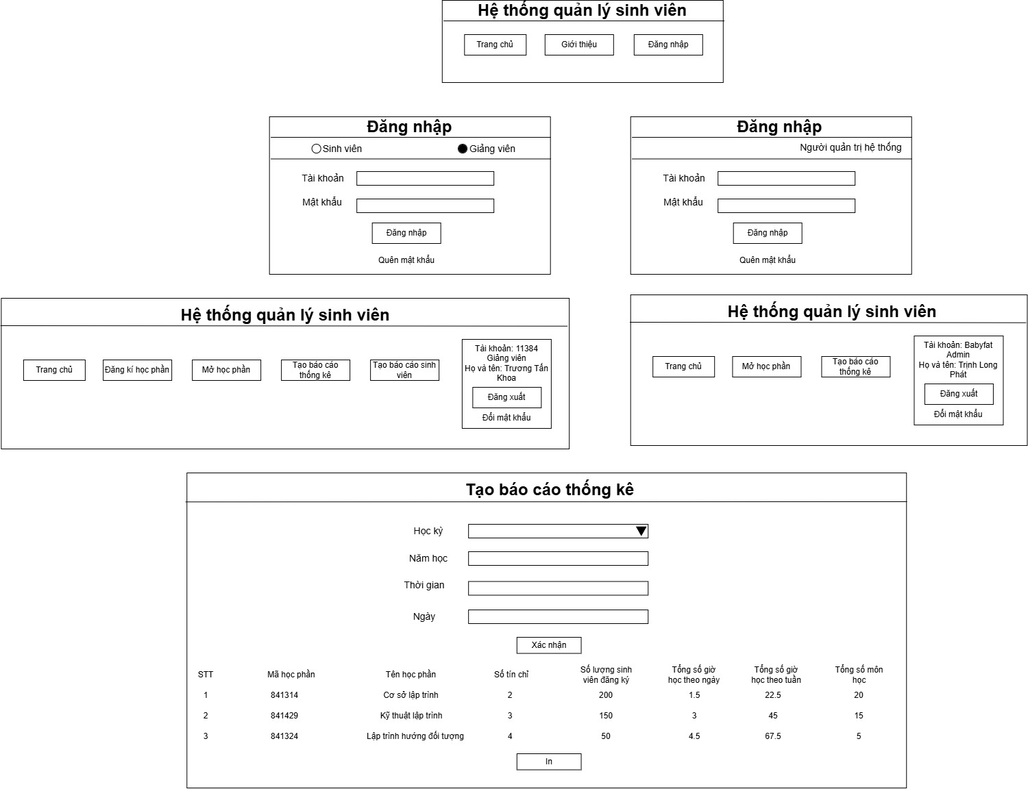

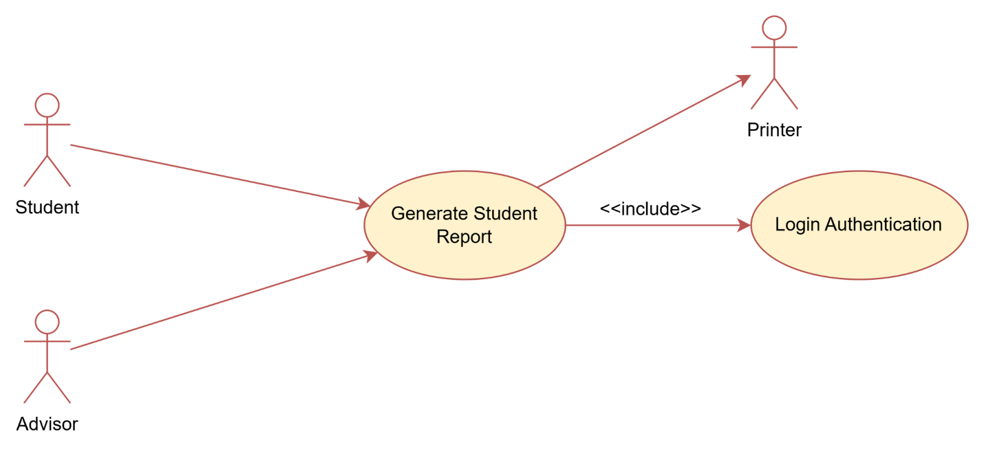
Use Case Number: | UC4
Use Case Name: | Generate Student Report
Actor (s): | Student, Advisor
Maturity: | Focused
Summary: | Actors will be able to generate a report summarizing student course history and future student preferences.
Basic Course of Events: | Actor Action |  | System Response
 | 1. Perform {Login Authentication}
 |  |  | 2. System displays welcome page with main features for actor to choose from.
3. The actor selects to generate the student report consisting of specific student information and the student’s course preferences.
A1.

 |  |  | 4. The system displays a summary of the student information and future student preferences.
5. The use case ends at this point.
A2

Alternative Paths: | A1. Check if an advisor
 | Actor Action | System Response
 | 1. The Advisor actor enters the student’s UNFID for the appropriate student.
 |  | 2. The system validates that the UNFID. E1
 | 3. The Advisor actor selects to generate the student report consisting of specific student information and the student’s course preferences.
 |  | Return to step 4 of the Basic Course of Events.
A2.
The actor can print the summary report. The use case ends at this point.
Exception Paths: | E1. If the system cannot find the UNFID in stored data, the system informs the user that their UNFID cannot be found and the actor is returned to step 1 of Alternate Path 1 (A1).
Extension Points: | None
Triggers: | The actor wishes to generate student report.
Assumptions: | Student preferences have been entered into the system.
Preconditions: | None
Post Conditions: | A student report may be generated.
Reference: Business Rules: | None
Reference: Risks | None
Author(s): | XXXXXX
Date: | 11-14-07
Activity Diagram:
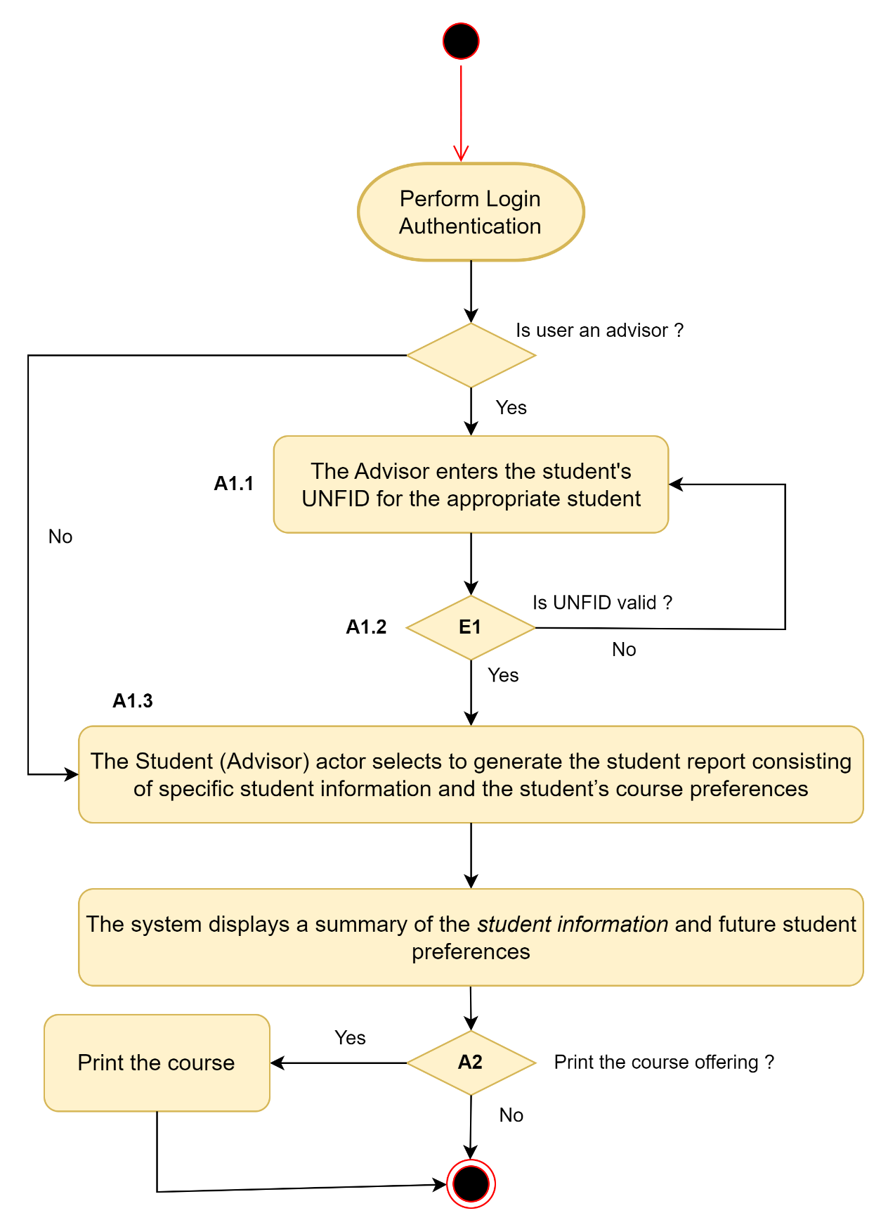

`
Sequence Diagram:
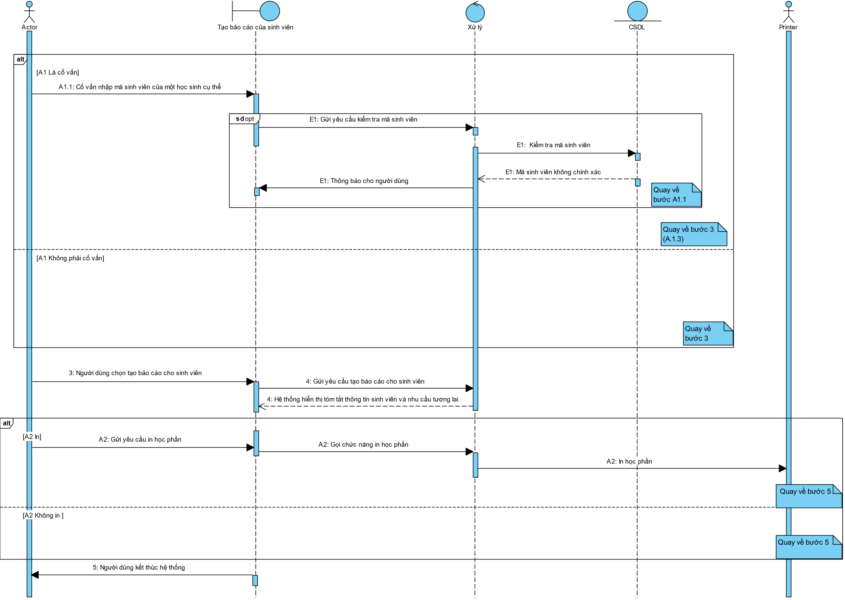
Interface:
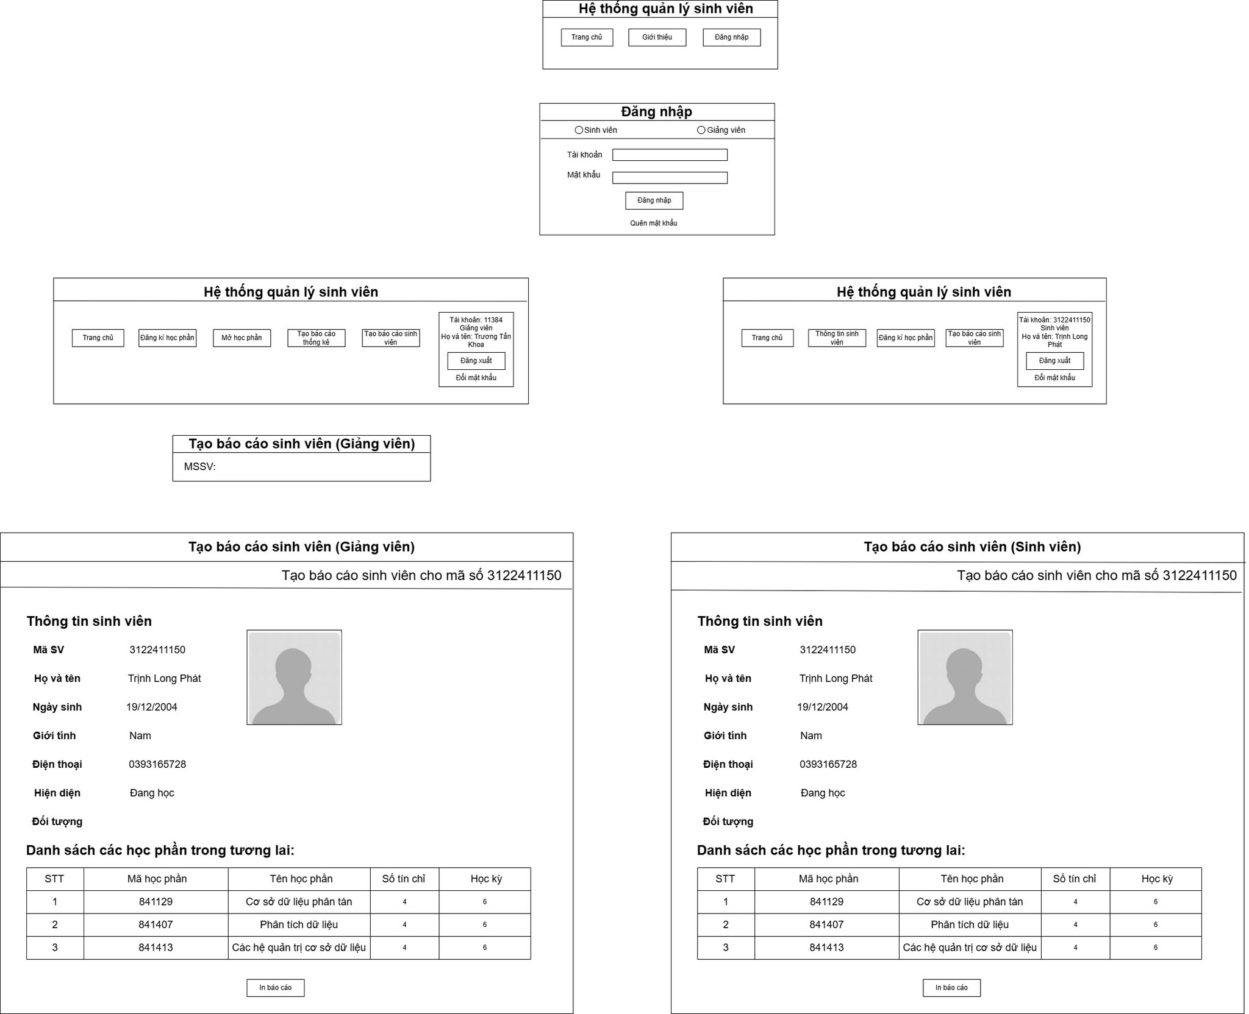
Trần Hảo Điền
Trần Hảo Điền

Use Case Number: | UC5
Use Case Name: | Login Authentication
Actor (s): | Student, Advisor, Administration Representative
Maturity: | Focused
Summary: | All actors will log in to Course Cast. Features are available to the actor according to User Type i.e. Student, Advisor, Administration Representative.
Basic Course of Events: | Actor Action | System Response
 | 1. The actor types their UNFID and their Password.
2. The system will retrieve the actor’s name and User Type from the database for the supplied UNFID and Password thus beginning a Session.
E1

3.
Students have access to:
Student Information
Course Planning
Log Off A1,A2

 |  | 4. The system redirects the actor to the Home page.
Alternative Paths: | A1. If the usertype is an Advisor. The system show: Student information, Course planning, Course offering, Statistics, Log Off
 | A2. If the usertype is an Administraction: The system show: Course offering, Statistics, Log Off.
Exception Paths: | E1. If the system cannot find the UNFID in the database, the system informs the user that their UNFID cannot be found and the actor is returned to the beginning of the course of events. As in other UNF systems, there is no limit to the number of times a user may attempt to log in to Course Cast.  If the system finds the UNFID in the database but the actor supplied Password does not match the Password in the database for the UNFID, the system informs the user that their Password is incorrect and the actor is returned to the beginning of the course of events. As in other UNF systems, there is no limit to the number of times a user may attempt to log in to Course Cast.
Extension Points: | None
Triggers: | The actor is visiting the website but has not yet begun a Session.  The actor’s Session has timed out as a result of inactivity.  The actor has ended a Session by selecting Log Off.
Assumptions: | None
Preconditions: | The actor is visiting Course Cast but does not have an active Session. Therefore the actor has been redirected to the Log On page.
Post Conditions: | The actor has an active Session.  The actor is visiting the Home page.  The actor has the appropriate features available.
Reference: Business Rules | 2.7, 2.8, 2.9, 2.10
Author(s): | XXXXXX
Date: | 11-14-07
Activity Diagram:
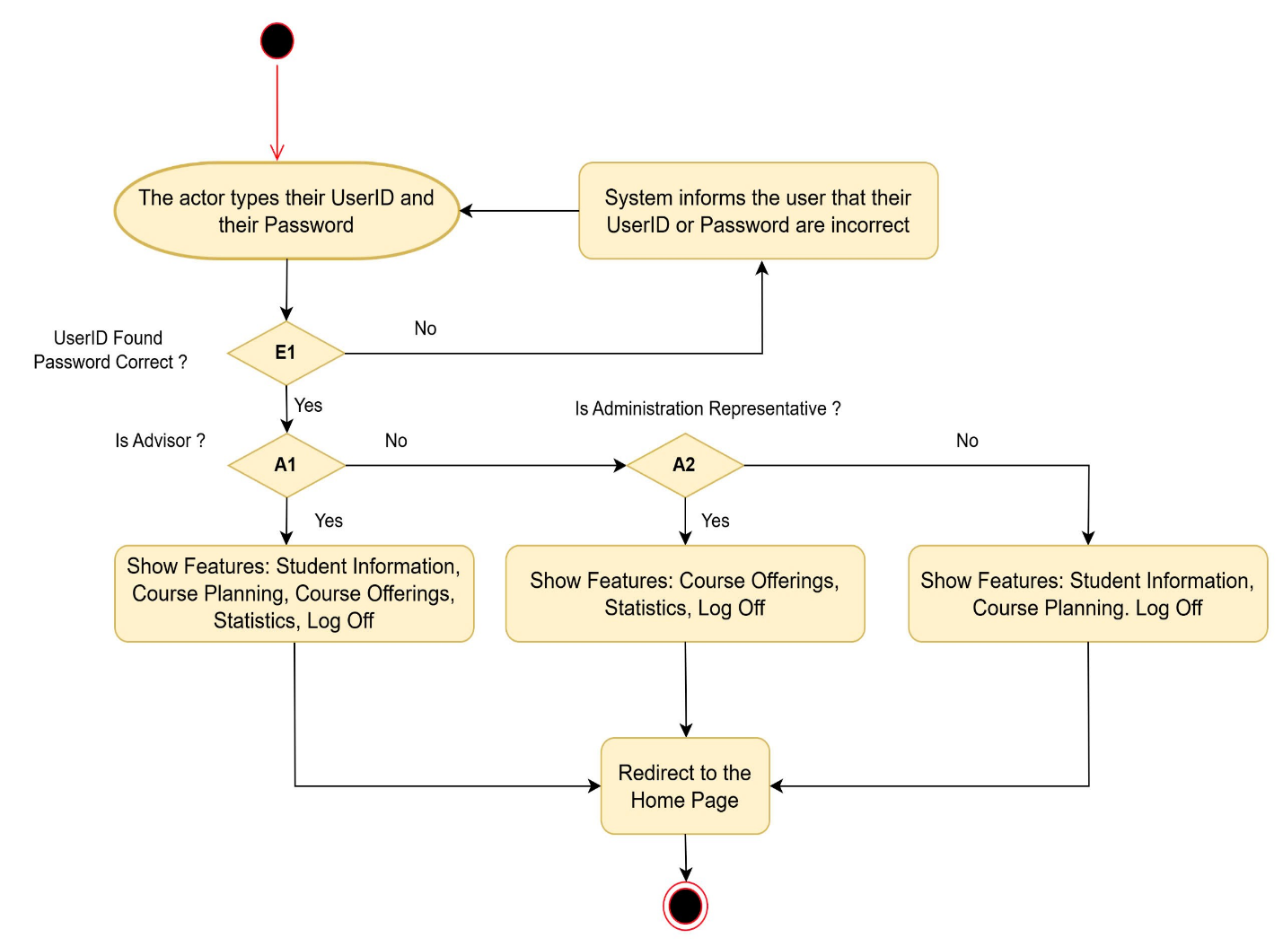
Sequence Diagram:
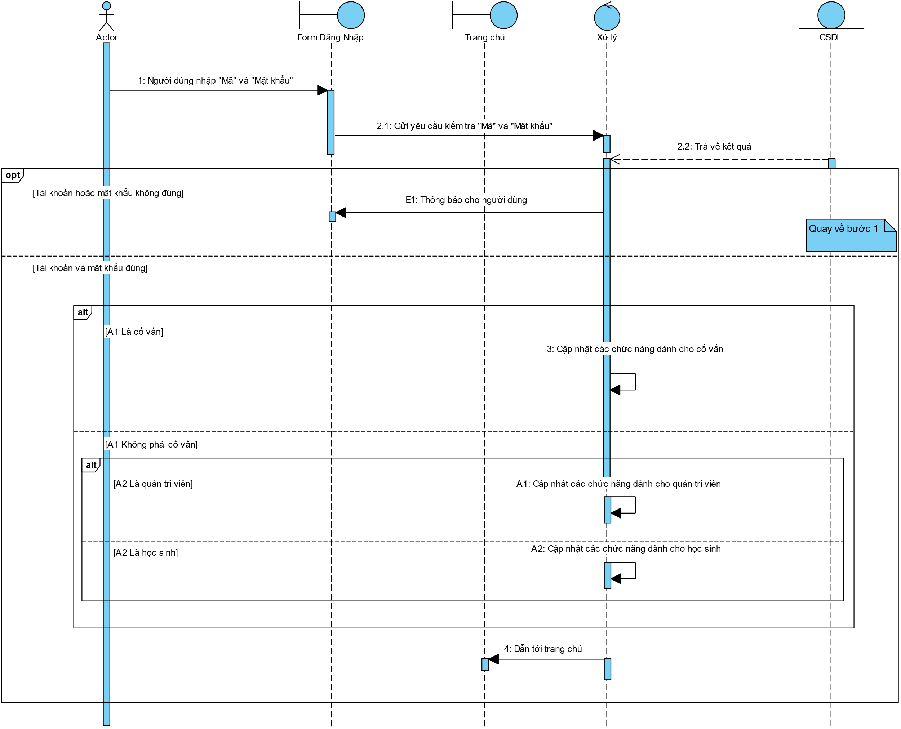
Interface:
