PRACTICE
Course: Test Case Design Methods – BlackBox
(Decision Table)
Time: 115 minutes
- o0o –
1 Requirement
Counter Sales is a system which is installed at XYZ company’s branches to sell products to retail & non-retail customers. The following are requirements of the system.
2 Graphical User Interface
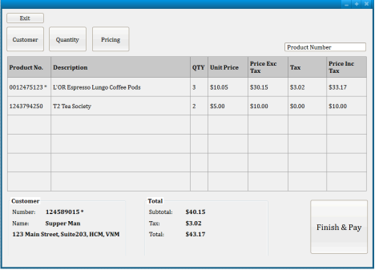
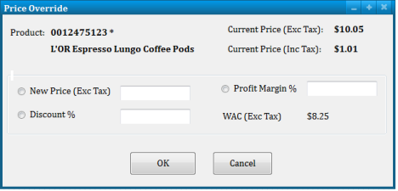
2.1 Controls
Control | Description
Product Number | Key-enter a product number.
Customer | Open Customer Search screen for the user to associate an existing customer.
Quantity | Open Product Quantity Change screen for the user to change ordered quantity.
Pricing | Open Product Price Change screen for the user to change product price.
Finish & Pay | Open Finalize Transaction screen for the user to make the payment.
Profit Margin% | When it loses focus, New Price will be recalculated.
Discount%  New Price | When it loses focus, New Price will be recalculated.  The user entered price or calculated price from Profit Margin & Discount.
OK  Cancel | The product will be updated with new price.  Return to parent screen without changes.

2.2 Business Requirements
Products can be sold to retail customer (customer is optional) or non-retail customers (customer is mandatory) within domestic or overseas.
At least one product is required to complete the selling.
Product Number field is masked to accept 10 digits only.
Product number may have leading zeros.
If the product number is not found, message ‘Item not found’ or similar message should be displayed to the user.
If a product is taxable, its Product Number will be marked with an asterisk. Similarly if a customer is taxable, Customer Number will be marked with an asterisk.
10% of tax will be charged to the customer if the selling occurs within domestic & both customer & product are taxable.
Price Exc Tax = Extension price excluding tax = QTY * Unit Price
Price Inc Tax = Extension price including tax = Price Exc Tax + Tax
Total
Subtotal: sum of Price Exc Tax of all product lines
Tax: sum of Tax of all product lines
Total = Subtotal + Tax
WAC = weight average cost = trung bình trọng số chi phí vốn.
Profit Margin = lợi nhuận biên sai = lợi nhuận thu được khi bán 1 đơn vị sản phẩm Profit Margin % = ( - 1) * 100
New Price = (+ 1) * WAC
New Price = Current Price – (Current Price * )
Acceptable range of currency is $0 - 999,999.99
It’s requested that any selling must make at least 30% profit.
2.3 Information Architecture
Product
Column Name | Data Type |  | COMMENTS
ProductId | Bigint | Not  null | Primary key (identity). This is system generated id for a product.

Active | Boolean | Not  null | Indicate if a product is active or not.  Valid values: Y/N  Default value: Y
Description | String | Not  null | Product name or product description
Taxable | Boolean | Not  null | Indicate if a product is taxable or not. Valid values: Y/N  Default value: N

Location
Column Name | Data Type |  | COMMENTS
LocationId | Bigint | Not  null | Primary key (identity). This is system generated id for a branch.
Active | Boolean | Not  null | Indicate if a branch is active or not.  Valid values: Y/N  Default value: Y
Name | String | Not  null | Branch name
Address Line 1  Address Line 2 | String  String | Not  Null  Null | Number & street  Apartment or suite or floor
City  State | String  String | Not  Null  Null/  Not  Null | Mandatory or optional depends on country
Country | String | Not  Null | Country code, in 3 letters  Default value: VNM (Vietnam)

ProductLocation
Column Name | Data Type |  | COMMENTS
ProductId | Bigint | Not  null | Foreign key
LocationID | Bigint | Not  Null | Foreign key  The combination of Product ID & Location ID must be unique.
Active  Unit Price | Boolean  Currency | Not  null  Not  Null | Indicate if a product is currently sold at the location.  Valid values: Y/N  Default value: Y  Default value: 0

WAC Currency Not Null
Default value: 0

Customer
Column Name | Data Type |  | COMMENTS
CustomerId | Bigint | Not  null | Primary key (identity). This is system generated id for a non-retail customer.
Active | Boolean | Not  null | Indicate if a customer is active or not.  Valid values: Y/N  Default value: Y

Name String Not null
Customer name in this format: FirstName<a space>LastName
Address Line 1 String Null Number & street Address Line 2 String Null Apartment or suite or floor
City | String | Null
State | String | Null
Country | String | Null | Country code, in 3 letters  (The validation of country code is handled from graphical user interface.)  See the following for valid country code list http://www.worldatlas.com/aatlas/ctycodes.htm

3 Exercises
Create test cases to test
Products can be sold to retail customer (customer is optional) or non-retail customers
(customer is mandatory) within domestic or overseas. 10% of tax will be charged to the customer if the selling occurs within domestic & both customer & product are taxable.
Bài làm

1. Tax Decision Table

Product Sale and Tax | TC 1 | TC 2 | TC 3 | TC 4 | TC 5 | TC 6 | TC 7 | TC 8
Conditions
Location = Domestic | N | N | N | N | Y | Y | Y | Y
Product Taxable? | N | N | Y | Y | N | N | Y | Y
Customer Taxable? | Y | N | Y | N | Y | N | Y | N
Actions
Apply 10% Tax |  |  |  |  |  |  | X

