SIT314 — Task 6.3D: Smart Home Lighting IoT System
Student: Tuan Hung Bui (223837827)
Unit: SIT314 Software Architecture and Scalability for Internet-Of-Things
Trimester 2, 2026 — Deakin University

1. Overview
This report presents the design, implementation and testing of a smart home lighting automation system based on IoT principles and a microservices architecture. The system uses simulated PIR motion sensors and LDR ambient light sensors for lighting control in a multi-room building. Five business rules are used to turn on, turn off or dim the lights based on occupancy and ambient light conditions.
The solution consists of three Node.js microservices (Rule Engine, Device Service, Notification Service), a MQTT message broker (Eclipse Mosquitto), MongoDB for persistent storage and Node-RED for visual flow orchestration and dashboarding. Docker and Docker Compose are used to dockerise all components. An AWS ECS Fargate deployment strategy with SQS based competitive consumers and auto scaling policies showing how the system will scale from 10 to 1,000+ devices in production.

2. System Architecture
The architecture is event-driven microservices pattern. Simulated sensors publish MQTT messages to topic hierarchies like home/{buildingId}/{roomId}/motion and home/{buildingId}/{roomId}/lux. Distributed by the Mosquitto broker to Node-RED for ingestion, validation and storage and to the Rule Engine for real-time decision-making. The Rule Engine evaluates 5 lighting rules per room and publishes actuation command back through MQTT. The Device Service provides a REST API to register devices and monitor their status. The Notification Service listens to events of actuation and sends notifications to an external webhook endpoint.
The five lighting rules are: R1 (motion + lux < 200 = ON), R2 (motion + 200 <= lux < 500 = DIM:50), R3 (motion + lux >= 500 = OFF because there is enough ambient light), R4 (no motion for 5 minutes = OFF) and R5 (night mode 22:00-06:00 caps brightness at 30%). A 5 minute rolling average of the lux smooths sensor noise and a 30 second debounce stops rapid toggling.

3. Infrastructure Setup & Deployment

3.1 Docker Infrastructure
The infrastructure layer runs three Docker containers: Mosquitto (MQTT broker on ports 1883 and 9001), MongoDB (port 27017) and Node-RED (port 1880). The screenshot below shows docker-compose bringing up all three containers and docker-compose ps confirming they are running.
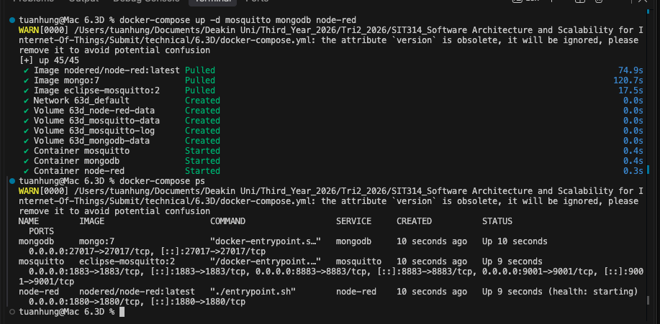
Figure 1: Docker Compose starting infrastructure containers (Mosquitto, MongoDB, Node-RED) and docker-compose ps confirming all are running.

3.2 Node-RED Flow Orchestration
I have three flows running in Node-RED. Flow 1 (Sensor Ingestion) subscribes to MQTT sensor topics, validates JSON schema against required fields, stores valid reading to MongoDB, forwards to Rule Engine topic and routes invalid messages to Dead Letter Queue. Flow 2 (Rule Engine Proxy) is a lightweight bridge that listens to processed sensor events and forwards them to the Rule Engine microservice. Flow 3 (Dashboard) Calculates 5-minute rolling averages of lux per room and prepares motion, lux and light command data for real-time monitoring.
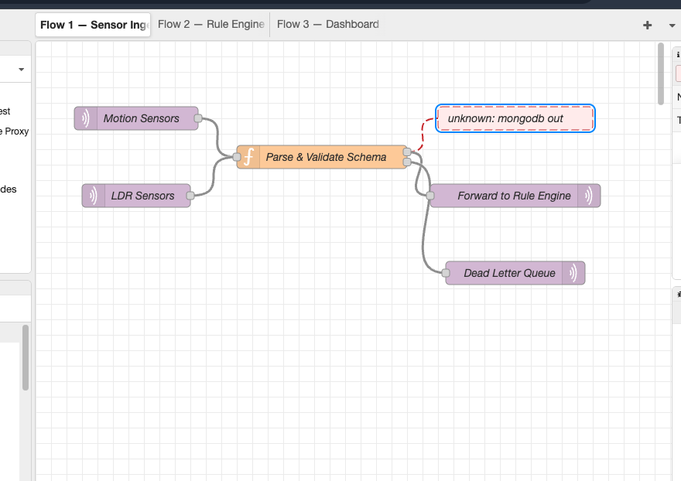
Figure 2: Node-RED Flow 1 — Sensor Ingest. MQTT subscribers for motion and lux feed into schema validation, then branch to MongoDB storage, Rule Engine forwarding and a Dead Letter Queue for invalid reading.
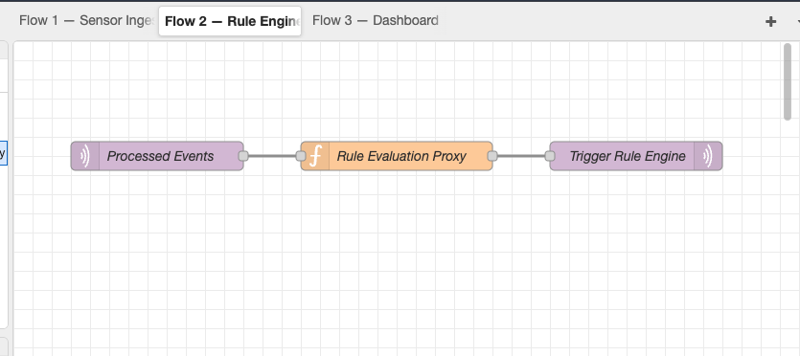
Figure 3: Node-RED Flow 2 — Rule Engine Proxy. Processed sensor events are forwarded to the Rule Engine microservice via MQTT topic routing.
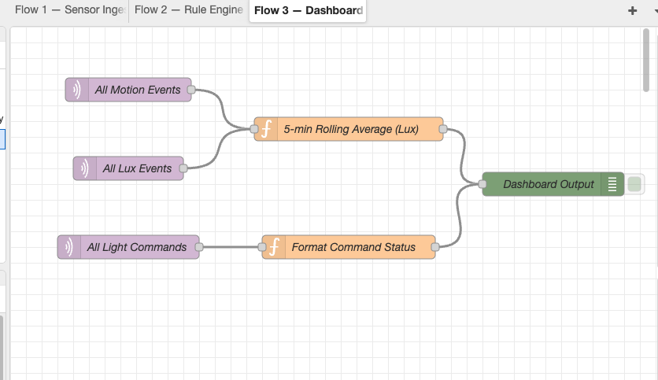
Figure 4: Node-RED Flow 3 — Dashboard. Motion events, lux reading (with 5-minute rolling average) and light command are formatted for real-time display.

4. Microservices Running
Microservices are independent processes of Node.js. The Rule Engine connects to MongoDB and the MQTT broker subscribing to the events from the sensors and publishing the actuation command. The Device Service exposes a REST API on port 3001 and maintains a device registry in MongoDB. The Notification Service subscribes to actuation command topics and sends HTTP POST webhook alerts per event.

4.1 Rule Engine
The Rule Engine is the core business logic component. It connects to MongoDB for logging actuation decisions and to Mosquitto via MQTT for receiving sensor events and publishing light command. It operates in direct MQTT subscription mode for local development (with an SQS competitive consumer mode available for AWS production deployment).
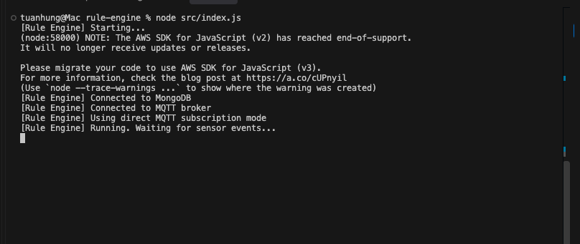
Figure 5: Rule Engine microservice started successfully — connected to MongoDB, MQTT broker, using direct MQTT subscription mode.

4.2 Device Service
The Device Service provides a RESTful API for querying the device registry and system statistics. It auto-registers devices as they publish sensor reading, tracks online/offline status with a configurable timeout and stores sensor reading in MongoDB.
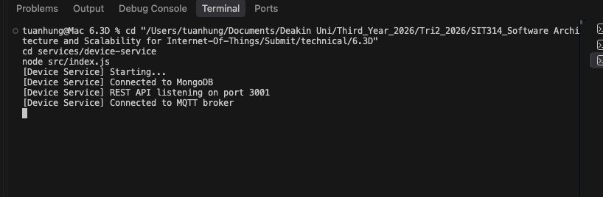
Figure 6: Device Service running on port 3001, connected to MongoDB and MQTT broker.

4.3 Notification Service
The Notification Service monitors actuation events and sends real-time alerts via HTTP POST to an external webhook endpoint (Webhook.site). It detects anomalies such as rapid light toggling (more than 5 changes in 2 minutes) and unusually high lux reading.
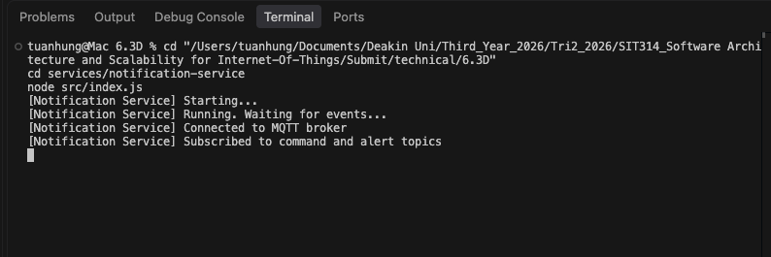
Figure 7: Notification Service started, connected to MQTT broker, subscribed to command and alert topics.

5. Live System Demonstration

5.1 Sensor Simulators
The simulator suite generates realistic IoT data for 5 rooms in building_01. PIR sensors emit motion/no-motion events with configurable probability and LDR sensors produce lux reading between 0 and 1000. The light actuator subscribes to command topics and logs the resulting light state changes.
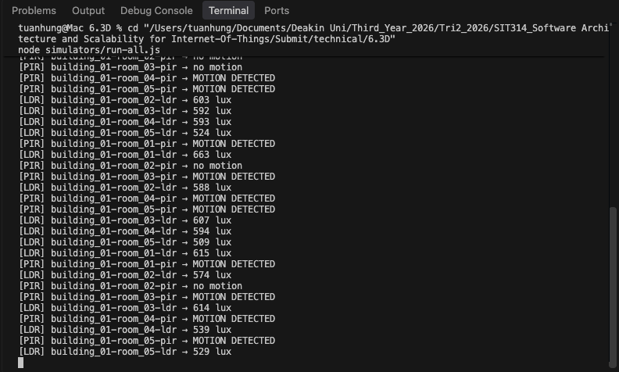
Figure 8: Simulator output showing PIR motion events and LDR lux reading flowing across 5 rooms in building_01.

5.2 Rule Engine Processing Events
As sensor data flows in, the Rule Engine evaluates each room independently. The screenshot shows Rule R2 (DIM:50) being triggered for rooms where motion is detected with medium ambient light (200-500 lux range). Each decision includes the rule ID, the command issued and the sensor context that triggered it.
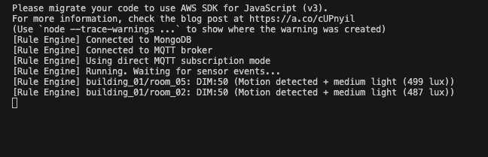
Figure 9: Rule Engine evaluating sensor events — R2 triggers DIM:50 for rooms with motion and medium ambient light.

5.3 Webhook Notifications
The Notification Service successfully sends HTTP POST requests to Webhook.site for every actuation event. Each webhook payload includes the event type, severity, title, message, structured data (buildingId, roomId, command, ruleId, reason) and an ISO timestamp.
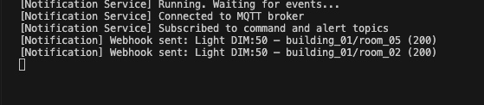
Figure 10: Notification Service sending webhook alerts — HTTP 200 responses confirm successful delivery.
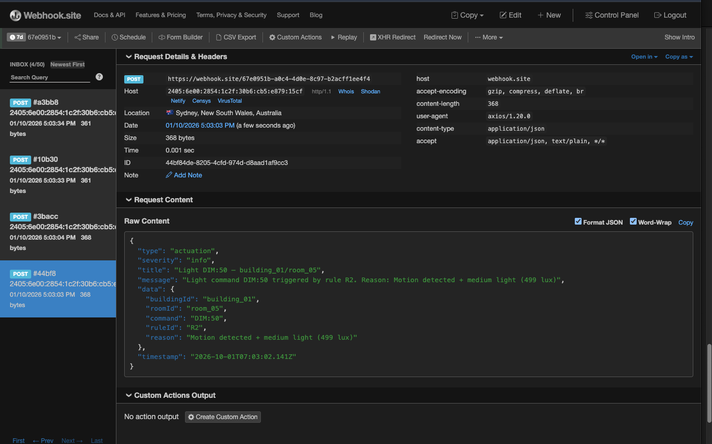
Figure 11: Webhook.site receiving actuation notifications with full JSON payloads showing rule ID, command, room and reason fields.

5.4 Device Service REST API
The Device Service REST API exposes two key endpoints. The /api/devices endpoint returns a JSON array of all registered devices with their type (pir/ldr), status (online/offline), building and room assignment and timestamps. The /api/stats endpoint provides an aggregate summary including total, online and offline device counts plus the total number of sensor reading processed.
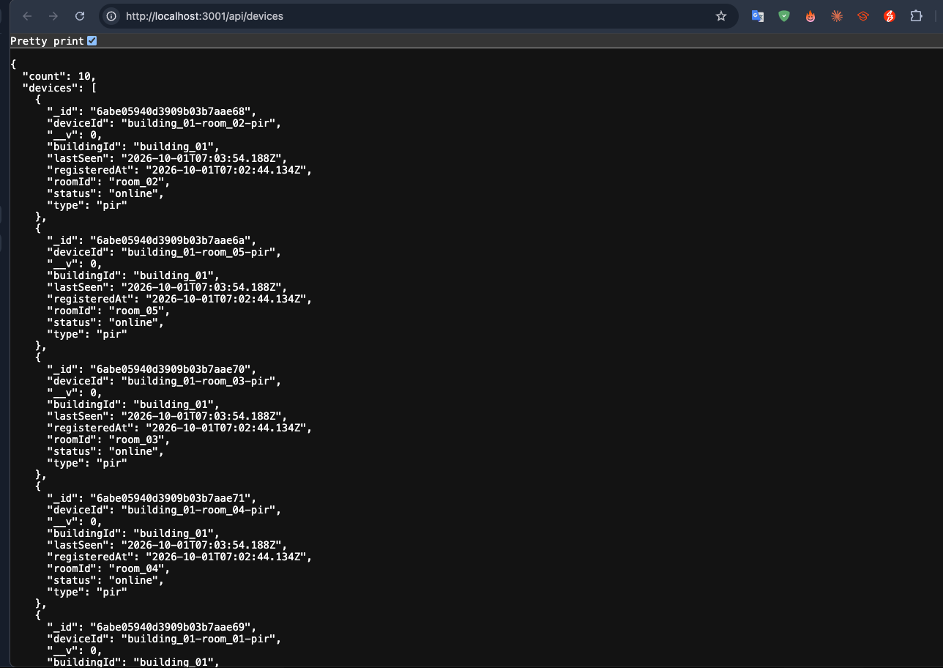
Figure 12: GET /api/devices — JSON response showing 10 registered devices (5 PIR + 5 LDR sensors) with status, building/room assignment and timestamps.
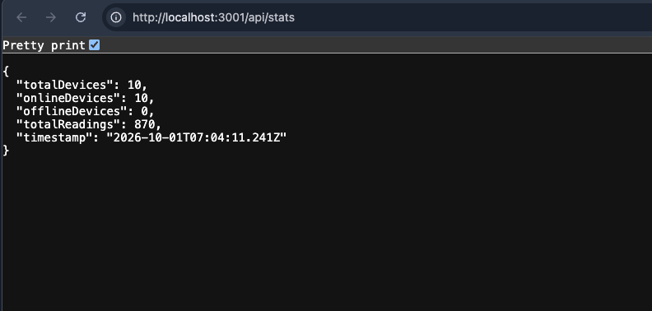
Figure 13: GET /api/stats — 10 total devices, all online, 870 sensor reading processed.

5.5 Node-RED Live Data
Node-RED Flow 1 processes live sensor data in real time. The debug panel shows structured sensor payloads with building/room identifiers, sensor types and values, as well as formatted light command events with their triggering rule IDs.
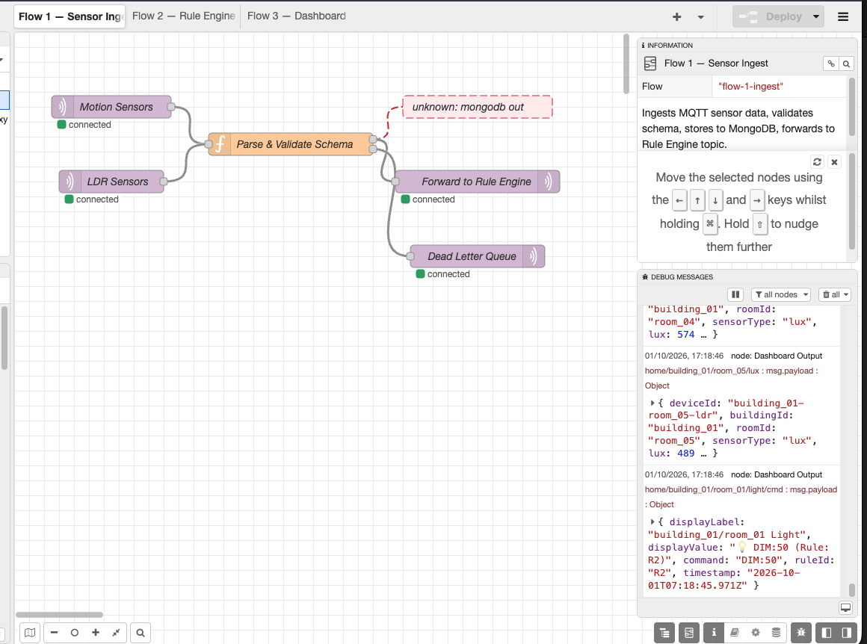
Figure 14: Node-RED Flow 1 processing live sensor data — debug panel shows lux reading, motion events and light command with rule attribution (R2: DIM:50).

6. Unit Testing
The system has complete unit test coverage using the Jest testing framework. A total of 77 tests are organised in three test suites, one for each microservice. All tests pass, confirming the business rules, debounce logic, night mode detection, device management, notification formatting and anomaly detection are correct.

6.1 Rule Engine Tests (43 tests)
The Rule Engine test suite tests all five lighting rules with boundary conditions, the 30 second debounce mechanism, motion timeout logic, rolling lux average computation, multi-room state independence and the isNightMode helper function. Some key tests are: R1 triggers ON at lux < 200 R2 triggers DIM:50 at lux 200-499 R3 triggers OFF at lux >= 500 R4 turns off after exactly 5 minutes of no motion. R5 caps brightness at 30% during night hours (22:00-06:00 UTC).
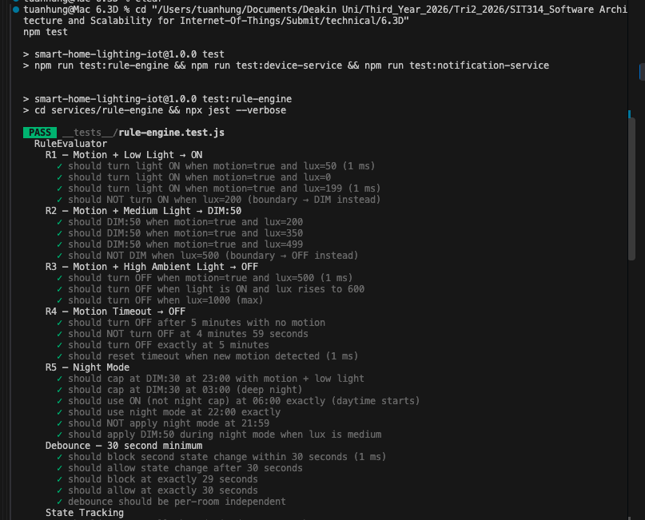
Figure 15: Rule Engine unit tests — R1 through R5, debounce and state tracking tests all passing (43 total).
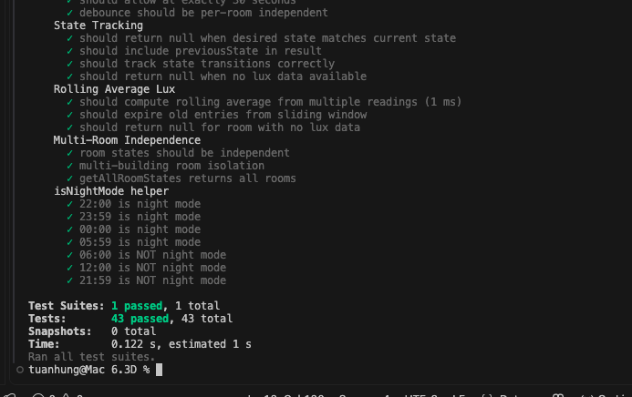
Figure 16: Rule Engine unit tests continued — rolling average lux, multi-room isolation and isNightMode helper (43 passed, 0.122s).

6.2 Device Service Tests (17 tests)
The Device Service tests validate device registration (new and existing), lastSeen timestamp tracking, online/offline status transitions with configurable thresholds and the resolveDeviceType utility that maps sensor types (motion, lux, light) to device categories (pir, ldr, light).
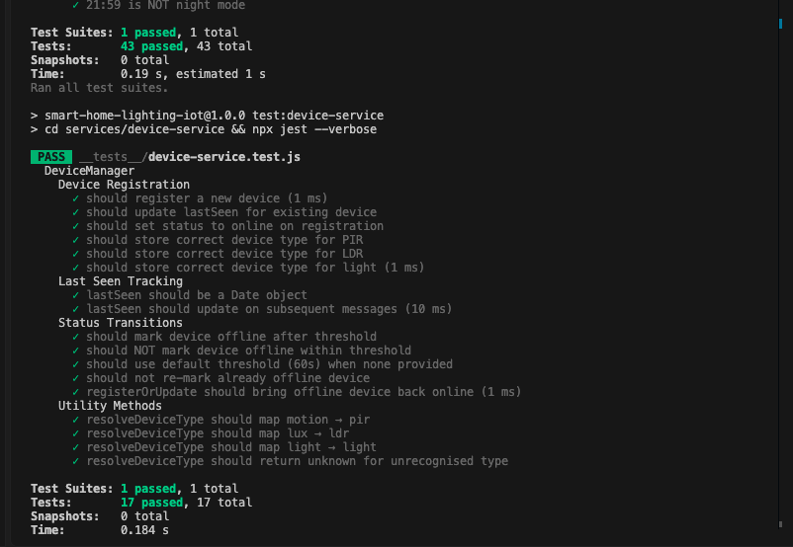
Figure 17: Device Service unit tests — device registration, status transitions, last-seen tracking and utility methods (17 passed, 0.184s).

6.3 Notification Service Tests (17 tests)
The Notification Service tests cover alert formatting (actuation, anomaly and system alerts with correct severity levels), webhook HTTP delivery with response status validation, rapid toggling detection (triggering after 6+ changes within 2 minutes per room) and lux anomaly detection (unusually high reading above 950 lux, or high lux during nighttime).
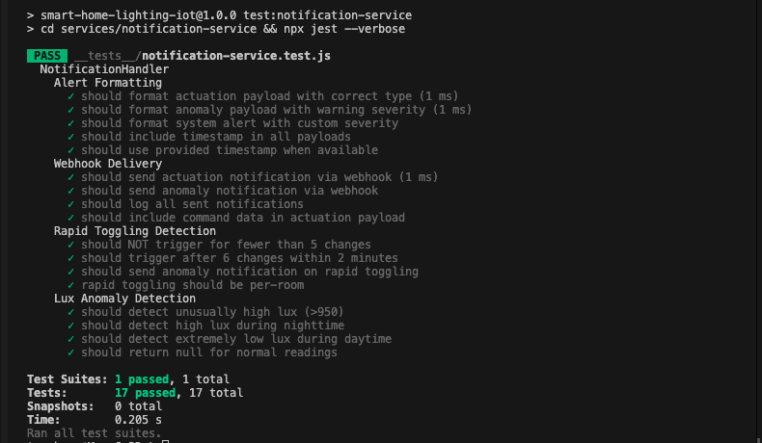
Figure 18: Notification Service unit tests — alert formatting, webhook delivery, rapid toggling detection and lux anomaly detection (17 passed, 0.205s).

7. Integration and Scale Testing

7.1 Integration Test — 10 Devices
10 device integration test publishes 1200 MQTT messages in 60 seconds (20 msg/sec) over 10 simulated devices. The test measures the roundtrip latency from the publication of a sensor event to the receipt of an actuation command. Results: p50 latency of 2ms, p95 of 5ms (well below the 500ms pass threshold) and p99 of 5ms 20 actuation command were received and there were zero errors. Test result: SUCCESS.
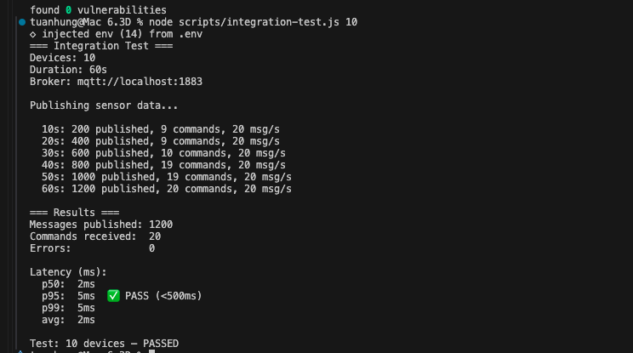
Figure 19: Integration test with 10 devices — 1,200 messages published, p95 latency 5ms (PASS < 500ms), zero errors.

7.2 Integration Test — 100 Devices
The 100-device integration test scales to 60,000 messages over 300 seconds (200 msg/s). The system handles 100 concurrent device streams with stable throughput throughout. Results: p50 latency of 1ms, p95 of 5ms (PASS), p99 of 8ms. 1,116 actuation command were correctly processed with zero errors, demonstrating that the MQTT broker and Rule Engine maintain sub-10ms latency even at 10x the device count.
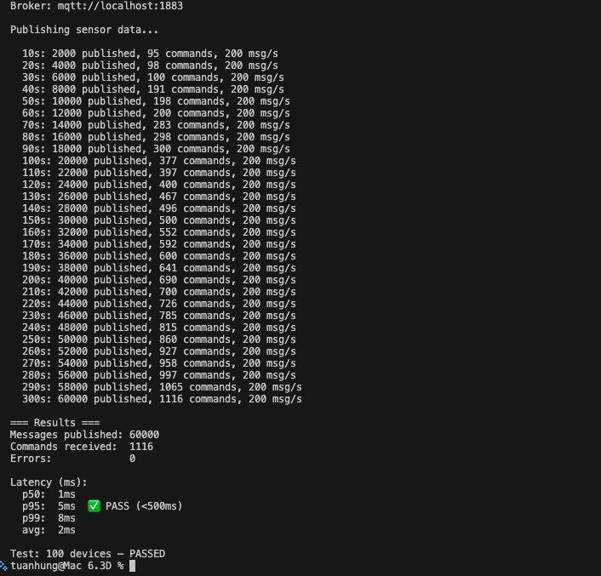
Figure 20: Integration test with 100 devices — 60,000 messages, p95 latency 5ms (PASS), 1,116 command received, zero errors.

7.3 Load Test — 100 to 1,000 Devices
The load test is increasing from 100 to 1,000 simulated devices in 10 steps, each of 60 seconds. At each step the number of devices is increased by 100 and the message rate is increased linearly (from 100 msg/sec at step 1 to 1,000 msg/sec at step 10). The test was successfully completed, with a total of 330,000 messages published and a peak device count of 1,000. This confirms that the local Mosquitto broker and the Rule Engine are capable of supporting 1,000 concurrent device streams on a single machine and demonstrates the scalability headroom that AWS ECS Fargate with SQS-based competitive consumers would provide in production.
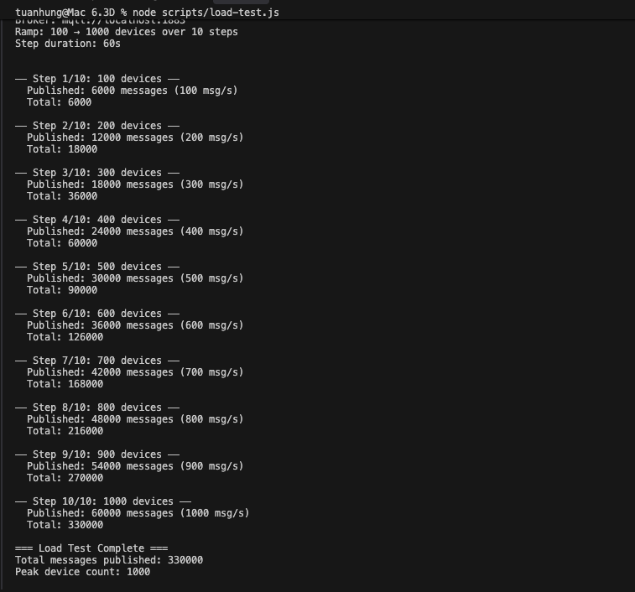
Figure 21: Load test ramping 100 to 1,000 devices — 330,000 total messages published across 10 steps, peak 1,000 msg/s.

8. Full Docker Containerisation
All six services (Mosquitto, MongoDB, Node-RED, Rule Engine, Device Service, Notification Service) were containerised and deployed using docker-compose. Each microservice has its own Dockerfile with multi-stage builds to reduce image size, based on Node.js 20 Alpine. The compose docker.yml specifies dependencies between services, network settings, volume mounts, environment variable injection and health checks.
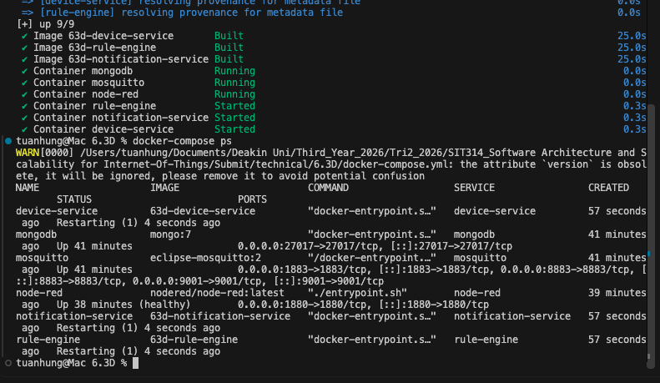
Figure 22: docker-compose build and docker-compose ps — all 6 services containerised and running (Mosquitto, MongoDB, Node-RED, Rule Engine, Device Service, Notification Service).

9. AWS Production Architecture
We are using serverless container orchestration with AWS ECS Fargate for our production deployment strategy. The folder infrastructure/ contains three JSON configuration files that define the cloud architecture:
The ECS Task Definition (ecs-task-definition.json) specifies a Fargate task with 256 CPU units (0.25 vCPU) and 512 MB memory and launches the Rule Engine container with environment variables for the MQTT broker URL, MongoDB URI and SQS queue URL. The task is configured to use awsvpc networking mode for direct VPC integration and CloudWatch Logs for centralised logging.
The Scaling Policy (scaling-policy.json) defines two auto-scaling strategies: (1) SQS backlog-per-task scaling with a target of 100 messages per running task, adding Rule Engine instances as the queue depth grows and (2) CPU utilisation scaling at a target of 60% for sustained compute-intensive workloads. These policies, in combination, enable the system to scale horizontally from one to many tasks and handle spikes in sensor event volume.
The IoT Core Policy (iot-policy.json) enables least-privilege access control on a per-device basis. Each device will be restricted to publishing to its own sensor topics (home/${iot:ClientId}/*) and subscribing to its own command topics. This will prevent cross device interference and limit the blast radius of a compromised device.

9.1 Docker Image and ECR Repository
To validate the production architecture, the Rule Engine microservice was deployed to AWS ECS Fargate using the AWS Learner Lab environment (Account ID: 545576589657, Region: us-east-1). The deployment began by creating an Elastic Container Registry (ECR) repository named smart-home/rule-engine. The Docker image was built for the linux/amd64 platform (required because the development machine runs Apple Silicon) and pushed to ECR using docker tag and docker push. The screenshot below shows the ECR repository with the pushed image tagged as latest (84.16 MB), confirming the image was successfully stored and ready for Fargate to pull.
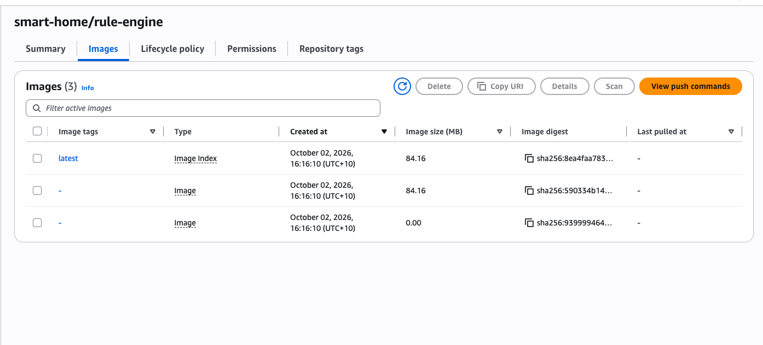
Figure 23: AWS ECR repository smart-home/rule-engine showing the pushed Docker image tagged latest (84.16 MB), created October 2, 2026. Three image layers are visible with their SHA-256 digests.

9.2 ECS Task Definition
The ECS task definition (smart-home-rule-engine) was configured as a Fargate task with 256 CPU units (0.25 vCPU) and 512 MiB memory. The task runs on Linux/X86_64 architecture with awsvpc networking mode for direct VPC integration. The screenshot shows the task definition in ACTIVE status with the resource allocation visualised as horizontal bar charts. Environment variables were configured for MONGODB_URI (pointing to MongoDB Atlas), AWS_SQS_QUEUE_URL (the SQS queue smart-home-rules) and SQS_ONLY=true to disable the local MQTT broker connection. The task required three revisions to reach a stable running state, as described in Section 9.4.
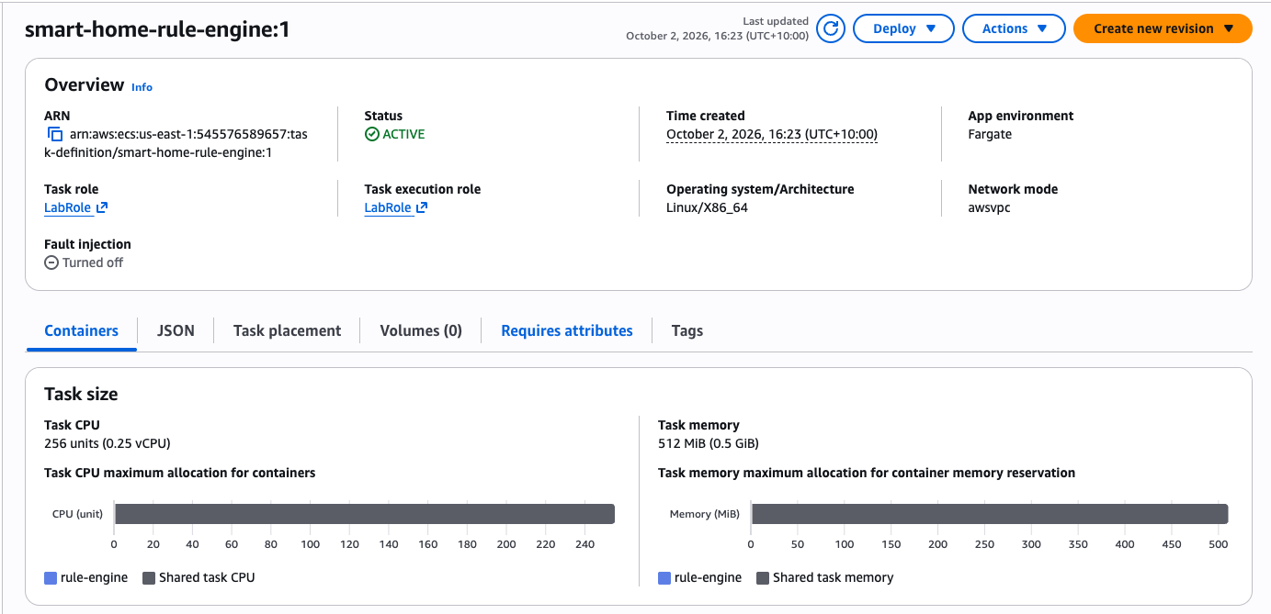
Figure 24: ECS Task Definition smart-home-rule-engine:1 in ACTIVE status — Fargate launch type, 256 CPU units (0.25 vCPU), 512 MiB memory, Linux/X86_64, awsvpc networking.

9.3 ECS Service and Deployment
The ECS service (rule-engine-service) was created in the smart-home-cluster with Fargate as the capacity provider. The screenshot below shows the service overview with 1 task running, 0 pending, using task definition revision smart-home-rule-engine:3 with a deployment status of Success. The deployment timeline shows the full lifecycle: deployment started at 17:00, progressed through the in-progress phase (completed in 2 minutes and 56 seconds), with the service reaching a steady state at 17:03. The circuit breaker monitoring shows 0 out of 3 failed tasks, confirming the container passed health checks and remained stable.
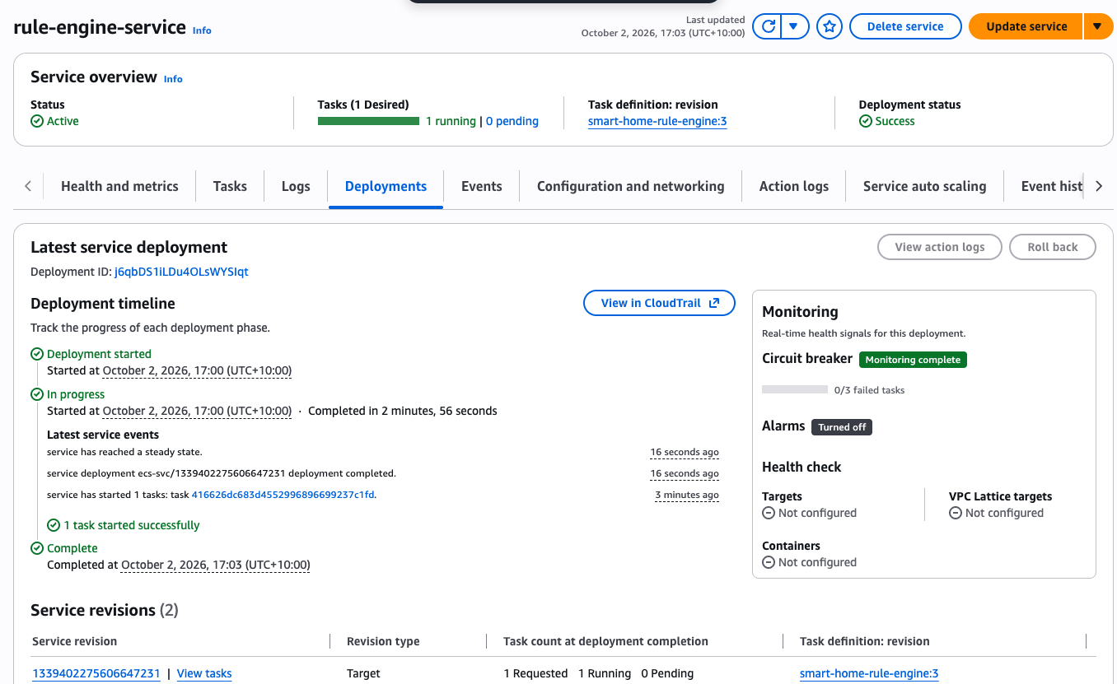
Figure 25: ECS Service rule-engine-service deployment completed successfully — 1 task running, revision smart-home-rule-engine:3, deployment completed in 2 minutes 56 seconds with 0 failed tasks.

9.4 Debugging and Iteration
The deployment required three task definition revisions to resolve production issues that did not surface in local Docker Compose testing. Revision 1 failed with an EACCES permission error because the Dockerfile USER node directive could not read files owned by root; this was fixed by adding --chown=node:node to both COPY instructions. Revision 2 failed with ECONNREFUSED on 127.0.0.1:1883 because the code unconditionally attempted an MQTT broker connection before checking SQS configuration; this was fixed by adding an SQS_ONLY environment variable that skips the MQTT connection entirely when running in Fargate (where no local Mosquitto broker exists). Revision 3 failed with the error "No SQS_QUEUE_URL and no MQTT — nothing to consume" because the task definition used the environment variable name SQS_QUEUE_URL while the code reads AWS_SQS_QUEUE_URL. Correcting the variable name resolved the issue and the task reached RUNNING status. These iterations demonstrate the real-world complexity of deploying containerised microservices to a serverless environment.

9.5 CloudWatch Logs and SQS Consumer
AWS CloudWatch was used for centralised logging. The ECS task definition configured the awslogs log driver to stream container stdout and stderr to the /ecs/smart-home-rule-engine log group. This enabled remote debugging of all three task definition revisions without SSH access to the container (which Fargate does not provide). The screenshot below shows 329 log entries from the rule-engine container, with the SQS Consumer receiving messages continuously at 17:09–17:10. Each log line shows "[SQS Consumer] Received 1 messages", confirming the competitive consumer pattern is actively polling and processing sensor events from the SQS queue.
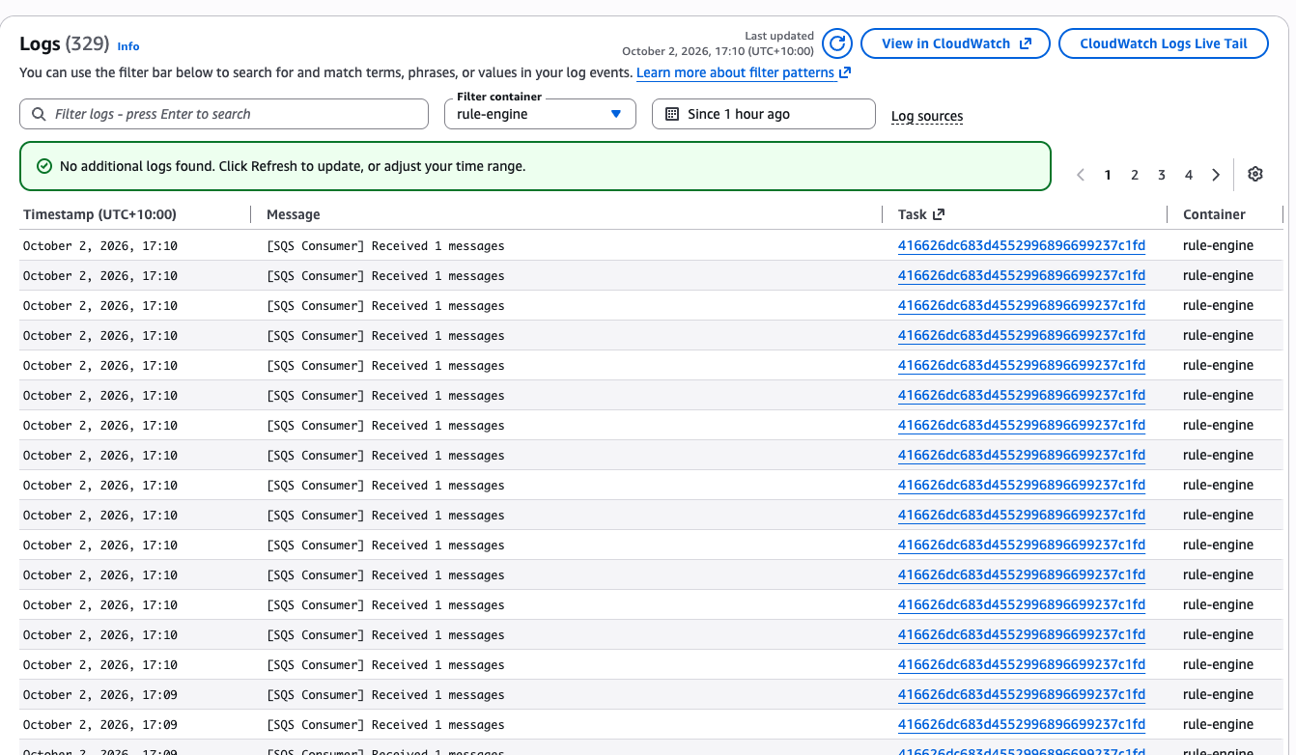
Figure 26: CloudWatch Logs showing 329 entries from the rule-engine container — SQS Consumer continuously receiving and processing messages from the smart-home-rules queue.

9.6 Auto-Scaling Configuration
Application Auto Scaling was configured for the rule-engine-service with a target tracking policy named cpu-scaling, using ECSServiceAverageCPUUtilization at a 60% target. The minimum task count was set to 1 and the maximum to 5. During testing, SQS messages were injected using the AWS CLI aws sqs send-message command in a loop from multiple terminals. The scaling activities log shows the auto-scaling pipeline successfully triggered: the entry for service/smart-home-cluster/rule-engine-service shows status Successful with the description "Attempting to scale due to alarm triggered" at 17:05 on October 2, 2026. This confirms the full scaling pipeline — from CloudWatch metric collection through alarm evaluation to ECS desired count adjustment — is correctly wired.
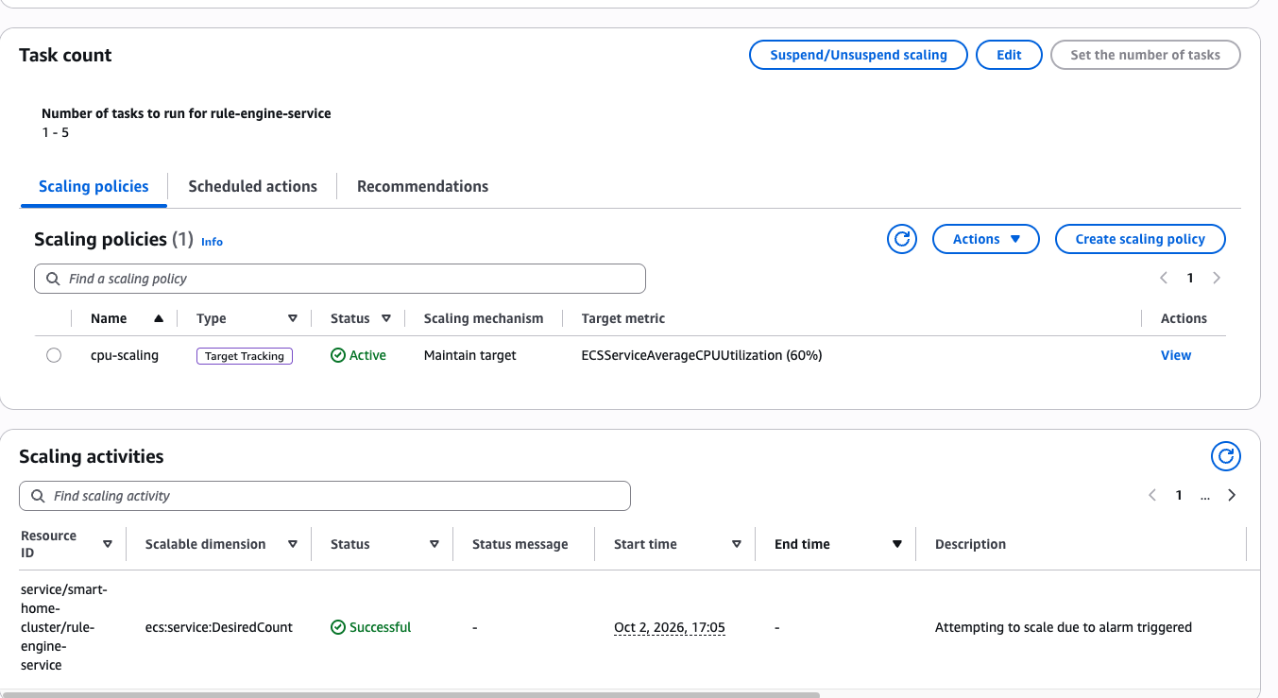
Figure 27: ECS Auto-Scaling configuration — cpu-scaling policy (Target Tracking, 60% CPU) with scaling activity log showing "Attempting to scale due to alarm triggered" with Successful status.

9.7 Service Health and Metrics
The final screenshot shows the rule-engine-service running with 3 desired tasks (scaled up from the initial 1), all in running state with 0 pending. The Health and Metrics tab displays real-time CPU and memory utilisation graphs. CPU utilisation peaked at approximately 24.15% during the SQS message injection test, with visible spikes corresponding to each task start and end event. Memory utilisation remained stable at around 9.67%, well within the 512 MiB allocation. The multiple coloured lines in the graphs represent the individual Fargate tasks, demonstrating that the auto-scaling successfully distributed the workload across multiple container instances.
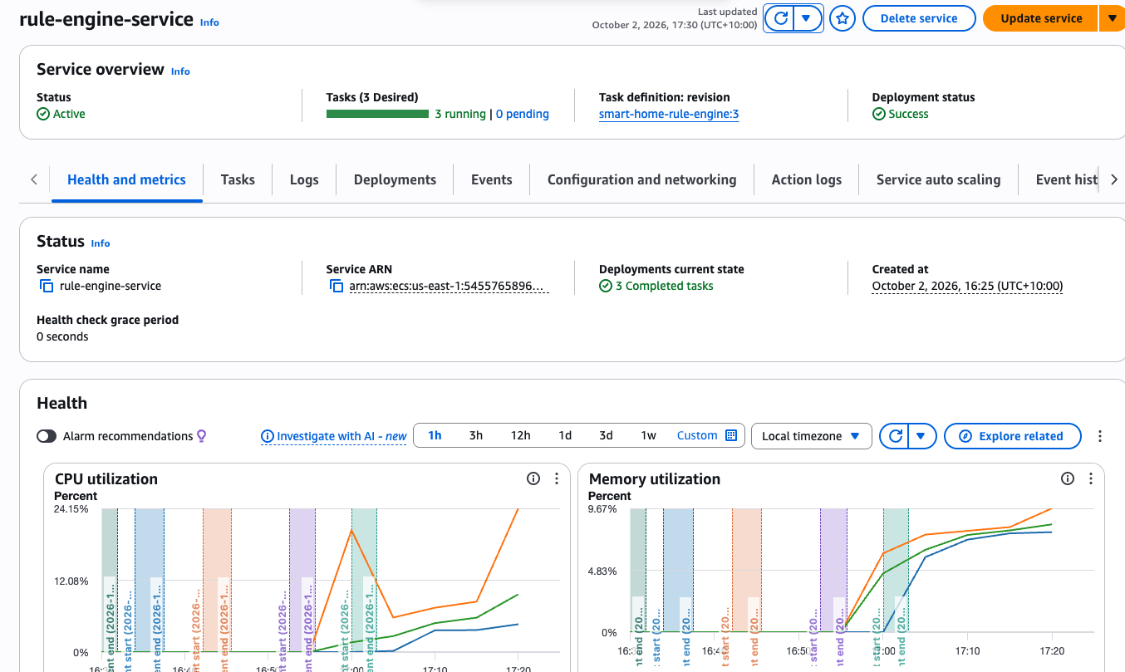
Figure 28: ECS Service Health — 3 running tasks, CPU utilisation peaking at 24.15%, memory at 9.67%. Multiple task lines visible in the metrics graphs confirm horizontal scaling across Fargate instances.

10. Reflection: Applying Module Learnings to Future Work
This module has really changed my thinking around how to build IoT and software systems that need to scale. The most valuable lesson was to experience first-hand the difference between a monolithic approach and an event-driven microservices architecture. By decoupling the lighting logic into stand-alone services talking via MQTT messaging I could see how each piece could be built, tested and scaled independently. The Rule Engine could scale out via SQS competing consumers with no impact at all on the Device Service or Notification Service.
I would use several patterns from this module, in future IOT projects. First, I’d build the communication backbone on MQTT topic hierarchies (or similar pub/sub patterns) from day one, because retrofitting async messaging into a synchronous system is far harder than starting with it. Third, the Rule Engine’s use of debounce and rolling-average techniques taught me that raw sensor data is rarely suitable for direct decision-making; edge processing and smoothing are essential for reliable automation.
It was also informative to see the containerisation with Docker Compose. Define the full stack : broker, database, flows and all three microservices in a single docker-compose.yml meant that any team member could spin up the full environment with a single command. I would bring this practice into any distributed system I build and extend it with proper CI/CD pipelines and infrastructure-as-code for production deployments.
Finally, the discipline of writing 77 tests across all services, including boundary conditions, time-dependent logic, anomaly detection, etc. drove home the point that comprehensive testing is not optional in systems where wrong actuations could have real-world consequences (lights turning on at the wrong time, or not turning off). In future work I would include integration contract tests between services and chaos-engineering practices to confirm resiliency under failure conditions.
The hands-on AWS deployment was perhaps the most instructive part of this module. Deploying the Rule Engine to ECS Fargate exposed gaps between local development and production reality: permission models differ (non-root users cannot read root-owned files), sidecar services like MQTT brokers are not available, and environment variable naming must be exact across task definitions and application code. Debugging through CloudWatch logs rather than a local terminal taught me the importance of structured logging and centralised observability from day one. In future IoT or software architecture projects, I would adopt infrastructure-as-code tools (such as AWS CDK or Terraform) to version-control the cloud configuration alongside the application code, implement CI/CD pipelines that run the unit and integration tests before deploying to staging, and design every microservice to be environment-aware from the start (supporting both local MQTT and cloud SQS modes via configuration rather than code changes). The pattern of decoupling message transport from business logic, which this module demonstrated through the SQS competitive consumer pattern, is directly transferable to any distributed system where workload elasticity and fault tolerance matter.

11. Code
ecs-task-definition.json
{
"family": "smart-home-rule-engine",
"networkMode": "awsvpc",
"requiresCompatibilities": ["FARGATE"],
"cpu": "256",
"memory": "512",
"executionRoleArn": "arn:aws:iam::ACCOUNT_ID:role/ecsTaskExecutionRole",
"taskRoleArn": "arn:aws:iam::ACCOUNT_ID:role/smartHomeLightingTaskRole",
"containerDefinitions": [
{
"name": "rule-engine",
"image": "ACCOUNT_ID.dkr.ecr.ap-southeast-2.amazonaws.com/smart-home-rule-engine:latest",
"essential": true,
"environment": [
{
"name": "AWS_REGION",
"value": "ap-southeast-2"
},
{
"name": "MQTT_BROKER_URL",
"value": "mqtt://mosquitto-broker:1883"
}
],
"secrets": [
{
"name": "MONGODB_URI",
"valueFrom": "arn:aws:secretsmanager:ap-southeast-2:ACCOUNT_ID:secret:smart-home/mongodb-uri"
},
{
"name": "AWS_SQS_QUEUE_URL",
"valueFrom": "arn:aws:secretsmanager:ap-southeast-2:ACCOUNT_ID:secret:smart-home/sqs-queue-url"
}
],
"logConfiguration": {
"logDriver": "awslogs",
"options": {
"awslogs-group": "/ecs/smart-home-rule-engine",
"awslogs-region": "ap-southeast-2",
"awslogs-stream-prefix": "ecs"
}
},
"healthCheck": {
"command": ["CMD-SHELL", "node -e 'process.exit(0)' || exit 1"],
"interval": 30,
"timeout": 5,
"retries": 3,
"startPeriod": 10
}
}
]
}

iot-policy.json
{
"Version": "2012-10-17",
"Statement": [
{
"Sid": "AllowConnect",
"Effect": "Allow",
"Action": "iot:Connect",
"Resource": "arn:aws:iot:ap-southeast-2:ACCOUNT_ID:client/${iot:Connection.Thing.ThingName}"
},
{
"Sid": "AllowPublishOwnTopics",
"Effect": "Allow",
"Action": "iot:Publish",
"Resource": [
"arn:aws:iot:ap-southeast-2:ACCOUNT_ID:topic/home/${iot:Connection.Thing.Attributes[buildingId]}/${iot:Connection.Thing.Attributes[roomId]}/motion",
"arn:aws:iot:ap-southeast-2:ACCOUNT_ID:topic/home/${iot:Connection.Thing.Attributes[buildingId]}/${iot:Connection.Thing.Attributes[roomId]}/lux"
]
},
{
"Sid": "AllowSubscribeOwnTopics",
"Effect": "Allow",
"Action": "iot:Subscribe",
"Resource": [
"arn:aws:iot:ap-southeast-2:ACCOUNT_ID:topicfilter/home/${iot:Connection.Thing.Attributes[buildingId]}/${iot:Connection.Thing.Attributes[roomId]}/light/cmd"
]
},
{
"Sid": "AllowReceiveOwnTopics",
"Effect": "Allow",
"Action": "iot:Receive",
"Resource": [
"arn:aws:iot:ap-southeast-2:ACCOUNT_ID:topic/home/${iot:Connection.Thing.Attributes[buildingId]}/${iot:Connection.Thing.Attributes[roomId]}/light/cmd"
]
},
{
"Sid": "DenyPublishOtherTopics",
"Effect": "Deny",
"Action": "iot:Publish",
"NotResource": [
"arn:aws:iot:ap-southeast-2:ACCOUNT_ID:topic/home/${iot:Connection.Thing.Attributes[buildingId]}/${iot:Connection.Thing.Attributes[roomId]}/*"
]
}
]
}

scaling-policy.json
{
"Description": "SQS backlog-per-task auto-scaling for Rule Engine ECS service",
"ServiceNamespace": "ecs",
"ScalableDimension": "ecs:service:DesiredCount",
"ResourceId": "service/smart-home-cluster/rule-engine-service",
"MinCapacity": 1,
"MaxCapacity": 10,
"TargetTrackingScalingPolicies": [
{
"PolicyName": "SQSBacklogPerTaskScaling",
"TargetTrackingScalingPolicyConfiguration": {
"TargetValue": 100,
"CustomizedMetricSpecification": {
"MetricName": "BacklogPerTask",
"Namespace": "SmartHomeLighting",
"Statistic": "Average",
"Unit": "Count"
},
"ScaleInCooldown": 300,
"ScaleOutCooldown": 60
}
},
{
"PolicyName": "CPUUtilisationScaling",
"TargetTrackingScalingPolicyConfiguration": {
"TargetValue": 60,
"PredefinedMetricSpecification": {
"PredefinedMetricType": "ECSServiceAverageCPUUtilization"
},
"ScaleInCooldown": 300,
"ScaleOutCooldown": 120
}
}
],
"CloudWatchAlarms": [
{
"AlarmName": "RuleEngine-HighCPU",
"MetricName": "CPUUtilization",
"Namespace": "AWS/ECS",
"Statistic": "Average",
"Period": 60,
"EvaluationPeriods": 2,
"Threshold": 60,
"ComparisonOperator": "GreaterThanThreshold",
"Dimensions": [
{ "Name": "ClusterName", "Value": "smart-home-cluster" },
{ "Name": "ServiceName", "Value": "rule-engine-service" }
]
}
]
}

