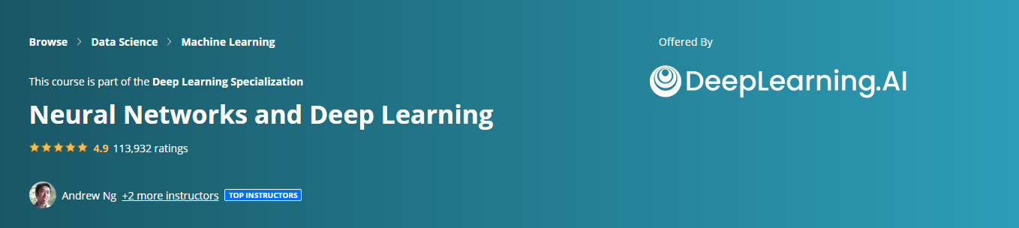

|  |  |  |  |  |
| --- | --- | --- | --- | --- |
| Module | Videos | Notes | Homeworks | Solutions |
| Week1 | [Welcome](https://youtu.be/CS4cs9xVecg)  [Introduction to Deep Learning](https://youtu.be/n1l-9lIMW7E) |  |  |  |
| Week 2 |  |  |  |  |
| Week 3 |  |  |  |  |
| Week 4 |  |  |  |  |