Tuan Pham

Allow the user to enter a starting city and an ending city - determine the shortest path.

|  |  |  |  |  |  |  |  |  |  |  |
| --- | --- | --- | --- | --- | --- | --- | --- | --- | --- | --- |
| City | Detroit | St. Louis | Chicago | Los Angeles | New York | Washington DC | Miami | Denver | Seattle | Dallas |
| Detroit |  | 470 | 250 |  |  |  | 1185 |  |  |  |
| St. Louis |  |  |  |  |  |  |  | 800 |  | 555 |
| Chicago | 250 |  |  |  | 720 | 600 | 1185 |  |  |  |
| Los Angeles |  |  |  |  |  |  |  | 810 | 925 | 1250 |
| New York |  |  | 720 |  |  | 215 |  |  |  |  |
| Washington DC |  |  |  |  | 215 |  | 915 |  |  | 1190 |
| Miami |  |  |  |  |  |  |  |  |  |  |
| Denver |  |  | 925 | 810 |  |  |  |  | 1030 |  |
| Seattle |  |  |  |  |  |  |  | 1030 |  |  |
| Dallas |  | 555 |  | 1250 |  | 1190 |  |  |  |  |

|  |  |  |
| --- | --- | --- |
| City | Flies To | Can Be Flown Into From |
| Detroit | Chicago | Chicago |
| St. Louis | Denver, Dallas | Detroit, Dallas |
| Chicago | New York, Miami, Washington DC | Denver, New York, Detroit |
| Los Angeles | Seattle, Denver, Dallas | Denver, Dallas |
| New York | Washington DC, Chicago | Chicago, Washington DC |
| Washington DC | New York, Dallas, Miami | New York, Dallas |
| Miami |  | Chicago, Washington DC |
| Denver | Seattle, Los Angeles, Chicago | Los Angeles, St. Louis, Los Angeles |
| Seattle | Denver | Los Angeles, Denver |
| Dallas | Los Angeles, Washington DC, St. Louis | St. Louis, Los Angeles, Washington DC |

Flying from New York to Seattle:

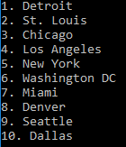 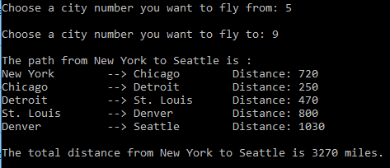But flying from Seattle to New York is much shorter:

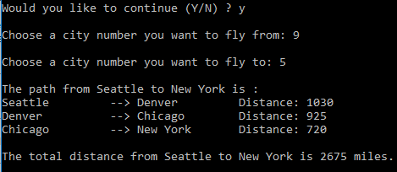

Check invalid input or limited number from 1 to 10:

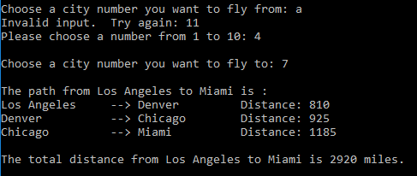

Check the same city:

