Tuan Pham

Build a Red Black tree based on 10 random numbers

<Number> indicates that this node is red node.

The tree displays as **horizontal** direction

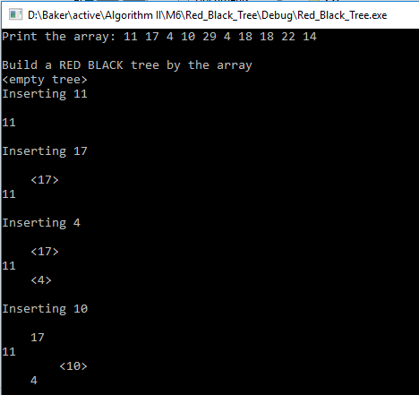

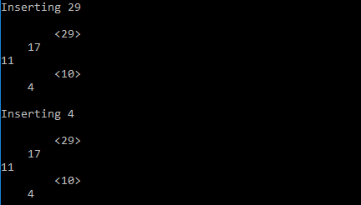

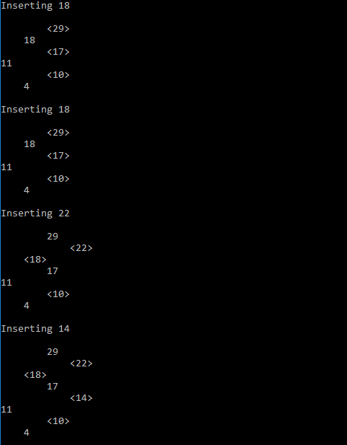

Find a node in the tree (should find successfully)

and a node not in the tree (will not able to find it).



Inserted demonstration:

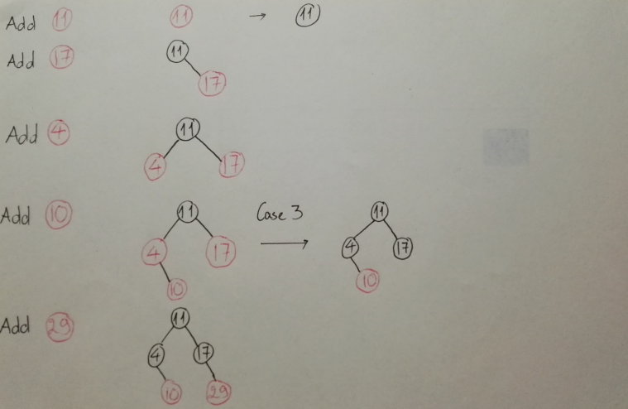

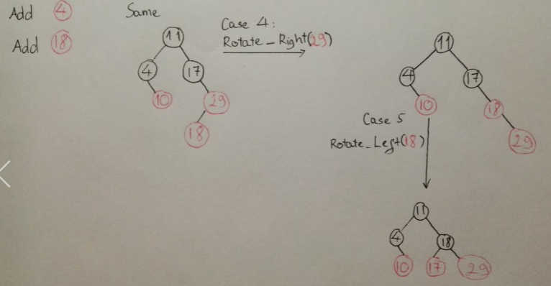

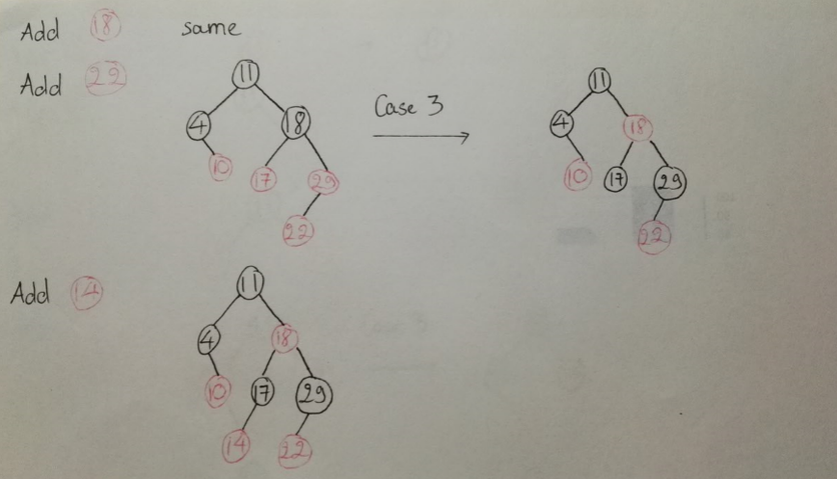

This matches with my program’s result:

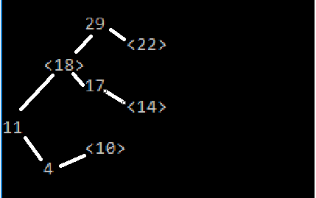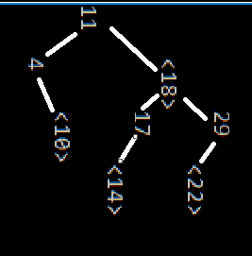

(Horizontally) (Vertically)

Deletes 5 random nodes in the tree

