- docker --version
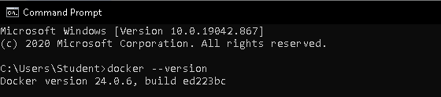
- docker run hello-world

