VIETNAM GENERAL CONFEDERATION OF LABOUR

**TON DUC THANG UNIVERSITY**

**FACULTY OF INFORMATION TECHNOLOGY**



**PROJECT**

**BUILD A FIRE AND EXPLOSION WARNING SYSTEM (IOT)**

*Instructor*: **PhD TRƯƠNG ĐÌNH TÚ**

*Excutor* : **TRƯƠNG MINH TRÍ – 51600095**

**LÊ ANH TUẤN - 51600098**

**HO CHI MINH CITY, 2020**

VIETNAM GENERAL CONFEDERATION OF LABOUR

**TON DUC THANG UNIVERSITY**

**FACULTY OF INFORMATION TECHNOLOGY**



**PROJECT**

**BUILD A FIRE AND EXPLOSION WARNING SYSTEM (IOT)**

*Instructor*: **PhD TRƯƠNG ĐÌNH TÚ**

*Excutor* : **TRƯƠNG MINH TRÍ – 51600095**

**LÊ ANH TUẤN - 51600098**

**HO CHI MINH CITY, 2020**

ACKNOWLEDGEMENTS

During the period of probation, I received a plenty of zealous help and support from teachers in my university, encourage me to overcome all serious difficutltives and then I finish this hard but meaningful time.

Sincerely thanks to teacher: PhD Trương Đình Tú who gave me knowledge about  internet of things (iot), arduino software ,thinker cảd and help me gain a lot of improving my skills and my learning

**PROJECT IS COMPLETED**

**AT TON DUC THANG UNIVERTY**

I commit that this project is our own project and is supervised by PhD Trương Đình Tú . The contents, results in this topic are honest and unpublished in any form before. The data in the tables for analyzing, commenting and evaluating are collected from various sources and by the authors and the citations are specified in References section.

In addition, a number of comments and assessments as well as data from other authors and organizations are also used in the project are referenced and annotated clearly.

**If this project has any cheating or plagiarism, I take full responsibility for the content of my project.** Ton Duc Thang University is not related to infringement of copyright caused by me during the process of this project implementation.

*Ho Chi Minh City…………..*

*Authors*

*(signature and full name)*

*Trương Minh Trí*

*Lê Anh Tuấn*

**PARTNER FOR ASSESSMENT AND EVALUATION**

OF TEACHERS

**Confirmation part of teacher instructing.**

________________________________________________________________________________________________________________________________________________________________________________________________________________________________________________________________________________________________________________________________________________________________________________________________________

Ho Chi Minh city, ….. ……….

*(Signature and full name)*

**The evaluation part of the teacher marking the lesson**

________________________________________________________________________________________________________________________________________________________________________________________________________________________________________________________________________________________________________________________________________________________________________________________________________

Ho Chi Minh city, ….. ………..

*(Signature and full name)*

ABSTRACT

This automated device is used with IoT. It makes people safer to discover fire and explosion hazards at home or apartment. The device consists of 3 sensors: temperature and himidity DHT22, flame sensor, MQ-135 gas sensor, so it will easily detect the fire risk. This device has a variety of alert levels to help users easily monitor the situation of a possible fire. It helps people protect the strength of themselves and their families and property.

**CONTENTS**

ACKNOWLEDGEMENTS 3

ABSTRACT 6

CONTENTS 7

LIST OF SYMBOLS AND ABBREVIATIONS 8

LIST OF TABLES, FIGURES, GRAPHS 9

CHAPTER 1 – INTRODUCTION 10

1.1. Introduction about Internet of Things(IoT) 10

1.1.1 What is the IoT? 10

1.1.2 How influential and meaningful is the Internet of Things? 11

1.1.3 How does Internet of Things work? 11

1.1.4 Application Internet of Things 12

1.2. NodeMCU & sensors 12

1.2.1 Introduction to nodeMCU 12

1.2.2 How to start with NodeMCU 12

1.2.3 How to write codes for NodeMCU with Arduino IDE 13

1.2.4 Introduction about sensors 13

CHAPTER 2 – SITUATION AND SOLUTION 16

2.1 Identify ideas 16

2.1.1 The current situation 16

2.1.2 Solution 17

2.1.3 Ideas to build product 17

2.2 Effectuate the project 17

CHAPTER 3 – CONCLUDE 23

3.1 Conclude: 23

3.2 Oriented development 23

**LIST OF SYMBOLS AND ABBREVIATIONS**

**ABBREVIATIONS**

IoT Internet of things

IDE Integated Development Environment

NTC Negative Temperature Coefficient

**LIST OF TABLES, FIGURES, GRAPHS**

**LIST OF FIGURES**

Fig. 1.: Internet of things 10

Fig. 1.2: Internet of things works 11

Fig. 1.3: Application Internet of things 12

Fig. 1.4: NodeMCU device 13

Fig. 1.5: Temperature and humidity sensor DHT22 14

Fig. 1.6: Flame sensor 15

Fig. 1.7: **MQ-135 gas sensor** 16

Fig. 2.2: Product 18

Fig. 2.3: Firebase 20

Fig. 2.4: Update information to website 20

CHAPTER 1 – INTRODUCTION

1.1. Introduction about Internet of Things(IoT)

*1.1.1. What is the IoT?*

The “ Thing ” in IoT can be any device with any kind of built-in-sensors with the ability to collect and transfer data over a network without manual intervention. The embedded technology in the object helps them to interact with interal states and the environment, which in turn helps in decisions making process.

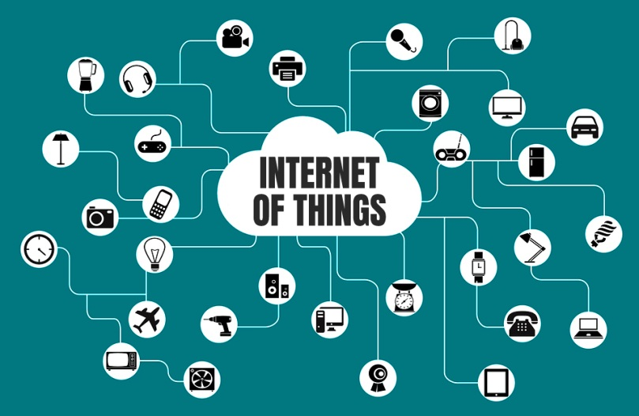In a nutshell, IoT is a concept that connects all the devices to the internet and let them communicate with ech other over the internet. IoT is a giant network of connected devices – all of which gather and share data about how they are used and the environments in the which they are operated.

Fig. 1.: Internet of things

*1.1.2. How influential and meaningful is the Internet of Things?*

When all things share a connection network, communication and work becomes very easy. People can realize their goals in the future. We can completely control everything. Suppose a wallet that you are using has integrated IoT technology. They are responsible for checking the amount of money in the wallet, checking the expiration date of the papers you put in it such as: health insurance, tuition payment deadline, ... and informing its status to we know via SMS, facebook, skype, zalo, ... applications.

It is new and convenient. We can save a lot of time as well as avoid having to encounter difficult situations when not mastering and managing everything around us.

*1.1.3. How does Internet of Things work?*

The magic here is the sensor. The devices to be connected must be integrated with a sensor chip to be able to convert and detect phenomena in the natural environment and turn it into data in the Internet environment to process data and conduct implementation. Internet navigation in the way that users want.

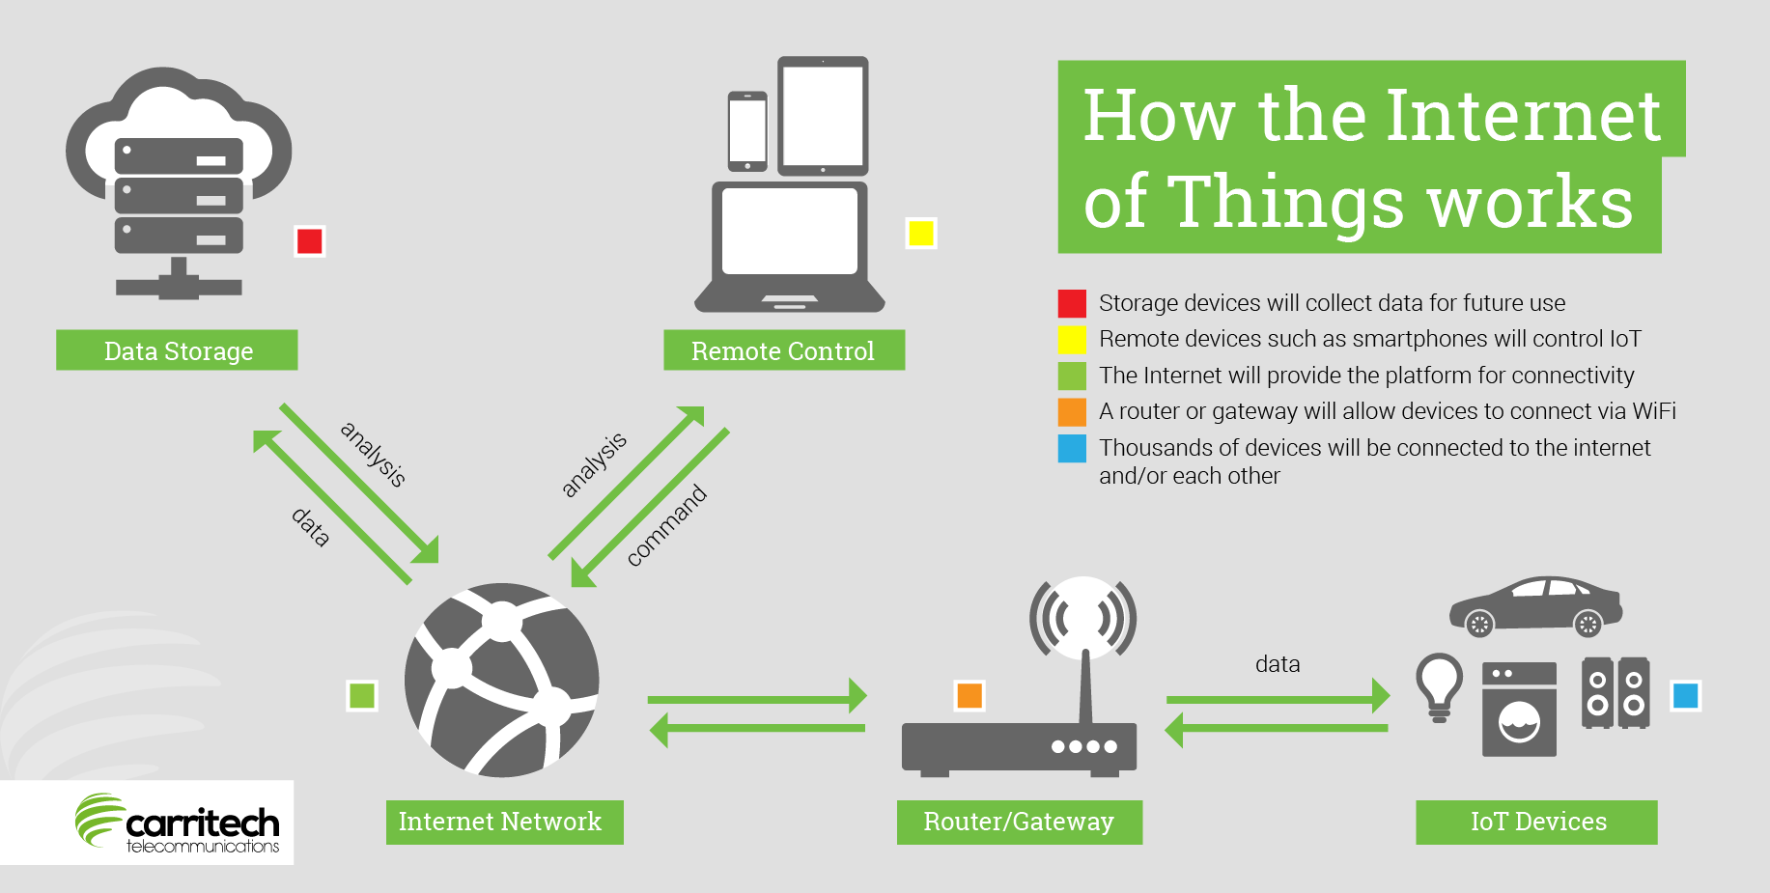For example, the automatic watering system as above, our ecosystem must be attached with 1 sensor to identify factors such as: temperature, water volume, humidity, weather, ... It is then converted into data and these data are used and set up the settings according to the intended use. And this process will connect and operate in the Internet environment to inform and create an interface to users.

Fig. 1.2: Internet of things works

***1.2.4. Application Internet of Things.***

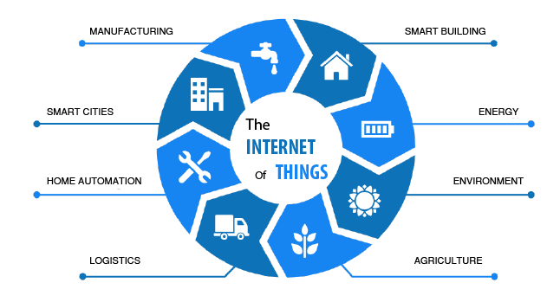In fact, the Internet Of Things concept was launched in 1999. As Internet technology is gradually developing. And to this day, Internet Of Things is no longer a far-fetched issue, in particular a lot of inventions, applications are released. The concept of smart devices, smart refrigerators, smart TVs, ... is used extensively in today's technology world. You can control 1 television by hand navigation, voice, ... by smart TV technology of Samsung, air conditioning automatically adjusts the temperature according to the weather, ... Or as a car with functional integration Automatic shock protection, automatically informs the user when the tire is falling or hitting the front obstacle about how many meters, for example. Even the house - the place we live in now defines a smart home with a lot of modern technology applications.

Fig. 1.3:Application Internet of things

1.2. NodeMCU & sensors

*1.2.1. Introduction to nodeMCU.*

NodeMCU is an open source Lua-based firmware developed for ESP8266 wifi chip. By exploring functionality with ESP8266 chip, NodeMCU firmware comes with ESP8266 Development board/kit i.e. NodeMCU Development board.

*1.2.2. How to start with NodeMCU?*

NodeMCU Development board is featured with wifi capability, analog pin, digital pins and serial communication protocols.

To get start with using NodeMCU for IoT applications first we need to know about how to write/download NodeMCU firmware in NodeMCU Development Boards. And before that where this NodeMCU firmware will get as per our requirement.

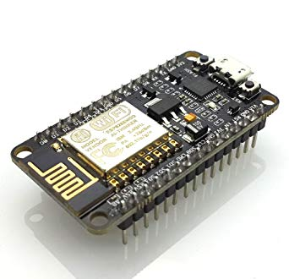There is online NodeMCU custom builds available using which we can easily get our custom NodeMCU firmware as per our requirement.

Fig. 1.4: NodeMCU device

*1.2.3. How to write codes for NodeMCU with Arduino IDE*

After setting up ESP8266 with Node-MCU firmware, let’s see the IDE (Integrated Development Environment) required for development of NodeMCU.

Arduino IDE is another way of developing NodeMCU with a well-known IDE i.e. Arduino IDE. We can also develop applications on NodeMCU using Arduino development environment. This makes easy for Arduino developers than learning new language and IDE for NodeMCU.

*1.2.4. Introduction about sensors*

The Sensor is called a sensor to convert the environmental object signal into a 4-10mA 0-10V current signal; transfer control device to give the desired use. There are sensor types like temperature sensors, ultrasonic sensor, water level sensors….

1.2.4.1. Temperature and humidity sensor DHT22 Arduino

* What is the temperature and humidity sensor DHT22 Arduino
* 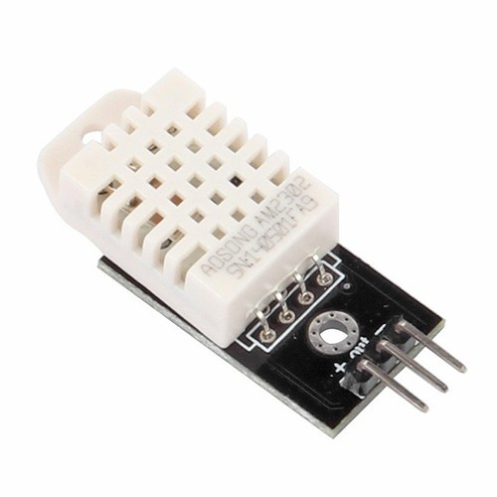The DHT22 sensor is used to measure the temperature and humidity. It is also known as the AM2302. This sensor is cheap and also has better accuracy. So in this tutorial, we are going to interface the DHT22 temperature and humidity sensor with Arduino and also we will display the data on the LCD.

Fig. 1.5: Temperature and humidity sensor DHT22

* Specifications of DHT22

The specifications of the temperature and humidity sensor DHT22 are as follows.

• Temperature range is from -40 to 125 degree Centigrade with accuracy of ±0.5 ͦ C.

• Humidity range is from 0 to 100% with accuracy of ± 2-5%.

• Sampling rate is 0.5 Hz.

• Operating Voltage is 3-5V.

• Maximum Current while measuring is 2.5mA.

* Working temperature and himidity DHT22
* DHT22 sensor consists of two components for measuring; Humidity sensing component and the NTC temperature sensor (or a thermistor). There is a IC on the back side which makes the readings to be able to read by the Arduino.
* While measuring the humidity, the humidity sensor comes into play. The humidity sensor consists of two electrodes with moisture holding substrate between them. So when the humidity changes, the conductivity of substrate changes or you can say that the resistance between the electrodes changes. This change in resistance is then given to IC which makes it to read by the Arduino.
* While measuring the temperature, the NTC temperature sensor or thermistor comes into play. The resistance of the thermistor changes with change in the temperature. These are negative temperature coefficient (NTC) which means that their resistance decreases with the increase in temperature.

1.2.4.2. Flame sensor

* What is the flame sensor?
* 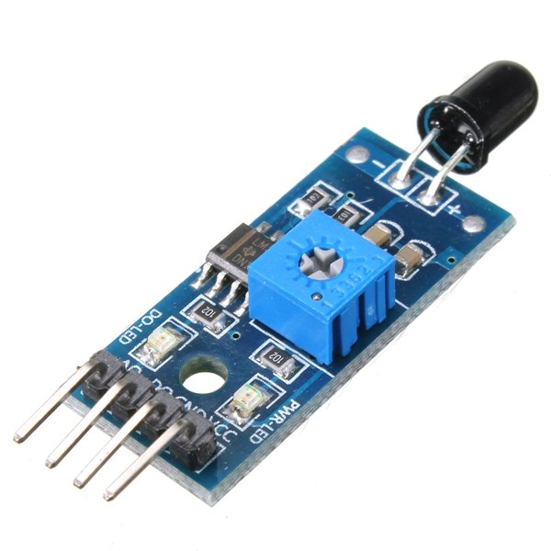These types of sensors are used for short range fire detection and can be used to monitor projects or as a safety precaution to cut devices off / on.

Fig. 1.6:Flame sensor

* It has found this unit is mostly accurate up to about 3 feet.
* How flame sensor work?
* The flame sensor is very sensitive to IR wavelength at 760 nm ~ 1100 nm light.
* Analog output (A0): Real-time output voltage signal on the thermal resistance.
* Digital output (D0): When the temperature reaches a certain threshold, the output high and low signal threshold adjustable via potentiometer.

### 1.2.4.3. The MQ-135 Gas sensor

### **What is MQ-135 gas sensor and how does it work?**

* The gas sensor module consists of a steel exoskeleton under which a sensing element is housed. This sensing element is subjected to current through connecting leads. This current is known as heating current through it, the gases coming close to the sensing element get ionized and are absorbed by the sensing element. This changes the resistance of the sensing element which alters the value of the current going out of it.

### **Specifications of MQ-135 gas sensor**

Fig. 1.7: **MQ-135 gas sensor**

* Wide detecting scope
* Fast response and High sensitivity
* Stable and long life Simple drive circuit
* Used in air quality control equipment for buildings/offices, is suitable for detecting  
  of NH3, NOx, alcohol, Benzene, smoke, CO2, etc.
* Size: 35mm x 22mm x 23mm (length x width x height)
* Working voltage: DC 5 V
* Signal output instruction.
* Dual signal output (analog output, and high/low digital output)
* 0 ~ 4.2V analog output voltage, the higher the concentration the higher the voltage.

CHAPTER 2 – SITUATION AND SOLUTION

2.1. Identify ideas

*2.1.1. The current situation*

In 2018, in the first 9 months of the year, there were 2,989 fires.

* Killed 73 people
* Injured 163 people
* The total damage of the fire amounted to 1,590 billion VND.

Fire and explosion of houses and apartments are at extremely dangerous levels, affecting the personality and property of people. Therefore, it is necessary to build a system to anticipate the risk of fire to warn people.

*2.1.2. Solution*

We should build a smart fire warning system :

* Temperature sensor in the home or in the apartment.
* Gas leak sensor in the kitchen.
* Humidity sensor for warning of danger of explosion.
* Fire sensor help to notification people

***2.1.3. Ideas to build product***

NodeMCU link with 3 sensors: flame sensor, dht22 temperature and himidity sensor, mq-135 gas sensor. When the sensors detect signs of a fire hazard sent to nodemcu, the mcu node will update the information to the database to alert people about the danger. The data will be updated to the web for users to easily follow.

2.2 Effectuate the project

We use two NodeMCU: A nodeMCU is collecting information and update it to the data, a nodeMCU is to enter information from the data

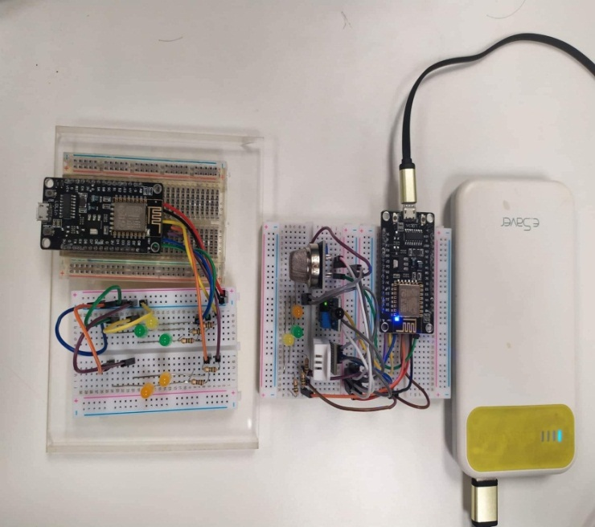Fig. 2.2: Product

In this project we use four library are FirebaseESP8266, ESP8266WiFi, DHT22 and MQ135. There are used for:

* FirebaseESP 8266: This library have many function support sent and revive data to cloud database Firebase.
* ESP8266Wifi: Connecting to wifi.
* DHT: read value of tempeture and huminity from DHT22 sensor to node MCU.
* MQ135: read value of gas when MQ-135 sensor to detect gases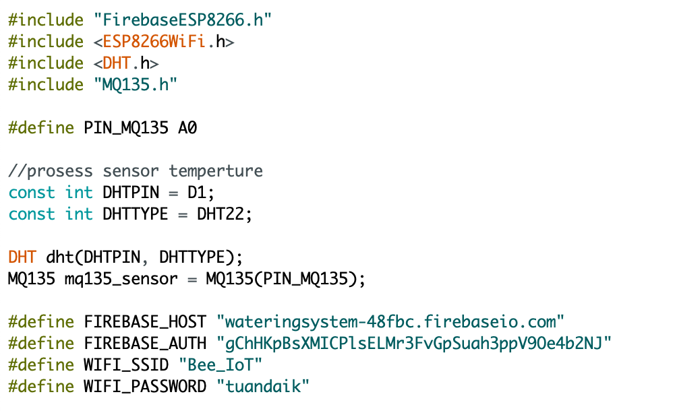

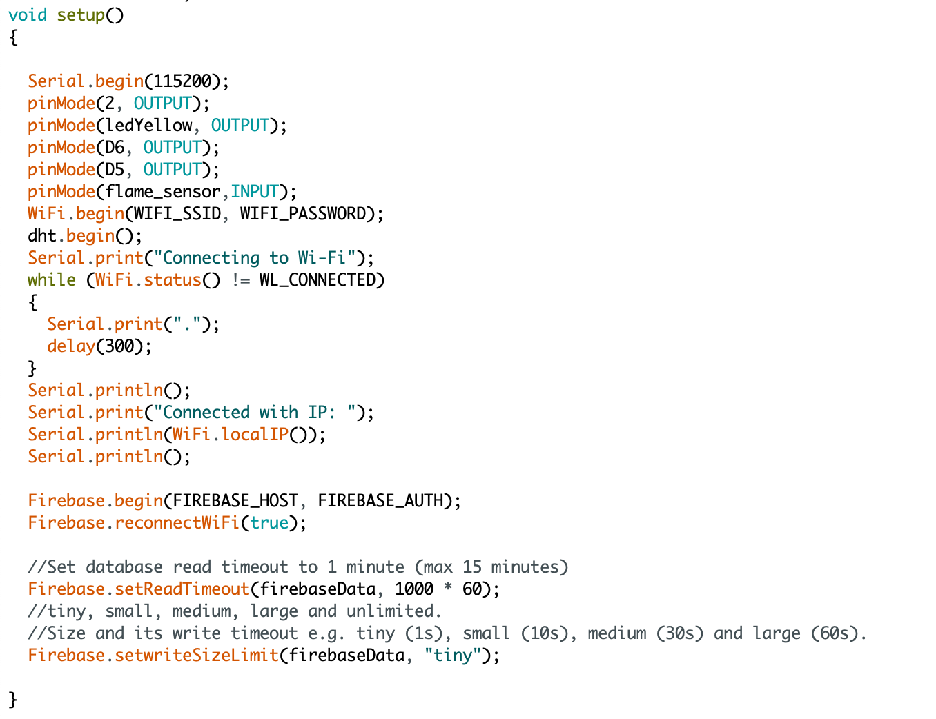Define information about database and wifi.

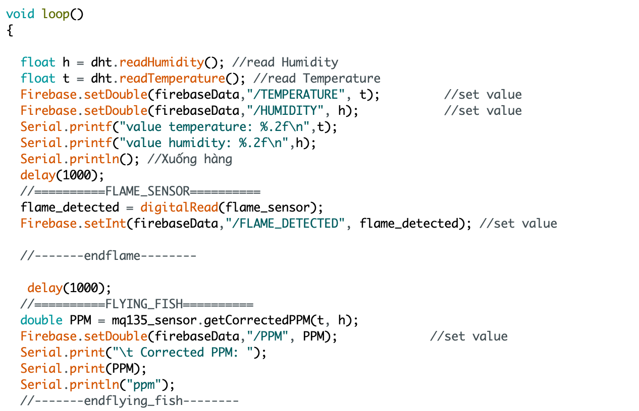Function setup will run when nodeMCU start at first time for set up something new: set Pin output,input, set connection with Wifi and set database read timeout...

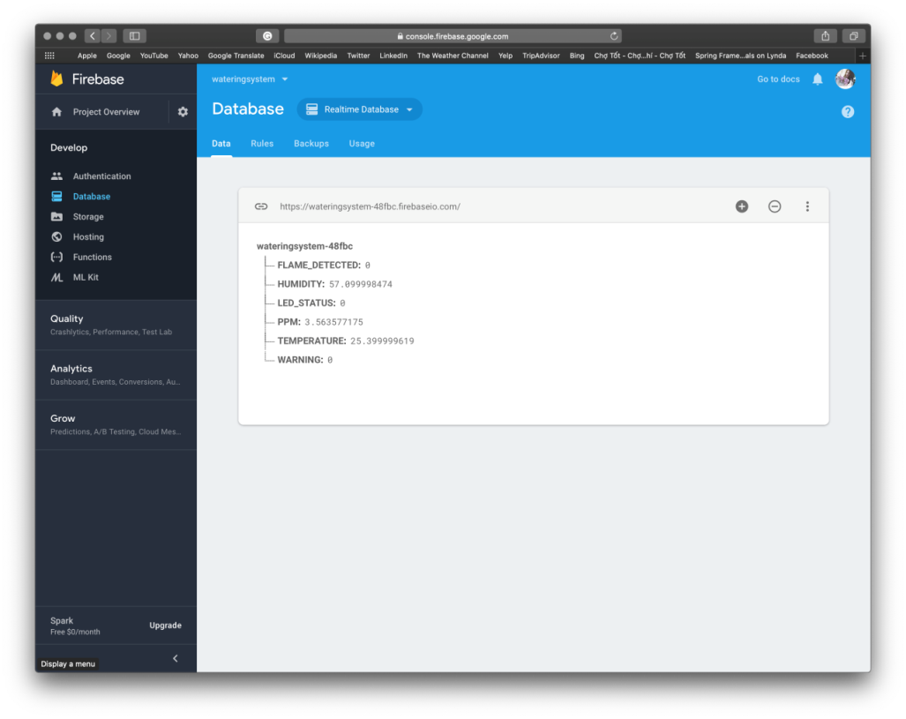Void loop() is function responsible for sending data from the sensors to the database through library FirebaseESP8266 we are include before.

Fig. 2.3: Firebase

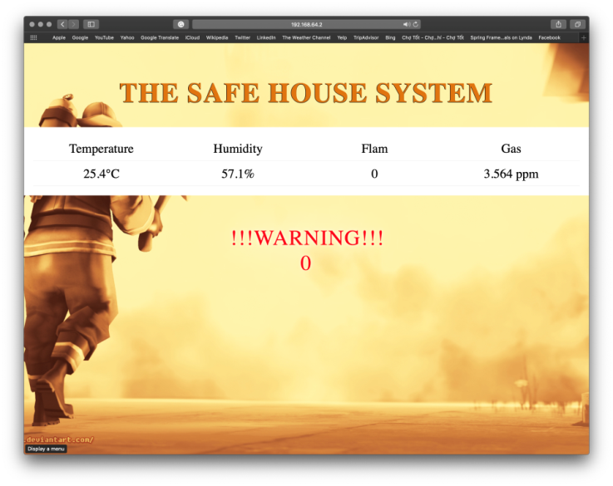This is console window of database Firebase. In case we use Realtime Database because we must have the newest data to handle in an emergency. When nodeMCU sent the data to database successfully then value at Firebase will updated.

Fig. 2.4: Update information to website

After database have updated data from nodeMCU, server will get data almost at the same time process it and sent to device of user about they home with 5 level warning and .

