Lab report – Project Management

**LAB REPORT**

**Software Project Management**

**Student Name: Nguyễn Hữu Tuấn**

**ID: 21118131**

**Class: DHKTPM17CTT**

**Course:**

STUDENT NAME **1**

Lab report – Project Management

Contents

Module 1: 3

Exercise 1: Creating a link 3

Exercise 2: Setting duration 3

Exercise 3: Creating phases 4

Lab report – Project Management

# Module 1:

### Exercise 1: Creating a link

View Project Timeline:

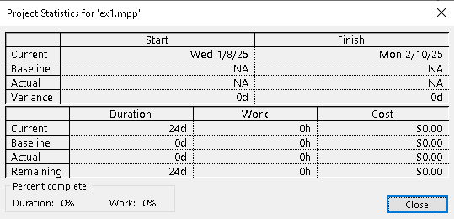

Gant Chart:

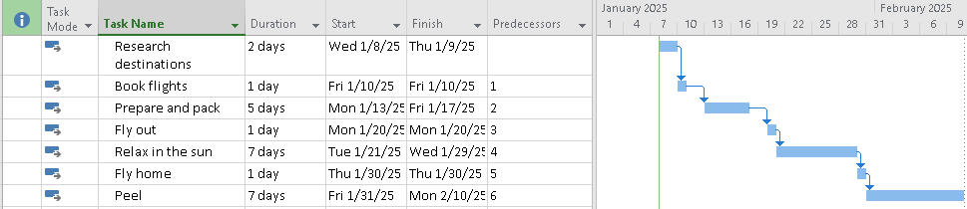

Network Diagram:





### Exercise 2: Setting duration

View Project Timeline:

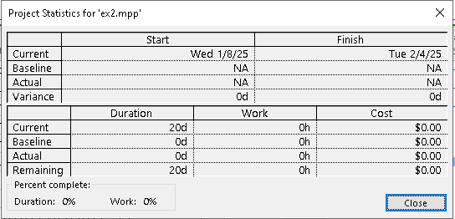

Gant Chart:

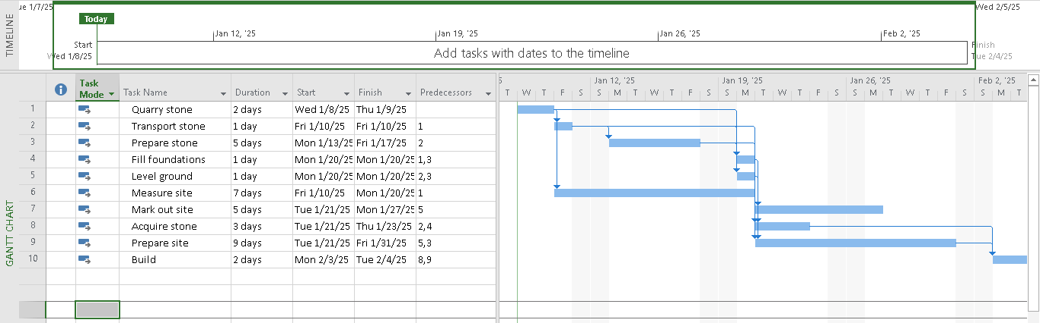

Network Diagram:

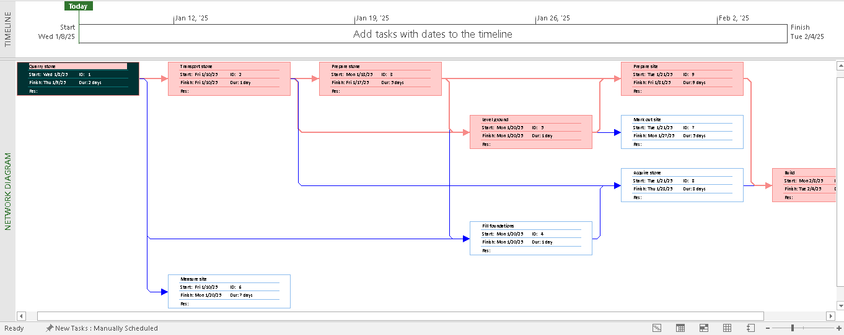

### Exercise 3: Creating phases

View Project Timeline:

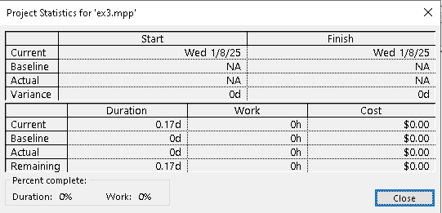

Gant Chart:

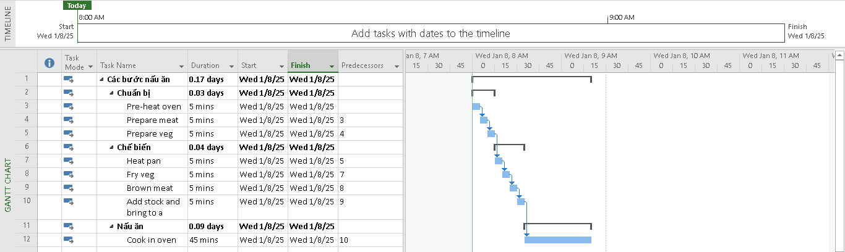

Network Diagram:

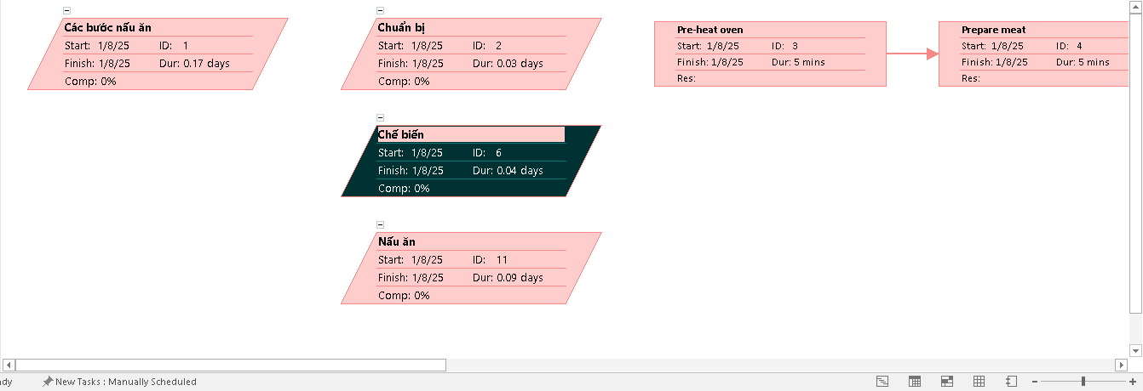

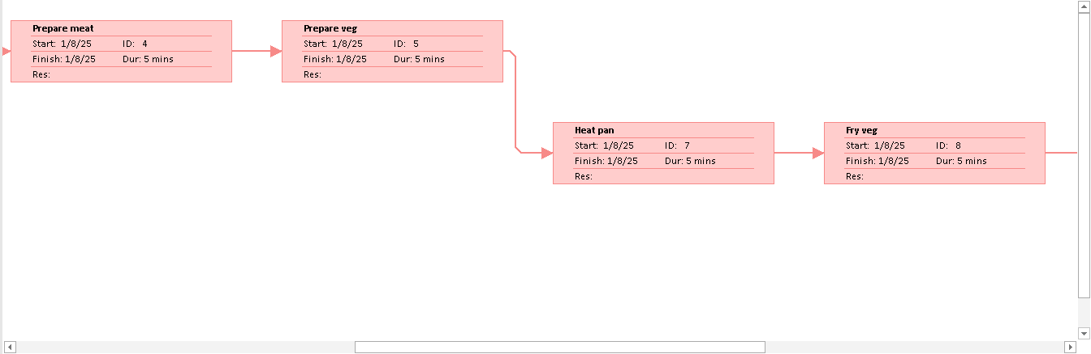

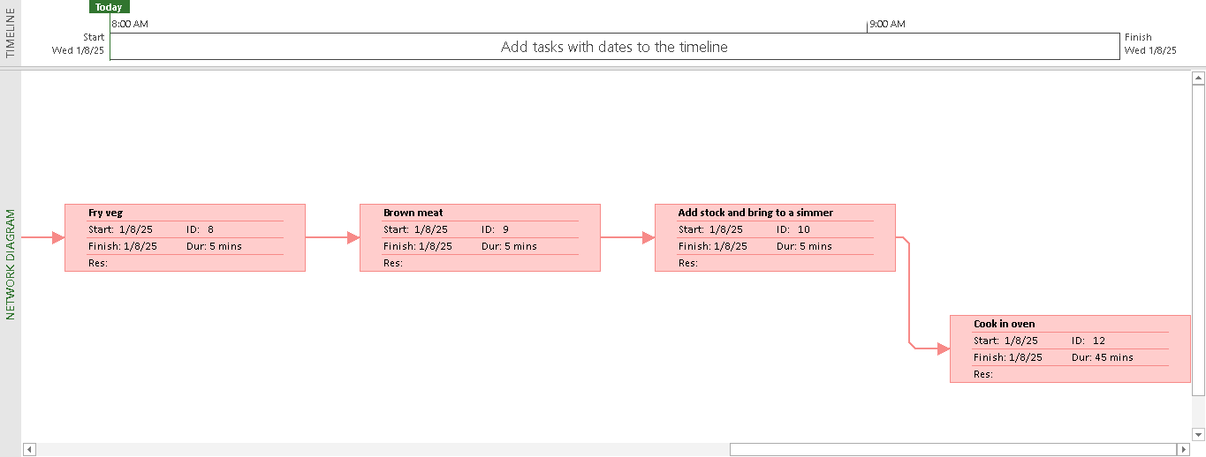

### Exercise 4: Noah – Linking

View Project Timeline:

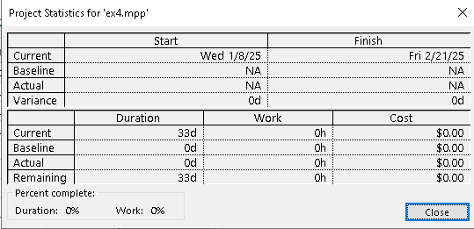

Gant Chart:

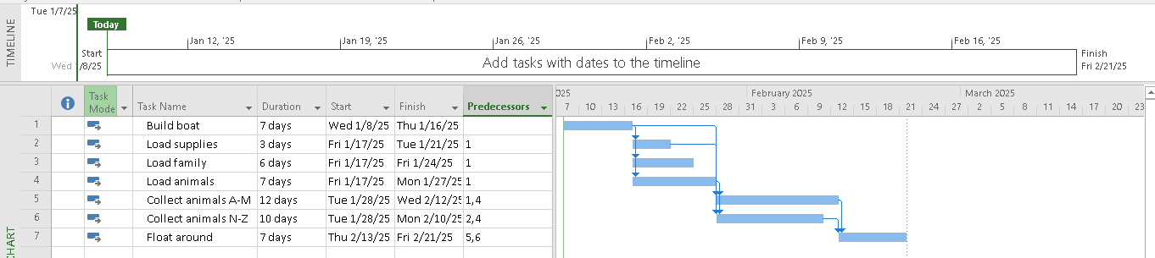

Network Diagram:

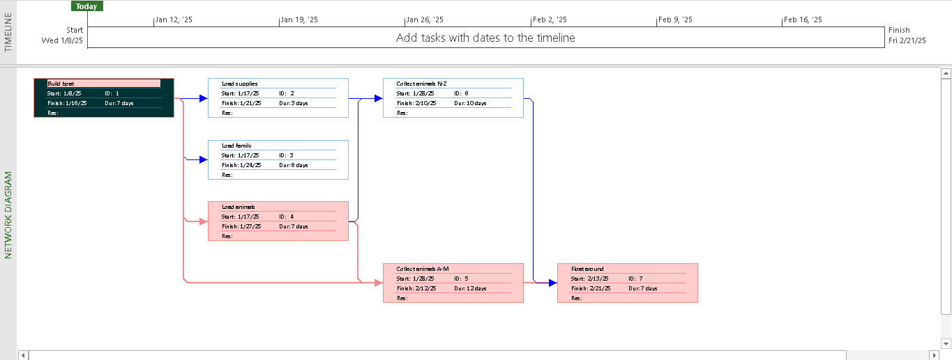

### Exercise 5: Pyramid - Multi level grouping

View Project Timeline:

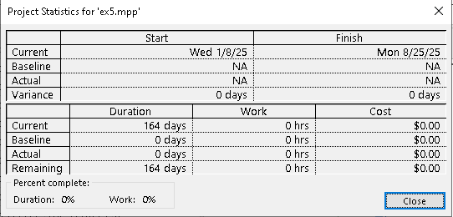

Gant Chart:

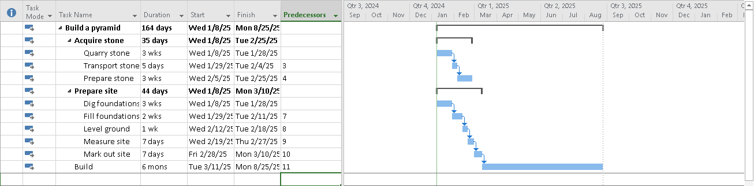

Network Diagram:

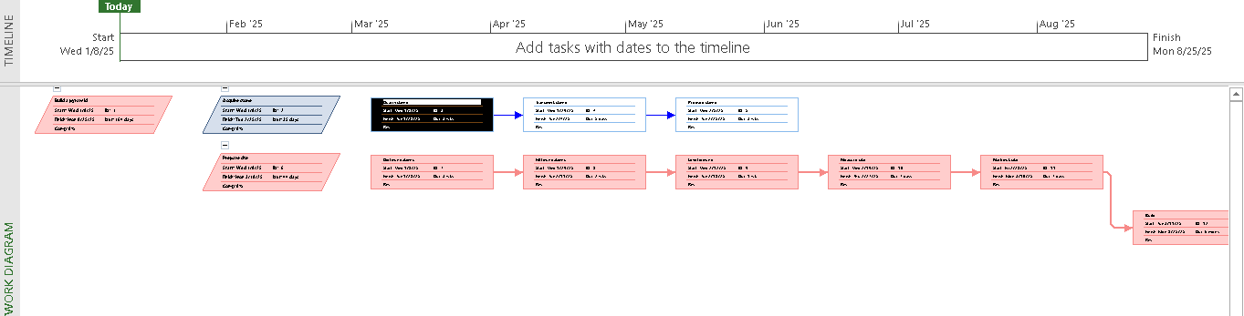

### Exercise 6: Creating a plan for Staff Training

View Project Timeline:

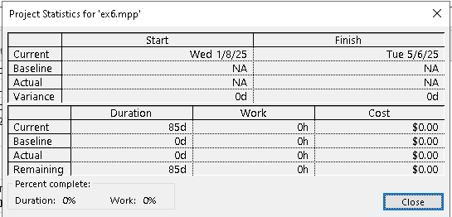

Gant Chart:

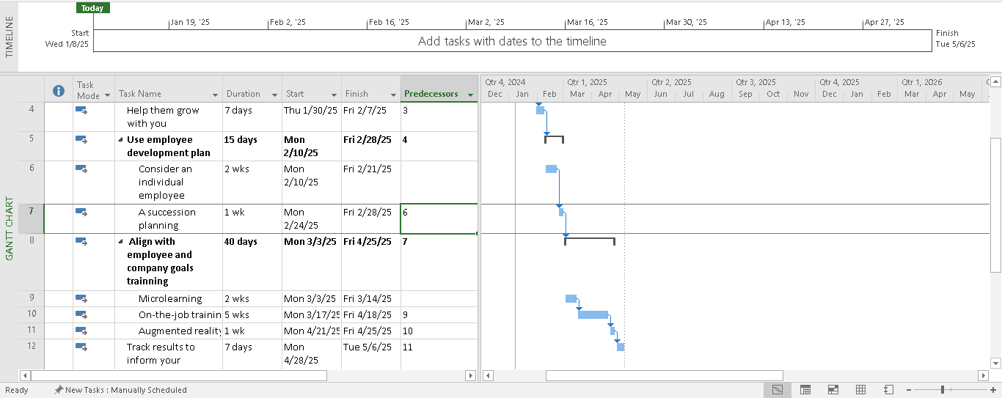

Network Diagram:

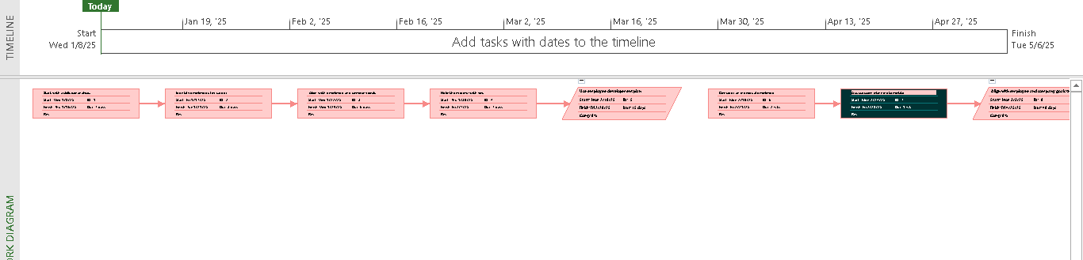

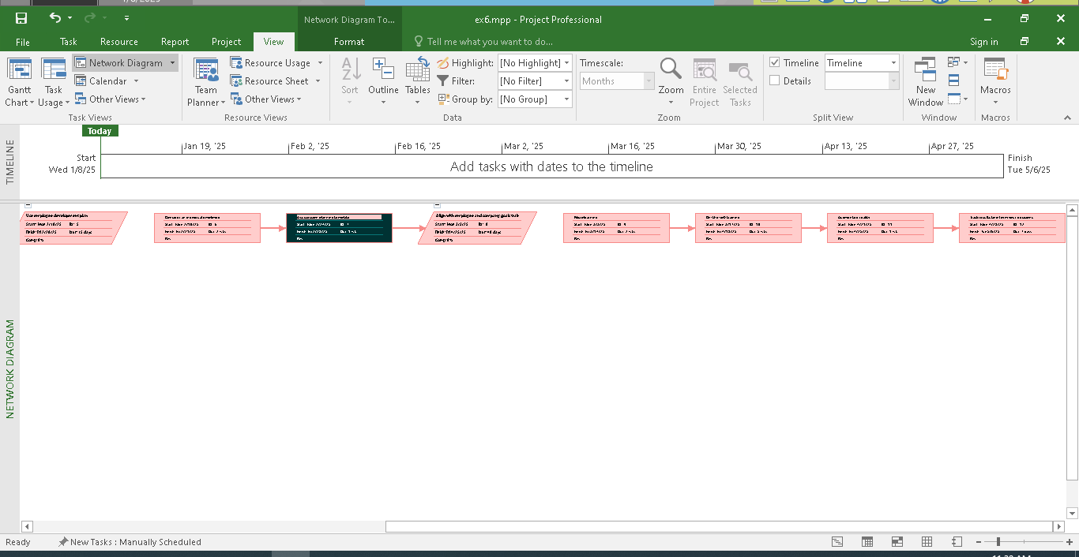

### Exercise 7: Recurring tasks

View Project Timeline:

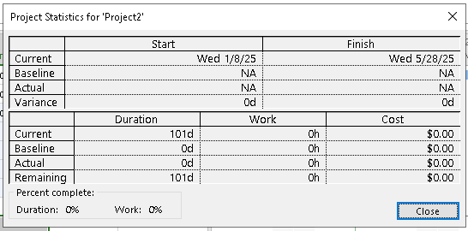

Gant Chart:

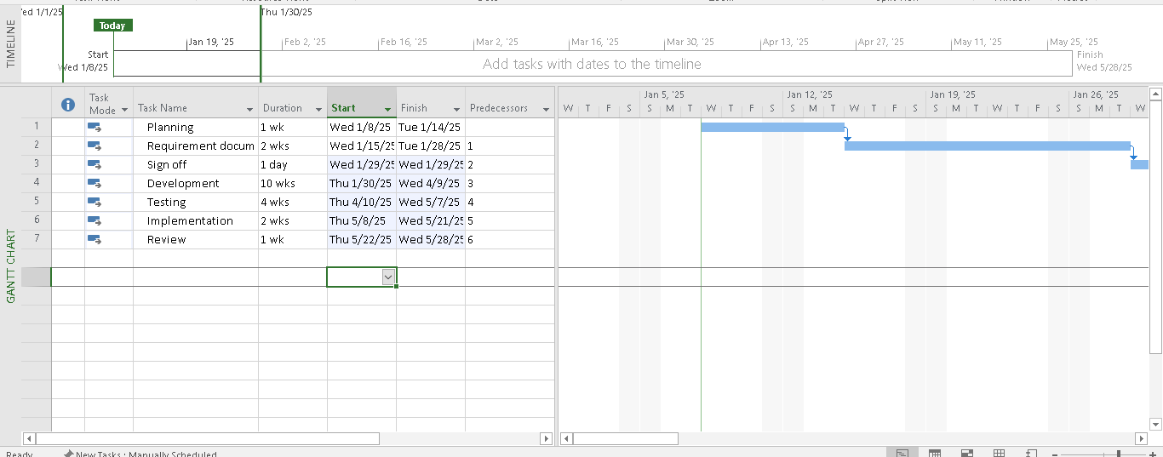

Network Diagram:

