Lab report – Project Management

**LAB REPORT**

**Software Project Management**

**Student Name: Nguyễn Hữu Tuấn**

**ID: 21118131**

**Class: DHKTPM17CTT**

**Course:**

STUDENT NAME **1**

Lab report – Project Management

Contents

MODULE 1. 3

Exercise 1. Creating a link 3

Exercise 2. Setting duration 4

Exercise 3. Creating phases 4

Exercise 4. Noah – Linking 6

Exercise 5. Pyramid - Multi level grouping 7

Exercise 6. Creating a plan for Staff Training 8

Exercise 7. Recurring tasks 9

MODULE 2. 11

Exercise 1. Part Time - creating new calendar 11

Exercise 2. Changing Working Time 12

Exercise 3. Changing Working Time 13

Exercise 4. Changing Working Time 14

Exercise 5. Create the private Time for a project 15

MODULE 3. 16

Lab report – Project Management

# 

## Creating a link

View Project Timeline:

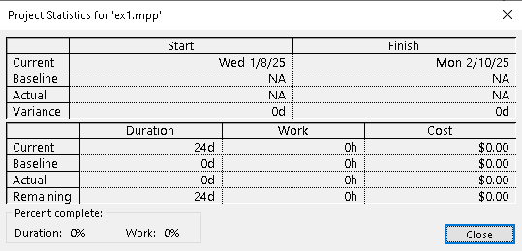

Gant Chart:

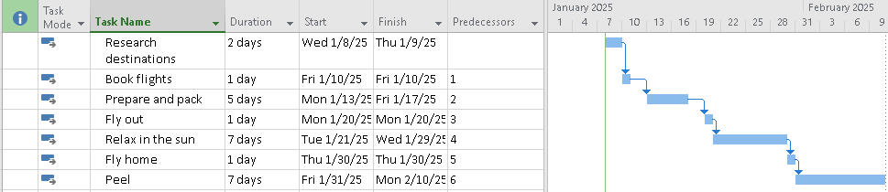

Network Diagram:





## Setting duration

View Project Timeline:

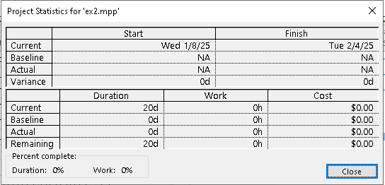

Gant Chart:

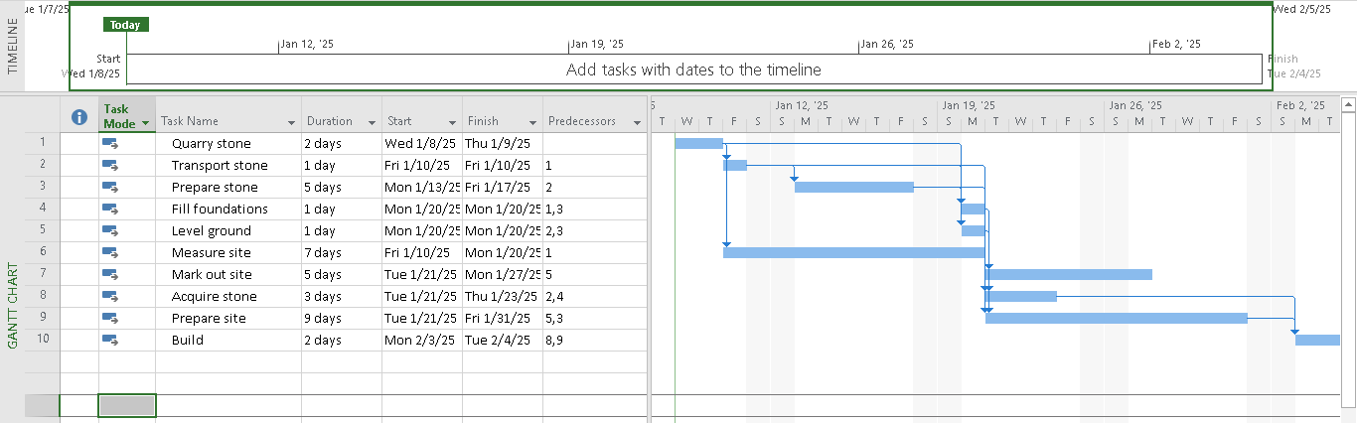

Network Diagram:

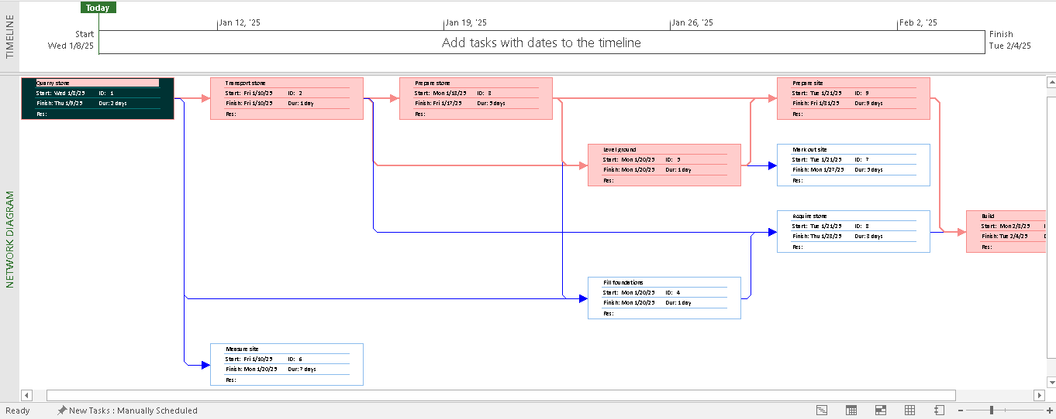

## Creating phases

View Project Timeline:

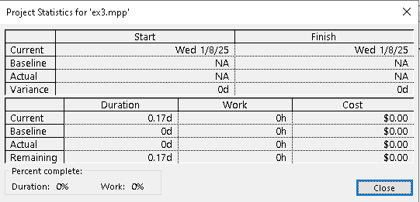

Gant Chart:

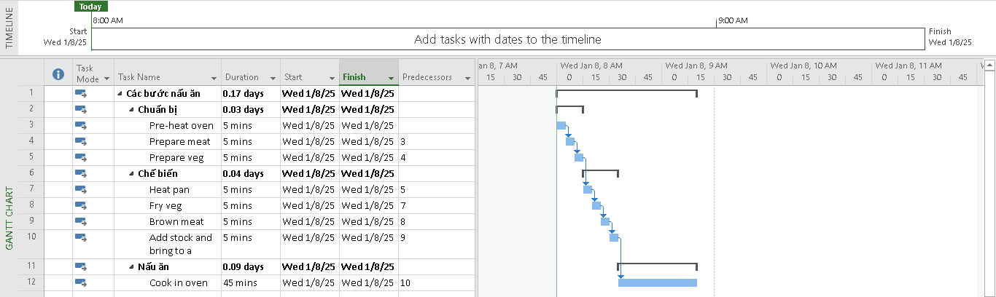

Network Diagram:

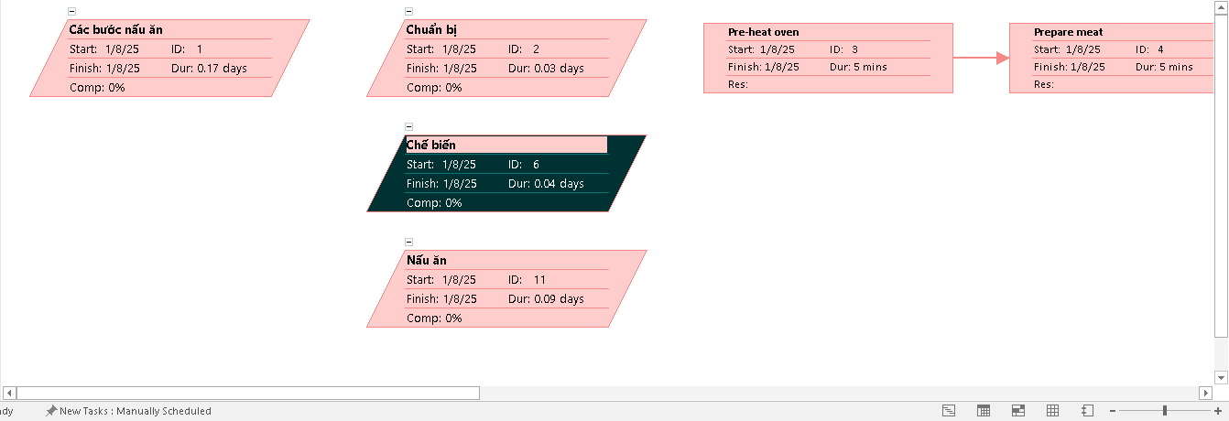

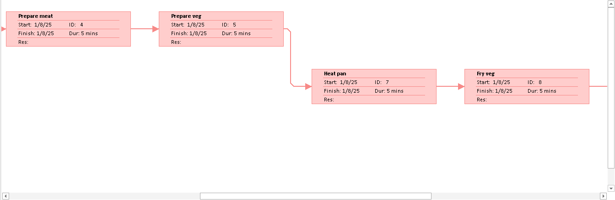

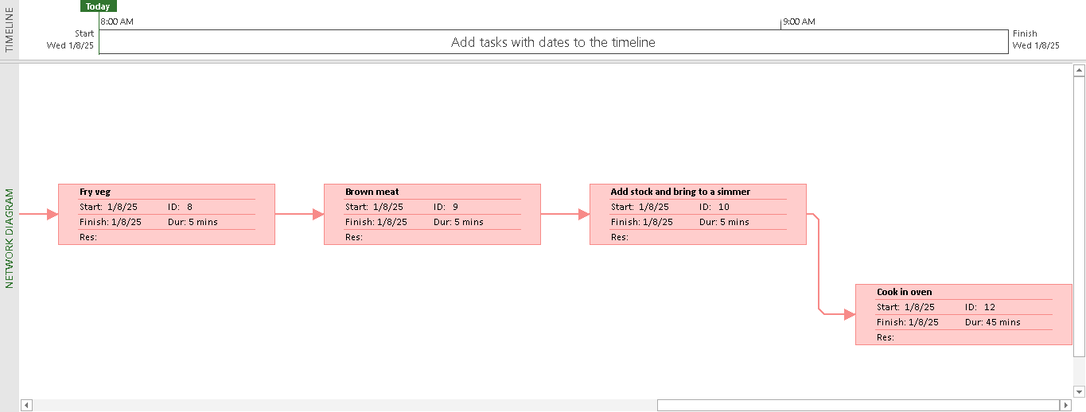

## Noah – Linking

View Project Timeline:

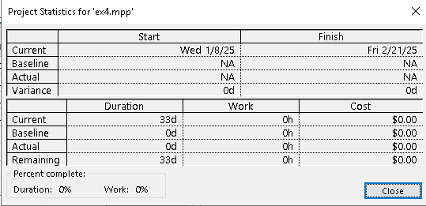

Gant Chart:

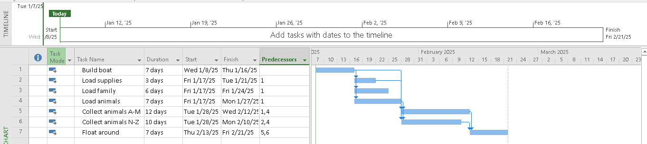

Network Diagram:

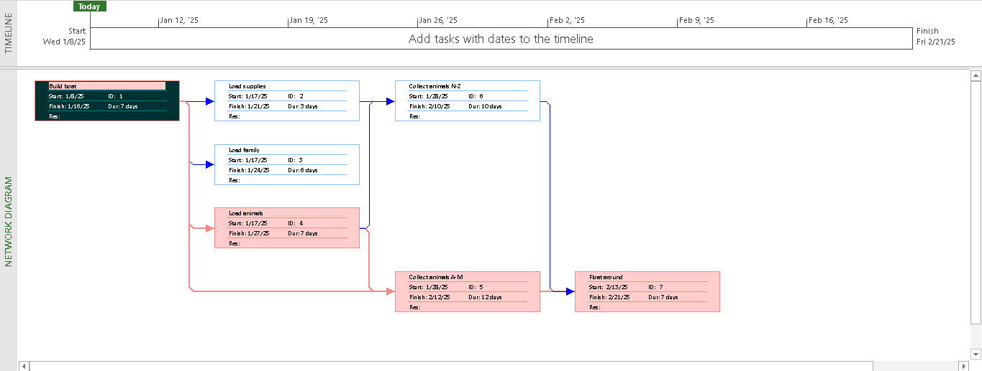

## Pyramid - Multi level grouping

View Project Timeline:

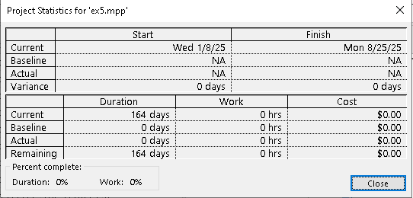

Gant Chart:

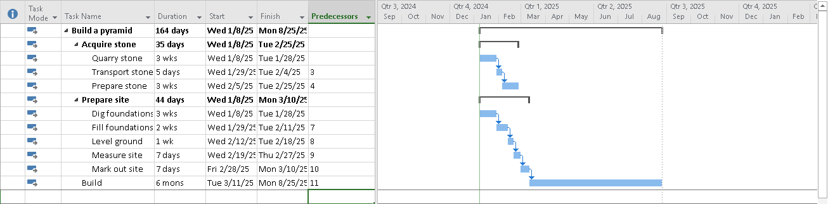

Network Diagram:

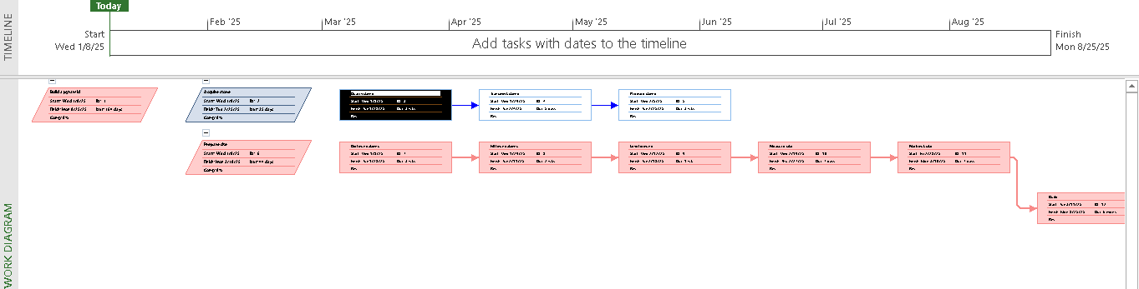

## Creating a plan for Staff Training

View Project Timeline:

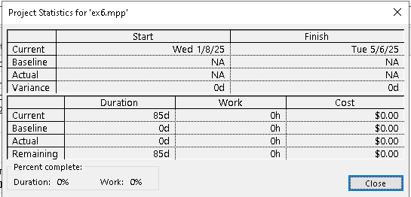

Gant Chart:

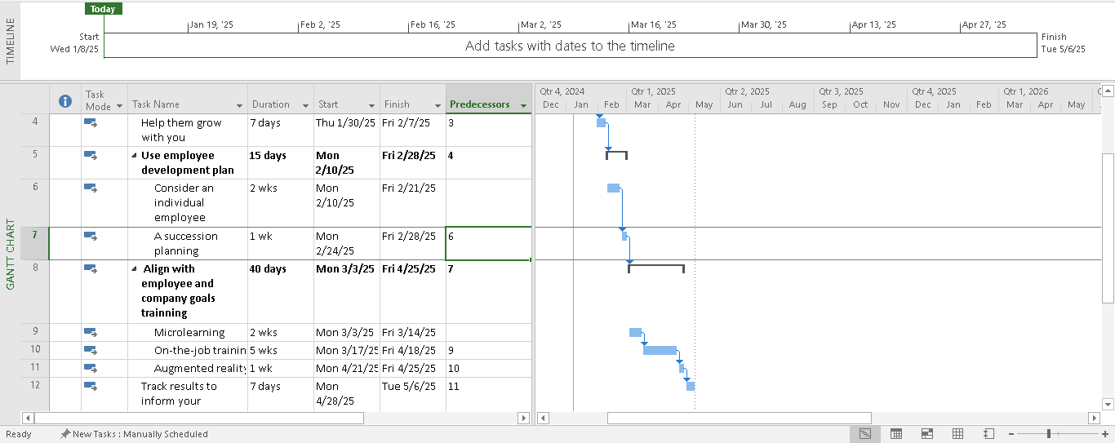

Network Diagram:

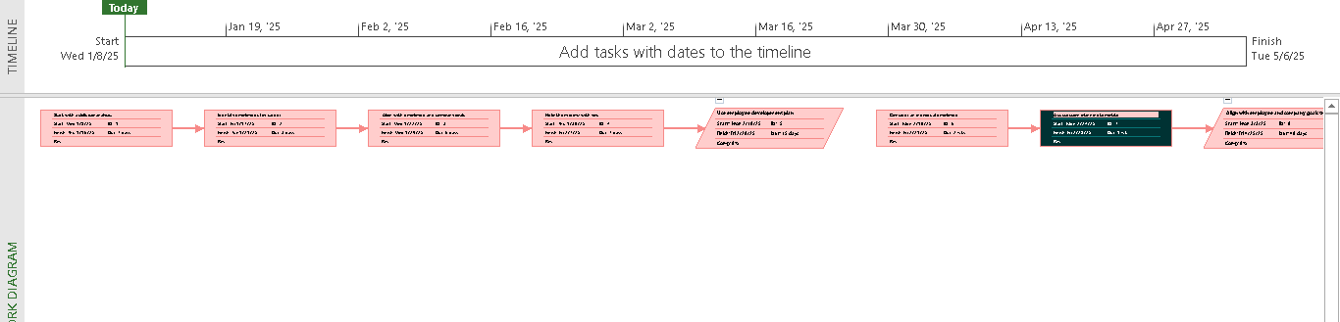

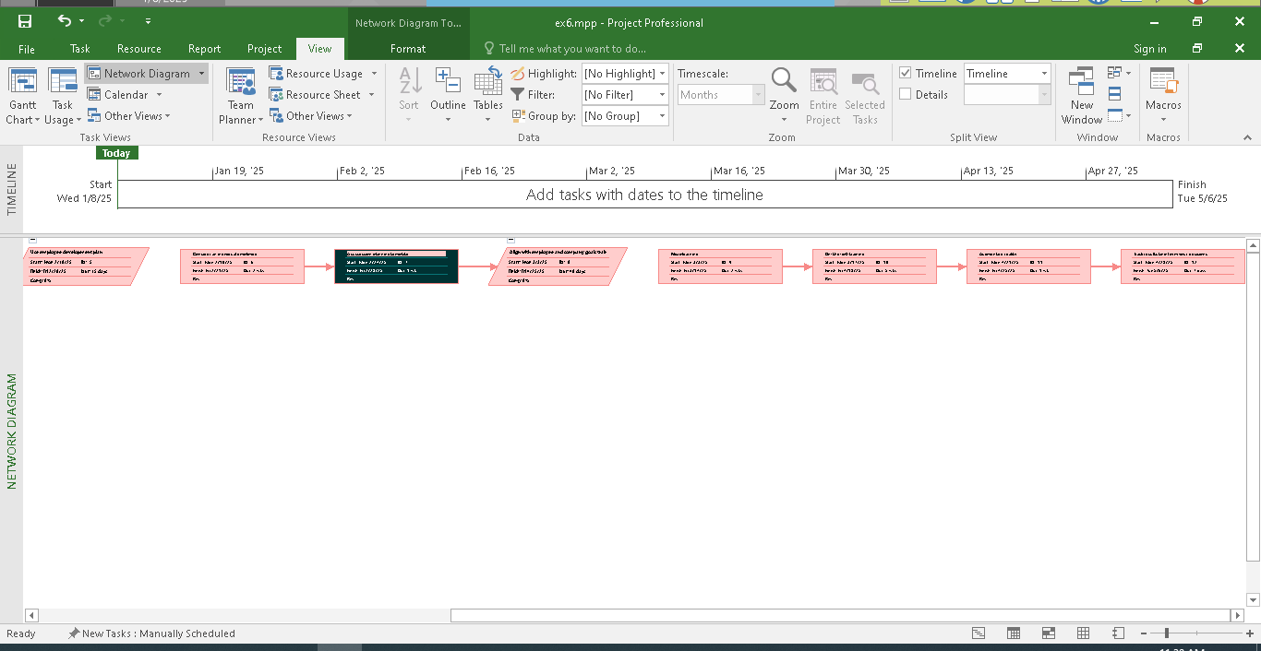

## Recurring tasks

View Project Timeline:

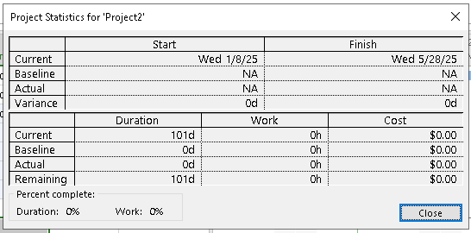

Gant Chart:

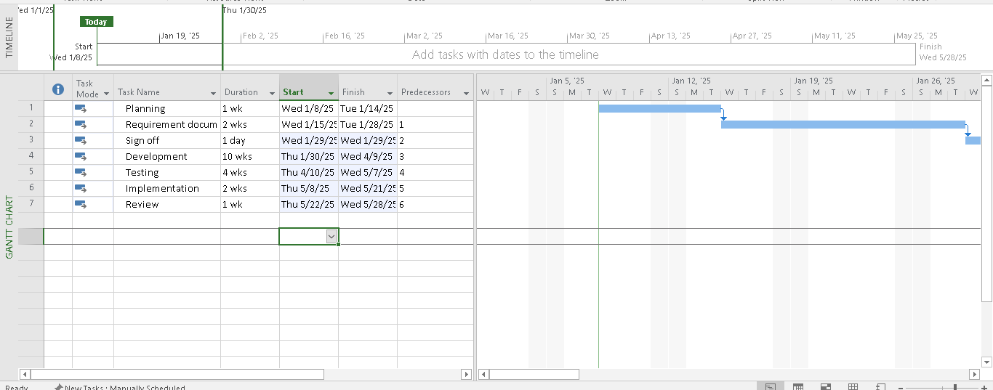

Network Diagram:

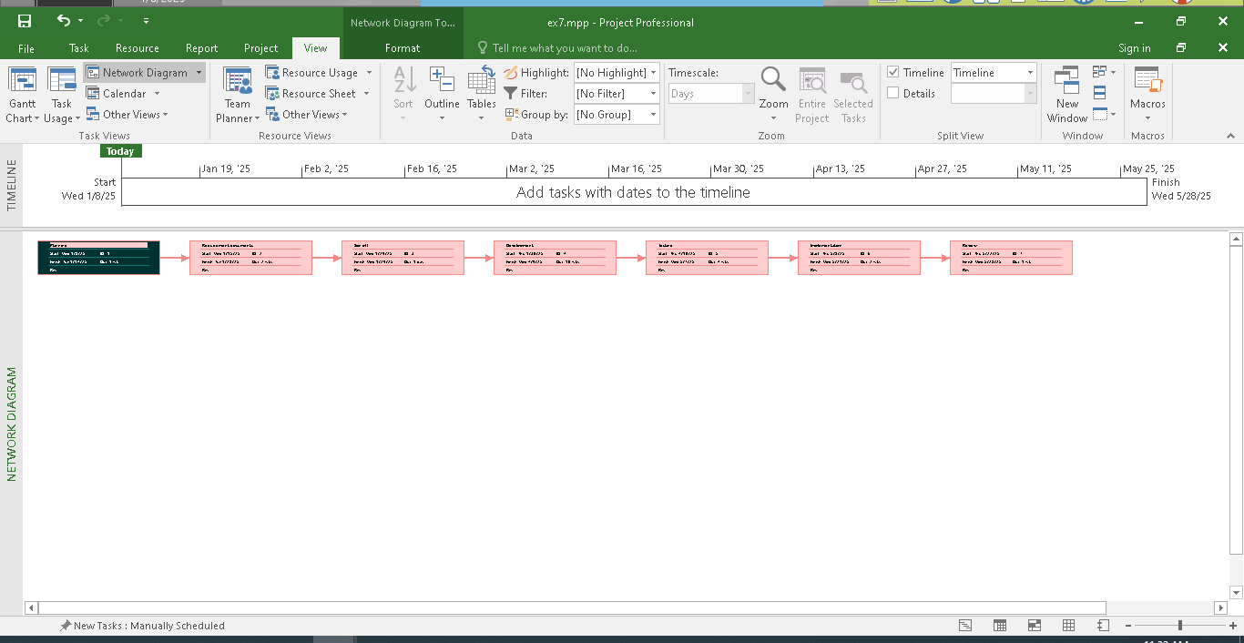

# 

## Exercise 1. Part Time - creating new calendar

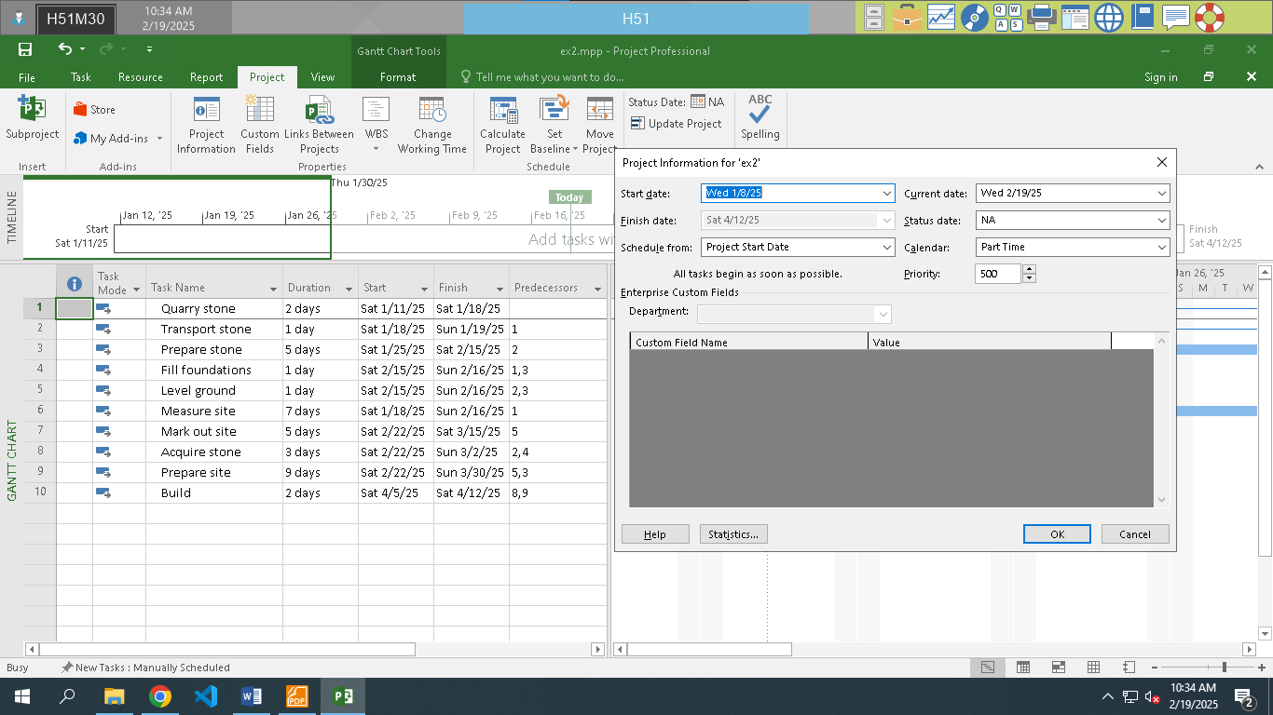

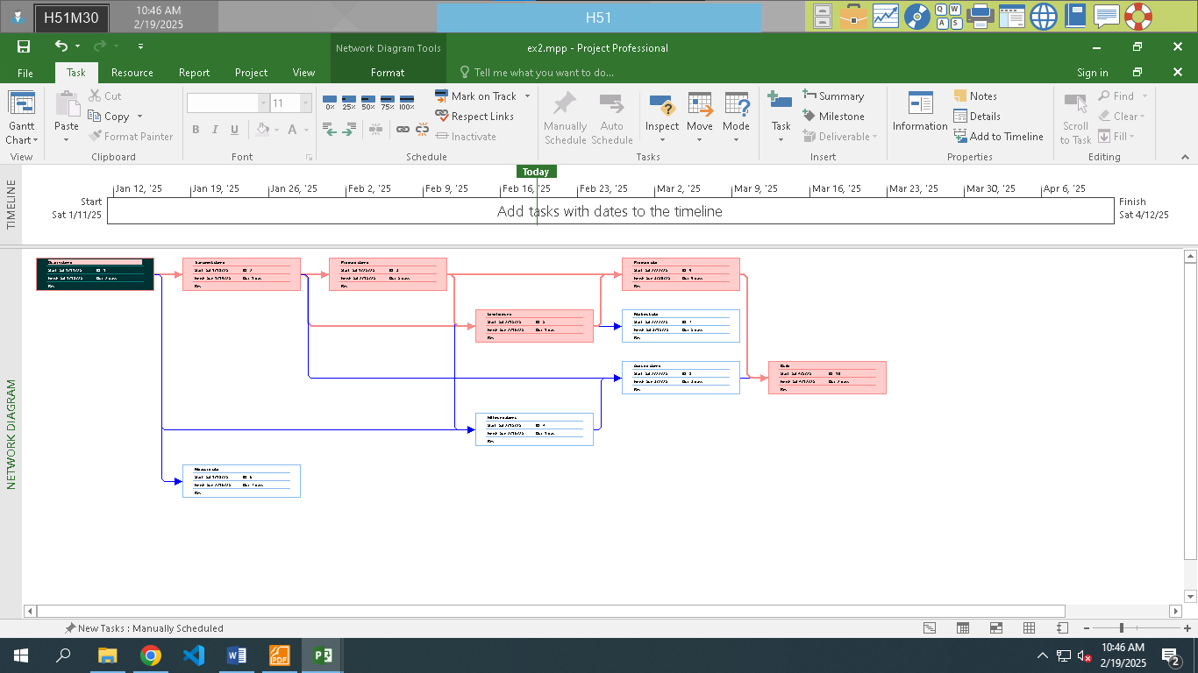

## Exercise 2. Changing Working Time

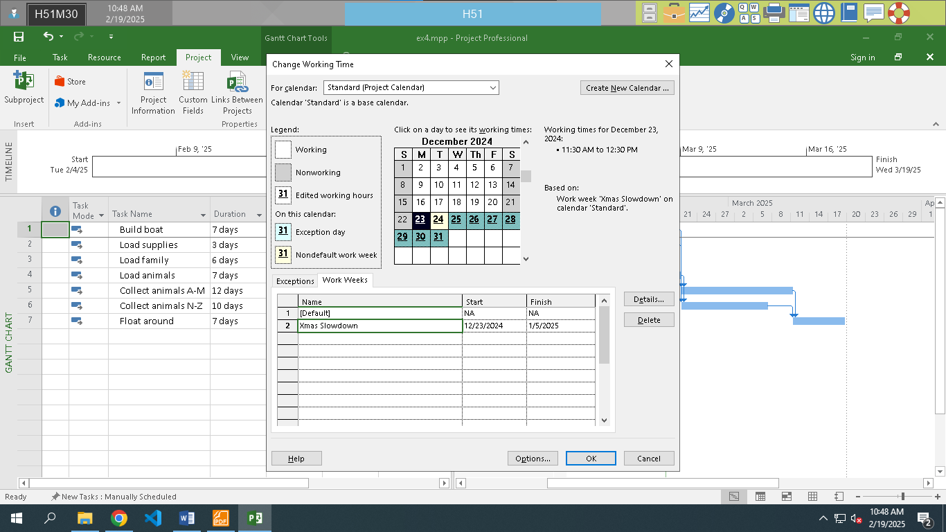

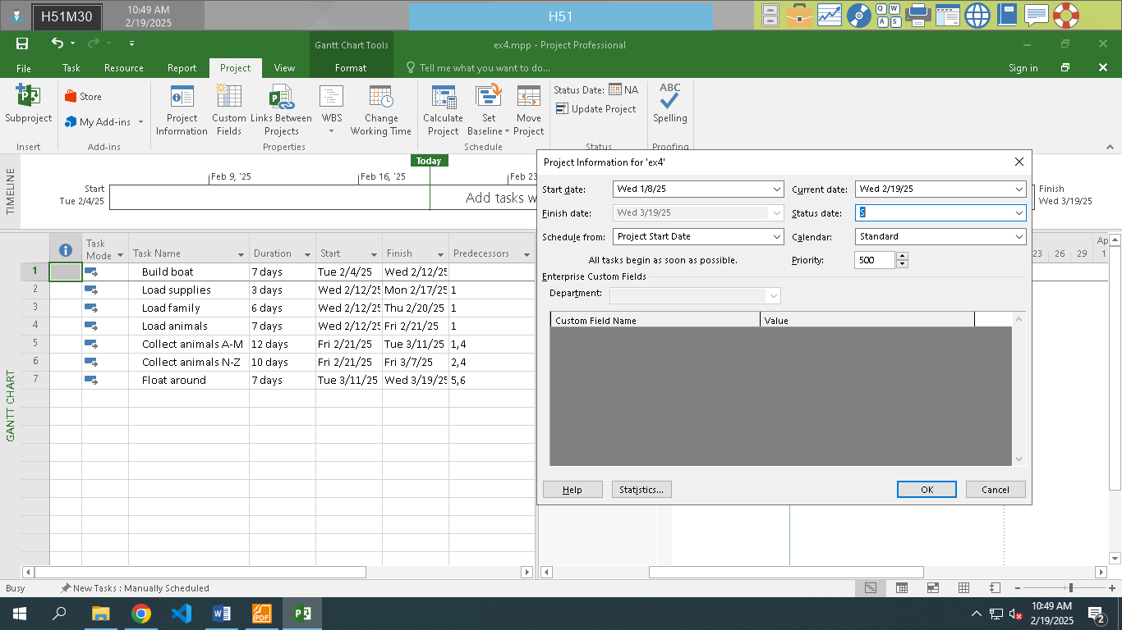

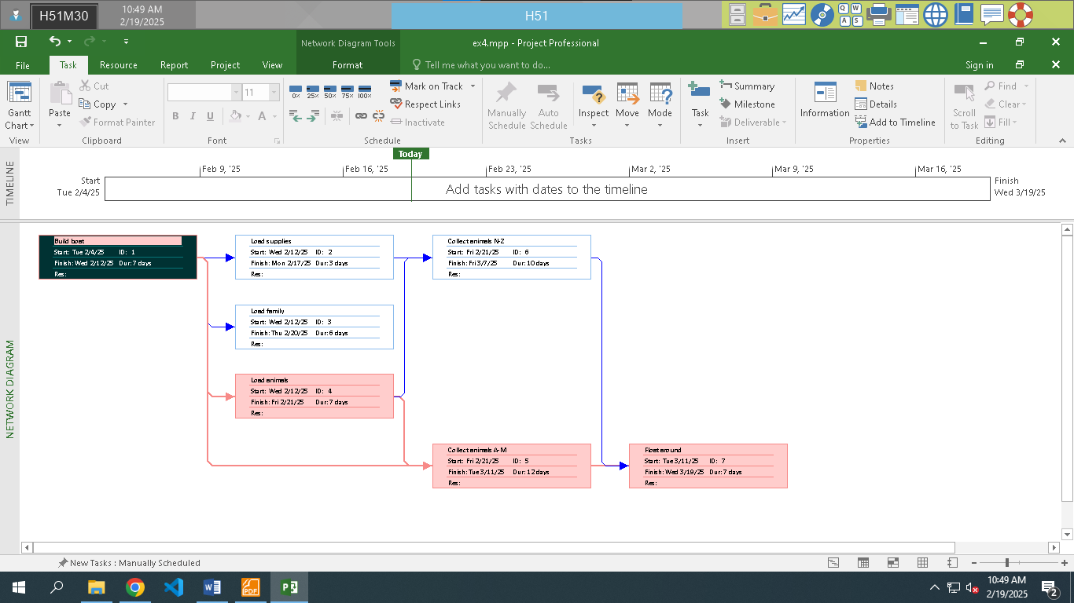

## Exercise 3. Changing Working Time

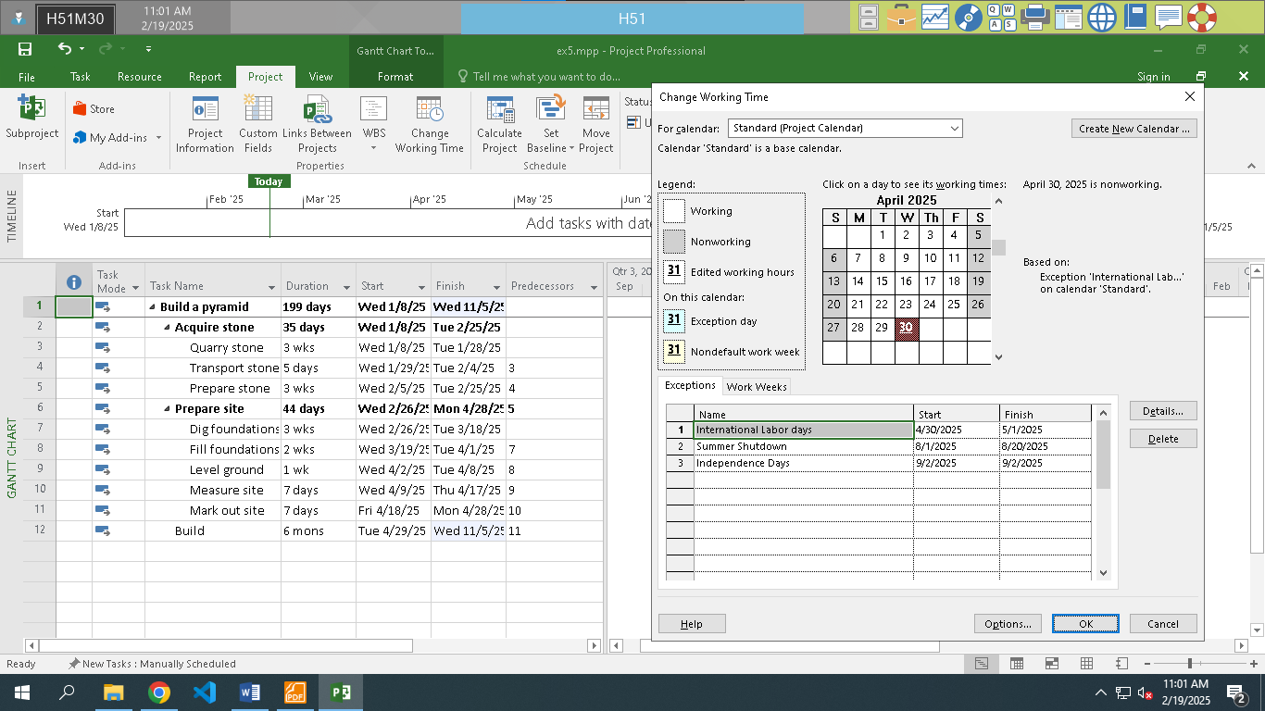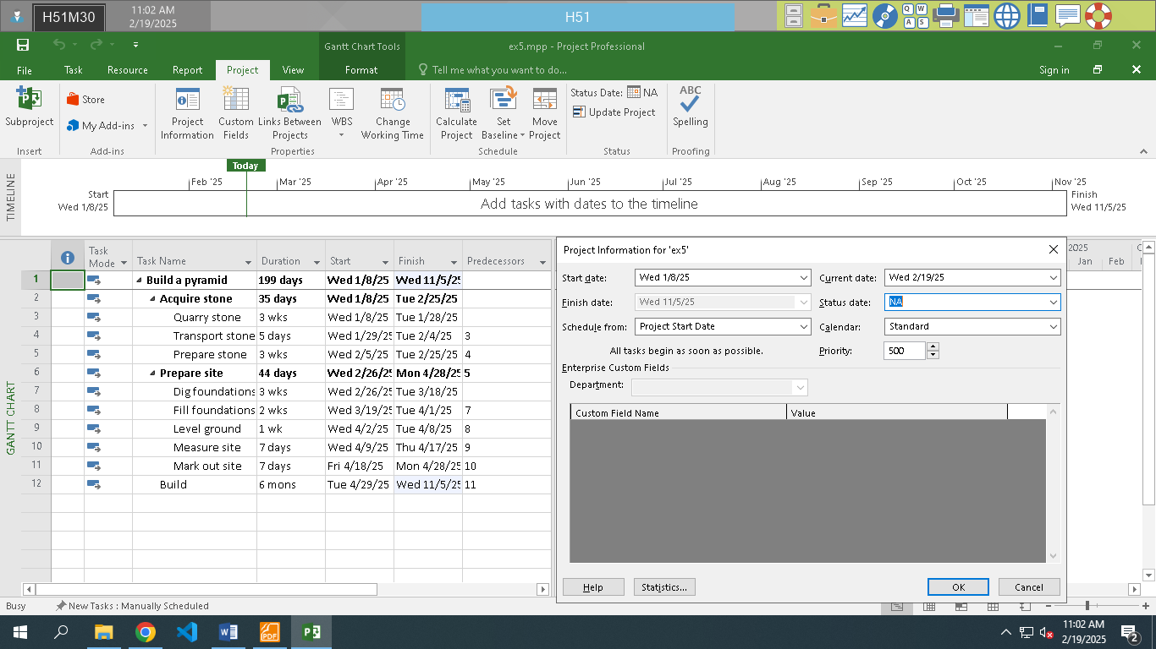

## Exercise 4. Changing Working Time

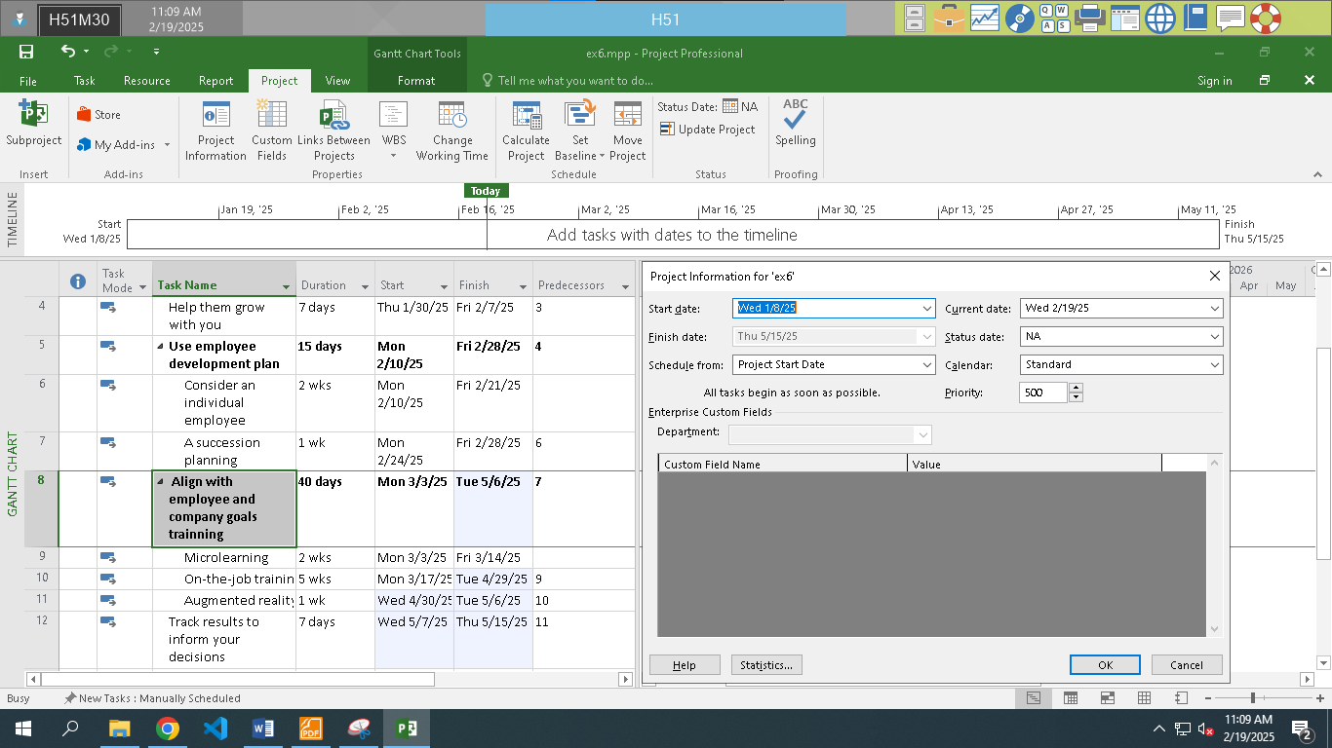

## Exercise 5. Create the private Time for a project

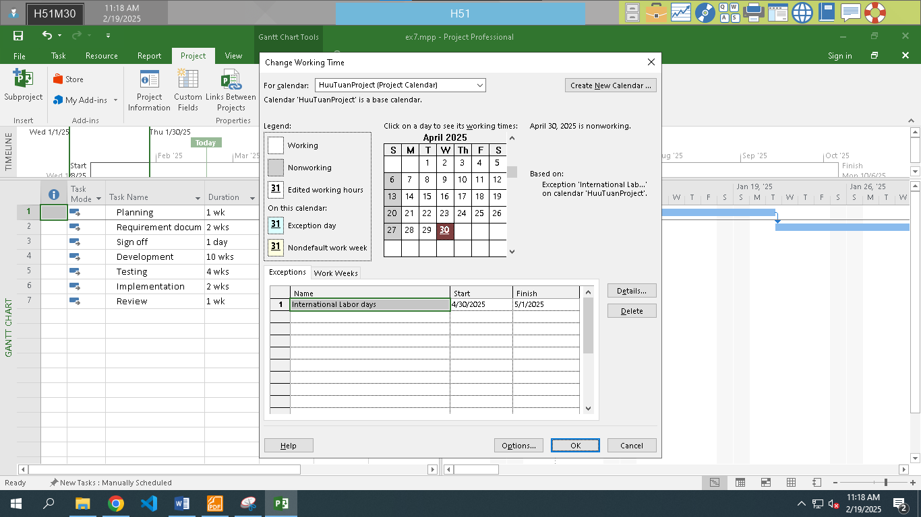

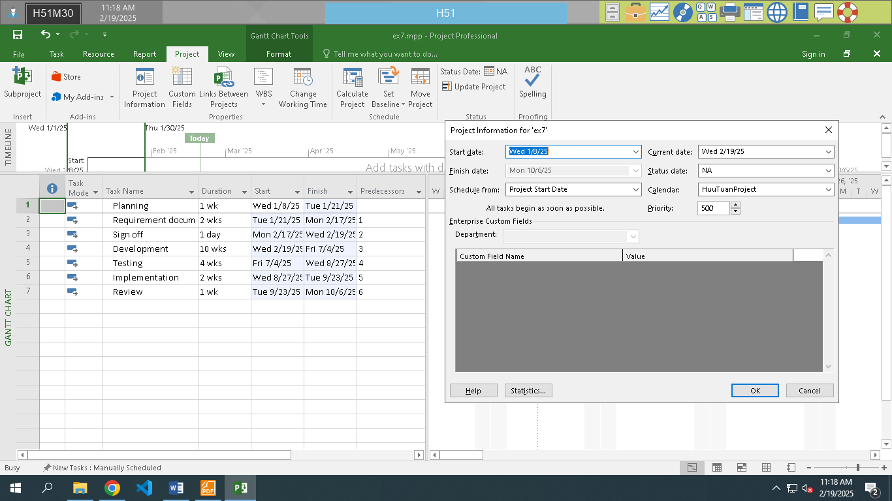

# 

## Exercise 1. Changing Working Time (Start Date 1/3/2025)

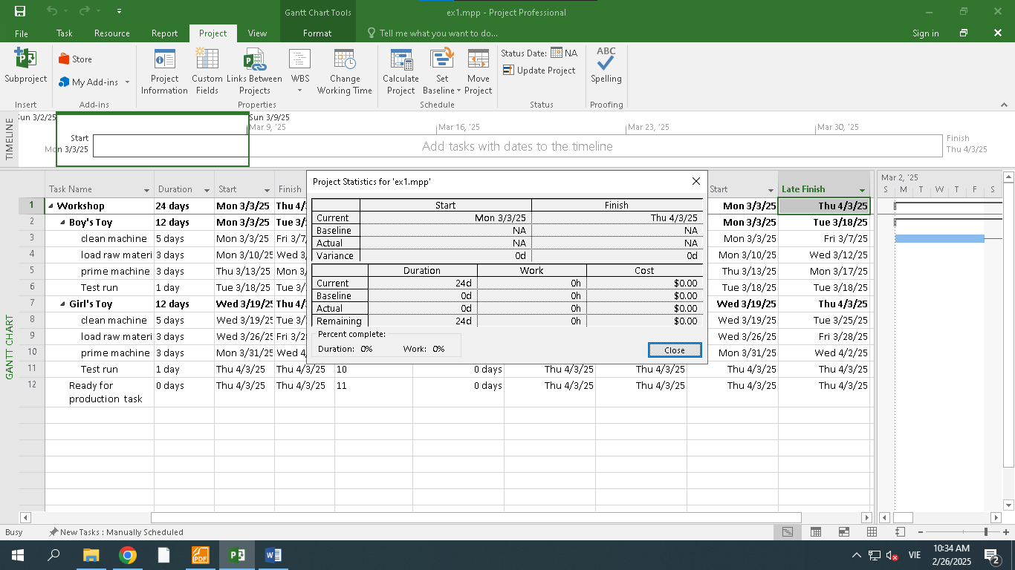

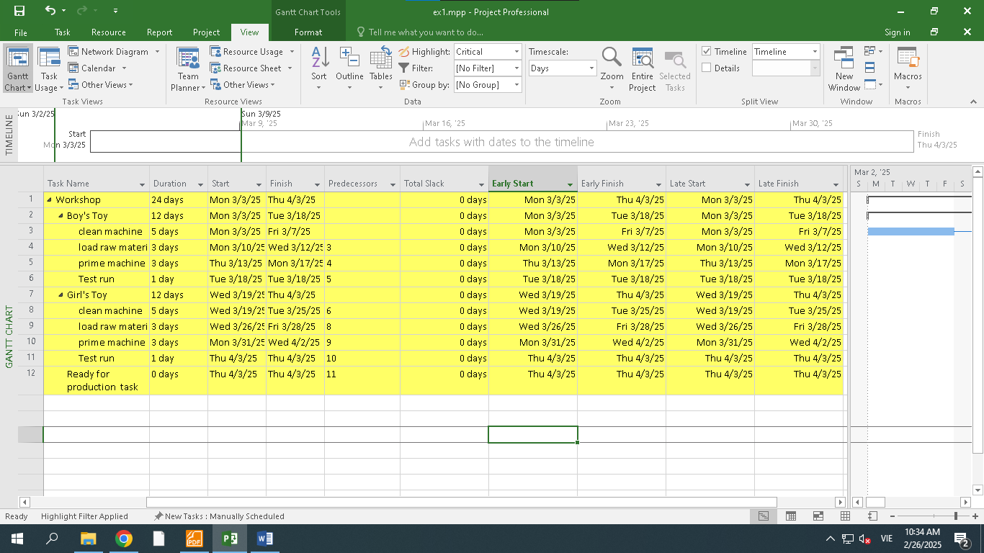

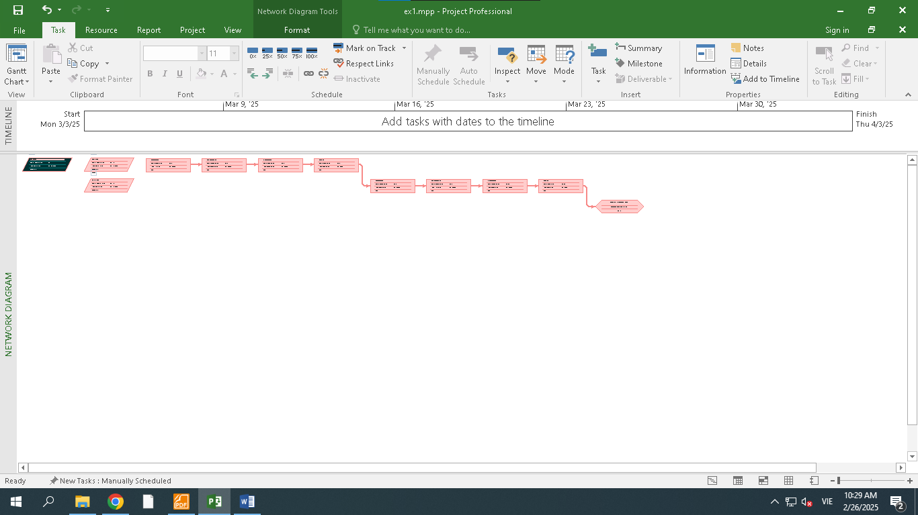

## Exercise 2. Changing Working Time (Start Date 1/3/2025)

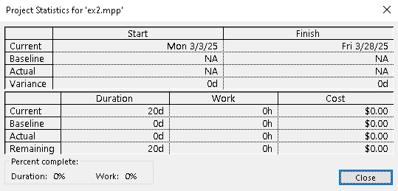

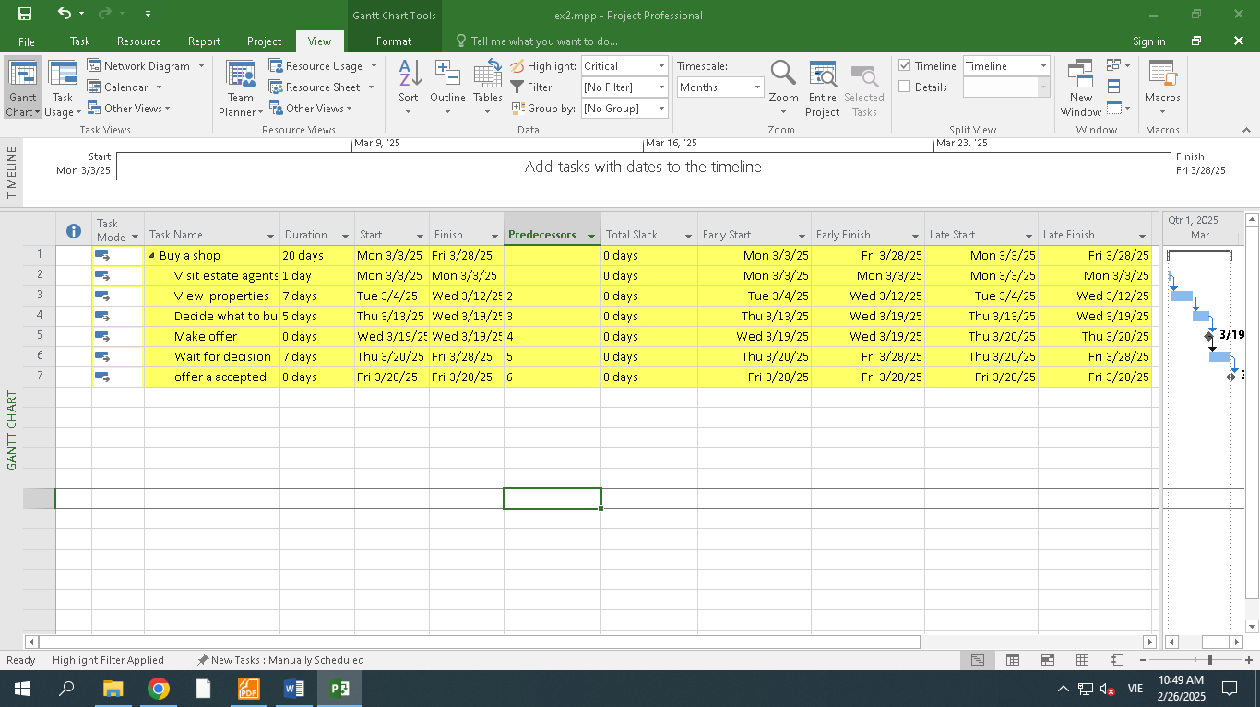

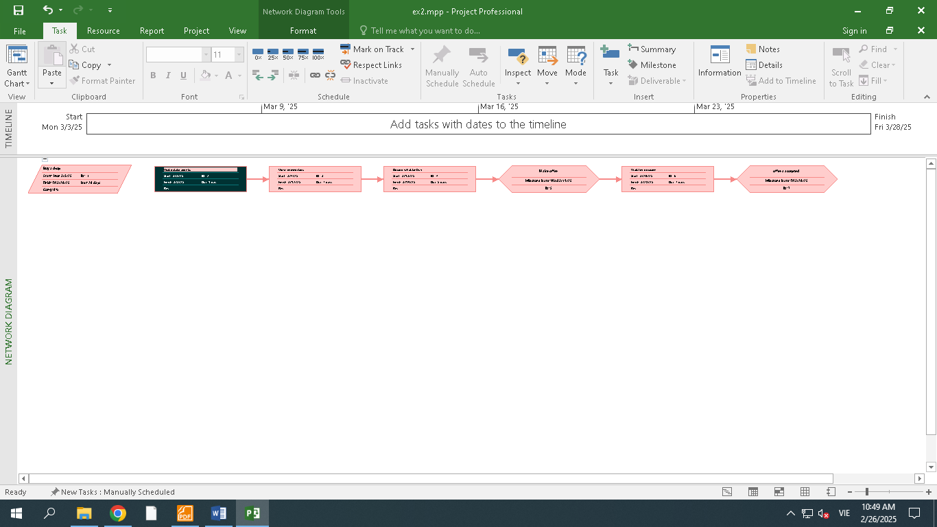

## Exercise 3. Scheduling – Task dependencies

