Lab report – Project Management

**LAB REPORT**

**Software Project Management**

**Student Name: Nguyễn Hữu Tuấn**

**ID: 21118131**

**Class: DHKTPM17CTT**

**Course:**

STUDENT NAME **1**

Lab report – Project Management

Mục Lục

**Module 1. 3**

Exercise 1. Creating a link 3

Exercise 2. Setting duration 4

Exercise 3. Creating phases 4

Exercise 4. Noah – Linking 6

Exercise 5. Pyramid - Multi level grouping 7

Exercise 6. Creating a plan for Staff Training 8

Exercise 7. Recurring tasks 9

**Module 2. 11**

Exercise 1. Part Time - creating new calendar 11

Exercise 2. Changing Working Time 12

Exercise 3. Changing Working Time 13

Exercise 4. Changing Working Time 14

Exercise 5. Create the private Time for a project 15

**Module 3. 16**

Exercise 1. Changing Working Time (Start Date 1/3/2025) 16

Exercise 2. Changing Working Time (Start Date 1/3/2025) 17

Exercise 3. Scheduling – Task dependencies 19

**Module 4. 22**

Exercise 1. Entering Resources 22

Exercise 2. Entering resources 23

Exercise 3. Entering resources 24

Exercise 4. Entering resources 25

Exercise 5. Resources with the private working time 26

Lab report – Project Management

# Module 1.

## Exercise 1. Creating a link

View Project Timeline:

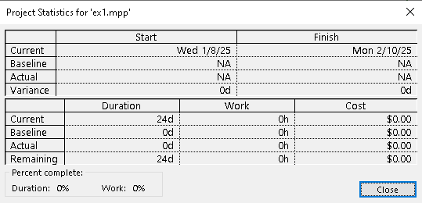

Gant Chart:

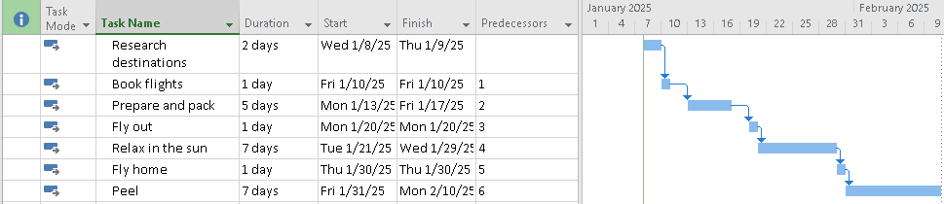

Network Diagram:





## Exercise 2. Setting duration

View Project Timeline:

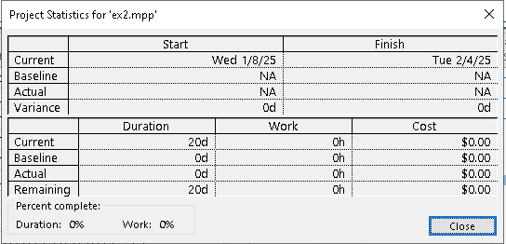

Gant Chart:

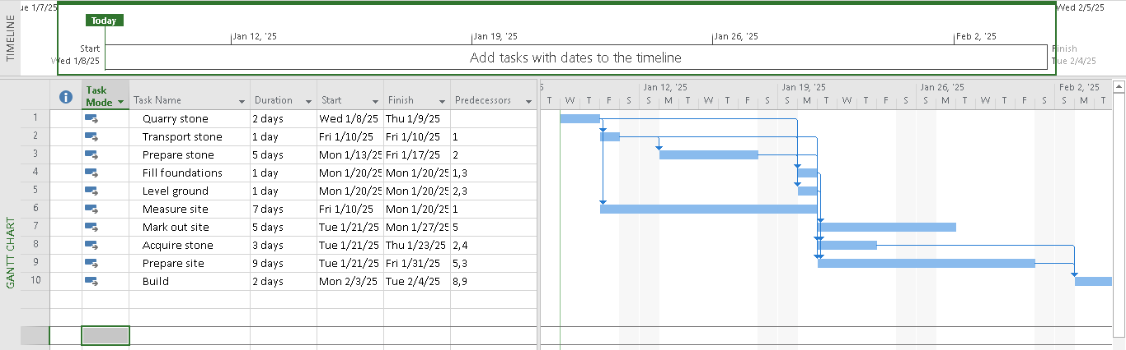

Network Diagram:

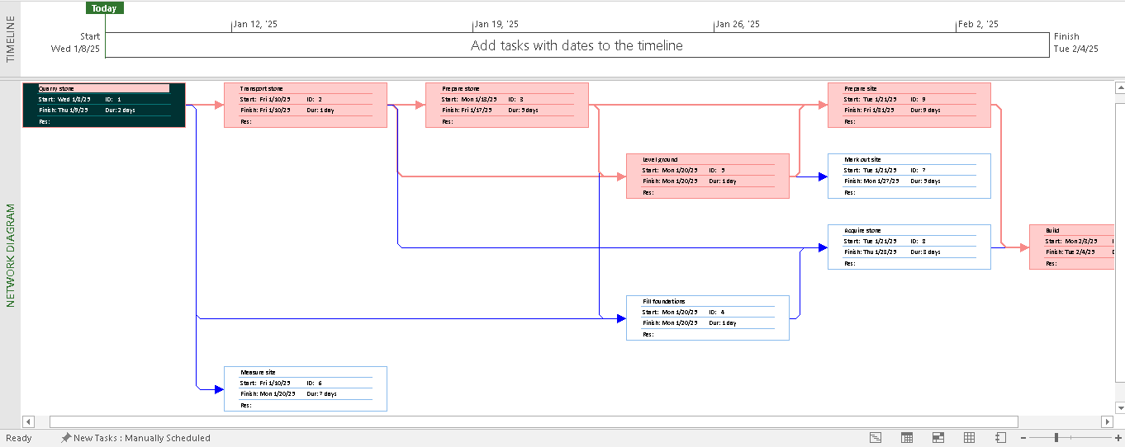

## Exercise 3. Creating phases

View Project Timeline:

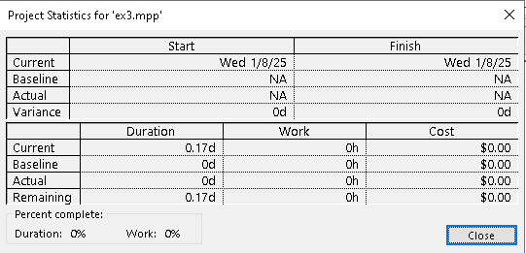

Gant Chart:

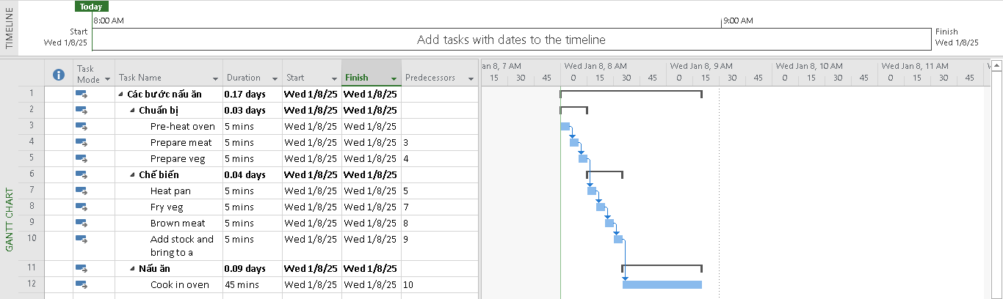

Network Diagram:

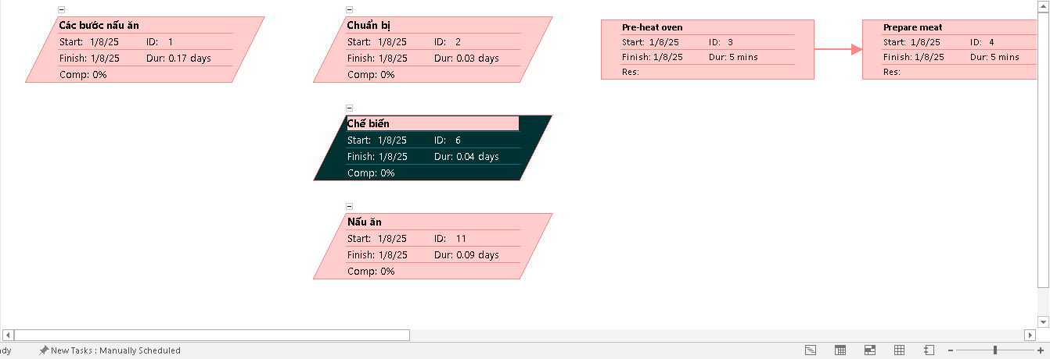

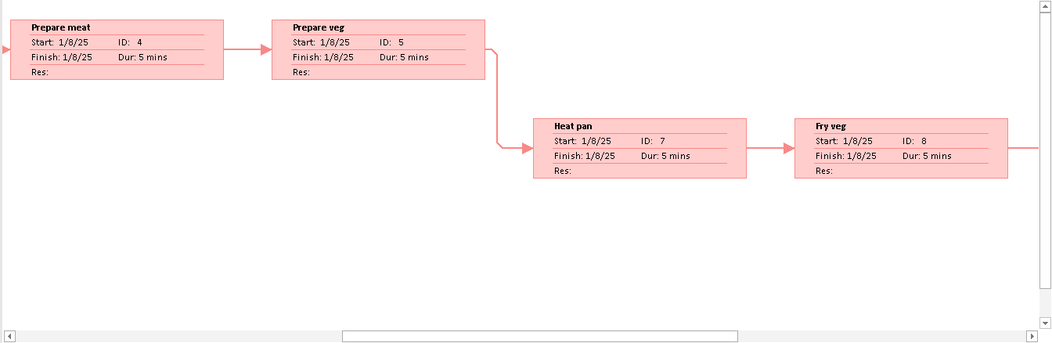

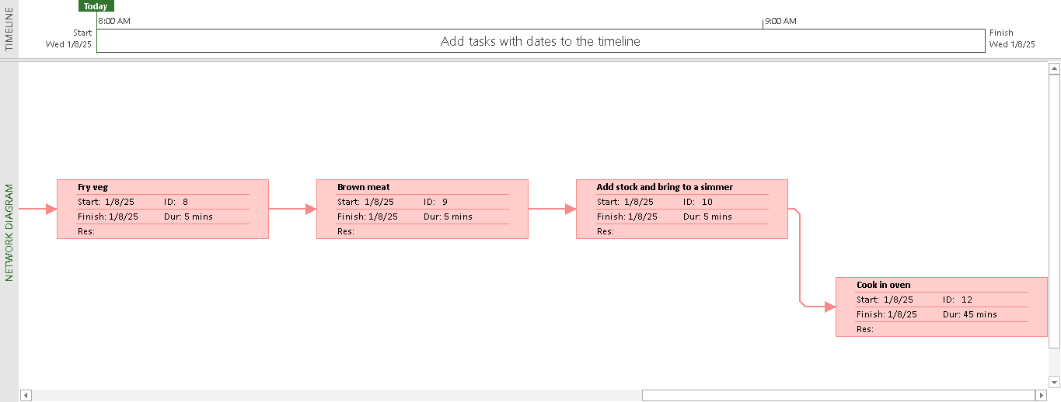

## Exercise 4. Noah – Linking

View Project Timeline:

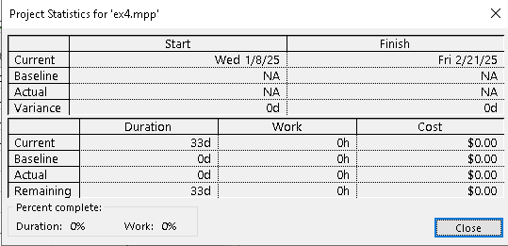

Gant Chart:

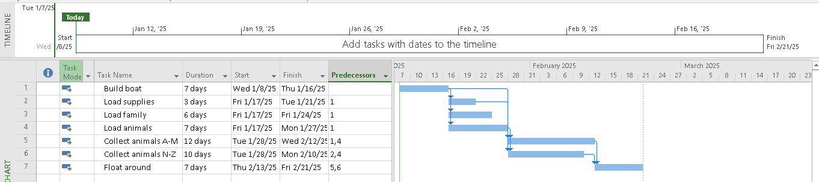

Network Diagram:

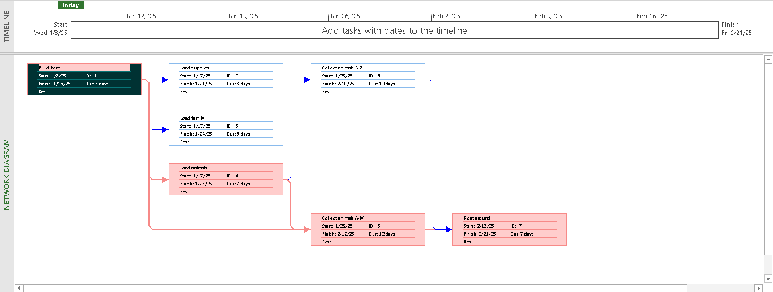

## Exercise 5. Pyramid - Multi level grouping

View Project Timeline:

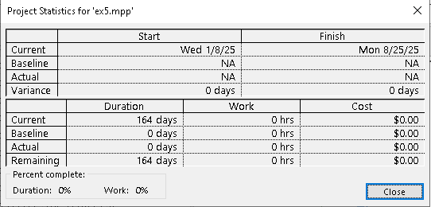

Gant Chart:

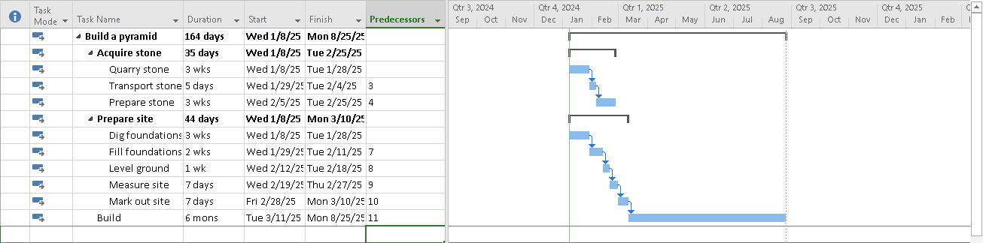

Network Diagram:

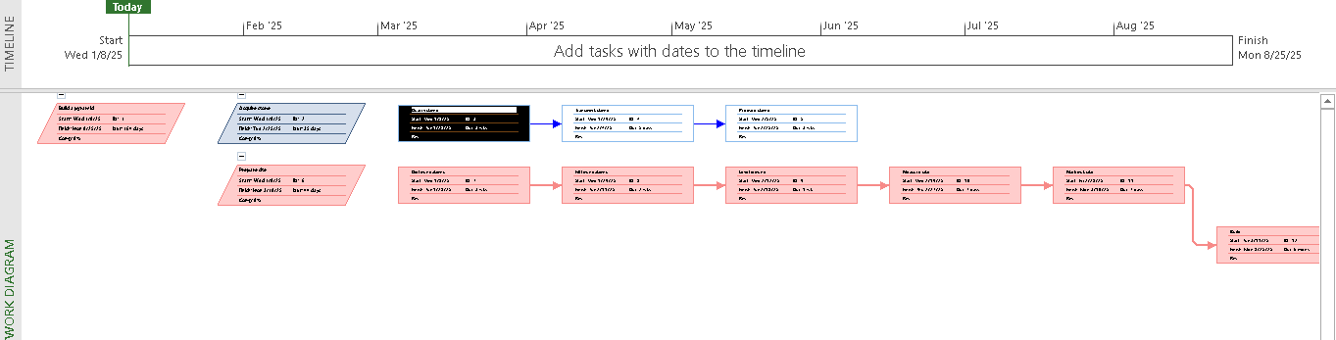

## Exercise 6. Creating a plan for Staff Training

View Project Timeline:

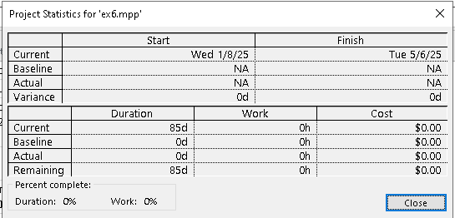

Gant Chart:

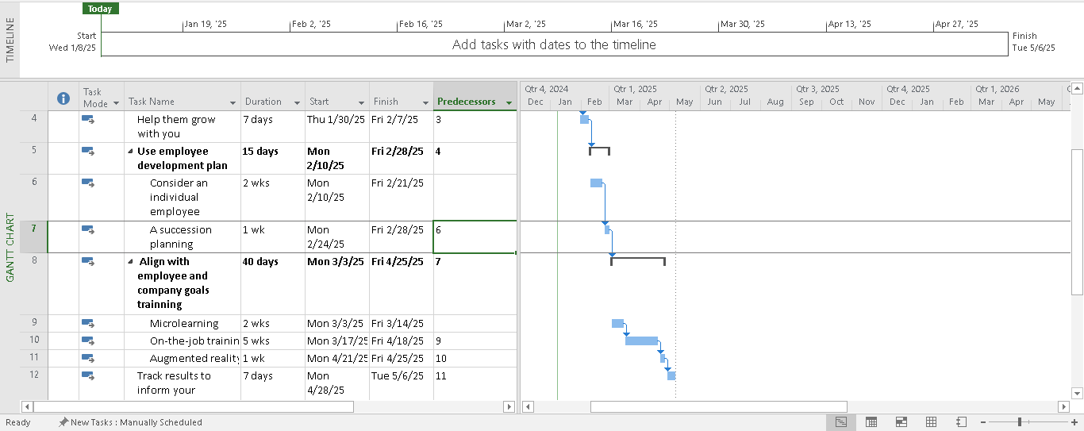

Network Diagram:

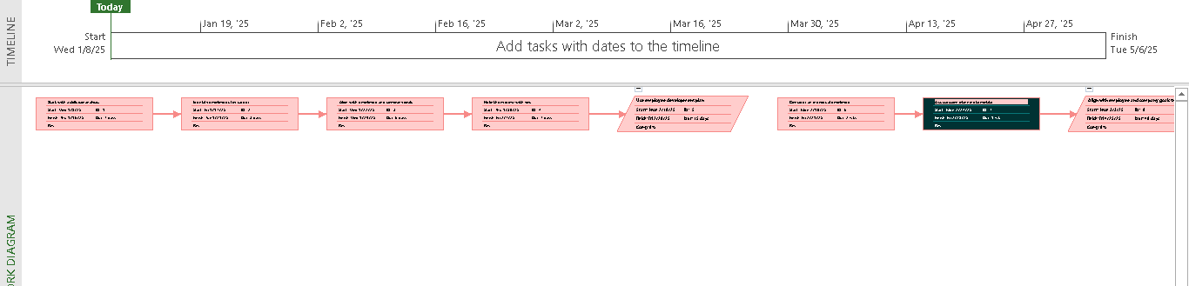

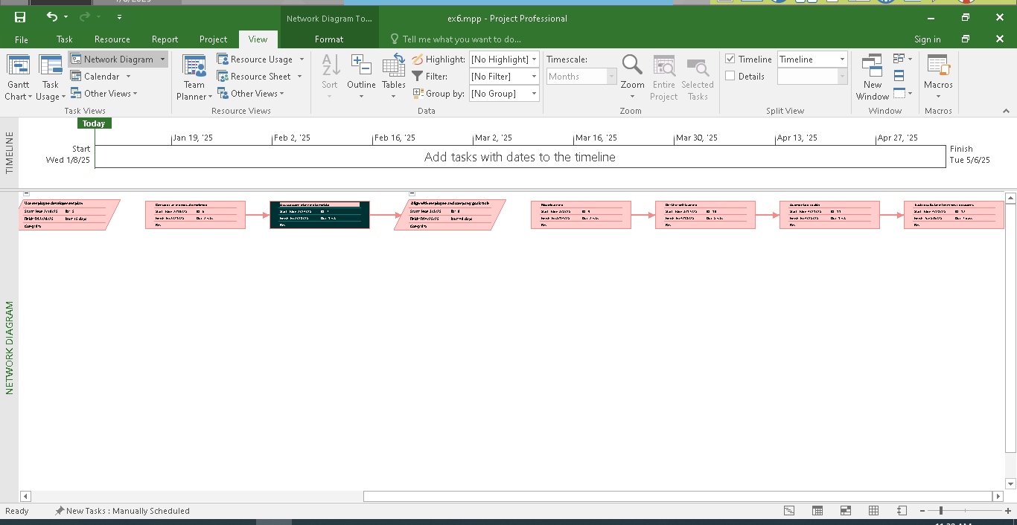

## Exercise 7. Recurring tasks

View Project Timeline:

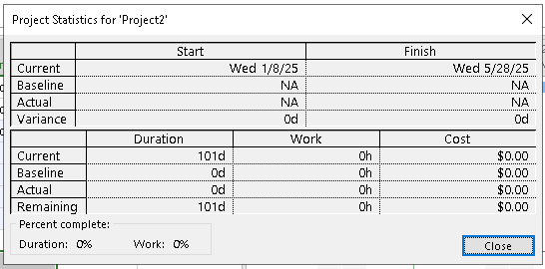

Gant Chart:

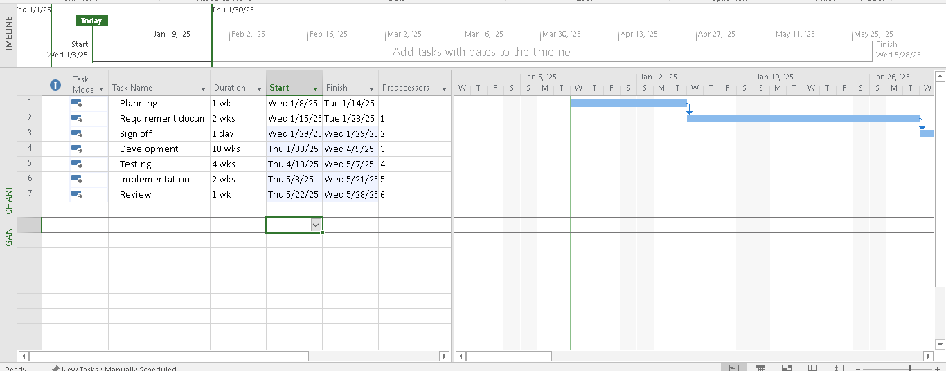

Network Diagram:

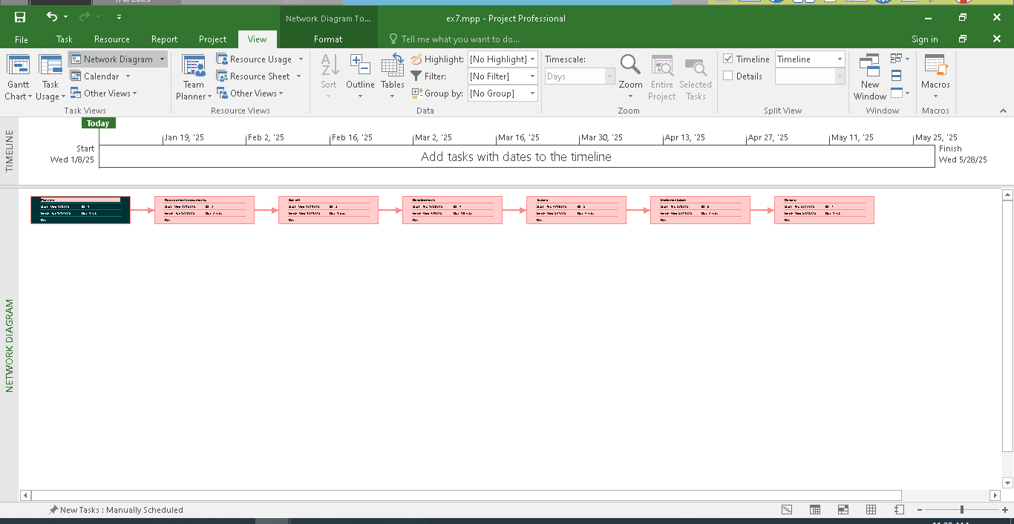

# Module 2.

## Exercise 1. Part Time - creating new calendar

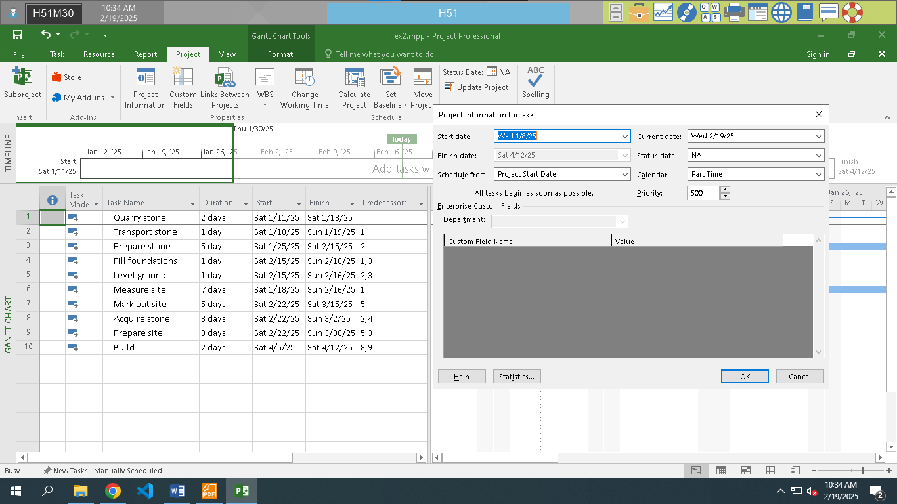

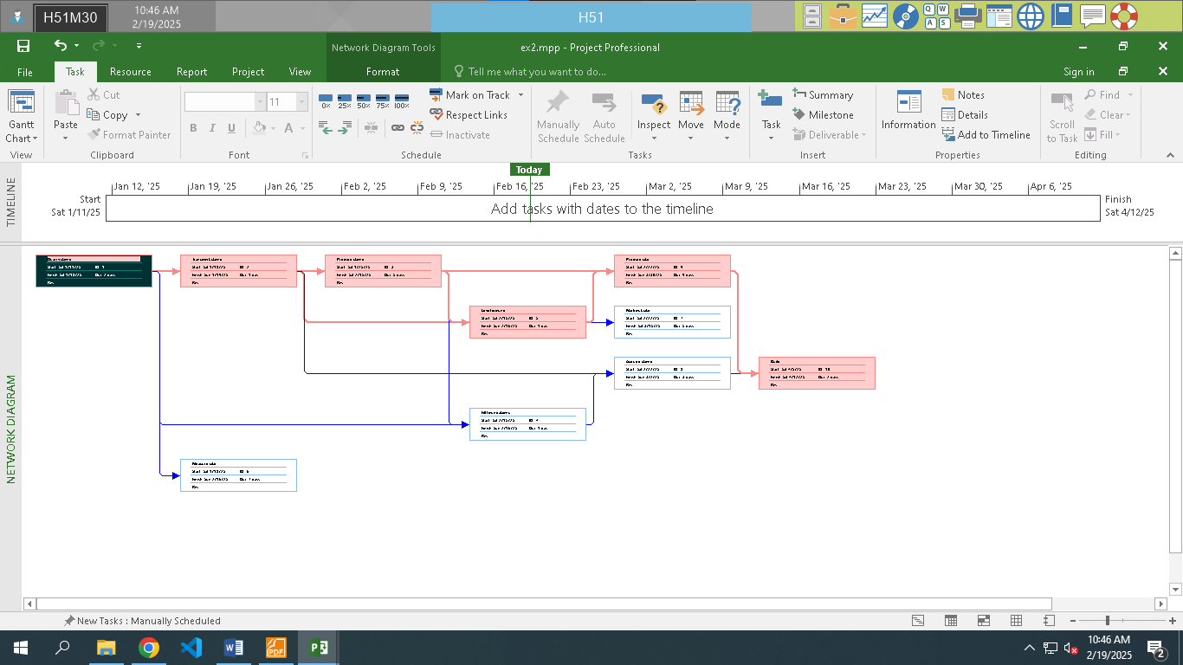

## Exercise 2. Changing Working Time

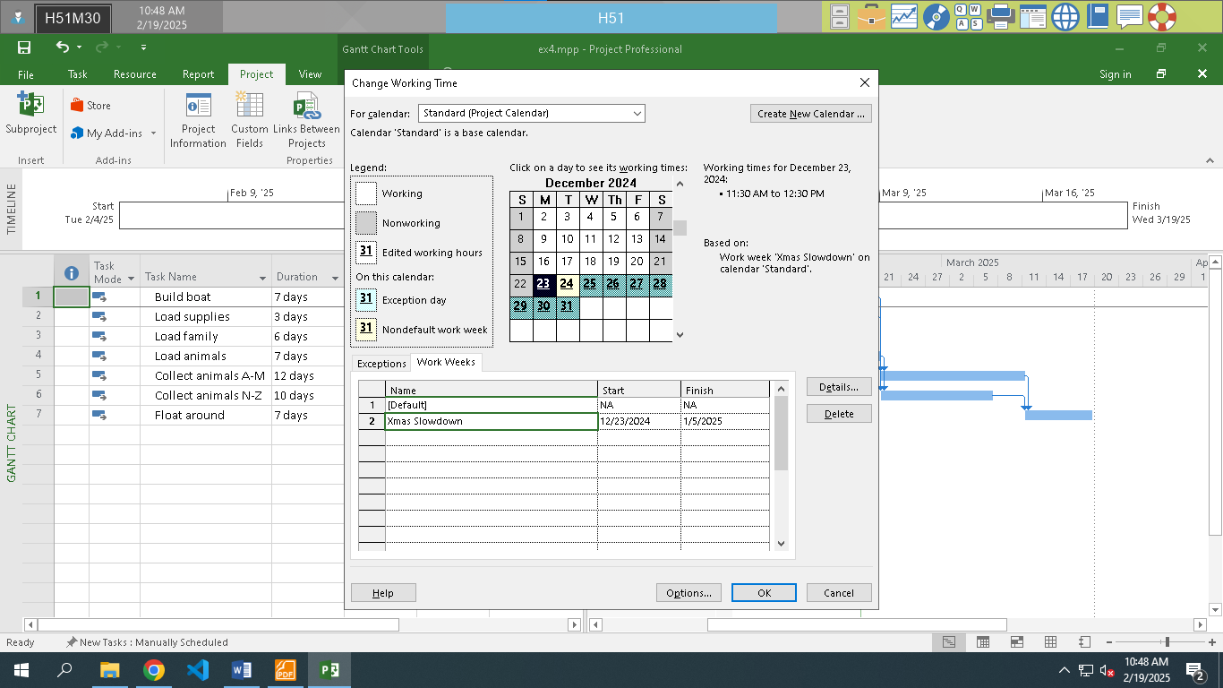

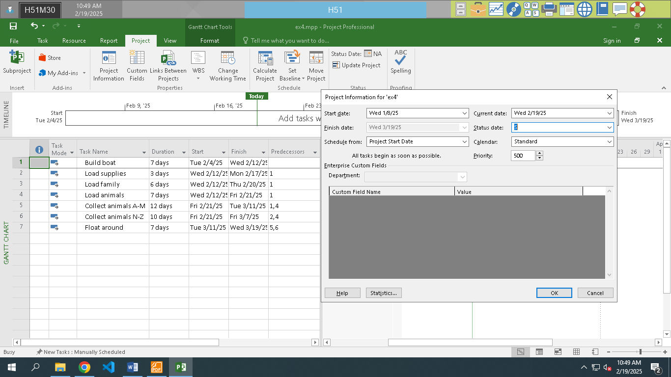

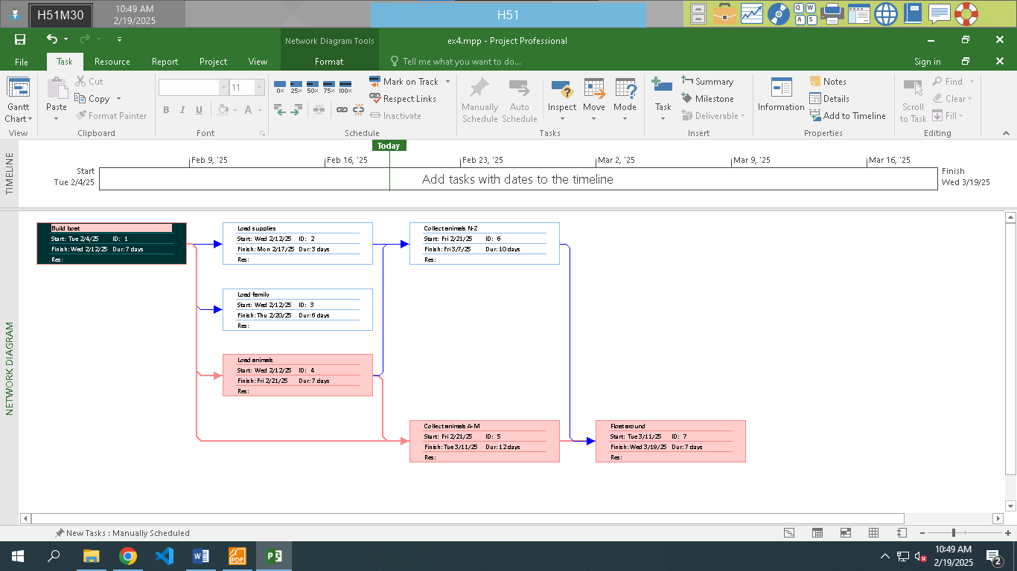

## Exercise 3. Changing Working Time

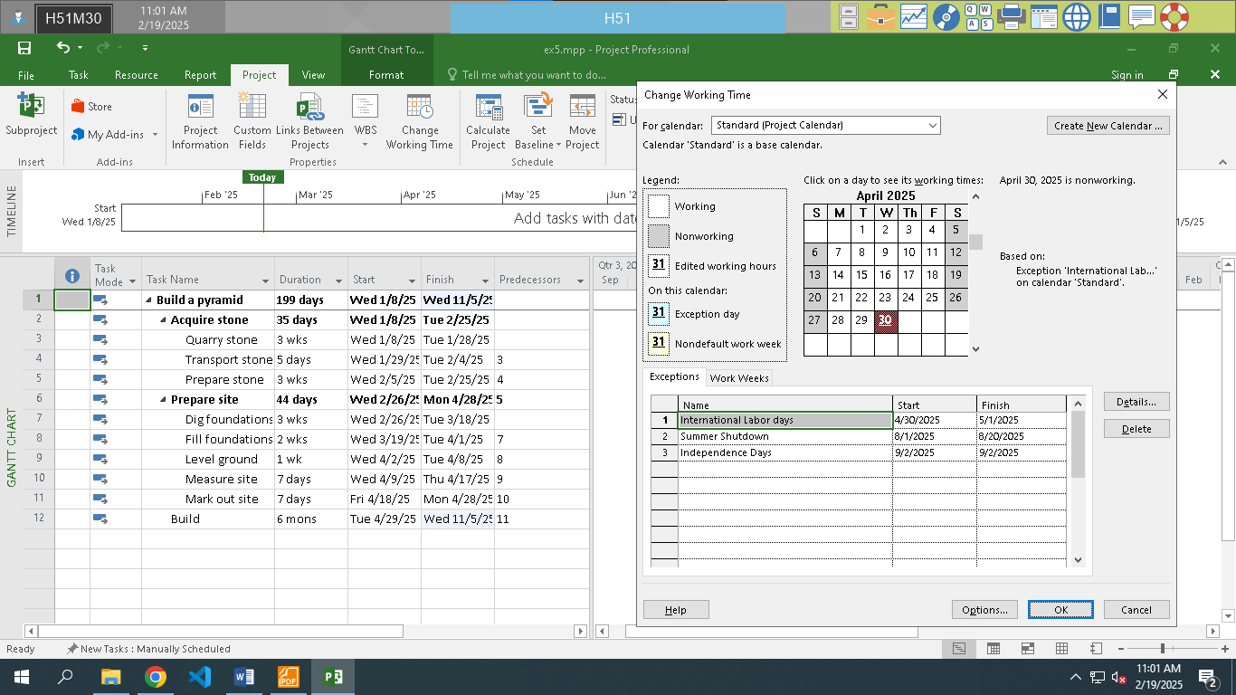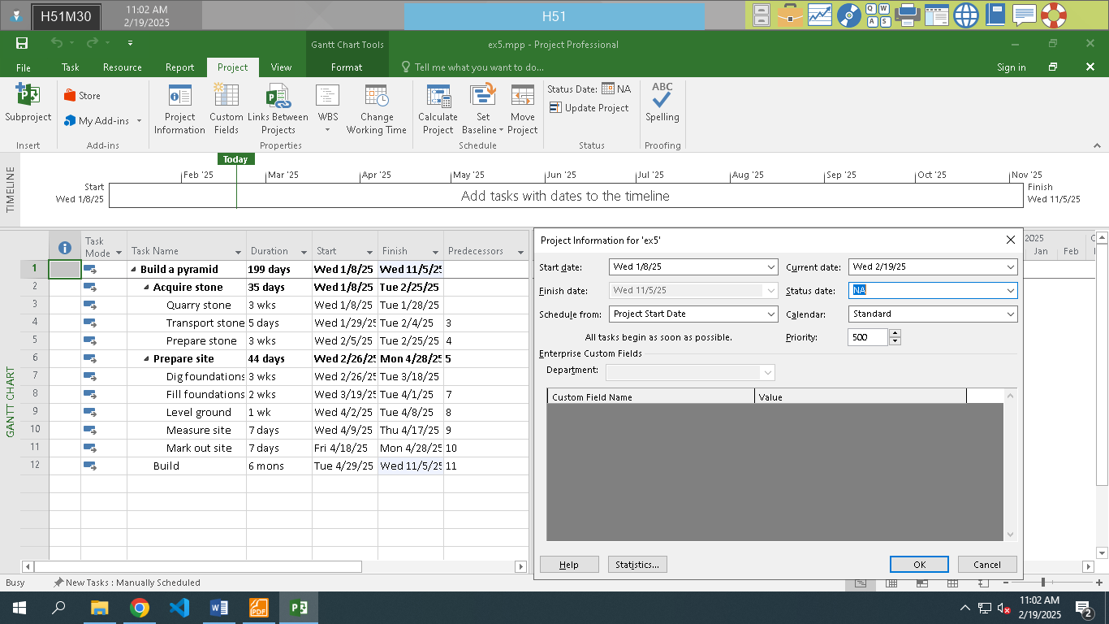

## Exercise 4. Changing Working Time

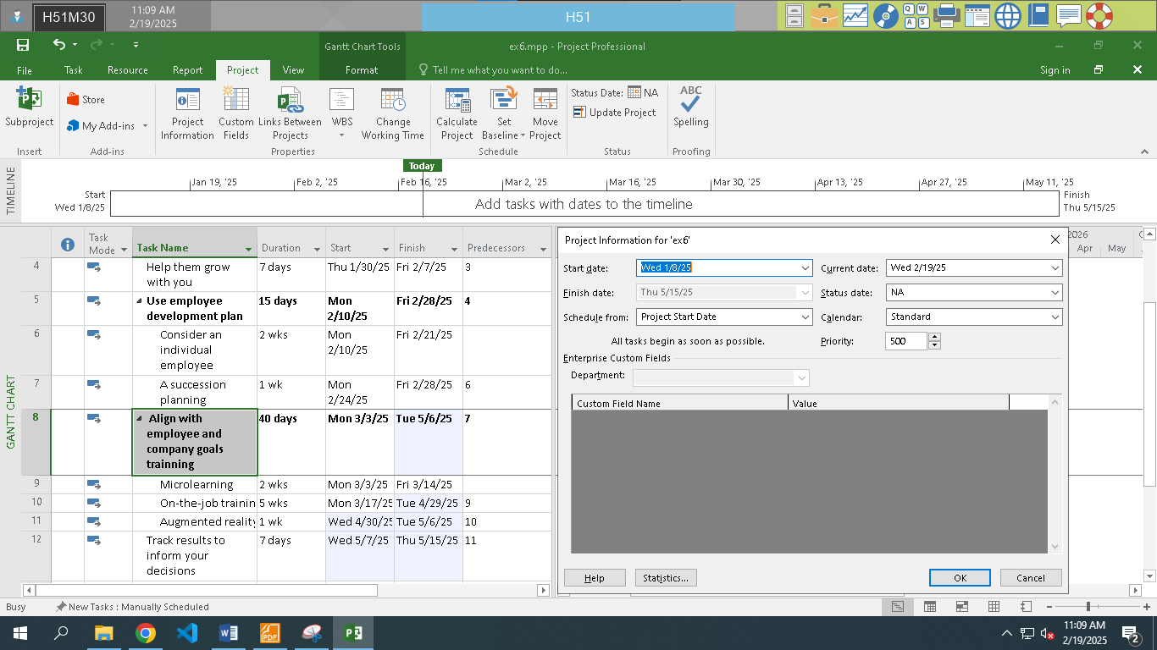

## Exercise 5. Create the private Time for a project

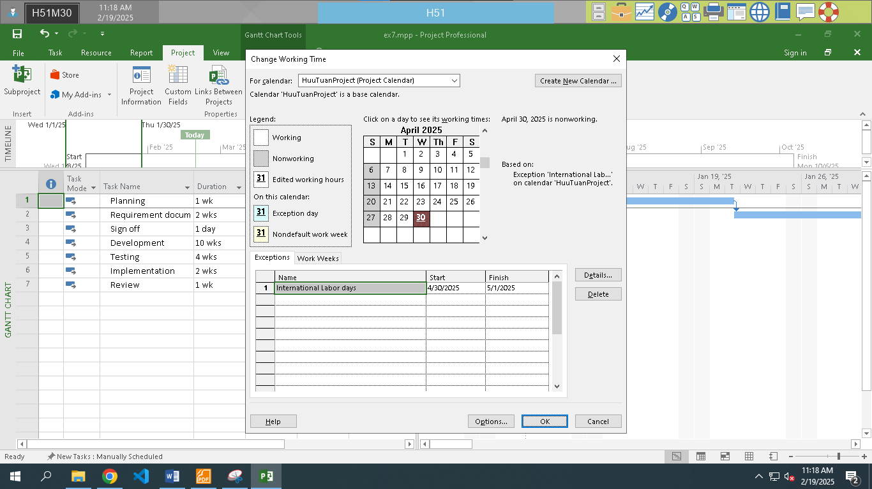

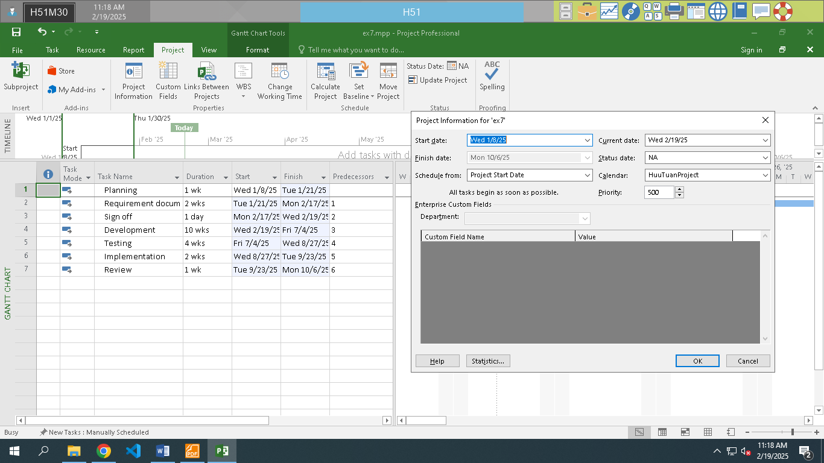

# Module 3.

## Exercise 1. Changing Working Time (Start Date 1/3/2025)

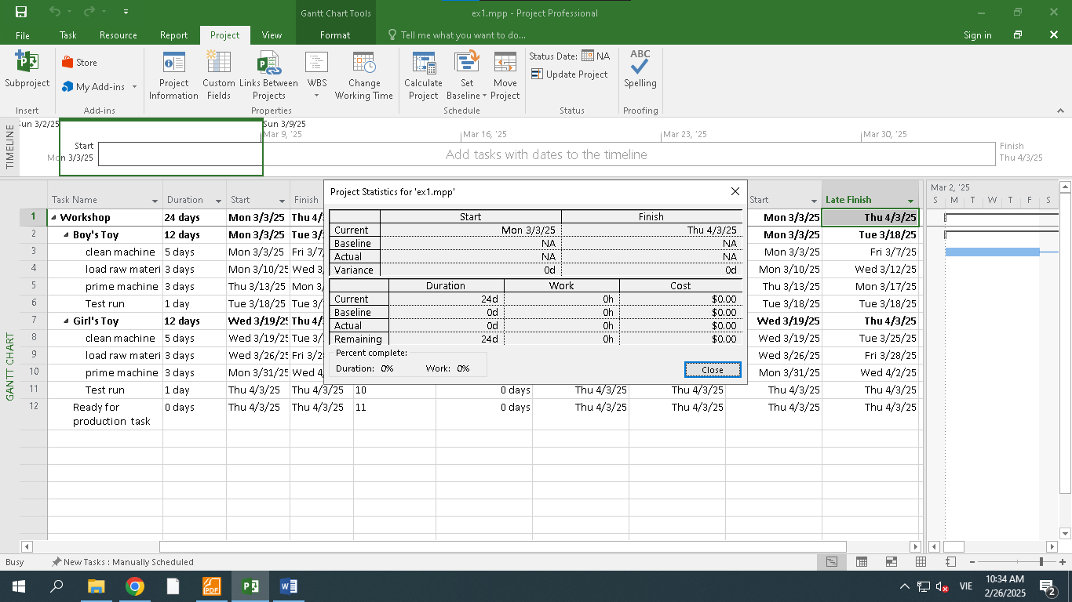

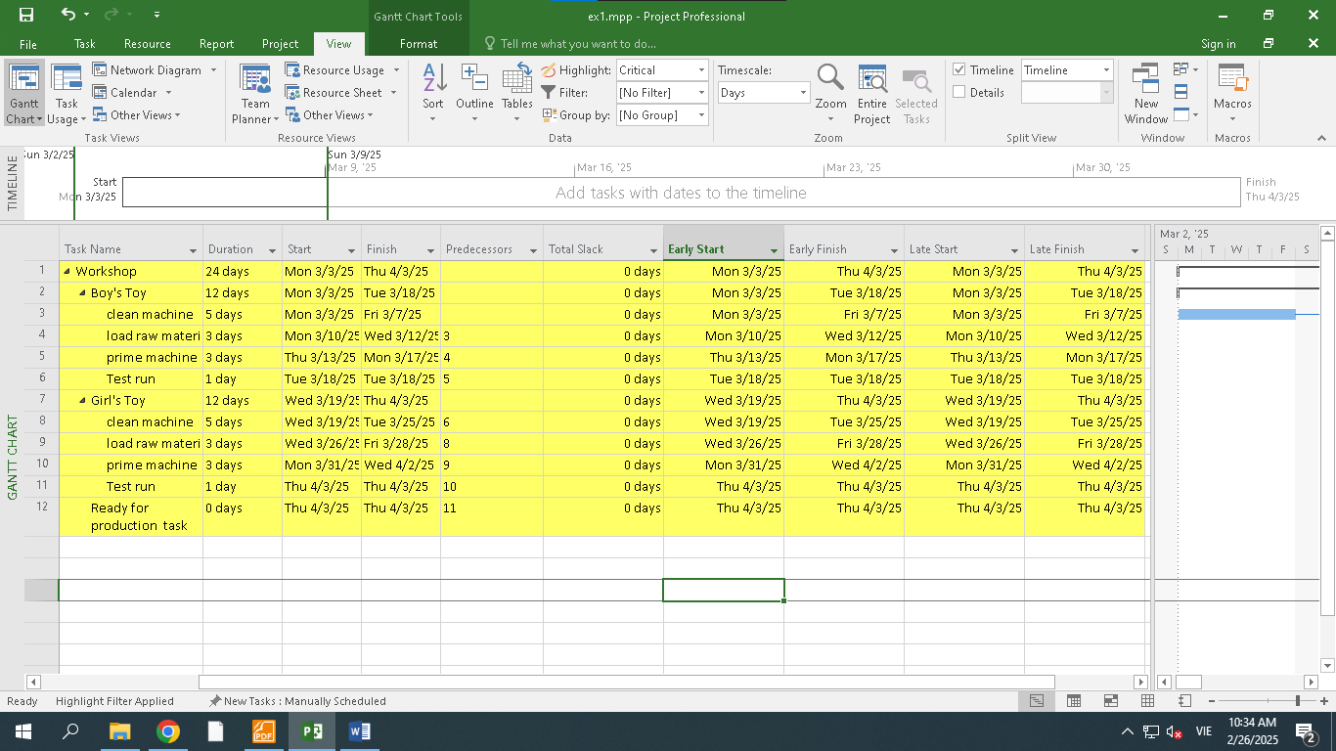

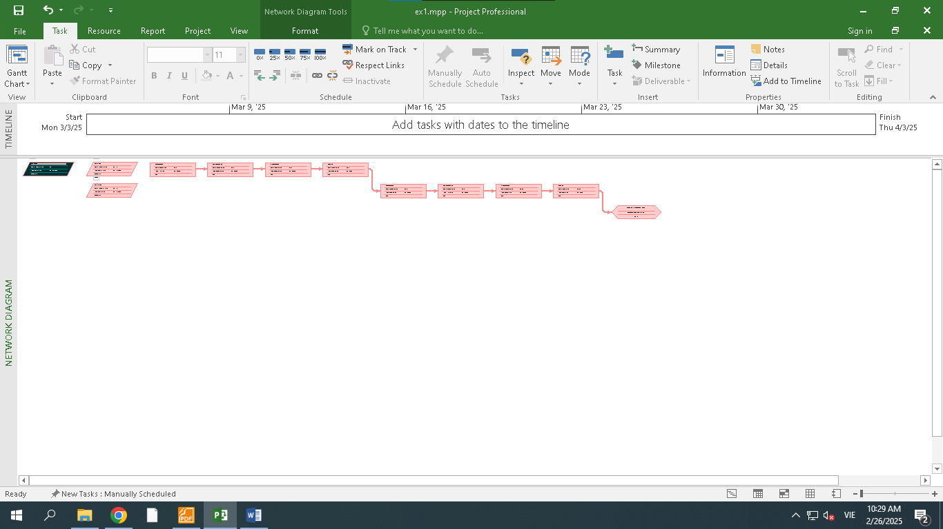

## Exercise 2. Changing Working Time (Start Date 1/3/2025)

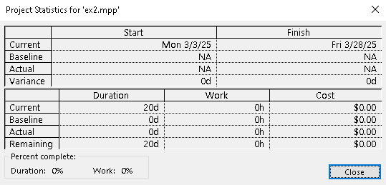

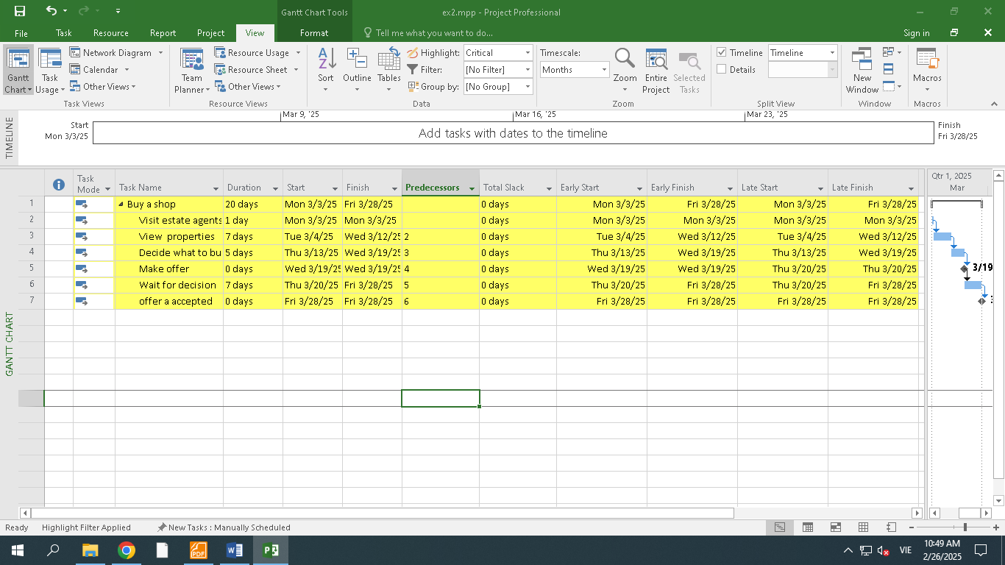

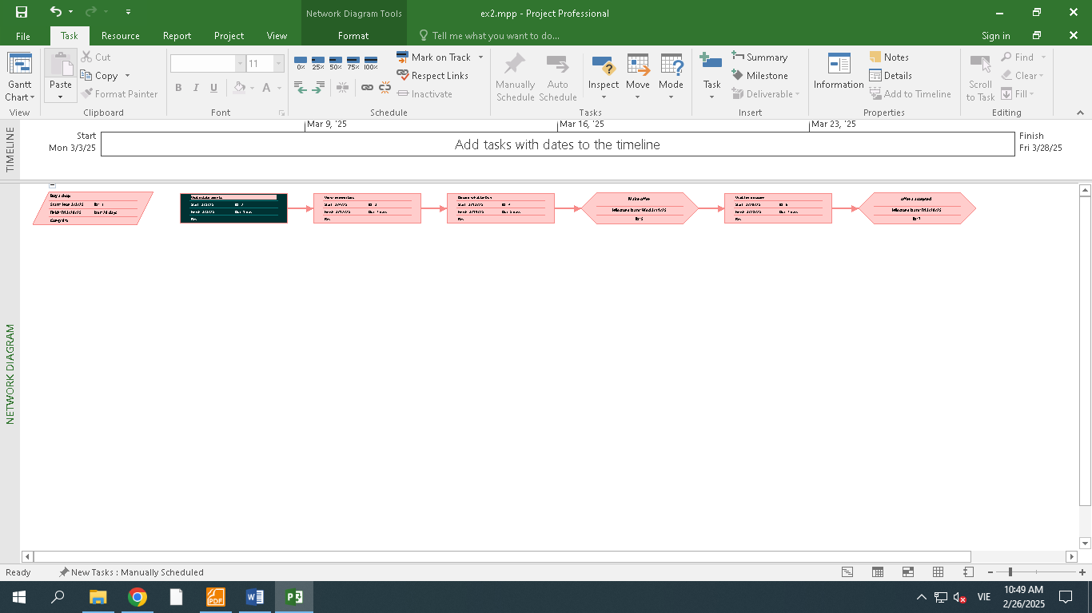

## Exercise 3. Scheduling – Task dependencies

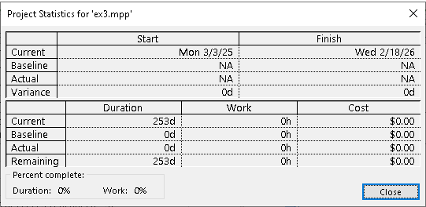

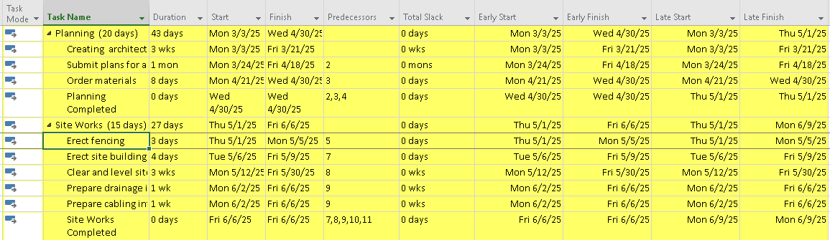

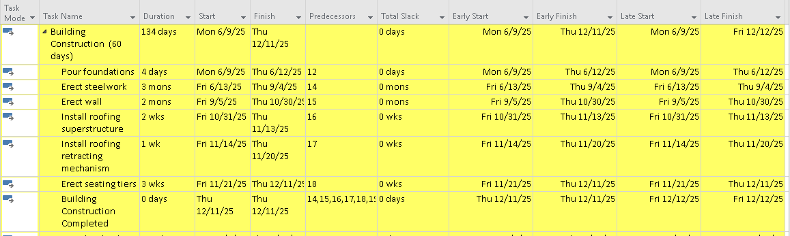

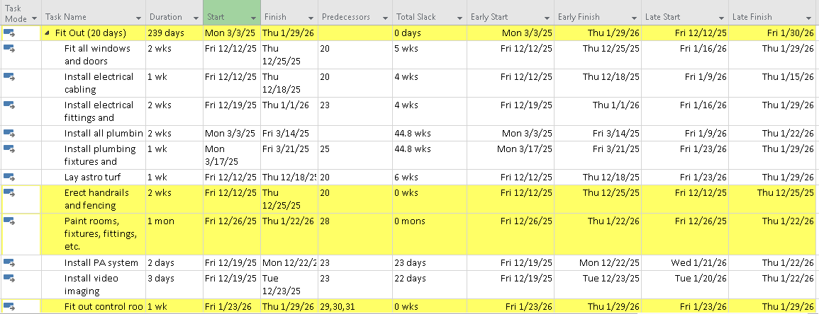

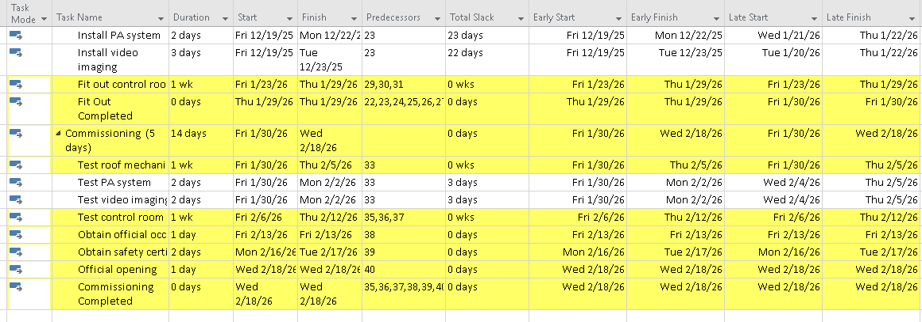

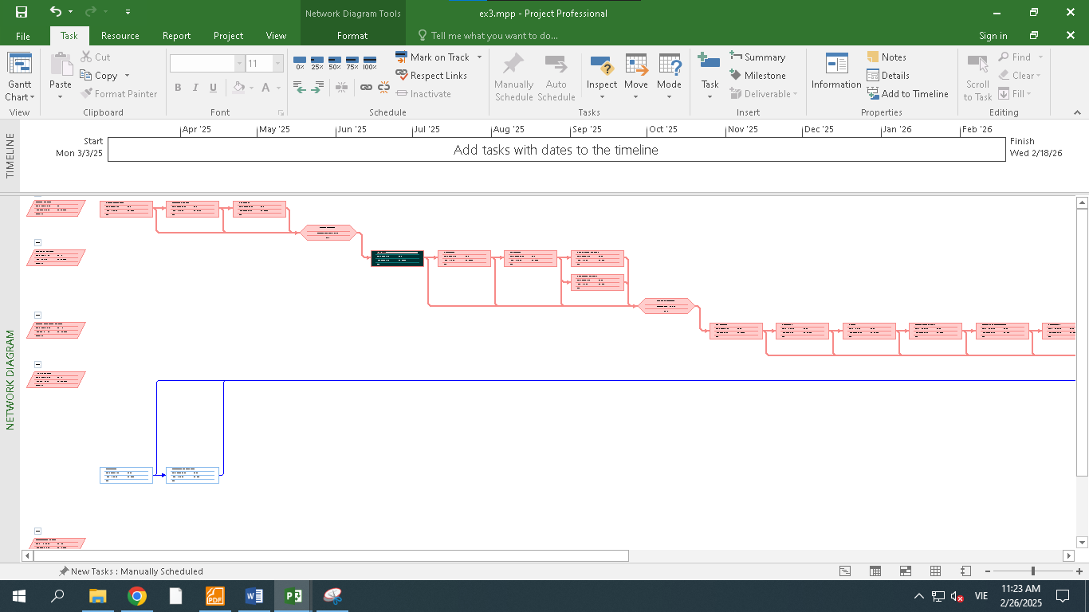

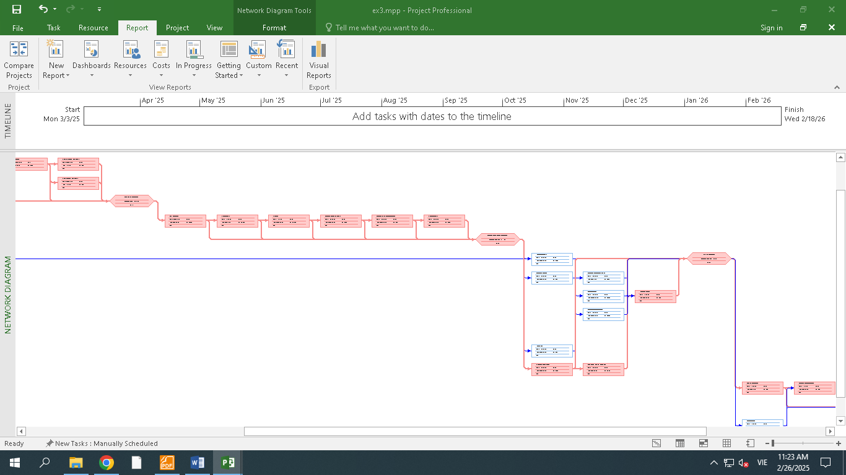

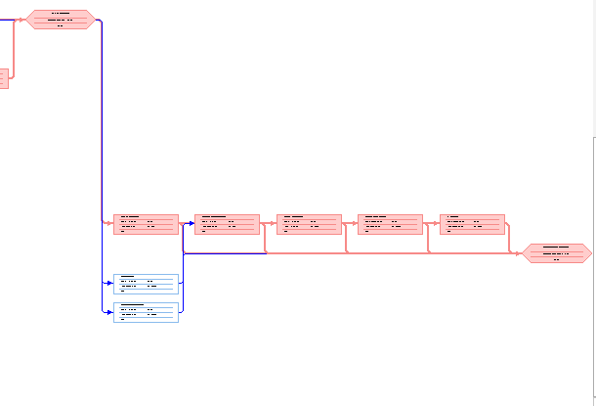

# Module 4.

## Exercise 1. Entering Resources

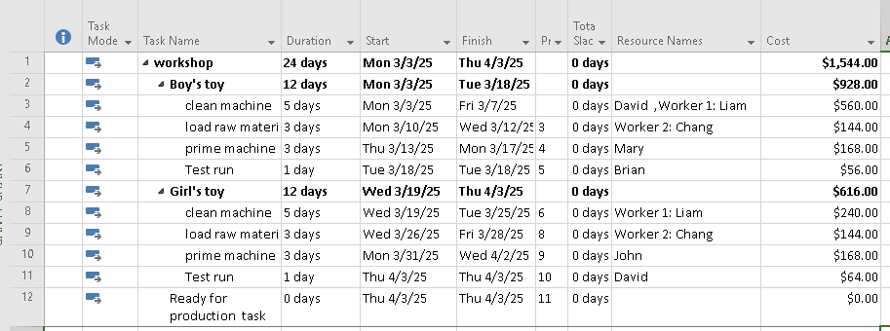

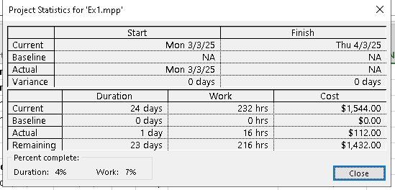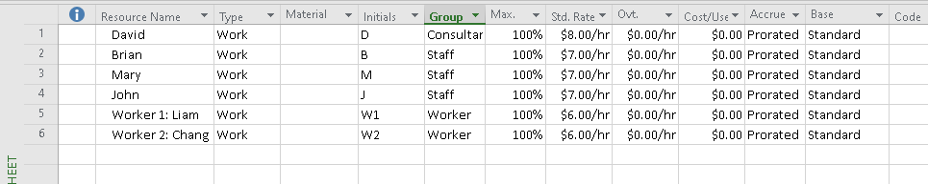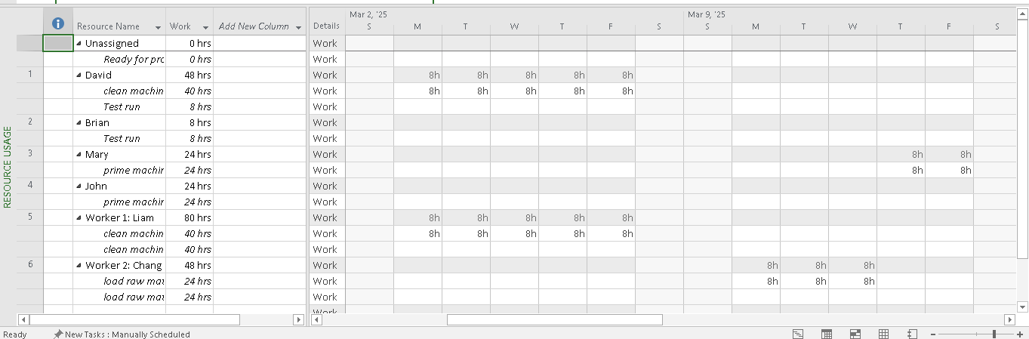

## Exercise 2. Entering resources

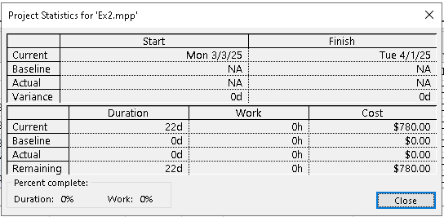

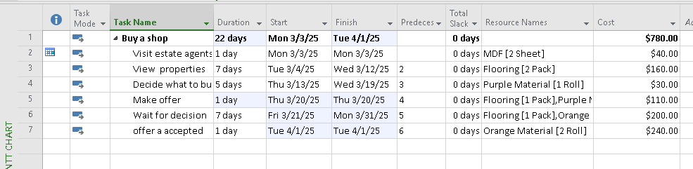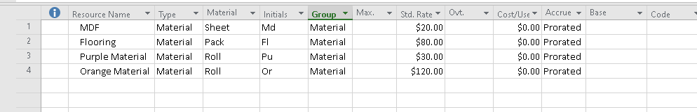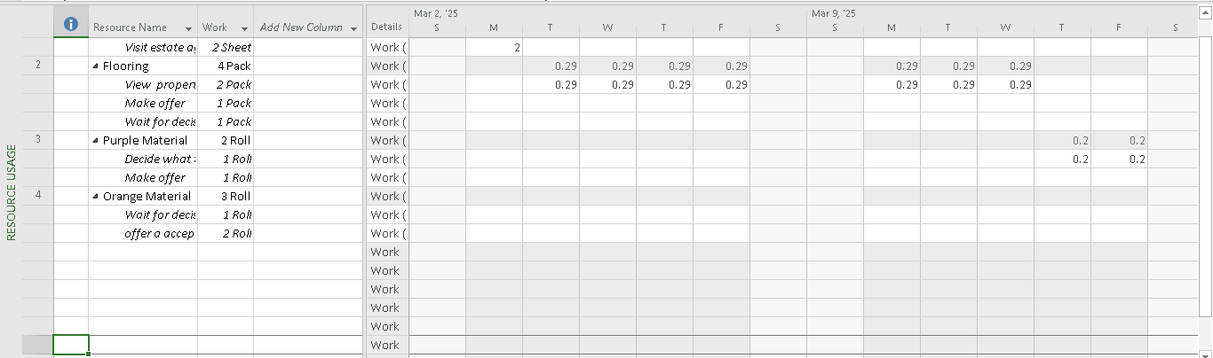

## Exercise 3. Entering resources

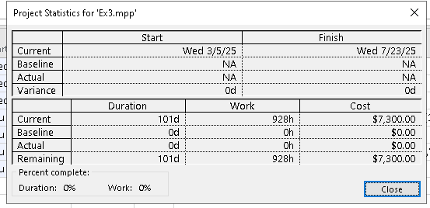

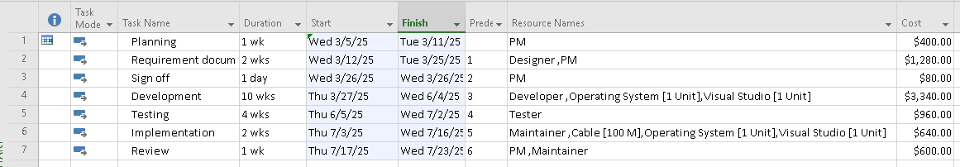

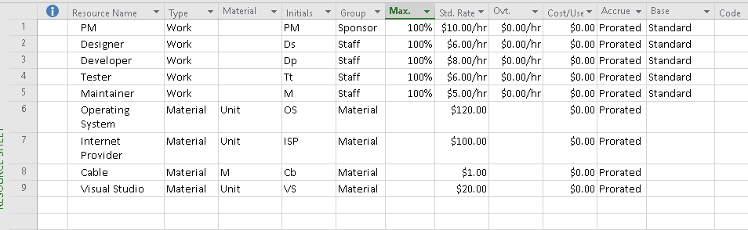

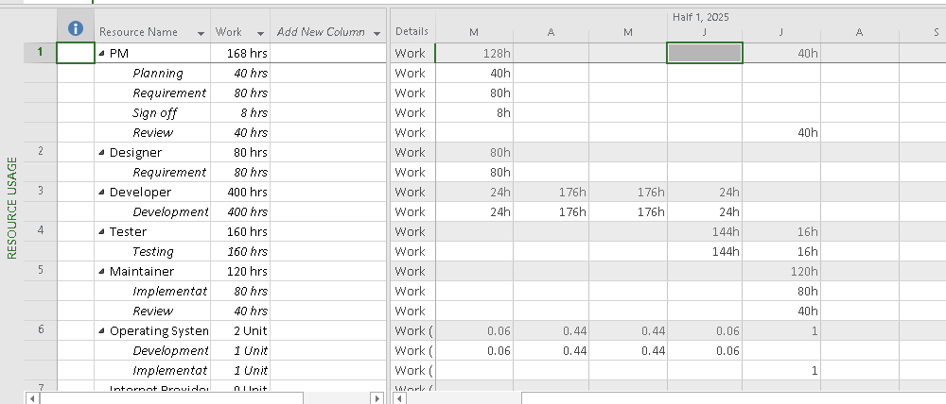

## Exercise 4. Entering resources

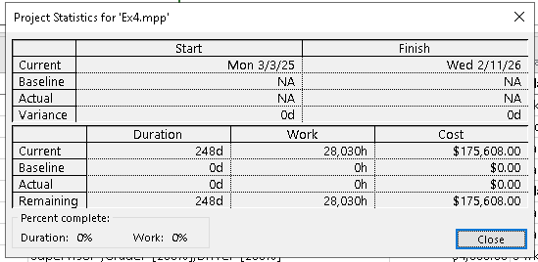

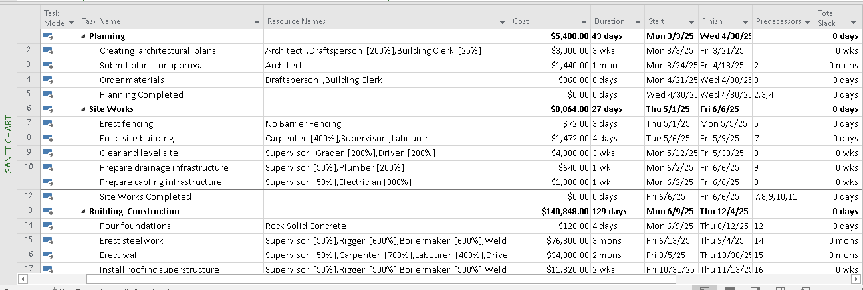

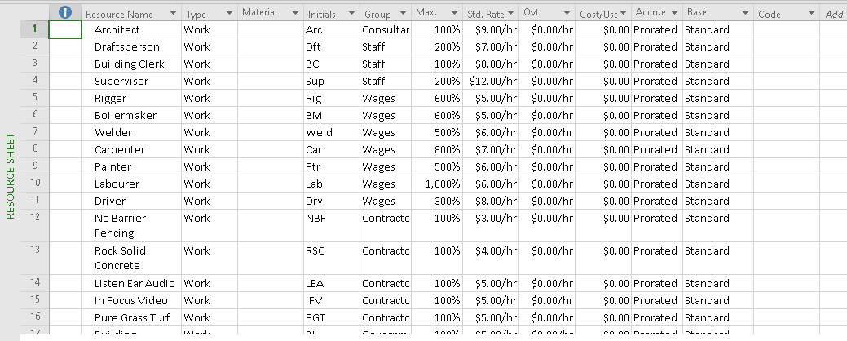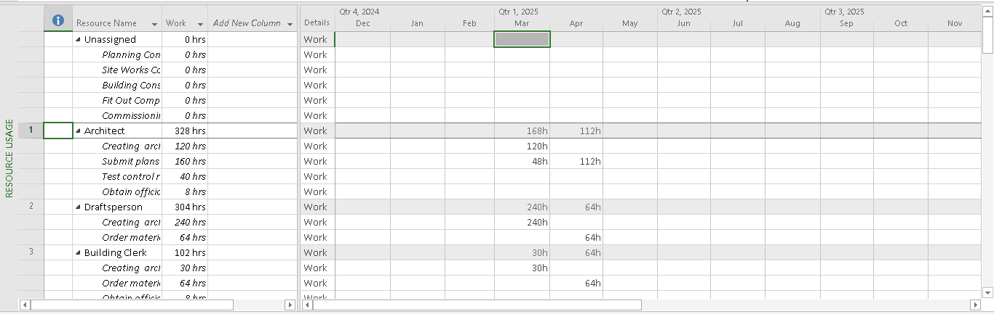

## Exercise 5. Resources with the private working time