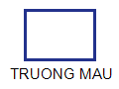 | BÀI KIỂM TRA THỬ  MÔN: TIẾNG ANH – LỚP 3
I. Vocabulary
1. Look and CIRCLE the correct answer. There is one example. (………/ 2 points)
0. | /b/ | A. | 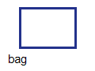 | B. | 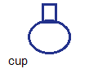 | C. | 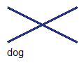
1. | /c/ | A. | 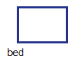 | B. | 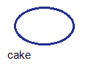 | C. | 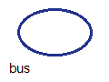
2. | /d/ | A. | 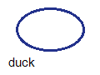 | B. | 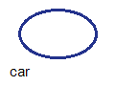 | C. | 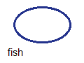
2. Read and WRITE the correct LETTERS in the blank. There is an extra answer.
(………/ 2 points)
A. on | C. under | E. big
B. in | D. small
0. | The cat is ___ the box. (B)
3. | The book is ______ the bag.
4. | My bag is very ______.
II. Reading
3. Read. CIRCLE the correct answer. There is one example. (………/ 2 points)
My pet
I have a __(0)__ cat. Her name (5) ______ Kitty. She likes (6) ______ fish.
0. | A. small | B. smalls | C. smaller
5. | A. are | B. is | C. am
6. | A. eat | B. eats | C. eating

4. Look and read. CIRCLE YES or NO. There is one example. (………/ 2 points)
0. Kitty is a dog. A. Yes B. No
7. Kitty is a cat. | A. Yes | B. No
8. Kitty likes milk. | A. Yes | B. No
III. Writing
5. Look. READ and WRITE the answer. (………/ 2 points)
9. |  | Where is the cat? (under)  Answer: ____________________
10. |  | What does she like? (fish)  Answer: ____________________
The End!

