- NO — em dashes in the system.
- PREVIEW - https://concept-artisan-space.lovable.app

CHANGES IN THE NEW MEETINGS INSIDE DASHBOARD
- Increased all text sizes by ~1px across all Meeting Insight components (DateGroupAccordion, MeetingCard, BrowseNav, PersonalisationCard, CompanyTimeline)
- Redesigned meeting cards: each card now has a color-coded "Scopri di più" button
- Meeting cards are colored by interest level. Card borders are now lighter and more subtle..
- 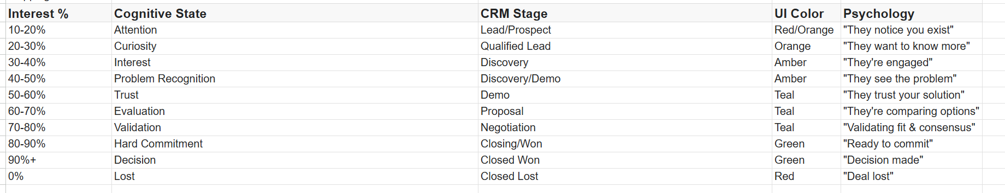
- "Find out more" button to use the sidebar's brand gradient (forskale-green → forskale-teal → forskale-blue) with a rounded-full shape.
- Inside the day/date collapsible/extendable list, chevron always faces downward inside a circular background. Made the circle larger (w-8 h-8) with a subtle border and shadow to match the reference.
- Logic Stays the Same

- First time clicking on a Meeting Insight
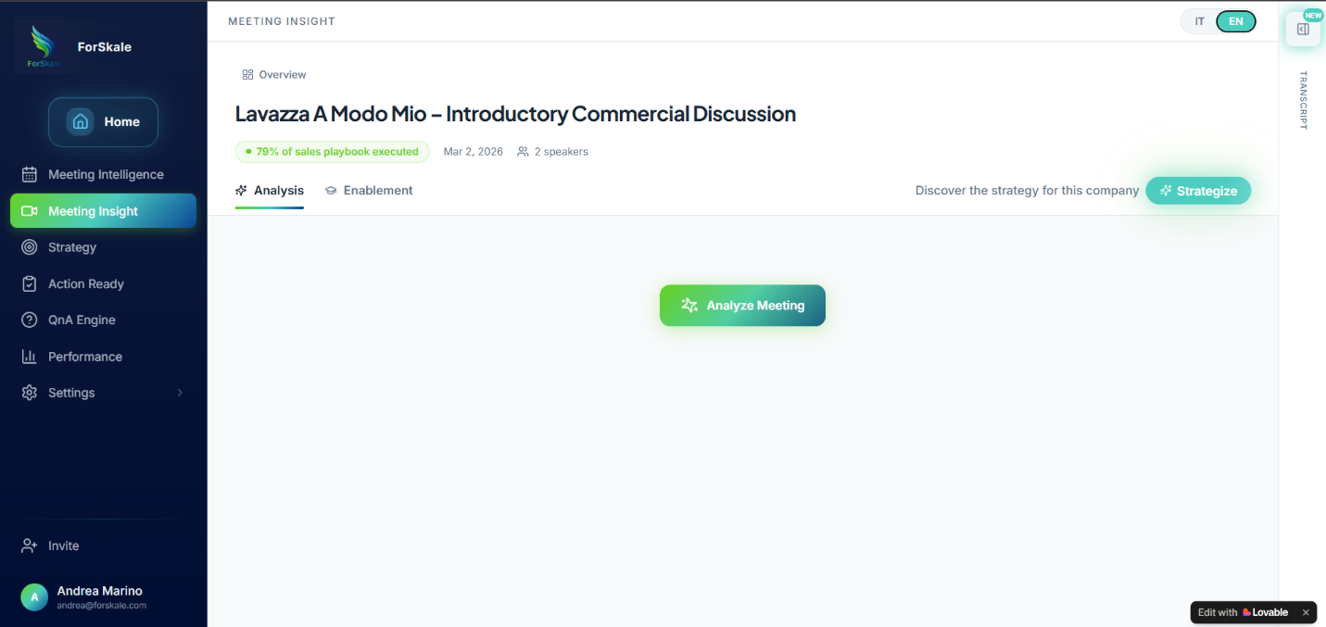
Option to Analyze Meeting
New modal to analyze meeting
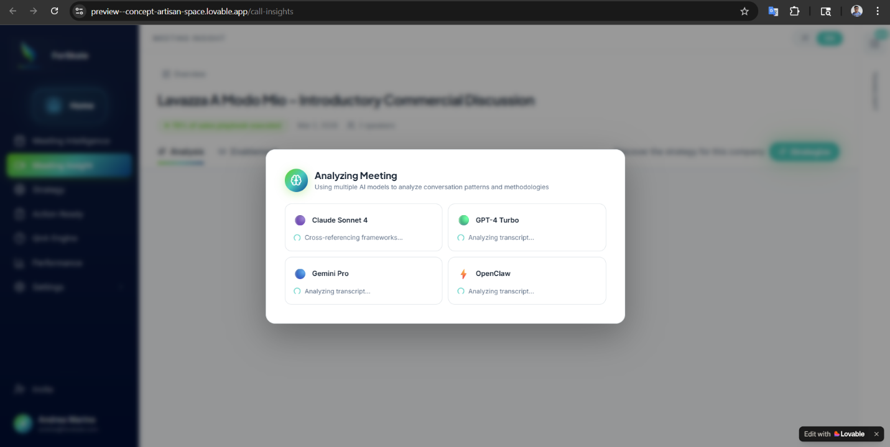
Post Meeting Analysis
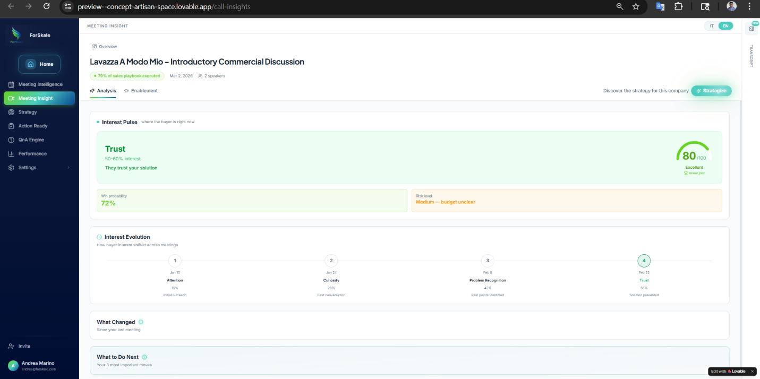
Use-cases for Interest Pulse:
Interest Pulse Technical Foundation
What Interest Pulse Represents: Interest Pulse is a real-time buyer sentiment diagnostic that translates meeting transcript analysis into actionable intelligence. It answers the critical question:
"Where is this buyer's mind right now?"
by combining cognitive psychology, sales methodology, and predictive analytics into a single, actionable widget.
Core Data Model:
InterestPulse {
meeting_id: UUID,
interest_percent_range: "10-20%" | "20-30%" | ... | "90%+",
cognitive_state: enum,
crm_stage_suggestion: enum,
ui_color_theme: "red" | "orange" | "amber" | "teal" | "green",
psychology_label: string,
pulse_score: integer, // 0-100 meeting quality
win_probability: integer, // 0-100 cumulative deal health
risk_level: "Low" | "Medium" | "High" | "Critical",
risk_reason: string, // No em dashes allowed
computed_at: ISO8601
}

Complete State Logic Table
Each Interest Pulse state maps directly to buyer psychology and recommended system behavior:
Interest % | Cognitive State | CRM Stage | UI Color | Psychology | System Behavior
10-20% | Attention | Lead/Prospect | Red/Orange | "They notice you exist" | Generate awareness content
20-30% | Curiosity | Qualified Lead | Orange | "They want to know more" | Suggest discovery meeting
30-40% | Interest | Discovery | Amber | "They're engaged" | Recommend needs analysis
40-50% | Problem Recognition | Discovery/Demo | Amber | "They see the problem" | Propose solution demo
50-60% | Trust | Demo | Teal | "They trust your solution" | Generate proof points
60-70% | Evaluation | Proposal | Teal | "They're comparing options" | Create competitive analysis
70-80% | Validation | Negotiation | Teal | "Validating fit and consensus" | Prepare stakeholder materials
80-90% | Hard Commitment | Closing/Won | Green | "Ready to commit" | Generate contract templates
90%+ | Decision | Closed Won | Green | "Decision made" | Initiate onboarding
0% | Lost | Closed Lost | Red | "Deal lost" | Trigger loss analysis

Primary Use Cases by User Persona
Sales Representative: Post-Meeting Deal Health Assessment
Scenario: After completing a discovery call with client, the rep opens Meeting Insight to understand buyer sentiment.
Interest Pulse Workflow:
- Cognitive State Analysis: System displays "Problem Recognition" at 40-50% interest, indicating the buyer has moved beyond curiosity to acknowledging specific pain points
- Score Interpretation: Meeting score of 85/100 ("Excellent") shows strong conversation quality and engagement signals
- Win Probability Update: Cumulative deal health increases to 72% based on progression from previous meetings
- Risk Assessment: "Medium: budget unclear" flag identifies the primary obstacle to advancement
- Next Action Generation: System automatically suggests "Schedule CFO discovery call within 24h" based on the risk reason
Business Value: Eliminates guesswork about buyer sentiment and provides data-driven next steps instead of generic follow-up sequences.
Sales Manager: Pipeline Health Monitoring
Scenario: Manager reviews team pipeline to identify deals requiring intervention or coaching opportunities.
Interest Pulse Workflow:
- Deal Progression Tracking: View Interest Pulse history across multiple meetings to identify advancement patterns
- Stalled Deal Detection: Flag deals with three consecutive meetings at the same cognitive state
- Score vs. Win Probability Divergence: Identify reps with high meeting scores but low deal advancement (coaching opportunity)
- Risk Escalation: Automatically surface deals with "High" or "Critical" risk levels for manager intervention
- Team Performance Analysis: Compare Interest Pulse progression rates across team members to identify best practices
Business Value: Proactive deal management and targeted coaching based on objective buyer sentiment data rather than rep self-reporting.
- Clicking on Enablement -> Feedback(default)
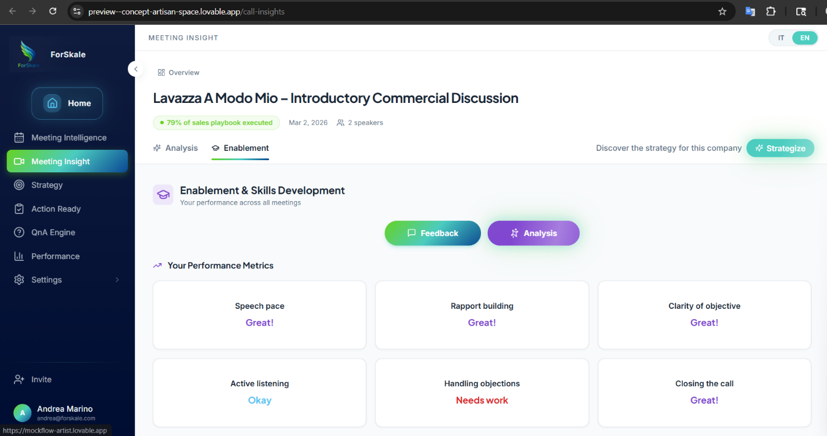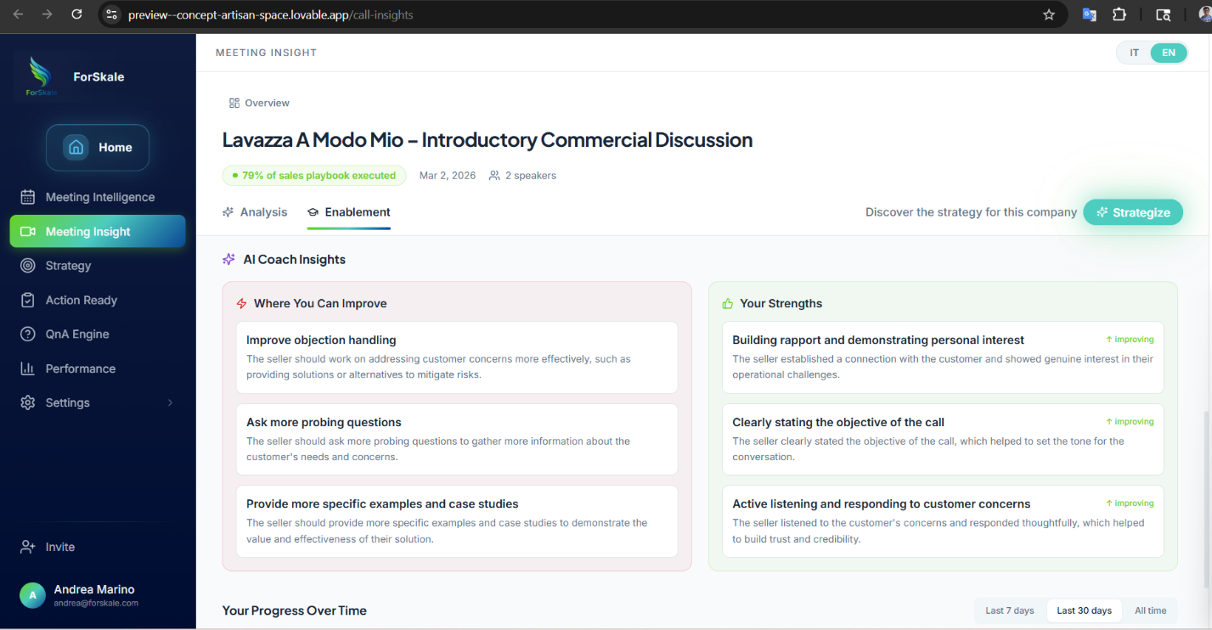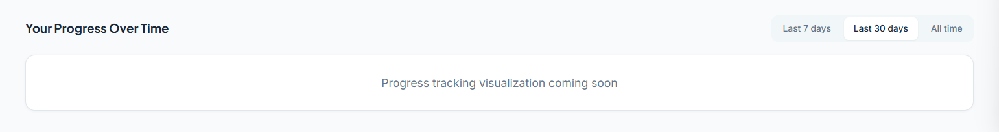
Your Performance Metrics - NO CHANGE
AI Coach Insights - NO CHANGE
Your Progress Over Time - NO CHANGE
Addition of new Analysis button-
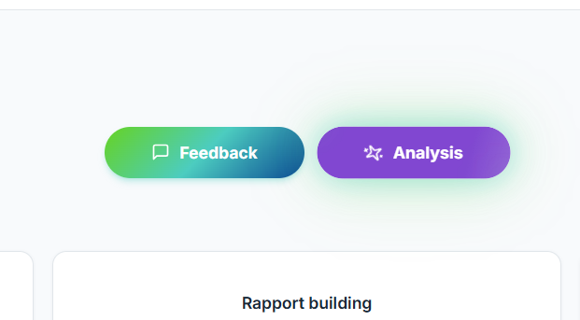
Section Headers and Primary Actions
"Enablement & Skills Development" (Purple Graduation Cap Icon) The main section heading that frames the entire tab's purpose: analyzing and improving the seller's demonstrated skills based on meeting performance. The purple color system is used exclusively within this tab to distinguish it from the teal/green Analysis tab.

"Your performance across all meetings" (Subtitle) Critical scope clarification indicating that performance metrics are aggregated across the user's historical meeting data, not limited to the current meeting. This affects backend data sourcing and user interpretation of the scores.

Primary Action Buttons:

"Feedback" (Gradient Teal-Green Button): Triggers conversational AI coaching based on the current meeting's analysis
"Analysis" (Purple Button with Spinning Sparkles): Generates or refreshes the deep AI skills analysis for all sections below

- After clicking on Analysis button
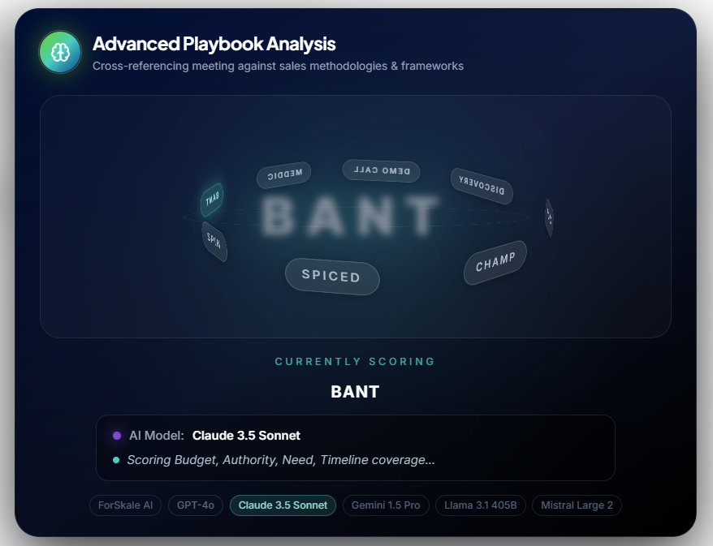
Deal Health Score Will be generated,
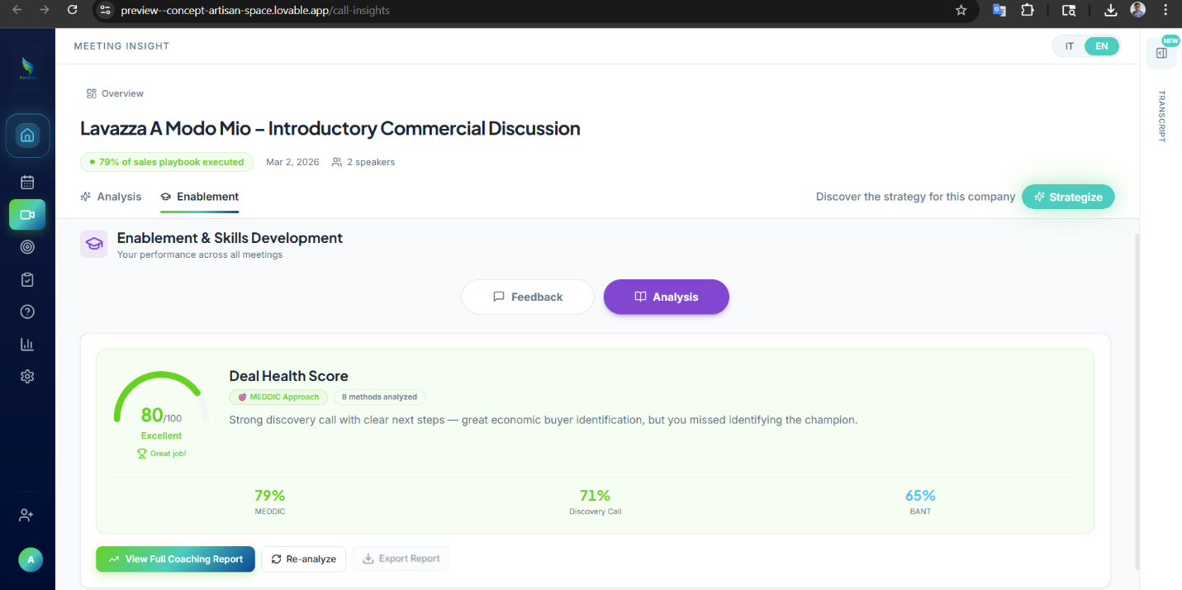
Re-Analyze does the same analysis once again to find a better health score
Once the button 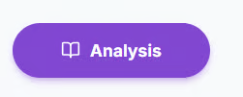comes with an open book,
, and when changing to other tab and coming back to Analysis button again, loading effect of Advanced Playbook ANalysis shouldnt happen. Also it shouldnt be clickable and re-analysis shouldnt happen.

- Clicking on View Full Coaching Report
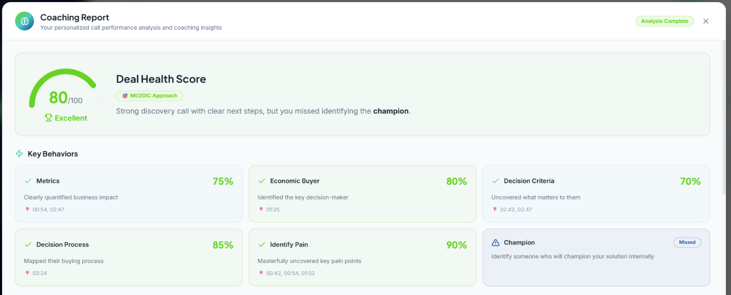
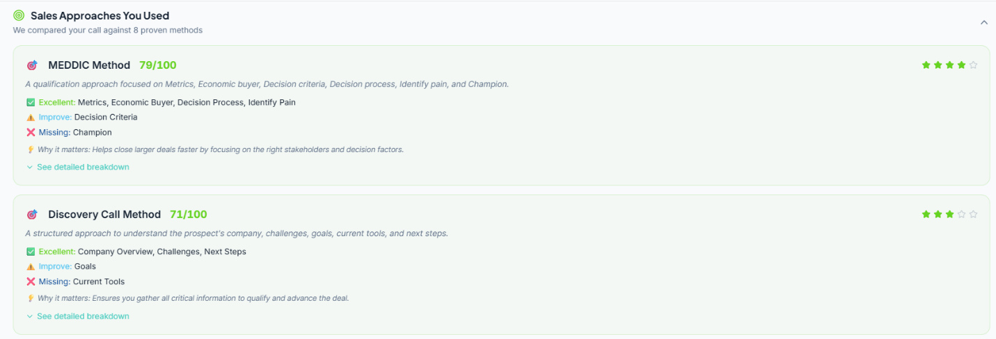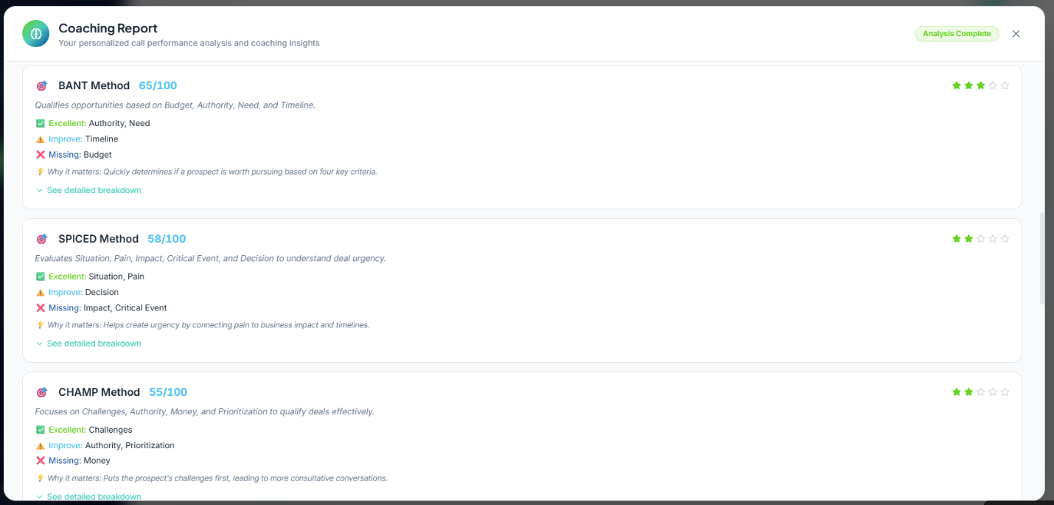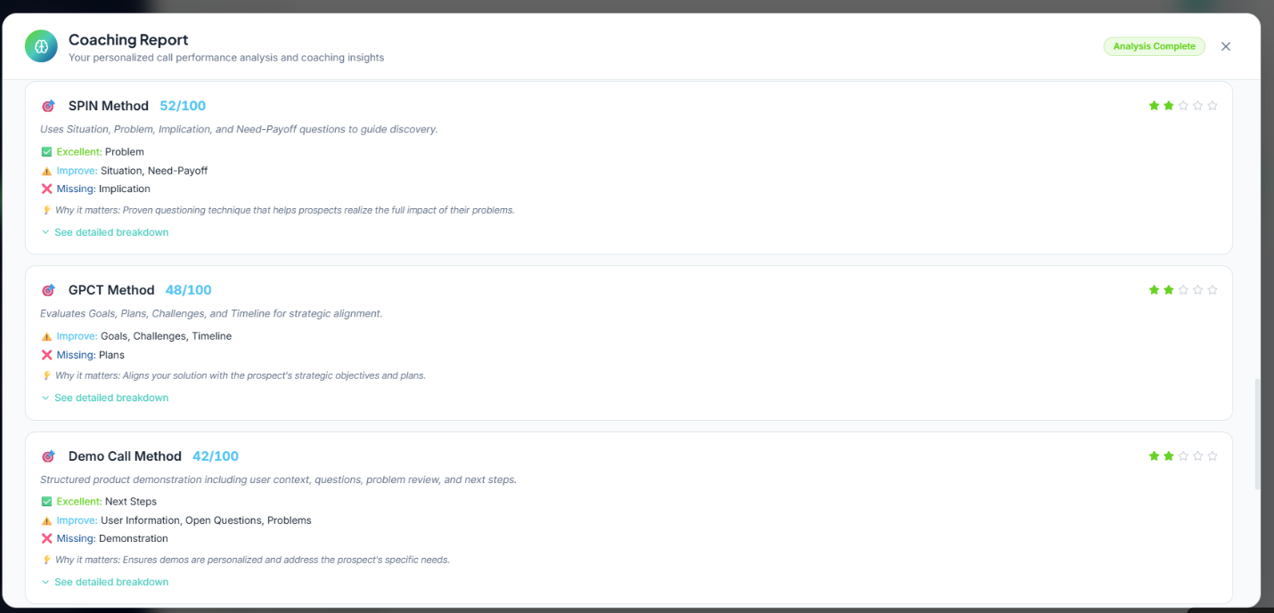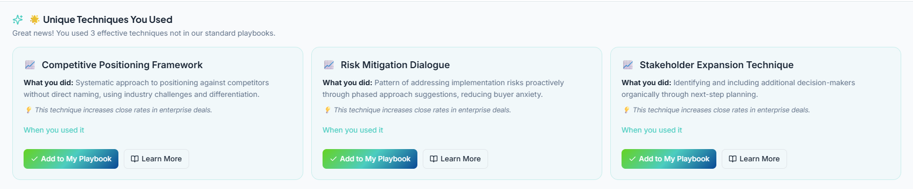
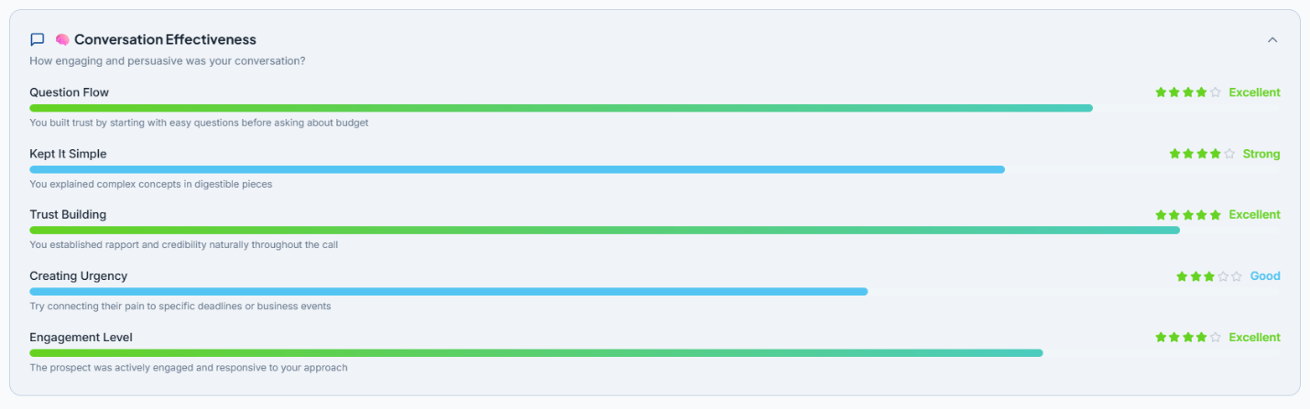
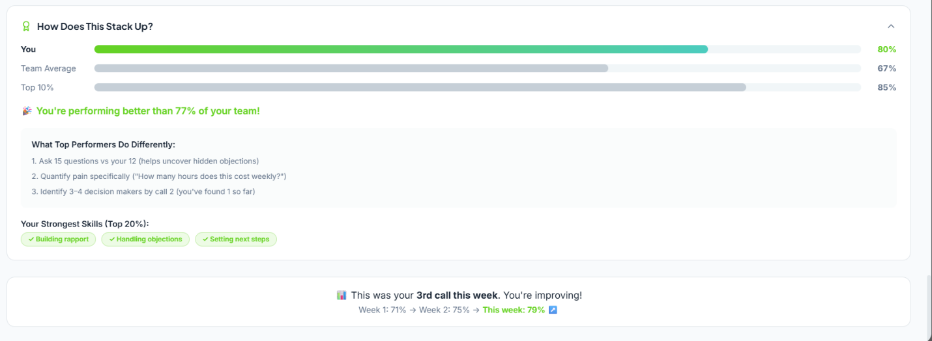

Here's a complete breakdown of the Coaching Report — what every label means and the logic that drives it.

🧮 Score Thresholds (Global Logic)
All scores follow the same color + label system defined in getScoreColor / getScoreLabel:
Score | Color | Label
≥ 80 | Green | Excellent
70–79 | Green | Strong
50–69 | Yellow/Cyan | Good
40–49 | Yellow/Cyan | Fair
< 40 | Red | Needs Work
Stars (⭐) map the same way: 5 stars ≥ 90, 4 stars ≥ 75, 3 stars ≥ 60, 2 stars ≥ 40, 1 star below.

🔵 Section 1 — Deal Health Score (the gauge)
What it is: A semi-circle gauge showing the consensusScore, which is the averaged result across all LLM model outputs (79.5 → rounded to 80).
Logic:
- The gauge arc fills proportionally: (score / 100) × π × radius → rendered as SVG strokeDasharray
- The label beneath (MEDDIC Approach) is the top-ranked framework — whichever methodology has the highest overallScore after sorting
- The coach sentence is generated dynamically: it finds the top framework, lists which elements were strong, and calls out the first undetected element (e.g. "you missed identifying the champion")

🟢 Section 2 — Key Behaviors Grid
What it is: The 6 MEDDIC elements shown as individual cards, each scored independently.
Logic per card:
- Pulled from the top framework's elementsDetected array
- Each element has detected: true/false, score: 0–100, instances (how many times it appeared), and transcriptReferences (timestamps like "02:47")
- Green card = detected AND score ≥ 80
- Yellow/cyan card = detected but score < 80
- Red/faded card = not detected at all → shows "Missed" badge
- The description text comes from the hardcoded behaviorDescriptions map — each element has a good string (if detected) and a bad coaching tip (if missed)
- Timestamps shown as 📍 pins are the actual transcriptReferences from the data

🎯 Section 3 — Sales Approaches You Used
What it is: All 8 frameworks ranked by score, collapsed by default, expandable.
Frameworks analyzed: MEDDIC (79), Discovery Call (71), BANT (65), SPICED (58), CHAMP (55), SPIN (52), GPCT (48), Demo Call (42)
Logic per framework card:
- Score and stars rendered as above
- Elements split into 3 buckets:
  - ✅ Excellent = detected AND score ≥ 75
  - ⚠️ Improve = detected but score < 75
  - ❌ Missing = not detected
- "See detailed breakdown" expands to show every individual element with its score, instance count, and timestamps
- Only top 3 shown by default; "Show X more" reveals the rest

🌟 Section 4 — Unique Techniques You Used
What it is: Custom elements that were detected in the transcript but don't belong to any standard framework — extracted as novel patterns.
The 3 techniques:
- Competitive Positioning Framework — How the rep handled competitor mentions without naming them (timestamps 02:32, 02:42)
- Risk Mitigation Dialogue — Proactively offering a phased rollout to address implementation concerns (02:47, 03:04)
- Stakeholder Expansion Technique — Naturally surfacing the need for a finance stakeholder during next-steps (03:19, 03:24)
Each has a confidence score (87%, 74%, 81%) and a source tag linking it to an originating methodology (challenger-sale, sandler, gap-selling). The "When you used it" toggle reveals the exact transcript snippets.

🧠 Section 5 — Conversation Effectiveness
What it is: 5 "neuroscience" metrics measuring conversation quality beyond framework adherence.
Label | What it measures | Score
Question Flow | Whether easy questions were asked before hard ones (budget etc.) | 85
Kept It Simple | Cognitive load — avoiding overwhelming the prospect | 78
Trust Building | Rapport and credibility signals throughout the call | 92
Creating Urgency | Connecting pain to deadlines/business events | 67
Engagement Level | Prospect's responsiveness and active participation | 81
The progress bars fill to score% width with a gradient if ≥ 80, cyan if ≥ 60, blue otherwise. The average is shown in the collapsed header.

📊 Section 6 — How Does This Stack Up? (Benchmarking)
Logic:
- You = the consensusScore (80)
- Team Average = hardcoded at 67
- Top 10% = hardcoded at 85
- percentile is computed as Math.min(99, Math.round((score / 100) × 90 + 5)) — a scaled estimate placing an 80 score at ~77th percentile
- "What Top Performers Do Differently" is hardcoded coaching copy
- Strongest Skills badges are hardcoded (building rapport, handling objections, setting next steps)

📈 Weekly Progress Banner (bottom)
Hardcoded text showing a week-over-week improvement narrative: Week 1: 71% → Week 2: 75% → This week: 79% (note: the gauge shows 80 but this uses the raw consensusScore of 79.5 rounded differently in context).

Summary of the Data Flow
Transcript
↓
8 Framework Scorers → elementsDetected[] per framework
↓
mockLLMModels (4 AI models) → each votes on top framework + score
↓
consensusScore = average of votes (79.5)
↓
Top framework = highest overallScore = MEDDIC (79)
↓
Dashboard renders all sections from mockPlaybookAnalysis

The key thing to know: all the data is currently mock/hardcoded in playbookAnalysisData.ts. The framework scores, element detections, timestamps, and neuroscience metrics are all static — the real system would populate these from actual transcript analysis.

