lovable preview
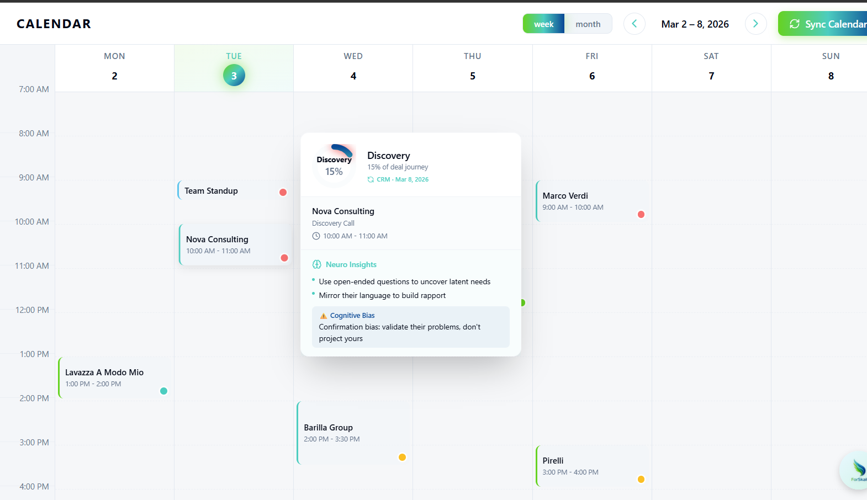
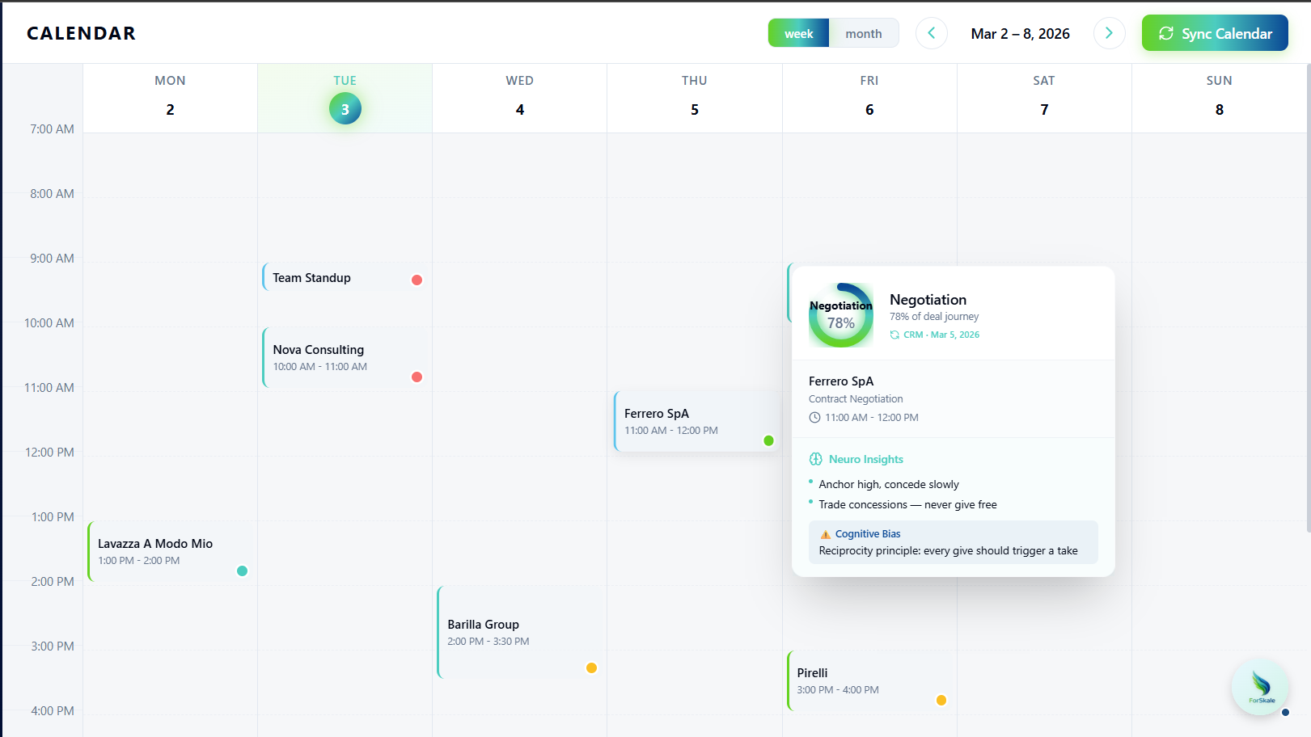

🎯 What is the Hover Tooltip?
When a sales rep hovers over a calendar event in week view only, a floating tooltip appears that transforms raw meeting data into actionable psychological intelligence. This isn't just showing "who" the meeting is with - it's showing "how to influence this person's decision-making process."
Core Philosophy: The tooltip serves as a cognitive influence snapshot that answers:
- Where is this deal in the sales pipeline?
- What psychological approach should I use for this stage?
- What cognitive risks should I be aware of?
Visual Context: The tooltip appears next to calendar event blocks (like "Nova Consulting 10:00-11:00 AM") after a 150ms hover delay, positioned to avoid screen edge cropping.

📋 Tooltip Content Structure (4 Essential Components)
The backend must provide data for these four distinct sections that the frontend will render:

Component 1: Deal Stage Circular Indicator
What Users See:
- Circular progress ring (e.g., 37.5% filled)
- Stage name in center (e.g., "Discovery")
- Confidence indicator below ("High confidence • CRM source")
What Backend Must Provide:
Copy
{
"stageName": "Discovery",
"stageProgress": 37.5,
"stageConfidence": "HIGH",
"stageSource": "CRM",
"lastUpdated": "2026-03-03T08:45:00Z"
}

Component 2: Meeting Context
What Users See:
- Meeting title and time
- Call objective (e.g., "Confirm fit & uncover operational blockers")
- Meeting type indicator (first meeting vs. follow-up)
What Backend Must Provide:
Copy
{
"title": "Nova Consulting",
"startTime": "2026-03-03T10:00:00Z",
"endTime": "2026-03-03T11:00:00Z",
"callIntent": "Understand current workflow and quantify impact of delays",
"isFirstMeeting": false
}

Component 3: Neuroscience Approach Guidance
What Users See:
- 2-3 tactical bullet points specific to the deal stage
- Cognitive bias alerts relevant to this stage
What Backend Must Provide:
Copy
{
"neuroApproach": [
"Ask open-ended questions about current pain points",
"Use concrete metrics from similar consulting clients",
"Validate their problems before proposing solutions"
],
"dominantBias": "Confirmation Bias",
"biasDescription": "They'll seek information that confirms existing beliefs"
}

Component 4: Risk Alerts
What Users See:
- 1-2 cognitive risk warnings with mitigation advice
- Color-coded by severity (amber/red)
What Backend Must Provide:
Copy
{
"riskAlerts": [
{
"type": "Budget Sensitivity",
"description": "Previous notes mention budget constraints - frame as ROI, not cost",
"severity": "MEDIUM"
}
]
}

🔍 Backend Detection Logic: 3-Priority System
The backend must determine deal stage using this priority hierarchy:

Priority 1: CRM System Lookup (Highest Confidence)
Process:
- Extract attendee email addresses from calendar event
- Extract company domains from emails
- Query CRM integration (HubSpot, Salesforce, Pipedrive) for active deals
- Map CRM stage names to internal 8-stage system
Stage Mapping Examples:
CRM Stage → Internal Stage
├── "Lead" → "Prospecting"
├── "Qualified" → "Qualification"
├── "Needs Analysis" → "Discovery"
├── "Demo Scheduled" → "Demo / Presentation"
├── "Proposal Sent" → "Proposal"
├── "Negotiating" → "Negotiation"
├── "Closing" → "Closing"
└── "Customer" → "Post-sale"

Output:
- Confidence: "HIGH"
- Source: "CRM"
- Include CRM deal ID for reference

Priority 2: Internal History Analysis (Medium Confidence)
When to Use: No CRM deal found, fall back to interaction patterns
Analysis Methods:
A. Interaction Count Logic:
Interaction Pattern → Likely Stage
├── 1st interaction → "Prospecting"
├── 2-3 interactions → "Qualification" or "Discovery"
├── 4-6 interactions → "Demo / Presentation" or "Proposal"
├── 7+ interactions → "Negotiation" or "Closing"

B. Keyword Analysis from Past Communications:
Keywords Found → Stage Inference
├── "intro", "initial", "first" → "Prospecting"
├── "demo", "presentation", "walkthrough" → "Demo / Presentation"
├── "proposal", "quote", "pricing" → "Proposal"
├── "contract", "negotiation", "terms" → "Negotiation"
├── "onboarding", "implementation" → "Post-sale"

C. Time-Based Progression:
- If previous stage recorded + significant time elapsed → infer advancement
- Discovery + 2 weeks → likely moved to Demo
- Proposal + 1 month → likely moved to Negotiation
Output:
- Confidence: "MEDIUM"
- Source: "HISTORY"
- Include interaction count and matched keywords

Priority 3: AI Inference from Meeting Data (Low Confidence)
When to Use: New contact with no CRM record or interaction history
Analysis Inputs:
A. Meeting Title Keywords:
Title Contains → Inferred Stage
├── "intro", "introductory" → "Prospecting"
├── "demo", "product tour" → "Demo / Presentation"
├── "proposal", "pricing" → "Proposal"
├── "negotiation", "contract" → "Negotiation"
├── "discovery", "needs assessment" → "Discovery"

B. Attendee Seniority Boost:
- C-level attendees → likely later stages (Negotiation/Closing)
- Manager-level → likely mid-stages (Demo/Proposal)
- Individual contributors → likely early stages (Discovery)
C. Meeting Duration Hints:
- 30-minute meetings → likely Discovery or check-in
- 60+ minute meetings → likely Demo or detailed Negotiation
- Recurring meetings → likely Post-sale relationship
Output:
- Confidence: "LOW"
- Source: "AI"
- Include reasoning for debugging

Priority 4: Default Fallback
- Stage: "Prospecting" (12.5% progress)
- Confidence: "LOW"
- Source: "DEFAULT"

📊 Stage Progress Calculation
The 8 Standard Deal Stages:
- Prospecting → 12.5% (1/8 × 100)
- Qualification → 25% (2/8 × 100)
- Discovery → 37.5% (3/8 × 100)
- Demo / Presentation → 50% (4/8 × 100)
- Proposal → 62.5% (5/8 × 100)
- Negotiation → 75% (6/8 × 100)
- Closing → 87.5% (7/8 × 100)
- Post-sale → 100% (8/8 × 100)
Mathematical Formula:
Stage Progress=
8
Stage Index
​
×100

🧠 Neuroscience Guidance Generation
Stage-Specific Guidance Library:

Discovery Stage (37.5%):
Copy
{
"neuroApproach": [
"Ask open-ended questions to uncover pain points",
"Use 'what happens if you do nothing?' to surface urgency",
"Validate their problems before proposing solutions"
],
"dominantBias": "Confirmation Bias",
"biasDescription": "They'll seek info that confirms existing beliefs about problems"
}

Proposal Stage (62.5%):
Copy
{
"neuroApproach": [
"Frame pricing as ROI and cost avoidance, not investment",
"Use specific metrics from similar client successes",
"Present 3 options to create choice architecture"
],
"dominantBias": "Loss Aversion",
"biasDescription": "Fear of losing current state outweighs potential gains"
}

Negotiation Stage (75%):
Copy
{
"neuroApproach": [
"Anchor high on initial pricing, make strategic concessions",
"Use reciprocity - give small concession to get larger one",
"Focus on mutual win, not zero-sum competition"
],
"dominantBias": "Anchoring Effect",
"biasDescription": "First number presented heavily influences final agreement"
}

⚡ Performance & Caching Strategy
Critical Performance Requirement: Hover tooltips must load instantly (under 200ms) when calendar opens.

Pre-Computation Approach:
When to Analyze Stages:
- During calendar sync (Google Calendar, Outlook integration)
- When new interactions added (emails, meeting notes)
- When CRM webhooks received (deal stage updates)
What NOT to do:
- Don't run CRM lookups during calendar API requests
- Don't call Claude API in real-time for neuroscience guidance
- Don't analyze stages on every page load

Caching Strategy:
Database Storage:
Copy
ALTER TABLE calendar_events ADD COLUMN:
├── deal_stage VARCHAR(50)
├── stage_progress DECIMAL(5,2)
├── stage_confidence ENUM('HIGH','MEDIUM','LOW')
├── stage_source ENUM('CRM','HISTORY','AI','MANUAL','DEFAULT')
├── stage_last_analyzed TIMESTAMP
├── neuro_guidance_json TEXT
├── crm_deal_id VARCHAR(100)

Refresh Triggers:
- Immediate: CRM webhook received
- Hourly: New email or meeting note added
- Daily: Automatic staleness check (re-analyze if >24 hours old)
- Manual: "Sync Calendar" button forces refresh
Cost Optimization:
- Cache neuroscience guidance per stage (reuse across all Discovery meetings)
- Batch process multiple meetings in single Claude API call
- Use static guidance library for common scenarios

┌─────────────────────────────────────────────────────────────┐
│ CALENDAR SYNC TRIGGER │
│ (Meeting appears in calendar) │
└────────────────────────────┬────────────────────────────────┘
│
▼
┌─────────────────────────────────────────────────────────────┐
│ EXTRACT MEETING METADATA │
├─────────────────────────────────────────────────────────────┤
│ • Meeting ID, title, description │
│ • Attendee emails and domains │
│ • Scheduled date/time │
│ • Meeting type (first-time, follow-up, etc.) │
└────────────────────────────┬────────────────────────────────┘
│
▼
┌─────────────────────────────────────────────────────────────┐
│ PRIORITY 1: CRM LOOKUP (Highest Confidence) │
├─────────────────────────────────────────────────────────────┤
│ Query CRM by attendee email OR company domain │
│ │
│ IF CRM Deal Found: │
│ ├─ Extract: deal.stage, deal.amount, deal.probability │
│ ├─ Map CRM stage → Internal 8-stage system │
│ ├─ Confidence Level: HIGH │
│ └─ Source: "CRM" │
│ │
│ CRM Stage Mapping Examples: │
│ • "New Lead" → Prospecting │
│ • "Qualified" → Qualification │
│ • "Needs Analysis" → Discovery │
│ • "Proposal Sent" → Proposal │
│ • "Contract Review" → Negotiation │
│ • "Closed Won" → Post-sale │
└────────────────────────────┬────────────────────────────────┘
│
┌───────────┴───────────┐
│ │
Found in CRM Not Found
│ │
▼ ▼
┌─────────────────────────────────────────────────────────────┐
│ PRIORITY 2: INTERNAL HISTORY (Medium Confidence) │
├─────────────────────────────────────────────────────────────┤
│ Search internal database for: │
│ • Previous calls with same contact/company │
│ • Email thread history │
│ • Past meeting outcomes and notes │
│ │
│ Pattern Analysis: │
│ • 1st interaction → Prospecting/Discovery │
│ • 2-3 interactions → Qualification/Discovery │
│ • Keywords in notes: "demo", "pricing" → Later stages │
│ • Previous stage progression │
│ │
│ IF Pattern Found: │
│ ├─ Infer stage based on interaction count + keywords │
│ ├─ Confidence Level: MEDIUM │
│ └─ Source: "HISTORY" │
└────────────────────────────┬────────────────────────────────┘
│
┌───────────┴───────────┐
│ │
History Found No History
│ │
▼ ▼
┌─────────────────────────────────────────────────────────────┐
│ PRIORITY 3: AI INFERENCE (Low Confidence) │
├─────────────────────────────────────────────────────────────┤
│ Analyze meeting title + attendee seniority: │
│ │
│ Title Keywords: │
│ • "intro", "first", "initial" → Prospecting │
│ • "demo", "presentation" → Demo/Presentation │
│ • "proposal", "quote", "pricing" → Proposal │
│ • "negotiation", "contract" → Negotiation │
│ • "close", "final", "signature" → Closing │
│ • "onboarding", "kickoff" → Post-sale │
│ │
│ Attendee Seniority Boost: │
│ • C-level attendees → Boost to later stages │
│ • Manager level → Mid-stage bias │
│ • Individual contributor → Early stage bias │
│ │
│ Output: { stage, confidence: "LOW", source: "AI" } │
└────────────────────────────┬────────────────────────────────┘
│
▼
┌─────────────────────────────────────────────────────────────┐
│ FINAL STAGE ASSIGNMENT │
├─────────────────────────────────────────────────────────────┤
│ Decision Logic (Priority Order): │
│ 1. Use CRM stage if confidence = HIGH │
│ 2. Use History pattern if confidence = MEDIUM │
│ 3. Use AI inference if confidence = LOW │
│ 4. Default to "Prospecting" if all methods fail │
│ │
│ Calculate Progress Percentage: │
│ progress = (stageIndex / 8) * 100 │
│ │
│ Stage Index Mapping: │
│ Prospecting: 1 → 12.5% │
│ Qualification: 2 → 25% │
│ Discovery: 3 → 37.5% │
│ Demo/Presentation: 4 → 50% │
│ Proposal: 5 → 62.5% │
│ Negotiation: 6 → 75% │
│ Closing: 7 → 87.5% │
│ Post-sale: 8 → 100% │
└────────────────────────────┬────────────────────────────────┘
│
▼
┌─────────────────────────────────────────────────────────────┐
│ NEUROSCIENCE LAYER INJECTION │
├─────────────────────────────────────────────────────────────┤
│ Based on detected stage, append coaching guidance: │
│ │
│ Discovery Stage: │
│ • Approach: "Use open-ended questions to uncover pain" │
│ • Bias Alert: "Confirmation bias - validate problems" │
│ │
│ Proposal Stage: │
│ • Approach: "Frame pricing as ROI, not cost" │
│ • Bias Alert: "Loss aversion - show missed opportunities" │
│ │
│ Negotiation Stage: │
│ • Approach: "Anchor high, make small concessions" │
│ • Bias Alert: "Reciprocity - give to get" │
└────────────────────────────┬────────────────────────────────┘
│
▼
┌─────────────────────────────────────────────────────────────┐
│ STORE & API RESPONSE │
├─────────────────────────────────────────────────────────────┤
│ Database Storage: │
│ { │
│ meetingId: "cal_123", │
│ dealStage: "Discovery", │
│ stageProgress: 37.5, │
│ confidence: "HIGH", │
│ source: "CRM", │
│ lastUpdated: timestamp, │
│ neuroGuidance: { approach: "...", bias: "..." } │
│ } │
│ │
│ Frontend API Response: │
│ Include dealStage and stageProgress in calendar events │
└─────────────────────────────────────────────────────────────┘

