|  |  |  |
| --- | --- | --- |
| No. | Student Name | Student ID |
| 1 | Vu Tuan Anh | 17110004 |
| 2 | Pham Vu Thien | 17110075 |
| 3 | Tran Ngoc Minh Quan | 17110069 |

|  |  |  |  |
| --- | --- | --- | --- |
| **Task** | **Member in charge** | **Expected product** | **Rate** |
| Searching document | Teams | Knn documents | 100% |
| Coding demo using matlab | Tuan Anh | Demo for team members | 100% |
| Searching financial papers about stock | Thien | Data using for test and analyst documents research | 100% |
| Coding Knn to predict stock | Thien+Quan | Predict stock complete | 100% |

**Introdution:**

“Security prices fully reflect all available information” (Fama, 1991). In her 1991 paper on Effective Capital Markets, Fama reiterates that a security prices at any time will “fully reflect” all available information. Based on this assumption she makes, the world today is dedicated to researching on ways to predict future stock prices based on their current information. And for this, many researches and data mining is done based on the data from stock market. In this paper, we attempt to do such analysis but with an emphasis of using a machine learning algorithm. We applied k-nearest neighbor algorithm in order to predict stock prices for a sample of seven major companies listed on the NASDAQ stock market to assist investors, management, decision makers, and users in making correct and informed investments decisions. According to the results, the kNN algorithm is mildly robust with a good accuracy; consequently the results were rational and also reasonable. In addition, depending on the actual stock prices data; the prediction results were close and fairly parallel to actual stock prices.

Even though, a lot of businesses are vested in researching on predicting the Stock market, financial data is considered as complex data to forecast and or predict. Predicting market prices are seen as problematical, and as explained in the efficient market hypothesis (EMH henceforth) (Fama 1991). The EMH is considered as bridging the gap between financial information and the financial market; it also affirms that the fluctuations in prices are only a result of newly available information; and that all available information reflected in market prices. The EMH assert that stocks are at all times in equilibrium and are difficult for inventors to speculate. Furthermore, it has been affirmed that stock prices do not pursue a random walk and stock prediction needs more evidence (Gallagher and Taylor, 2002).

|  |  |
| --- | --- |
| **Variable** | **Description** |
| Price | Current Price |
| Open | Opening price of a stock for the day |
| Close | Closing price of a stock for the day |
| High | Highest price of a stock for the day |
| Low | Lowest price of a stock for the day |

**Figure 1: Main variables that affect stock movement**

1. **When do we use KNN algorithm?**

KNN can be used for both classification and regression predictive problems. However, it is more widely used in classification problems in the industry. To evaluate any technique, we generally look at 3 important aspects:

* Ease to interpret output
* Calculation time
* Predictive power

Let us take a few examples to place KNN in the scale:

|  |  |  |  |  |
| --- | --- | --- | --- | --- |
|  | Logistic Regression | CART | Random Forest | KNN |
| Ease to interpret output | 2 | 3 | 1 | 3 |
| Calculation time | 3 | 2 | 1 | 3 |
| Predictive power | 2 | 2 | 3 | 2 |

KNN algorithm fairs across all parameters of considerations. It is commonly used for its easy of interpretation and low calculation time.

1. **How does the KNN algorithm work?**

Let’s take a simple case to understand this algorithm. Following is a spread of red circles (RC) and green squares (GS):

You intend to find out the class of the blue star (BS). BS can either be RC or GS and nothing else. The “K” is KNN algorithm is the nearest neighbor we wish to take the vote from. Let’s say K = 3. Hence, we will now make a circle with BS as the center just as big as to enclose only three datapoints on the plane. Refer to the following diagram for more details:

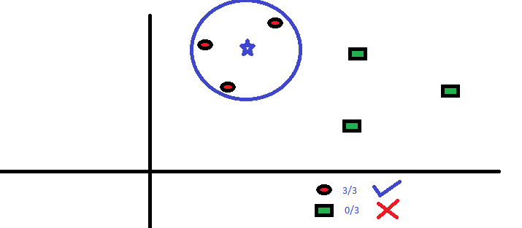

**Figure 1.** KNN algorithm applied

The three closest points to BS are all RCs. Hence, with a good confidence level, we can say that the BS should belong to the class RC. Here, the choice became very obvious as all three votes from the closest neighbor went to RC. The choice of the parameter K is very crucial in this algorithm. Next, we will understand what are the factors to be considered to conclude the best K.

1. **How do we choose the factor K?**

First let us try to understand what exactly does K influence in the algorithm. If we see the last example, given that all the 6 training observations remain constant, with a given K value we can make boundaries of each class. These boundaries will segregate RC from GS. In the same way, let’s try to see the effect of value “K” on the class boundaries. The following are the different boundaries separating the two classes with different values of K.

**Figure 2**. The differences between vary k

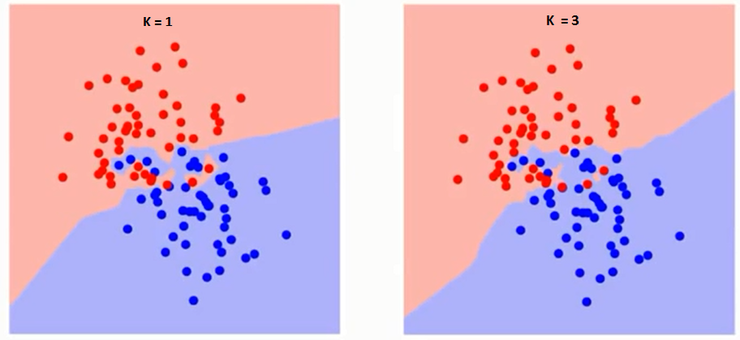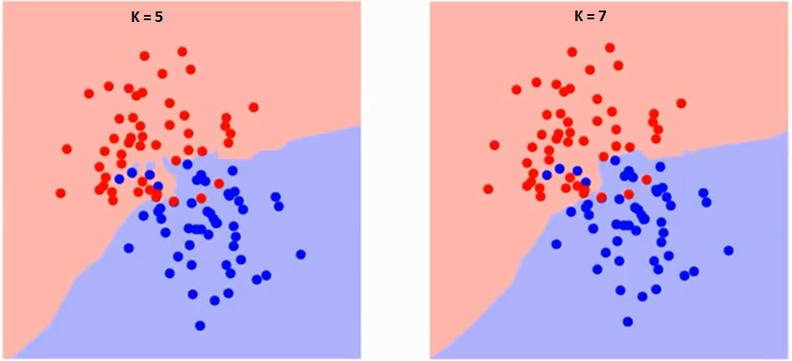

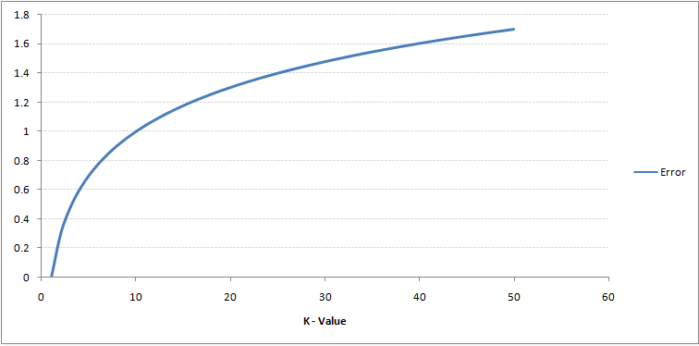If you watch carefully, you can see that the boundary becomes smoother with increasing value of K. With K increasing to infinity it finally becomes all blue or all red depending on the total majority. The training error rate and the validation error rate are two parameters we need to access different K-value. Following is the curve for the training error rate with a varying value of K:

**Figure 3.** Relationship between the rate of error and the value k

As you can see, the error rate at K=1 is always zero for the training sample. This is because the closest point to any training data point is itself. Hence, the prediction is always accurate with K=1. If validation error curve would have been similar, our choice of K would have been 1. Following is the validation error curve with varying value of K:

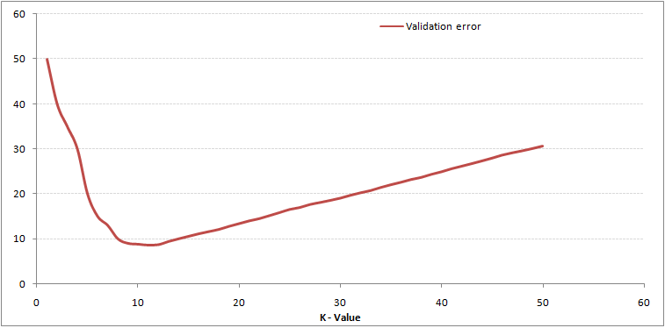

**Figure 4.** The relationship between the rate of validation error and the value k

This makes the story more clearly. At K=1, we were overfitting the boundaries. Hence, error rate initially decreases and reaches a lowest point. After the minima point, it then increases with increasing K. To get the optimal value of K, you can segregate the training and validation from the initial dataset. Now plot the validation error curve to get the optimal value of K. This value of K should be used for all predictions.

1. **Breaking it Down – Pseudo Code of KNN**

We can implement a KNN model by following the below steps:

* Load the data
* Initialize the value of k
* For getting the predicted class, iterate from 1 to total number of training data points
  + Calculate the distance between test data and each row of training data. Here we will use Euclidean distance as our distance metric since it’s the most popular method. The other metrics that can be used are Chebyshev, cosine, etc.
  + Sort the calculated distances in ascending order based on distance values
  + Get top k rows from the sorted array
  + Get the most frequent class of these rows
  + Return the predicted class

**Reference**

https://www.analyticsvidhya.com/blog/2018/03/introduction-k-neighbours-algorithm-clustering/