

|  |
| --- |
| Tuan Nguyen (e1801917)  Severino Flórez (e2002012)  Ernesto Ibañez (e2001998) |
| TRANSLATOR |
| Requirement Specification |

**Version history**

|  |  |  |  |
| --- | --- | --- | --- |
| **Version** | **Change description** | **Person** | **Date** |
| **V1.0** | Making a plan for project. | Tuan Nguyen | 18/09/2020 |
| V2.0 | Looking for template, Api. | Tuan Nguyen, Ernesto Ibañez,  Severino Flórez | 18/09/2020 |
|  |  |  |  |

**Returned: _____________________**

**Checked: _____________________**

**Approved: _____________________**

|  |
| --- |
|  |
|  |

# INTRODUCTION

* TRANSLATOR is a web application which can be used as a translation method and be installed in all of environment in device. For more details, I applied React library to develop the function of this application. Besides, I utilized Java Springboot Backend to provide a PDF reading function for users when they use the application.

# overview - This web application can run all of devices, the interface will be separated into two parts, one left part is belong to user interaction, where user can attach file pdf and submit after. Besides, one right part is belong to text translated.

* Use case diagram drawn with Visual Paradigm

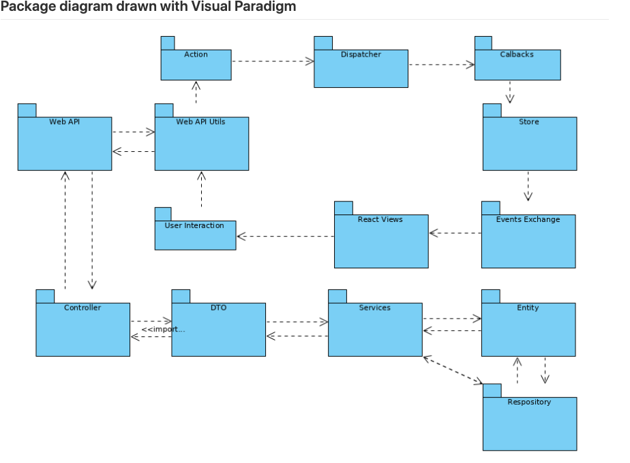

# functions

Priority levels:

1 – Must have

2 – Should have

3 – Nice to have

Table 1. Table of functional requirements

|  |  |  |
| --- | --- | --- |
| **Reference** | **Description** | **Priority** |
| F1 | Choosing file button | 1 |
| F2 | Show a notification when choose file | 1 |
| F3 | Edit text | 1 |
| F4 | Insert text | 1 |
| F5 | File Complaint | 3 |
| F6 | Advertise Service | 3 |
| F7 | Recall Service | 2 |

# EXTERNAL INTERFACE

Table 2. External interfaces

|  |  |
| --- | --- |
| **Reference** | **Description** |
| I1 | Web terminal |

# NON-FUNCTIONAL CHARACTERISTICS

|  |  |
| --- | --- |
| **Characteristic** | **Description** |
| Usability | The final product should be a web application that has user-friendly interface where users can easily navigate and use all the functions, including choose file and type text. Additionally, the status of text(available or not,..) should be shown in real time. |
| Response time | The web responds to every text when click button. All measurements and control take 10ms. |
| Maintainability | The web application to easy to maintain due to the component was separated to easy read code and each component will responsibility for its task. |
| Performance | The web application applied react library to load single page quickly without loading. |