* Step 1: setup EurekaServer
  + Navigate to eureka-service folder
  + Open terminal
  + Type mvn clean install
  + Type mvn spring-boot:run
  + Open web browsers: <http://localhost:8761/>
* Step 2: set product-service
  + Navigate to product-service-client folder
  + Type mvn clean install
  + Type mvn spring-boot:run
  + Open mysql and import file database product.sql
  + Open web browsers: <http://localhost:8200/product-service/swagger-ui.html#/>
  + Please see like screenshot

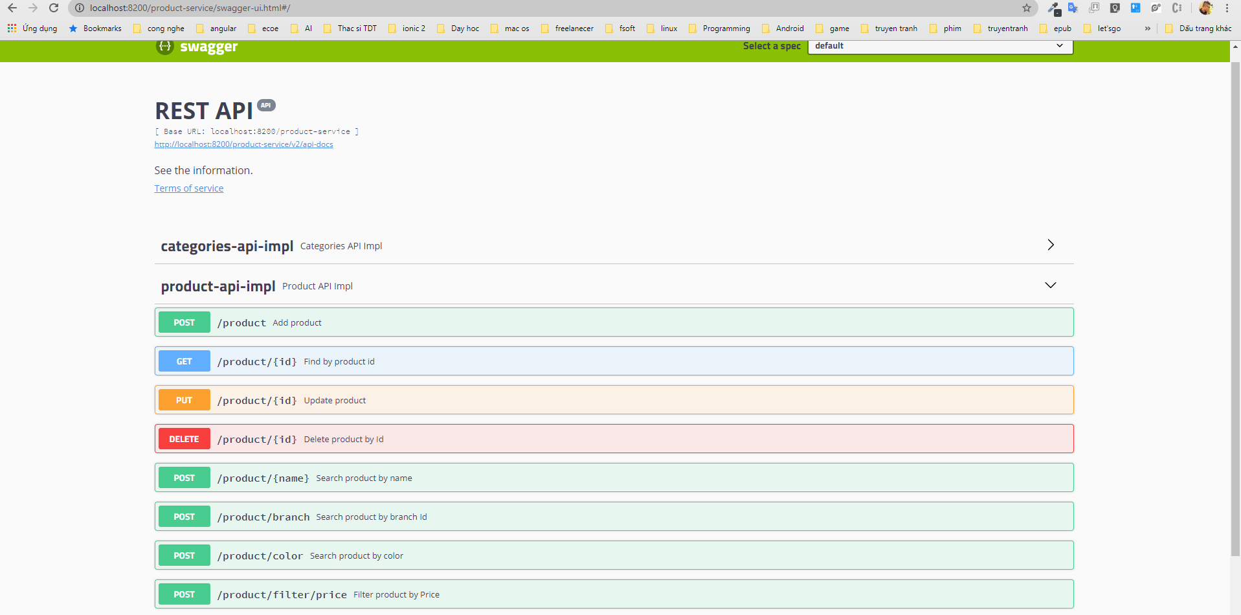

* Step3: How to use API
  + To search product by Name:

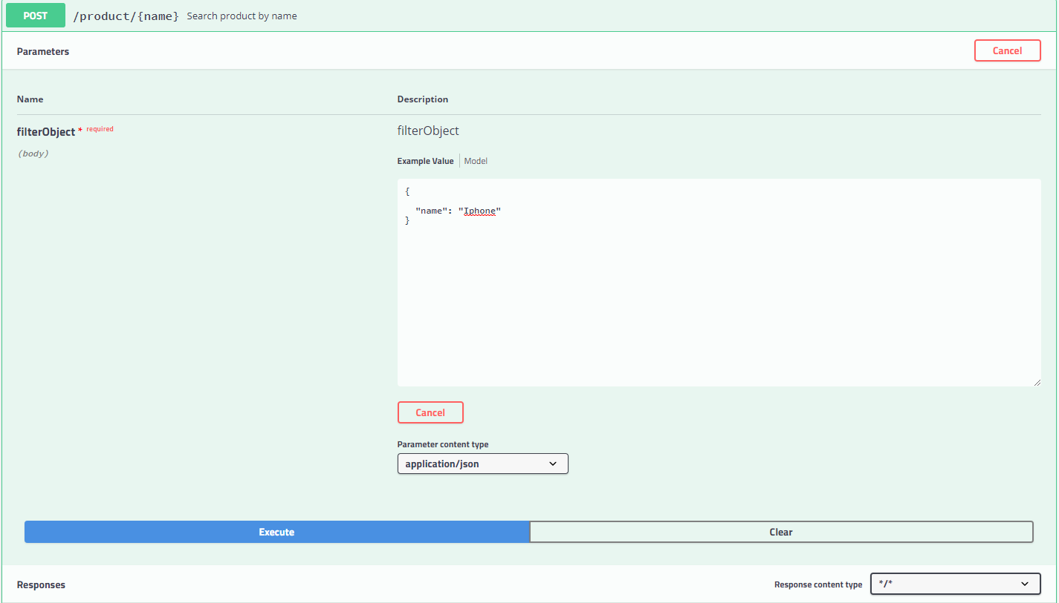

* + Result:

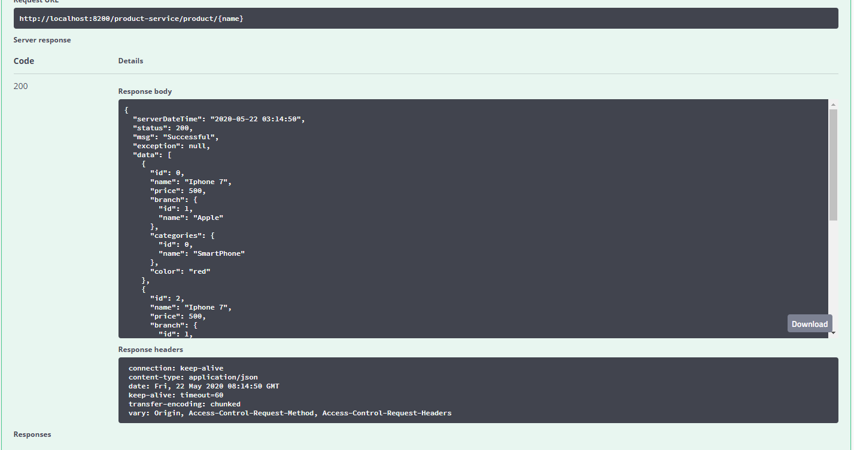

* + To filter by price:

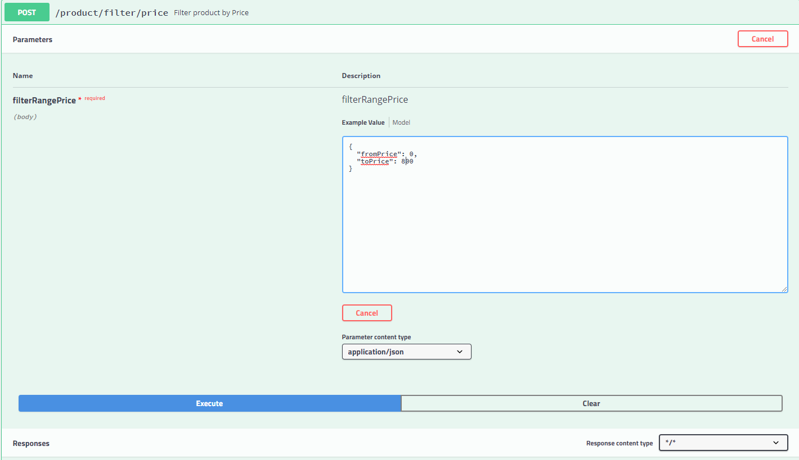

* + Result:

