Danang Semiconductor & AI Center DSAC



THIẾT KẾ HỆ THỐNG ĐỒNG HỒ BÁO THỨC
VÀ ĐIỀU KHIỂN NGOẠI VI TRÊN MCU SN8F5708

CONTENTS
1. Overview
1.1. Team Information & Project Repository
1.2. Introduction
1.3. Objectives
1.4. Main Features
1.5. Block Diagram
2. Specification
2.1. Hardware Platform
2.2. System Interface
2.3. Behavioral & Timing Specifications
3. Functional Description
3.1. Clock Core
3.2. Application FSM
3.3. Alarm Core
3.4. Driver & Hardware Platform
3.5. Application Integration
4. Verification and Experimental Results
4.1. Stage-Based Integration
4.2. Final Build Provenance
4.3. Final EVK Smoke Test
4.4. Acceptance Matrix
4.5. Requirement Compliance Summary
5. Revision History
6. Final Release and Demo

1. Overview

1.1. Team Information & Project Repository
Member | Responsibility
Cao Minh Tuấn | MCU Application / Core / Integration — Clock, FSM, Alarm behavior, application-driver integration, integration testing, release documentation
Nguyễn Đình Phan Trung | MCU Driver / Platform / Hardware — GPIO, Timer/Interrupt, Button, Display, Buzzer, LED, EEPROM, EVK-side validation and later integration/closure

Project Repository: https://github.com/tuancm24/icf-dsac-mcu-danang2026
Verified firmware baseline: 1ecf0b4b1bfc60bebf6ea378d640378528d91d12
Target board: SONiX SN8F5708 EVK

1.2. Introduction
This report documents the design, integration, verification and final hardware validation of an embedded digital clock and alarm-control system developed for the MCU track of the FPGA & MCU Design Competition Da Nang 2026. The target platform is the SONiX SN8F5708 EVK and the production firmware is written in Embedded C with the Keil C51 toolchain.
The design separates Application/Core logic from Drivers/Platform/Hardware through explicit interfaces. This separation allowed the team to develop and verify timing, Clock, FSM and Alarm behavior independently, then integrate the application with the verified EVK driver layer. The final integration candidate was clean-built, programmed to the real EVK, and re-checked through a final owner smoke test.
Release identity: The verified firmware baseline is Git commit 1ecf0b4, tagged dsac-mcu-final-2026. The clean production build reports DATA=81.0 bytes, XDATA=62 bytes, CODE=4786 bytes, 0 errors and 4 reviewed L16 warnings.

1.3. Objectives
- Implement a modular real-time digital clock with one-second ticking, 24-hour rollover, and user adjustment of hours and minutes.
- Implement a deterministic five-state Application FSM: NORMAL, SET_TIME_HOUR, SET_TIME_MINUTE, SET_ALARM_HOUR and SET_ALARM_MINUTE.
- Implement an Alarm Core with configurable HH:MM alarm time and exact time matching.
- Integrate button input, 4-digit 7-segment display, LED D4, buzzer, Timer/Interrupt services and 24C05 EEPROM through public driver interfaces.
- Verify the application behavior through staged integration gates and then validate the complete system on the physical SN8F5708 EVK.
- Produce a verified firmware release baseline with traceable Git/build/HEX/flash provenance and a demo flow suitable for the competition judging criteria.

1.4. Main Features
- 24-hour digital clock, displayed as HH.MM with seconds maintained internally.
- Current-time editing with explicit hour/minute wrap-around (23↔00 and 59↔00) and second preservation.
- Selected HH/MM field blinks with a 1 s period (approximately 500 ms visible / 500 ms blank) in SET states.
- Alarm-time editing with temporary edit state followed by confirmation and EEPROM persistence.
- Button feedback: accepted SW3, SW6, SW10 and SW16 presses each generate a short approximately 0.3 s beep.
- LED D4 policy: D4 blinks only during SET_ALARM states with an approximately 1 s period (500 ms ON / 500 ms OFF) and is OFF in all other application modes.
- 30-second inactivity timeout from SET states back to NORMAL with audible feedback.
- Natural alarm occurrence with a five-second buzzer sequence using approximately 500 ms ON / 500 ms OFF.
- One-shot alarm behavior preventing repeated triggering during the same alarm occurrence.
- EEPROM persistence across power-cycle using the board's 24C05 device.

1.5. Block Diagram
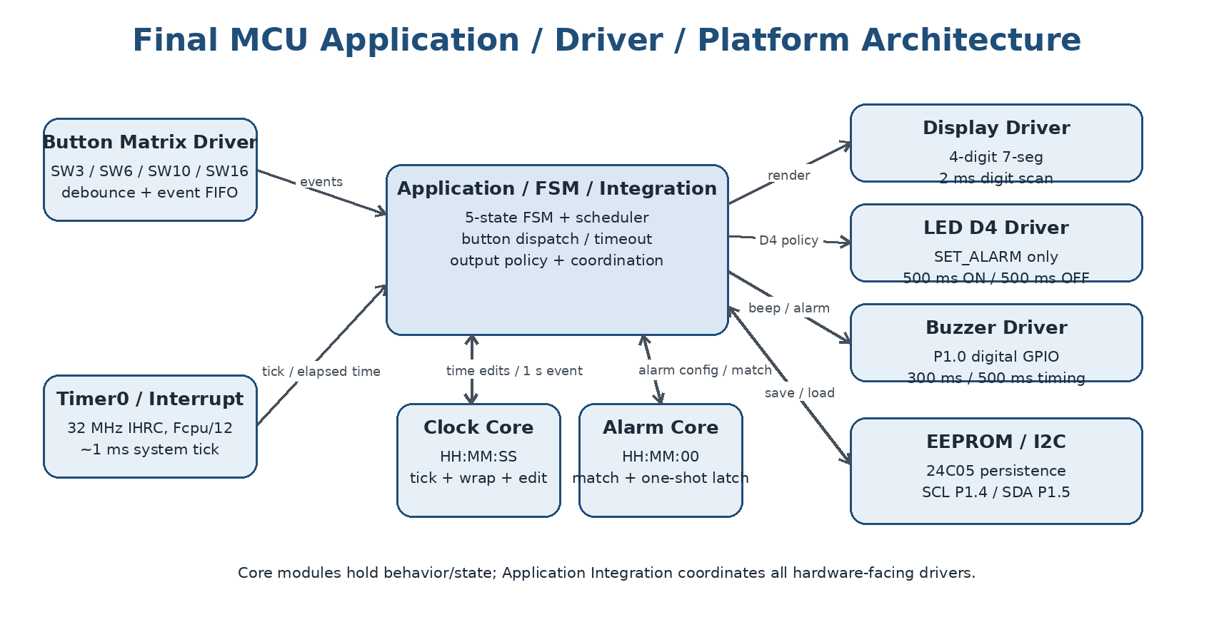
Figure 1. Final software/hardware architecture and integration boundaries.

2. Specification

2.1. Hardware Platform
Item | Specification
MCU | SONiX SN8F5708
Evaluation board | SONiX SN8F5708 EVK
Toolchain | Keil PK51 / C51 9.60.7.0
Programmer | SONiX SN-LINK
Display | 4-digit 7-segment display
Buzzer | PZ1 / P1.0 active-high digital GPIO output
Status LED | D4 / P0.3, active-low
EEPROM | 24C05 over I2C; SCL=P1.4, SDA=P1.5
Button matrix | SW3, SW6, SW10, SW16 using EVK row/column matrix

The final board validation used the real SN8F5708 EVK. Hardware-facing ownership is intentionally separated from application behavior so that the Application/Core layer consumes public APIs instead of accessing MCU registers directly.

2.2. System Interface
Interface / Signal | Description
Timer0 / system tick | Timer0 Mode 1 at 32 MHz IHRC (Fcpu/12) provides an approximately 1 ms interrupt time base. The application derives the 1-second Clock event and other elapsed-time services from this tick.
Buttons / Switches | SW3, SW6, SW10 and SW16 generate debounced button events for mode entry, increment/decrement, confirmation and inactivity tracking.
7-segment display | Displays NORMAL time and edit values. The selected HH or MM field blinks with an approximately 1 s period (500 ms visible / 500 ms blank). Digits are multiplexed every 2 ms.
LED D4 | Visual state indication; D4 blinks only in SET_ALARM states at approximately 500 ms ON / 500 ms OFF and is OFF elsewhere.
Buzzer | Accepted SW3/SW6/SW10/SW16 actions and timeout exit use an approximately 300 ms feedback beep. Natural alarm output lasts 5 s with approximately 500 ms ON / 500 ms OFF.
EEPROM 24C05 | Stores confirmed alarm settings so that data survives power-cycle.
I2C lines | P1.4 SCL and P1.5 SDA provide the EEPROM serial interface.

2.3. Behavioral & Timing Specifications
Item | Final specification
Clock format | 24-hour HH:MM:SS
Hour range | 00–23 with wrap-around: 23 + 1 → 00; 00 − 1 → 23.
Minute/second range | 00–59 with wrap-around: 59 + 1 → 00; 00 − 1 → 59.
FSM states | NORMAL, SET_TIME_HOUR, SET_TIME_MINUTE, SET_ALARM_HOUR, SET_ALARM_MINUTE
Time-setting lifecycle | Clock progression pauses during SET_TIME and receives a fresh one-second scheduler anchor on exit.
Inactivity timeout | 30 s from a SET state → audible feedback → return to NORMAL.
Alarm representation | HH:MM:00; seconds forced to 00 for the configured alarm.
Alarm match | Alarm is checked against the current time and latched as a one-shot occurrence.
Natural alarm output | 5 s total, approximately 500 ms ON / 500 ms OFF.
EEPROM persistence | Confirmed alarm setting survives power-cycle on the EVK.
Timer0 time base | 32 MHz IHRC, Fcpu/12, Mode 1; approximately 1 ms periodic interrupt with software reload.
Setting-field blink | 1 s period: approximately 500 ms visible / 500 ms blank for the selected HH or MM field.
LED D4 blink | 1 s period: approximately 500 ms ON / 500 ms OFF in SET_ALARM_HOUR and SET_ALARM_MINUTE only.
Button feedback | Accepted SW3, SW6, SW10 and SW16 presses generate an approximately 300 ms beep; timeout exit also generates the short beep.
Display multiplex | One 7-segment digit is scanned every 2 ms in the production target.

3. Functional Description

3.1. Clock Core
The Clock Core owns the current-time state and exposes a controlled API for initialization, time retrieval and user adjustment. Clock_Init() initializes the system to 00:00:00. Clock_Tick1Second() advances seconds and performs minute/hour/24-hour rollover. Increment/decrement functions operate on hours and minutes with wrap-around.
- Clock_Init()
- Clock_Tick1Second()
- Clock_IncrementHour() / Clock_DecrementHour()
- Clock_IncrementMinute() / Clock_DecrementMinute()
- Clock_GetTime()
Integration behavior: Timer0 provides an approximately 1 ms system tick; the foreground application derives the 1-second Clock event from elapsed time rather than using a 1-second ISR. The application uses a coherent time snapshot and avoids ISR re-entry into the timer tick getter. During current-time configuration, normal clock progression is paused and a fresh scheduling anchor is established when returning to NORMAL.

3.2. Application FSM
The Application FSM is the main user-facing control layer. Five states are used to keep current-time editing and alarm editing deterministic. Button events are drained through the application boundary, mapped to state transitions or setting actions, and followed by output rendering and activity management.
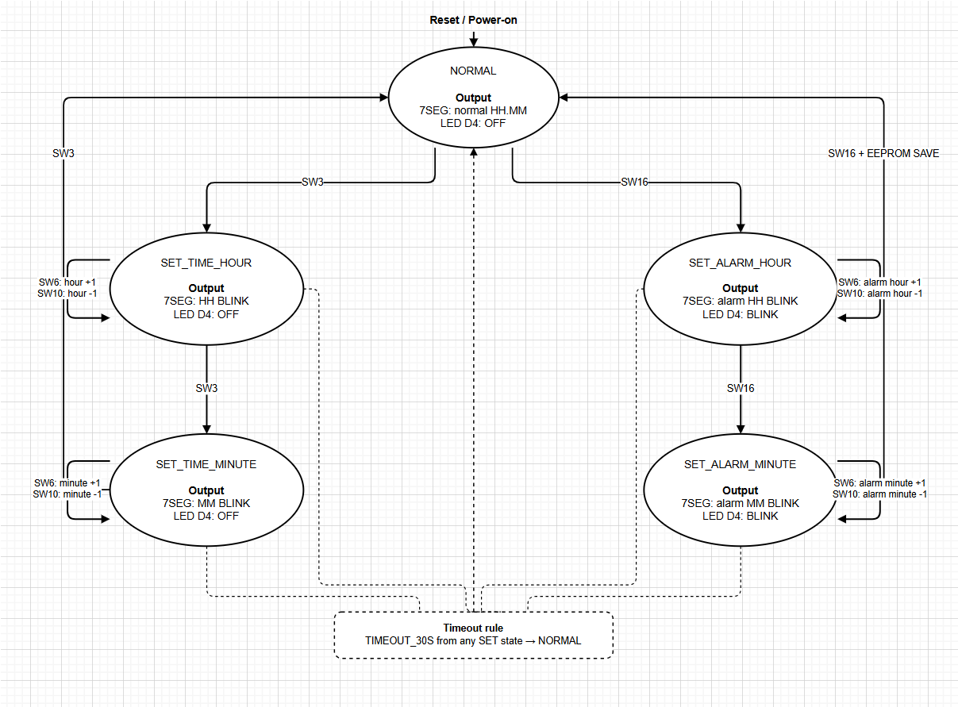
Figure 2. Final five-state Application FSM, button actions, timeout path and D4 output policy.
Repository design artifact: docs/design/fsm-state-diagram.png (editable source: fsm-state-diagram.drawio).

3.3. Alarm Core
The Alarm Core stores the configured hour/minute pair and normalizes the seconds field to 00. The integration layer keeps temporary edit state separate from the confirmed alarm, allowing the user to edit without destroying the previous confirmed value until the final confirmation action.
- Alarm_Init()
- Alarm_SetTime(hour, minute)
- Alarm_GetTime()
- Alarm_Check(current_time)
- Confirmed alarm is persisted through the EEPROM integration path on confirmation.
At runtime, alarm matching is evaluated against the current clock opportunity. Once the condition is accepted, the natural alarm sequence is triggered once and a latch prevents retriggering during the same occurrence.

3.4. Driver & Hardware Platform
The Driver/Platform layer provides public interfaces for Button, Display, Buzzer, LED, EEPROM, GPIO, Timer and interrupt support. The final production application does not manipulate these hardware registers directly; instead it consumes the defined public API boundaries. Timer0 runs as a 16-bit Mode 1 time base with an approximately 1 ms interrupt at 32 MHz IHRC (Fcpu/12).
Subsystem | Final responsibility
Button | EVK matrix scan, debouncing and FIFO event production.
Display | 4-digit multiplexing and state-dependent display rendering/blink behavior.
Buzzer | P1.0 active-high digital GPIO control; non-blocking 300 ms feedback beep and 5-second alarm envelope scheduled from the system tick.
LED | D4 mode indication; final output policy is application-state driven.
EEPROM | 24C05 non-volatile alarm persistence across power-cycle.
GPIO | Pin direction/mode ownership and hardware initialization.
Timer / Interrupt | Timer0 Mode 1 at 32 MHz IHRC (Fcpu/12), approximately 1 ms system tick, software reload and interrupt service; 2 ms display-scan divider.
I2C | Serial access path used by the 24C05 EEPROM integration.

Buzzer implementation note: the final firmware drives PZ1 through P1.0 as an active-high digital GPIO and schedules the required 300 ms and 500 ms timing from the Timer0-derived system tick.
During development, a key button-matrix issue was traced to hardware/software ownership: the EVK reference uses P4 rows/columns and P2 pull-up inputs in the scan path. The corrected scan direction and GPIO ownership were validated on the real EVK. This became a representative hardware-boundary debugging case for the project.

3.5. Application Integration
Application Integration coordinates the complete flow: button events enter through the public Button API; the FSM determines the active mode; Clock and Alarm cores provide behavioral state; and Application Integration coordinates Display, D4, Buzzer and EEPROM driver actions. Activity tracking enforces the 30-second timeout, while EEPROM save/load provides alarm persistence.
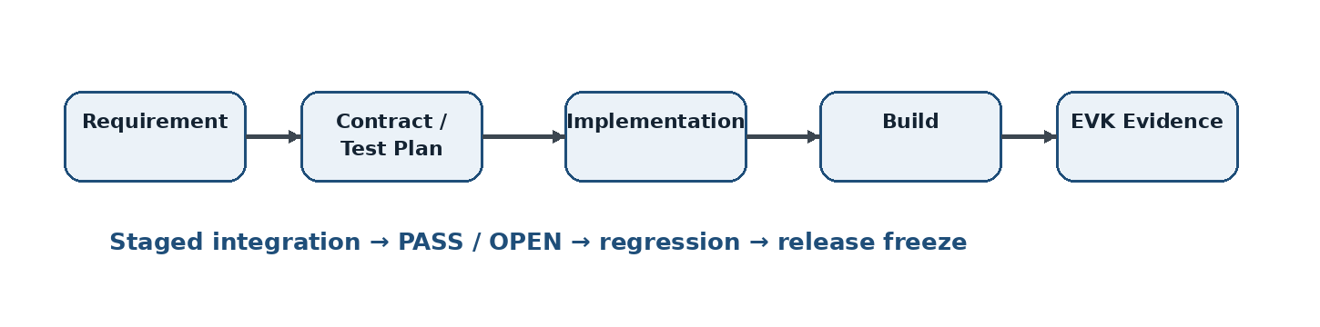
Figure 3. Evidence-first application integration flow used for the project.

4. Verification and Experimental Results
Verification combines core-level tests, staged application/driver integration, clean production-build provenance, flash verification and physical SN8F5708 EVK smoke testing. The release gate therefore relies on both software evidence and observable board behavior.

4.1. Stage-Based Integration
Stage | Scope | Final result
INT01–INT02 | Startup, 32 MHz timing foundation, system tick | PASS / CLOSED
INT03 | Clock → display mapping, 2 ms digit multiplexing and 500 ms blink half-period | PASS / CLOSED
INT04 | Button matrix, debounce and FIFO event path | PASS / CLOSED
INT05 | Current-time setting, pause/resume and fresh anchor | PASS / CLOSED
INT06 | Transactional alarm editing and persistence path | PASS / CLOSED
INT07 | Display/D4 resulting-state policy | PASS / CLOSED
INT08 | SW3/SW6/SW10/SW16 accepted-key 300 ms audible feedback | PASS / CLOSED
INT09 | 30-second inactivity timeout | PASS / CLOSED
INT10 | 24C05 EEPROM power-cycle persistence | PASS / CLOSED
INT11 | Natural alarm occurrence and one-shot latch | PASS / CLOSED
INT12 | 5-second buzzer sequence | PASS / CLOSED
INT13 | Full software regression | 11/11 cases reported PASS
INT14 | Final EVK end-to-end closure | 10/10 criteria reported PASS

The staged ownership split was deliberate: Tuấn owned Application/Core/Integration through the INT01–INT06 foundation, while Trung owned the Driver/Platform/Hardware layer and later integration/closure work. The final acceptance evidence combines the two sides rather than treating either side as a complete system independently.

4.2. Final Build Provenance
Field | Final release evidence
Build branch | feature/application-integration
Git SHA | 1ecf0b4b1bfc60bebf6ea378d640378528d91d12
Working tree at build | Clean
Target | dsac — Keil Production Target
Build mode | Clean Rebuild
Build timestamp | 2026-08-21 16:55:14 (+07)
Toolchain | Keil PK51 9.60.7.0 / C51 V9.60.7.0 / BL51 V6.22.4.0
Program size | DATA 81.0 / XDATA 62 / CODE 4786
Diagnostics | 0 errors / 4 reviewed L16 warnings
HEX | firmware/project/Objects/dsac.hex; 14,408-byte HEX text
Flash | 4786 bytes programmed and verified via SN-LINK

4.3. Final EVK Smoke Test
After the verified firmware baseline provenance was locked, the physical board held by the Application/Release owner was used for a final smoke-test pass. The smoke-test scope intentionally targeted release-critical behaviors rather than changing the firmware.
Smoke item | Observed behavior on final EVK | Result
Boot / NORMAL | Reset produced 00.00; D4 OFF; buzzer silent. | PASS
Current-time setting | Selected HH/MM field blinked at approximately 500 ms visible / 500 ms blank; SW6/SW10 increment/decrement and boundary wrap behaved as expected; return to NORMAL preserved D4 OFF. | PASS
Alarm setting + D4 | SET_ALARM_HOUR and SET_ALARM_MINUTE used the selected-field blink; D4 blinked at approximately 500 ms ON / 500 ms OFF and turned OFF after final SW16 confirmation/save. | PASS
EEPROM power-cycle | Alarm 03:07 was saved, verified by immediate read-back, then restored as 03:07 after power OFF/ON. | PASS
Natural alarm | At the configured minute the buzzer started on time, alternated ON/OFF evenly, and lasted 5 seconds. | PASS
One-shot | The alarm occurred once and did not retrigger again during the same minute. | PASS
30-second timeout | No-input timeout produced the short beep, returned to NORMAL and turned D4 OFF. | PASS
Button feedback | Accepted SW3, SW6, SW10 and SW16 presses each produced the expected short approximately 0.3 s feedback beep during their valid operations. | PASS

Important: These observations are direct physical-board smoke-test results associated with the verified firmware baseline. They complement the staged INT01–INT14 acceptance record and do not replace the detailed test plan/evidence.

4.4. Acceptance Matrix
Gate | Evidence source | Status
Source identity | Exact Git SHA 1ecf0b4; clean working tree at build | CLOSED
Production build | Clean rebuild target dsac; 0 errors | CLOSED
Warnings | Four L16 warnings reviewed as intentional/non-blocking | CLOSED
HEX generation | dsac.hex generated from final target | CLOSED
Flash provenance | 4786 bytes programmed and verified via SN-LINK | CLOSED
Physical-board smoke test | Verified firmware baseline exercised on SN8F5708 EVK | CLOSED
INT01–INT14 team acceptance | Release acceptance record; staged PASS/CLOSED evidence | CLOSED
Demo preparation | Final hardware demo recorded and uploaded; official demo link included in submission materials | READY
Submission package | Final release record + release tag + build/flash identity + YouTube demo | READY FOR SUBMISSION

4.5. Requirement Compliance Summary
Req. | Official behavior | Final evidence | Result
1 | Clock HH.MM; reset to 00.00; minute/hour progression and 00–23 range | Clock Core + final EVK boot/progression evidence | PASS
2 | SW3: SET_TIME_HOUR → SET_TIME_MINUTE → NORMAL; selected field 1 s blink | Final FSM artifact + display timing + EVK smoke | PASS
3 | SW16: alarm hour/minute setting; final confirmation saves EEPROM | Final FSM + INT06/INT10 + power-cycle smoke | PASS
4 | SW6 increment with hour/minute wrap-around | Clock/FSM boundary tests; 23→00 and 59→00 behavior | PASS
5 | SW10 decrement with hour/minute wrap-around | Clock/FSM boundary tests; 00→23 and 00→59 behavior | PASS
6 | Buzzer: 0.3 s key/timeout beep; alarm 5 s at 0.5 s ON / 0.5 s OFF | Buzzer timing constants + INT08/INT12 + EVK smoke | PASS
7 | Bonus: D4 blinks only in alarm-setting states at 0.5 s ON / 0.5 s OFF | FSM output policy + INT07 + EVK smoke | PASS
8 | EEPROM stores alarm HH:MM with seconds fixed to 00 and survives power-cycle | 24C05/I2C integration + 03:07 power-cycle test | PASS
9 | Bonus: 30 s inactivity in any SET state returns to NORMAL with short beep | INT09 + final EVK timeout smoke | PASS
Coverage result: all nine functional requirements in the competition brief are mapped to implementation and/or physical-EVK evidence; requirements 7 and 9 correspond to the bonus criteria.

5. Revision History
Date | Version | Description | Author
2026-08-14 | 0.1 | Initial MCU report draft based on Application Core design and early simulator verification. | Cao Minh Tuấn
2026-08-20 | 0.2 | Updated with finalized application/driver architecture, integration contract and stage-based test plan. | Cao Minh Tuấn / Nguyễn Đình Phan Trung
2026-08-21 | 0.3 | Updated through INT01–INT14 integration; added final build provenance, 4786-byte production image and EVK acceptance. | Cao Minh Tuấn / Nguyễn Đình Phan Trung
2026-08-22 | 1.0 | Final technical-report revision for the verified firmware release baseline, including final EVK smoke-test results, release provenance and demo/submission information. | Cao Minh Tuấn / Nguyễn Đình Phan Trung
2026-08-22 | 1.1 | Updated final release status, release tag/PR provenance, final YouTube demo link and submission-package references. | Cao Minh Tuấn / Nguyễn Đình Phan Trung
2026-08-22 | 1.2 | Corrected system architecture and FSM presentation; added requirement-compliance mapping, explicit timing/boundary specifications and Timer0/GPIO buzzer implementation clarification. | Cao Minh Tuấn / Nguyễn Đình Phan Trung
2026-08-22 | 1.3 | Final correctness cleanup: removed unsupported/overstated submission wording, clarified verified-baseline terminology, and retained only implementation claims supported by release evidence. | Cao Minh Tuấn / Nguyễn Đình Phan Trung

6. Final Release and Demo

6.1. Release Freeze
Commit 1ecf0b4b1bfc60bebf6ea378d640378528d91d12 is the verified firmware release baseline for the competition and is tagged dsac-mcu-final-2026. The verified firmware was promoted to main through PR #12, while PR #13 finalized documentation only. The documentation-only update does not modify the frozen firmware tree. Any firmware source change after this baseline would require a new candidate identity and a new verification cycle.

6.2. Demo Video
The competition scoring includes a 20% Demo Video component covering introduction and functional testing, including test-flow presentation and teamwork. The final demo is therefore structured around observable input → expected behavior → physical result rather than a code walkthrough.
- Introduce the team and project on the SONiX SN8F5708 EVK.
- Show reset/startup and NORMAL mode.
- Demonstrate current-time hour/minute setting and audible feedback.
- Demonstrate alarm setting and D4 behavior.
- Demonstrate EEPROM persistence through power-cycle.
- Demonstrate natural alarm timing and the five-second 500 ms ON/OFF buzzer pattern.
- Demonstrate one-shot behavior.
- Demonstrate 30-second inactivity timeout.
- Close with the two-person responsibility split and verified firmware baseline identity.

6.3. Submission Package
- Verified firmware baseline SHA: 1ecf0b4b1bfc60bebf6ea378d640378528d91d12
- Final production target: dsac
- Final program size: DATA=81.0, XDATA=62, CODE=4786
- Final build diagnostics: 0 errors / 4 reviewed warnings
- Verified clean-build output: dsac.hex generated locally at firmware/project/Objects/dsac.hex (build artifact; not tracked in Git)
- Final release record: docs/release/FINAL_RELEASE_1ecf0b4.md
- Release tag: dsac-mcu-final-2026
- Final YouTube demo: https://youtu.be/f7Rsa1xx3BQ
- Final technical report: v1.3

Appendix A. Engineering Case Highlights
During development, the team solved several non-trivial embedded integration problems that are useful as engineering evidence: (1) MCU DATA-space pressure and relocation of non-critical state to XDATA; (2) timer/interrupt integration and ISR re-entry avoidance; (3) button-matrix row/column ownership correction against the EVK reference; (4) production/test target isolation after a historical linker failure involving test-module membership; and (5) transactional alarm editing and persistence semantics.
Evidence basis: DSAC MCU 2026 competition brief; project Integration Contract/Test Plan; Git history and final release provenance; final EVK smoke-test observations recorded during release closure.

