BookHouse

Use-Case Specification

Version <1.0>

Revision History

| **Date** | **Version** | **Description** | **Author** |
| --- | --- | --- | --- |
| <dd/mmm/yy> | <x.x> | <details> | <name> |
|  |  |  |  |
|  |  |  |  |
|  |  |  |  |

Table of Contents

1. Use-case Model 4

2. Use-case Specifications 4

2.1 Use-case: Add a product to cart 4

2.2 Use-case: Create a new account 5

# Use-case Model

* This is the link to the diagram if you want to see it more clearly: [usecases.drawio - diagrams.net](https://app.diagrams.net/#G1rlPwB5lrPe31NYkbJoO_M49wjFWuHBRc)

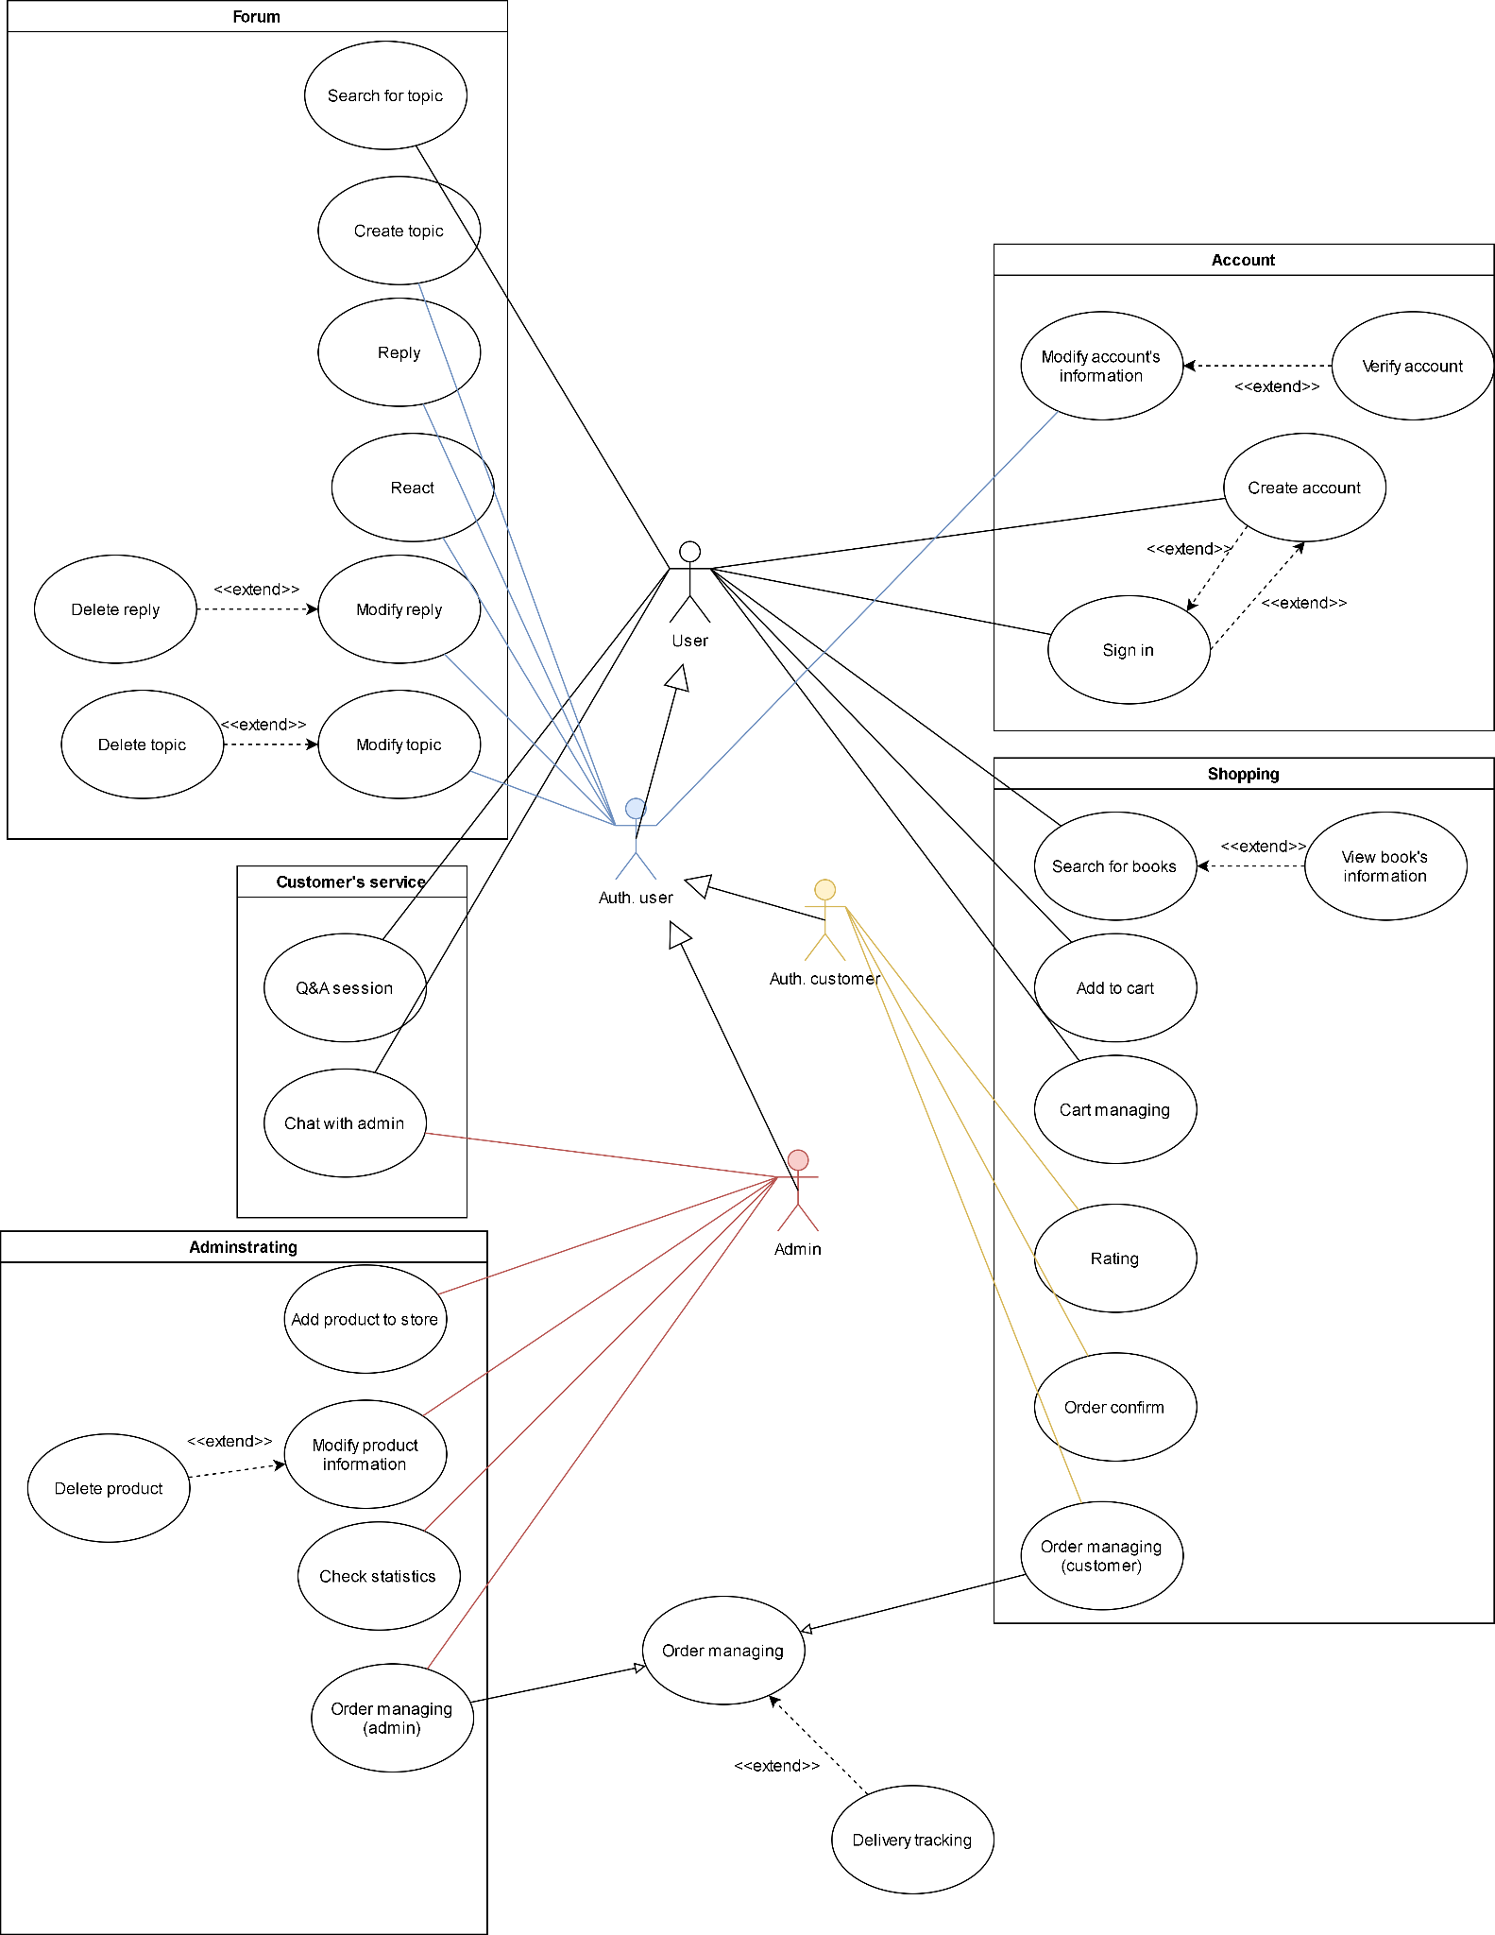

# Use-case Specifications

## Use-case: Create an account

| Use case Name | Create account. |
| --- | --- |
| Brief description | This use case describes how the Customer can create an account. |
| Actors | Customer |
| Basic Flow | 1. At the homepage, the user clicks on the “sign-up” button. 2. User fills in information to the form and submit. 3. The system displays the success message and sends verifying email or message at the same time. |
| Alternative Flows | Alternative flow 1: Users enters invalid input   1. From #2 of the basic flow, users enter invalid input. 2. The system displays messages on where the user needs to enter again. 3. Continue #2 of this flow until all fields in the form are valid. 4. Continue from #3 of the basic flow. |
| Pre-conditions | User goes to the homepage at ... |
| Post-conditions | The system displays a success message and goes back to the homepage after a few seconds. |

## Use-case: Sign in

| Use case Name | Sign in. |
| --- | --- |
| Brief description | This use case describes how the Customer and admin log-in to account |
| Actors | Customer, admin |
| Basic Flow | 1. At the homepage, the user clicks on the “sign in” button. 2. The screen for sign-in is displayed, user fills in username and password. 3. Back to the homepage, the user got into the account. |
| Alternative Flows | Alternative flow 1: Users enters wrong username or password   1. From #2 of the basic flow, users enter wrong username or password. 2. System displays messages to notify that the username or password is invalid. 3. Back to #2 of the basic flow. |
| Pre-conditions | User goes to the homepage at ... |
| Post-conditions | Back to the homepage, the user got into the account. |

## Use-case: Modify account’s information

| Use case Name | Modify account’s information |
| --- | --- |
| Brief description | This use case describes how the Customer can modify the information of the personal account. |
| Actors | Customer |
| Basic Flow | 1. At the homepage, the user clicks on the*avatar image*button or the “user name” text view and chooses“Account’s information” . 2. User fills in information to the form and submit. 3. System displays the success changing message, saves to the database and updates the information of the account. |
| Alternative Flows | Alternative flow 1: Users enters invalid input   1. From #2 of the basic flow, users enter invalid information input. 2. System displays messages on where the user needs to enter again. 3. Continue #2 of this flow until all fields in the form are valid. 4. Continue from #3 of the basic flow. |
| Pre-conditions | User goes to the profile page at ... |
| Post-conditions | System displays a success message and goes back to the profile page after a few seconds. |

## Use-case: Search for books

| Use case Name | Searching |
| --- | --- |
| Brief description | This use case describes how to search for a specific product. |
| Actors | Customer |
| Basic Flow | 1. At the homepage, the user clicks on the searching input. 2. User fills in information (keyword) in the input. 3. The system displays the book’s information. |
| Alternative Flows | Alternative flow 1: Users enters invalid input   1. From #2 of the basic flow, users enter invalid input. 2. The system displays messages on where the user needs to enter again. 3. Continue #2 of this flow until all fields in the form are valid.   Alternative flow 2: The query didn’t return any result   1. Display notification message for the customer. |
| Pre-conditions | User goes to the homepage. |
| Post-conditions | The system displays the book’s information to satisfy the query. |

## Use-case: Add to cart

| Use case Name | Add to cart |
| --- | --- |
| Brief description | This use case describes how the Customer add products to cart |
| Actors | Customer |
| Basic Flow | 1. At the screen of the product, the user chooses the number of products and clicks on the “Add to cart” button. 2. The message “Add to cart successfully” is displayed. |
| Alternative Flows | Alternative flow 1: Out of stock  After #1, the system will check whether the number of products that customers add to the cart is in stock, if not, the system will display the message “Out of stock” |
| Pre-conditions | The screen of the product. |
| Post-conditions | System displays a success message and goes back to the screen of products. |

## Use-case: Rating

| Use case Name | Rating. |
| --- | --- |
| Brief description | This use case describes how a customer can rate a product they bought. |
| Actors | Customer. |
| Basic Flow | 1. From the product information page, users click on the “add rating” button. 2. The customer chooses a rating, adds a comment (optional), and clicks submit. 3. The system adds the rating to the rating session. |
| Alternative Flows | Alternative flow 1: Users enters invalid input   1. From #2 of the basic flow, users enter invalid input. 2. The system displays messages on where the user needs to enter again. 3. Continue #2 of this flow until all fields in the form are valid.   Alternative flow 2: User cancel rating   1. From #2 of the basic flow, the user clicks on the “X” button. 2. The rating window closes. |
| Pre-conditions | The user signed in, user bought the product, and received the product |
| Post-conditions | The rating is displayed in the product page if the user submitted the form. |

## Use-case: Add product to store

| Use case Name | Add product. |
| --- | --- |
| Brief description | This use case describes how the Admin can add a product to the cart. |
| Actors | Admin. |
| Basic Flow | 1. At the homepage, the admin clicks on the “add_product”button. 2. Admin adds more products and information to the form. 3. The system displays the adding success message after storing the product in the database. |
| Alternative Flows | Alternative flow 1: Users enters invalid input   1. From #2 of the basic flow, the admin enters invalid input. 2. The system displays messages on where the admin needs to enter again. 3. Continue #2 of this flow until all fields in the form are valid. |
| Pre-conditions | The user goes to the homepage of the admin. |
| Post-conditions | The system displays a success message and shows a back button to the admin’s homepage. |

## Use-case: Modify product information

| Use case Name | Modify product information. |
| --- | --- |
| Brief description | This use case describes how the Admin can modify the information of the product. |
| Actors | Admin |
| Basic Flow | 1. At the homepage, the user clicks on the “modify_product” button. 2. The user chooses the product that needs to be modified. 3. User fills in information to the form and submit. 4. The system displays the success message, saves it to the database, and updates the information of the product. |
| Alternative Flows | Alternative flow 1: Users enters invalid input   1. From #3 of the basic flow, users enter invalid information. 2. The system displays messages on where the user needs to enter again. 3. Continue #2 of this flow until all fields in the form are valid. 4. Continue from #3 of the basic flow. |
| Pre-conditions | The user goes to the product page at ... |
| Post-conditions | The system displays a success message and goes back to the product page after a few seconds. |

## Use-case: Delete product

| Use case Name | Delete account. |
| --- | --- |
| Brief description | This use case describes how the Admin can delete a product of the store. |
| Actors | Admin |
| Basic Flow | 1. At the product page, the user clicks on the “delete product” button next to the product view frame. 2. The system displays the verification message with 2 options: accept or not accept. 3. If the user chooses the accept option, the system displays the success message and deletes the product. 4. If the user chooses the not accept option, the system will come back to the product page. |
| Alternative Flows | **None** |
| Pre-conditions | The user goes to the product page at ... |
| Post-conditions | System displays a success message and goes back to the product page after a few seconds. |

## Use-case: Check statistics

| Use case Name | Check statistics. |
| --- | --- |
| Brief description | This use case describes how the Admin can check the statistics of the store. |
| Actors | Admin |
| Basic Flow | 1. At the homepage, the user clicks on the “statistics” button. 2. The user chooses what statistics to see. 3. The system displays the statistics. |
| Alternative Flows | **None** |
| Pre-conditions | The user is an Admin and signed in. |
| Post-conditions | The system displays the statistics. |

## Use-case: Verify account.

| Use case Name | Verify account |
| --- | --- |
| Brief description | This use case describes how the new users can verify their account |
| Actors | Authentication User |
| Basic Flow | 1. At the modify account’s information interface, the user clicks the “verify account” button. 2. The system displays the form to verify email and phone number. 3. Enter an email to verify, and the system will send you an authentication password. Enter this password to the form and finish verifying the email. 4. Enter a phone number to verify, and the system will send you an authentication password. Enter this password to the form and finish verifying the phone number. |
| Alternative Flows | Alternative flow 1: Email or phone number is wrong   1. Bold the specific form to let the user know that there is something wrong. 2. Users enter the new email or phone number and verify again.   Alternative flow 2: Wrong authentication password   1. Bold the specific form to let the user know that there is something wrong. 2. Users enter the new authentication password and verify again. |
| Pre-conditions | The user needs to have an account. |
| Post-conditions | A successful message is shown to the user. |

## Use-case: Cart managing.

| Use case Name | Cart managing |
| --- | --- |
| Brief description | This use case describes the status of the user’s cart |
| Actors | User |
| Basic Flow | 1. At the main page, the user clicks on the cart button. After clicking to the avatar, the UI will appear with a list of options to choose. 2. The system will transfer to the cart page. 3. The users can update their cart by changing the number of items or deleting or canceling the order. 4. If the users choose to modify their cart, the systems will change in realtime and need a submission with a notification message box. |
| Alternative Flows | **None** |
| Pre-conditions | The user needs to log in. |
| Post-conditions | **None** |

## 

## Use-case: Order managing (customer).

| Use case Name | Order managing (customer) |
| --- | --- |
| Brief description | This use case describes how the customer can manage their active orders. |
| Actors | Customer |
| Basic Flow | 1. At the homepage customer clicks on the account icon and then chooses “Order managing”. 2. The website goes to the order management window where customers can see their active orders. 3. User chooses one of their orders, the website goes to the **delivery tracking** window of that order. |
| Alternative Flows | **None** |
| Pre-conditions | The user is a customer and signed in. |
| Post-conditions | **None** |

## 

## Use-case: Order managing (admin).

| Use case Name | Order managing (admin) |
| --- | --- |
| Brief description | This use case describes how the admin can manage active orders. |
| Actors | Customer |
| Basic Flow | 1. At the homepage admin clicks on the “Order managing” button. 2. The website goes to the order management window where admin can see their active orders. 3. Admin can choose “Confirm order” to confirm the order. 4. User chooses one of the active orders, the website goes to the **delivery tracking** window of that order. |
| Alternative Flows | **None** |
| Pre-conditions | The user is an admin and signed in. |
| Post-conditions | **None** |

## 

## Use-case: Q&A session.

| Use case Name | Q&A session |
| --- | --- |
| Brief description | This use case describes the fundamental question for the systems and a domain to contact with the admin if they have any more questions. |
| Actors | User |
| Basic Flow | 1. At the main page, the user clicks on the Q&A button at the bottom right floating button. 2. The system will transfer to the Q&A page. 3. The user has various options: choose the basic questions of the systems, or choose the domain to contact with the admin. 4. If the user chooses the basic option, the system will show the answer, instructions for that question. 5. If the user chooses the contacting option, the admin will show the chat box. |
| Alternative Flows | **None** |
| Pre-conditions | The user need to log in |
| Post-conditions | The system goes to the Q&A page after a few seconds. |

## 

## Use-case: Delivery tracking.

| Use case Name | Delivery tracking |
| --- | --- |
| Brief description | This use case describes how the admin can manage their active orders. |
| Actors | Customer |
| Basic Flow | 1. User goes to the delivery tracking window from the **Order managing** window. 2. Users can see the delivery status of the order they chose. 3. If there is a “Cancel order” button, users can click on that button if they want to cancel that order. |
| Alternative Flows | **None** |
| Pre-conditions | The user clicked on an order from the **Order managing** window. |
| Post-conditions | If the user cancels the order, the order is canceled. |

## 

## View book’s information

| Use case Name | View book’s information |
| --- | --- |
| Brief description | This use case describes the information for a book containing the book ID, author, publisher, price, description. |
| Actors | User |
| Basic Flow | 1. At the main page, the users click on the book they want to take a glance at. 2. The system will display the book information frame. 3. The system has an add to cart option or create a review if the users have bought this book before. |
| Alternative Flows | **None** |
| Pre-conditions | The user need to log in |
| Post-conditions | The system will display the information frame after a few seconds. |