TỔNG LIÊN ĐOÀN LAO ĐỘNG VIỆT NAM

**TRƯỜNG ĐẠI HỌC TÔN ĐỨC THẮNG**

**KHOA CÔNG NGHỆ THÔNG TIN**



**BÁO CÁO HOMEWORK 10% MÔN HỌC**

**Công Nghệ Phần Mềm**

*Người hướng dẫn*: **Thầy Phạm Thái Kì Trung**

*Người thực hiện*: **Ngô Anh Tuấn  
MSSV: 521H0379**

Khoá  **: 25**

**THÀNH PHỐ HỒ CHÍ MINH, NĂM 2023**

TỔNG LIÊN ĐOÀN LAO ĐỘNG VIỆT NAM

**TRƯỜNG ĐẠI HỌC TÔN ĐỨC THẮNG**

**KHOA CÔNG NGHỆ THÔNG TIN**



**BÁO CÁO HOMEWORK 10% MÔN HỌC**

**Ticket Vendor Machine**

Người hướng dẫn: **Thầy Phạm Thái Kì Trung**

Người thực hiện: **Ngô Anh Tuấn**

**MSSV: 521H0379**

Khoá  **: 25**

**THÀNH PHỐ HỒ CHÍ MINH, NĂM 2023**

LỜI CẢM ƠN

Sau một thời gian học tập cùng với sự giúp đỡ, hướng dẫn tận tình của thầy Phạm Thái Kì Trung môn học Công Nghệ Phần Mềm trên các lớp lý thuyết và thực hành, em đã có thể hoàn thành bài báo cáo cuối khóa một cách đầy đủ. đủ. Sự tinh tế trong phong cách giảng dạy đa dạng của thầy đã mang đến cho học sinh trải nghiệm mới về bộ môn này, giúp các em lĩnh hội kiến thức mới và cách nhìn nhận vấn đề hợp lý. Ngoài ra, chúng em còn được thầy cô hỗ trợ làm thêm bài tập về nhà để nắm vững kiến thức cũng như phát triển tư duy về chuyên ngành học. Qua đó, em thấy được sự tận tụy với công việc, lòng yêu nghề của các thầy cô giáo Trường Đại học Tôn Đức Thắng.

Chúng em xin chân thành cảm ơn.

**BÀI TẬP ĐƯỢC HOÀN THÀNH**

**TẠI TRƯỜNG ĐẠI HỌC TÔN ĐỨC THẮNG**

Tôi xin cam đoan đây là Bài tập của riêng tôi và được sự hướng dẫn khoa học của Thầy Phạm Thái Kì Trung;. Các nội dung nghiên cứu, kết quả trong bài tập này là trung thực và chưa công bố dưới bất kỳ hình thức nào trước đây. Những số liệu trong các bảng biểu phục vụ cho việc phân tích, nhận xét, đánh giá được chính tác giả thu thập từ các nguồn khác nhau có ghi rõ trong phần tài liệu tham khảo.

Ngoài ra, trong luận văn còn sử dụng một số nhận xét, đánh giá cũng như số liệu của các tác giả khác, cơ quan tổ chức khác đều có trích dẫn và chú thích nguồn gốc.

**Nếu phát hiện có bất kỳ sự gian lận nào tôi xin hoàn toàn chịu trách nhiệm về nội dung luận văn của mình.** Trường đại học Tôn Đức Thắng không liên quan đến những vi phạm tác quyền, bản quyền do tôi gây ra trong quá trình thực hiện (nếu có).

*TP. Hồ Chí Minh, ngày 13 tháng 3 năm 2023*

*Tác giả*

*(ký tên và ghi rõ họ tên)*

*Ngô Anh Tuấn*

MỤC LỤC

Details

LỜI CẢM ƠN iii

MỤC LỤC 1

**I.** **System introduction:** 3

***1.1.*** ***Specification of the topic:*** 3

**II.** **System functionalities and non-functional:** 3

***2.1.*** ***Ticket Purchase Function:*** 3

***2.2.*** ***Destination selection function:*** 3

***2.3.*** ***Payment function:*** 4

**III.** **Use Case modelling and Description:** 5

***3.1.*** ***Use Case modelling:*** 5

***3.2.*** ***Use Case Description:*** 6

***By word:*** 6

Passengers after boarding public transport will be asked by flight attendants to buy tickets through the vendor machine system, the system will display the word "Buy ticket" on the screen, the user's task is to click on it and then the system will transfer them to the place to choose the destination, after the user chooses a suitable place they decide to get off here, the machine will display asking them to choose a payment method. 6

If they choose to pay by credit card, passengers will be directed to a screen to enter their card number and after they enter the correct screen the information will be sent to the ticketing machine, otherwise, if they enter it wrong, the machine will report error and ask to re-enter. 6

If you choose the payment method by E-wallet, the user will be asked to choose one of the two supported e-wallets, Momo and VNPay, after the user has selected their e-wallet, a code will appear on the screen. QR requires the user to scan the code, after successful scanning the system will be asked to issue a ticket to the passenger. 7

***By Table:*** 7

**IV.** **System design with custom diagrams:** 8

1. **System introduction:**
   1. ***Specification of the topic:***

- Automated ticketing system that sells public transport (Bus, subway, etc.). User selects destination and chooses payment method (such as Credit Card, QR Code payment linked to banking system or e-wallet).

- In case of payment by credit card, the ticket machine will issue a paper ticket with a barcode and their credit card account will be charged. When the passenger presses the start button, a menu showing potential destinations is activated, along with a message for him/her to select the destination. Once a destination has been selected, he/she is asked to enter their credit card. Once the credit transaction has been validated, the ticket will be issued.

- Same for digital wallet which means ticket provider's machine will show QR Code after passenger selects payment route on his mobile phone account for the purpose of reuse for the next visit.

* 1. ***Question and Answer about requirements of the topic:***
* Information about the question as well as the answer has been compiled in the file

🡪 521H0379_NgoAnhTuan_Requirement(excel)

1. **System functionalities and non-functional:**
   1. ***Ticket Buy Function:***

* This is the function that will appear first when the user gets on the bus and proceeds to buy a ticket.
* Passengers will touch the screen where the text is "Buy Ticket". -> The screen of other functions will appear for the user to continue to choose.
  1. ***Destination selection function:***
* This is the function that will appear after the user clicks on the buy ticket button.
* Passengers will be asked to choose a fixed destination because public transport will often stop at places with pre-routed routes.
  1. ***Payment function:***
* *This is the last function that determines the user will travel by this vehicle to their destination in addition to the user's interaction with the driver.*
* *Passengers will be asked which payment method to choose after choosing a destination. There are 2 payment methods: by credit card or e-wallet:*

*+ If the customer chooses to pay by bank card, they need to enter the card number -> if the card number is valid, their account will be deducted and then move to the next step.*

*+ If customers choose to pay by e-wallet, they will be sent a payment QR code on the display screen of the machine after that -> if their e-wallet pays successfully, their account will be deducted and then move on to the next step.*

* 1. ***Exporting the ticket function:***
* *This is a function that belongs to the system and the user will not be able to interact with it.*
* *When and only if the user has succeeded in the previous payment step -> The system will automatically save the information the user has just selected and write on the bus ticket, then print and export it to the user.*
  1. ***Convenience non-functional:***
* The creation of this new system can bring a lot of convenience to customers and drivers. For example, if a customer needs to book a trip to a certain destination, the driver will not have to remember each customer's location and ask again and again each time to a certain stop.
* Customers can rest without having to track the distance the driver has traveled to see if they have reached their destination.
* This system can also bring convenience to managers such as making it easier for managers to view reports and it can be used to summarize the number of customers, most popular locations and routes. receive the most customers.
  1. ***Improve efficiency non-functional:***
* The process time of the current system are time consuming because the current systems are using paper work to record down all the information.
* It is taking a lot of time to serve the customer when the staff searching the available time and seat. The purpose of create this system is to improve the efficiency time of process. It can let the staff search the information faster and easier and maintain the data faster and reduce the paperwork.  
  1. ***Reduce problems non-functional:***
* Because of this convenience, customers can use the vehicle more comfortably, reduce crowding, and vices such as pickpocketing, fraud or harassment, and ticket evasion.
* In addition, each person is assigned a seat in the order of ticket purchase by the ticketing staff to avoid seat confusion.
  1. ***Reduce error data:***
* The purpose of creating this new system is let the staff to reduce key in wrong data, because the systems are using computer to key in the data, there got some validation to check when staff key in the data wrongly and system will provide some selection to let staff direct choose the data. It also reduces the paper work to record all the information, so it brings the benefit for reduce error data

1. **Use Case modelling and Description:**
   1. ***Use Case modelling:***

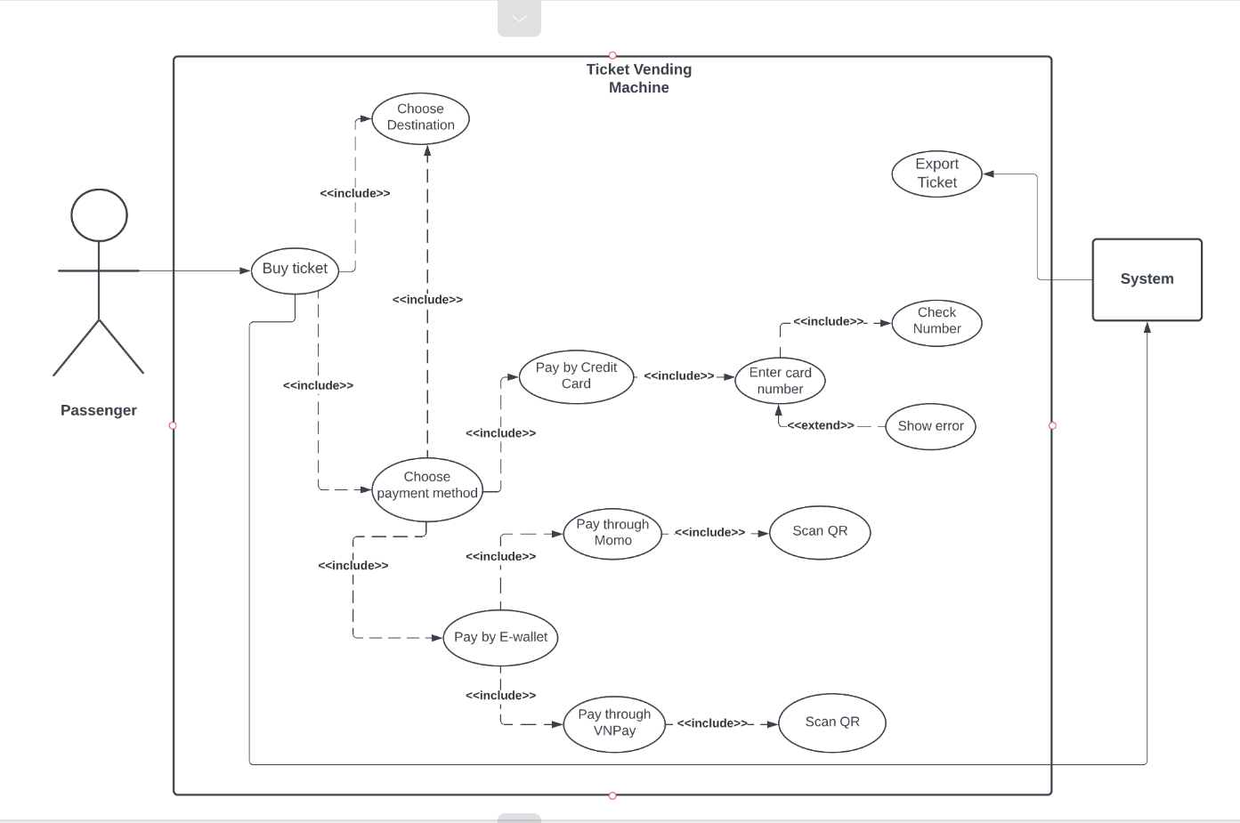

* 1. ***Use Case Description:***

***By word:***

Passengers after boarding public transport will be asked by flight attendants to buy tickets through the vendor machine system, the system will display the word "Buy ticket" on the screen, the user's task is to click on it and then the system will transfer them to the place to choose the destination, after the user chooses a suitable place they decide to get off here, the machine will display asking them to choose a payment method.

If they choose to pay by credit card, passengers will be directed to a screen to enter their card number and after they enter the correct screen the information will be sent to the ticketing machine, otherwise, if they enter it wrong, the machine will report error and ask to re-enter.

If you choose the payment method by E-wallet, the user will be asked to choose one of the two supported e-wallets, Momo and VNPay, after the user has selected their e-wallet, a code will appear on the screen. QR requires the user to scan the code, after successful scanning the system will be asked to issue a ticket to the passenger.

***By Table:***

|  |  |
| --- | --- |
| **Use Case modelling for Ticket Vendor Machine**  **(This use case is allow passenger purchase for a ticket)** | |
| Action | System Response |
|  | 1. Display purchase home screen |
| 2. Click “Buy ticket” button | 3. Display choosing destination home screen |
| 4. Click “choose destination” | 5. Show the places where the bus will stop. |
| 6. Click to the place user want to get off | 7. Display choosing payment method |
| 8. Choose the payment method | |
| 9.1. Click “Pay by Credit card”  9.1.1 Display “enter number” box home  9.1.2 When enter finish, start to check  9.1.3 Valid -> Export ticket for passenger  9.1.3 Invalid -> Return to “enter number” box home screen | 9.2. Click “Pay by E-wallet”  9.2.1 Display choose method “Pay by Momo” or “Pay by VNPay”  9.2.2 Show QR code |
| 10. Export Ticket for passenger |  |

1. **System design with custom diagrams:**
   1. **Activity diagram of passenger’s buying a ticket from ticket vendor machine:**

* The Activity Diagram describes how activities are coordinated to provide a service, and these diagrams can have various levels of abstraction. Usually, an event needs to be successfully accomplished by several activities. In particular, when any place where an activity is expected to achieve different results, or how events in one use case (UC) are related to an event in another, in particular, use cases where activities may overlap, where coordination is required. This diagram is also suitable for modeling how a set of UCs work together to represent business process flow.
* *Activity diagram to present the process of passenger’s buying a ticket from ticket vendor machine:*

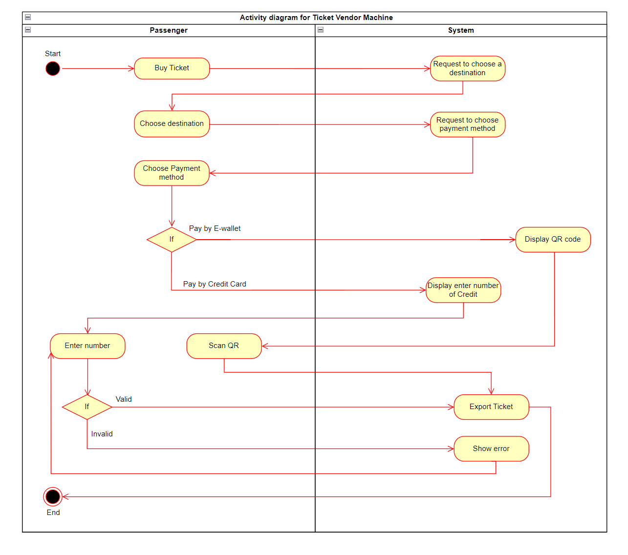

* 1. **Activity diagram for communication among systems:**
* The activity diagram below shows the interaction between the ticket vending machine system and the e-wallet. Because this is the connection on both sides, it needs many different conditions to satisfy each problem posed by the system, in addition, because this is the interaction between the 3 sides, the user, the system, and the user. -wallet system should meet the right conditions to what the user wants with high reliability.
* *Activity diagram to present the process of passenger’s buying a ticket from ticket vendor machine:*

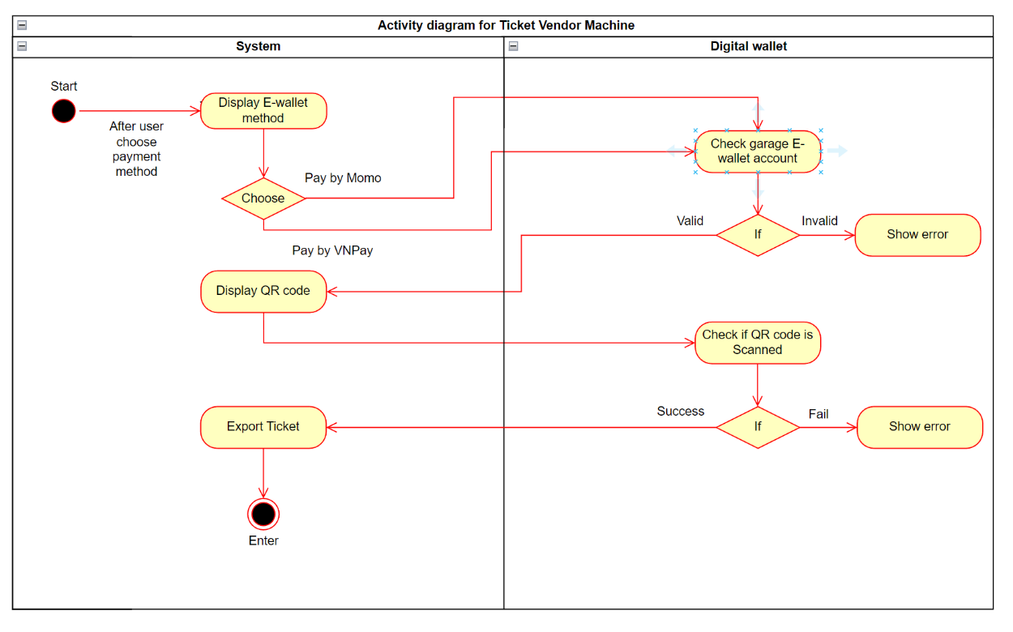

* 1. **Sequence diagram:**
* A sequence diagram is a type of interaction diagram because it describes how—and in what order—a group of objects works together. These diagrams are used by software developers and business professionals to understand requirements for a new system or to document an existing process:
* *Here is the sequence diagram with the ticket purchase function:Diagram, box and whisker chart

  Description automatically generated*
  1. **Class diagram:**
* In software engineering, a class diagram in the Unified Modeling Language (UML) is a type of static structure diagram that describes the structure of a system by showing the system's classes, their attributes, operations (or methods), and the relationships among objects.
* *Here is the class diagram with the ticket purchase function:*

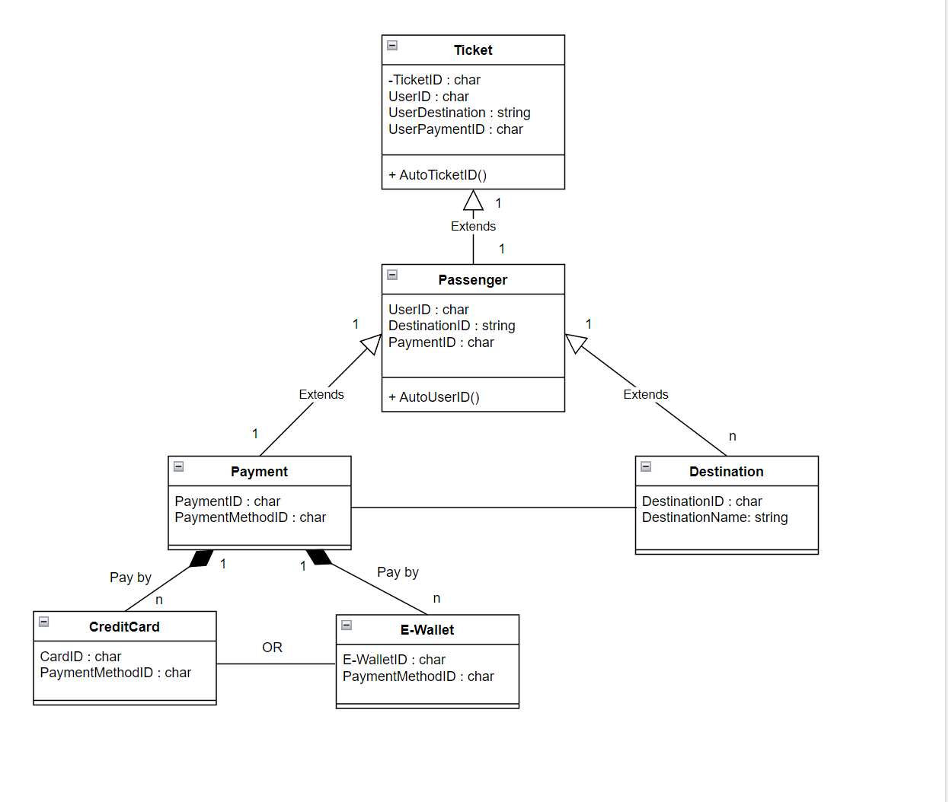

1. **Develop Architecture design:**
   1. **Describe the system structure:**

* Need a robust processor such as ARM with a rich set of peripherals that are low cost. ARM7TDMIis a better controller available with LPC2148 controller with its rich set of peripherals. A set of motors are required for loading different material for the beverage making. Stepper motor leads to the reliability and low-cost source of motors. Stepper motor consists of a permanent magnet rotating shaft called the rotor and the electromagnets which are surrounded to the shaft are called the stator. The electromagnets are energized by an external control circuit, such as ARM controller. To make the motor shaft turn, first, one electromagnet is given power. In this design, a high torque stepper motor which drives more power is used. Extreme variations in temperature (too cold, too hot) can spoil the drinks and damage the motors. Hence, a temperature controller is required to monitor the temperature of the system components and the motors. The solenoid valves are mainly used in tea / coffee vending machines systems. This liquid spent valves are reliable and dependable low pressure valves designed to dispense water or similar liquid from tank. It has a built-in flow controller for precise control. It is designed & developed to meet harsh tropical demands. The solenoid valve mainly finds application in coffee vending machines. It has two coils for double control and has a controlled forward flow as well as a reverse leakage control. Solenoid Valve is used to control the flow of hot water for the preparation of coffee, tea, milk and black tea. A solenoid valve is an electromechanical valve for use with liquid. The valve is controlled by an electric current through a solenoid; in the case of a two-port valve the flow is switched on or off; in the case of a three-port valve, the outflow is switched between the two outlet ports. Water heating Coil converts electrical energy into heat energy. Beverage vending machine systems uses water heating coil to get hot water which is required for the preparation of hot beverages. A vending machine consists of a money box comprising of currency detector and currency dispenser. It accepts payment and dispenses the change to the customer. The process involves examining the currency that has been inserted, and by using various tests, determine if the currency is counterfeit. In operation, if the item is accepted, it is retained by the machine and placed in a storage device. If the item is rejected, the machine returns the item. Later based on customer’s selection of beverage, the operation is preceded. For the system a weatherproof LCD screen that is installed at the front face of the machine as a user interface is used. The screen provides an interactive user interface for user to select a desired product whether tea, black tea, coffee, or cold coffee. The LCD screen alternately will display preloaded advertisement images one at a time when there is no interface with the user. The video will be cleared when a user wishes to buy something from the machine by simply pressing the right switch. For every electronic device there is a need for power supply to conduct its operation. It is equipped with a battery that able to stores energy which sufficient enough for the machine to and an electric supply backup. A vending machine reads currency based on the physical characteristics of individual pieces of currency such as the diameter, thickness and ridges of the edge. A Vending Machine scans paper money by automated denomination recognition. The primary method vending machines use to recognize the denomination of paper money is through a magnetic scan, paper currency is printed with magnetic ink, similar to the ink on the MICR line of a check, that makes it easily identifiable to machines with magnetic scanners whether it is a original currency or not. In addition, each denomination is marked with different fluorescent properties. Many vending machines and other machines that read paper currency use an ultraviolet light to scan the bill and give the appropriate credit i.e., what amount of currency is being fed. The currency dispensing mechanism as an electric eye that counts each bill as it exits the dispenser, in money stack in which there will be separate slots for different amount, so that it will be help full while dispensing money, currency paper note dispenser unit will be having a roller and a hopper by using this
  1. **Deployment diagram:**
* *A deployment diagram is a UML diagram type that shows the execution architecture of a system, including nodes such as hardware or software execution environments, and the middleware connecting them. Deployment diagrams are typically used to visualize the physical hardware and software of a system.*
* *Here is the deployment diagram for ticket vending machine:*

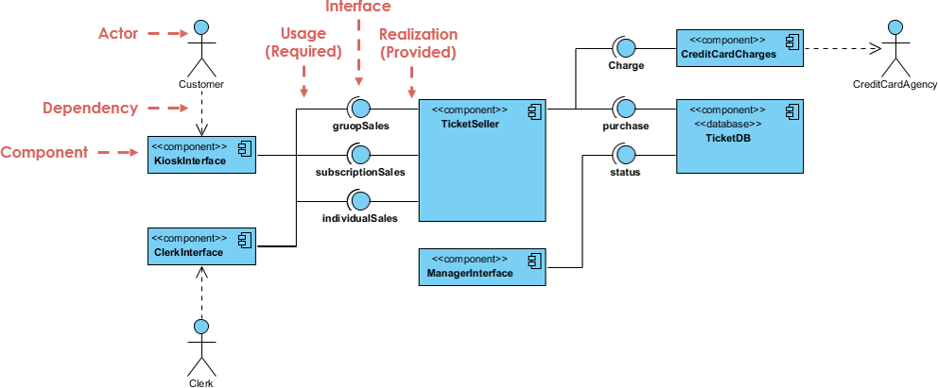

1. **Conclusion:**

* In this design a stepper motor which has low efficiency i.e., the motor draws substantial power regardless of load. Instead, if a use dc motor it has high efficiency, it can approach 90% at little loads. Also, dc motor had much reduced stepper motor. Instead of accepting the coins and cash, if an attempt can be made to improve it to accept ATM credit cards it would be a better option to customers as its jus requires a card swipe. Also, there will be some problems occurred when the customers enter high currency notes, in this case sometimes it would be difficult to return back the remaining amount to the customers. Also, instead of using switches or buttons in the design the system can improve by adding a touch screen. Since buttons can get jammed. Once it gets jammed it is very tough for the customers to select the beverages of their choices. Cashbox security is a main problem, so by using some cameras or server tracking we can put some safety measures on the beverage vending machine.

1. **Demo use case**

