 ASSIGNMENT 1

**Giảng viên: Nguyễn Hữu Quốc**

**Team 09: O.W.L**

1. Introduction 1

2. Purpose 1

3. Software Development Process 1

4. Software Quality Management Process Acitivities 1

4.1 Software Quality Management Process 1

4.2 Roles and Responsibilities 1

5. Software Quality Management Process Activities 2

5.1Quality Planning 2

5.2 Actual Result 2

5.3 Quality Control 2

# Introduction

Instructions: Provide the purpose of the Quality Management Plan. This document should be tailored to fit the particular project needs. Identify which project(s), product(s), and/or the portion of the project life cycle that are covered by this plan and the overall quality objectives for this project.

The Quality Management Plan documents the necessary information required to effectively manage project quality from project planning to delivery. It defines a project’s quality policies, procedures, criteria for and areas of application, and roles, responsibilities and authorities.

The Quality Management Plan is created during the Planning Phase of the project and is considered a component of the Project Management Plan. Its intended audience is the project manager, project team, project sponsor and any senior leaders whose support is needed to carry out the plan.

# Purpose

Easily manage team activities and work in the right process. Because Scrum has many advantages especially is flexible - updated and constantly changed to adapt to working conditions

# Software Development Process

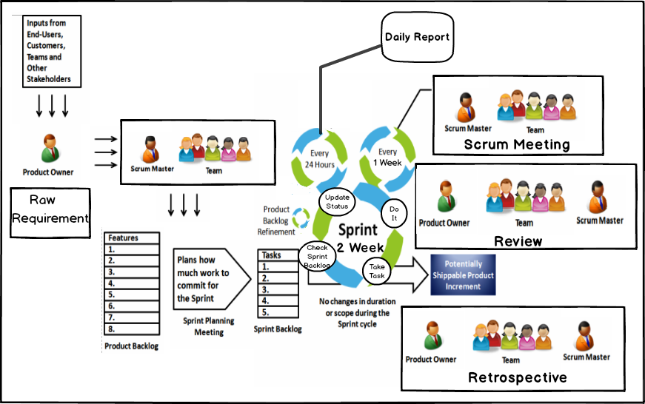

# Software Quality Management Process Activities

* 1. Software Quality Management Process
* Planning: Kick off document.
* Estimate time for total project.
* Sprint Backlog and Assign task.
* Control.
  1. Roles and Responsibilities

| Name | Role | Quality Responsibility |
| --- | --- | --- |
| Trang Quoc Duong | Scrum Master  Development Team | Make sure the Scrum Team works best through Scrum. Scrum Master also has the task of eliminating all obstacles encountered by the team, protecting the team against all the causes that affect the team's work. |
| Nguyen Le Minh Tuan | Development Team | A collection of 3 to 9 members directly responsible for production. The two most important characteristics of the Development Team are self-organization and inter-function. Self-organization means the members themselves arrange the work, make decisions to achieve the purpose of the group without the management. An Inter-function means the group is full of all the skills needed to be able to independently complete all the work without waiting for anyone else from outside. |
| Nguyen Thanh Tuan | Development Team |
| Trinh Minh Khoi | Development Team |
| Huynh Phu Tai | Product Owner | Be responsible for the success of the product being developed. Product Owner may be the person who directly owns the product or may represent other stakeholders but is always responsible and has a voice on all product-related decisions. The primary job of the Product Owner is to optimize the value of the product through the management of the Product Backlog. |

# Software Quality Management Process Activities

**Problem: Bug on old project**

* Team 9 have an old project of K22T2 and customer Pham Ngoc Duy need improve this application and fix some bug on this.
* Team 9 distribute process to 2 phase (fix bug and improve).
* An old process have many thing not clear to know and we need Quality Process to guaranteed the phase 1.

## 5.1Quality Planning



|  |  |
| --- | --- |
| **Activity name** | Establish quality goals |
| **Description** | Determine which quality goals the team wants to achieve based on the scope, capabilities of the team, requirements from customers and stakeholders.  **Quality goals is guaranteed team find out all bug on old project, fix them and tracking them.** |
| **Role & Responsibility** | Scrum Team |
| **Input/Output** | - Input: Scope of the project, the ability of the team  - Output: Identify quality goals. |
| **Metric** | File old document of this project and compare with team ability. |

|  |  |
| --- | --- |
| **Activity name** | Establish Team rule and schedule working |
| **Description** | Schedule to implement the quality goals that the scrum team has set.    **Team meeting on 3,5,7 and Sunday.** |
| **Role & Responsibility** | Scrum Team |
| **Input/Output** | - Input: Quality goals  - Output: Identify schedules for quality goals |
| **Metric** | Schedule timelog every member. |

|  |  |
| --- | --- |
| **Activity name** | Determine role and responsibility for quality |
| **Description** | Determine who will be responsible for quality goals.  **Team meeting and discuss to make clear.** |
| **Role & Responsibility** | Scrum Team |
| **Input/Output** | - Input: Quality goals and schedules for that quality goals  - Output: Identify who is responsible for quality goals |

|  |  |
| --- | --- |
| **Activity name** | Define Quality Planning |
| **Description** | Plan step by step to achieve the set goal quality. |
| **Role & Responsibility** | Scrum Master |
| **Input/Output** | - Input: Quality goals, schedule for quality goals and who is responsible for those quality goals  - Output: Planning documents to make quality goals |
| **Metric** | Member estimate time < Team estimate time. |

## Actual Result

|  |  |
| --- | --- |
| **Activity name** | Review Document |
| **Description** | Team read all of old document and define which need to be fix or make new. |
| **Role & Responsibility** | Development Team |
| **Input/Output** | - Input: Old documents  - Output: New documents and documents remade. |
| **Metric** | * Time to review * Amount of document / person. |

|  |  |
| --- | --- |
| **Activity name** | Remake Document completely |
| **Description** | Flow mentor’s ideal need to remake documents. |
| **Role & Responsibility** | All Member |
| **Input/Output** | - Input: Requirement  - Output: Sprint 0 |
| **Metric** | Document with relative with project and need for this time. |

|  |  |
| --- | --- |
| **Activity name** | Get requirement and Assign tasks |
| **Description** | Get requirement from customer create product backlog then choose user stories with “High” priority into sprint backlog and assign tasks. |
| **Role & Responsibility** | Development Team |
| **Input/Output** | - Input: Requirement  - Output: Sprint1 |
| **Metric** | -User stories  -Estimate time for this sprint and task.  -Amount of task. |

|  |  |
| --- | --- |
| **Activity name** | Using Trello |
| **Description** | Using Trello to assign tasks for member. When Scrum Master choose task for member add task name and add member to finish this task. Tester describe task, development team list step to work. Tester list acceptance criteria. |
| **Role & Responsibility** | Scrum Master, Development Team, Tester. |
| **Input/Output** | - Input: Product Backlog  - Output: Tasks assigned. |
| **Metric** | - Estimate time for tasks.  - Amount of steps. |

|  |  |
| --- | --- |
| **Activity name** | Meeting Report |
| **Description** | Record when meeting Mentor or Customer by a file and send this report for customer, mentor within 24hours. |
| **Role & Responsibility** | Team |
| **Input/Output** | - Input: mentor or customer’s ideal  - Output: Problems need to resolve. |
| **Metric** | - Time Meeting.  - Deal time, function… |

* 1. Quality Control

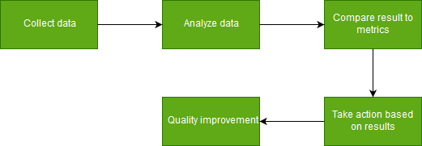

|  |  |
| --- | --- |
| **Activity name** | Check step done |
| **Description** | Check steps clicked done |
| **Role & Responsibility** | Development Team |
| **Input/Output** | - Input: Acceptance Criteria  - Output: Accepted. |
| **Metric** | -Amount of steps checked done 100%  -function no error. |

|  |  |
| --- | --- |
| **Activity name** | Check document |
| **Description** | Document right with real time working with acceptance of mentor and member in team. |
| **Role & Responsibility** | Development Team |
| **Input/Output** | - Input: Old documents  - Output: New documents. |

|  |  |
| --- | --- |
| **Activity name** | Compare Result To Metrics |
| **Description** | Use reports and results from “Analyze Data” activity to compare with the metrics from initial goals. Define the current status of this process, quality or other objects from the quality goals |
| **Role & Responsibility** | Development Team |
| **Input/Output** | - Input: Measurement reports and results from “Analyze Data”  - Output: Status Reports documents based on compared results |

|  |  |
| --- | --- |
| **Activity name** | Take Actions Based on Result |
| **Description** | After defined the current status of process, evaluate that in this case, what we should do. These decisions may involve re-planning, corrective actions, changes or simply moving on without changes |
| **Role & Responsibility** | Development Team |
| **Input/Output** | - Input: Current Status Report form “Compare Result To Metrics” activity  - Output: Decisions from team members |

|  |  |
| --- | --- |
| **Activity name** | Quality Improvement |
| **Description** | Team members will implement tasks to improve quality, based on decisions were approved. After that, all changes and data will be stored and baselined for later phases |
| **Role & Responsibility** | Scrum Team |
| **Input/Output** | - Input: Decisions were approved by team after “Take Actions Based on Results” activity  - Output: Improvement Reports after implement decisions |