Lab 1: Result of running StudentTester.java

Test Files: Student.java, Address.java

Test case1: Check Constructor

Student student = new Student("Marry","jones",10000001);

System.out.println(student); // calls toString() method

|  |  |  |
| --- | --- | --- |
| Returned: | Expected: | Status |
| [Marry, jones,10000001,mjone01] | [Marry, jones,10000001,mjone01] | passed |

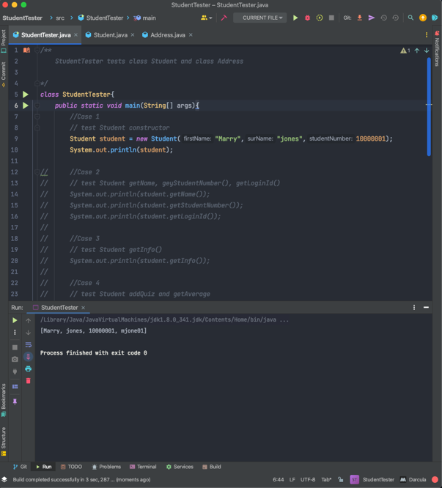

**Methods:**

Test case2: test getName, getStudentNumber, getLoginId

student.getName();

student.getStudentNumber();

student.getLoginId();

|  |  |  |
| --- | --- | --- |
| Returned: | Expected: | Status |
| Marry jones  10000001  mjone01 | Marry jones  10000001  mjone01 | passed |

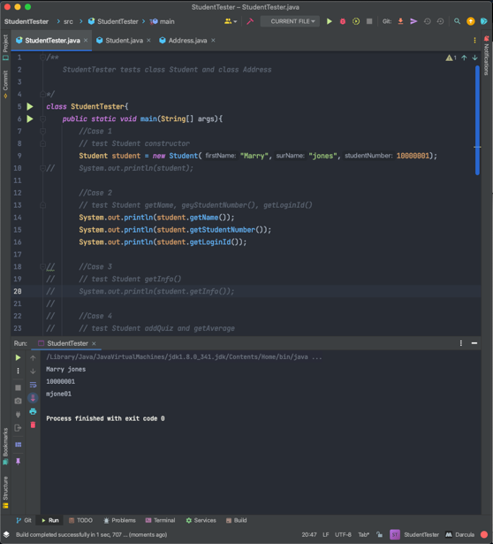

Test case3: Test getInfo( )

student.getInfo();

|  |  |  |
| --- | --- | --- |
| Returned: | Expected: | Status |
| Marry, jones (mjone01,1000001) | Marry, jones (mjone01,1000001) | passed |

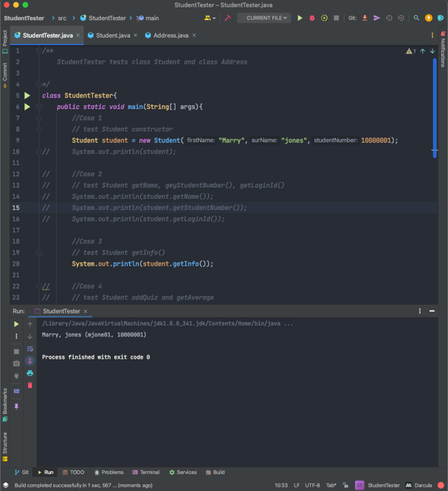

Test case4: Test addQuiz( ) and getAverge( )

student.addQuiz(6.0);

student.addQuiz(8.5);

student.addQuiz(9.8);

student.getAverage();

|  |  |  |
| --- | --- | --- |
| Returned: | Expected: | Status |
| 8.1 | 8.1 | passed |

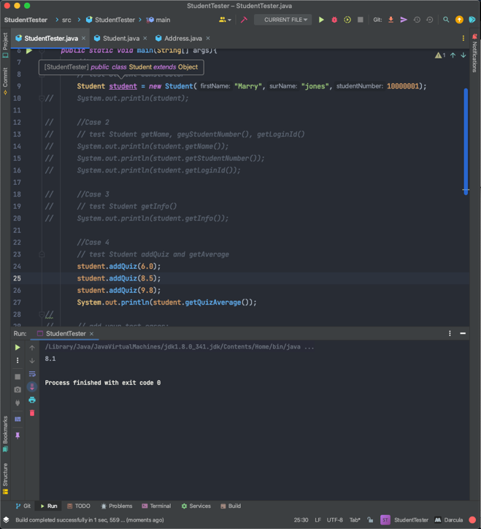

Test case5: Test setName(), getName(), and getLoginId()

student.setName(“Jay”, “Nguyen”);

System.out.println(student.getName());

System.out.println(student.getLoginId());

|  |  |  |
| --- | --- | --- |
| Returned: | Expected: | Status |
| Jay Nguyen  mjone01 | Jay Nguyen  mjone01 | passed |

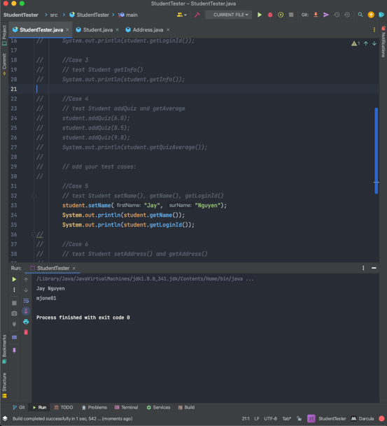

Test case6: Test setAddress() and getAddress()

student.setAddress(“1234”, “Hastings”, “Vancouver”, “BC”, “V5K1Q1”);

System.out.println(student.getAddress());

|  |  |  |
| --- | --- | --- |
| Returned: | Expected: | Status |
| 1234 Hastings St, Vancouver, BC, V5K1Q1 | 1234 Hastings St, Vancouver, BC V5K1Q1 | passed |

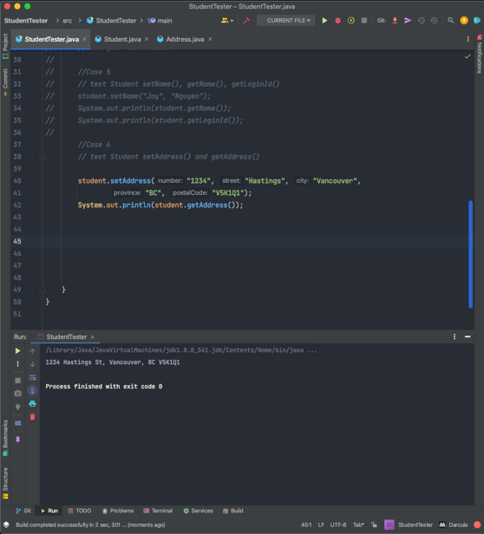

**Notes:**

1. Add more test cases as required. What else should you test?

2. All test cases should pass.

3. You normally should create test cases that test all methods of class Student and class Address separately, and then create test cases to test whole program.

However, since Address is a very simple class, you do not need to create separate test harness for it in this lab assignment. Just test methods of Student class that uses Address as an object to verify correctness of both classes.