1. <https://www.vietnamonline.com/destination/hue.html>

* One thing that this website has done well is that they optimized the layout for different devices from small devices to large devices.
* One thing this website can be improved is to change the color of the header to another color that has higher contrast with the background image, which makes us easier to read.
* One thing I would do differently is to indent all paragraphs that describe each section. The reason is because it helps us differentiate clearly between headings and paragraphs.

<https://www.thecrazytourist.com/25-best-things-to-do-in-hue-vietnam/>

* One thing that this website has done well is that their layout is really good. It is pretty easy to read the website.
* One thing that this website can be improved is to add an icon for the website.
* One thing I would do differently is to draw the bottom border for the nav element. It will make the nav element and the main element be differentiated

<https://vietnam.travel/places-to-go/central-vietnam/hue>

* One thing this website has done well is that they
* One thing that this website can be improved is to add some images to the sub-headings.
* One thing I would do differently is to increase the font of the headings so that users can clearly read this website.

1. Site map

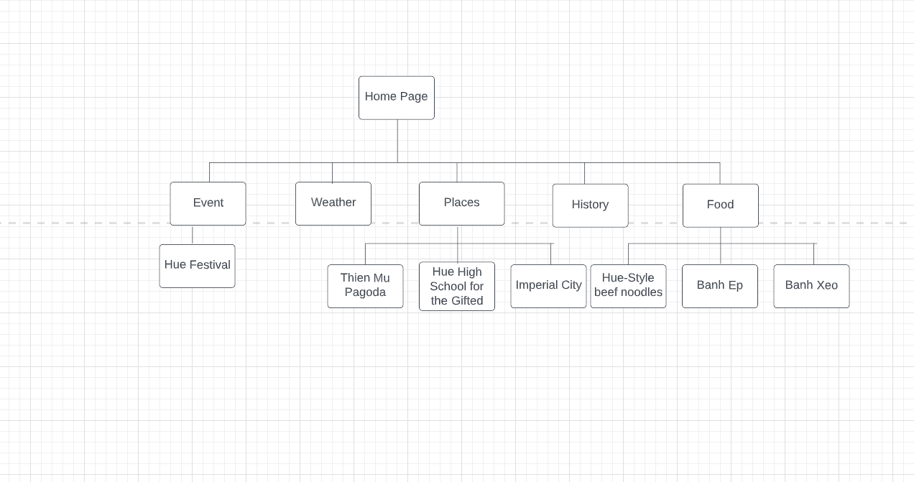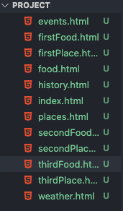

1. Wireframes

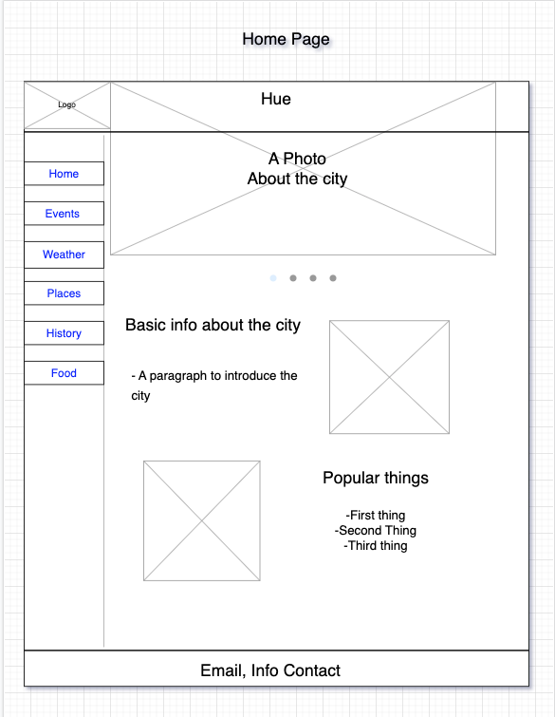

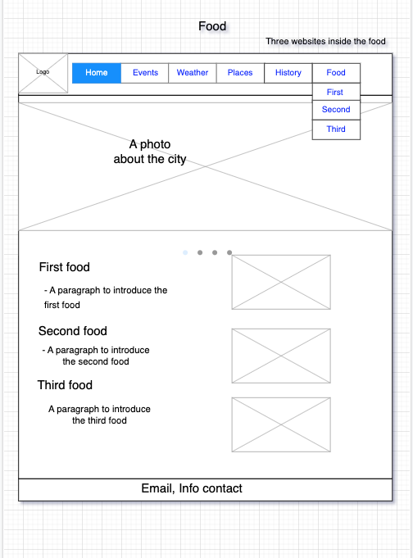

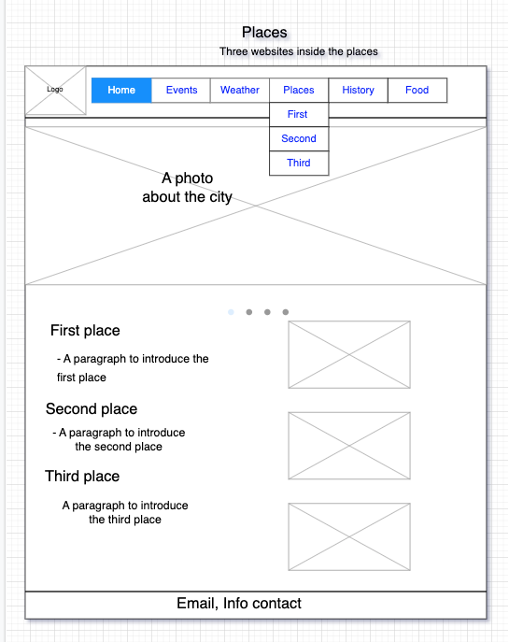

4)

Case2: a list of filenames



Case3:

* Common fonts: Times New Roman, Sans-serif, Helvetica, Arial.
* Common colors: white, black, blue, green.