**Group Project   
Subject: Basic Cross-Platform Application Programming With .NET**

***<Pet Shop Management System>***

**Prepared by <Group 8>**

**Table of Contents**

Table of Contents [ii](https://docs.google.com/document/d/1jQ00e5-C2pO1aQ-QEGTIRdtpv7M83T-Y/edit#heading=h.30j0zll)

Revision History [ii](https://docs.google.com/document/d/1jQ00e5-C2pO1aQ-QEGTIRdtpv7M83T-Y/edit#heading=h.1fob9te)

1. Case Study [1](https://docs.google.com/document/d/1jQ00e5-C2pO1aQ-QEGTIRdtpv7M83T-Y/edit#heading=h.3znysh7)

2. Database Design [1](https://docs.google.com/document/d/1jQ00e5-C2pO1aQ-QEGTIRdtpv7M83T-Y/edit#heading=h.2et92p0)

3. System Architecture [1](https://docs.google.com/document/d/1jQ00e5-C2pO1aQ-QEGTIRdtpv7M83T-Y/edit#heading=h.tyjcwt)

4. Implementation [2](https://docs.google.com/document/d/1jQ00e5-C2pO1aQ-QEGTIRdtpv7M83T-Y/edit#heading=h.3dy6vkm)

**Revision History**

|  |  |  |  |  |
| --- | --- | --- | --- | --- |
| **Name** | **Date** | **Reason For Changes** | | **Version** |
| *Initial draft* | *1.0 draft 1* | |
|  |  |  | |  |

1. **Case Study**

We are now living in the computer age, and now it seems that the computer is controlling all the important works in our routine life. Man has invented many electronic devices but out of these computers has made the greatest impact on society. Computers are so versatile because they are indispensable to present day engineers, scientists, businessmen and students. They have strengthened men's capability in numerical computations, information processing etc. and there by increasing the effectiveness of the organization.

And so, the effectivity of the "PET SHOP MANAGEMENT SYSTEM" will be discussed in this paper.

This database manages the records of the entire employee, makes work efficient, removes redundancy, and removes inconsistency. As to use this Pet Shop Management System all its user will have a valid user id and password associated with it. Admin will responsible to provide their user id and password by creating it. Admin can grant special permission to any particular working employee. Admin can add new user, delete user, modify user and generate bills. Check stock, get reports on sales and purchase of products from suppliers and get information on their regular customers to provide special discounts.

Valid user or working employee will be able to enter product details, their code, and price and categorize products according to their size and price. This user can also search any particular product using price and size options as well as using product code options to check whether it is available in the pet Shop Management System or not.

Bill section of pet Shop Management System will generate bill details such as bill number which will be unique for each customer and supplier. If the bill is for customer, then it will include product type, size, number of items purchased, total price along with customer name and address.

Admin will also able to prepare balance sheet for their business transactions for a particular date, between given period, weekly basis or monthly basis or as per user requirement.

1. **Database Design**

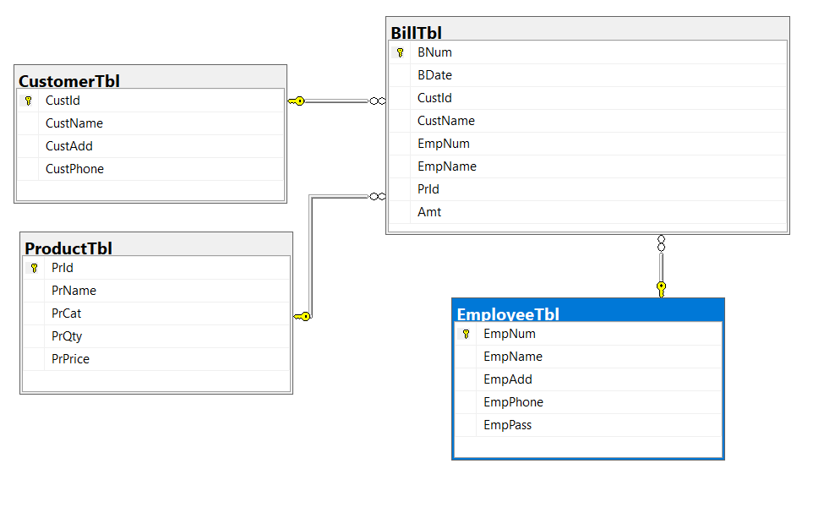

1. **System Architecture**

3.1. Operating Environment.

-Visual Studio 2019

-Microsoft SQL Sever 2019

3.2. System Feature

3.2.1. Login: The User can login to system if they have account.

3.2.2. CRUD Product : The User can add, view , update , delete product to the

system.

3.2.3. CRUD Employee: The User can add, view , update , delete employee to the

system.

3.2.4: Generate bill: The User can generate bill .

1. **Implementation**

