 

Q1:

Software Requirements Specification

for

**Koi pond construction ordering system**

**Version 1.0 approved**

**Prepared by**

**FPT University Hoa Lac Campus**

**July 24, 2024**

Q2:

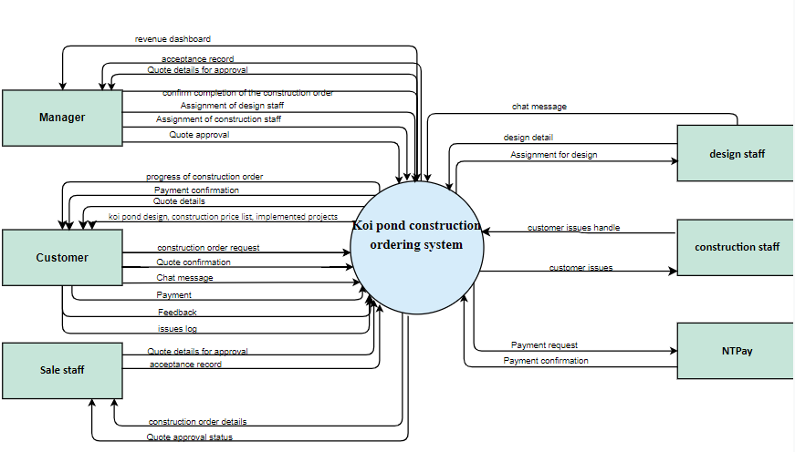

Q3:

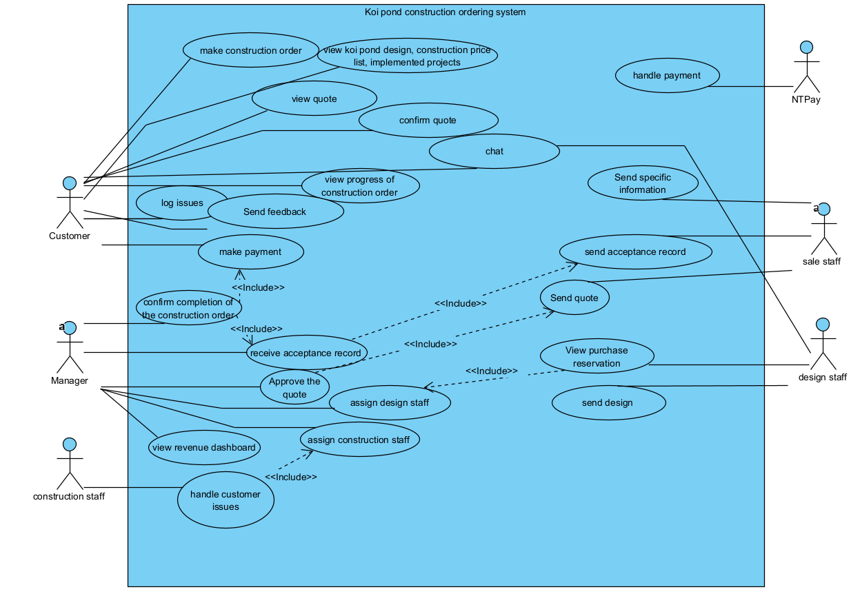

| **#** | **Actor** | **Description** |
| --- | --- | --- |
| 01 | Customer | Customer is a person make construction order. They have function such as view quote, confirm quote, make payment, chat,… |
| 02 | Manager | Manager is the person manage the system. Manager have the function such as send quote, send acceptance record |
| 03 | Sale staff | Sale staff is the staff of system, have some function such as send quote, send acceptance record |
| 04 | Construction staff | Construction staff is the staff of system, have some function such as handle customer issues |
| 05 | Design staff | Design staff is the staff of system, have some function such as send design and chat |
| 06 | NTPay | NTPay is the system have function handle payment when customer make payment |

| **#** | **Use Case** | **Actors** | **Description** |
| --- | --- | --- | --- |
| UC-01 | handle customer issues | Construction staff | Construction staff handle customer issues |
| UC-02 | confirm quote | Customer | Customer confirm quote |
| UC-03 | feedback | Customer | Customer feedback |
| UC-04 | log issues | Customer | Customer log issues |
| UC-05 | make construction order | Customer | Customer make construction order |
| UC-06 | make payment | Customer | Customer make payment |
| UC-07 | view koi pond design, construction price list, implemented projects | Customer | Customer view koi pond design, construction price list, implemented projects |
| UC-08 | view progress of construction order | Customer | Customer view progress of construction order |
| UC-09 | view quote | Customer | Customer view quote |
| UC-10 | chat | Customer, design staff | Customer can chat with design staff |
| UC-11 | send design | Design staff | Design staff send design |
| UC-12 | approve quote | Manager | Manager approve quote |
| UC-13 | assign construction staff | Manager | Manager assign construction staff |
| UC-14 | assign design staff | Manager | Manager assign design staff |
| UC-15 | confirm completion of the construction order | Manager | Manager confirm completion of the construction order |
| UC-16 | receive acceptance record | Manager | Manager receive acceptance record |
| UC-17 | view revenue dashboard | Manager | Manager view revenue dashboard |
| UC-18 | handle payment | NTPay | NTPay handle payment |
| UC-19 | send acceptance record | Sale staff | Sale staff send acceptance record |
| UC-20 | send quote | Sale staff | Sale staff send quote |

Q4:

| **ID** | **Rule Definition** | **Use cases** |
| --- | --- | --- |
| BR-01 | First payment equivalent to 20% of the total value of the construction order | UC-06 |
| BR-02 | When the completed design drawing are finalized by the customer, the customer needs to makes the second payment equivalent to 20% of the total value of the construction order | UC-06 |
| BR-03 | The third payment equivalent to 50% of the total value of the construction order. | UC-06 |
| BR-04 | The manager can view revenue dashboard | UC-17 |
| BR-05 | The customer can track the progress of the construction order for Koi pond, log issues during the construction process | UC-08 |
| BR-06 | The manager only confirm completion of the construction order in the system after receiving the acceptance record and third payment from customer | UC-15, UC-06, UC-16 |

**Q5:**

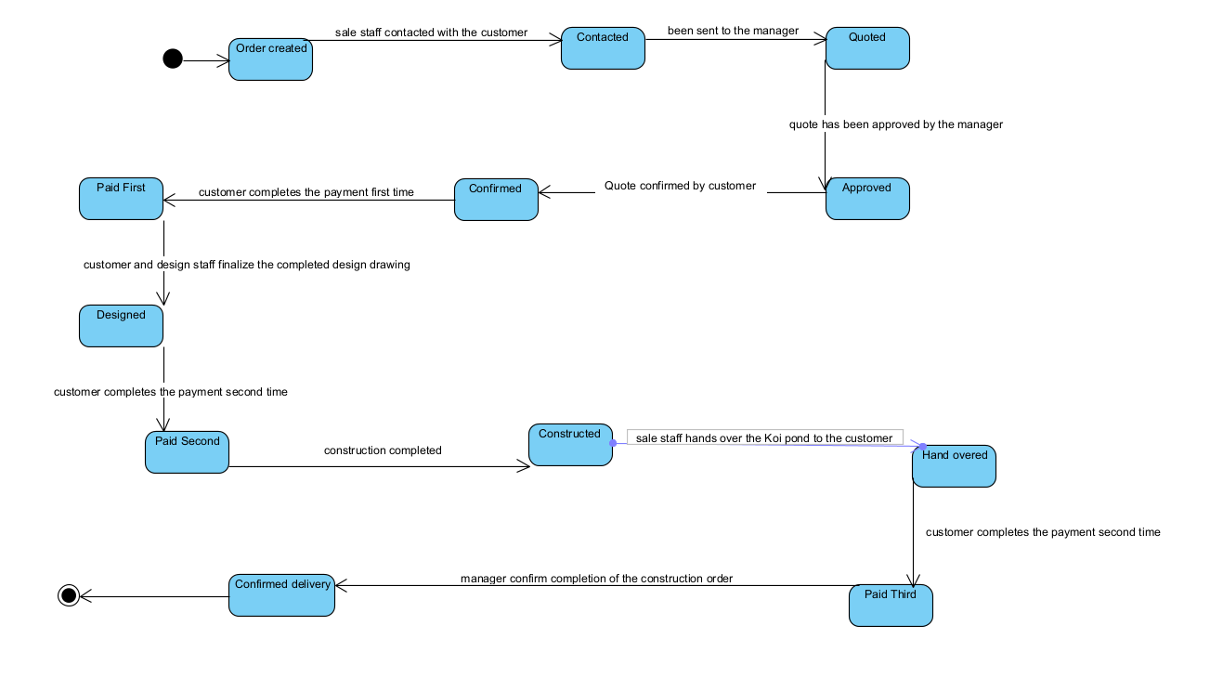

| **#** | **State** | **Description** |
| --- | --- | --- |
| 1 | Order created | The state when a order request is created. |
| 2 | Contacted | The state when the sale staff contacted with the customer |
| 3 | Quoted | The state when the quote has been sent to the manager. |
| 4 | Approved | The state when the quote has been approved by the manager and the customer can view the quote |
| 5 | Confirmed | The state when the customer confirms the quote. |
| 6 | Paid First | The state when the customer completes the payment first time (20% total value) |
| 7 | Designed | The state when the customer and design staff finalize the completed design drawing |
| 8 | Paid Second | The state when the customer completes the payment second time (30% total value) |
| 9 | Constructed | The state when the construction completed |
| 10 | Hand overed | The state when the sale staff hands over the Koi pond to the customer |
| 11 | Paid Third | The state when the customer completes the payment second time (50% total value) |
| 12 | Completed | The state when the manager confirm completion of the construction order in the system. |