Name: Tuan Huynh

Class: TCSS 445A

Final Project

How to Install and Run My Application

1. I created this application on MS Access which is very easy to set up the GUI and code in order to run my application. First I created 2 forms: Customerform and Computerform that help me insert, update and delete a specific record that is associated with that table.

The code of each form is very straight forward and easy to understand. Every button in the application should be working as its name. Each button is also associated with a method (show its action) in the code form. All data and records of each table should be shown as a sub-form next to or below the main form.

1. How to run this application

* **Insert**: to insert a data in either customer form or computer form, you need to add information in the text box equivalent to the name of its label. However, the input must match the data type of each text box. For example, add integer to the customerID text box. After inserting the record, that record should be added to that table in the sub-form.
* **Update**: First you will need to choose which customer or computer you want to product by clicking the mouse on that record or looking up the ID or UPC by pressing the number in the box as the shown picture. Then, you click EDIT button, so that specific record will show exactly in a respectively text box in the main form. After you make a change, you will need to click on UPDATE button. Since you are editing a record, the ADD button will change to UPDATE and EDIT will be disable to click. You can check the updated information you made then click CLEAR button to make sure nothing in the text boxes.

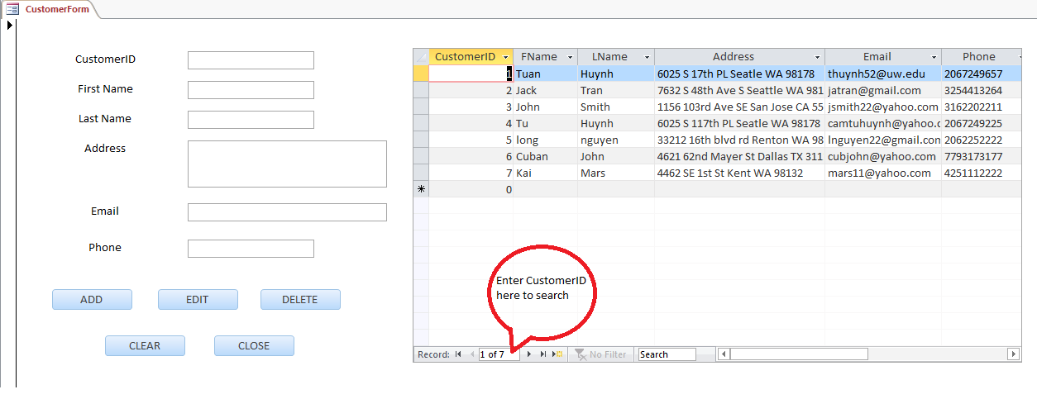

* **Delete:** For the deletion, what you need to do is just the same as update’s step, you will need to first look up a row which you want to delete. Then you will receive a message box to make sure you want to delete that record from the table. Click ‘Yes’ to delete or ‘No’ to cancel the process. Since you **delete** that record, it will no longer live in that table. After you’re done doing on that form, click on CLOSE button, it will close the form with saved data.