**ADMIN DASHBOARD LAYOUT**

|  |  |  |  |
| --- | --- | --- | --- |
| LOGO ||| 1. **Navbar** userInfor | | | |
| 2. **Sidebar** |  |  |  |
| 4. **Control-bar** |
|  |
| 5. **Content** |
|  |
| 3. **footer** | | |

# NAVBAR

Include logo, current user management, toggle sidebar button.

# SIDEBAR

List of pages and subpages.

# FOOTER

Information of Copyright, Company’s information, Contact, …

# CONTROL-BAR

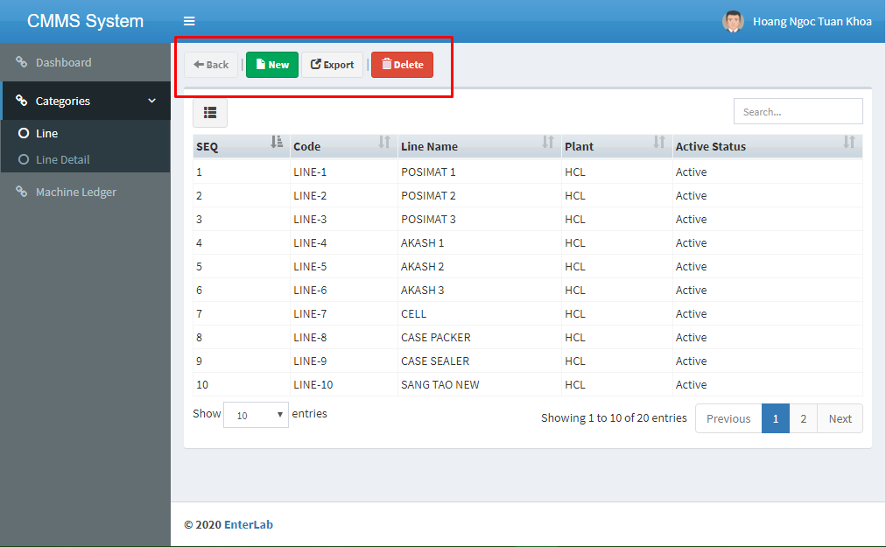

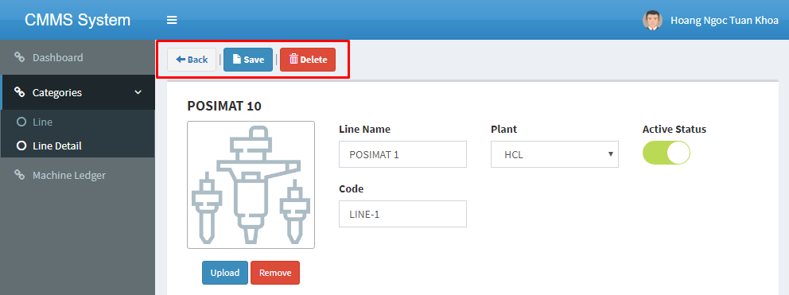

## Navigation button

## Function button (Add new, Update, Delete data)

## Another functions

# CONTENT

## Table data

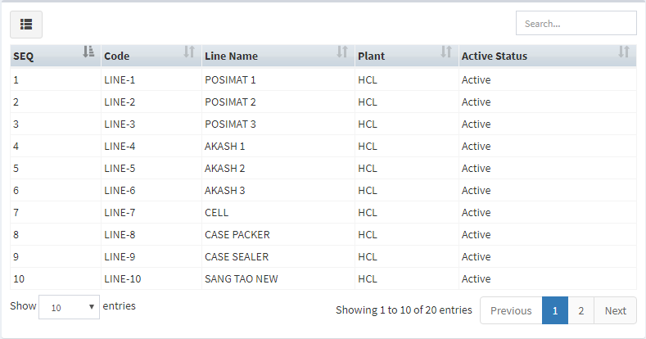

### Data (rows)

### Sort colums

### Columns visible button

### Search box

### Search panes

### Another function

#### Search in columns

#### Reorder columns

#### Row click

#### Select rows

#### Fixed header/columns

#### Style of “Show 10 entries”, “Showing 1 to 10 of 20 entries”, Pages number, … in footer of table

#### Another functions

## Details of data

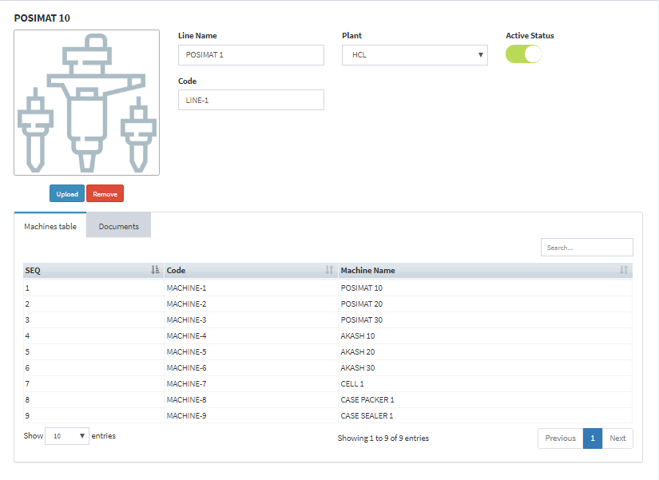

### Images (How to show; Upload/Reupload, Remove button)

### Informations of data

#### Textbox

#### Selectbox

#### Checkbox/Switch button

### Tabs another information

#### Sub/Related tables

#### Documents

#### Another information

## Calendar table

Similar to Table data.

## Chart

Bar charts and Pie charts.

# Timeline

Generic Layout (1, 2, 3): 1 day

Control-bar (4): a few minutes (Add/Edit when add/edit content (5)

Content (5):

* Table data (5.1): 1 day
* Details of data (5.2.1 & 5.2.2): 1 day
* Details of data (5.2.3): 1 day
* Calendar table (5.3): … day
* Chart (5.4): 1 day

Summary: about 5 days (don’t have Calendar table)

|  |  |  |
| --- | --- | --- |
| **✓🗶** | **Date of Week** | **Todo** |
| **✓** | SAT (14/3) | Generic Layout |
| 🗶 | SUN | Table data full function |
| 🗶 | MON | Details of data (5.2.1 & 5.2.2) |
| 🗶 | TUE | Details of data (5.2.3) |
| 🗶 | WED | Chart |
| 🗶 | THU | Calendar table ~~ |