1. docker --version

2.

3.

4.

5.

6.

7.

8.

9.

10.

11.

12.

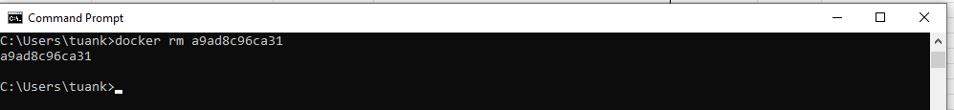

13.

14.

15.

16.

17.

18.

19.

20.

21.

22.

23.

24.

25.

26.

27.

28.

30.

31.

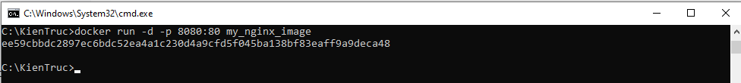

Phần 2:

Bài 1:

