A\*

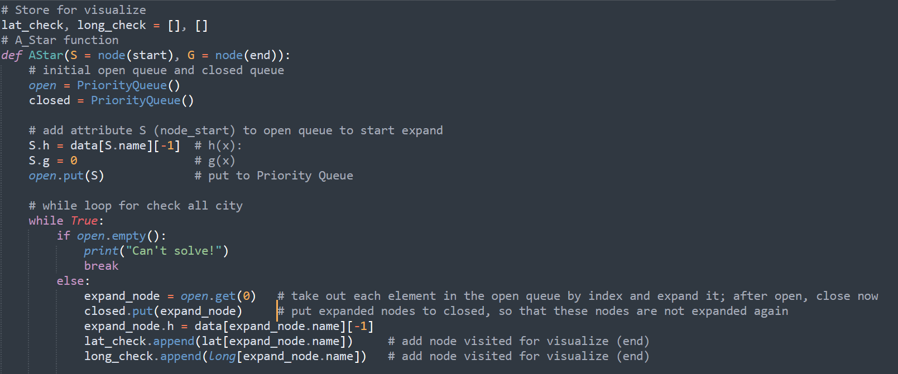

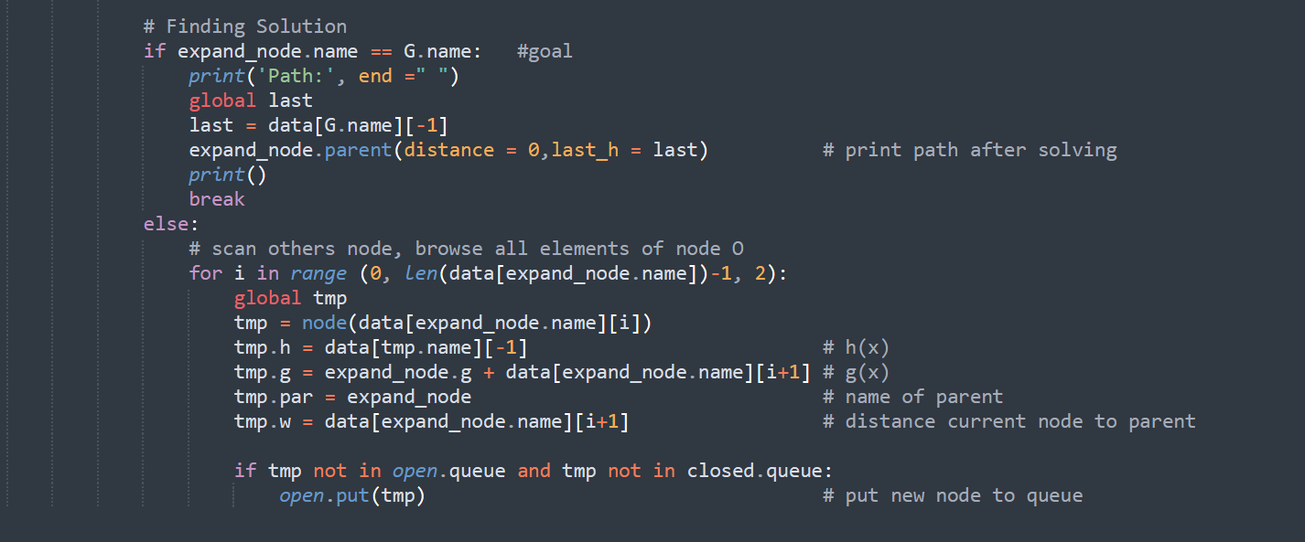

- Completeness: Not complete. It is only complete if the state space is finite, and we avoid repeated states and all costs are >ε.

- Time complexity: The number of nodes expanded is exponential in the depth of the solution (the shortest path) *d*: *O*(*bd*), where *b* is the branching factor (the average number of successors per state).

- Space complexity: *O*(*bd*), It keeps all the generated nodes in memory.

- - Optimality: Expand node in frontier with best evaluation function score f(n):

+ f(n) = h(n) + g(n)

+ h(n) : heuristic estimate of cost to get from n to goal.

+ g(n) : cost to get from initial state to n.

* Optimal when h(n) is admissible.

IDA\*

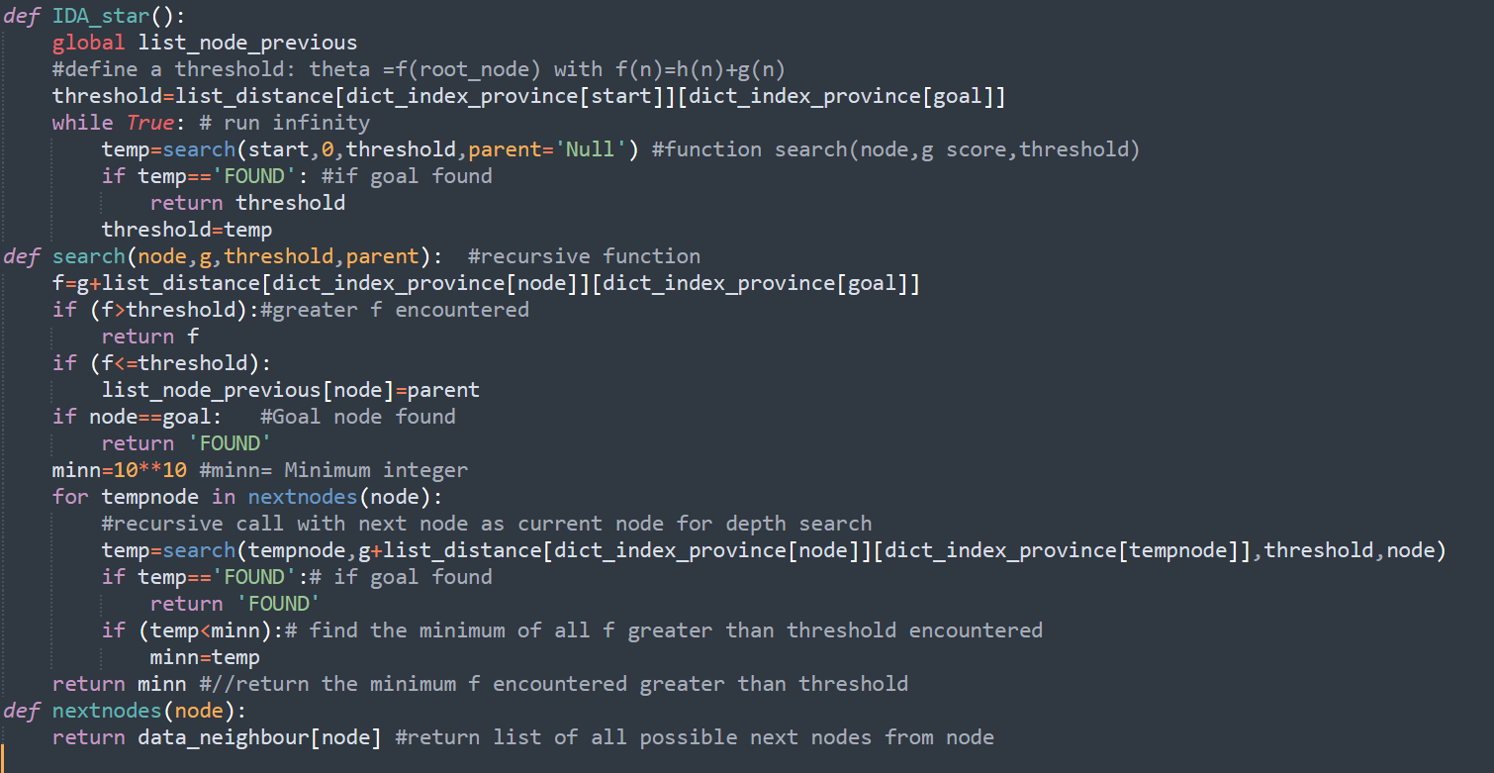

-Completeness and optimal: It is only complete if : h is admissible and Finite branching factor

- Time complexity: The number of nodes expanded is exponential in the depth of the solution (the shortest path) *d*: *O*( *bd* ), where *b* is the branching factor (the average number of successors per state).

Space complexity: O(bd) in the worst case.

Uniform cost search:

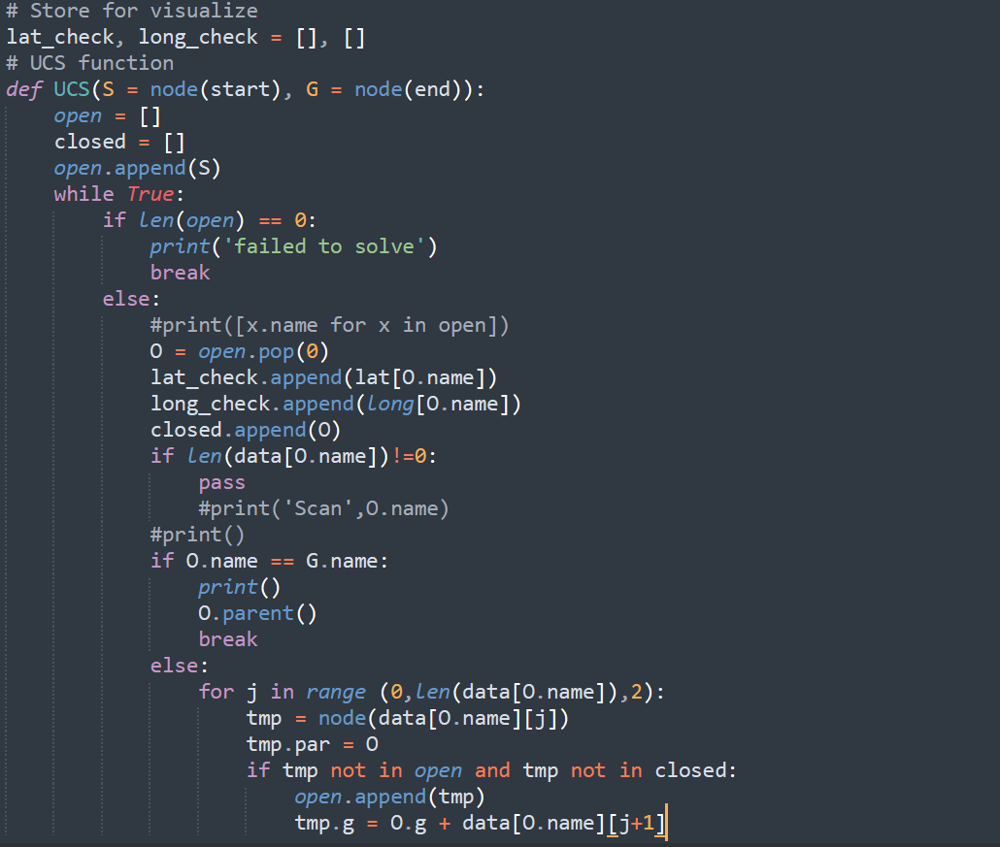

- Completeness: Yes, if step cost .

- Time complexity: O ( $b^{1+ (\frac{C*}{ε})})$ where C\* is the cost of the optimal solution.

- Space complexity: O (.

- Optimality: Yes - nodes expanded in increasing order of g(n).

DFS:

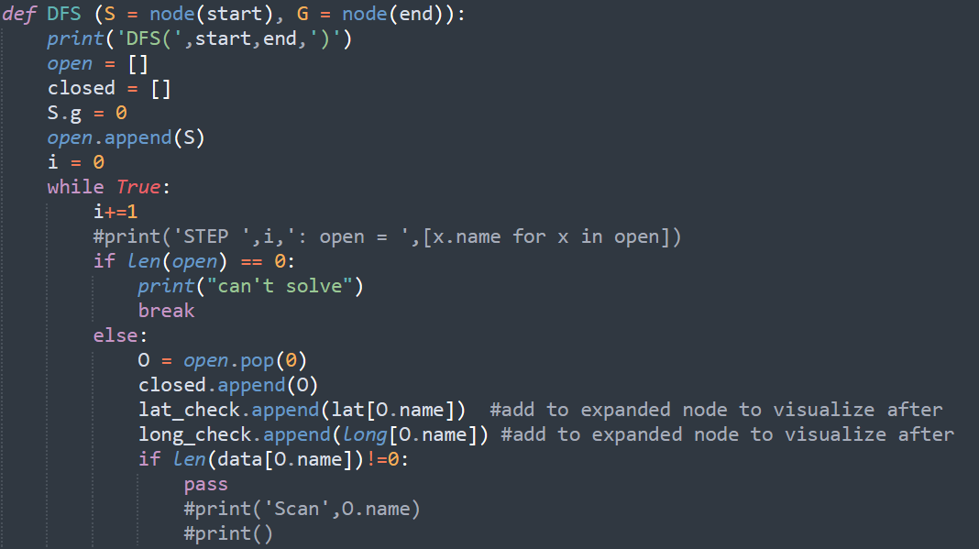

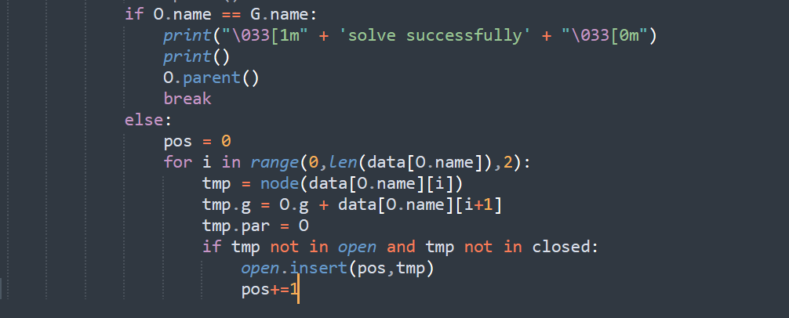

Complete: No, complete in finite space

Time : O(b^m) where m is maximum depth of the state space , so it will be terrible if mis much larger than d

Space: O(bm)

Optimal: No