**Lê Đình Tuân - He160710**

**Class: SE1647**

**Subject: DBI202**

**Final Report For Assignment**

1. **brief description of the database**

* This database includes has **10** data tables including Students, Lecturers, GradeSheets, Courses, Semesters, TypeGrades, Groups,a table is created by Lecturers and Courses has name is Supervises, a table is created by Students and Groups, and a table between GradeSheets and TypeGrades
* the relationship between Students and Groups is many to many, so we make a table is Students_Groups between Students and Groups
* The relationship between Student and GradeSheets is one-to-many
* The relationship between Lecturers and Courses is many-to-many, therefore we make a table has name is Supervises
* The relationship between Groups and Courses is many-to-one
* The relationship between Semesters and GradeSheets is one-to-many
* The relationship between Courses and GradeSheets is one-to-many
* The relationship between GradeSheets and TypeGrades is many-to-many, therefore we have a table has name is Detail

This table will define the primary key for each table

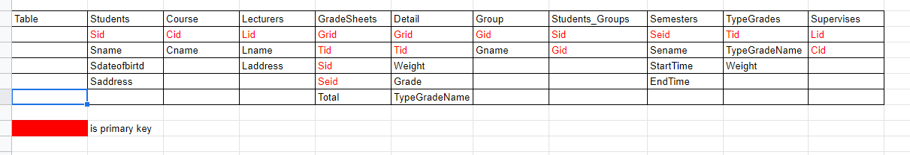

1. **An ERD (Entity Relationship Diagram) that fully describes the database**

