**GoBear Selenium Demo**

Eclipse Selenium project information

1. **Java project structure**

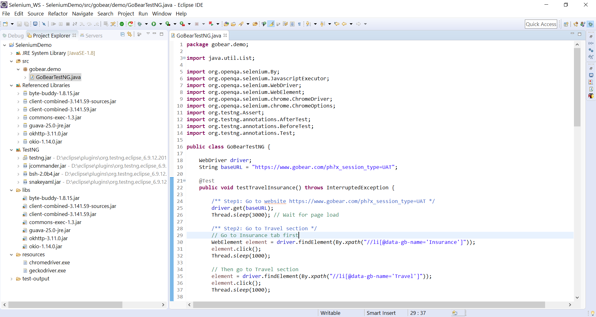

1. **Test information:**

- Selenium Java 3.141

- Chrome 74.0 (latest)

- WebDriver: ChromeDriver 74.0

1. **How to run**

- Open Eclipse project in folder SeleniumDemo.

- Update Project Build Path for TestNG libraries if needed

- Run test by right click on Java class GoBearTestNG.java. Then choose Run As > TestNG Test as below screen shot.

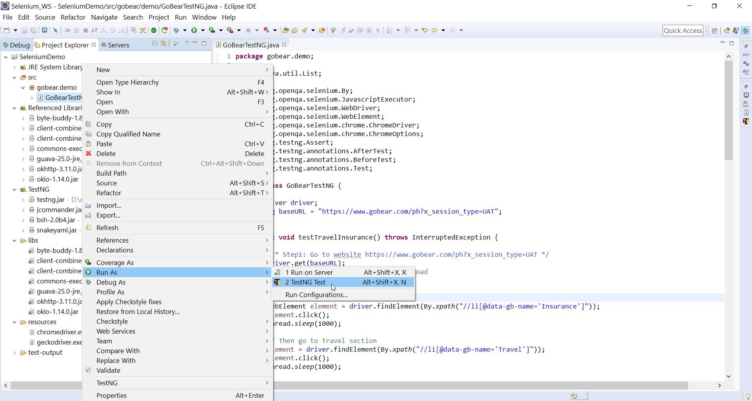

The result will be displayed in TestNg result tab as below.

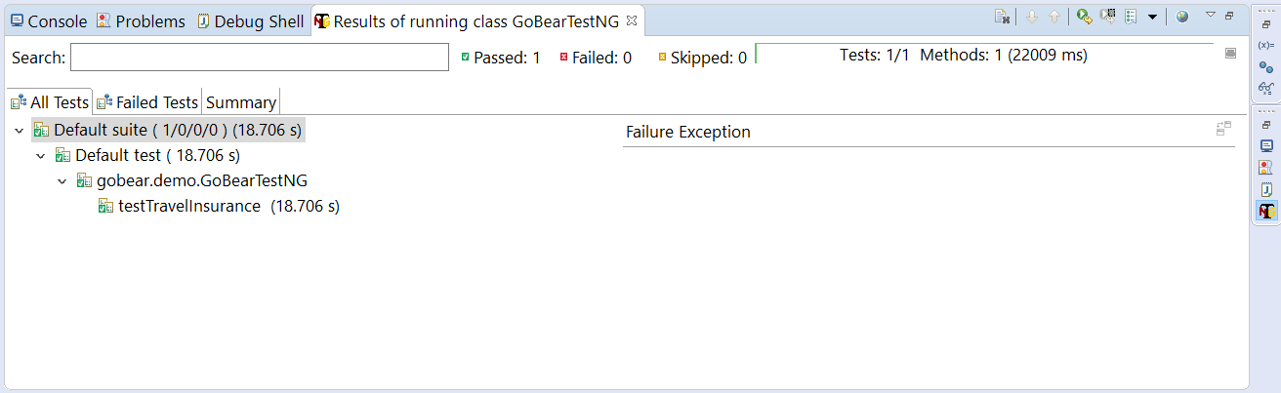

The results are also reviewed at ***index.html*** file in test-output folder.

