Swagger UI <http://localhost:9090/swagger-ui/#/>

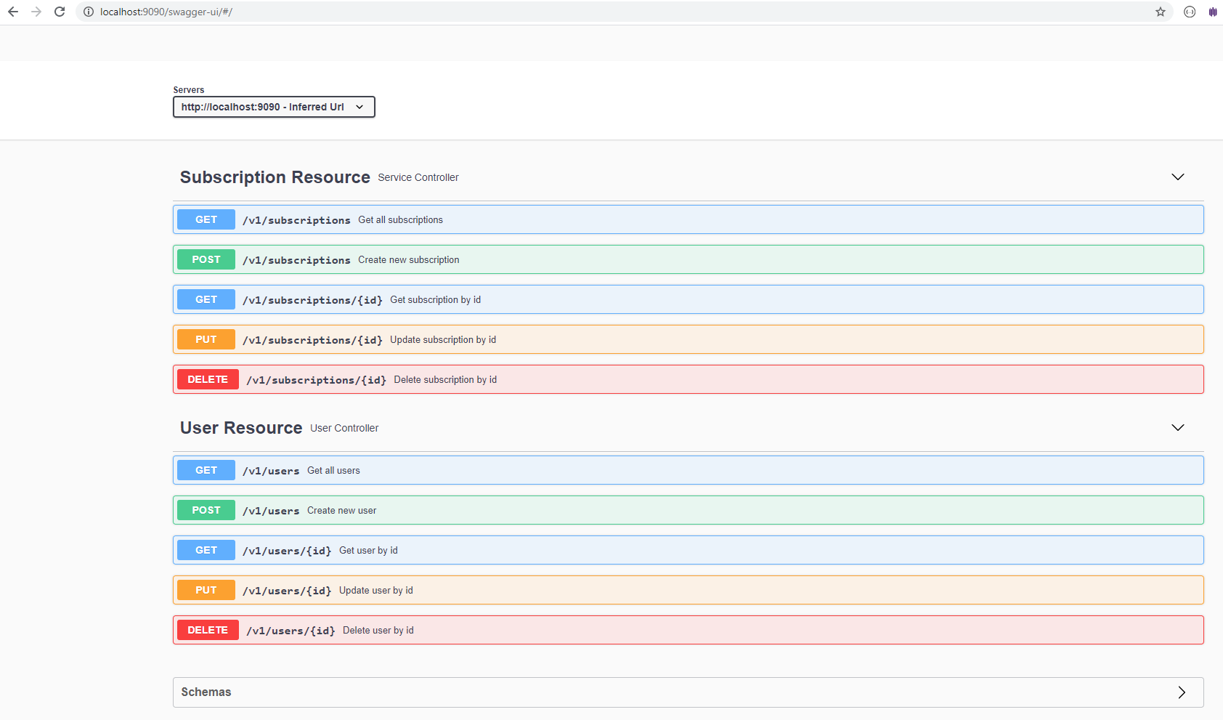

Get All Users

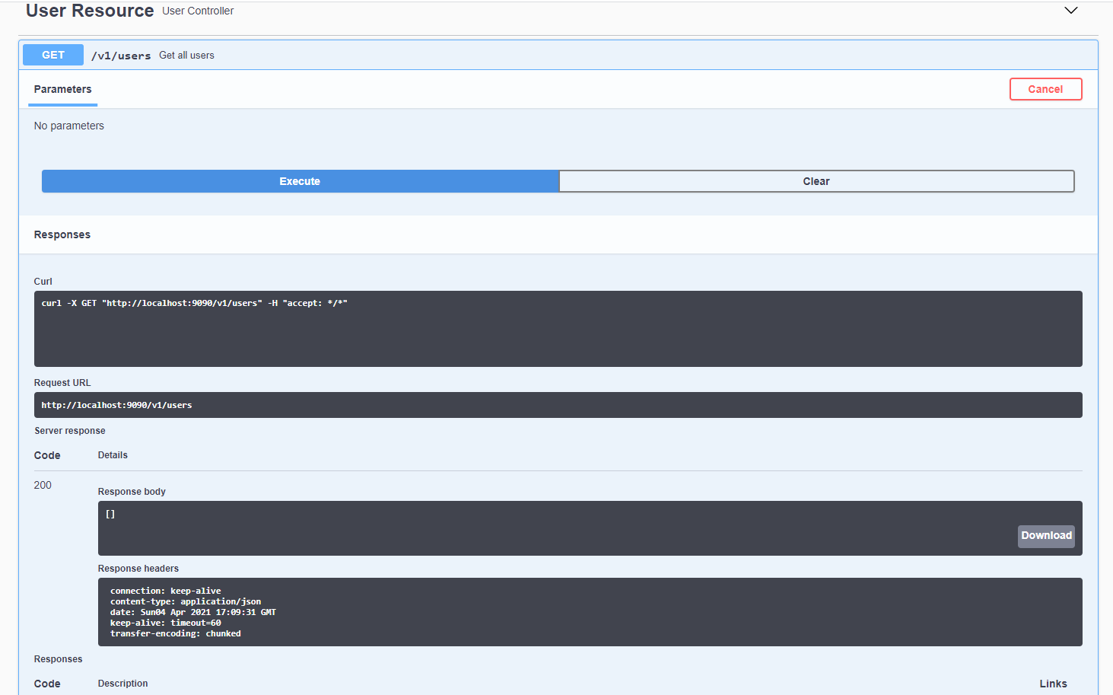

Get all users:

<http://localhost:9090/v1/users>

Get uses when DB is not empty.

