Register

General information
- Use case’s name: Register.
- Actors: Guest
- Requirements: None

Short description
- From the Main page, a guest chooses the text Register. The interface for the function will be displayed.
- The guest fills out the Register Form, the click the button Register. The system will validate the textboxes, if so, a success message will be displayed, otherwise, the warning message what is wrong.

Basic scenarios
- From the Main page, a guest chooses the text Register at the upper-right side of the website. The interface for the function, containing a form consisting of text-boxes FullName, DateOfBirth, Email, Phone, Username, and Password , will be displayed.
- The guest then fills all textboxes and clicks the button Register, the system will validate the textboxes, if so, a success message will be displayed.
- The guest clicks the button Close in the message, the system will redirect to the Main page

Exceptional scenarios
- If the values of textboxes are not valid, a warning message will be displayed. The guest clicks the button Close in the message, the message will disappear and he/she then modifies the textboxes. Reasons for invalidation are:
  - At least one textbox is not filled
  - The username exists
  - The password does not contain at least 8 characters, 1 uppercase letter, 1 lowercase letter, 1 digit and 1 special character
  - The date of birth is in the future
  - Email is not the right format (Regex: ^[a-zA-Z0-9._%+-]+@[a-zA-Z0-9.-]+\.[a-zA-Z]{2,}$ )
  - Phone is not the right format (Regex: ^0[0-9]{9}$)

Visualization
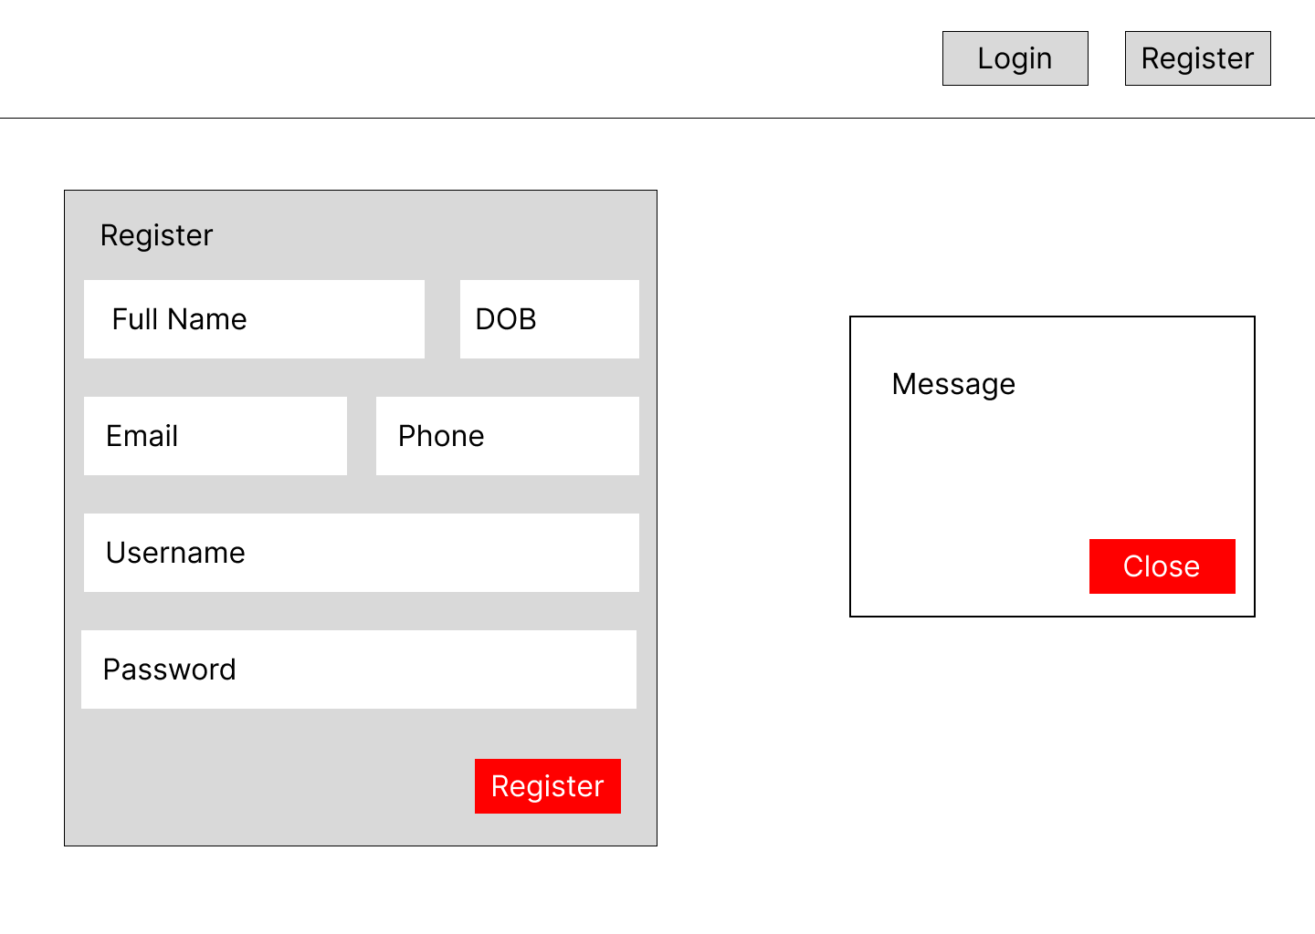

Activity Diagram
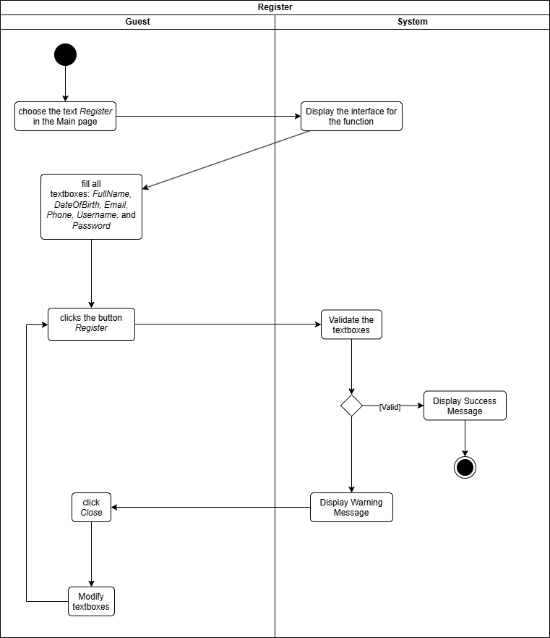

Login

General information
- Use case’s name: Login.
- Actors: Customer
- Requirements: None

Short description
- From the Main page, a customer chooses the text Login. The interface for the function will be displayed.
- The customer fills out the Login Form, the click the button Login. The system will validate the textboxes, if so, a success message will be displayed, otherwise, the warning message what is wrong.

Basic scenarios
- From the Main page, a customer chooses the text Login at the upper-right side of the website. The interface for the function, containing a form consisting of text-boxes Username, and Password, will be displayed.
- The customer then fills all textboxes and clicks the button Login, the system will validate the textboxes, if so, a success message will be displayed.
- The customer clicks the button Close in the message, the system will redirect to the Main page. Also, a session is created.

Exceptional scenarios
- If the values of textboxes are not valid, a warning message will be displayed. The customer clicks the button Close in the message, the message will disappear and he/she then modifies the textboxes. Reasons for invalidation are:
  - At least one textbox is not filled
  - The username exists
  - The password does not contain at least 8 characters, 1 uppercase letter, 1 lowercase letter, 1 digit and 1 special character

Visualization
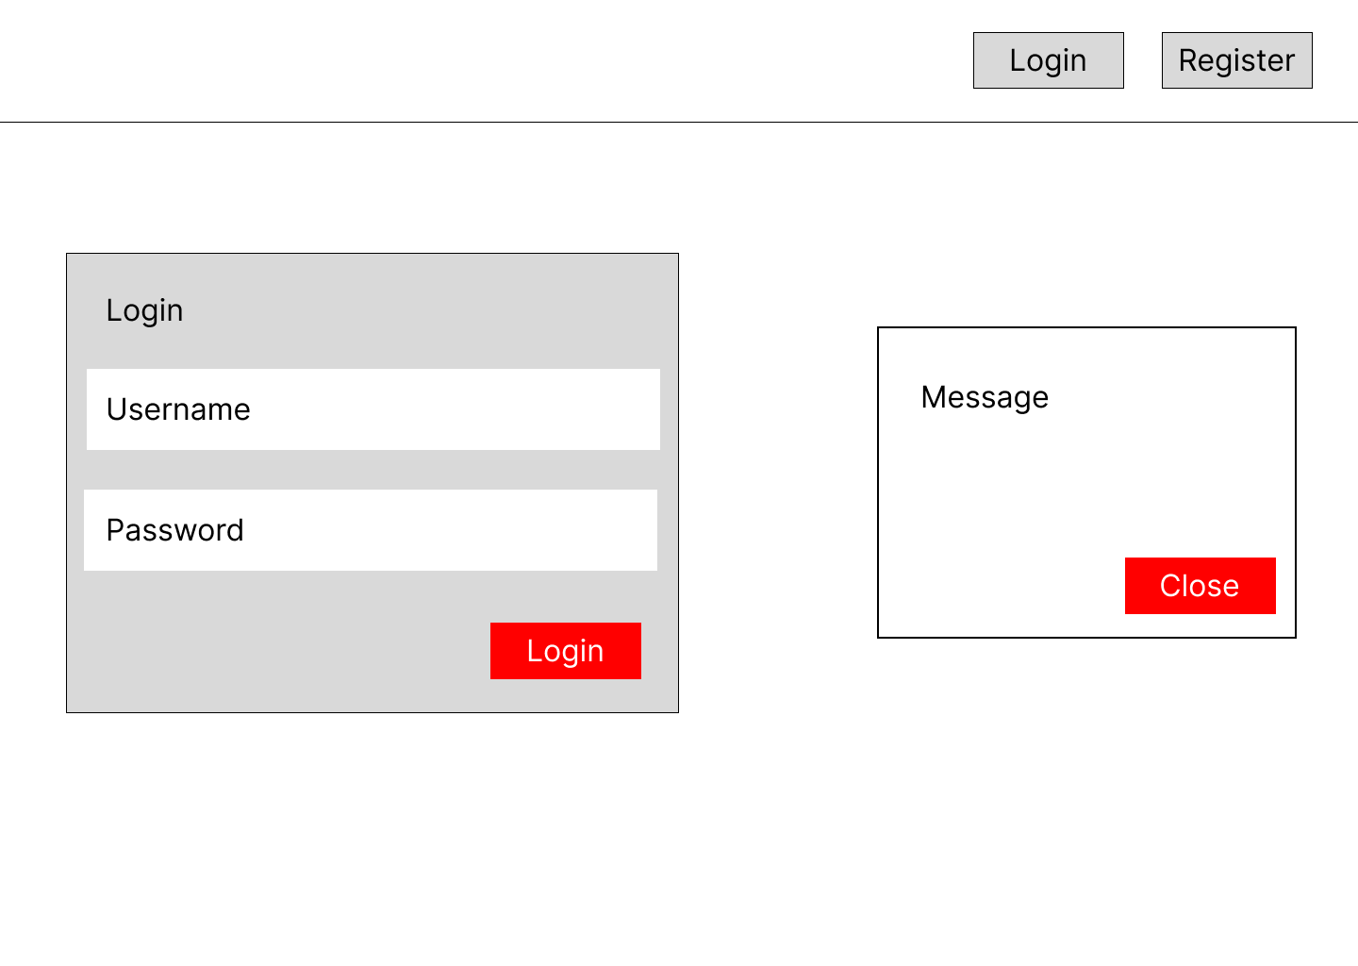

Activity Diagram
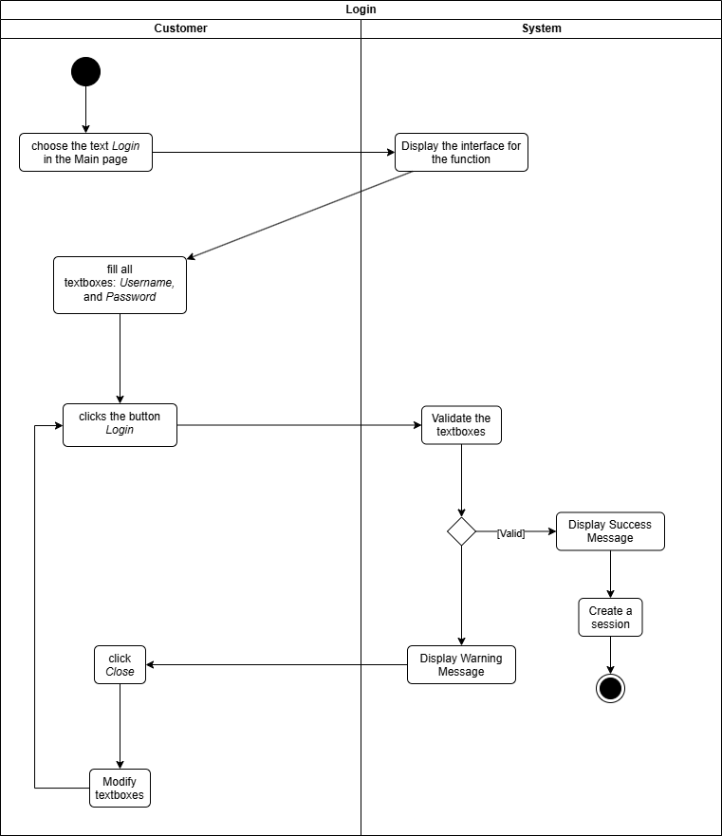

Logout

General information
- Use case’s name: Logout.
- Actors: Customer
- Requirements: Login

Short description

Basic scenarios
- From the Main page, the customer clicks the avatar, an option named Logout will be displayed.
- The customer clicks the button Logout, the website then will be reloaded. Also, the session will be cancelled.

Exceptional scenarios

Visualization
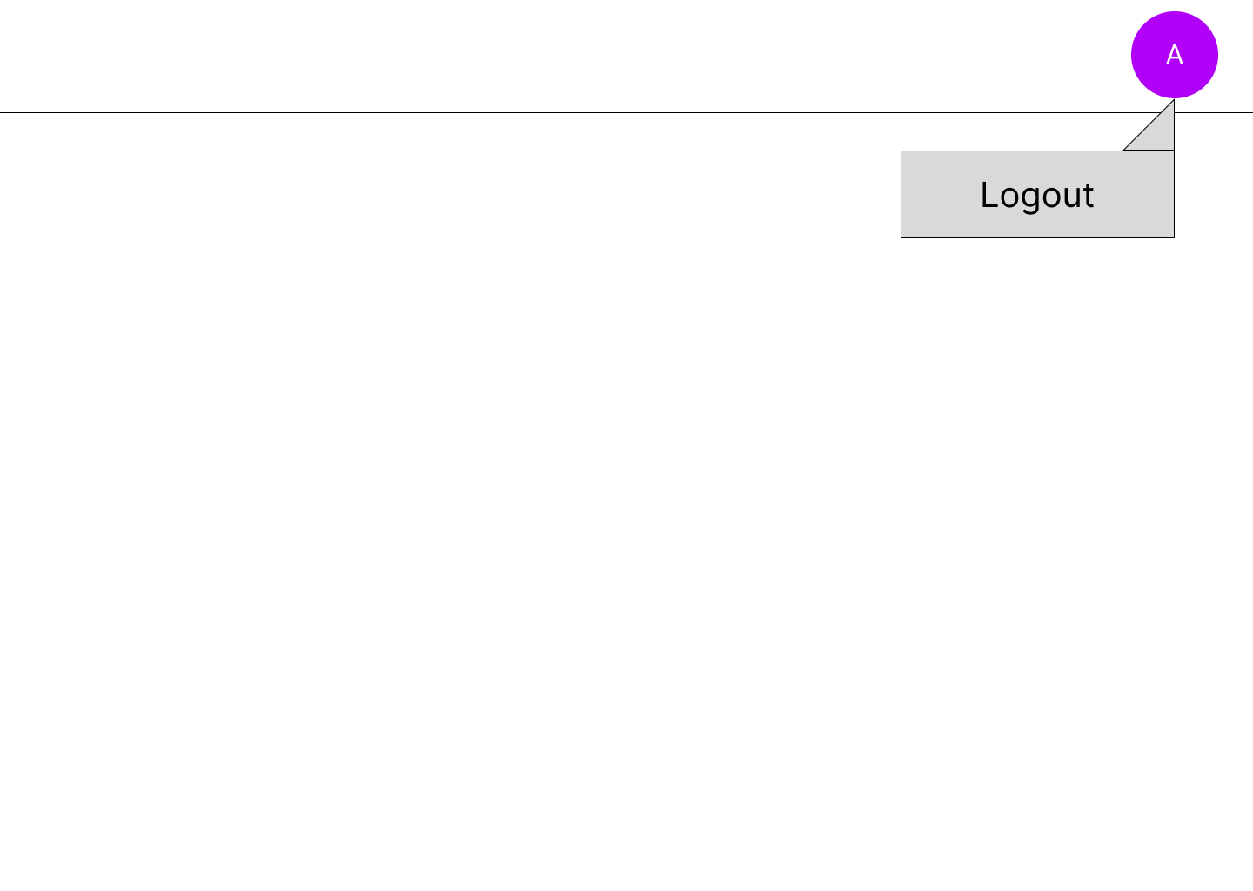

Activity Diagram
