VIETNAM GENERAL CONFEDERATION OF LABOR

**TON DUC THANG UNIVERSITY FACULTY OF**

**INFORMATION TECHNOLOGY**



**SOFTWARE ENGINEERING**

**FINAL REPORT**

*Instructing Lecturer*: **Mr. DANG MINH THANG**

*Student’s name*: **LE TUAN MINH – 517H0066**

**NGUYEN HOANG KHAI – 517H0058**

Class **: 17050211**

Course **: 21**

**HO CHI MINH CITY, YEAR 2019.**

VIETNAM GENERAL CONFEDERATION OF LABOR

**TON DUC THANG UNIVERSITY FACULTY OF**

**INFORMATION TECHNOLOGY**



**SOFTWARE ENGINEERING**

**FINAL REPORT**

*Instructing Lecturer*: **Mr. DANG MINH THANG**

*Student’s name*: **LE TUAN MINH – 517H0066**

**NGUYEN HOANG KHAI – 517H0058**

Class **: 17050211**

Course **: 21**

**HO CHI MINH CITY, YEAR 2019.**

**ACKNOWLEDGEMENT**

In order to make this report complete and achieve good results, we have received the support and assistance of many teachers and classmates.

With deep affection, sincerity, we express deep gratitude to all individuals and agencies who have helped us in our study and research.

First of all, I would like to express a special appreciation to Ton Duc Thang University’s teachers for their conscientious guidance and advices throughout the last semester by gave me their modern outlook and meticulous supervision to carry out the job perfectly.

Especially we would like to send our sincere thanks to Mr. Dang Minh Thang has paid attention, help, guide us to complete the report well over the past time.

We would like to express our sincere gratitude to the leadership of Ton Duc Thang University for supporting, helping and facilitating us to complete the report well during the study period.

With limited time and experience, this report can not avoid mistakes. We are looking forward to receiving advice and comments from teachers so that we can improve our awareness, better serve the practical work later.

We sincerely thank you!

**THE PROJECT WAS COMPLETED AT TON DUC THANG UNIVERSITY**

I pledge that this is a product of our own project and is under the guidance of Mr. Dang Minh Thang. The content of research, results in this subject is honest and not published in any form before. The data in the tables used for the analysis, comment, and evaluation were collected by the authors themselves from various sources indicated in the reference section.

Besides, in my project, I also use many comments, evaluations as well as figures of other authors, organizations. Their documental sources are all quoted.

*Ho Chi Minh City, December 8th 2019*

*Authors*

*(Sign and write full name)*

*Le Tuan Minh*

*Nguyen Hoang Khai*

**EVALUATION AND INSTRUCTION LECTURER**

**Confirmation of the instructor**

Ho Chi Minh City, December 8th 2019

(Sign and write full name)

**The assessment of the teacher marked**

Ho Chi Minh City, December 8th 2019

(Sign and write full name)

**TABLE OF CONTENTS**

**ACKNOWLEDGEMENT** i

**THE PROJECT WAS COMPLETED AT TON DUC THANG UNIVERSITY** ii

**EVALUATION AND INSTRUCTION LECTURER** iii

**TABLE OF CONTENTS** 1

**LIST OF FIGURES AND MODELS** 3

**CHAPTER 1 – REQUIREMENT ENGINEERING** 4

**1.1 Admin website requirement** 4

**1.2 Website requirement** 11

**1.3 Functional requirement** 18

**1.4 Non-functional requirement** 19

**CHAPTER 2 – USE CASES** 20

**2.1 Use case diagram** 20

**2.2 Use case description** 20

***2.2.1 Login*** 20

***2.2.2 Manage order*** 21

***2.2.3 Confirm/cancel order*** 22

***2.2.4 Manage category*** 22

***2.2.5 Manage product*** 23

***2.2.6 Add product*** 24

***2.2.7 Delete product*** 24

***2.2.8 Modify existing product*** 25

***2.2.9 View product*** 26

***2.2.10 Search product*** 26

***2.2.11 Add to cart*** 27

***2.2.12 Make a payment*** 28

***2.2.13 confirm/cancel email*** 28

**CHAPTER 3 – DIAGRAMS AND MODELS** 30

**3.1 Class Diagrams** 30

**3.2 Activity Diagrams** 31

**3.3 Sequence Diagrams** 32

***3.3.1 Manage order*** 32

***3.3.2 Login*** 32

**3.4 Entity Relational Diagrams** 33

**3.5 Relational Data Model** 35

**CHAPTER 4 – PROJECT APPLICATION** 36

**4.1 Technology** 36

**4.2 Testing** 37

**4.3 website** 38

***REFERENCES*** 42

**LIST OF FIGURES AND MODELS**

Figure 1: Use case diagram 20

Figure 2: Class diagram 30

Figure 3: Activity diagram 31

Figure 4: Sequence diagram-Manage order 32

Figure 5: Sequence diagram-Login 33

Figure 6: Entity relational diagram 34

Figure 7: Relational data model 35

Figure 8: MVC architecture 37

Figure 9: login panel 38

Figure 10: Admin dashboard 38

Figure 11: Customer homepage 39

Figure 12: Detail information of product 39

Figure 13: Add to cart 40

Figure 14: complete order 40

Figure 15: Email for owner shop 41

Figure 16: Email for customer 41

**CHAPTER 1 – REQUIREMENT ENGINEERING**

**1.1 Admin website requirement**

|  |  |  |  |  |  |  |  |
| --- | --- | --- | --- | --- | --- | --- | --- |
| No. | Module/  screen | Description | creator | Create date | Answer | Answer date | Status |
| 1. | Login | Regarding login functional. Description of the Login screen but not the case of entering an incorrect username or password, whether an error message is required or not. As I understand it, an error message is needed, the error message content will be "Invalid username or password". This message will be displayed in red,top at the of the Login button. Did I understand it correctly?? | Le Tuan Minh | 04/10/2019 |  |  | OPEN |
| 2. | Homepage screen | Regarding the display of Homepage screen. The case of login is already or not into homepage screen doesn’t have. As I understand it, when user close screen but loged in successfully so when they open again creen again. It will show homepage. And if user hadn’t loged in before but they try access homepage screen so it will go back login page. Did I understand it correctly?? | Le Tuan Minh | 04/10/2019 |  |  | OPEN |
| 3. | Add product | For Adding the product information screen, when performing the following operations:  Step 1: Choose product button in Homepage screen.  Step 2: Choose add button on the top of the product list screen.  The program will automatically switch to add product screen. Write information of new product to add.  After adding the product, it will save in data and show on product list in product page. Did I understand it correctly?? | Le Tuan Minh | 04/10/2019 |  |  | OPEN |
| 4. | Update product | For Updating the product information screen, when performing the following operations:  Step 1: Choose product button in Homepage screen.  Step 2: Choose update button on the right and next to the each product in list screen.  The program will automatically switch to update product screen. Write information of product to change.  After update the product, it will save in data and show on product list in product page. Did I understand it correctly? | Le Tuan Minh | 06/10/2019 |  |  | OPEN |
| 5. | Delete product | For deleting the product information screen, when performing the following operations:  Step 1: Choose product button in Homepage screen.  Step 2: Choose delete button on the right of the each product in list screen, it will show a message alert for user can choose final decision.  After delele the product, it will delete in data and update new product list in product page. Did I understand it correctly? | Le Tuan Minh | 04/10/2019 |  |  | OPEN |
| 6. | Add category | For Adding the information screen, when performing the following operations:  Step 1: Choose category button in Homepage screen.  Step 2: Choose add button on the right of the category list screen.  The program will automatically switch to add category screen. Write information of new category to add.  After adding the category, it will save in data and show on category list in product page. Did I understand it correctly? | Le Tuan Minh | 08/10/2019 |  |  | OPEN |
| 7. | Update category | For Updating the category information screen, when performing the following operations:  Step 1: Choose category button in Homepage screen.  Step 2: Choose update button on the right of the each product in list screen.  The program will automatically switch to Update category screen. Write information of category to change. If category already have, it will show alert message.  After updating the category, it will save in data and show on product list in product page. Did I understand it correctly? | Le Tuan Minh | 09/10/2019 |  |  | OPEN |
| 8. | Delete category | For deleting category information screen, when performing the following operations:  Step 1: Choose category button in Homepage screen.  Step 2: Choose delete button on the right of the each product in list screen, it will show a message alert for user choose final decision.  After deleling the product, it will delete in data and update new product list in product page. Did I understand it correctly? | Le Tuan Minh | 11/10/2019 |  |  | OPEN |
| 9. | Update order list (Confirm) | For updating order list screen, when performing the following operations:  Step 1: Choose order list button in Homepage screen.  Step 2: Click “x” button status collumn of each order list, it will show a message alert that user choose final decision.  After Updating order list, it will show a message that order confirms sucessfully. | Le Tuan Minh | 11/10/2019 |  |  | OPEN |

**1.2 Website requirement**

|  |  |  |  |  |  |  |  |
| --- | --- | --- | --- | --- | --- | --- | --- |
| No. | Module/  Screen | Description | creator | Create date | Answer | Answer date | Status |
| 1. | Outstanding product | For displaying outstanding product. Customer use website to buy items , but it doesn’t display outstanding product in homepage of website. As I understand it, when customer use website. In website, it will display outstanding product in homepage. Did I understand it correctly? | Lê Tuấn Minh | 1/11/2019 |  |  | OPEN |
| 2. | New product | For displaying new product. Customer use website to buy items , but it doesn’t display new product in homepage of website. As I understand it, when customer use website. In website, it will display new product in homepage. Did I understand it correctly? | Lê Tuấn Minh | 1/11/2019 |  |  | OPEN |
| 3. | Advertisement | For displaying advertisement. Customer use website to buy items , but it doesn’t display new product in homepage of website. As I understand, in homepage, it will display advertisement. Did I understand it correctly? | Lê Tuấn Minh | 1/11/2019 |  |  | OPEN |
| 4. | Detail information of product | For displaying detail information of product. when performing the following operations:  Step 1: Click “watch detail” button of item.  The program will automatically switch to detail information of product screen and display all necessary information of product. It also display comment of customer. Did I understand it correctly? | Lê Tuấn Minh | 2/11/2019 |  |  | OPEN |
| 5. | Order items | For ordering items. When performing following operations:  Step 1: Click “watch detail” button of item will switch to detail information of product screen.  Step 2: Click “order items”  Button.  The program will automatically switch to order items screen and display form for purchase confirmation. Did I understand it correctly? | Lê Tuấn Minh | 04/11/2019 |  |  | OPEN |
| 6. | Delete order | For deleting order items. When performing following operations:  Step 1: Click “watch detail” button of item will switch to detail information of product screen.  Step 2: Click “order items”  Button.  Step 3: Click “Delete order”. It will show a message alert for user can choose final decision.  After deleting the order, it will update new orderlist list in order page. Did I understand it correctly? | Lê Tuấn Minh | 05/11/2019 |  |  | OPEN |
| 7. | Update order | For updating order items. When performing following operations:  Step 1: Click “watch detail” button of item will switch to detail information of product screen.  Step 2: Click “order items”  Button.  Step 3: Customer want to change quantity. Click “ Update order”.  After updating the order, it will update new orderlist list in order page. Did I understand it correctly? | Lê Tuấn Minh | 06/11/2019 |  |  | OPEN |
| 8. | Buy more order | For buying order items. When performing following operations:  Step 1: Click “watch detail” button of item will switch to detail information of product screen.  Step 2: Click “order items”  Button.  Step 3: Customer want to change quantity. Click “ Update order”. Did I understand it correctly?  After buying more the order, it will update new order list in order page. Did I understand it correctly? | Lê Tuấn Minh | 07/11/2019 |  |  | OPEN |
| 9. | Complete order | For completing order. When performing following operations:  Step 1: write form for purchase confirmation in order page.  Step 2: click “confirm” button.  The program will automatically switch to complete order screen and display announcements for customer and also send e-mail for customer. Did I understand it correctly? | Lê Tuấn Minh | 08/11/2019 |  |  | OPEN |

**1.3 Functional requirement**

- Admin must have an account to access and manage the store.

- When customer add one item to shopping card, the system must save and keep it until the customer delete or purchase it.

- Customer can search item through key word such as name, product id, manufacturer, …

- System must show a recommend product to the customer when the access to the web.

- Staff can add, delete any product from web and it won’t be displayed in the store anymore.

- When staff manage order, confirm any order, system will calculate price, quantity and sent an email for customer.

- Product(item) can be manage and search through the category. Customer also can view a product follow the category.

- Customer can comment to discuss about the product.

- When customer choose one item to purchase, they can choose different payment to purchase such as visa, credit card, banking card, …

- When staff cancel any order, an email must be sent to notify them that their order has been cancel.

**1.4 Non-functional requirement**

- Security: Can protect private information of the customer such as payment id card, name, phone, ….

- Maintainability: Easy to maintain and update, have reasonably price to maintain and update.

- Availability: Have 1 hour to downtime every 6 month.

- Usability: Staff can easily use system after 5 hours training. Customer can easily use a web to search, view, buy a product after 2~3 times buy product in there.

- Capacity: can withstand up to 1000 people visiting at the same time.

- Interoperability: Friendly interface for customer, pleasant color, easy to remember and use.

- Reliability: Information about product on web must be right. Products sold must be in accordance with the picture.

- Environmental: Web can run on different browser such as Firefox, Google Chrome, … And can run on different divides such as laptop, ipad, phone, …

**CHAPTER 2 – USE CASES**

**2.1 Use case diagram**

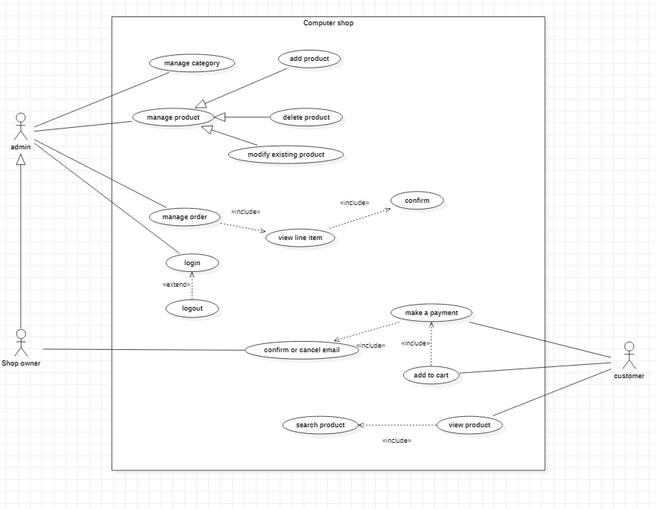

Figure 1: Use case diagram

**2.2 Use case description**

***2.2.1 Login***

|  |  |
| --- | --- |
| ID: | 1 |
| Title: | Login |
| Description: | This use case allow staff to login to system which he/she can manage the store on web. |
| Primary Actor: | Staff. |
| Preconditions: | Staff must have an account opened by the store’s manager. |
| Post - conditions: | Successful login. |
| Main Success Scenario: | This use case starts when the account of staff is activated by the manager.  Basic flows:  +Staff must have an account that was opened by store’s manager.  +Staff input a user name and a password that’s provided by the manager of store.  +System shows functions that staff can use to manage the online store.  +If the user name/password is wrong, system will show an error announcement. |
| Extensions: | There is no extensions point for this use case |

***2.2.2 Manage order***

|  |  |
| --- | --- |
| ID: | 2 |
| Title: | Manage order |
| Description: | This use case allowed the staff to manage the order of customer. That he can know about product’s name, quantity … and take it from store and ship to customer . |
| Primary Actor: | Staff. |
| Preconditions: | Staff must login to the system. |
| Post - conditions: | Staff will get basic information about the customer and their order. |
| Main Success Scenario: | This use case starts when staff receive 1 order from shopping card of customer.  Basic flow:  +When customer add 1 item into their shopping card, the order will be recorded.  +Staff view list of the order line of different customer which displayed by each line (use case “view line item”). |
| Extensions: | Staff can get information of customer after they purchase the order. |

***2.2.3 Confirm/cancel order***

|  |  |
| --- | --- |
| ID: | 3 |
| Title: | Confirm or cancel order |
| Description: | This use case allow staff confirm/cancel order of customer. |
| Primary Actor: | Staff |
| Preconditions: | The order have to added into the shopping card of the customer. |
| Post - conditions: | One mail will be sent to the customer to announce him/her: the products which he/she want to buy are confirmed or canceled. |
| Main Success Scenario: | This use case starts when staff receive 1 order from shopping card of customer.  Basic flow:  +Staff will get information of customer and item that they want to buy through use case: “Manage order” and “View line item”.  +Staff can confirm/cancel the order by click to 2 button “Confirm order” and “Cancel order”. |
| Extensions: | There is no extension for this use case |

***2.2.4 Manage category***

|  |  |
| --- | --- |
| ID: | 4 |
| Title: | Manage category |
| Description: | This use case allowed the staff to manage the products follow the types of that product such as laptop, ram, hardware, … He/she can add the new category into online store, delete the category that store does not sell anymore. |
| Primary Actor: | Staff |
| Preconditions: | Staff must login to the system |
| Post - conditions: | The new category was added must be displayed. The category was delete must be deleted from system and not showed anymore. |
| Main Success Scenario: | This use case allow staff can add a new category that the store wants to sell in store, or delete 1category that the store don’t want to sell anymore.  Basic flow:  +Staff login to system.  +Staff choose 1 in 2 function.  +After that staff can add new category, delete 1 category which they want to delete through 2 button “add cate” and “delete cate”. |
| Extensions: | There is no extensions for this use case. |

***2.2.5 Manage product***

|  |  |
| --- | --- |
| ID: | 5 |
| Title: | Manage product |
| Description: | This use case allowed the staff to manage the products with 3 functions: add, delete and modify existing product. He/she can add the new product into online store, delete the product that store does not sell anymore or update the status of product for customer know that product is out of or not. |
| Primary Actor: | Staff |
| Preconditions: | Staff must login to the system. |
| Post - conditions: | There is no post – condition for this use case. |
| Main Success Scenario: | This use case starts when staff want to add, delete or modify existing of one product.  Basic flow:  +Staff login to system.  +Staff choose 1 in 3 function.  +After that staff can add new item, delete 1 item which they want to delete or modify the quantity of remain product. |
| Extensions: | The product is added/deleted must be displayed/deleted on the web. |

***2.2.6 Add product***

|  |  |
| --- | --- |
| ID: | 6 |
| Title: | Add product |
| Description: | This use case allow staff can add a new product that the store want to sell into store. |
| Primary Actor: | Staff |
| Preconditions: | Have some new product that the store want to add it into the web. |
| Post - conditions: | The system will save the product’s information which was added into database and customer can find this product throughout a Search page. |
| Main Success Scenario: | This use case starts when store have new product which they want to sell.  Basic flow:  +Staff will input the basic information about new item such as name, image, product id, price, basic introduce, …  +After that, the system will record about new item and show it on the web. |
| Extensions: | Customer can search, view new item after the staff add it into the store, it’s also showed in the recommend page on the web |

***2.2.7 Delete product***

|  |  |
| --- | --- |
| ID: | 7 |
| Title: | Delete product |
| Description: | This use case allow staff can add a delete product that the store want to sell into store. |
| Primary Actor: | This use case allow staff can delete a product that the store don’t want to sell on web anymore. |
| Preconditions: | Have some product that the store want to delete it from the web. |
| Post - conditions: | The system will delete the product’s information from database, customer can’t find it anymore and the system will also not show anything about the deleted product. |
| Main Success Scenario: | This use case starts when store want to delete product which they don’t sell anymore.  Basic flow:  +Staff will delete all the information about item such as name, image, product id, price, basic introduce, …  +After that, the system will record and delete all of it from database of system. |
| Extensions: | Customer can’t search, view item after the staff delete it from the store, it’s also not showed in the web anymore. |

***2.2.8 Modify existing product***

|  |  |
| --- | --- |
| ID: | 8 |
| Title: | Modify existing product |
| Description: | This use case allow the staff can edit the number of inventory of product. |
| Primary Actor: | Staff |
| Preconditions: | Product has been added into system. |
| Post - conditions: | There is no post – conditions for this use case. |
| Main Success Scenario: | This use case starts when staff want to change number product which remain on the web.  Basic flow:  +Staff will choose the item that they want to change a number of remain product.  +After that, the system will record it and display it on the web for customer to know the number of remain product |
| Extensions: | After each time has 1 order for any product. The quantity of that product will decrease by 1 and system must to display it on the web. |

***2.2.9 View product***

|  |  |
| --- | --- |
| ID: | 9 |
| Title: | View product |
| Description: | This use case allow customer can view a list of product on the store. Customer also view information of item such as price, warranty date,… |
| Primary Actor: | Customer |
| Preconditions: | Customer want to view information of some item. |
| Post - conditions: | The system shows information of the product which customer chose. |
| Main Success Scenario: | This use case starts when customer want to view information of some item.  Basic flow:  + Customer want to view information of some item.  +Customer click to item that they want to see more information.  +The system will show more information about the product that customer chose such as price, warranty date, basic introduce about that item… |
| Extensions: | There is no extension for this use case |

***2.2.10 Search product***

|  |  |
| --- | --- |
| ID: | 10 |
| Title: | Search product |
| Description: | This use case allow customer can search a product that they want to find on the store. |
| Primary Actor: | Customer |
| Preconditions: | Customer have to input the key word of a product that they want to find such as name, product id,… |
| Post - conditions: | The system shows product which customer want to find through the key word. |
| Main Success Scenario: | This use case starts when customer input the key word of a product which they want to find into the web.  Basic flow:  + Customer input the key word of product that they want to find such as name, product id, …  +Through the key, system will find all product that have information coincide with key word  +System show all product that have information coincide with key word |
| Extensions: | If the product which customer want to find doesn’t exist, the system will show a message “This product doesn’t exist in our store” |

***2.2.11 Add to cart***

|  |  |
| --- | --- |
| ID: | 11 |
| Title: | Add to card |
| Description: | This use case allow customer to add the product they want to buy to a card which will save his/ her order before he/she purchase his/her order. |
| Primary Actor: | Customer |
| Preconditions: | The customer want to add item into the card and want to review it. |
| Post - conditions: | Customer can review his/her order before he/she purchase it. |
| Main Success Scenario: | This use case starts when customer want to add some product to the shopping card.  Basic flow:  +Customer want to add the product which he/she decides to buy into shopping card  +The system will save his/her order and show the new item in shopping card which customer can review at before they decide to purchase it. |
| Extensions: | Customer can edit the quantity of the product which they want to buy.  Customer can add a lot of product, but needn’t to purchase all in one time.  Delete the item which they change the decision to buy. |

***2.2.12 Make a payment***

|  |  |
| --- | --- |
| ID: | 12 |
| Title: | Make a payment |
| Description: | This use case allow customer to purchase the product that they want to buy |
| Primary Actor: | Customer |
| Preconditions: | Customer must add at least one product into the card. |
| Post - conditions: | Customer can choose a method to purchase his/her order. |
| Main Success Scenario: | This use case starts when the order of customer is confirmed.  Basic flow:  +When the order is confirmed, one mail will be sent to the customer and now the customer can purchase it.  +Customer can choose the method to purchase his/her order. |
| Extensions: | There is no extensions for this use case |

***2.2.13 confirm/cancel email***

|  |  |
| --- | --- |
| ID: | 4 |
| Title: | Confirm/cancel email |
| Description: | This use case allow the staff can announce the customer that their order are confirmed/canceled. |
| Primary Actor: | System |
| Preconditions: | Staff confirm/cancel 1 order. |
| Post - conditions: | Confirm/cancel mail will be sent to customer. |
| Main Success Scenario: | This use case starts when staff confirm/cancel 1 order.  Basic flow:  +If the staff cancel the order of customer, 1 mail will be sent to them to announce them about that.  + If the staff confirm the order of customer, 1 mail will be sent to them to announce them about that, customer have to purchase and input the information within 3 days, if not the order will be canceled |
| Extensions: | There is no extensions for this use case |

**CHAPTER 3 – DIAGRAMS AND MODELS**

**3.1 Class Diagrams**

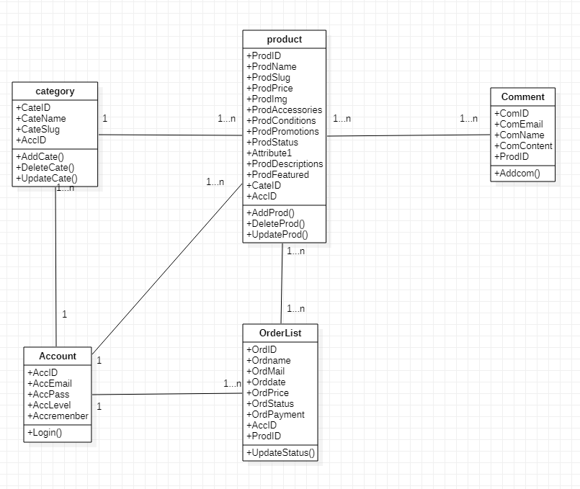

Figure 2: Class diagram

**3.2 Activity Diagrams**

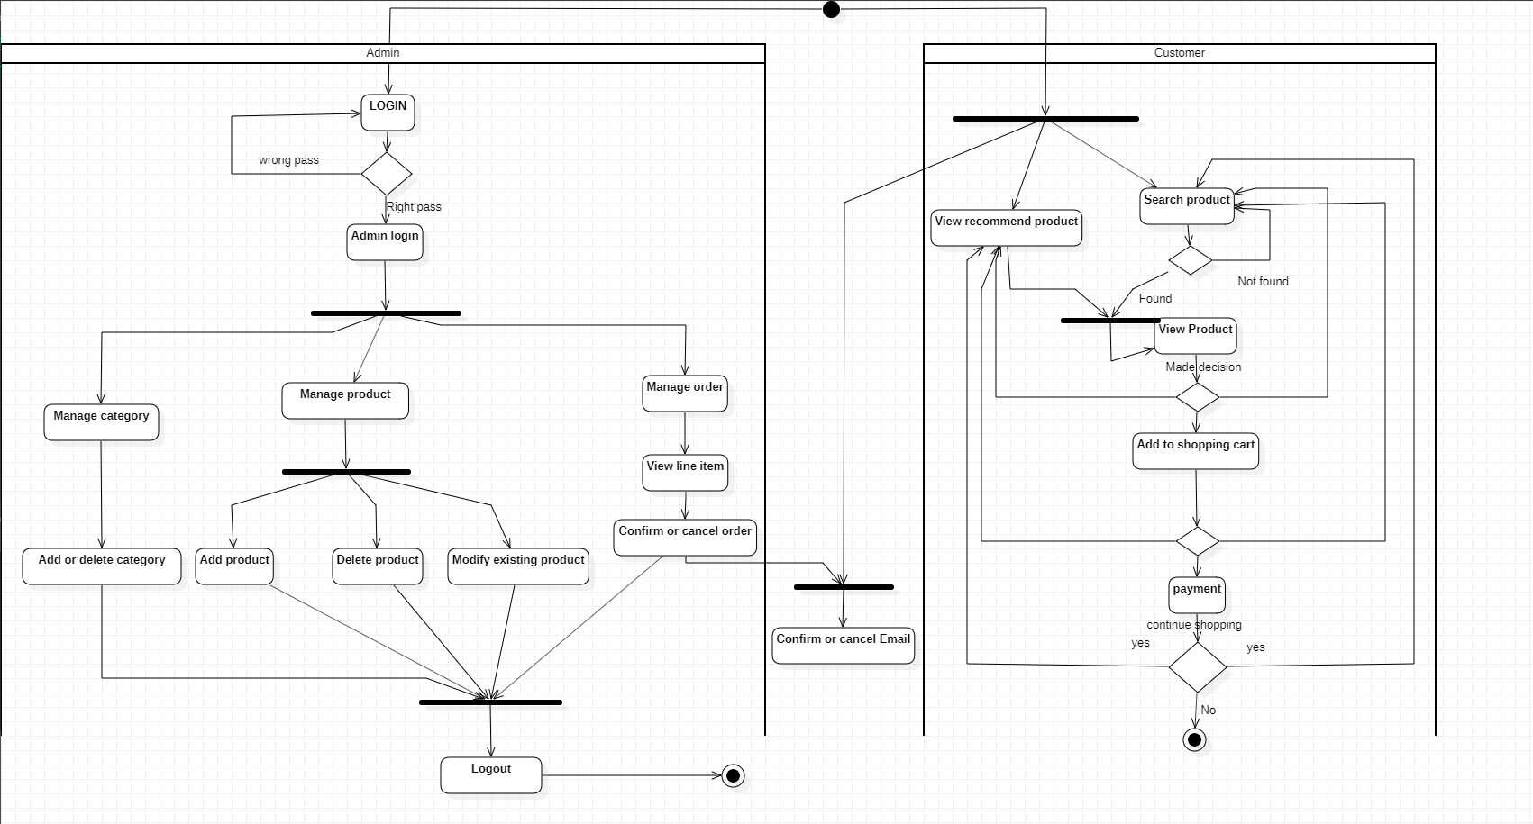

Figure 3: Activity diagram

**3.3 Sequence Diagrams**

***3.3.1 Manage order***

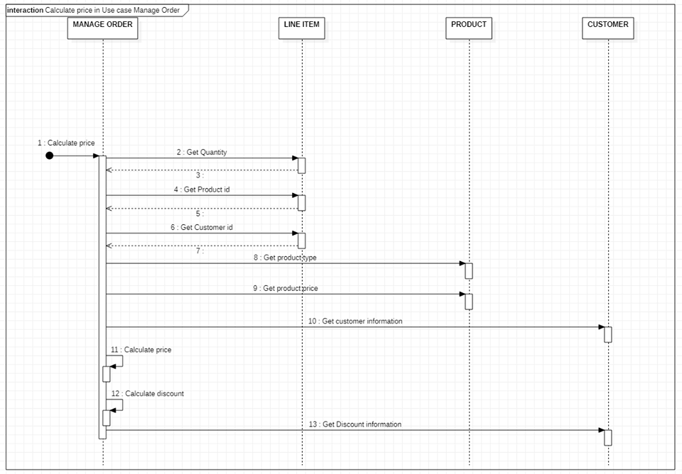

Figure 4: Sequence diagram-Manage order

***3.3.2 Login***

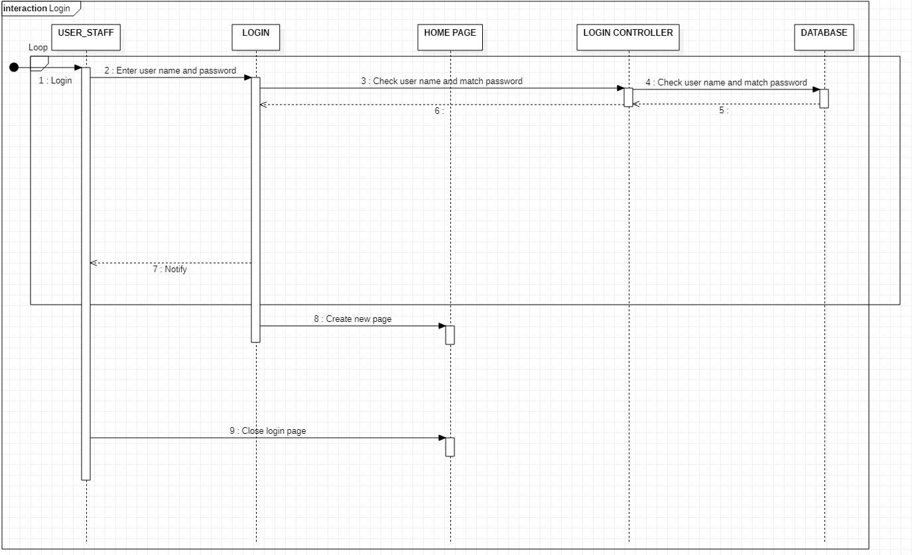

Figure 5: Sequence diagram-Login

**3.4 Entity Relational Diagrams**

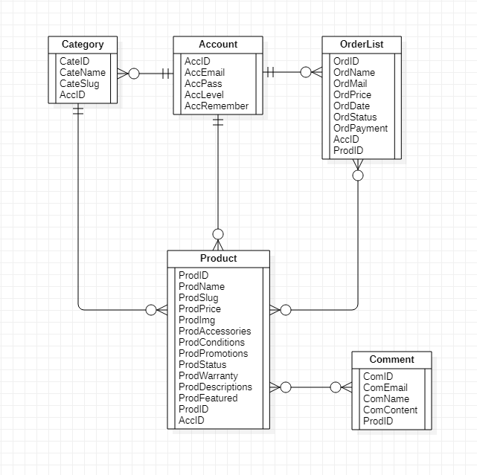

Figure 6: Entity relational diagram

**3.5 Relational Data Model**

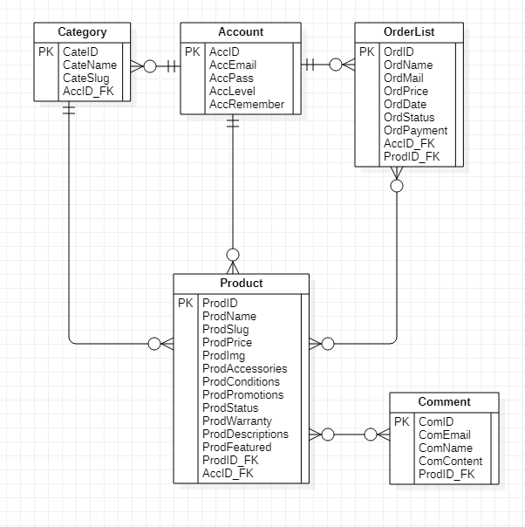

Figure 7: Relational data model

**CHAPTER 4 – PROJECT APPLICATION**

**4.1 Technology**

**-** The programming langague we use is: PHP. Because PHP is a lot easier to get started. By learning just a few simple functions, I am able to do a lot of things with my website. Once I know the basics, check out the wealth of scripts available on the internet that I only need to tweak slightly to fit my needs.

- The framework we use is: laravel. Because Laravel is a framework for creating web applications with an easy to use syntax. The idea behind Laravel is that it makes common development tasks easy such as routing, authentication, sessions, and caching.

- We use XAMPP to test the clients or your website before uploading it to the remote web server. This XAMPP server software gives you the suitable environment for testing MYSQL, PHP, Apache and Perl projects on the local computer.

- The architecture we use is: MVC. Because it has faster development process, ability to provide multiple views, the modification does not affect the entrie model, support for asynchronous technique, MVC model returns the data without formatting, SEO friendly development platform.

* **Model:** Model represents shape of the data and business logic. It maintains the data of the application. Model objects retrieve and store model state in a database.
* **View:** View is a user interface. View display data using model to the user and also enables them to modify the data.
* **Controller:** Controller handles the user request. Typically, user interact with View, which in-turn raises appropriate URL request, this request will be handled by a controller. The controller renders the appropriate view with the model data as a response.

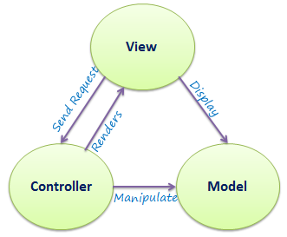

Figure 8: MVC architecture

**4.2 Testing**

**-** We use selenium to test the website. Specific, we will test on login of admin website.

import org.openqa.selenium.By;

import org.openqa.selenium.WebDriver;

import org.openqa.selenium.WebElement;

import org.openqa.selenium.chrome.ChromeDriver;

import org.openqa.selenium.support.ui.ExpectedConditions;

import org.openqa.selenium.support.ui.WebDriverWait;

public class elenium {

public static void main(String[] args) {

// TODO Auto-generated method stub

System.setProperty("webdriver.chrome.driver","D:\nam3\công nghệ phần mềm\chromedriver.exe");

WebDriver driver=new ChromeDriver();

driver.get("http://localhost/kachi_store/login");

WebElement username= driver.findElement(By.id("pseudonym_session_unique_id"));

WebElement password= driver.findElement(By.id("pseudonym_session_password"));

WebElement logginButton= driver.findElement(By.className("Button--login"));

username.sendKeys("admin@gmail.com");

password.sendKeys("123456");

logginButton.click();

}

}

- Login page before testing:

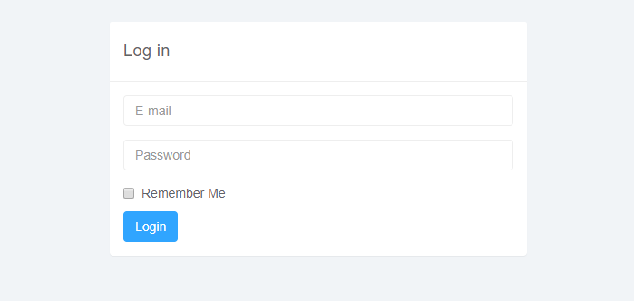

Figure 9: login panel

-After testting:

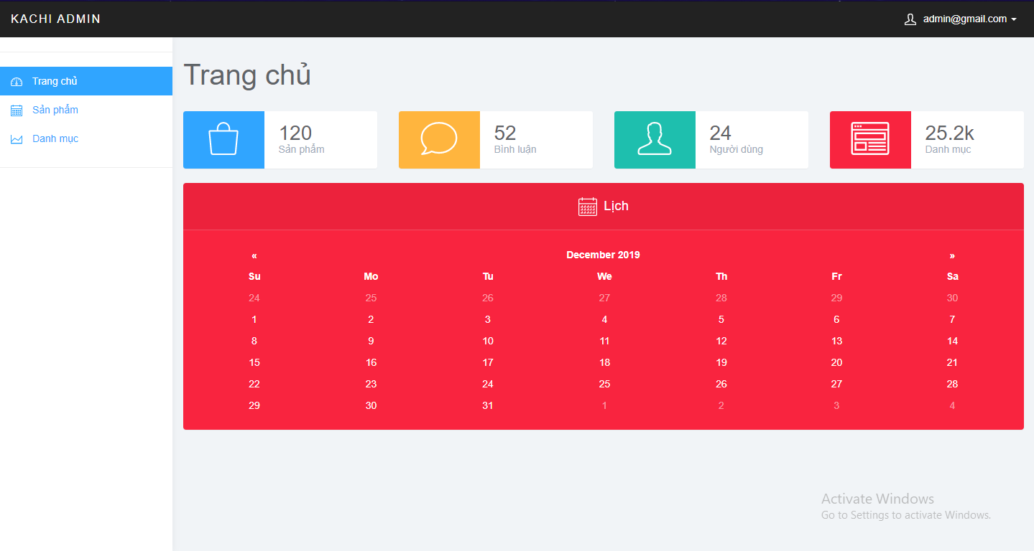

Figure 10: Admin dashboard

**4.3 website**

- When customer use website. It will show:

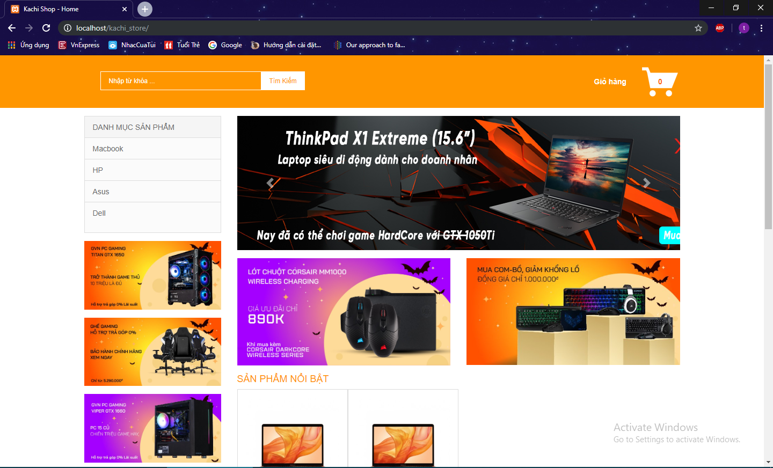

Figure 11: Customer homepage

- When customer want to check detail information of product.

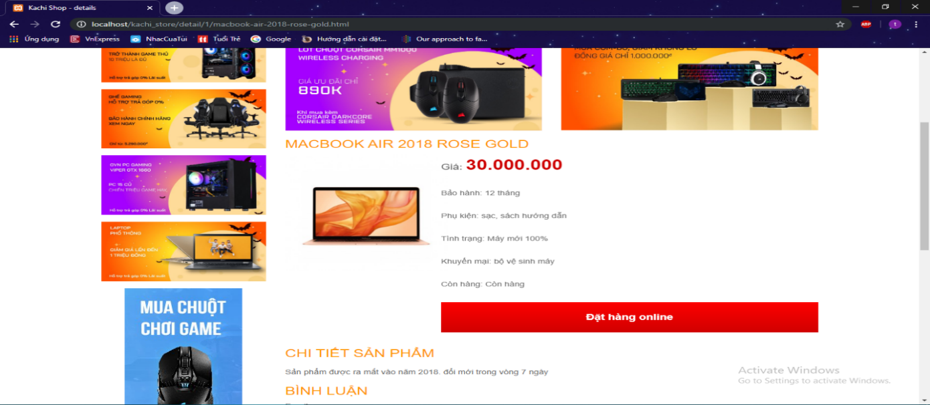

Figure 12: Detail information of product

- When customer want add to cart.

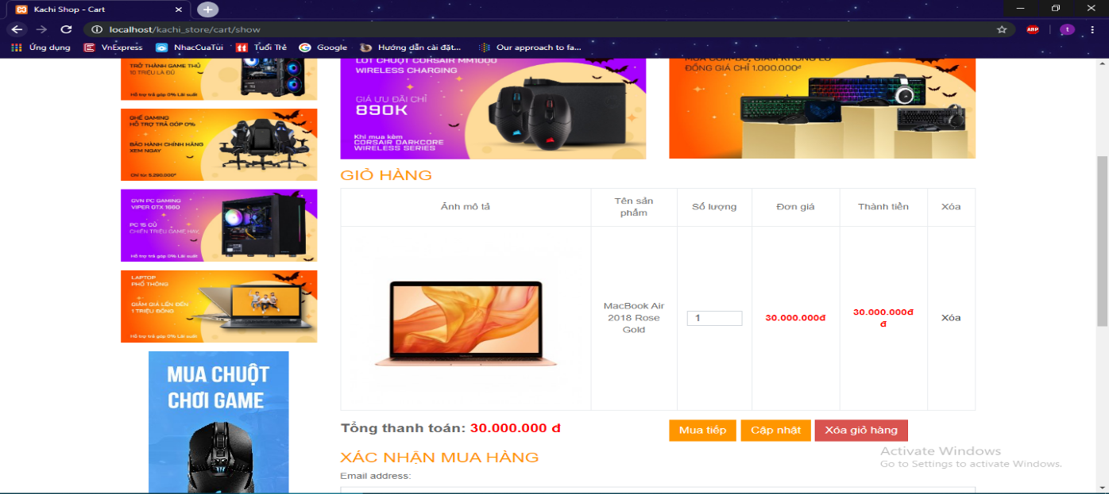

Figure 13: Add to cart

- After, customer complete order. A program will show:

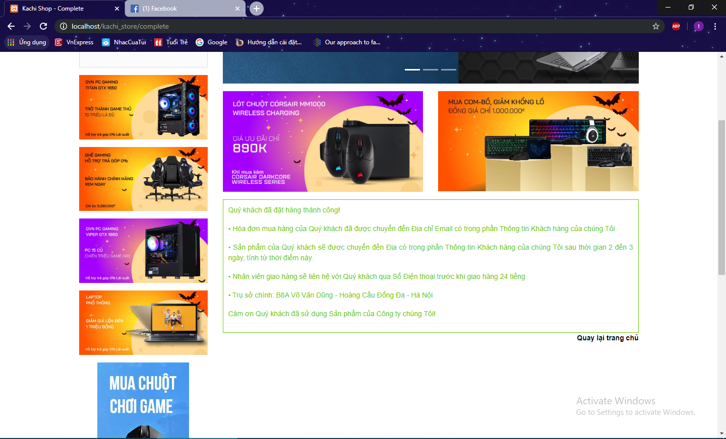

Figure 14: complete order

- Program will send email of customer and owner shop.

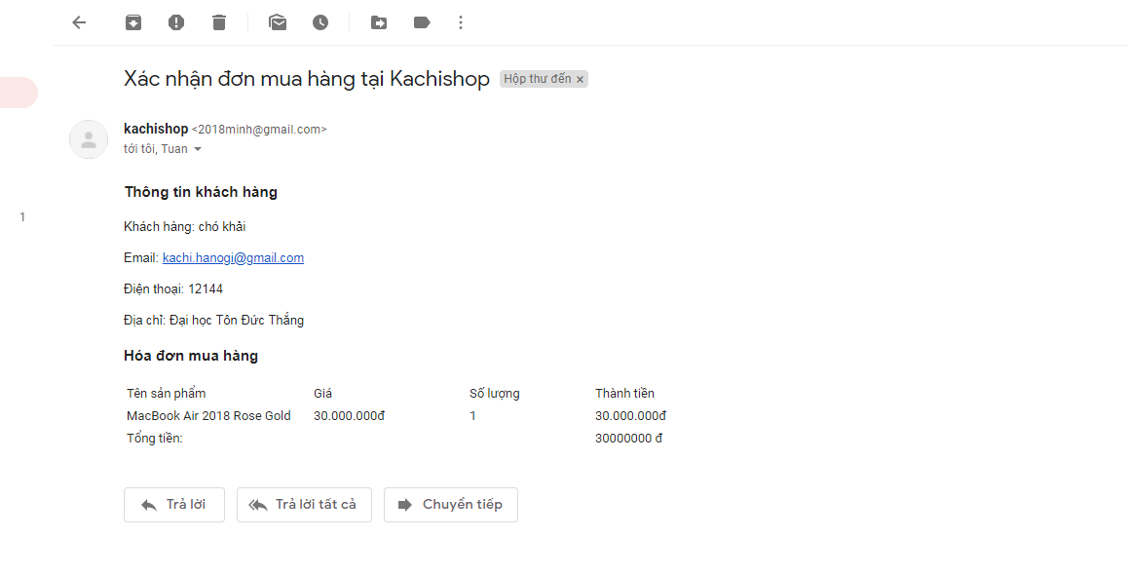

Figure 15: Email for owner shop

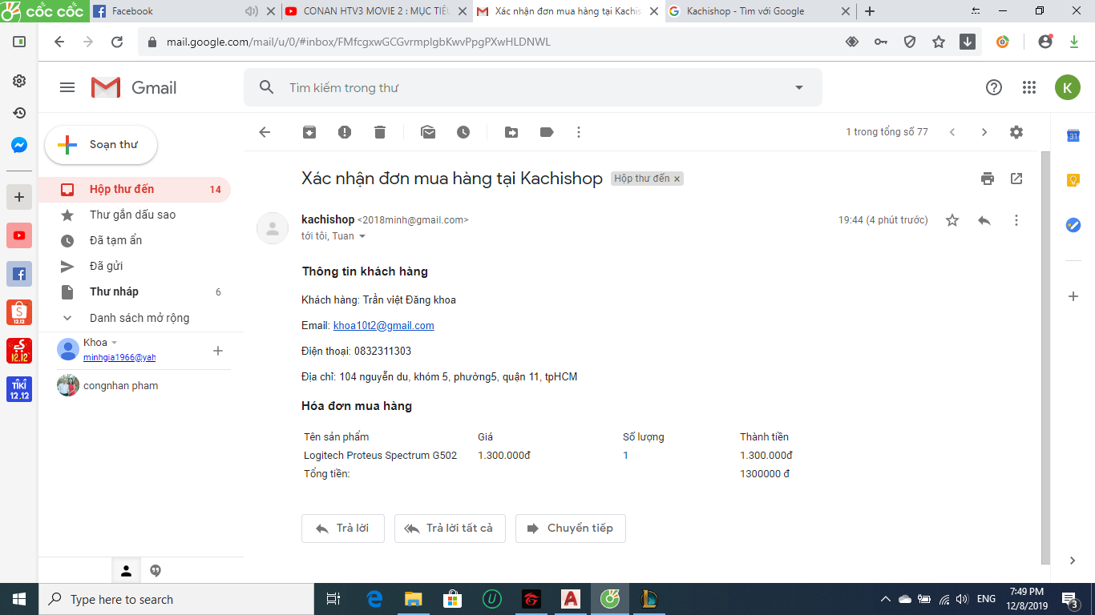

Figure 16: Email for customer

***REFERENCES***

[1] <https://www.tutorialsteacher.com/mvc/mvc-architecture?fbclid=IwAR27zcPKMml46gNsZF1HhL1n5N_UAdhlSOlRt-1g4kicAf22cqs8ncWiAZ4>

[2] <https://www.brainvire.com/six-benefits-of-using-mvc-model-for-effective-web-application-development/?fbclid=IwAR316XGv-DjLO0MEZ-rCTcf8p-pvSfSE76_eztGL5Unme8aGMTolWBNIWAM>

[3] <https://techmaster.vn/posts/34646/lap-trinh-laravel-cho-nguoi-moi-bat-dau>

[4] <https://www.guru99.com/functional-vs-non-functional-requirements.html>

[5] <https://vietpro.net.vn/laravel-project-a-z-01-gioi-thieu-ve-laravel-framework-5-3.html>

[6] <https://www.browserstack.com/guide/xpath-in-selenium>

[7] <https://github.com/darryldecode/laravelshoppingcart>

[8] <https://www.geeksforgeeks.org/software-engineering-requirements-engineering-process/>

[9] <https://www.visual-paradigm.com/guide/uml-unified-modeling-language/what-is-sequence-diagram/>

[10] <https://www.visual-paradigm.com/guide/uml-unified-modeling-language/what-is-activity-diagram/>