Question 1 (Convolutions and Filters):

a)

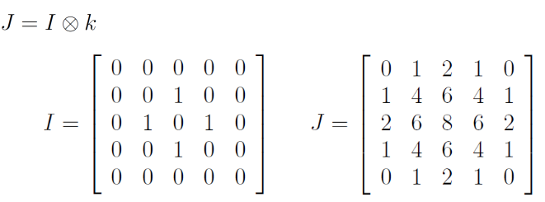

* Let *k* = 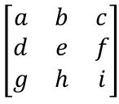
* An easy way to find the values of individual elements of *k* is to find instances where the convolution has only one non-zero input. For example:
  + 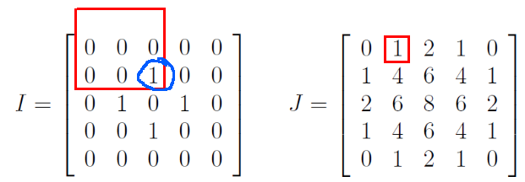
    - In this case, i*1 = 1. So, i=1.
* In this way, we find a*1=1, b*1=2, c*1=1, d*1=2, f*1=2, g*1=1, h*1=2, i*1=1
* Lastly, e*1+g*1+i*1=6
* SO: *k =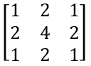*

b)



* With boundary reflection padding, I = 0.4 0.3 | 0.3 0.4 0.9 0 0.2 0.1 0.4 0.9 0 | 0 0.9
* Answer: [0.46 0.38 0.36 0.32 0.32 0.32 0.32 0.28 0.44]
* Gaussian vs box blur: The box blur can create artifacts in the blurred image, especially when there are high-frequency components in the image. The gaussian blur avoids this. For applications like edge detection, it’s important that we avoid the box filter’s edge-like artifacts.

c.) The Laplacian operator applied to a function f is defined as

If we define the Gaussian as then the Lapalacian of the Gaussian (LoG) is

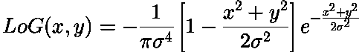

The Laplacian of the Gaussian results in strong positive responses for dark blobs of radius σ{\displaystyle r={\sqrt {2t}}} and strong negative responses for bright blobs of similar size.

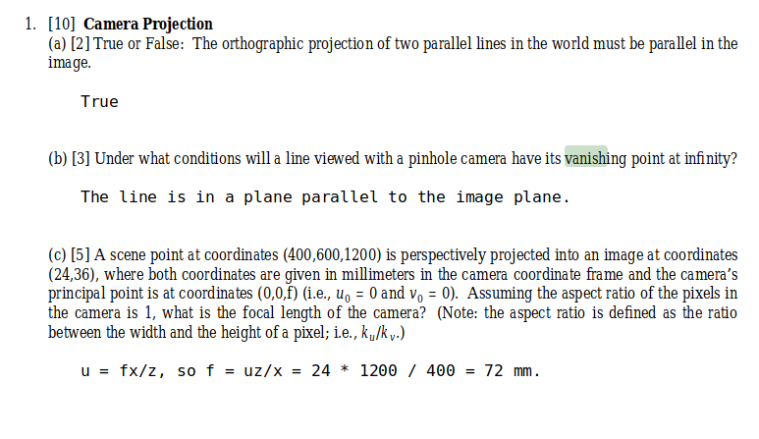

**3. Geometric Transforms**

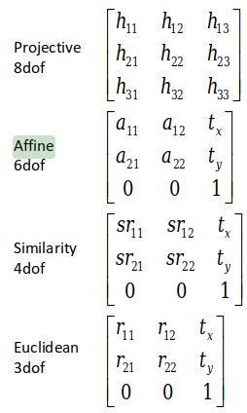

3A:

* 4 point correspondences
* 3 point correspondences
* 2 point correspondences
* 2 point correspondences

b.)

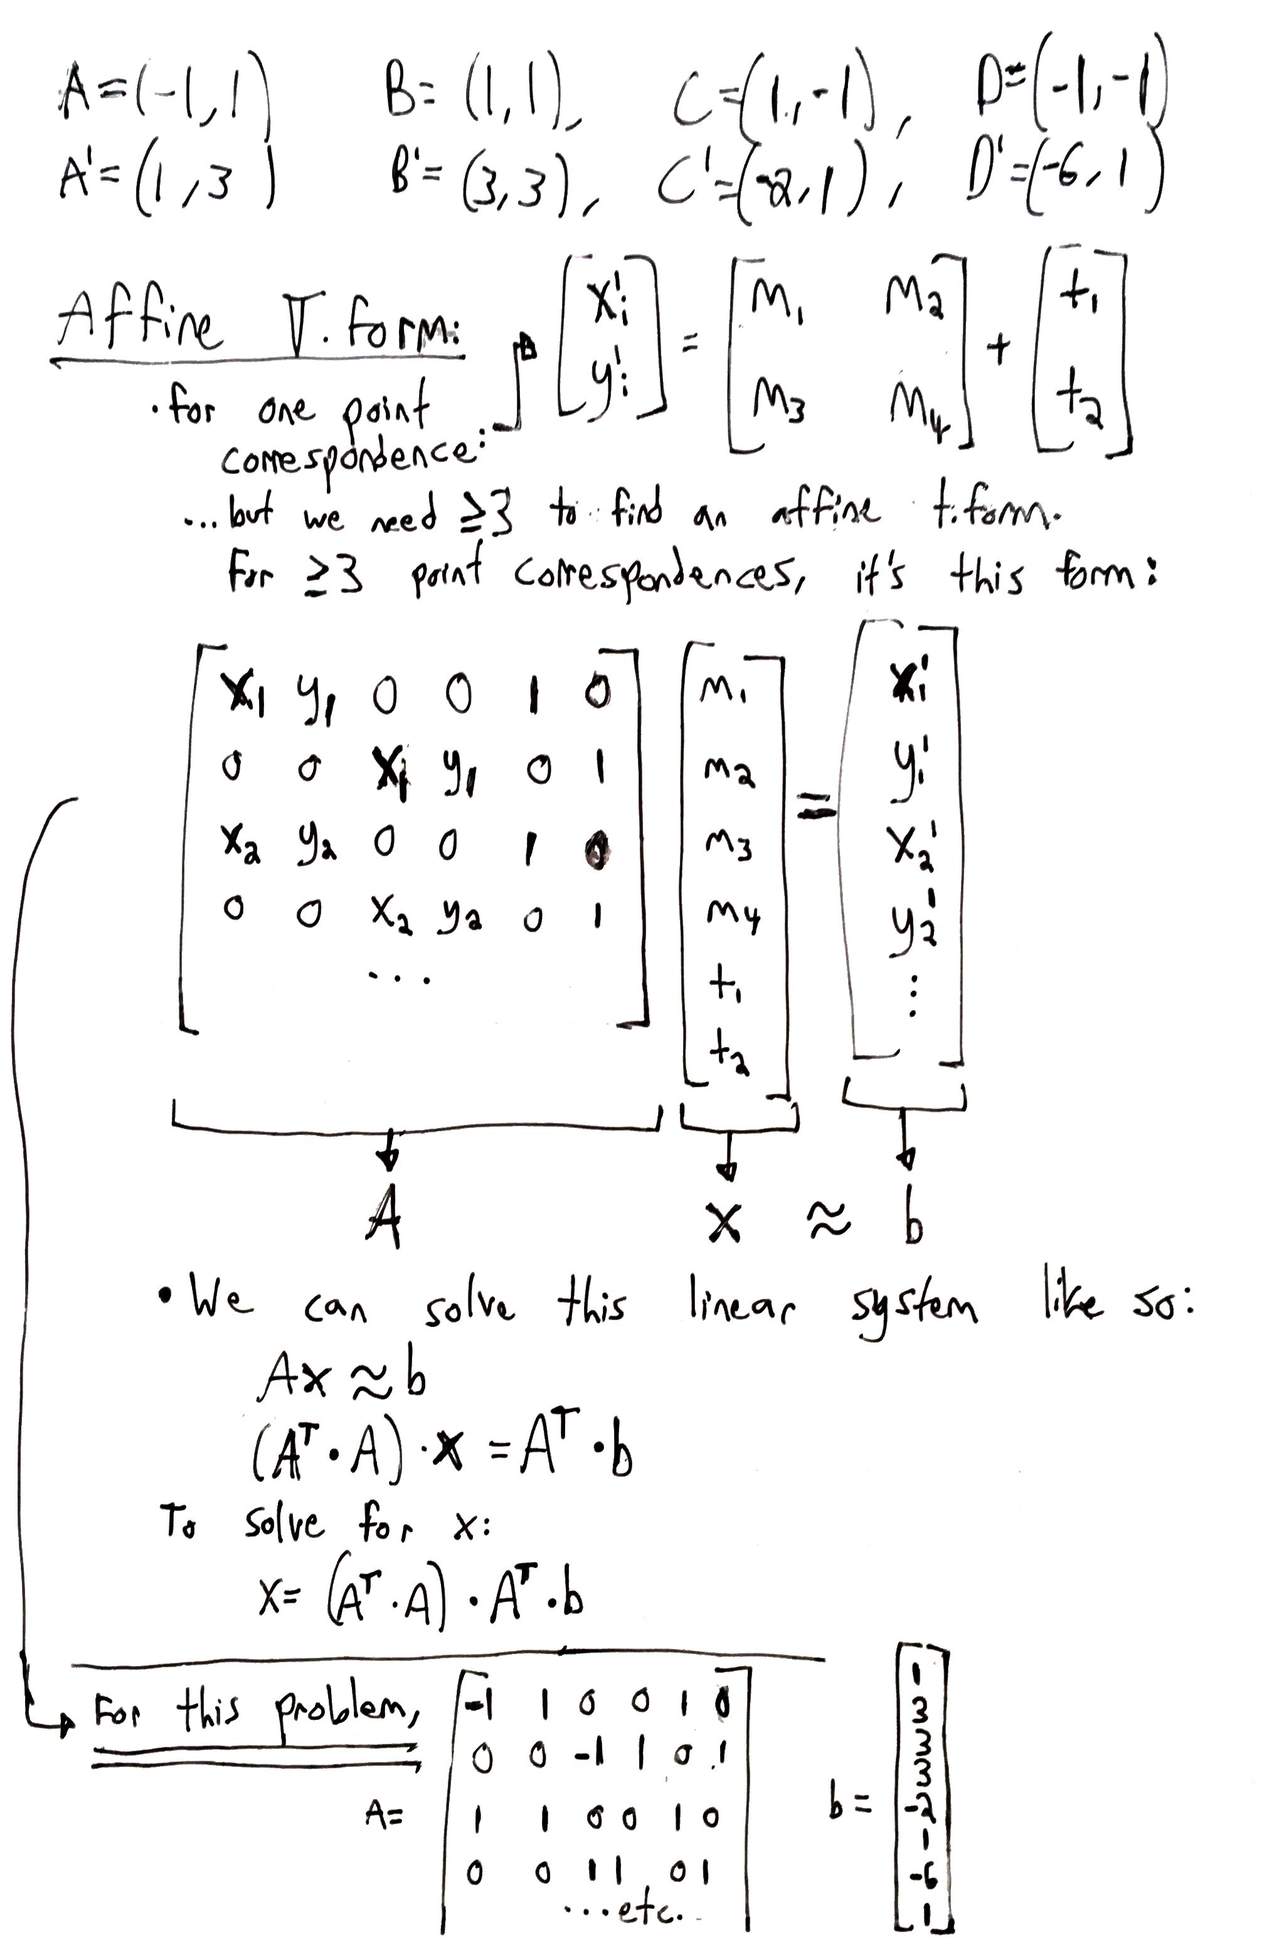

**4.) Geometric Transforms 3D**

a.)

b.)

AOb =  BOc ==  .

c.)

AOb =  BOc ==  .

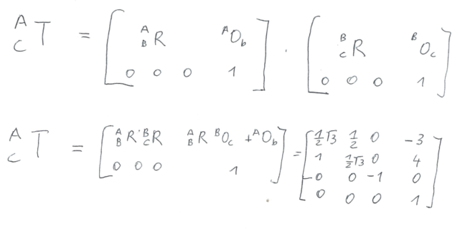

5. Image features

A:

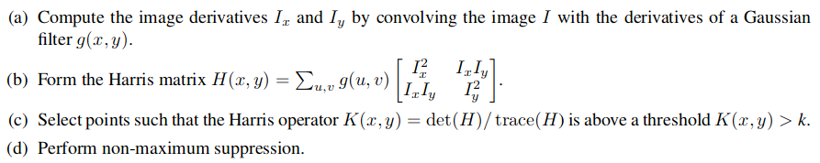

B:

“Invariance” means that the value of the descriptor doesn’t change when the region under consideration undergoes changes in appearance (such as rotation, brightness, etc.). This is useful because we often want to match features between different images of the same scene, where there can be small changes in orientation, lighting, etc.

**6. Image Transforms**

|  |  |  |  |  |  |  |  |  |  |
| --- | --- | --- | --- | --- | --- | --- | --- | --- | --- |
| Number I | 1 | 2 | 3 | 4 | 5 | 6 | 7 | 8 | 9 |
| Histogram: 1/16 * | 4 | 4 | 4 | 1 | 0 | 1 | 0 | 1 | 1 |
| Cum Hist. C(i) : 1/16* | 4 | 8 | 12 | 13 | 13 | 14 | 14 | 15 | 16 |

f(i) = k*C(i) and we round it.

So for 9 elements, we have:

|  |  |  |  |  |  |  |  |  |  |
| --- | --- | --- | --- | --- | --- | --- | --- | --- | --- |
| Number I | 1 | 2 | 3 | 4 | 5 | 6 | 7 | 8 | 9 |
| f1 (i) = 9/16* | 4 | 8 | 12 | 13 | 13 | 14 | 14 | 15 | 16 |
| round(f1(i)) | 2 | 5 | 7 | 7 | 7 | 8 | 8 | 8 | 9 |

For 16 elements, we have:

|  |  |  |  |  |  |  |  |  |  |
| --- | --- | --- | --- | --- | --- | --- | --- | --- | --- |
| Number I | 1 | 2 | 3 | 4 | 5 | 6 | 7 | 8 | 9 |
| f2 (i) = 16/16* | 4 | 8 | 12 | 13 | 13 | 14 | 14 | 15 | 16 |