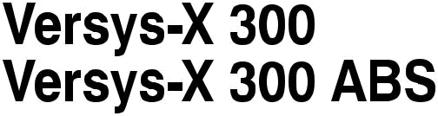




Hướng dẫn tham khảo nhanh
Hướng dẫn tham khảo nhanh này sẽ giúp bạn tìm thông tin bạn đang tìm kiếm.

THÔNG TIN AN TOÀN | j
THÔNG TIN CHUNG | j
LÀM THẾ NÀO ĐỂ TRÊN XE MÁY | j
BẢO TRÌ VÀ ĐIỀU CHỈNH | j
PHỤ LỤC | j
MAINTENANCE RECORD | j

Một Mục lục được đưa vào sau Lời nói đầu.

Bất cứ khi nào bạn nhìn thấy các biểu tượng được hiển thị bên dưới, hãy lưu ý hướng dẫn của họ! Luôn tuân thủ các hoạt động bảo trì và vận hành an toàn.

NGUY HIỂM

NGUY HIỂM cho biết một tình huống nguy hiểm, nếu không tránh được, sẽ dẫn đến tử vong hoặc bồi thẩm đoàn nghiêm trọng.

CẢNH BÁO

CẢNH BÁO cho biết tình huống nguy hiểm, nếu không tránh được, có thể dẫn đến tử vong hoặc thương tích nghiêm trọng.

ĐỂ Ý

THÔNG BÁO được sử dụng để giải quyết các thực tiễn không liên quan đến bồi thẩm đoàn cá nhân.

LƯU Ý
○ LƯU Ý cho biết thông tin có thể giúp hoặc hướng dẫn bạn trong hoạt động hoặc dịch vụ của xe.
WARNING

Engine exhaust, some of its constituents, and certain vehi-cle components contain or emit chemicals known to the State of California to cause cancer and birth defects or other reproduc-tive harm.

NOTICE

THIS PRODUCT HAS BEEN MANUFACTURED FOR USE IN A REASONABLE AND PRUDENT MANNER BY A QUALIFIED OP-ERATOR AND AS A VEHICLE ONLY.

Foreword

Congratulations on your purchase of a new Kawasaki motorcycle. Your new mo-torcycle is the product of Kawasaki’s advanced engineering, exhaustive testing, and continuous striving for superior reliability, safety and performance.

Please read this Owner’s Manual carefully before riding so that you will be thoroughly familiar with the proper operation of your motorcycle’s controls, its fea-tures, capabilities, and limitations. This manual offers many safe riding tips, but its purpose is not to provide instruction in all the techniques and skills required to ride a motorcycle safely. Kawasaki strongly recommends that all operators of this vehi-cle enroll in a motorcycle rider training program to attain awareness of the mental and physical requirements necessary for safe motorcycle operation.

To ensure a long, trouble-free life for your motorcycle, give it the proper care and maintenance described in this manual. For those who would like more detailed in-formation on their Kawasaki Motorcycle, a Service Manual is available for purchase from any authorized Kawasaki motorcycle dealer. The Service Manual contains de-tailed disassembly and maintenance information. Those who plan to do their own work should, of course, be competent mechanics and possess the special tools described in the Service Manual.

Keep this Owner’s Manual aboard your motorcycle at all times so that you can refer to it whenever you need information.

This manual should be considered a permanent part of the motorcycle and should remain with the motorcycle when it is sold.

All rights reserved. No part of this publication may be reproduced without our prior written permission.

This publication includes the latest information available at the time of printing. However, there may be minor differences between the actual product and illustra-tions and text in this manual.

All products are subject to change without prior notice or obligation.

KAWASAKI HEAVY INDUSTRIES, LTD.
Motorcycle & Engine Company

© 2016 Kawasaki Heavy Industries, Ltd. | Dec. 1, 2016. (2)

Emission Control Information

To protect the environment in which we all live, Kawasaki has incorporated crankcase emission (1) and exhaust emission (2) control systems in compliance with applicable regulations of the United States Environmental Protection Agency and California Air Resources Board. Additionally, Kawasaki has incorporated an evaporative emission control system (3) in compliance with applicable regu-lations of the United States Environmental Protection Agency and California Air Resources Board.
1. Crankcase Emission Control System

This system eliminates the release of crankcase vapors into the atmosphere. Instead, the vapors are routed through an oil separator to the intake side of the engine. While the engine is operating, the vapors are drawn into the combustion chamber, where they are burned along with the fuel and air supplied by the fuel injection system.

2. Exhaust Emission Control System
This system reduces the amount of pollutants discharged into the atmosphere by the exhaust of this motorcycle. The fuel, ignition and exhaust systems of this motorcycle have been carefully designed and constructed to ensure an efficient engine with low exhaust pollutant levels. The exhaust system of this model motor-cycle includes a catalytic converter system.

3. Evaporative Emission Control System
The evaporative emission control system for this vehicle consists of low perme-ation fuel hoses and fuel tank.

3. Evaporative Emission Control System (California)
Vapors caused by fuel evaporation in the fuel system are not vented into the atmosphere. Instead, fuel vapors are routed into the running engine to be burned, or stored in a canister when the engine is stopped.

High Altitude Performance Adjustment Information
High Altitude adjustment is not required.
Maintenance and Warranty

Proper maintenance is necessary to ensure that your motorcycle will continue to have low emission levels. This Owner’s Manual contains those maintenance rec-ommendations for your motorcycle. Those items identified by the Periodic Mainte-nance Chart are necessary to ensure compliance with the applicable standards.

As the owner of this motorcycle, you have the responsibility to make sure that the recommended maintenance is carried out according to the instructions in this Owner’s Manual at your own expense.

The Kawasaki Limited Emission Control System Warranty requires that you re-turn your motorcycle to an authorized Kawasaki dealer for remedy under warranty. Please read the warranty carefully, and keep it valid by complying with the owner’s obligations it contains.

You should keep a maintenance record for your motorcycle. To assist you in keeping this record, we have provided space on pages 169 through 172 of this manual where an authorized Kawasaki dealer, or someone equally competent, can record the maintenance. You should also retain copies of maintenance work orders, bills, etc., as verification of this maintenance.
Tampering With Noise Control System Prohibited

Federal law prohibits the following acts or the causing thereof: (1) the removal or rendering inoperative by any person other than for purposes of maintenance, re-pair, or replacement, of any device or element of design incorporated into any new vehicle for the purpose of noise control prior to its sale or delivery to the ultimate purchaser or while it is in use, or (2) the use of the vehicle after such device or element of design has been removed or rendered inoperative by any person.

Among those acts presumed to constitute tampering are the acts listed below:
- Replacement of the original exhaust system or muffler with a component not in compliance with Federal regulations.
- Removal of the muffler(s) or any internal portion of the muffler(s).
- Removal of the air box or air box cover.
- Modifications to the muffler(s) or air intake system by cutting, drilling, or other means if such modifications result in increased noise levels.
TABLE OF CONTENTS

SAFETY INFORMATION .................... | 13 | GENERAL INFORMATION................. | 25
Read Owner’s Manual ..................... | 13 | Specifications ................................... | 25
Training ............................................ | 13 | Serial Number Locations.................. | 29
Daily Checks and Periodic |  | Location of Labels ............................ | 30
Maintenance ................................. | 13 | Location of Parts .............................. | 39
Loading and Accessories |  | Meter Instruments ............................ | 42
Information.................................... | 14 | Indicators ...................................... | 43
Passenger .................................... | 15 | Speedometer/Tachometer ............ | 50
Baggage and Luggage ................. | 16 | Coolant Temperature Gauge ........ | 51
Accessories .................................. | 16 | Display Setting.............................. | 52
Other Load.................................... | 17 | Clock............................................. | 58
If You are Involved in an Accident.... | 17 | Features ....................................... | 59
Safe Operation ................................. | 18 | Keys ................................................. | 62
Carbon Monoxide Hazard............. | 18 | Ignition Switch/Steering Lock ........... | 62
Fueling .......................................... | 19 | Right Handlebar Switches................ | 64
Never Ride with Drugs or Alcohol. | 19 | Left Handlebar Switches .................. | 65
Protective Gear and Clothing ....... | 19 | Fuel .................................................. | 66
Safe Riding Techniques ................ | 20 | Fuel Requirements ....................... | 66
Additional Considerations for High |  | Filling the Tank.............................. | 69
Speed Operation ....................... | 23 | Side Stand ....................................... | 72

Seat.................................................. | 73 | Air Cleaner ....................................... | 113
Rear Carrier/Tie Hooks .................... | 74 | Throttle Control System ................... | 117
Tool Kit/Storage Compartments ....... | 76 | Idle Speed ........................................ | 119
Helmet Hooks................................... | 77 | Clutch ............................................... | 120
Electric Accessory Connectors ........ | 78 | Drive Chain ...................................... | 122
Rear View Mirrors ............................ | 79 | Brakes .............................................. | 126
Event Data Recorder........................ | 80 | Brake Light Switches........................ | 129
HOW TO RIDE THE MOTORCYCLE . | 82 | Suspension System ......................... | 132
Break-In ........................................... | 82 | Front Fork ..................................... | 132
Starting the Engine .......................... | 83 | Rear Shock Absorber ................... | 132
Moving Off........................................ | 85 | Setting Table ................................. | 135
Shifting Gears .................................. | 86 | Wheels ............................................. | 136
Braking ............................................. | 87 | Battery.............................................. | 139
Anti-lock Brake System (ABS) ......... | 89 | Headlight .......................................... | 143
Stopping the Engine......................... | 91 | Fuses ............................................... | 146
Stopping the Motorcycle in an |  | General Lubrication.......................... | 147
Emergency ................................... | 91 | Cleaning ........................................... | 148
Parking ............................................. | 92 | General Precautions ..................... | 148
MAINTENANCE AND ADJUSTMENT | 94 | Where to be Careful ..................... | 152
Daily Checks .................................... | 96 | Washing Your Vehicle ................... | 153
Periodic Maintenance....................... | 99 | APPENDIX .......................................... | 155
Engine Oil ........................................ | 104 | Storage ............................................ | 155
Coolant............................................. | 111 | Troubleshooting Guide..................... | 158

Your Warranty/Owner Satisfaction ... | 163 | MAINTENANCE RECORD ................. | 169
Environmental Protection ................. | 168

SAFETY INFORMATION 13

SAFETY INFORMATION

Read Owner’s Manual

Read this Owner’s Manual care-fully before riding so that you will be thoroughly familiar with the proper op-eration of your motorcycle’s controls, its features, capabilities, and limita-tions. This manual offers many safe riding tips, but its purpose is not to pro-vide instruction in all of the techniques and skills required to ride a motorcycle safely.

Daily Checks and Periodic Maintenance

It is important to keep your motorcy-cle properly maintained and in safe rid-ing condition. Inspect your motorcy-cle before every ride and carry out all periodic maintenance. See the Daily Checks section and the Periodic Main-tenance section in the MAINTENANCE AND ADJUSTMENT chapter for more information.

Training

Kawasaki strongly recommends that all operators of this vehicle complete a suitable motorcycle rider training pro-gram to learn the proper skills and tech-niques necessary for safe motorcycle operation.

WARNING

Failure to perform these checks or to correct a problem before operation may result in serious damage or an accident. Always perform daily checks before op-eration.

- SAFETY INFORMATION

To ensure your motorcycle is ser-viced using the latest servicing infor-mation, it is recommended that an authorized Kawasaki Dealer performs the periodic maintenance as directed in the Owner’s Manual.

If you notice any irregular operat-ing condition, have your motorcycle thoroughly checked at an authorized Kawasaki dealer as soon as possible.
Loading and Accessories Information

WARNING

Incorrect loading, improper in-stallation or use of accessories, or modification of your motorcy-cle may result in an unsafe riding condition. Before you ride the motorcycle, make sure it is not overloaded and that you have followed these instructions.

Maximum Load

Weight of rider, passenger, baggage, and accessories must not exceed 180 kg (397 lb).

With the exception of genuine Kawasaki Parts and Accessories, Kawasaki has no control over the design or application of accessories. In some cases, improper installation
or use of accessories, or motorcycle modification, will void the motorcycle warranty; can negatively affect perfor-mance, stability and safety; and can even be illegal.

In selecting and using accessories, and in loading the motorcycle, you are personally responsible for your own safety and the safety of other persons involved.

NOTE
○Kawasaki Parts and Accessories have been specially designed for use on Kawasaki motorcycles. We strongly recommend that all parts and accessories you add to your motorcycle be genuine Kawasaki components.

Because a motorcycle is sensitive to changes in weight and aerodynamic forces, you must take extreme care in carrying cargo, passengers and/or in
SAFETY INFORMATION 15

fitting additional accessories. The fol-lowing general guidelines have been prepared to assist you in making your determinations.

Passenger

- Never carry more than one passen-ger.

- The passenger should only sit on the pillion.
- Any passenger should be thor-oughly familiar with motorcycle op-eration. The passenger can affect control of the motorcycle by im-proper positioning during cornering and sudden movements. It is im-portant that the passenger sits still while the motorcycle is in motion and not interfere with the operation of the motorcycle. Do not carry ani-mals on your motorcycle.
- SAFETY INFORMATION

- Do not carry passengers unless passenger footpegs are installed. Instruct any passenger before riding to keep his or her feet on the pas-senger footpegs and hold on to the operator or grab rail. Do not carry a passenger unless he or she is tall enough to reach the footpegs with their feet.

Baggage and Luggage

- All baggage should be carried as low as possible to reduce the effect on the motorcycle’s center of grav-ity. Baggage weight should also be distributed equally on both sides of the motorcycle. Avoid carrying bag-gage that extends beyond the rear of the motorcycle.

- Baggage should be securely at-tached. Make sure that the baggage
will not move around while you are riding. Recheck baggage security as often as possible (not while the motorcycle is in motion) and adjust as necessary.

- Do not carry heavy or bulky items on a luggage rack. It is designed for light items, and overloading can affect handling due to changes in weight distribution and aerodynamic forces.

Accessories

- Do not install accessories or carry baggage that impairs the perfor-mance of the motorcycle. Make sure that you have not adversely affected any lighting components, road clearance, banking capability (i.e., lean angle), control operation, wheel travel, front fork movement,
or any other aspects of the motor-cycle’s operation.
- Weight attached to the handlebars or front fork will increase the mass of the steering assembly and can result in an unsafe riding condition.

- Fairings, windshields, backrests, and other large items have the ca-pability of adversely affecting stabil-ity and handling of the motorcycle, not only due to their weight, but also due to the aerodynamic force acting on these surfaces while the motorcycle is in operation. Poorly designed or installed items can re-sult in an unsafe riding condition.

Other Load

- This motorcycle is not intended to be equipped with a sidecar or to be
SAFETY INFORMATION 17

used to tow any trailers or other ve-hicles. Kawasaki does not manu-facture sidecars or trailers for mo-torcycles and cannot predict the ef-fects of such accessories on han-dling or stability, but can only warn that the effects can be adverse and that Kawasaki cannot assume re-sponsibility for the results of such unintended use of the motorcycle.

- Furthermore, any adverse effects on motorcycle components caused by the use of such accessories will not be remedied under warranty.

If You are Involved in an Accident

Make sure of your own safety first. Determine the severity of any injuries and call for emergency assistance if needed. Always follow applicable laws

- SAFETY INFORMATION

and regulations if any other person, ve-hicle or property is involved.
Do not attempt to continue riding without first evaluating your motorcy-cle’s condition. Inspect for fluid leaks, check critical nuts and bolts, and check the handlebars, control levers, brakes, and wheels for damage and proper function. Ride slowly and cautiously

- your motorcycle may have suffered damage that is not immediately appar-ent. Have your motorcycle thoroughly checked at a Kawasaki dealer as soon as possible.

Safe Operation
Carbon Monoxide Hazard

DANGER

Exhaust gas contains carbon monoxide, a colorless, odor-less poisonous gas. Inhaling carbon monoxide can cause serious brain injury or death. DO NOT run the engine in en-closed areas. Operate only in a well-ventilated area.

The following should be carefully ob-
served for safe and effective vehicle

operation.

Fueling

WARNING

Xăng cực kỳ dễ cháy và có thể nổ trong những điều kiện nhất định. Để tránh cháy hoặc nổ, hãy tắt công tắc đánh lửa. Không hút thuốc. Đảm bảo khu vực được thông thoáng và không có nguồn lửa hoặc tia lửa; điều này bao gồm bất kỳ thiết bị nào có đèn phi công.

SAFETY INFORMATION 19

Never Ride with Drugs or Alcohol

Alcohol and drugs impair your judg-ment and reaction time. Never con-sume alcohol or drugs before or while riding motorcycles.

Protective Gear and Clothing

Helmet
Kawasaki strongly recommends both the operator and passenger wear a DOT- approved helmet even if this is not a legal requirement.

- Make sure that your helmet fits cor-rectly and is properly fastened.

- Choose a motorcycle helmet that meets DOT safety standards. Ask your motorcycle dealer to advise you if necessary.
- SAFETY INFORMATION

Eye Protection
Always use eye protection. If your helmet does not have a visor installed, wear goggles.

Gloves
Wear gloves which have suitable protection for your hands, especially against abrasion.

Clothing
Wear the riding wear which have protectors for each parts of the body (chest, shoulders, back, elbows and knees, etc.) as much as possible, or wear protectors for them.

- Always wear a long-sleeved jacket and long trousers which are abrasion resistant and keep you warm.

- Wear clothing that allows freedom of movement.

- Avoid wearing clothes which have loose cuffs or other fastenings which
could interfere with the controls of your motorcycle.
- Wear bright, highly visible clothing.

Boots
Wear proper protective boots that fit properly and do not interfere with gear shifting or braking.

Safe Riding Techniques

Keep Hands on Handlebars
When riding always keep both hands on the handlebars and both feet on the footpegs. Removing your hands from the handlebars or feet from the foot-pegs while riding can be hazardous. If you remove even one hand or foot, you reduce your ability to control the motor-cycle.
Nhìn qua vai của bạn

Trước khi thay đổi làn đường, hãy nhìn qua vai của bạn để đảm bảo cách rõ ràng. Không chỉ dựa vào gương chiếu hậu; bạn có thể đánh giá sai khoảng cách và tốc độ của vehi-cle, hoặc bạn có thể không thấy nó l.

Tăng tốc và phanh trơn tru
In general your actions should be smooth as sudden acceleration, brak-ing or turning may cause loss of control, especially when riding in wet conditions or on loose road surfaces, when the ability to maneuver will be reduced.

Select Correct Gear Speeds
When going up steep slopes, shift to a lower gear so that there is power to spare rather than overloading the en-gine.
SAFETY INFORMATION 21

Use Both Front and Rear Brakes
When applying the brakes, use both the front and rear brakes. Applying only one brake for sudden braking may cause the motorcycle to skid and lose control.

Use Engine Brake
When going down long slopes, help control vehicle speed by closing the throttle so that the engine can act as an auxiliary brake. Use the front and rear brakes for primary braking.

Riding in Wet Conditions
Rely more on the throttle to control vehicle speed and less on the front and rear brakes. The throttle should also be used judiciously to avoid skidding the rear wheel from too rapid acceleration or deceleration.

Braking performance is also reduced in wet conditions. Carefully ride at a
- SAFETY INFORMATION

slow speed and apply the brakes sev-eral times to help dry and restores them to normal operating performance.

Lubricate the drive chain after wet -weather riding to prevent rust and cor-rosion.

Ride Prudently
Riding at the proper speed and avoid-ing unnecessarily fast acceleration are important not only for safety and low fuel consumption but also for long ve-hicle life and quieter operation.

Riding on Rough Roads
Exercise caution, slow down, and grip the fuel tank with the knees for better stability.
Acceleration
When quick acceleration is neces-sary to pass another vehicle, shift to a lower gear to obtain the necessary power.

Downshifting
To avoid engine damage and rear wheel lock-up do not downshift at high rpm.

Avoid Unnecessary Weaving
Unnecessary weaving jeopardizes the safety of both the rider and other motorists.
Additional Considerations for High Speed Operation

WARNING

Xử lý đặc điểm của một chiếc xe máy ở tốc độ cao có thể khác với những gì bạn quen thuộc với tốc độ đường cao tốc hợp pháp. Không thử vận hành tốc độ cao trừ khi bạn đã được đào tạo đầy đủ và có các kỹ năng cần thiết.
Không hoạt động ở tốc độ cao trên đường công cộng.

Brakes
The importance of the brakes, es-pecially during high speed operation, cannot be overemphasized. Check to
SAFETY INFORMATION 23

see that they are correctly adjusted and functioning properly.

Steering
Looseness in the steering can cause loss of control. Check to see that the handlebars turns freely but has no play.

Tires
High speed operation is hard on tires, and good tires are crucial for safe rid-ing. Examine their overall condition, in-flate them to the proper pressure, and check the wheel balance.

Fuel
Have sufficient fuel for the high fuel consumption during high speed opera-tion.

Engine Oil
To avoid engine seizure and resulting loss of control, make sure that the oil level is at the upper level line.
- SAFETY INFORMATION

Coolant
To avoid overheating, check that the coolant level is at the upper level line.

Electrical Equipment
Make sure that the headlight, tail/brake light, turn signals, horn, etc., all work properly.
Miscellaneous
Make sure that all nuts and bolts are tight and that all safety related parts are in good condition.
GENERAL INFORMATION 25

GENERAL INFORMATION

Specifications

PERFORMANCE

Minimum Turning Radius

2.5 m (8.2 ft)

DIMENSIONS

Overall Length

Overall Width

Overall Height

Wheelbase

Road Clearance

2 170 mm (85.43 in.)

860 mm (33.9 in.)

1 390 mm (54.72 in.)

1 450 mm (57.09 in.)

180 mm (7.09 in.)

Curb Mass:

KLE300B

KLE300C

173 kg (381 lb)

175 kg (386 lb)

ENGINE

Type

Displacement

DOHC, 2-cylinder, 4-stroke, liquid-cooled 296 cm³ (18.1 cu in.)

- GENERAL INFORMATION

Bore × Stroke |  | 62.0 × 49.0 mm (2.44 × 1.93 in.)
Compression Ratio |  | 10.6:1
Starting System |  | Electric starter
Cylinder Numbering Method |  | Left to right, 1-2
Firing Order |  | 1-2
Fuel System |  | FI (Fuel Injection)
Ignition System |  | Battery and coil (transistorized ignition)
Ignition Timing |  | 10° BTDC @1 300 r/min (rpm) ∼ 35° BTDC @4 000
(Electronically advanced) |  | r/min (rpm)
Spark Plug: | Type | NGK CR8E
 | Gap | 0.7 ∼ 0.8 mm (0.028 ∼ 0.031 in.)
Lubrication System |  | Forced lubrication (wet sump)
Engine Oil: | Type | API SG, SH, SJ, SL, or SM with JASO MA, MA1 or MA2
 | Viscosity | SAE 10W-40
 | Capacity | 2.4 L (2.5 US qt)
Coolant Capacity |  | 1.5 L (1.6 US qt)

 |  |  | GENERAL INFORMATION 27
TRANSMISSION
Transmission Type |  | 6-speed, constant mesh, return shift
Clutch Type |  | Wet, multi disc
Driving System |  | Chain drive
Primary Reduction Ratio |  | 3.087 | (71/23)
Final Reduction Ratio |  | 3.286 | (46/14)
Overall Drive Ratio |  | 8.694 | (Top gear)
Gear Ratio: | 1st | 2.714 | (38/14)
 | 2nd | 1.789 | (34/19)
 | 3rd | 1.409 | (31/22)
 | 4th | 1.160 | (29/25)
 | 5th | 1.000 | (27/27)
 | 6th | 0.857 | (24/28)
FRAME
Caster |  | 24.3°
Trail |  | 108 mm (4.25 in.)

- GENERAL INFORMATION

Tire Size: | Front | 100/90–19M/C 57S
 | Rear | 130/80–17M/C 65S
Rim Size: | Front | J19 × 2.15
 | Rear | J17M/C × MT3.00
Fuel Tank Capacity |  | 17 | L (4.5 US gal)
Brake Fluid: | Front | DOT3 or 4
 | Rear | DOT4
ELECTRICAL EQUIPMENT
Battery |  | 12 | V 8 Ah (10 HR)
Headlight: | High Beam | 12 | V 60 W
 | Low Beam | 12 | V 55 W
Brake/Tail Light |  | 12 | V 21/5 W

Specifications are subject to change without notice.
GENERAL INFORMATION 29

Vị trí số sê-rI

Số sêri của động cơ và khung được sử dụng để đăng ký xe máy. Chúng là phương tiện duy nhất để xác định máy tính cụ thể của bạn từ những người khác thuộc cùng một kiểu máy. Những số serial này có thể là cần thiết bởi đại lý của bạn khi đặt hàng các bộ phận. Trong trường hợp trộm cắp, các cơ quan điều tra sẽ yêu cầu cả hai số cũng như loại mô hình và bất kỳ tính năng đặc biệt nào của máy tính của bạn có thể giúp họ xác định nó.

Số máy |  |  | Số khung
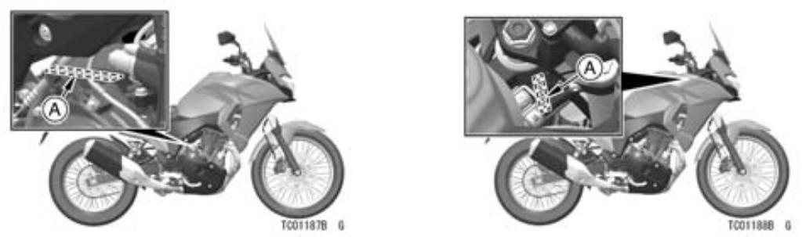

A. Số động cơ A. Số khung

- GENERAL INFORMATION

Vị trí của Nhãn

Tất cả các nhãn cảnh báo trên xe của bạn được lặp lại ở đây. Đọc nhãn trên xe của bạn và hiểu chúng kỹ lưỡng. Chúng chứa thông tin quan trọng cho sự an toàn của bạn và sự an toàn của bất kỳ ai khác có thể làm cho chiếc xe của bạn bị xáo trộn. Do đó, điều quan trọng là tất cả các nhãn cảnh báo đều có trên xe của bạn ở các vị trí được hiển thị. Nếu bất kỳ nhãn nào bị thiếu, hư hỏng hoặc mòn, hãy thay thế từ đại lý Kawasaki của bạn và lắp nó vào đúng vị trí.

NOTE
○The sample warning labels in this section have part numbers to help
you and your dealer obtain the cor-rect replacement.

○Refer to the actual vehicle label for model specific data grayed out in the illustration.
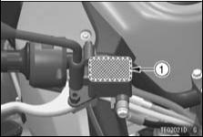

1. Brake Fluid (Front)
GENERAL INFORMATION 31
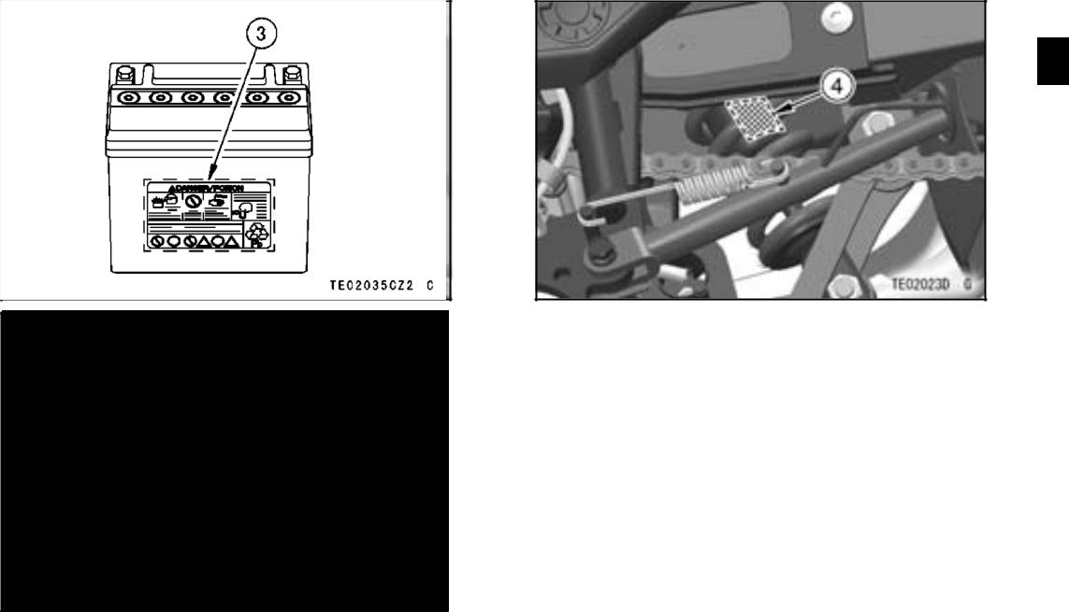

- Brake Fluid (Rear)
- Battery Poison/Danger
- Rear Shock Absorber Warning
- GENERAL INFORMATION
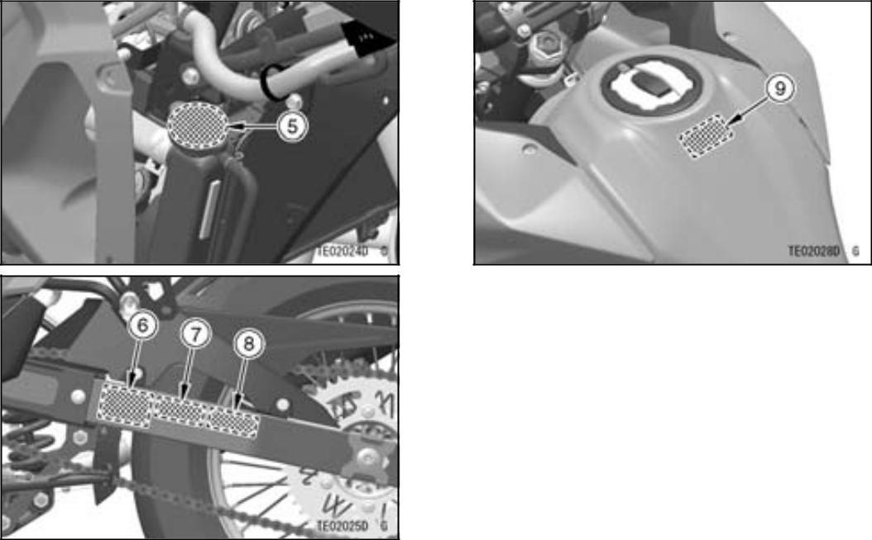

5. Radiator Cap Danger
6. Tire and Load Data
7. Important Drive Chain Information
8. Noise Emission Control Information
*9. Fuel Level

*: only on California model
GENERAL INFORMATION 33
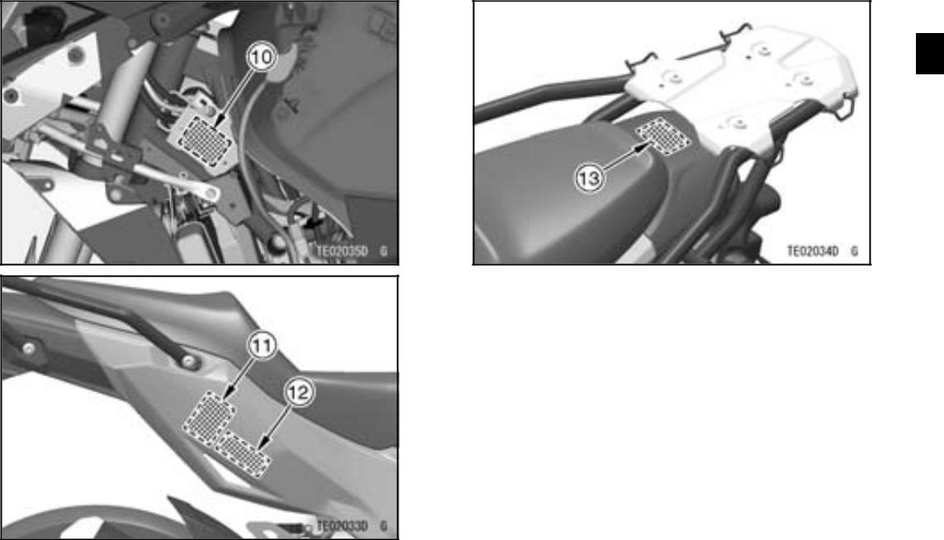

10. Weight and Manufacture
*11. Vacuum Hose Routing Diagram
- Vehicle Emission Control Information
- Rear Carrier Load Limit Warning

*: only on California model
- GENERAL INFORMATION

1) 3)
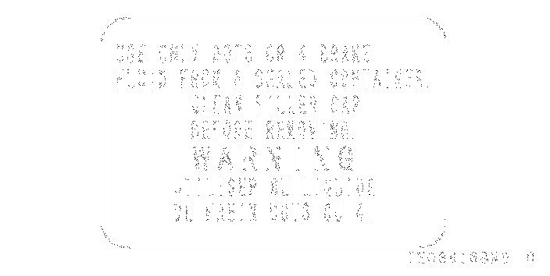
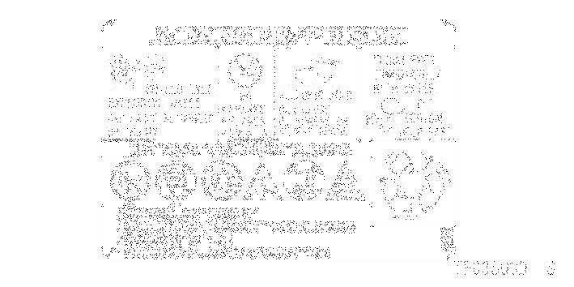

2)
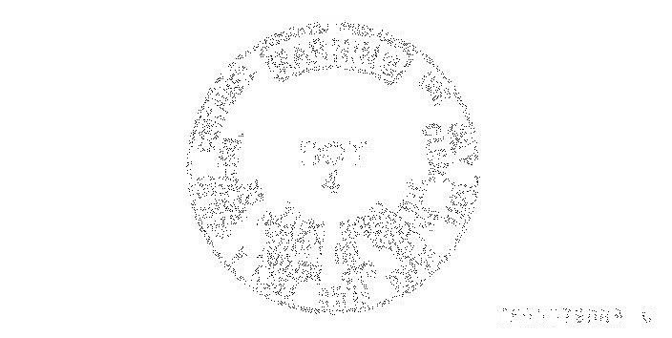
GENERAL INFORMATION 35

4) 5)
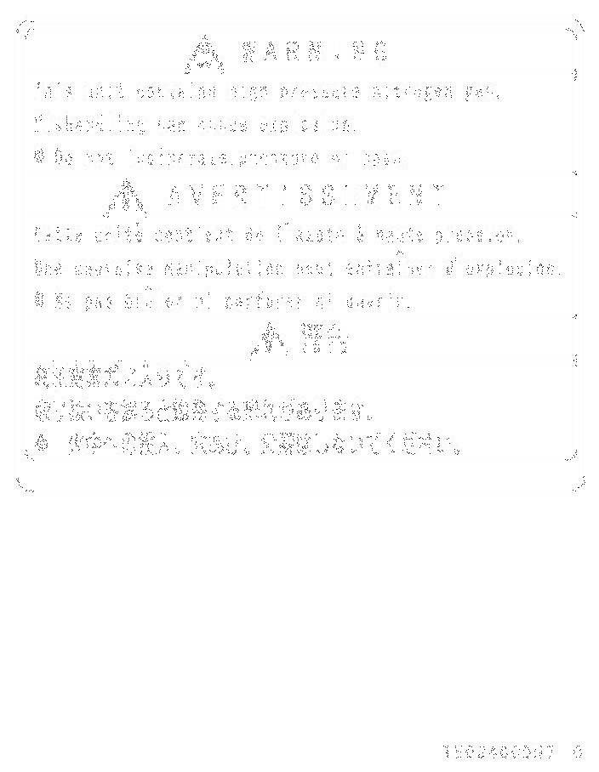
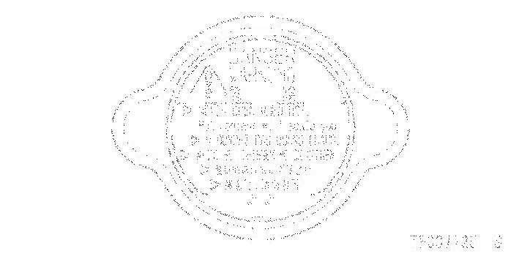

6)
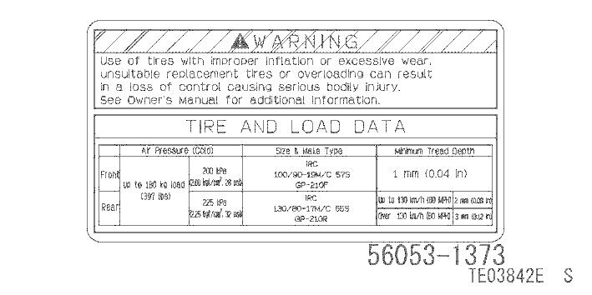
- GENERAL INFORMATION

7) 9) only on California model
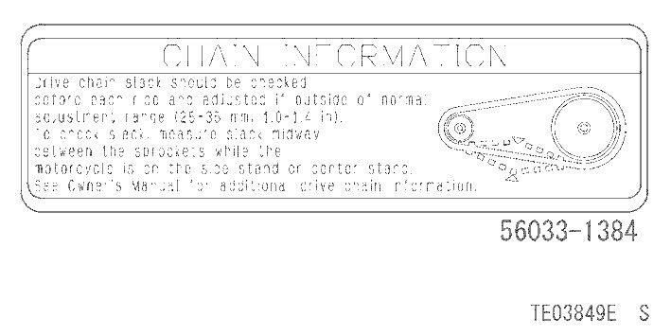
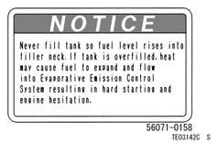

8)
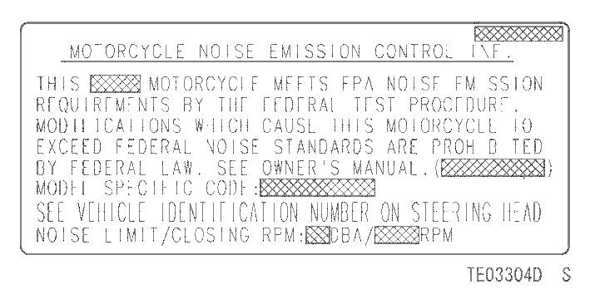

10)
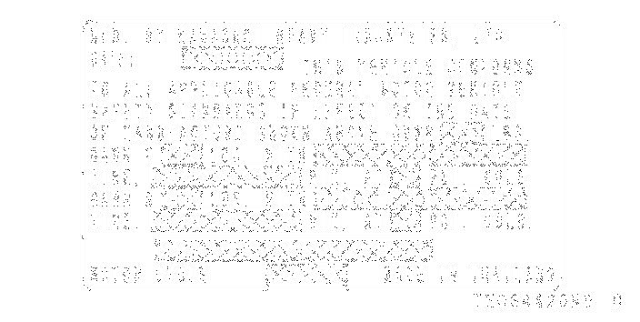
GENERAL INFORMATION 37

11) only on California model 12) only on California model
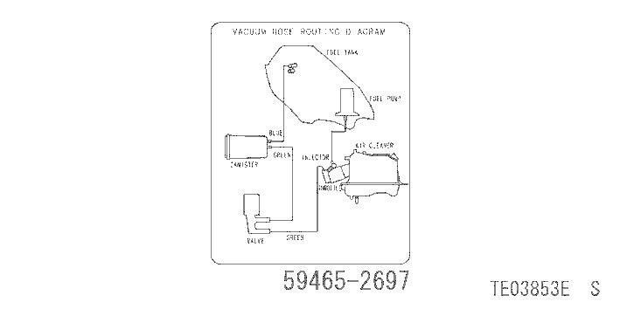
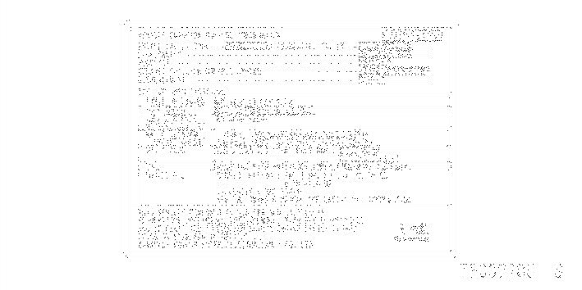

12)
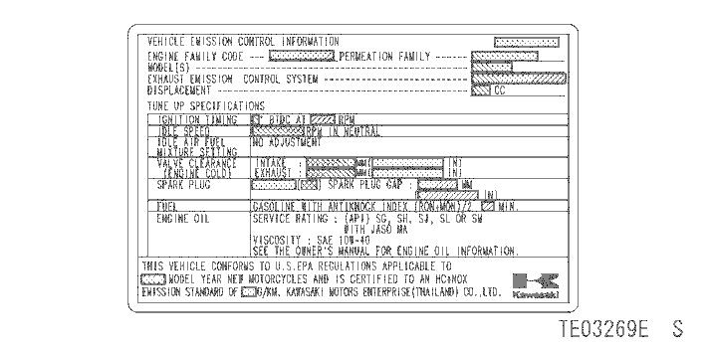
- GENERAL INFORMATION

13)
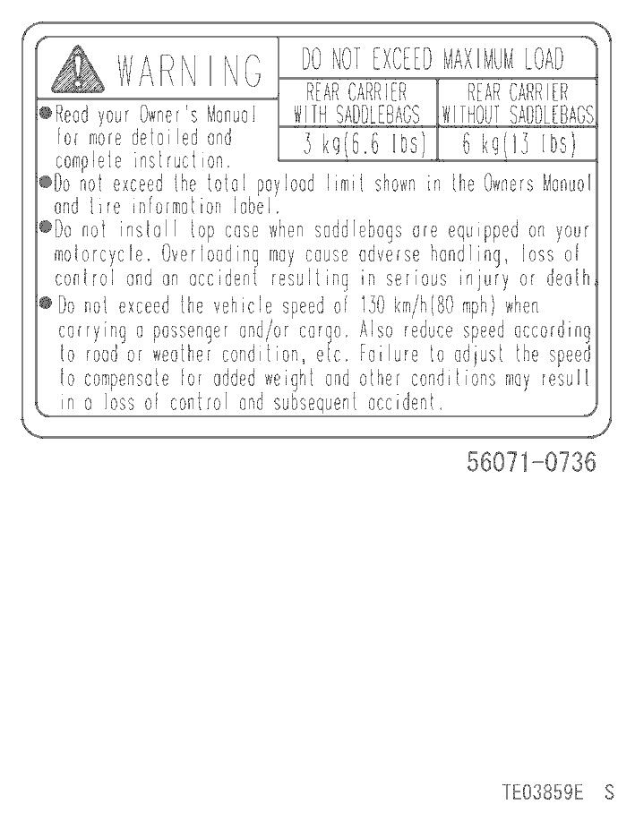
GENERAL INFORMATION 39

Location of Parts
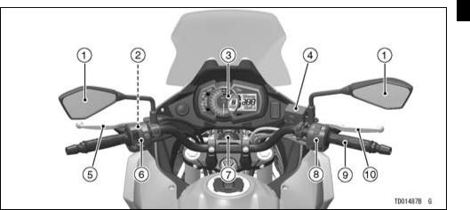

1. | Rear View Mirrors | 6. | Left Handlebar Switches
2. | Starter Lockout Switch | 7. | Ignition Switch/Steering Lock
3. | Meter Instrument | 8. | Right Handlebar Switches
4. | Brake Fluid Reservoir (Front) | 9. | Throttle Grip
5. | Clutch Lever | 10. | Front Brake Lever

- GENERAL INFORMATION
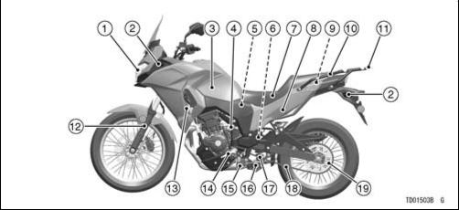

1. | Headlight | 11. | Rear Carrier
2. | Turn Signal Lights | 12. | Front Fork
3. | Fuel Tank | 13. | Radiator
4. | Idle Adjusting Screw | 14. | Shift Pedal
5. | Air Cleaner | 15. | Side Stand Switch
6. | Spring Preload Adjuster | 16. | Side Stand
7. | Seat | 17. | Rear Shock Absorber
8. | Seat Lock | 18. | Drive Chain
9. | Tool Kit | 19. | Chain Adjuster
10. | Grab Rail

GENERAL INFORMATION 41
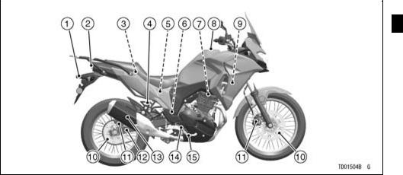

1. | License Plate Light | 6. | Rear Brake Light | 11. | Brake Calipers
2. | Tail/Brake Light | 7. | Switch | 12. | Swingarm
3. | Fuse Box | 7. | Spark Plugs | 13. | Muffler
4. | Brake Fluid Reservoir | 8. | Fuel Tank Cap | 14. | Oil Level Inspection
5. | (Rear) | 9. | Coolant Reserve Tank | 15. | Window
5. | Battery | 10. | Brake Discs | 15. | Brake Pedal

- GENERAL INFORMATION

Meter Instruments

- Lower Meter Button
- Upper Meter Button
- Tachometer
- Multifunction Meter
- Gear Position Indicator
- Fuel Gauge
- Multifunction Display
  - Odometer
  - Trip Meter A/B
- Speedometer
- Economical Riding Indicator
- Multifunction Display
  - Current Mileage/Average Mileage/Cruising Range

- Coolant Temperature Gauge
- Clock
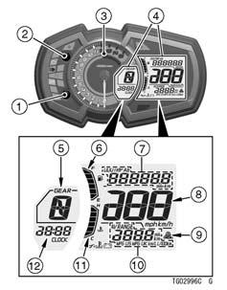

When the ignition switch is turned on, all LCD functions are shown for a few seconds, then the multifunction meter turns to operational mode.
GENERAL INFORMATION 43

Indicators

1. ABS Indicator (Yellow) (ABS model)
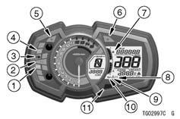
2. Neutral Indicator (Green)
3. High Beam Indicator (Blue)
4. Engine Warning Indicator (Yellow)
5. Left Turn Signal Indicator (Green)
6. Right Turn Signal Indicator (Green)
7. Fuel Level Warning Indicator

8. Battery Warning Indicator

9. Coolant Temperature Warning Indicator
10. Oil Pressure Warning Indicator

11. Warning Indicator (Red)
- GENERAL INFORMATION

Indicator Initial Operation
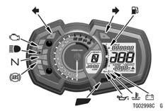

When the ignition switch is turned on, all indicators go on/off as shown in the table. If any indicator does not operate as shown, have it checked by an autho-rized Kawasaki dealer.

ON |  |  |  |  | Indicators
□ | □ | □
□ | □ | ■
□ | ■ | ■
■ | ■ | ■


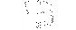

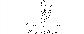



ON: When ignition switch is turned on.

: After a few seconds

: When engine starts.

- : Goes on. ■ : Goes off.

* :  goes off shorty after the motorcycle starts moving.
GENERAL INFORMATION 45

When Warning Indicators Go On
or Blink

When warning indicators appear, there could be a problem with vehicle function.
Follow actions in the table after stopping the vehicle in a safe place.

*: The numbers in this column corresponds to reference numbers on page 43.

*No. |  | Indi- |  | Status | Actions
*No. | cators |  |  | Status | Actions
1 |  |  |  | ON*¹ | The ABS has malfunctioned. ABS will not work but
1 |  |  |  | ON*¹ | conventional brakes function. Have the ABS checked by
 |  |  |  |  | an authorized Kawasaki dealer.
4 |  |  |  | ON | The DFI system has malfunctioned. Have it checked by
4 |  |  |  | ON | an authorized Kawasaki dealer.
 |  |  |  |  | These indicators go on if the battery voltage is less than
11 |  |  |  |  | 11.0 V or more than 16.0 V. If the voltage is less than 11.0
11 |  |  |  | ON | V, charge the battery. If the voltage is more than 16.0
8 |  |  |  | ON | V, or if indicators still go on after charging the battery,
 |  |  |  |  | have the battery and/or charging system checked by an
 |  |  |  |  | authorized Kawasaki dealer.

- GENERAL INFORMATION

*No. |  | Indi- |  | Status | Actions
*No. | cators |  |  | Status | Actions
 |  |  |  |  | These indicators go on whenever the oil pressure is
 |  |  |  |  | dangerously low or the ignition switch is in the “ON”
11 |  |  |  |  | position with the engine not running. If these indicators
11 |  |  |  | ON | go on when the engine speed is above idle, stop the
10 |  |  |  | ON | engine immediately and check the engine oil level. If
 |  |  |  |  | the amount of engine oil is insufficient, add engine oil.
 |  |  |  |  | If the oil level is good, have the engine checked by an
 |  |  |  |  | authorized Kawasaki dealer.
 |  |  |  |  | These indicators go on whenever the coolant temperature
11 |  |  |  | ON | rises to about 115°C (239°F). Refer to the Coolant
9 |  |  |  | ON | Temperature Gauge section for more information and
 |  |  |  |  | follow instructions in it.
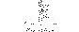
 |  |  |  |  | GENERAL INFORMATION 47
*No. |  | Indi- |  | Status | Actions
*No. | cators |  |  | Status | Actions
 |  |  |  |  | The lowest segment and fuel level warning indicator
 |  |  |  |  | blink in the multifunction display when approximately 3.0
 |  |  |  | Blink | L (0.79 US gal) of usable fuel remains. Refuel at the
 |  |  |  | Blink | earliest opportunity. If the vehicle is on the side stand, the
7 |  |  |  |  | warning indicator cannot estimate the amount of fuel in
7 |  |  |  |  | the tank. Stand the vehicle upright to check the fuel level.
 |  |  |  | Blink (including | The fuel level warning system has malfunctioned. Have
 |  |  |  | Blink (including | the fuel level warning system checked by an authorized
 |  |  |  | all segments) | Kawasaki dealer.
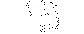

- GENERAL INFORMATION

*1: ABS indicator may go on:
○After continuous riding on a rough road.

○When the engine is started with the stand raised and the transmission engaged, and the rear wheel turns.
○When accelerating so abruptly that the front wheel leaves the ground.
○When the ABS has been subjected to strong electrical interference.
○When tire pressure is abnormal. Adjust tire pressure.
○When a tire different in size from the standard size is being used. Replace with standard size.
○When the wheel is deformed. Replace the wheel.

If this happens, first turn the ignition switch off, and then back on, and ride the motorcycle at 5 km/h (3.1 mph) or more. The ABS indicator should then go off. If it does not, have the ABS checked by an authorized Kawasaki dealer.
 |  |  |  | GENERAL INFORMATION 49
Other Indicators
*No. | Indicators |  |  | Status
2 |  |  |  | When the transmission is in neutral, this indicator goes on.
3 |  |  |  | When the headlight is on high beam, this indicator goes on.
5 |  |  |  | When the turn signal switch is pushed to the left, this indicator blinks.
6 |  |  |  | When the turn signal switch is pushed to the right, this indicator blinks.

- GENERAL INFORMATION

Speedometer/Tachometer
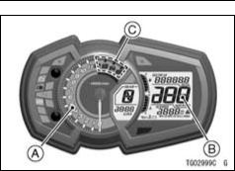

- Tachometer
- Speedometer
- Red Zone

Speedometer
The speedometer is digital and can be set for km/h or mph.

The unit setting can be changed ac-cording to local regulations. Make sure
the unit setting (km/h or mph) is cor-rectly displayed before riding.
Refer to the Unit Setting in the Dis-play Setting section.

Tachometer
The tachometer shows the engine speed in revolutions per minute (r/min, rpm).

NOTICE

Engine speed should not be al-lowed to enter the red zone; op-eration in the red zone will over-stress the engine and may cause serious engine damage.

When the ignition switch is turned on, the tachometer needle momentar-ily sweeps from the minimum to the maximum reading, then back the mini-mum reading to check its operation. If
the tachometer does not operate cor-rectly, have it checked by an authorized Kawasaki dealer.

Coolant Temperature Gauge

The coolant temperature gauge in-dicates temperature of the engine coolant by the number of segments displayed.
GENERAL INFORMATION 51
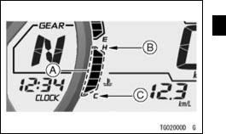

- Segments
- H (Hot)
- C (Cold)

If the coolant temperature rises to above 115°C (239°F), all segments go on, and the warning indicator and coolant temperature warning indicator go on. This warns the operator that the coolant temperature is high. Stop the engine and check the coolant level in the reserve tank after the engine cools down. If the amount of the coolant is
- GENERAL INFORMATION

insufficient, add coolant to the reserve tank. If the coolant level is good, have the cooling system checked by an au-thorized Kawasaki dealer.
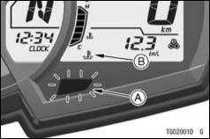

A. Warning Indicator (Red)
B. Coolant Temperature Warning Indicator
NOTICE

Stop the engine if the warning indicator and coolant temper-ature warning indicator go on. Prolonged engine operation will result in severe engine damage from overheating.

Display Setting

Multifunction Display

WARNING

For safety, do not operate the meter buttons while riding the motorcycle.

- Push the upper meter button or lower meter button to select the display
modes. The display modes can be shifted in the following order.
GENERAL INFORMATION 53

NOTE
○The multifunction display is dis-played in the unit depending on the unit mode setting.

- GENERAL INFORMATION
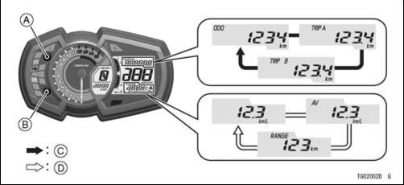

A. Upper Meter Button
B. Lower Meter Button

C. Flow when pushing upper meter button D. Flow when pushing lower meter button

Odometer
The odometer shows the total dis-tance. This meter cannot be reset.
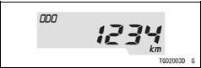

NOTE
○When the figures come to 999999, the display is stopped and locked.

Trip Meter
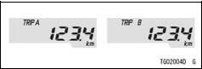
GENERAL INFORMATION 55

- Push the upper meter button and hold it in until the display turns to 0.0.

NOTE
○When the trip meter reaches 9999.9 while riding, the meter resets to 0.0 and continues counting.

Current Mileage
The current mileage display is re-newed every 4 seconds.
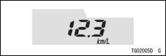

To reset the trip meter:

- Push the upper meter button to select the trip meter A or B.

NOTE
○When the ignition switch is turned on, the numerical value shows “– –.–.” After a few seconds of riding the nu-merical value is displayed.

- GENERAL INFORMATION

Average Mileage
This display shows the average fuel consumption from the reset. The aver-age mileage display is renewed every 5 seconds.
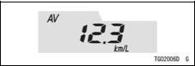

To reset the average mileage:

- Push the lower meter button and hold it in until the average mileage values resets to “– –. –.”

NOTE
○When the battery is disconnected, the average mileage resets to “– –.–.” ○After resetting the average mileage, the numerical value is not displayed until the vehicle has travelled 100 m

(328 ft).
Cruising Range
This display shows the cruising range by numerical value, and indicates the cruising range from the remaining fuel in the fuel tank. This cruising range display is renewed every 20 seconds.
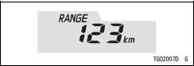

NOTE
○The cruising range value is no longer shown if the fuel level gets too low after the fuel level warning indicator starts blinking.

○To recover the cruising range value display add fuel to at least the level needed for the fuel level warning in-dicators to stop blinking. The cruis-ing range may still be displayed with

a low fuel level, but it will not be ac-curate until enough fuel is added to stop the fuel level warning indicator from blinking.

Unit Setting
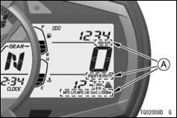

A. Units
GENERAL INFORMATION 57

- Push the lower meter button while pushing the upper meter button to se-lect the meter display units. The dis-play units can be shifted in the follow-ing order.
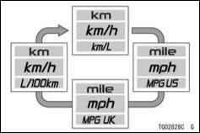

- Display the odometer in the multi-function display.

- GENERAL INFORMATION

Clock

To adjust the clock:

- Push the upper and lower meter but-tons and hold them until both the hour and minute displays blink.

- Push the lower meter button and hold it until “12h” or “24h” is appeared on the display.

- Push the upper meter button to select “12h” or “24h.”

- Push the lower meter button to select the hour or minute digits.
- Push the upper meter button to ad-just the hour or minute digits.

- To finish the clock adjustment, push the upper meter button when both the hour and minute digits blink.
A. Flow when pushing and holding upper and lower meter buttons
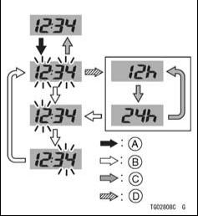
B. Flow when pushing lower meter button

C. Flow when pushing upper meter button

D. Flow when pushing and holding lower
meter button

NOTE
○When the battery is disconnected, the clock is reset to 1:00 (“24h” dis-play: 13:00) and starts working again when the battery is connected.

Features

Economical Riding Indicator
When riding the motorcycle effi-ciently, the economical riding indicator appears on the multifunction meter to indicate favorable fuel consumption. Monitoring the economical riding indi-cator can help the rider maximize fuel efficiency.
GENERAL INFORMATION 59
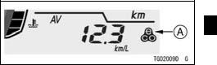

A. Economical Riding Indicator

WARNING

Failing to properly observe the road ahead increases the chance of an accident resulting in se-vere injury or death. Do not con-centrate on the economical rid-ing indicator by taking your eyes off the road; observe using pe-ripheral vision.

Fuel Gauge

The fuel in the fuel tank is shown by
the number of segments displayed.

- GENERAL INFORMATION
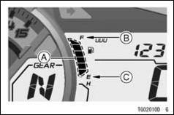

- Segments
- F (Full)
- E (Empty)

NOTE
○When the fuel tank is full, all the seg-ments are displayed. As the fuel level in the tank goes down, the seg-ments disappear one by one from F (full) to E (empty).
○When the fuel level warning indicator and bottom segment blink, refer to the “When Warning Indicators Go On or Blink” of Indicators in this chapter.

Gear Position Indicator
This display shows the correspond-ing gear position when the transmis-sion is shifted. As the transmission is shifted, the corresponding gear posi-tion (1st ∼ 6th) is shown in this display. When the transmission is in neutral, “N” is displayed, and the neutral indicator goes on.
- When the transmission is in 1st gear, “1” is displayed.

- When the transmission is in 2nd gear, “2” is displayed.

- When the transmission is in 3rd gear, “3” is displayed.

- When the transmission is in 4th gear, “4” is displayed.

- When the transmission is in 5th gear, “5” is displayed.

- When the transmission is in 6th gear, “6” is displayed.

GENERAL INFORMATION 61
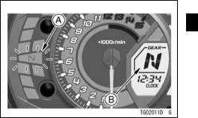

A. Neutral Indicator (Green)
B. Gear Position Indicator

NOTE
○If the gear position display in the mul-tifunction meter blinks “-,” the trans-mission is not properly shifted to 1st. Be sure to shift the transmission.

- GENERAL INFORMATION

Keys

You will need the key number or spare key to have a duplicate made.
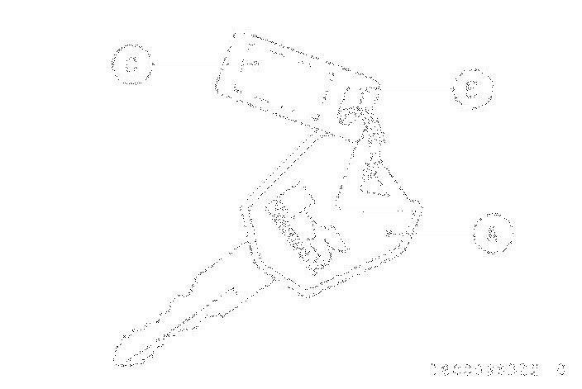
Contact your Kawasaki dealer to pur-chase additional spare keys.

Ignition Switch/Steering Lock

This is a four-position, key-operated switch.

The key can be removed when it is in the “OFF” or “LOCK” position.
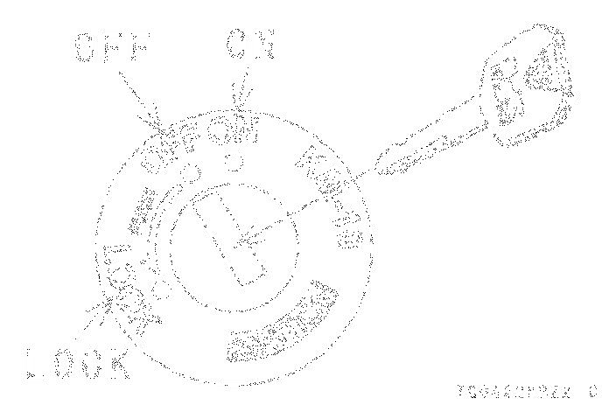

A. Ignition Key
B. Key Number Tag

C. Key Number

If you lose all keys and the key num-ber, you will need to replace the ignition switch and all other locks operated by that key.

 | • Engine can be started.
ON | • _{be}^{All} _{used.}^{electrical equipment can}
 | • Key cannot be removed.
 | • Engine off.
OFF | • Electrical equipment is off.
 | • Key can be removed.
 | • Steering locked.
LOCK | • Engine off.
 | • Electrical equipment is off.
 | • Key can be removed.

For Locking:
- Turn the handlebars fully to the left.
- Push the key down in the “OFF” po-sition and turn it to “LOCK.”
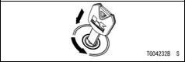
GENERAL INFORMATION 63

WARNING

Turning the ignition switch to the “OFF” position while riding the motorcycle shuts down the entire electrical system (head-light, brake light, turn signal light, etc.) and the engine will stop, which could cause an ac-cident resulting in severe injury or death. Never operate the ignition switch while riding the motorcycle; only operate it when the motorcycle is at a standstill.

NOTE
○The tail, city and license plate lights are on whenever the ignition key is in the “ON” position. The headlight goes on when the starter button is released after starting the engine.

○Do not leave the ignition switch at the “ON” position for an extended time
- GENERAL INFORMATION

with the engine stopped, or the bat-tery may become totally discharged.

○Do not leave the hazard lights switched on for a long time with-out the engine running or the battery will become discharged.

Right Handlebar Switches
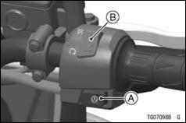

A. Starter Button
B. Engine Stop Switch
Starter Button
Refer to the Starting the Engine section in the HOW TO RIDE THE MOTORCYCLE chapter for starting instructions.

Engine Stop Switch
To stop the engine in an emergency, move the engine stop switch to the
 position.

Ordinarily, the engine stop switch

must be in the  position for the motorcycle to operate.

NOTE
○Ordinarily, the ignition switch should be used to stop the engine.

○Although the engine stop switch stops the engine, it does not turn off all the electrical circuits and eventu-ally the battery will be discharged.
Left Handlebar Switches
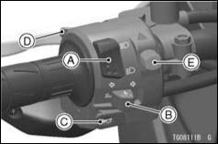

A. Dimmer Switch
B. Turn Signal Switch
C. Horn Button
D. Passing Button
E. Hazard Switch

Dimmer Switch
High or low beam can be selected with the dimmer switch.

High beam... (High beam indica-tor: see Meter Instruments section)
GENERAL INFORMATION 65

Low beam...

NOTE
○Do not allow anything to cover the headlight lens when the headlight is on. If covered, heat can build up in the headlight lens causing lens dis-coloration or melting, as well as dam-age to the item covering the lens.

Turn Signal Switch
When the turn signal switch is turned

to the left () or right () the cor-responding turn signal lights and turn signal indicator blinks. To cancel the turn signal, push the switch in.

Horn Button 
When the horn button is pushed, the horn sounds.
- GENERAL INFORMATION

Passing Button 
The high beam turns on only while the passing button is pushed.

Hazard Switch 
Push in the hazard switch with the ignition switch in the “ON” position. All the turn signal lights and turn signal indicators will blink.

NOTE
○Be careful not to use the hazard lights for an extended period of time, otherwise the battery may become totally discharged.
Fuel

WARNING

Gasoline is extremely flammable and can be explosive under cer-tain conditions, creating the po-tential for serious burns. Turn the ignition switch off.
Do not smoke.

Make sure the area is well ven-tilated and free from any source of flame or sparks; this includes any appliance with a pilot light.

Fuel Requirements

Use clean, flesh unleaded gasoline with the following conditions.
- Antiknock Index of 87 or more
- Up to 10% of ethanol contained
NOTICE

Use only unleaded gasoline. Never use leaded gasoline. Leaded gasoline significantly reduces the capability of the cat-alytic converter in the exhaust system.

NOTICE

Use minimum of 87 octane gaso-line only to prevent severe en-gine damage.

GENERAL INFORMATION 67

NOTICE

If engine “knocking” or “ping-ing”occurs, use a different brand of gasoline of a higher octane rating. If this condition is allowed to continue it can lead to severe engine damage. Gaso-line quality is important. Fuels of low quality or not meeting standard industry specifications may result in unsatisfactory per-formance. Operating problems that result from the use of poor quality or nonrecommended fuel may not be covered under your warranty.

- GENERAL INFORMATION

NOTICE

Avoid using blends of unleaded gasoline and methanol (wood al-cohol) whenever possible, and never use “gasohol” containing more than 5% methanol.

Fuel system damage and perfor-mance problems may result.

NOTE
○Other oxygenates approved for use in unleaded gasoline include TAME (up to 16.7%) and ETBE (up to 17.2%). Fuel containing these oxy-genates can also be used in your Kawasaki.
NOTICE

Never use gasoline with an oc-tane rating lower than the min-imum specified by Kawasaki. Never use “gasohol” with more than 10% ethanol, or more than 5% methanol.

Gasoline containing methanol must also be blended with cosol-vents and corrosion inhibitors.

Certain ingredients of gasoline may cause paint fading or dam-age. Be extra careful not to spill gasoline or gasoline oxygenate blends during refueling.

When not operating your Kawasaki for 30 to 60 days, mix a fuel stabilizer (such as STA-BIL) with the gasoline in the fuel tank. Fuel stabilizer additives inhibit oxidation of the fuel which mini-mizes gummy deposits.

Fuel Type and Octane Rating
Use clean, fresh unleaded gasoline. The Antiknock Index is posted on ser-vice station pumps. The octane rating of a gasoline is a measure of its resis-tance to detonation or “knocking.” The Antiknock Index is an average of the Research Octane Number (RON) and the Motor Octane Number (MON) as

shown in the table.

Fuel Type | Unleaded Gasoline
Ethanol Content | E10 or less
Antiknock Index | 87 or more
GENERAL INFORMATION 69

NOTICE

Do not use any fuel that con-tains more ethanol or other oxy-genates than specified for E10 fuel* in this vehicle. Damage to the engine and fuel system, or engine starting and/or per-formance problems may result from the use of improper fuel.

*E10 means fuel containing up to 10% ethanol.

Filling the Tank

Avoid filling the tank in the rain or where heavy dust is blowing so that the fuel does not get contaminated.
- GENERAL INFORMATION

WARNING

Gasoline is extremely flammable and can be explosive under cer-tain conditions, creating the po-tential for serious burns. Turn the ignition switch off. Do not smoke.

Make sure the area is well ven-tilated and free from any source of flame or sparks; this includes any appliance with a pilot light. Never fill the tank completely to the top.

If the tank is filled completely to the top, heat may cause the fuel to expand and overflow through the vents in the tank cap.

After refueling, make sure the tank cap is closed securely. If gasoline is spilled on the fuel tank, wipe it off immediately.

NOTICE

California model only: Never fill the tank so the fuel level rises into the filler neck. If the tank is overfilled, heat may cause the fuel to expand and flow into the Evaporative Emission Con-trol System resulting in hard starting, engine hesitation and non- compliance with the emis-sion regulation.

- Lift the key hole cover.

- Insert the ignition key into the fuel tank cap.

- Turn the key clockwise while pushing down the fuel tank cap.
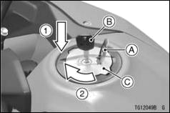
A. Key Hole Cover
B. Ignition Key

C. Fuel Tank Cap
- Open the fuel tank cap.

- Add fuel.
GENERAL INFORMATION 71
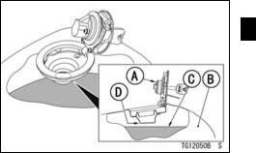

A. Tank Cap
B. Fuel Tank
C. Top Level
D. Bottom of Filler Neck (Maximum Fuel
Level)

NOTE
○Do not exceed the maximum fuel level as shown.

- Push the fuel tank cap down into place with the key inserted.
- GENERAL INFORMATION

- The key can be removed by turning counterclockwise to the original po-sition.

- Close the key hole cover.

NOTICE

Never fill the tank completely to the top.
If the tank is filled completely to the top, heat may cause the fuel to expand and overflow through the vents in the tank cap.

After refueling, make sure the tank cap is closed securely.
If gasoline is spilled on the fuel tank, wipe it off immediately.

NOTE
○The fuel tank cap cannot be closed without the key inserted, and the key
cannot be removed unless the cap is locked properly.

○Do not push on the key to close the cap, or the cap cannot be locked.

Side Stand

Always kick the stand fully up before moving the motorcycle. The engine will stop automatically if the motorcycle is in gear and the clutch is released with the side stand down.

NOTE
○When using the side stand, turn the handlebars to the left.
○Make sure the side stand is down se-curely before leaving the motorcycle.

○Do not sit on the motorcycle while it is on its side stand.
Seat

The seat can be removed using the ignition key.
Seat Removal

- Insert_{lock.} the ignition key into the seat

- Lift the rear part of the seat while turning the key clockwise.
- Remove the seat backward.
- Remove the ignition key.
GENERAL INFORMATION 73
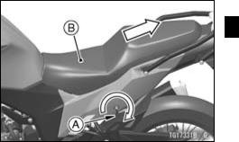

A. Ignition Key
B. Seat

Seat Installation

- Insert the hooks of the seat under the frame.

- Insert the projection at the rear part of the seat into the latch hole on the frame.

- Push down the rear part of the seat until the lock clicks.
- GENERAL INFORMATION
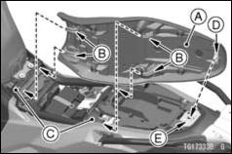

- Seat
- Hooks
- Frames
- Projection
- Latch Hole

- Pull up the front and rear ends of the seat to make sure they are securely locked.
Rear Carrier/Tie Hooks

This motorcycle is equipped with the rear carrier. The tie hooks are located under the rear carrier.
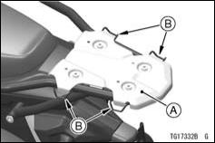

A. Rear Carrier
B. Tie Hooks
GENERAL INFORMATION 75

WARNING

Overloading the motorcycle with cargo and/or passengers, and/or not bal-ancing the weight of items carried on the rear carrier may cause adverse handling, loss of control and an accident resulting in serious injury or death. Do not carry loads of more than 6 kg (13 lb) on the rear carrier. Do not exceed the total payload limit of 180 kg (397 lb), including rider, pas-senger, baggage, and accessories. Do not exceed the vehicle speed of 130 km/h (80 mph) when carrying a passenger and/or cargo. Also reduce speed according to road or weather condition, etc. Failure to adjust the speed to compensate for added weight and other conditions may result in a loss of control and subsequent accident.

WARNING

During installing the saddle-
bags, follow precautions below.

- Do not carry loads of more than 3 kg (6.6 lb) on the rear carrier.

- Do not install the top case.

- GENERAL INFORMATION

Tool Kit/Storage
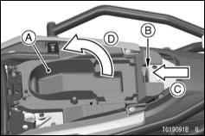
Compartments

The tool kit and storage compart-ments are located under the seat.

Keep the tool kit in the storage compartment under the compartment cover.

- Push the tab to open the compart-ment cover.

A. Compartment Cover (Storage
Compartment)
B. Tab
C. Push
D. Open
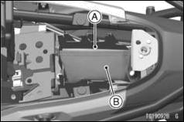
A. Storage Compartment
B. Tool Kit

Helmet Hooks

The Helmets can be secured to the motorcycle using the helmet hooks lo-cated under the seat.
GENERAL INFORMATION 77
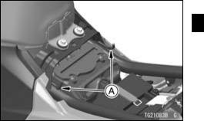

A. Helmet Hooks

WARNING

Riding with helmets attached to the hooks could cause an ac-cident by distracting the oper-ator or interfering with normal vehicle operation. Do not ride the motorcycle with helmets at-tached to the hooks.

- GENERAL INFORMATION

Electric Accessory Connectors

The electric power of the battery can be used through the electric accessory connectors.

- When using the electric accessory connectors, the electric accessory connection to the connectors should be done by an authorized Kawasaki dealer.

NOTICE

Do not connect the accessories other than specified acces-sories.

Accessory Connector

Location | Purpose
Lower of Headlight | Fog Lights

Maximum Current: 1.3 A

A. Accessory Connector (for Fog Lights) Accessory Connectors
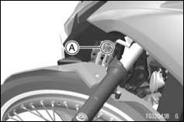
Location Purpose ^{Polar-} Wire Color ity

Back of | Acces- | (+) | White/Black
Back of | sory |  | Black/Yel-
Headlight | sory | (–) | Black/Yel-
 | Socket | (–) | low

Maximum Current: 1.2 A

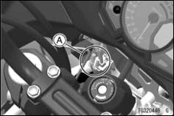
A. Accessory Connectors (for Accessory
Socket)
GENERAL INFORMATION 79

NOTICE

The vehicle has electrical acces-sory circuit (5 A fuse) for the fog lights and accessory socket. Al-ways install a fuse 5 A or less for the circuit. Do not connect more than 56 W of total load to the ve-hicle’s electrical system or the battery may become discharge, even with the engine running.

Rear View Mirrors

Rear View Mirror Adjustment

- Adjust the rear view mirror by slightly moving only the mirror portion of the assembly.

- If the rear visibility cannot be assured by moving the mirror, slide the rubber boot up, and loosen the locknut and turn the stay by hand.

- GENERAL INFORMATION

NOTE
○The locknut has left hand threads.
- Tighten the locknut securely.
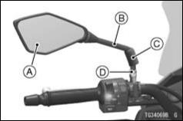

A. Rear View Mirror
- Stay
- Rubber Boot
- Locknut
Event Data Recorder

In common with many other ve-hicle manufacturers, Kawasaki has equipped this motorcycle with an event data recorder (EDR). The purpose of this device is to record data that assists with understanding of how some of the vehicle’s systems were performing during a short period of time immedi-ately before and during an accident or similar event involving minor damage. Due to accident variables, all vehicle performance data may not be stored on the EDR.

NOTE
○During normal riding, data is recorded but not saved unless the vehicle is involved in an accident event.

○At no time other than in the event of an accident or similar event involving
minor damage is it possible for EDR data to be stored for retrieval.

○Depending on the type of accident event, it is possible that the EDR may not record some or all of the data, or it may not record if the EDR is damaged.

○This device does not collect or store personal data or information (e.g. name, gender, age).

The EDR in this vehicle is designed to record only data that is relevant to the vehicle’s running condition at the time of an accident like, but not limited to,
GENERAL INFORMATION 81

vehicle speed, engine crankshaft rota-tional speed and throttle opening, etc.

This data can help provide a better understanding for both the rider and the manufacturer of how the vehicle was performing at the time of an accident or near accident-like situation.

To access information on an EDR, special equipment and access to the EDR is required. Kawasaki will not share EDR information without obtain-ing your consent, unless required by government authorities, or acting pur-suant to lawful authority.
- HOW TO RIDE THE MOTORCYCLE
HOW TO RIDE THE MOTORCYCLE

NOTICE

This vehicle is designed only for on - road riding including un-paved public roads. It is not designed for use off-road.

Break-In

The first 1 600 km (1 000 mile) that the motorcycle is ridden is designated as the break-in period. If the motorcy-cle is not used carefully during this pe-riod, you may very well end up with a “broken down” instead of a “broken in” motorcycle after a few thousand kilo-meters.

The following rules should be ob-served during the break-in period.

- The table shows maximum recom-mended engine speed during the break-in period.

Distance traveled | Maximum engine
Distance traveled | speed
0 ∼ 800 km (0 ∼ | 4 000 r/min (rpm)
500 mile) | 4 000 r/min (rpm)
800 ∼ 1 600 km | 6 000 r/min (rpm)
(500 ∼ 1 000 mile) | 6 000 r/min (rpm)

NOTE
○When operating on public roadways, keep maximum speed under traffic law limits.

- Do not start moving or race the en-gine immediately after starting it, even if the engine is already warm.

Run the engine for two or three min-utes at idle speed to give the oil a chance to work up into all the engine parts.

- Do not race the engine while the transmission is in neutral.

WARNING

New tires are slippery and may cause loss of control and injury. A break-in period of 160 km (100 miles) is necessary to estab-lish normal tire traction. During break - in, avoid sudden and max-imum braking and acceleration, and hard cornering.

In addition to the above, at 1 000 km (600 mile) it is extremely important that the owner has the initial mainte-nance service performed by an autho-rized Kawasaki dealer.
HOW TO RIDE THE MOTORCYCLE 83

Starting the Engine
- Check that the engine stop switch is
in the position.
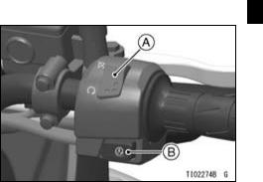

A. Engine Stop Switch
B. Starter Button
- Turn the ignition key to “ON” position.

- Make_{tral.} sure the transmission is in neu-
- HOW TO RIDE THE MOTORCYCLE
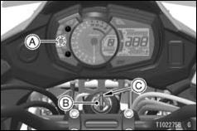

A. Neutral Indicator (Green)
B. Ignition Switch

C. “ON” Position

NOTE
○While the engine is cold, the fast idle system automatically raises the en-gine idling speed. At this time, the

engine warning indicator () may go on if you operate the throttle grip unnecessarily.
○The motorcycle is equipped with a vehicle-down sensor which causes the engine to stop automatically if the motorcycle falls down. After righting the motorcycle, first turn the ignition key to “OFF” and then back to “ON” before starting the engine.

- Without holding the throttle grip, push the starter button to start the engine.

NOTICE

Do not operate the starter con-tinuously for more than 5 sec-onds, or the starter will overheat and the battery power will drop temporarily. Wait 15 seconds between each operation of the starter to let it cool and the bat-tery power recover.

NOTE
○The motorcycle is equipped with a starter lockout switch. This switch is designed so that the engine does not start if the transmission is in gear and the side stand is down. However, the engine can be started if the clutch lever is pulled and the side stand is fully up.
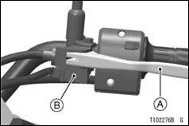

A. Clutch Lever
B. Starter Lockout Switch
HOW TO RIDE THE MOTORCYCLE 85

NOTICE

Do not let the engine idle longer than 5 minutes, or engine over-heating and damage may occur.

Moving Off
- Check that the side stand is up.

- Pull in the clutch lever.
- Shift into 1st gear.
- Open the throttle a little, and start to let out the clutch lever very slowly.
- As the clutch starts to engage, open the throttle a little more, giving the en-gine just enough fuel to keep it from stalling.

NOTE
○The motorcycle is equipped with a side stand switch. This switch is de-signed so that the engine does not

- HOW TO RIDE THE MOTORCYCLE

start if the transmission is in gear and the side stand is down.

Shifting Gears

- Close the throttle while pulling in the clutch lever.
- Shift_{gear.} into the next higher or lower
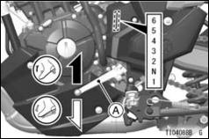
- Open the throttle part way, while re-leasing the clutch lever.
- For smooth riding, each gear position should cover the proper rate of speed shown in the table.

WARNING

Downshifting to a lower gear at high speed causes engine rpm to increase excessively, poten-tially damaging the engine and it may also cause the rear wheel to skid and cause an accident. Downshifting should be done below the vehicle speeds for each gear shown in the table.

A. Shift Pedal

Vehicle speed when shifting

Shifting up |  | km/h (mph)
1st → 2nd | 15 (9)
2nd → 3rd | 25 |  | (15)
3rd → 4th | 35 |  | (21)
4th → 5th | 45 |  | (27)
5th → 6th | 55 |  | (34)
Shifting down |  | km/h (mph)
6th → 5th |  | 30 |  | (19)
5th → 4th |  | 25 |  | (15)
4th → 3rd |  | 20 |  | (12)
3rd → 2nd |  | 15 (9)
2nd → 1st |  | 15 (9)
HOW TO RIDE THE MOTORCYCLE 87

NOTE
○The transmission is equipped with a positive neutral finder. When the mo-torcycle is standing still, the transmis-sion cannot be shifted past neutral from 1st gear. To use the positive neutral finder, shift down to 1st gear, then lift up on the shift pedal while standing still. The transmission will shift only into neutral.

Braking

- Close the throttle completely, leav-ing the clutch engaged (except when shifting gears) so that the engine will help slow down the motorcycle.

- Shift down one gear at a time so that you are in 1st gear when you come to a complete stop.

- When stopping, always apply both brakes at the same time. Normally
- HOW TO RIDE THE MOTORCYCLE

the front brake should be applied a lit-tle more than the rear. Shift down or fully disengage the clutch as neces-sary to keep the engine from stalling.

- Never lock the brakes, or it will cause the tires to skid. When turning a cor-ner, it is better not to brake at all. Re-duce your speed before you get into the corner.

- For emergency braking, disregard downshifting, and concentrate on applying the brakes as hard as pos-sible without skidding.

- Even in motorcycles equipped with ABS, braking during cornering may cause wheel slip. When turning a corner, it is better to limit braking to
the light application of both brakes or not to brake at all. Reduce your speed before you get into the corner.
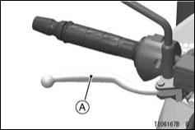

A. Front Brake Lever
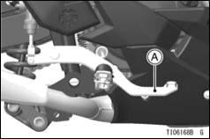
A. Rear Brake Pedal

Anti-lock Brake System (ABS)

(only on ABS model)
ABS is designed to help prevent the wheels from locking up when the brakes are applied hard while running straight. The ABS automatically regu-lates brake force. Intermittently gaining gripping force and braking force helps
HOW TO RIDE THE MOTORCYCLE 89

prevent wheel lock-up and allows sta-ble steering control while stopping.
Brake control function is identical to that of a conventional motorcycle. The brake lever is used for the front brake and the brake pedal for the rear brake.

Although the ABS provides stability while stopping by preventing wheel lock-up, remember the following char-acteristics:

- To apply the brake effectively, use the front brake lever and rear brake pedal simultaneously in the same manner as conventional motorcycle brake system.

- ABS cannot compensate for adverse road conditions, misjudgment or im-proper application of brakes. You must take the same care as with mo-torcycles not equipped with ABS.

- ABS is not designed to shorten the braking distance. On loose, uneven or downhill surfaces, the stopping
- HOW TO RIDE THE MOTORCYCLE

distance of a motorcycle with ABS may be longer than that of an equiv-alent motorcycle without ABS. Use special caution in such areas.

- ABS will help prevent wheel lock-up when braking in a straight line, but it cannot control wheel slip which may be caused by braking during corner-ing. When turning a corner, it is bet-ter to limit braking to the light appli-cation of both brakes or not to brake at all. Reduce your speed before you get into the corner.

- Same as conventional brake system, an excessive sudden braking may cause wheel lock up that makes it harder to control a motorcycle.

- During braking, ABS will not prevent the rear wheel lifting.
WARNING

ABS cannot protect the rider from all possible hazards and is not a substitute for safe rid-ing practices. Be aware of how the ABS system operates and its limitations. It is the rider’s responsibility to ride at appro-priate speeds and manner for weather, road surface and traffic conditions.

- The computers integrated in the ABS compare vehicle speed with wheel speed. Since non-recommended tires can affect wheel speed, they may confuse the computers, which can extend braking distance.

WARNING

Use of non-recommended tires may cause malfunctioning of ABS and can lead to extended braking distance. The rider could have an accident as a re-sult. Always use recommended standard tires for this motorcy-cle.

NOTE
○When the ABS is functioning, you may feel a pulsing in the brake lever or pedal. This is normal. You need not suspend applying brakes.

○ABS does not function at speeds of approx. 5 km/h (3.1 mph) or below.

○ABS does not function if the battery is discharged. When riding with an insufficiently charged battery, ABS may not function. Keep the bat-tery in good condition according to
HOW TO RIDE THE MOTORCYCLE 91

the “Battery Maintenance” section in the MAINTENANCE AND ADJUST-MENT chapter.

Stopping the Engine
- Close the throttle completely.

- Shift the transmission into neutral.
- Turn the ignition key to “OFF.”
- Support the motorcycle on a firm, level surface with the side stand.
- Lock the steering.

Stopping the Motorcycle in an Emergency

Your Kawasaki Motorcycle has been designed and manufactured to pro-vide you optimum safety and conve-nience. However, in order to fully ben-efit from Kawasaki’s safety engineering and craftsmanship, it is essential that
- HOW TO RIDE THE MOTORCYCLE

you, the owner and operator, properly maintain your motorcycle and become thoroughly familiar with its operation. Improper maintenance can create a dangerous situation known as throt-tle failure. Two of the most common causes of throttle failure are:

- An improperly serviced or clogged air cleaner may allow dirt and dust to enter the throttle body and stick the throttle open.

- During removal of the air cleaner, dirt is allowed to enter and jam the fuel injection system.

In an emergency situation such as throttle failure, your vehicle may be stopped by applying the brakes and disengaging the clutch. Once this stopping procedure is initiated, the en-gine stop switch may be used to stop
the engine. If the engine stop switch is used, turn off the ignition switch after stopping the motorcycle.

Parking

WARNING

Operating or parking the vehi-cle near flammable materials can cause a fire, and can result in property damage or severe per-sonal injury.

Do not idle or park your vehicle in an area where tall or dry veg-etation, or other flammable ma-terials could come into contact with the muffler or exhaust pipe.

WARNING

The engine and exhaust system get extremely hot during normal operation and can cause serious burns.

Never touch a hot engine, ex-haust pipe, or muffler during op-eration or after stopping the en-gine.

- Shift the transmission into neutral and turn the ignition key to “OFF.”
- Support the motorcycle on a firm, level surface with the side stand.

NOTICE

Do not park on a soft or steeply inclined surface, or the motorcy-cle may fall over.

- If parking inside a garage or other structure, be sure it is well ventilated
HOW TO RIDE THE MOTORCYCLE 93

and the motorcycle is not close to any source of flame or sparks; this includes any appliance with a pilot light.

WARNING

Gasoline is extremely flammable and can be explosive under cer-tain conditions, creating the po-tential for serious burns. Turn the ignition switch off. Do not smoke. Make sure the area is well ventilated and free from any source of flame or sparks; this includes any appliance with a pi-lot light.

• ^{Lock}_{theft.} ^{the steering to help prevent}
- MAINTENANCE AND ADJUSTMENT
MAINTENANCE AND ADJUSTMENT

The maintenance and adjustments outlined in this chapter must be carried out in accordance with the Daily Checks and Periodic Maintenance to keep the motorcy-cle in good running condition and to reduce air pollution. The initial maintenance is vitally important and must not be neglected.

WARNING

Failure to perform these checks or to correct a problem before opera-tion may result in serious damage or an accident. Always perform daily checks before operation.

With a basic knowledge of mechanics and the proper use of tools, you should be able to carry out many of the maintenance items described in this chapter. If you lack proper experience or doubt your ability, all adjustments, maintenance, and repair work should be completed by a qualified technician.

Please note that Kawasaki cannot assume any responsibility for damage result-ing from incorrect or improper adjustment made by the owner.
MAINTENANCE AND ADJUSTMENT 95

DANGER

Exhaust gas contains carbon monoxide, a colorless, odorless poisonous gas. Inhaling carbon monoxide can cause serious brain injury or death. DO NOT run the engine in enclosed areas. Operate only in a well-ventilated area.

WARNING

The cooling fan spins at high speed and can cause serious injuries. Keep your hands and clothing away from the cooling fan blades at all times.

NOTE
○If a torque wrench is not available, the maintenance items which require a specific torque value should be serviced by an authorized Kawasaki dealer.
- MAINTENANCE AND ADJUSTMENT

Daily Checks

Check the following items each day before you ride. The time required is minimal, and habitual performance of these checks will help ensure you a safe, reliable ride.
If any irregularities are found during these checks, refer to the MAINTENANCE AND ADJUSTMENT chapter or see your dealer for the action required to return the motorcycle to a safe operating condition.

Operation | See
Operation | Page
Fuel
Adequate supply in tank, no leaks | –
Engine oil
Oil level between level lines | 104
Tires
Air pressure (when cold), install the air valve cap | 136
Tire wear | 137
Drive chain
Slack | 122
Lubricate if dry | 122

MAINTENANCE AND ADJUSTMENT 97

Operation | See
Operation | Page
Bolts, nuts and fasteners
Check for loose and/or missing bolts, nuts and fasteners | –
Steering
Action smooth but not loose from lock to lock | –
No binding of control cables | –
Brakes
Brake pad wear | 128
Brake fluid level | 127
No brake fluid leakage | –
Throttle
Throttle grip free play | 117
Clutch
Clutch lever free play | 120
Clutch lever operates smoothly | –
Coolant
No coolant leakage | –

98 MAINTENANCE AND ADJUSTMENT

Operation | See
Operation | Page
Coolant level between level lines (when engine is cold) | 111
Electrical equipment
All lights (head, city, tail/brake, turn signal, license plate, warning/indicator) and | –
horn work | –
Engine stop switch
Stops engine | –
Side stand
Return to its fully up position by spring tension | –
Return spring not weak or not damaged | –
Rear view mirrors
Rear view sight | –

MAINTENANCE AND ADJUSTMENT 99

Periodic Maintenance

*A: Service at number of years shown or indicated odometer reading intervals, whichever comes first.

*B: For higher odometer readings, repeat at the frequency interval established here.

*C: Service more frequently when operating in severe conditions: dusty, wet, muddy, high speed, or frequent starting/stopping.

*D: California model only
○: Emission Related Item

: | Inspection | : | Dealer Inspection
: | Change or Replace | : | Dealer Change or Replace
: | Lubrication | : | Dealer Lubrication
100 MAINTENANCE AND ADJUSTMENT

 |  |  |  | Odometer Reading (*B)
 |  | year | × 1 000 km (× 1 000 mile) |  |  |  |  |  | See
 |  | (*A) |  |  |  |  |  |  | Page
 | Items | (*A) | 1 |  | 6 | 12 | 18 | 24 | Page
 | Items |  | (0.6) |  | (3.8) | (7.6) | (11.4) | (15.2)
○ | Air cleaner element (*C) | :2 |  |  |  |  |  |  | 113
○ | Idle speed |  |  |  |  |  |  |  | 119
○ | Throttle control system (play, smooth | :1 |  |  |  |  |  |  | 117
○ | return, no drag) | :1 |  |  |  |  |  |  | 117
○ | Engine vacuum synchronization |  |  |  |  |  |  |  | –
 | Fuel system | :1 |  |  |  |  |  |  | –
 | Fuel filter |  |  |  |  |  |  |  | –
 | Fuel hose | :5 |  |  |  |  |  |  | –
○ | _{(*D)}Evaporative emission control system |  |  |  |  |  |  |  | –
 | Coolant level |  |  |  |  |  |  |  | 111
 | Cooling system | :1 |  |  |  |  |  |  | –
MAINTENANCE AND ADJUSTMENT 101

 |  |  |  | Odometer Reading (*B)
 |  | year | × 1 000 km (× 1 000 mile) |  |  |  |  |  | See
 |  | (*A) |  |  |  |  |  |  | Page
 | Items | (*A) | 1 |  | 6 | 12 | 18 | 24 | Page
 | Items |  | (0.6) |  | (3.8) | (7.6) | (11.4) | (15.2)
 | Coolant, water hose and O-ring | :3 |  |  | : every 36 000 km |  |  |  | –
 |  |  |  |  | (22 500 mile)
○ | Valve clearance |  |  |  |  |  |  |  | –
○ | Air suction system |  |  |  |  |  |  |  | –
 | Clutch operation (play, engagement, |  |  |  |  |  |  |  | 120
 | disengagement) |  |  |  |  |  |  |  | 120
 | Engine oil (*C) and oil filter | :1 |  |  |  |  |  |  | 105
 | Tire air pressure | :1 |  |  |  |  |  |  | 136
 | Wheel and tire | :1 |  |  |  |  |  |  | 137
 | Wheel bearing damage | :1 |  |  |  |  |  |  | –
 | Spoke tightness and rim runout |  |  |  |  |  |  |  | –
102 MAINTENANCE AND ADJUSTMENT

 |  |  |  | Odometer Reading (*B)
 |  | year | × 1 000 km (× 1 000 mile) |  |  |  |  |  | See
 |  | (*A) |  |  |  |  |  |  | Page
 | Items | (*A) | 1 |  | 6 | 12 | 18 | 24 | Page
 | Items |  | (0.6) |  | (3.8) | (7.6) | (11.4) | (15.2)
 | Drive chain lubrication condition (*C) |  |  | : every 600 km (400 mile) |  |  |  |  | 122
 | Drive chain slack (*C) |  |  |  | : every 1 000 km |  |  |  | 122
 |  |  |  |  | (600 mile)
 | Drive chain wear (*C) |  |  |  |  |  |  |  | –
 | Drive chain guide wear |  |  |  |  |  |  |  | –
 | Brake system | :1 |  |  |  |  |  |  | –
 | Brake operation (effectiveness, play, | :1 |  |  |  |  |  |  | –
 | no drag) | :1 |  |  |  |  |  |  | –
 | Brake fluid level | :1 |  |  |  |  |  |  | 127
 | Brake fluid (front and rear) | :2 |  |  |  |  |  |  | –
 | Brake hose | :4 |  |  |  |  |  |  | –
MAINTENANCE AND ADJUSTMENT 103

 |  |  |  | Odometer Reading (*B)
 |  | year | × 1 000 km (× 1 000 mile) |  |  |  |  |  | See
 |  | (*A) |  |  |  |  |  |  | Page
 | Items | (*A) | 1 |  | 6 | 12 | 18 | 24 | Page
 | Items |  | (0.6) |  | (3.8) | (7.6) | (11.4) | (15.2)
 | Rubber parts of brake master cylinder | :4 |  |  | : every 48 000 km |  |  |  | –
 | and caliper | :4 |  |  | (30 000 mile)
 | Brake pad wear (*C) |  |  |  |  |  |  |  | 128
 | Brake light switch operation |  |  |  |  |  |  |  | 129
 | Suspension system | :1 |  |  |  |  |  |  | –
 | Lubrication of rear suspension |  |  |  |  |  |  |  | –
 | Steering play | :1 |  |  |  |  |  |  | –
 | Steering stem bearings | :2 |  |  |  |  |  |  | –
 | Electrical system | :1 |  |  |  |  |  |  | –
○ | Spark plug |  |  |  |  |  |  |  | –
104 MAINTENANCE AND ADJUSTMENT

 |  |  |  | Odometer Reading (*B)
 |  | year | × 1 000 km (× 1 000 mile) |  |  |  |  |  | See
 |  | (*A) |  |  |  |  |  |  | Page
 | Items | (*A) | 1 |  | 6 | 12 | 18 | 24 | Page
 | Items |  | (0.6) |  | (3.8) | (7.6) | (11.4) | (15.2)
 | Chassis parts | :1 |  |  |  |  |  |  | –
 | Condition of bolts, nuts and fasteners |  |  |  |  |  |  |  | –

Engine Oil

Oil Level Inspection

- If the engine is cold, start the engine and run it for several minutes at idle speed.

- Stop the engine, then wait several minutes until the oil settles.

NOTICE

Racing the engine before the oil reaches every part can cause en-gine seizure.

- Check the engine oil level through the oil level inspection window. With the motorcycle held level, the oil level should come up between the upper and lower level lines next to the oil level inspection window.

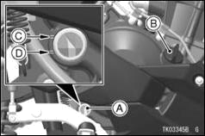
A. Oil Level Inspection Window
B. Oil Filler Cap
C. Upper Level Line
D. Lower Level Line

- If the oil level is too high, remove the excess oil through the oil filler open-ing using a syringe or some other suitable device.

- If the oil level is too low, add oil to reach the correct level. Use the same type and brand of oil that is already in the engine.
MAINTENANCE AND ADJUSTMENT 105

Oil and/or Oil Filter Change

- ^{Remove}_{collars.} ^{the lower fairing bolts and}
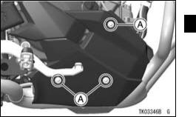

A. Lower Fairing Bolts and Collars

Pull the right lower fairing outward to clear the projection, and remove the right lower fairing.

- MAINTENANCE AND ADJUSTMENT
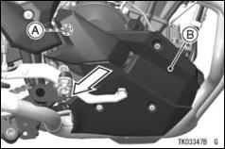

- Projection
- Right Lower Fairing

- Warm up the engine thoroughly, and then stop it.
- Place an oil pan beneath the engine.
- ^{Remove}_{gasket.} ^{the engine oil drain bolt and}
WARNING

Engine oil is a toxic substance. Dispose of used oil properly. Contact your local authorities for approved disposal methods or possible recycling.
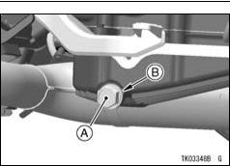

A. Engine Oil Drain Bolt
B. Gasket

- Let the oil completely drain with the motorcycle perpendicular to the ground.

- If the oil filter is to be replaced, re-move the oil filter and replace it with a new one.

NOTE
○If a torque wrench or required Kawasaki special tool is not avail-able, this item should be serviced by an authorized Kawasaki dealer.
MAINTENANCE AND ADJUSTMENT 107
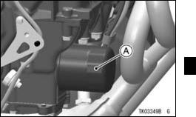

A. Oil Filter

- Apply a thin film of oil to the gasket and tighten the oil filter to the speci-fied torque.
- MAINTENANCE AND ADJUSTMENT
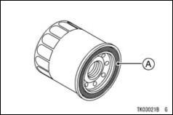

A. Gasket

- Install the drain bolt with a new gas-ket. Tighten it to the specified torque.

NOTE
○Replace the gasket with a new one.
Tightening Torque

Oil Filter:

17.5 N·m (1.78 kgf·m, 12.9 ft·lb)

Engine Oil Drain Bolt:

30 N·m (3.1 kgf·m, 22 ft·lb)

- Fill the engine up to the upper level line with a good quality engine oil specified in the table.

Recommended Engine Oil

Type:
Kawasaki Performance 4-Stroke Motorcycle Oil*

Kawasaki Performance 4-Stroke Semi-Synthetic Oil*

Kawasaki Performance 4-Stroke Full Synthetic Oil*

or other 4 -stroke oils with API SG, SH, SJ, SL or SM with JASO MA, MA1 or MA2 rating
Viscosity:
SAE 10W-40

*Kawasaki Performance Oils and Lu-bricants have been specifically engi-neered for your vehicle. Consistent use of these products meets or ex-ceeds warranty and service require-ments and can help to extend the life of your Kawasaki.

NOTE
○Do not add any chemical additive to the oil. Oils fulfilling the above re-quirements are fully formulated and provide adequate lubrication for both the engine and the clutch.

Engine Oil Capacity

2.0 L (2.1 US qt)

[when filter is not removed]

2.2 L (2.3 US qt)

[when filter is removed]

MAINTENANCE AND ADJUSTMENT 109

Although 10W-40 engine oil is the recommended oil for most condi-tions, the oil viscosity may need to be changed to accommodate atmo-spheric conditions in your riding area.
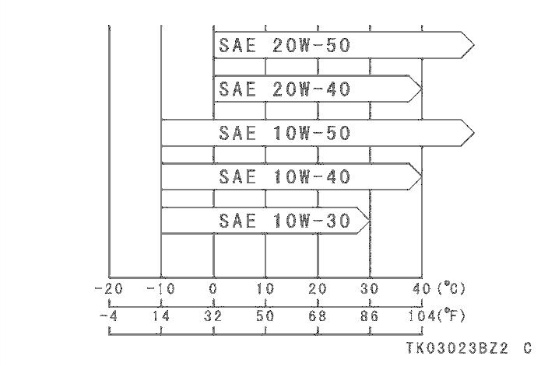

- Start the engine.
- Check the oil level and oil leakage.
- Insert the projection of the right lower fairing into the grommet.
- MAINTENANCE AND ADJUSTMENT
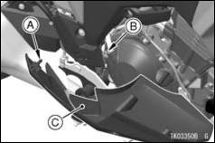

- Projection
- Grommet
- Right Lower Fairing

- Tighten the lower fairing bolts with the collars to specified torque.
A. Lower Fairing Bolt (Upper) and Collar B. Lower Fairing Bolts (Lower) and Collars
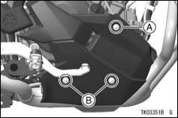

Tightening Torque

Lower Fairing Bolts (Lower)

8.8 N·m (0.90 kgf·m, 78 in·lb)

Lower Fairing Bolt (Upper)

4.4 N·m (0.45 kgf·m, 39 in·lb)

Coolant

Coolant Level Inspection

- Position the motorcycle so that it is perpendicular to the ground.
- Check the coolant level through the coolant level gauge on the reserve tank located in right middle fairing. The coolant level should be between the F (Full) and L (Low) level lines.
MAINTENANCE AND ADJUSTMENT 111
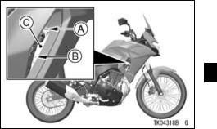

A. F (Full) Level Line
B. L (Low) Level Line

C. Reserve Tank

NOTE
○Check the level when the engine is cold (room or atmospheric tempera-ture).

- If the amount of coolant is insuffi-cient, add coolant into the reserve tank.

- MAINTENANCE AND ADJUSTMENT

Coolant Filling

- Remove the cap from the reserve tank and add coolant through the filler opening to the F (Full) level line.
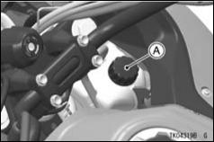

A. Reserve Tank Cap
however it must be returned to the correct mixture ratio by the addition of antifreeze concentrate as soon as possible.

NOTICE

If coolant must be added of-ten, or the reserve tank com-pletely runs dry, there is proba-bly leakage in the system. Have the cooling system inspected by your authorized Kawasaki dealer.

Coolant Change

NOTE
○In an emergency you can add wa-ter alone to the coolant reserve tank,
Have the coolant changed by an au-thorized Kawasaki dealer.

Coolant Requirement

WARNING

Coolant containing corrosion in-hibitors for aluminum engines and radiators include harm-ful chemicals for human body. Drinking coolant can result in serious injury or death. Use coolant in accordance with the instructions of the manufacturer.

Use a permanent type of antifreeze (soft water and ethylene glycol plus cor-rosion and rust inhibitor chemicals for aluminum engines and radiators) in the cooling system. On the mixture ratio of coolant, choose the suitable one re-ferring to the relation between freezing point and strength directed on the con-tainer.
MAINTENANCE AND ADJUSTMENT 113

NOTICE

If hard water is used in the sys-tem, it causes scale accumula-tion in the water passages, and considerably reduces the effi-ciency of the cooling system.

NOTE
○A permanent type of antifreeze is in-
stalled in the cooling system when
shipped. It is mixed at 50% and has

the freezing point of –35°C (–31°F).

Air Cleaner

Air Cleaner Element Removal

- Remove the seat (see Seat section in the GENERAL INFORMATION chapter).

- ^{Remove}_{screws.} ^{the air cleaner element cap}
- MAINTENANCE AND ADJUSTMENT
- Remove the air cleaner cap.
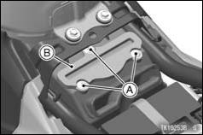

A. Air Cleaner Element Cap Screws B. Air Cleaner Element Cap

- Pull out the air cleaner element from the air cleaner housing.
A. Air Cleaner Element
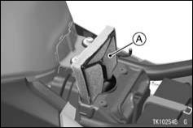

- Remove the air cleaner element from the frame.
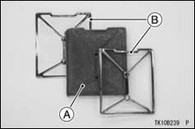
A. Air Cleaner Element
B. Frame

- Put a clean, lint-free towel into the air cleaner housing to keep dirt or other foreign material from entering.

- Inspect the element material for dam-age. If any part of the element is damaged, the element must be re-placed.
MAINTENANCE AND ADJUSTMENT 115

WARNING

If dirt or dust is allowed to pass through into the throttle body assembly, the throttle may be-come stuck, possibly causing accident. Be sure to keep the dust from entering during clean-ing.

NOTICE

If dirt gets through into the en-gine, excessive engine wear and possibly engine damage will oc-cur.

Air Cleaner Element Cleaning

- Clean the element in a bath of a high flash-point solvent.

- Squeeze it dry in a clean towel. Do not wring the element or blow it dry; the element can be damaged.
- MAINTENANCE AND ADJUSTMENT

- Check_{age.} the element for visible dam-

- If element is damaged, replace it.
- After cleaning, saturate the element with a high-quality foam-air-filter oil, squeeze out the excess oil, then wrap it in a clean towel and squeeze it as dry as possible.

- Be careful not to tear the element.

WARNING

Gasoline and low flash-point sol-vents are extremely flammable and may explode, causing se-vere burns. Do not use gaso-line or a low flash-point solvent to clean the element. Clean the element in a well-ventilated area. Be sure there are no sparks or flame in the work area, including any appliance with a pilot light.

Air Cleaner Element Installation

- The removed parts installation is per-formed in the reverse order of re-moval.

Tightening Torque

Air Cleaner Element Cap Screws 4.2 N·m (0.43 kgf·m, 37 in·lb)

NOTE
○If a torque wrench is not available, this item should be serviced by an authorized Kawasaki dealer.

Oil Draining

- Inspect the transparent drain cap lo-cated the left lower end of the air cleaner housing to see if any oil has run down.
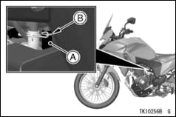
A. Transparent Drain Cap
B. Clamp

- If there is any oil in the drain cap, remove the clamp and drain cap, and drain the oil.
MAINTENANCE AND ADJUSTMENT 117

WARNING

Oil on tires will make them slip-pery and can cause an accident and injury. Be sure to install the drain cap to the air cleaner hous-ing after draining.

Throttle Control System

Throttle Grip

Throttle Grip Free Play Inspection

- Check that the throttle grip moves smoothly from full open to close, and the throttle closes quickly and completely by the return spring in all steering positions.

- If the throttle grip does not return properly, have the throttle control system checked by an authorized Kawasaki dealer.
- MAINTENANCE AND ADJUSTMENT

- Check the throttle grip free play by turning back and forth.
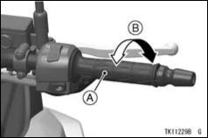

A. Throttle Grip
B. Throttle Grip Free Play

Throttle Grip Free Play

2 ∼ 3 mm (0.08 ∼ 0.12 in.)

- If there is improper play, adjust it.

Throttle Grip Free Play Adjustment

- Loosen the locknuts at the upper end of the throttle cables.
- Turn both throttle cable adjuster to give the throttle grip plenty of play.
- Turn the decelerator cable adjuster until there is no play when the throttle grip is completely closed.

- Tighten the locknut.
- Turn the accelerator cable adjuster until of 2 ∼ 3 mm (0.08 ∼ 0.12 in.) of throttle grip play is obtained.

- Tighten the locknut.
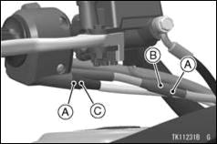
- Locknuts
- Decelerator Cable Adjuster
- Accelerator Cable Adjuster

- With the engine idling, turn the han-dlebars to each side. If handlebars movement changes the idle speed, the throttle cables may be improperly adjusted or incorrectly routed, or they may be damaged. Be sure to correct any of these conditions before idling.
MAINTENANCE AND ADJUSTMENT 119

WARNING

Operation with improperly ad-justed, incorrectly routed, or damaged cables could result in an unsafe riding condition. Be sure the control cables are ad-justed and routed correctly, and are free from damage.

Idle Speed

Idle Speed Adjustment

- Start the engine, and warm it up thor-oughly.
- Adjust the idle speed by turning the idle adjusting screw.

NOTE
○While the engine is cold, the fast idle system automatically raises the en-gine idling speed.
- MAINTENANCE AND ADJUSTMENT

Idle Speed

1 250 ∼ 1 350 r/min (rpm)
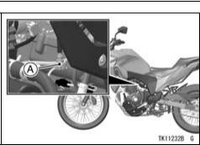

A. Idle Adjusting Screw

- Open and close the throttle a few times to make sure that the idle speed does not change. Readjust if necessary.

- With the engine idling, turn the han-dlebars to each side. If handlebars movement changes the idle speed,
the throttle cables may be improperly adjusted or incorrectly routed, or they may be damaged. Be sure to correct any of these conditions before riding.

WARNING

Operation with damaged cables could result in an unsafe riding condition. Replace damaged control cables before operation.

Clutch

Clutch Operation Inspection

- Check that the clutch lever operates properly and that the inner cable slides smoothly. If there is any irreg-ularity, have the clutch cable checked by an authorized Kawasaki dealer.

- Check the clutch lever free play.
Clutch Lever Free Play

2 ∼ 3 mm (0.08 ∼ 0.12 in.)
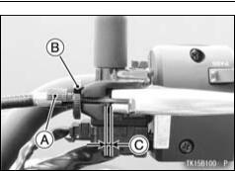

- Adjuster
- Locknut
- Clutch Lever Free Play

- If the free play is incorrect, adjust the clutch lever free play as follows.
MAINTENANCE AND ADJUSTMENT 121

Clutch Lever Free Play Adjustment

- Loosen the locknut, and turn the adjuster so that the clutch lever will have the specified free play.

WARNING

Excess clutch lever free play could prevent clutch disengage-ment and cause a crash result-ing in serious injury or death. When adjusting the clutch lever free play, be sure the upper end of the clutch outer cable is fully seated in its fitting so that it doesn’t slip into place later and create excessive free play.

- If it cannot be done, have the clutch cable adjusted by an authorized Kawasaki dealer.
- MAINTENANCE AND ADJUSTMENT

NOTE
○After the adjustment is made, start the engine and check that the clutch does not slip and that it releases properly.

Drive Chain

Drive Chain Lubrication
Lubrication is necessary after riding through rain or on wet roads, or any time that the chain appears dry.

Use a lubricant for sealed chains to prevent deterioration of chain seals. If the chain is especially dirty, clean it using a cleaner for sealed chains fol-lowing the instructions supplied by the chain cleaner manufacturer.

- Apply lubricant to the sides of the rollers so that it will penetrate to the rollers and bushings. Apply lubricant to the seals so that the seals will be
coated with lubricant. Wipe off any excess lubricant.
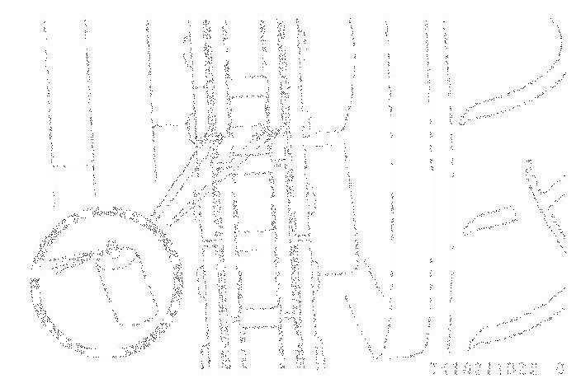

- Wipe off any lubricant that gets on the tire surface.

Drive Chain Slack Inspection

- Set the motorcycle up on its side stand.

- Clean the chain if it is dirty, and lubri-cate it if it appears dry.

- Rotate the rear wheel to find the po-sition where the chain is tightest, and
measure the maximum chain slack by pulling up and pushing down the chain midway between the engine sprocket and rear wheel sprocket.
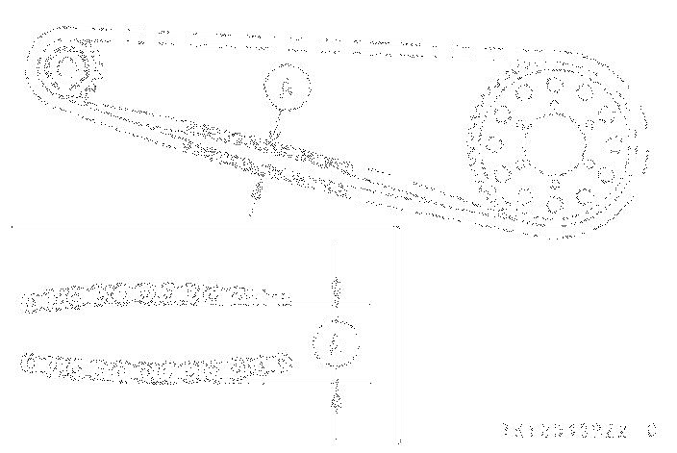

A. Chain Slack

- If the drive chain is too tight or too loose, adjust it so that the chain slack is within the standard value.

Drive Chain Slack

Standard: 25 ∼ 35 mm (1.0 ∼ 1.4 in.)

MAINTENANCE AND ADJUSTMENT 123

Drive Chain Slack Adjustment

- Loosen the left and right chain ad-juster locknuts.
- Remove the cotter pin, and loosen the axle nut.
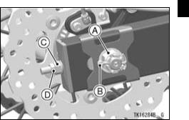

A. Axle Nut
B. Cotter Pin
- Adjuster
- Locknut

- If the chain is too loose, turn in the left and right chain adjusters evenly.
- MAINTENANCE AND ADJUSTMENT

- If the chain is too tight, turn out the left and right chain adjusters evenly.
- Turn both chain adjusters evenly until the drive chain has the cor-rect amount of slack. To keep the chain and wheel properly aligned, the notch on the left wheel alignment indicator should align with the same swingarm mark that the right wheel alignment indicator notch aligns with.
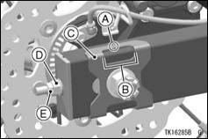

A. Marks
B. Notch
C. Wheel Alignment Indicator
D. Adjuster
E. Locknut

NOTE
○Wheel alignment can also be
checked using the straightedge or

string method.
WARNING

Misalignment of the wheel will result in abnormal wear, and may result in an unsafe riding con-dition. Align the rear wheel us-ing the marks on the swingarm or measuring the distance be-tween the center of the axle and swingarm pivot.

- Tighten both chain adjuster locknuts.

- ^{Tighten}_{torque.} ^{the axle nut to the specified}

Tightening Torque

Axle Nut:

98 N·m (10 kgf·m, 72 ft·lb)

NOTE
○If a torque wrench is not available, this item should be serviced by an authorized Kawasaki dealer.
MAINTENANCE AND ADJUSTMENT 125

- Rotate the wheel, measure the chain slack again at the tightest position, and readjust if necessary.

- Install a new cotter pin through the axle nut and axle, and spread its ends.
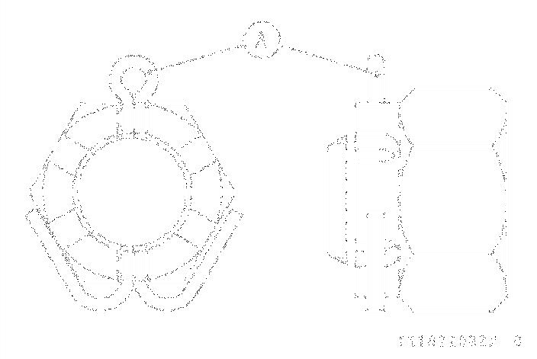

A. Cotter Pin

NOTE
○When inserting the cotter pin, if the slots in the nut do not align with the cotter pin hole in the axle shaft,
- MAINTENANCE AND ADJUSTMENT

tighten the nut clockwise up to the next alignment.
○It should be within 30 degrees.

○Loosen once and tighten again when the slot goes past the nearest hole.
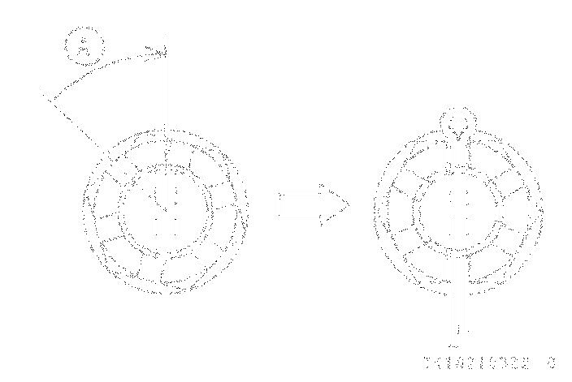

A. Turn Clockwise
WARNING

A loose axle nut can lead to an accident resulting in serious in-jury or death. Tighten the axle nut to the proper torque and in-stall a new cotter pin.

- Check the rear brake (see Brakes section).

Brakes

If you feel there is something wrong when applying the brakes, have the brake system checked by an autho-rized Kawasaki dealer immediately.
WARNING

Air in the brake lines diminish braking performance and can cause an accident resulting in injury or death. If the brake lever or pedal feels mushy when it is applied, there might be air in the brake lines or the brake may be defective. Have the brake checked immediately by an au-thorized Kawasaki dealer.

Brake Fluid Level Inspection

- With the front brake fluid reservoir held horizontal, the brake fluid level must be above the lower level line.
MAINTENANCE AND ADJUSTMENT 127
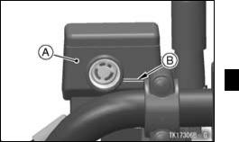

A. Front Brake Fluid Reservoir B. Lower Level Line

- With the rear brake fluid reservoir held horizontal, the brake fluid level must be kept between the upper and lower level lines.
- MAINTENANCE AND ADJUSTMENT

thickness of either pad lining is less than 1.5 mm (0.06 in.), replace both pads in the caliper as a set. Pad re-placement should be done by an autho-rized Kawasaki dealer.
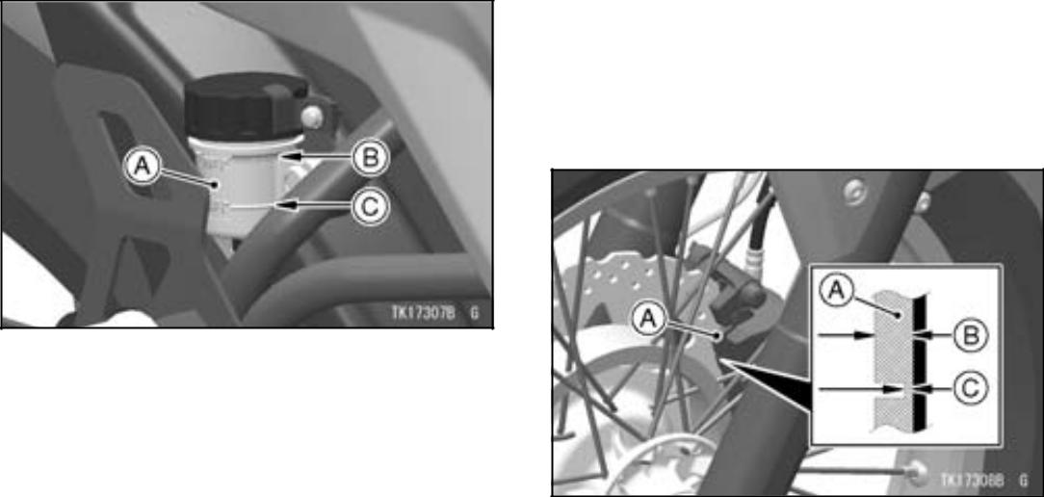

A. Rear Brake Fluid Reservoir B. Upper Level Line C. Lower Level Line

- If the fluid level is lower than the lower level line it may indicate that the fluid is leaking. In this case, have the brake system inspected by an au-thorized Kawasaki dealer.

Brake Pad Wear Inspection

A. Front Brake Pads
B. Lining Thickness

C. 1.5 mm (0.06 in.)

Inspect the brakes for wear. For each

front and rear disc brake caliper, if the

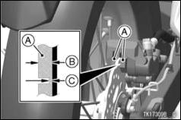
A. Rear Brake Pads
B. Lining Thickness

C. 1.5 mm (0.06 in.)

Brake Light Switches

Brake Light Switch Inspection
- Turn the ignition switch on.

- The brake light should go on when the front brake is applied.
MAINTENANCE AND ADJUSTMENT 129

- If it does not, ask your authorized Kawasaki dealer to inspect the front brake light switch.

- Check the operation of the rear brake light switch by depressing the brake pedal. The brake light should go on after the proper pedal travel.
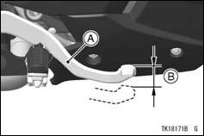

A. Brake Pedal
B. 10 mm (0.39 in.)

- If the light does not come on, adjust the rear brake light switch.

- MAINTENANCE AND ADJUSTMENT

Brake Pedal Travel

10 mm (0.39 in.)

Brake Light Switch Adjustment
- Remove the bolts and collars.
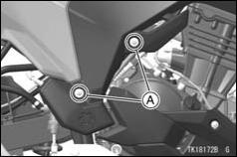

A. Bolts and Collars
- Projections
- Right Side Cover
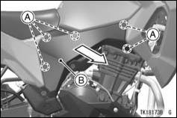

- To adjust the rear brake light switch, move the switch up or down by turn-ing the adjusting nut.

- Pull the right side cover outward to clear the projections, and remove the right side cover.

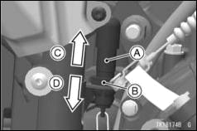
A. Rear Brake Light Switch
B. Adjusting Nut
C. Lights sooner
D. Lights later

NOTICE

To avoid damaging the electrical connections inside the switch, be sure that the switch body does not turn during adjustment.

MAINTENANCE AND ADJUSTMENT 131

- Insert the projections of the right side cover into the grommets.
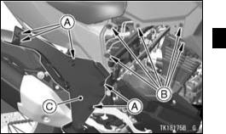

- Projections
- Grommets
- Right Side Cover
- Tighten the bolts with the collars.

- MAINTENANCE AND ADJUSTMENT

Suspension System

Front Fork

NOTICE

After riding on the normal road, the unpaved road and in the rainy weather, clean off any dirt (grit, mud or insect etc.) that stuck to inner tube before it hardens. If the motorcycle keeps running with the dirt stuck to the inner tube, the oil seal will be damaged and it causes the oil leak.

Rear Shock Absorber

Spring Preload Adjustment
The spring preload adjuster on the rear shock absorber has 5 positions.

Standard

3rd position

- Remove the bolts and collars.
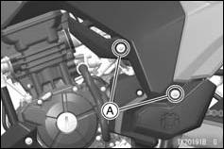

A. Bolts and Collars

- Pull the left side cover outward to clear the projections, and remove the left side cover.
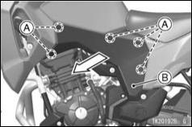

- Projections
- Left Side Cover
MAINTENANCE AND ADJUSTMENT 133
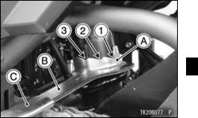

A. Spring Preload Adjuster
- Wrench
- Handle

- Insert the projections of the left side cover into the grommets.

- In accordance with the setting table, turn the preload adjuster with the wrench from the tool kit.

- MAINTENANCE AND ADJUSTMENT

• Tighten the bolts with the collars.
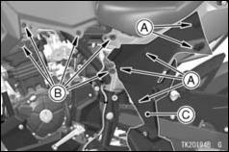

- Projections
- Grommets
- Left Side Cover
MAINTENANCE AND ADJUSTMENT 135

Setting Table

Rear Shock Absorber Spring Preload Setting

 | Softest setting | Standard | Hardest setting
 | limit | Standard | limit
Adjuster Position | 1st | 3rd | 5th
Spring Action | Weak | ←→ | Strong
Setting | Soft | ←→ | Hard
Load | Light | ←→ | Heavy
Road | Good | ←→ | Bad
Speed | Low | ←→ | High

- MAINTENANCE AND ADJUSTMENT

Wheels

Tire Pressure Inspection
- Remove the air valve cap.

- Check the tire pressure often, using an accurate gauge.
- Make sure to install the air valve cap securely.

NOTE
○Measure the tire pressure when the tires are cold (that is, when the mo-torcycle has not been ridden more than 1.6 km (1 mile) during the past 3 hours).

○Tire pressure is affected by changes in ambient temperature and altitude, and so the tire pressure should be checked and adjusted when your rid-ing involves wide variations in tem-perature or altitude.
A. Tire Pressure Gauge
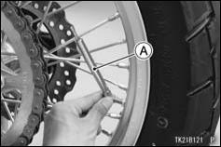

Tire Air Pressure (when cold)

Front | 200 kPa (2.00 kgf/cm², 28 psi)
Front | \
Rear | 225 kPa (2.25 kgf/cm², 32 psi)

Tire Wear, Damage
As the tire tread wears down, the tire becomes more susceptible to puncture and failure. An accepted estimate is that 90% of all tire failures occur during

the last 10% of tread life (90% worn). So it is false economy and unsafe to use the tires until they are bald.
Tire Wear Inspection

- Measure the depth of the tread with a depth gauge, and replace any tire that has worn down to the minimum allowable tread depth.
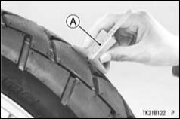
MAINTENANCE AND ADJUSTMENT 137 Minimum Tread Depth
Front | — | 1 mm (0.04 in.)
 | Under 130 km/h | 2 mm (0.08 in.)
Rear | (80 mph)
Rear | Over 130 km/h | 3 mm (0.12 in.)
 | (80 mph) | 3 mm (0.12 in.)

- Visually inspect the tire for cracks and cuts, replacing the tire in case of bad damage. Swelling or high spots indicate internal damage, requiring tire replacement.

A. Tire Depth Gauge

- MAINTENANCE AND ADJUSTMENT
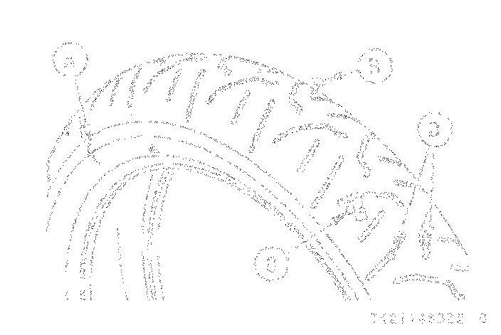

A. Crack or Cut
- Nail
- Swelling or High Spot
- Stone

- Remove any imbedded stones or other foreign particles from the tread.

NOTE
○Have the wheel balance inspected whenever a new tire is installed.
WARNING

Tires that have been punctured and repaired do not have the same capabilities as undam-aged tires and can suddenly fail, causing an accident resulting in serious injury or death. Re-place damaged tires as soon as possible. To ensure safe han-dling and stability, use only the recommended standard tires for replacement, inflated to the stan-dard pressure. If it is necessary to ride on a repaired tire, do not exceed 100 km/h (60 mph) until the tire is replaced.

NOTE
○When operating on public roadways, keep maximum speed under traffic law limits.
Standard Tire (Tube-type)

Make, Type:
_{Front} IRC, GP-210F
Size:
100/90-19M/C 57S

Make, Type:
_{Rear} IRC, GP-210R
Size:
130/80-17M/C 65S

WARNING

Mixing tire brands and types can adversely affect handling and cause an accident resulting in injury or death. Always use the same manufacturer’s tires on both front and rear wheels.

MAINTENANCE AND ADJUSTMENT 139

WARNING

New tires are slippery and may cause loss of control and injury.

- break-in period of 160 km (100 miles) is necessary to estab-lish normal tire traction. During break-in, avoid sudden and max-imum braking and acceleration, and hard cornering.

Battery

The battery installed in this motorcy-cle is a sealed type, so it is not nec-essary to check the battery electrolyte level or add distilled water.
- MAINTENANCE AND ADJUSTMENT

NOTICE

Never remove the sealing strip, or the battery can be damaged. Do not install a conventional battery in this motorcycle, or the electrical system cannot work properly.

Make | Siam Furukawa
Type | FTX9-BS

Battery Maintenance
It is the owner’s responsibility to keep the battery fully charged. Failure to do so can lead to battery failure and leave you stranded.

If you are riding your vehicle infre-quently, inspect the battery voltage weekly using a voltmeter. If it drops below 12.6 volts, the battery should be charged using an appropriate charger (check with your Kawasaki dealer).
If you will not be using the motorcy-cle for longer than two weeks, the battery should be charged using an appropriate charger. Do not use an au-tomotive-type quick charger that may overcharge the battery and damage it.

NOTE
○Leaving the battery connected causes the electrical components (clock etc.) to make the battery dis-charged, resulting the over discharge of the battery. In this case, the repair or replacement of the battery is not included in the warranty. If you do not drive for four weeks or more, dis-connect the battery from the vehicle.

Kawasaki-recommended chargers are:

Battery Mate 150-9
OptiMate 4
Yuasa MB-2040/2060

Christie C10122S
If the above chargers are not avail-able, use equivalent one.
For more details, ask your Kawasaki dealer.
Battery Charging

- Charge the battery following the in-structions of your battery charger.
- The charger will keep the battery fully charged until you are ready to re-install the battery in the motorcycle (see Battery Installation).
MAINTENANCE AND ADJUSTMENT 141


DANGER

- Battery acid generates hydro-gen gas which is flammable and explosive under certain conditions. It is present within a battery at all times, even in a discharged condition. Keep all flames and sparks (cigarettes) away from the battery.

- Wear eye protection when working with a battery. In the event of battery acid contact with skin, eyes, or clothing, wash the affected areas imme-diately with water for at least five minutes. Seek medical at-tention.

- MAINTENANCE AND ADJUSTMENT

WARNING

Battery posts, terminals and re-lated accessories contain lead and lead compounds, chemicals known to the State of California to cause cancer and reproduc-tive harm. Wash hands after handling.

Battery Removal

- Make sure the ignition switch is turned off.

- Remove the seat (see Seat section in the GENERAL INFORMATION chapter).

- Disconnect the negative (–) cable from the (–) terminal.
- Slide the red cap from the positive (+) terminal.
- Disconnect the positive (+) cable from the (+) terminal.
- Remove the band.
A. Red Cap and (+) Terminal B. (–) Terminal C. Band
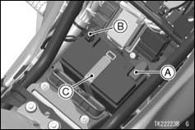

- Take_{case.} the battery out of the battery

- Clean the battery using a solution of baking soda and water. Be sure that the cable connections are clean.

Battery Installation
- Place the battery on the battery case.
- Connect the positive (+) cable to the
  - terminal, and then connect the negative (–) cable to the (–) terminal.

NOTICE

Installing the negative (–) cable to the (+) terminal of the battery or the positive (+) cable to the (–) terminal of the battery can seri-ously damage the electrical sys-tem.

- Put a light coat of grease on the ter-minals to prevent corrosion.
- Cover_{cap.} the (+) terminal with the red

MAINTENANCE AND ADJUSTMENT 143
- Install the removed parts.

Headlight

Headlight aiming should be done by an authorized Kawasaki dealer.

Headlight Aiming Adjustment

NOTE
○The left and right adjusters on the headlight can move the direction of the headlight beam to up, down, left and right by turning each adjuster it-self as the below table.
- MAINTENANCE AND ADJUSTMENT
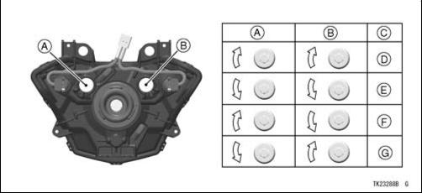

A. Left Adjuster
B. Right Adjuster
C. Moving Direction of Headlight Beam
- Up
- Down
- Left
- Right

- To move the headlight beam left-ward, turn the left adjuster clockwise and turn the right adjuster counter-clockwise same number until the beam points straight ahead.

- To move the headlight beam right-ward, turn the left adjuster counter-clockwise and turn the right adjuster clockwise same number until the beam points straight ahead.

- If not properly adjusted horizontally, the beam will point to one side rather than straight ahead.

- To move the headlight beam upward, turn the both adjusters clockwise same number.

- To move the headlight beam down-ward, turn the both adjusters coun-terclockwise same number.
MAINTENANCE AND ADJUSTMENT 145

- If adjusted too low, neither low nor high beam will illuminate the road far enough ahead. If adjusted too high, the high beam will fail to illuminate the road close ahead, and the low beam will blind oncoming drivers.

NOTE
○On high beam, the brightest points should be slightly below horizontal. The proper angle is 0.4 degrees be-low horizontal. This is a 50 mm (2.0 in.) drop at 7.6 m (25 ft) measured from the center of the headlight, with the motorcycle on its wheels and the rider seated.
- MAINTENANCE AND ADJUSTMENT
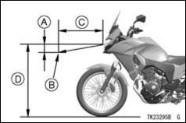

A. 50 mm (2.0 in.)
B. Center of Brightest Spot
C. 7.6 m (25 ft)
D. Height of Headlight Center

Fuses

Fuses are arranged in the fuse boxes located under the seat. The main fuse is located under the seat. If a fuse fails during operation, inspect the elec-trical system to determine the cause,
and then replace it with a new fuse of proper amperage.
If the fuse fails repeatedly, there is something wrong with the electrical system. Have the motorcycle checked by an authorized Kawasaki dealer.

The main fuse removal should be done by an authorized Kawasaki dealer.
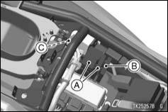

A. Fuse Boxes
B. Fuse Box (ABS)

C. Main Fuse
WARNING

Substituting fuses can cause wiring to overheat, catch fire and/or fail. Do not use any sub-stitute for the standard fuse. Replace the blown fuse with a new one of the correct capacity, as specified on the fuse boxes and main fuse.
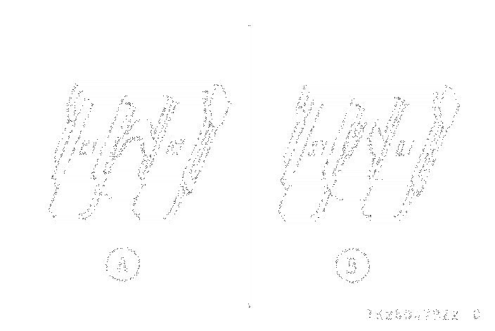

- Normal
- Failed
MAINTENANCE AND ADJUSTMENT 147

General Lubrication

Lubricate the points shown below, with either engine oil or regular grease, in accordance with the Periodic Main-tenance Chart or whenever the vehicle has been operated under wet or rainy conditions.

Before lubricating each part, clean off any rusty spots with rust remover and wipe off any grease, oil, dirt, or grime.

Apply motor oil to the following pivots
- Side Stand

- Clutch Lever
- Front Brake Lever
- Rear Brake Pedal

Lubricate the following cables with a pressure cable luber
- (K) Clutch Inner Cable

- (K) Throttle Inner Cables
- MAINTENANCE AND ADJUSTMENT

Apply grease to the following points
- (K) Clutch Inner Cable Upper End

- (K) Throttle Inner Cable Upper Ends

(K): Should be serviced by an authorized Kawasaki dealer.

NOTE
○After connecting the cables, adjust them.
Cleaning

General Precautions

Frequent and proper care of your ve-hicle will enhance its appearance, opti-mize overall performance, and extend its useful life. Covering your vehicle with a high quality, breathable vehicle cover will help protect its finish from harmful UV rays, pollutants, and re-duce the amount of dust reaching its surfaces.
WARNING

Build-up of debris or flammable material in and around the vehi-cle chassis, engine, and exhaust can cause mechanical problems and increase the risk of fire. When operating the vehicle in conditions that allow debris or flammable material to collect in and around the vehicle, inspect the engine, electrical component and exhaust areas frequently. If debris or flammable materials have collected, park the vehi-cle outside and stop the engine. Allow the engine to cool, then remove any collected debris. Do not park or store the vehicle in an enclosed space prior to in-specting for build-up of debris or flammable materials.

MAINTENANCE AND ADJUSTMENT 149

- Be sure the engine and exhaust are cool before washing.
- When washing the vehicle, always use a mild neutral detergent and wa-ter.

- Avoid applying all harsh chemi-cals, solvents, degreaser, oil re-mover, electrical contact cleaner, and household cleaning products such as ammonia-based window cleaners. They will damage or de-teriorate painted parts, plastic parts, rubber parts and other synthetic parts including covers and headlight lens.

- Avoid applying degreaser to seals, brake pads, and tires.
- Gasoline, brake fluid, and coolant will damage the finish of painted and plastic surfaces: wash them off im-mediately.

- Avoid wire brushes, steel wool, and all other abrasive pads or brushes.

- MAINTENANCE AND ADJUSTMENT

- Take care when washing the head-light lens and other plastic parts as they can easily be scratched.

NOTE
○After riding in an area where the roads are salted or near the ocean, immediately wash your vehicle with cold water. Do not use warm water as it accelerates the chemical reac-tion of the salt. After drying, apply a corrosion protection spray on all metal and chrome surfaces to pre-vent corrosion.

○Condensation may form on the inside of the headlight lens after riding in the rain, washing the vehicle or hu-mid weather. To remove the mois-ture, start the engine and turn on the headlight. Gradually the condensa-tion on the inside of the lens will clear off.
Radiator
Clean off any obstructions with a stream of low-pressure water.

NOTICE

Using high-pressure water, as from a car wash facility, could damage the radiator fins and impair the radiator’s effective-ness. Do not obstruct or deflect airflow through the radiator by installing unauthorized acces-sories in front of the radiator or behind the cooling fan. Inter-ference with the radiator airflow can lead to overheating and con-sequent engine damage.

Matte Paint Parts

- When washing the vehicle, always use a mild neutral detergent and wa-ter, or cleaners for matte paint.

- The matte paint effect may be lost when the paint is excessively rubbed.
- If any doubt, consult an authorized Kawasaki dealer.

Plastic Parts
After washing, use a soft cloth to gently dry plastic parts. When dry, treat the headlight lens and other non-painted plastic parts with an approved plastic cleaner/polisher product.
MAINTENANCE AND ADJUSTMENT 151

NOTICE

Plastic parts may deteriorate and break if they come in con-tact with chemical substances or household cleaning products such as gasoline, brake fluid, window cleaners, thread- locking agents, or other harsh chemi-cals. If a plastic part comes in contact with any harsh chemical substance, wash it off immedi-ately with water and a mild neu-tral detergent, and then inspect for damage. Avoid using abra-sive pads or brushes to clean plastic parts, as they will dam-age the part’s finish.

Chrome and Aluminum

Chrome and uncoated aluminum
parts can be treated with a chrome/alu-

minum polish. Coated aluminum

- MAINTENANCE AND ADJUSTMENT

should be washed with a mild neu-tral detergent and finished with a spray polish. Aluminum wheels, both painted and unpainted can be cleaned with special non-acid based wheel spray cleaners.

Leather, Vinyl, and Rubber
If your vehicle has leather acces-sories, special care must be taken. Use a leather cleaner/treatment to clean and care for leather accessories. Washing leather parts with detergent and water will damage them, shorten-ing their life.

Vinyl parts should be washed with the rest of the vehicle, then treated with a vinyl treatment.
The sidewalls of tires and other rub-ber components should be treated with a rubber protectant to help prolong their useful life.

Where to be Careful

Avoid spraying water with any great force near the following places.

- Disc brake master cylinder and caliper.

- Under the seat and fuel tank - if water gets into the fuse box or battery, it can ground out the spark. When this happens the vehicle will not operate properly and the affected parts must be wiped dry.
NOTICE

Coin operated, high pressure spray washers are not recom-mended. Water may be forced into bearings and other compo-nents causing eventual failure from rust and corrosion. Some soaps are highly alkaline and may leave a residue or cause spotting.

NOTE
○Abrasive cleanser or high pressure washer will damage the surface fin-ish on the bodywork.

Washing Your Vehicle

- Before washing, precautions must be taken to keep water off the following parts.
MAINTENANCE AND ADJUSTMENT 153

Muffler rear opening - cover with a plastic bag.
Ignition switch - cover the keyhole with tape.

- Rinse your vehicle with cold water from a garden hose to remove any loose dirt.

- Mix a mild neutral detergent (de-signed for motorcycles or automo-biles) and water in a bucket. Use a soft cloth or sponge to wash your vehicle.

- After washing, rinse your vehicle thoroughly with clean water to re-move any residue (residue from the detergent can damage parts of your vehicle).

- Remove the plastic bag and tape.
- Use a soft cloth to dry your vehicle. As you dry, inspect your vehicle for chips and scratches. Do not let the water air dry as this can damage the painted surfaces.

- MAINTENANCE AND ADJUSTMENT

- Carefully ride your vehicle at a slow speed and apply the brakes several times. This helps dry the brakes
and restores them to normal operat-ing performance.
APPENDIX 155

APPENDIX

Storage

Whenever your motorcycle will not be in use for a long period, proper storage is essential.

It consists of checking and replacing missing or worn parts; lubricating parts to ensure that they do not corrode and, in general, preparing the motorcycle so that when the time comes to use it again, it will be in top condition.

See your authorized Kawasaki dealer for this service or do the following.

Preparation for Storage
Make sure the area is well ventilated and free from any source of flame.

DANGER

Exhaust gas contains carbon monoxide, a colorless, odorless poisonous gas. Inhaling carbon monoxide can cause serious brain injury or death. DO NOT run the engine in enclosed areas. Operate only in a well-ventilated area.

- APPENDIX

WARNING

Gasoline is extremely flammable and can be explosive under certain con-ditions, creating the potential for serious burns.

- Turn the ignition key off.
- Do not smoke.
- Make sure the area is well ventilated and free from any source of flame or sparks; this includes any appliance with a pilot light.

WARNING

Gasoline is a toxic substance. Dispose of gasoline properly. Contact your local authorities for approved disposal methods.

- Clean the entire vehicle thoroughly.
- Run the engine for about five minutes to warm the oil, shut it off, and drain the engine oil. (see Engine Oil section in the MAINTENANCE AND ADJUSTMENT chapter)
APPENDIX 157

WARNING

Engine oil is a toxic substance. Dispose of used oil properly. Contact your local authorities for approved disposal methods or possible recy-cling.

- Put in fresh engine oil.
- Empty the fuel from the fuel tank using a pump or syphon.
- Remove the spark plugs and add fogging oil into the combustion chambers. If the spark plugs cannot be removed, take the motorcycle to an authorized Kawasaki dealer.

- Set the motorcycle on a stand so that both wheels are raised off the ground. (If this cannot be done, put boards under the front and rear wheels to keep damp-ness away from the tire rubber.)

- Spray oil on all unpainted metal surfaces to prevent rusting. Avoid getting oil on rubber parts or in the brakes.
- Lubricate the drive chain and all the cables.
- Remove the battery, and store it where it will not be exposed to direct sunlight, moisture, or freezing temperatures. During storage it should be given a slow charge (one ampere or less) about once a month. Keep the battery well charged especially during cold weather.

- Tie plastic bag over the muffler to prevent moisture from entering.
- Put a cover over the motorcycle to keep dust and dirt from collecting on it.

- APPENDIX
Preparation after Storage
- Remove the plastic bag from the muffler.
- Charge the battery if necessary and install the battery in the motorcycle.
- Fill the fuel tank with fresh fuel.
- Check all the points listed in the Daily Checks section.
- Lubricate the pivots, bolts, and nuts.

Troubleshooting Guide

If a Problem Occurs
Performing daily checks and periodic maintenance prevents unexpected troubles from occurring. In case of a breakdown, take emergency measures and contact your Kawasaki dealer to request repair. For safety, inspection and maintenance should be done within your knowledge and ability. If you are not confident in com-pleting an inspection or maintenance, ask an authorized Kawasaki dealer to do the work.
APPENDIX 159

WARNING
- When carrying out an inspection, follow the precautions below.

- Secure a place where you can work in safety without obstructing traffic around you. Do not carry out any inspection unless it is safe.
- Support the motorcycle on a firm, level surface with the stand.
- The engine and muffler will become hot during operation. To avoid burns etc., do not touch the hot engine or muffler just after the engine has stopped.

- Exhaust gas contains harmful substances such as carbon monoxide. Do not run the engine in an enclosed garage or poorly ventilated area.
- Wait until the engine cools down before carrying out inspection and maintenance or replenishing fuel. Make sure the area is well ventilated and free from any source of flame or sparks. Do not place any appliance with a pilot light nearby.

- If a test ride is needed, ride in a safe area and pay close attention to traffic around you.

When any warning indicators go on or blink, have the motorcycle inspected by an authorized Kawasaki dealer immediately.

If the Engine Does Not Start

When the engine turns over but the engine does not start, inspect as follows.

- APPENDIX

- Check the fuel level in the fuel tank. If only a small quantity of fuel remains in the bottom, replenish the fuel tank. (Fuel in the tank cannot be completely con-sumed.)

- Leaving the motorcycle unused for a long time may cause fuel in the tank to deteriorate. In that case, ask an authorized Kawasaki dealer for inspection.
- When the engine warning indicator on the meter goes on and stays on, there may be a problem with the fuel injection system. Ask an authorized Kawasaki dealer for inspection and maintenance.

- The motorcycle is equipped with a vehicle-down sensor which stops the engine automatically when the motorcycle falls down. When the starter button is pressed after the motorcycle has fallen down, the engine does not start. To start the engine, switch the ignition key to the “OFF” position and then back to the “ON” position.

If the engine will not start after completing the above inspection and maintenance, there may be something wrong with another system such as the ignition system. Ask an authorized Kawasaki dealer for inspection and maintenance.

When the starter motor does not rotate, inspect as follows.

- Check the position of the engine stop switch. Push the engine stop switch in the  position if it is in the  position.

- Make sure that the gear position is in the neutral position. If not, shift the trans-mission into neutral.
APPENDIX 161

- Inspect the fuse condition. If any fuse has blown, replace it with a new one of the same amperage.

WARNING

Substituting fuses can cause wiring to overheat, catch fire and/or fail. Use only standard fuses of the correct capacity and specifications.

- Check the battery cable connections etc. (see page 142). If necessary, tighten the connecting bolts to securely connect them.
- In case of slow blinking of the turn signal lights, low volume of the horn sound, or when you press the starter button and hear a click but the starter motor does not rotate, battery charging status is not good. Refresh the battery’s charge (see page 141) and check if the starter motor rotates.

- Even after a refresh charge, if the starter motor stops rotating the engine properly, the battery may have deteriorated. Have the battery inspected by an authorized Kawasaki dealer.

If the starter motor will not start after completing the above inspection and mainte-nance, there may be something wrong with another part such as the starter motor. Ask an authorized Kawasaki dealer for inspection and maintenance.
- APPENDIX

If the Engine Stalls or Runs Poorly

- Check the fuel level in the fuel tank. If only a small quantity of fuel remains, replenish the fuel tank. (Fuel in the tank cannot be completely consumed.)
- Raise the side stand fully up before starting the engine. (If you try to move off with the side stand is still down, the engine will stop.)
- Make sure that correct fuel is used. If not, replace the fuel the correct type (see page 69).

- Due to too much play in the clutch lever, the clutch may not disengage. If there is any problem, adjust the clutch lever free play correctly.
- In case of slow blinking of the turn signal lights, low volume of the horn sound, or when you press the starter button and hear a click but the starter motor does not rotate, the battery is discharged. Check the connections of the battery termi-nals for looseness (see page 142). If necessary, tighten the bolts to remove the looseness. If the above methods cannot solve the problems, ask an authorized Kawasaki dealer for inspection and maintenance.

- If the warning indicator goes on and coolant temperature warning indicator is dis-played, the engine may have overheated. Check the coolant level in the reserve tank after the engine cools down. If the coolant quantity is less than the lower level, replenish the coolant or soft water up to the upper level (see page 111). Ask an authorized Kawasaki dealer to identify the cause of the overheat immediately.

- When the engine warning indicator on the meter goes on and stays on, there is something wrong with the fuel injection system. Ask an authorized Kawasaki dealer for inspection and maintenance.
APPENDIX 163

If the engine stalls after completing the above inspection and maintenance, there may be something wrong with other system. Ask an authorized Kawasaki dealer for inspection and maintenance.

Your Warranty/Owner Satisfaction

Welcome to the Kawasaki family!

Congratulations on buying your Kawasaki vehicle. You’ve chosen a great, high-quality product with state-of-the- art features and built to Kawasaki’s high standards. Your satisfaction is important to your authorized Kawasaki dealer and to Kawasaki Motors Corp., U.S.A. Here is some important information regarding your vehicle’s limited warranty.

Frequently Asked Questions

What is a Limited Warranty?
The most important thing to know about your warranty is that it protects you from manufacturing defects in material or workmanship during the warranty pe-riod. You can find the warranty period in the Kawasaki Limited Warranty Certificate your Kawasaki dealer provided to you at the time of sale. The warranty does not cover the cost of regularly-scheduled maintenance. The warranty also does not ap-ply to the normal wear of items such as tires, brake pads, transmission drive belts, chains, sprockets, etc.
- APPENDIX

What is the Kawasaki Protection Plus?
Much of the warranty coverage offered by the limited warranty can be extended by purchasing the Kawasaki Protection Plus (KPP). See your Kawasaki dealer or go to Kawasaki.com for more information if you don’t already have the KPP.

What Am I Responsible For?
You are responsible for maintaining your vehicle according to the maintenance schedule shown in this owner’s manual.

You are responsible for notifying your dealer immediately if there is a problem, and you, as the owner, will need to authorize the dealer to inspect the unit.

You will be responsible for paying for routine maintenance, including the first scheduled service. You can have the required servicing done by your Kawasaki dealer (recommended) or an equally-qualified service facility. You can also do your own maintenance work if you have the proper tools, service references, and me-chanical skills. However, if a failure is found to be caused by improper servicing, it would not be covered by the limited warranty.

You may purchase a Kawasaki Service Manual and any necessary special tools directly from your Kawasaki dealer.
APPENDIX 165

You will be responsible for paying for repairs needed because of an accident, to replace worn parts such as tires, chains, brakes, and for repairs needed because of a lack of maintenance, misuse or racing.

Whether you do it yourself or take your vehicle to a Kawasaki dealer, be sure to record your service in the Maintenance Record section of this Owner’s Manual. Keep all receipts for the service and/or items necessary to perform the maintenance so that in the event of a failure you can document the service history.

What Are The Dealership’s Responsibilities?

Your Kawasaki dealer offers a wide range of services, parts, accessories, and information on your product and on Kawasaki.

Each dealer is independently owned and operated and is responsible for the deal-ership’s operations, its repair, warranty, and service work, and its personnel.

Your dealer is responsible for completing the set up and pre -delivery service of your new Kawasaki vehicle. The dealership should also explain its operation, main-tenance, and warranty provisions so you understand them at the time of purchase or at any other time you have questions.
- APPENDIX

The dealership is responsible for inspecting your Kawasaki vehicle if there is a failure, investigating the cause of the problem, and getting any needed authoriza-tion from Kawasaki if the repair is one that will be covered by the limited warranty. The dealership will also file all necessary paperwork. The dealership is responsi-ble for correctly completing any necessary repairs, whether they are covered by the limited warranty or not.

How Do I Get Warranty Service?

If there is a problem with your vehicle within the limited warranty period, you will need to schedule a service appointment and provide any maintenance records to an authorized Kawasaki dealer for inspection and diagnosis. You can go to any Kawasaki dealer for warranty repairs. Your Kawasaki dealer will inspect your vehi-cle and give you the results of the inspection. The dealer will perform the repairs at no cost to you if it is determined that the problem is covered by the warranty.

Kawasaki will work with your dealer to resolve any warranty issues. No autho-rization for warranty work can be given until your vehicle has been inspected by a Kawasaki dealer.
APPENDIX 167

What if I am not Satisfied With My Warranty Service?

If you aren’t satisfied with your dealership’s repair work or operations, it is best to discuss the situation with the appropriate dealership manager. If you have already done this, then contact the dealership’s owner or general manager to request a review of the issue.

If you are unable to resolve a problem after consulting with the dealership man-agement and need further assistance, contact Kawasaki Motors Corp., U.S.A. at the address below. Please be certain to provide the model, vehicle identification number (VIN), mileage or hours of use, accessories, dates that events occurred and what action has been taken by both you and your dealer. Include the name and address of the dealership. To assist us in resolving your inquiry, please include copies of related receipts and any other pertinent information including the name of the dealership personnel with whom you have been working. Upon receipt of your correspondence, Kawasaki Motors Corp., U.S.A. will contact the dealership and work with it in resolving your problem.

- APPENDIX

Want to Contact Kawasaki?

This owner’s manual should answer most of your questions about your Kawasaki. Your Kawasaki dealer should either be able to answer any other questions you might have immediately or be able to find the answer for you.

Please send your correspondence to:
Consumer Services
Kawasaki Motors Corp., U.S.A.
P.O. Box 25252
Santa Ana, CA 92799-5252

(949) 460-5688

Environmental Protection

To help preserve the environment, properly discard used batteries, tires, oils and fluids, or other vehicle components that you might dispose of in the future. Con-sult your authorized Kawasaki dealer or local environmental waste agency for their proper disposal procedure. This also applies to disposal of the entire vehicle at the end of its life.
MAINTENANCE RECORD 169

MAINTENANCE RECORD

Owner Name.......................................................................................

Address ..............................................................................................

Phone Number ...................................................................................

Engine Number ..................................................................................

Vehicle Number..................................................................................

Key Code ............................................................................................

Selling Dealer Name ..........................................................................

Phone Number ...................................................................................

Warranty Start Date ...........................................................................
Note: Keep this information and a spare key in a secure location.

Date | Odometer | Maintenance Performed | Dealer Name | Dealer Address
Date | Reading | Maintenance Performed | Dealer Name | Dealer Address

- MAINTENANCE RECORD

Date | Odometer | Maintenance Performed | Dealer Name | Dealer Address
Date | Reading | Maintenance Performed | Dealer Name | Dealer Address

MAINTENANCE RECORD 171

Date | Odometer | Maintenance Performed | Dealer Name | Dealer Address
Date | Reading | Maintenance Performed | Dealer Name | Dealer Address

- MAINTENANCE RECORD

Date | Odometer | Maintenance Performed | Dealer Name | Dealer Address
Date | Reading | Maintenance Performed | Dealer Name | Dealer Address

