Table of contents
Executive Summary 3
Part 1 – Data Ingestion 4
Part 2 – Data Cleaning 6
Part 3 – Data Analysis 9
Part 4 – Business Question 11
Conclusion 13
Limitations 13
Future work 13

Table of figures
Figure 1 - Overall Architecture Flow 4
Figure 2.1 - Duplicate Category Titles (normalized) 6
Figure 2.2 - Category Appearing in a Single Country 6
Figure 2.3 - Missing Category Title 6
Figure 2.4 - Imputation Result for NULL Category Titles 7
Figure 2.5 - Titles Without a Channel Title 7
Figure 2.6 - Removal of video_id = '#NAME?' Artifacts 7
Figure 2.7 - “Bad” Duplicates Flagged by ROW_NUMBER() 7
Figure 2.8 - Duplicate Deletion & Final Cardinality Check 8
Figure 2.9 - Final Record Count in TABLE_YOUTUBE_FINAL 8
Figure 3.1 - Top-3 Most Viewed Gaming Videos by Country on 2024-04-01 9
Figure 3.2 - Distinct “BTS” Videos by Country (case-insensitive) 9
Figure 3.3 - Monthly Most-Viewed Video & Likes Ratio (2024) 10
Figure 3.4 - 2022 Country Leaders by Distinct Videos & Share 10
Figure 3.5 - Most Prolific Channel by Distinct Videos (Global) 10
Figure 4.1 - Global Leaderboard (Non-Music/Entertainment) 11
Figure 4.2 - Global Recommendation 11
Figure 4.3 - Country-Level Validation of the Global Pick 11

Executive Summary
We implemented an end-to-end Data Lakehouse on Snowflake to analyse multi-country YouTube trending data from 2020-08-12 to 2024-04-15. Raw CSV (daily trending) and JSON (category catalogues) were staged from Azure Blob Storage, ingested as external tables, curated into typed internal tables, and consolidated into TABLE_YOUTUBE_FINAL. Quality fixes included normalising category titles, removing bogus #NAME? IDs, and de-duplicating by keeping the row with the highest view_count per (video_id, country, trending_date). The cleansed panel contains 2,597,494 records and underpins all results (SQL: part_1.sql, part_2.sql).
Our analysis (SQL: part_3.sql) answers five questions with constrained, reproducible outputs. On 2024-04-01, the top-3 per country in Gaming confirms category depth with recognisable creators (Q1). Titles containing “BTS” (case-insensitive) show concentrated distinct-video volume led by KR, then IN and US (Q2). Restricting to 2024, we identify the most-viewed video per country and month and compute likes_ratio as a percentage truncated to 2 decimals (Q3). For 2022, we report each country’s dominant category by distinct videos and its share of that country’s distinct total (also 2 decimals) - evidence that category leadership varies materially across markets (Q4). Globally, the most prolific channel_title by distinct videos is reported without scaling (Q5).
Addressing the business question (SQL: part_4.sql), we exclude Music and Entertainment and rank categories by distinct videos (with tie-breaks on video-days and median view_count). The global leaderboard recommends Sports. However, only 3/10 countries match this pick; country leaders split between Sports (BR, DE, GB), Gaming (CA, FR, JP, MX, US), and People & Blogs (IN, KR). Hence, our recommendation is global Sports if a single category must be chosen, but a localised strategy - Gaming in several Western markets and People & Blogs in selected Asian markets - maximises trending probability and reduces geographic risk.

Part 1 – Data Ingestion
We implement a Data Lakehouse on Snowflake fronted by Azure Blob Storage to support repeatable, auditable analytics. Raw CSV (daily YouTube trending) and JSON (category catalogues) land in a single Azure container and are exposed in Snowflake via an external stage configured with a scoped SAS token (blob service; container/object resource types; explicit expiry).
Parsing is stabilised by Snowflake file formats: a CSV format with FIELD_DELIMITER=',', SKIP_HEADER=1, FIELD_OPTIONALLY_ENCLOSED_BY='"', and NULL_IF guards, and a JSON format for category files. A preliminary LIST @stage confirms blob visibility and pathing.

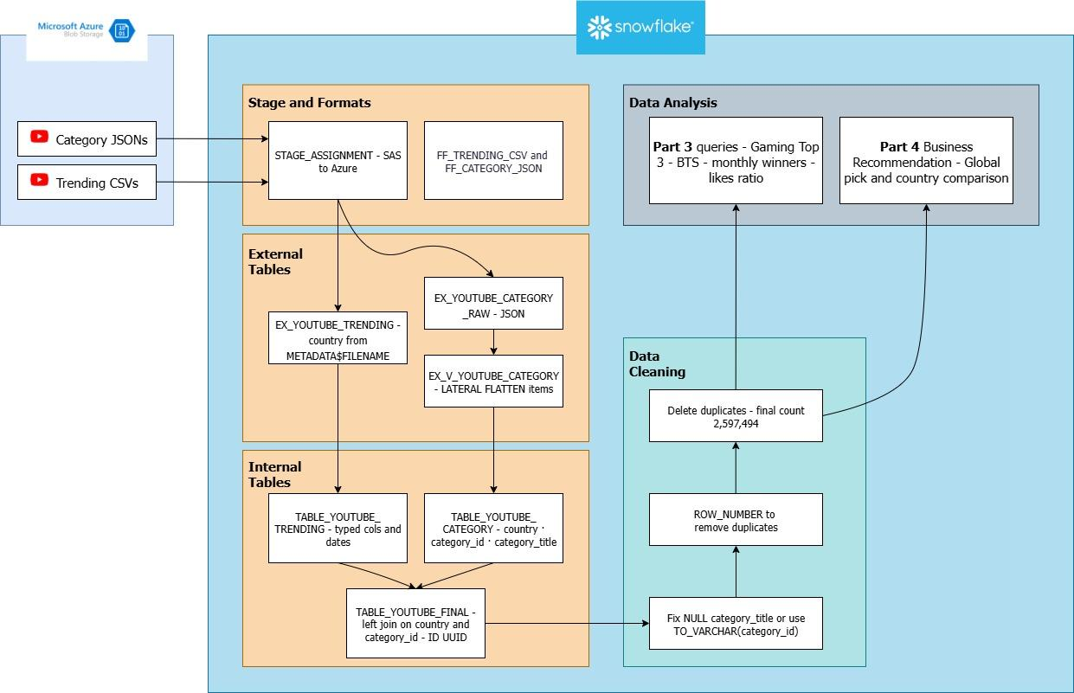Figure 1 - Overall Architecture Flow

For schema-on-read, we create external tables over the stage. The trending external table inspects value:c1…cN without coercion and derives country from METADATA$FILENAME (deterministic split). The category external table is normalised with LATERAL FLATTEN on items[], selecting id → category_id and snippet.title → category_title while also deriving country from the filename.
We then materialise curated internal tables for governed types and performance: TABLE_YOUTUBE_TRENDING (counts via TRY_TO_NUMBER; trending_date via TRY_TO_DATE; published_at via TRY_TO_TIMESTAMP_NTZ), and TABLE_YOUTUBE_CATEGORY (country, category_id, category_title).
The analytical fact, TABLE_YOUTUBE_FINAL, is built with a left join on (country, category_id) to avoid dropping trending rows if a label is missing, and is augmented with a stable row key UUID_STRING() (ID) to support deterministic de-duplication and audit trails.
Execution uses COMPUTE_WH with autosuspend; all DDL/DML runs under the assignment schema (ASSIGNMENT_1.PUBLIC). Validation captures row counts at each stage and samples records from external and curated layers to verify field alignment. This design preserves raw lineage in Azure, leverages external tables for flexible discovery, and provides typed internal tables for performant querying in Parts 2–4.

Part 2 – Data Cleaning
We treated Part 2: Data Cleaning as a reproducible data-quality study over the Snowflake corpus. Our objective was to surface label inconsistencies and structural duplicates, document their provenance, and apply deterministic, auditable fixes that preserve analytical signal. All steps are scripted in part_2.sql with query‐level comments and pre/post validation checks.
Q1 – Duplicate category titles (ignoring category_id)
Method: We standardized category_title (trim, lowercase, collapse multiple spaces) and grouped on the normalized token. We reported a single consolidated row by LISTAGG of all duplicate titles to show the taxonomy homonyms without overprinting lines.

Figure 2.1 - Duplicate Category Titles (normalized)

Q2 – Category title that appears in only one country
Method: Using the same normalized title, we counted distinct countries per label and filtered to COUNT(DISTINCT country)=1.

Figure 2.2 - Category Appearing in a Single Country

Q3 – category_id for rows missing category_title
Method: We isolated rows where category_title IS NULL and inspected distinct category_id.

Figure 2.3 - Missing Category Title

Q4 – Replace NULL category_title with the identified value
Method: We took a backup of table_youtube_final, then imputed category_title = TO_VARCHAR(category_id) only where it was NULL, preserving reversibility and avoiding guesses.

Figure 2.4 - Imputation Result for NULL Category Titles

Q5 – Videos without a channel_title
Method: We queried a distinct title where channel_title IS NULL OR TRIM(channel_title)=''.

Figure 2.5 - Titles Without a Channel Title

Q6 – Remove ingestion artifact video_id = '#NAME?'
Method: We pre-counted artifact rows, executed a targeted delete, then validated removals.

Figure 2.6 - Removal of video_id = '#NAME?' Artifacts

Q7 – Build only the bad duplicates with ROW_NUMBER()
Method: Within each (video_id, country, trending_date) group, we ranked rows by: view_count DESC → likes DESC → comment_count DESC → published_at DESC → id ASC. Rows with rn > 1 were materialized as table_youtube_duplicates for audit and rollback.

Figure 2.7 - “Bad” Duplicates Flagged by ROW_NUMBER()

Q8 – Delete duplicates and verify final cardinality
Method: We deleted from table_youtube_final by joining on the staged duplicate ids, then re-tested for any remaining multi-row groups per (video_id, country, trending_date).

Figure 2.8 - Duplicate Deletion & Final Cardinality Check

Collectively, these interventions yielded a clean master with a final count of 2,597,494 rows - exactly the expected cardinality in the brief. Methodologically, the pipeline emphasizes idempotence (pre-update backups), explainability (normalization rules and ordered tie-breakers), and traceability (staging the to-be-deleted duplicates). The outcome is a dataset whose categorical labels are consistent, whose identifiers are valid, and whose daily records are unique and analytically reliable.

Figure 2.9 - Final Record Count in TABLE_YOUTUBE_FINAL

Part 3 – Data Analysis
We analyse the post-clean, de-duplicated panel (2,597,494 rows) using stable keys (video_id, country, trending_date) and normalised category_title. All queries and outputs are provided in part_3.sql as sections Q1–Q5.
Q1 – Top-3 Gaming on 2024-04-01 (per country)
Method: For each country, we filter to category_title = 'Gaming' and trending_date = '2024-04-01', rank by view_count DESC using ROW_NUMBER() (ties broken deterministically by likes, comment_count, published_at, then video_id), and return the top 3 rows per country.

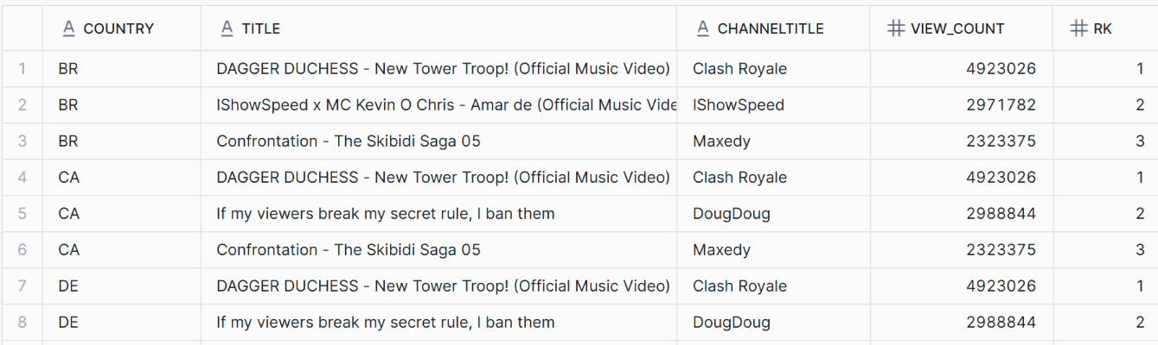Figure 3.1 - Top-3 Most Viewed Gaming Videos by Country on 2024-04-01

Q2 – Distinct videos with “BTS” in the title (case-insensitive)
Method: We compute COUNT(DISTINCT video_id) per country for titles matching title ILIKE '%BTS%', and sort in descending order of the count. This approximates the cross-country reach of BTS-related content.

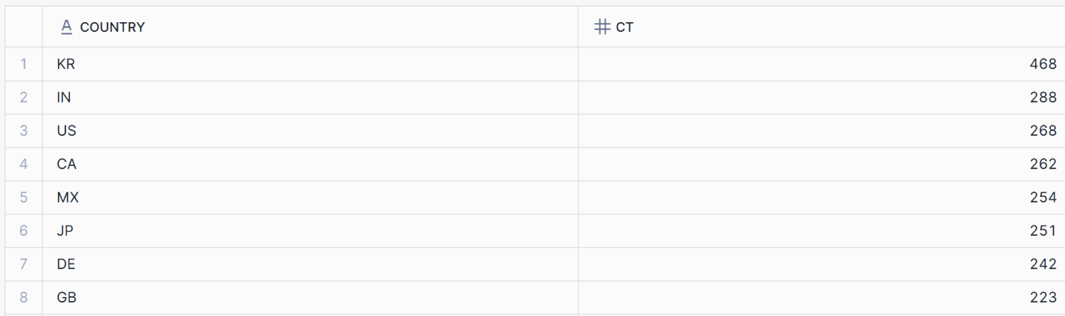Figure 3.2 - Distinct “BTS” Videos by Country (case-insensitive)

Q3 – Monthly winners (2024 only) + likes_ratio (2 decimals)
Method: Within 2024 we form YEAR_MONTH as a single column (e.g., 2024-01) from trending_date. For each (country, YEAR_MONTH) we pick the row with max view_count, and compute likes_ratio = 100 * likes / view_count, truncated to 2 decimals with a null-safe denominator.

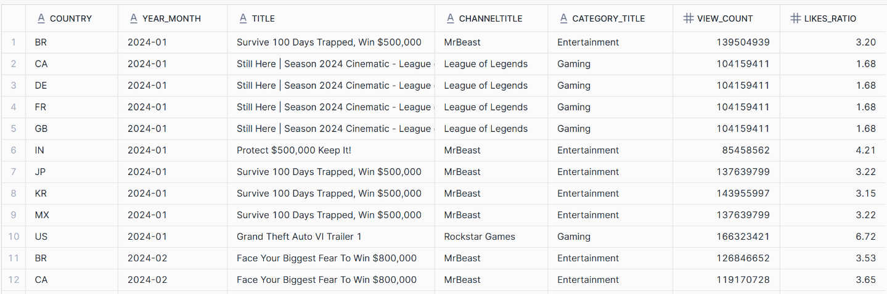Figure 3.3 - Monthly Most-Viewed Video & Likes Ratio (2024)

Q4 – Dominant category per country from 2022 onward (distinct share, 2 decimals)
Method: From 2022 onward, we count distinct videos per (country, category_title), compute each country’s total distinct count, and report for each country the category with the largest distinct count together with its percentage of the country’s distinct total, truncated to 2 decimals.

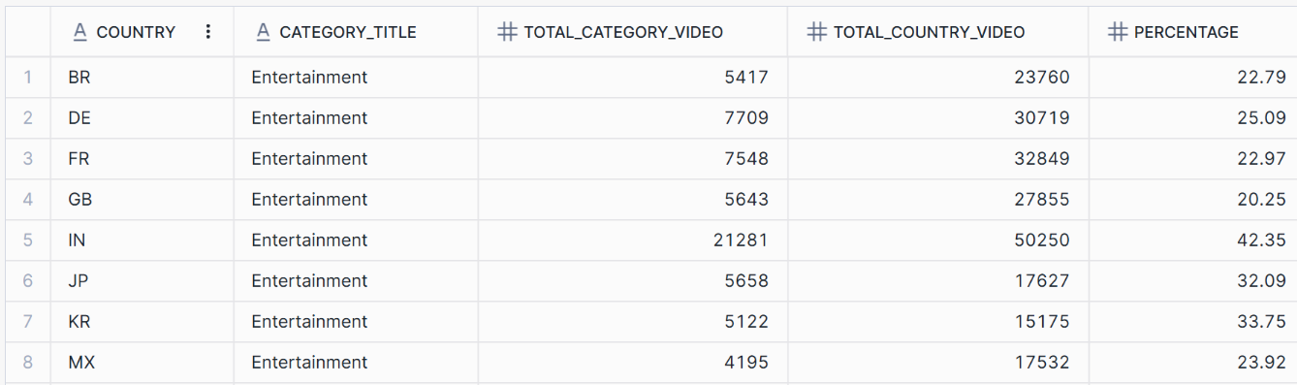Figure 3.4 - Country Leaders by Distinct Videos & Share (from 2022 onward)

Q5 – Most prolific channel_title (distinct videos)
Method: Globally, we rank COUNT(DISTINCT video_id) by channel_title (excluding blanks), break ties alphabetically, and return the single top result

Figure 3.5 - Most Prolific Channel by Distinct Videos (Global)

Across queries, we keep reproducibility central: each output is generated by a single, documented SQL block; all ranking uses explicit partition/order clauses; and every division or filter includes null-safe guards. Collectively, these analyses provide the empirical foundation used in Part 4 to recommend a global category strategy and to assess its cross-country generalisability.

Part 4 – Business Question
Using the cleaned table_youtube_final we ranked non-Music/Entertainment categories by a simple, reproducible rule: (1) maximise distinct videos (breadth of creators able to trend), with (2) tie-breakers on video-days (persistence/exposure) and (3) median view_count (robust central tendency).
The global leaderboard (Figure 4.1) shows a very tight three-way race in which Sports edges People & Blogs and Gaming, accounting for ≈21% of all global distinct trending videos and very high cumulative exposure. Our global recommendation is therefore Sports (Figure 4.2).

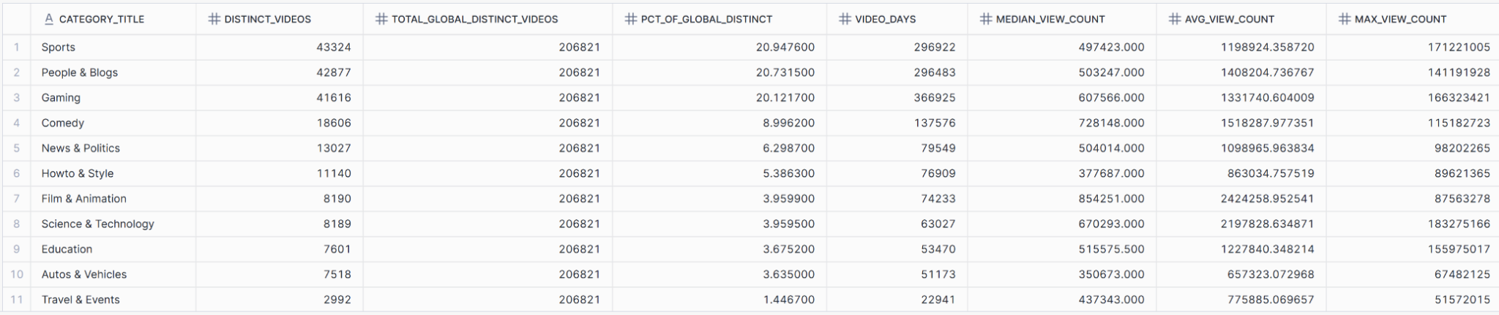Figure 4.1 - Global Leaderboard (Non-Music/Entertainment)

Figure 4.2 - Global Recommendation

However, the generalisation test (Figure 4.3) indicates that this strategy does not work in every country: only 3 of 10 markets have Sports as their top non-Music/Entertainment category (notably BR, DE, GB). The remaining markets split between Gaming (strong in CA, FR, JP, MX, US) and People & Blogs (IN, KR). In other words, while Sports is the best global bet, the signal is heterogeneous across locales, and a single global content playbook would leave material reach on the table.

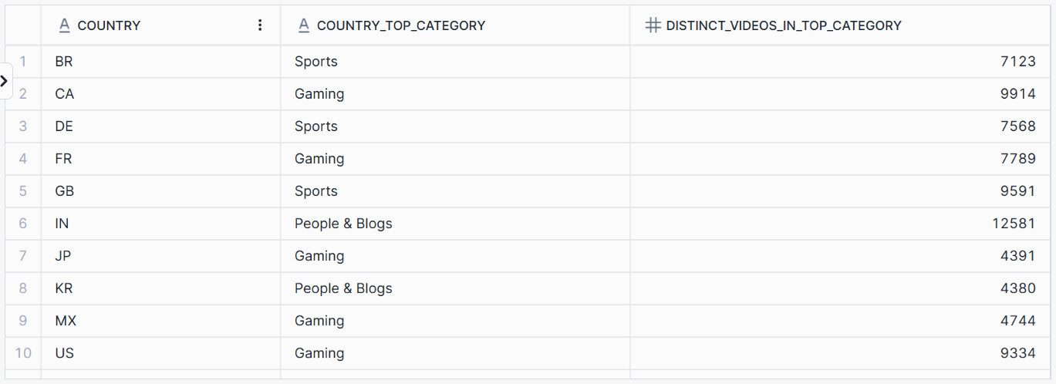Figure 4.3 - Country-Level Validation of the Global Pick

Our recommendation is a two-tier plan:
(i) if launching a global-first channel with no localisation, prioritise Sports to maximise overall trending probability;
(ii) for country-specific launches, pick the local top category (e.g., Gaming for the US and several Western markets; People & Blogs for selected Asian markets), and tune titles/thumbnails and posting windows to local norms.
This approach is directly supported by the SQL evidence: a global winner (Sports) combined with country-level winners reveals where the strategy holds and where it must be adapted.

Conclusion
This project demonstrates an end-to-end, reproducible pipeline - from Azure Blob Storage to Snowflake - that ingests, cleans, and analyzes YouTube trending data to answer concrete business questions. On top of this foundation, our analyses show (i) clear country-level heterogeneity in category performance, (ii) a global recommendation toward Sports as the most reliable bet by distinct volume, and (iii) monthly leaders and likes_ratio signals that help distinguish popularity from engagement.

Limitations
- Coverage bias: Trending data is not a census of all uploads; it reflects platform surfacing and may under-represent niche content or smaller creators.
- Temporal scope: Most analyses were cross-sectional (e.g., 2024 slices); seasonality and event effects are not fully modeled.
- Heuristics: Using view_count as the primary tie-breaker favors reach over depth; likes_ratio can be volatile for small denominators.
- Taxonomy drift: Category labels vary across countries; normalizing titles reduces but does not eliminate semantic ambiguity.
- External dependencies: Pipeline relies on SAS tokens and cloud stages; access lapses can interrupt reproducibility without governance.

Future work
- Time-series modeling: Forecast category demand and creator performance with seasonality and event controls; track cohort retention.
- Robust engagement metrics: Add watch time, comments sentiment, and completion rate; use winsorized ratios to stabilize small denominators.
- Causal/experimental design: A/B test thumbnails, titles, and upload cadence; estimate content-mix uplift per market.
- Semantic enrichment: Map videos to topics via NLP (e.g., embeddings), enabling finer-grained strategy than coarse categories.
- Automation & monitoring: Convert bulk loads to Snowpipe + Tasks, add data-quality checks (freshness, duplication, schema drift), and surface KPIs in a dashboard (category share, top creators, velocity).
- Localization framework: Build a scoring model that blends global scale with country-fit to recommend category focus per launch market.

