Image Segmentation with Explicit Mesh

**Abstract:**

**[June 15] The project have been proposed.**

# **Objective**

Image segmentation tries to segment image to piecewise constant function. The idea is to minimize an objective function (Reduced Mumford-Shah functional)

or it is similar to other form

where is the image domain, is approximated image, is original image and is the boundary of the piecewise region. This formula is similar to total variation.

There are several approaches to solve this problem. Generally, they employ level set function to represent the piecewise constant region. This approach works well with two phases and provides advantage in handling topology change. However they can only represent two phases and have difficulties with multiple phases.

In compare to level set (implicit function), representing piecewise constant functions by explicit mesh give some advantages: Explicit quantitative, precision as desired, etc.

In this project, I want to solve multiple-phase segmentation using explicit mesh. As the problem is non linear and large, the main approach is conjugate gradient method. Besides, I want to study effects of parameters choice to the accuracy and the convergence. Also I want to proposed better approach if there will exist any issue.

# What I have already had

I have had the draft version that works: Segment the image with multiple phases. DSC framework is employed to handle topology change during mesh evolution.

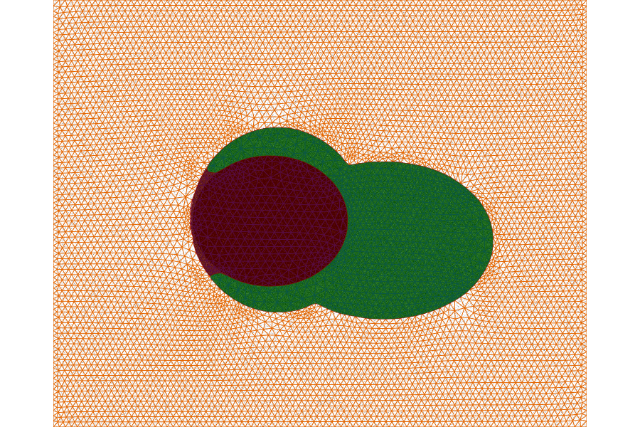

Figure 1: A 3-phases segmentation with explicit meshes

## Piecewise constant representation

The mesh is a set of triangles. Each triangle is labeled with a number that denotes the phase the triangle belongs to. The problem include

* Optimize the triangle label
* Optimize the boundary position of the mesh

## Issues

There are some issues that I want to solve in this project

* Triangle-label is integer. I have no idea to solve it with iterative method.
* Convergence: Because the segmentation is multiple-phase, there is no single value of time step that is optimal for all phases.