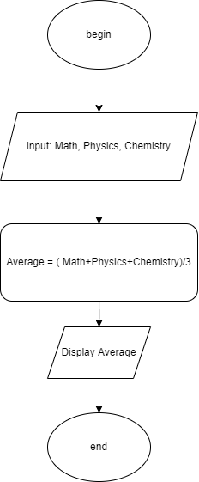BEGIN

INPUT math, physics, chemistry

average = math + physics + chemistry

DISPLAY average

END