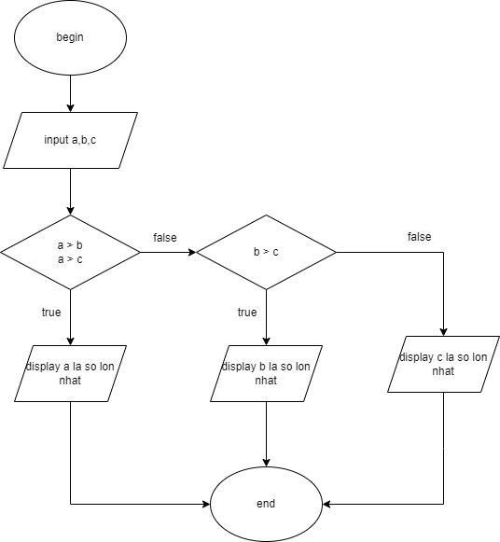

BEGIN

INPUT a,b,c

IF a>b & a>c

DISPLAY a la so lon nhat

ELSE

IF b > c

DISPLAY b la so lon nhat

ELSE

DISPLAY c la so lon nhat

END IF

END IF

END