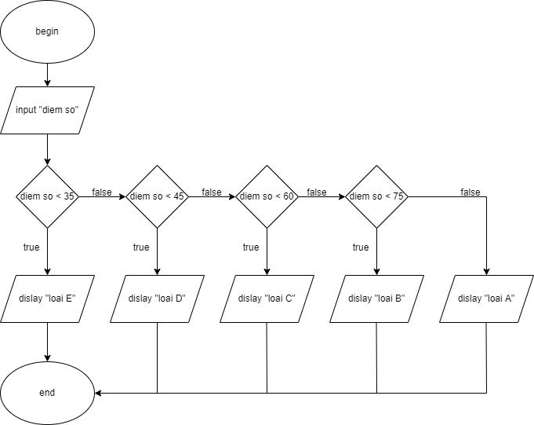BEGIN

INPUT “diem so”

IF diem so < 35

DISPLAY loai E

ELSE

IF diem so < 45

DISPLAY loai D

ELSE

IF diem so < 60

DISPLAY loai C

ELSE

IF diem so < 75

DISPLAY loai B

ELSE

DISPLAY loai A

END IF

END IF

END IF

END IF

END