
STUDENT PROFILE

ID: KB000107-746562
1. Họ tên: VŨ HUY HOÀNG | Fullname: VU HUY HOANG | 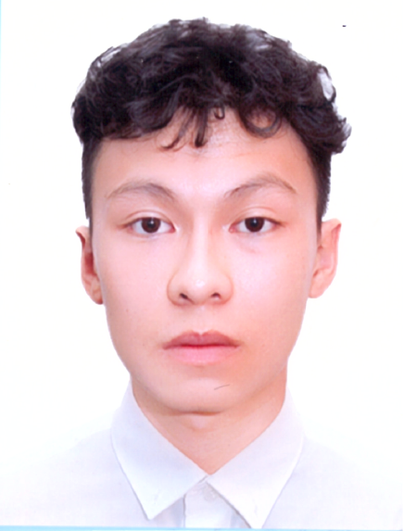
2. D.O.B: 2000.01.07 | 3. Gender: MALE
4. Passport: C5685996 | 5. Issue date: 2018.01.07
6. Home Address: Hung Vuong, Hong Bang, Hai Phong
7. Contact in Vietnam: +84.120.4114.069 | 8. Contact in Korea: 01025789653
9. Alien Registration No. 000107-714049 | 10. Duration stay: 2018/12/06 - 2019/06/05
11. Current Address in Korea: 인천광역시 남동구 간석동 216-5. 1004호
12. Manager Name: Ms Tham | 13. Manager Contact: 010-6688-2703
KOBEC Partner: KOBEC
FAMILY PROFILE---------------------------------------------------------
14. Total family member: 5
Member name | Relationship | DOB | Job | Contact
VU QUOC HUY | Father | 1963/04/13 | Driver
NGUYEN THI KIM LIEN | Mother | 1968/11/24 | Staff Mananger

SCHOOL PROFILE---------------------------------------------------------
15. Highschool
15-1. Highschool name:Marie Curie Highschool 15-2. Year of Graduation:2018
15-3. Highschool add: Hai Phong 15-4. Contact: +84.225.3829.517
Transcript | 10 class | 11 class | 12 class | Averange / Total
GPA | 8 | 7.9 | 8.5 | 8.13
Days-off | 0 | 0 | 1 | 1

16. Other Education
School name (University/college) | Major | Year of Graduation | GPA

APPLICATION PROCESS---------------------------------------------------------
17. School Name: Incheon National University
18. Major: Korean Language Trainning
19. Semester: 2018-Winter
KOBEC Process | Time - Note | UNI. Process | Time - Note
Online CV record | 2018.11.11 | Uni. Submission | 2019.04.13
CV Review | Accepted | Admission result | Accepted
Interview | Accepted | Invoice | 2018.10.30
Kobec admission | ACCEPTED | Tution payment | 2018.11.10 - 6500000 won
Hard Copy CV Record | 2018.11.13 | VISA code | 2018.11.06
Deposit amount | 70000000 | VISA | Yes
Deposit date | 2018.11.10 | Korea Entry | 2018.12.10
Profit (if any) | 6.6 %
Deposit terminated | 2019.12.10

KOREA EDUCATION PROCESS---------------------------------------------------------
20. Korean Language Education
CoursePeriodAttendedScoreUp/FNOTE2018-Winter2018-12-11 ~ 2018-12-11100%58100%전 영역에서 취약한 편임. 특히 듣기 영역이 취약하여 의사소통에 어려움이 있음. 문법 이해력이 부족한 편이어서 문법 활용 시 실수가 많은 편임.
21. Higher Education
Course | Period | GPA | Schoolarship | NOTE

RESIDENT PROCESS---------------------------------------------------------
22. Resident process
AddressPeriodManagerAccommodation feeAccommodation ownerNote인천광역시 남동구 간석동 216-5. 1004호2018-12-06 ~ 2019-06-05110.432.371106Ms Tham010-6688-2703

23. Partime process
Address | Period | Job | Note
 | NA ~ NA

NOTE

