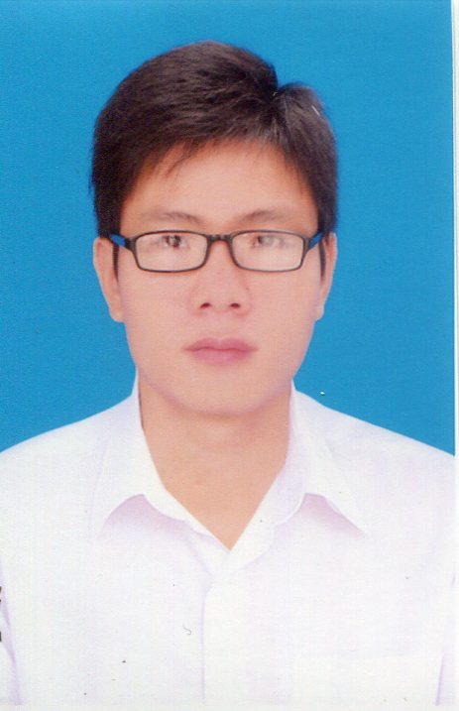
ID: KB000120.91243

STUDENT PROFILE

1. Họ tên: NGUYỄN HOÀNG DIỆU LINH Fullname: NGUYEN HOANG DIEU LINH
2. D.O.B: 2000.01.20 3. Gender: MALE
4. Passport: C6121434 5. Issue date: 2018.04.20
6. Home Address: Số 15 ngõ 01, đường Hoàng Việt – Tây Hồ - Hà Nội
7. Contact in Vietnam: +84.946481476 8. Contact in Korea: +82.1056878689

9. Alien Registration No. 000120-5231194 10. Duration stay: 2020.04.30
11. Current Address in Korea: 인천광역시 남동구 간석동 107-1, 301호
12. Manager Name: NGUYEN VAN A 13. Manager Contact: 010-4589-8596 KOBEC Partner: ICCPlus

FAMILY PROFILE
14. Total family member: 6
Member name | Relationship | DOB | Job | Contact
NGUYEN HOANG NHAT THANH  BUI THI VUI  …….. | Father  Mother | 1963  1966 | Worker  Farmer | +84.911122215  +84.911122215

SCHOOL PROFILE
15. Highschool.
15-1. Highschool name: NGHIA DO highshool 15-2. Year of Graduation: 2018
15-3. Highschool add: Nghia Do – Cau Giay – Ha Noi 15-4. Contact: +84.43558258
Transcript | 10 class | 11 class | 12 class | Averange / Total
GPA  Days-off | 7.0  1 | 7.2  2 | 7.1  1 | 7.1  4

16. Other Education
School name (University/college) | Major | Year of Graduation | GPA
Haiphong college (3 years college)  Haiphong University (4 years univer.) | Trading  Maketing | 2018  2018 | 3.0 / 4.0  2.5 / 4.0

APPLICATION PROCESS
17. School Name: Incheon National University
18. Major: Korean Language Trainning
19. Semester: 3-2019
KOBEC Process | Time - Note | UNI. Process | Time - Note
Online CV record  CV Review  Interview  Kobec admission  Full Original CV Record  Deposit amount  Deposit date  Profit (if any)  Terminated | 2019.01.01  Accepted  Accepted  Accepted  2019.01.20  70.000.000 VND (own)  2019.03.01  6.6%/year  T= Korea Entry + 365 days | Uni. Submission  Admission result  Invoice  Tution payment  VISA code  VISA  Korea Entry | 2019.01.22  Accepted – 2019.01.30  KB.2019-01065 / 2019.01.31  2019.02.07 – 6.600.000 won  2019.02.08  Y  2019.03.01

KOREA EDUCATION PROCESS
20. Korean Language Education
Course | Period | Attended | Score | Up / F | NOTE
한국어 – 1단게 | 2019.03.11 ~2019.06.11 | 80% | 59 | F
한국어 – 1단게 | 2019.06.11 ~2019.09.11 | 85% | 85 | Up | TOPIK 5

21. Higher Education
Course | Period | GPA | Schoolarship | NOTE
Univ. – 1 semester | 3/2019 ~ 6/2019 | 4.0 / 4.5 | 100%
Univ. – 2 semester | 9/2019 ~ 12/2019 | 3.75 / 4.5 | 75%

RESIDENT PROCESS
22. Resident process
Address | Period | Manager | Accommodation fee | Accommodation owner | Note
1. 인천광역시 남동구 간석동 107-1, 301호 | 2019.01~2019.06 | Under | 250.000 won (H+100k facility) | Kim Ki Bo  010-2551-2115
2. 인천광역시 남동구 간석동 107-1, 901호 | 2019.06~ | No | NA | Lee Bo Sik  010-2222-3333

23. Partime process
Address | Period | Job | Note
1. 인천광역시 남동구 간석동 107-1, 301호 | 2019.01~2019.06 | Buop | 사장: 김기보-010......

24. violation / Award
Award | Violation
1. Schoolarship: INU 100% Undergradate 1 semester – 6/2019  2.  3.  4. | 1. Traffic signal violation – 2019.05.02  2.  3.  4.

NOTE
- Địa chỉ người thân tại Hàn Quốc
- …

