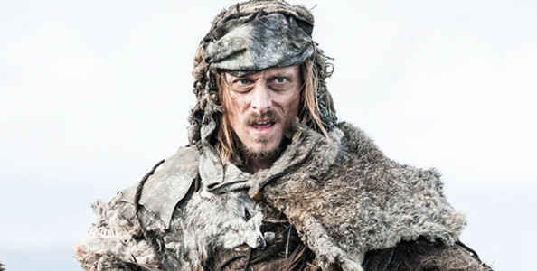

Styr, Magnar of Thenn  
Euron Greyjoy  
Rattleshirt, The Lord of Bones  
**Orell**

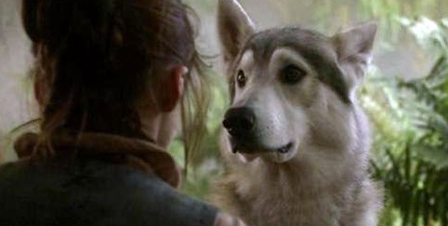

**Nymeria**  
Missandei  
Shaggydog  
Ghost

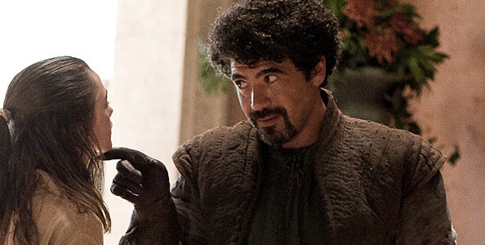

Ser Dontos  
Kyaznys Mo Nakloz  
**Syrio Forel**  
Illyrio Mopatis

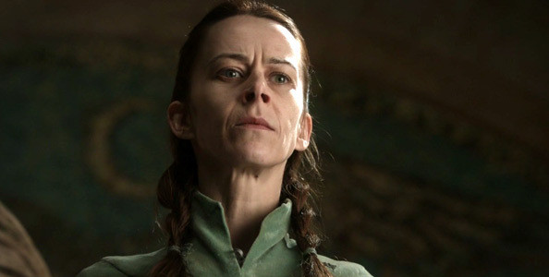

**Lysa Arryn**  
Catelyn Stark  
Roslin Slynt  
Selyse Baratheon

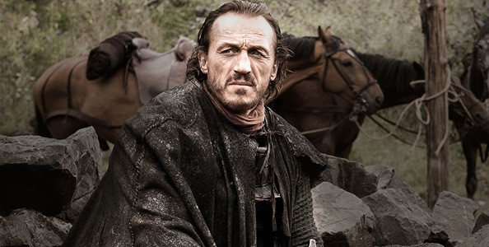

**Bronn**

Ser Dontos

Syrio Forel

Yoren

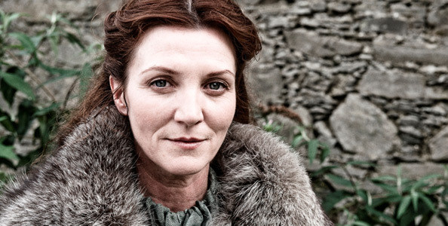

Lysa Arryn  
**Catelyn Stark**Selyse Baratheon  
Olenna Tyrell

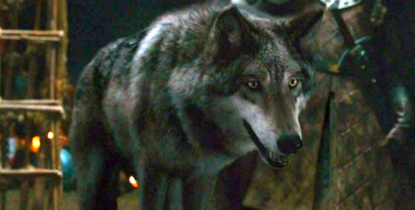

Pyp

**Grey Wind**

Shaggydog

Bowser

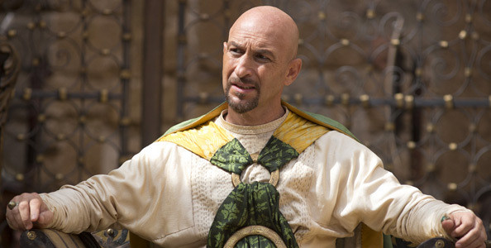

Pyat Pree  
Missander Navaxos  
Jorah Mormont  
**Kraznys Mo Nakloz**

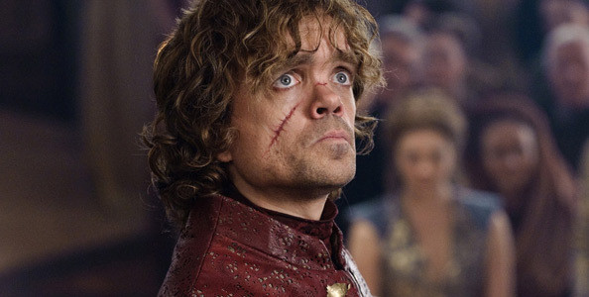

**Tyrion Lannister**

Waldor Stark

Tywin Frey

Jorah Clegane

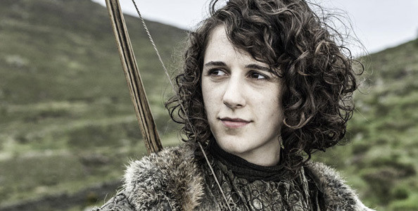

Doreah  
**Meera Reed**  
Roslin Frey  
Ros

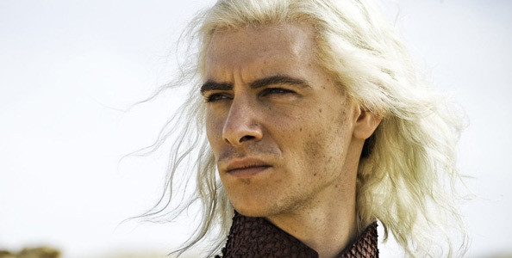

Jon Snow  
Varys Targaryen  
**Viserys Targaryen**  
Illyrio Mopatis

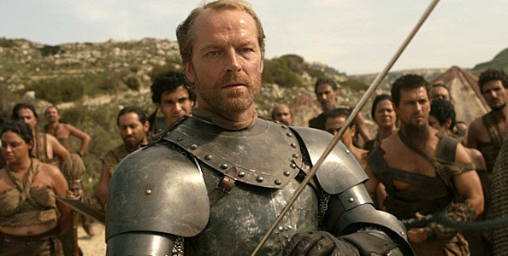

Bronn  
**Jorah Mormont**  
Barristan Selmy  
Baario Naharis

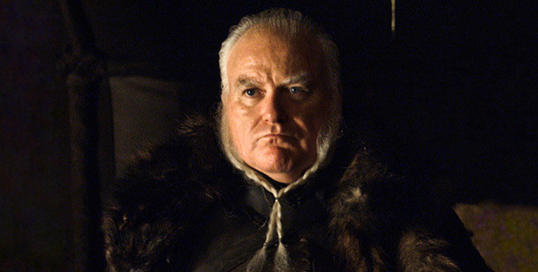

Alliser Thorne  
Ramsay Snow  
Edmure Tully  
**Rodrik Cassel**

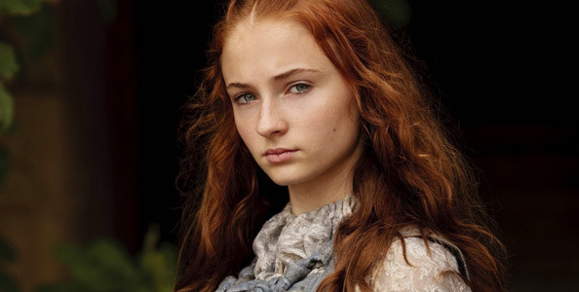

Ayra Stark  
Robin Arryn  
Margaery Tyrell  
Sansa Stark